**SCREENSHOT**

**SAMPLE SCREENSHOT**

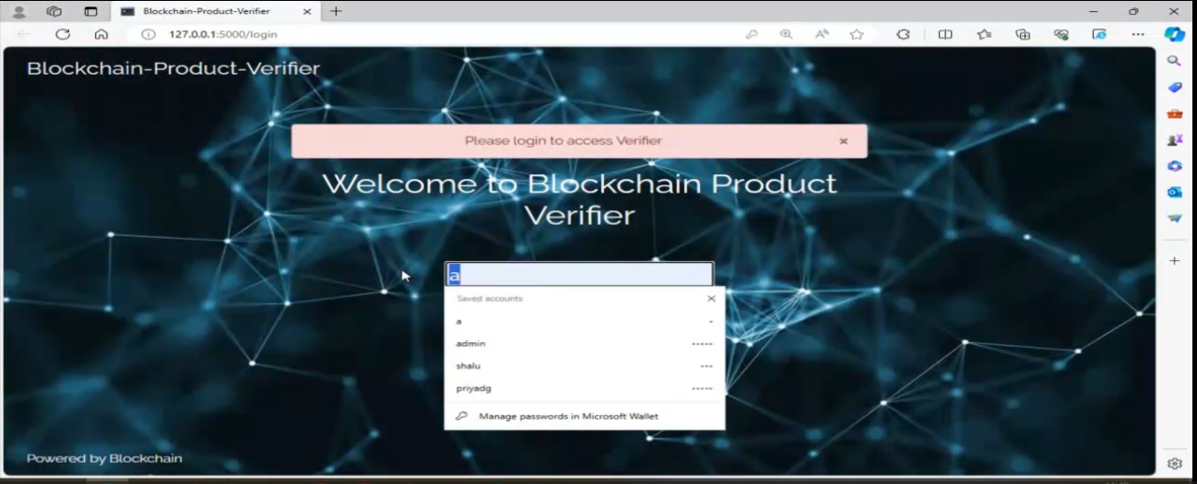

**Figure 1 Home page admin on Fake product Blockchain**

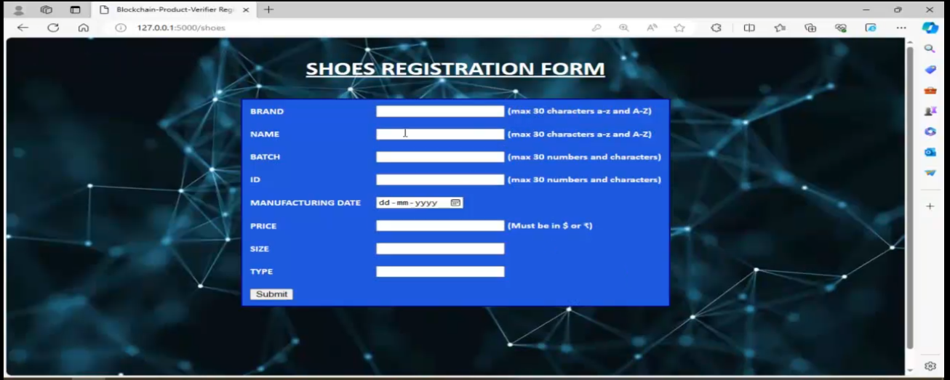

**Figure 2 Shoes Register Form on Fake product Blockchain**

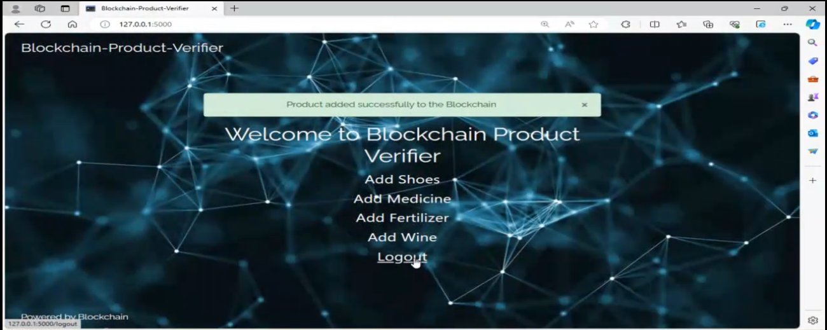

**Figure 3 Verified on Fake product Blockchain**

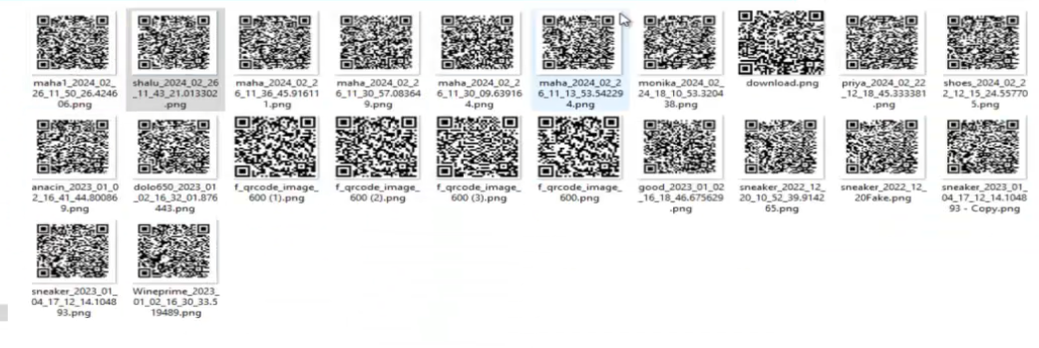

**Figure 4 QR Code Generated on Fake product Blockchain**

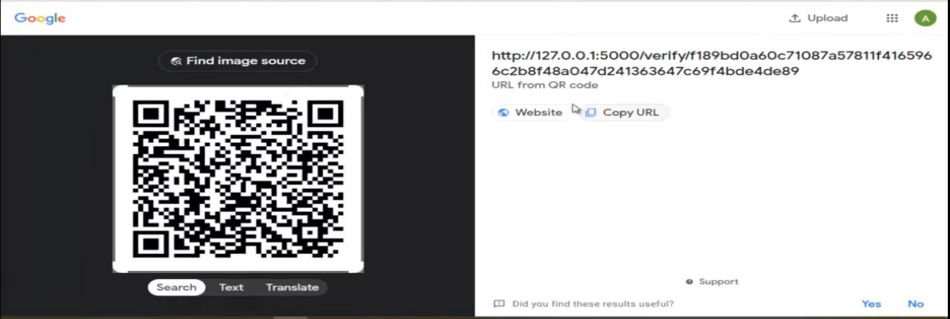

**Figure 5 Scanning based QR Code Generated on Fake product Blockchain**

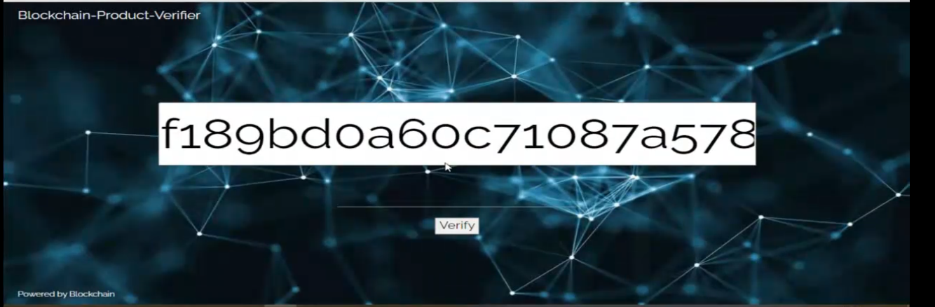

**Figure 6 Verified based hash data on Fake product Blockchain**



**Figure 7 Verified based product on Fake product Blockchain**

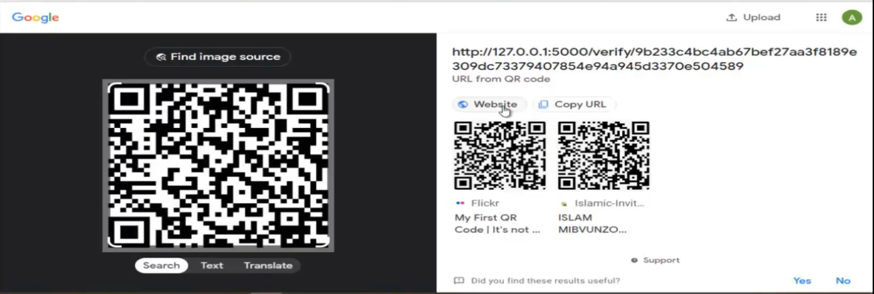

**Figure 8 Verified based Fake product Blockchain on QR code**



**Figure 9 Verified based Fake product**