**Impact of EWOM, Email-Marketing and TV Advertising on Consumer Purchase Intention: Mediating role of Brand Credibility**

Supervisor

Dr. Muhammad Asif Khan

Student Name

Fatima Nawaz Qureshi

Registration No

1621108

Program

MS (Management Sciences)

**Shaheed Zulfiqar Ali Bhutto Institute of Science and Technology**

**Islamabad Campus**

|  |  |  |
| --- | --- | --- |
| **TABLE OF CONTENTS** | | |
| **Para** | **Content** | **Page no** |
| **Chapter 1** | | |
| 1. | Introduction | 1 |
| 1.1 | Background | 1 |
| 1.2 | Contextual Analysis | 2 |
| 1.3 | Gap in Literature | 3 |
| 1.4 | Problem Statement | 4 |
| 1.5 | Objective of Study | 4 |
| 1.6 | Research Questions | 4 |
| 1.7 | Significance of the Study | 5 |
| 1.7.1 | Academic Significance | 5 |
| 1.7.2 | Managerial Significance | 5 |
| 1.8 | Delimitations | 5 |
| **Chapter 2** | | |
| 2. | Literature Review | 6 |
| 2.1 | Theoretical Background | 6 |
| 2.2 | Electronic Word Of Mouth (EWOM) | 6 |
| 2.3 | TV Advertising | 8 |
| 2.4 | Email Marketing | 11 |
| 2.5 | Brand Credibility | 12 |
| 2.6 | Consumer Purchase Intention | 14 |
| 2.7 | Ewom and Brand Credibility | 15 |
| 2.8 | TV Advertising and Brand Credibility | 15 |
| 2.9 | Email Marketing Brand Credibility | 16 |
| 2.10 | Ewom and Purchase Intention | 17 |
| 2.11 | Email marketing and Purchase Intention | 18 |
| 2.12 | TV Advertising and Purchase Intention | 18 |
| 2.13 | Brand Credibility and Purchase Intention | 19 |
| 2.14 | Theoretical Framework | 20 |
| 2.15 | Statements of Hypotheses | 20 |
| **Chapter 3** | | |
| 3 | METHODOLOGY | 21 |
| 3.1 | Research Philosophy | 21 |
| 3.2 | Approach | 21 |
| 3.3 | Research Strategy | 22 |
| 3.4 | Instrument Development | 22 |
| 3.5 | Unit of analysis | 22 |
| 3.6 | Time Horizon | 22 |
| 3.7 | Pilot Testing | 23 |
| 3.8 | Pilot Test Reliability | 23 |
| 3.9 | Data Collection Method | 23 |
| 3.10 | Statistical Tests used for data analysis | 24 |
| 3.11 | Face and Content Validity | 24 |
| 3.12 | Ethical Considerations | 24 |
| 3.13 | Demographics Statistics | 25 |
| 3.14 | Reliability | 26 |
| 3.15 | Regression Analysis | 26 |
| 3.15.1 | Normality | 26 |
| 3.15.2 | Linearity | 32 |
| 3.15.3 | Homoscedasticity | 35 |
| 3.15.4 | Multi Collinearity | 39 |
| **Chapter 4** | | |
| 4 | Results and Analysis | 40 |
| 4.1 | Descriptive Statistics | 40 |
| 4.2 | Correlation | 41 |
| 4.3 | Hypotheses Testing | 42 |
| 4.3.1 | Linear Regression Analysis | 42 |
| **Chapter 5** | | |
| 5 | Conclusion and Recommendations | 48 |
| 5.1 | Managerial Implications | 48 |
| 5.2 | Academic Implications | 49 |
| 5.3 | Limitations and future directions | 49 |
| 5.4 | Conclusion | 49 |

**CHAPTER 1**

**INTRODUCTION**

* 1. **Background**

Marketers strive to understand the mechanism of customer purchase decision making. In general, Consumers are found reluctant to those brands, about which they are uncertain or do not have enough information (Kim, Moris, & Swait, 2008). As pointed out by Keller (2008), an important role played by a brand is that it enables consumers to identify a firm’s products/services and can differentiate them from other competitors. Indeed, consumers are facing an increasingly varied range of products on the market, while firms always know more about their products than do consumers. This asymmetric information availability may cause confusion or uncertainty in consumers’ minds when they make a purchase. In such cases, brands can serve as symbols or signals for product positioning and it’s one important characteristic is brand credibility (Erdem & Swait, 2004; Wernerfelt, 1988). Brand credibility is associated with believability and it is one of those psychological factors which have impact on consumers buying intention (Erdem et al., 2004). The cosmetic industry in Pakistan is growing rigorously in last few years. Although Pakistan’s local products have less demand as compared to the international brands. The increasing of cosmetic products is due to the reason that people are bombarded with the advertisements through which they gather information and this factor motivate them to purchase it. Cosmetic industry is directly related with the fashion industry as consumers have the deep insight about their looks and the fashion trending at specific time. A desire to look good and be acceptable in the society highly influences the people to buy the cosmetic products (Jinah & Lodhi, 2015).

We are living in the age of digital world where dependability on internet and the time people spend online is constantly increasing. Marketers are looking for such marketing strategies and tools which are compatible with e-commerce .Although people surf on internet, there is still middle and old aged group of customers, who rely on TV and newspaper as a source of awareness and information (Todor, 2016).In past Email-marketing has been considered as an ineffective and deceptive tool of marketing but researches proved that consumers like to receive emails from the brands and companies they do like (Dufrene, 2005). The concept of electronic word of mouth has also been emerged in third world countries like Pakistan, as social media networking sites are becoming familiar with most of the residents of Pakistan (Saleem, Zahra, & Yaseen, 2017).

As past researchers, (Erdem & Swait, 2004; Kim & Yu, 2010) clearly mentioned the relation between advertising and brand credibility but no empirical study has been conducted to investigate the impact of advertising on brand credibility. In this research, the impact of TV advertising, EWOM and email marketing on brand credibility and its impact on consumers purchase intention has been studied. The area/sector of this study is limited to brands of cosmetic products and the respondents of this research are only female consumers of cosmetic products.

* 1. **Contextual Analysis**

According to the Euro monitor Market Research Report (2016), the demand for Cosmetics and personal care products is increasing rapidly in Pakistan. There are few economic factors behind this but one of the most influential factors is media exposure of brands and products. Not only women but men are also spending more for these products. If we discuss the details of even a single category shampoo, data from Euro monitor shows that retail sales of hair shampoo in 2014, was US$158m, and increased upto $179m in 2015, almost 13.3%. Its been forecasted that by 2020 sales could reach $240m.

According to Economic Outlook of Pakistan August 2015, the market for beauty products is rising and national and international brands are targeting this market. The renowned international brands like Maybelline, BODY SHOP, L’Oreal Paris, are just like household names in urban areas of Pakistan. As compared to 2013, the import of cosmetic/beauty products has been increased 67% in 2014. Due to all these national and international brands, the competition is very high.

In last WWD (Women’s Wear Daily) summit, the biggest conference of fashion and beauty industry, it has been discussed that there are no more unfeasible barriers in beauty industry and now there is a competitive threat for the already established brands. The taste of consumers is changing. In 2016, the growth of independent brands was 42%. Millennial have completely different perspective of communication. They spend more time looking at their phones and share their experiences on social media. They take what they are given and spread the word. So the brands are changing the channels and preferences according to the trends in industry.

* 1. **Gap in Literature**

Elseidi & Baz, (2016) investigated the impact of EWOM on brand image and brand attitude. Authors further recommended scrutinizing the impact of EWOM on purchase intention with other variables and constructs such as brand credibility and brand trust. Past studies have measured brand credibility’s direct affect on consumer purchase intention and also kept it as a moderator in some studies(Jin, Lee, & Jun, 2015; Wang & Yang, 2010). Brand credibility has weakness in its literature because there are only few empirical studies available outside the US (Erdem & Swait, 2006).Future studies are required to test this construct in other countries to see if it is a universal phenomenon or just limited to the US (Bougoure, Bennett, Hasan, & Mortimer, 2016).

Use of digital information by consumers, has already been studied by many researchers. Future studies are required to investigate the impact of this digital information on consumer’s psychological outcomes such as psychological constructs (Stephen, 2016).This study focused on brand credibility as according to Erdem et al., (2004), brand credibility is psychological construct. Past studies selected the product categories such as smart phones, automobiles; and services categories like hotels, restaurants and tourism to see positive impact of EWOM on consumer purchase intention (Jeng, 2016). To look in to new insights regarding this area of research, future studies should choose other product categories. (Kudeshia, Kudeshia, Kumar, & Kumar, 2017). So, the focus of present study is cosmetic industry in Pakistan.

There is lack of research studies, which can provide empirical evidence regarding role of TV advertising in building brand credibility. Previous studies mentioned that advertising can build and increase brand credibility but no empirical evidence has been given (Erdem & Swait, 2004; Baek & King, 2011; Jeng, 2016).

* 1. **Problem statement**

**Because of high competition in cosmetic industry worldwide and also in Pakistan, brands are changing their preferences.**

As competition is increasing and brands are changing marketing channels and preferences according to the industry (WWD, 2016), it is important to understand which marketing activities and promotional tools can lead to increase consumers purchase intention in Pakistan.

This study analyzed the effect of social media marketing activity EWOM and traditional marketing tool/activity TV advertising on brand credibility and intention to purchase. This study also examined the impact of email marketing on brand credibility and consumers purchase intention in context of cosmetic industry.

* 1. **Objective of the study**

The research objectives of this study are to examine the effect of EWOM, email-marketing and TV-advertising on brand credibility. This study investigates if brand credibility mediates the relationship between EWOM, Email-marketing, TV-advertising and purchase intention.

* 1. **Research Questions**

1. What are the effects of EWOM, email-marketing, and TV advertising on brand credibility?
2. Does brand credibility mediate the relationship between EWOM, email-marketing, TV-advertising and consumer purchase intention?
   1. **Significance of the study**

This study is a consumer focused research. The findings of this study will facilitate the marketers, particularly of cosmetic brands. It will assist them to create a blend of traditional and social media marketing communication tools in order to boost up their brand credibility. With the help of this study, marketers will be able to understand which marketing communication tools have more impact on consumer’s decision making process.

* + 1. **Academic Significance:**

This study will contribute to the literature of brand credibility as in recent study (Bougoure, Bennett, Hasan & Mortimer, 2016) it was recommended to test this construct in other cultures, out of US. This study will not only strengthen the literature of brand credibility but also show the significance of TV-advertising in current digital era.

* + 1. **Managerial Significance:**

Briefly, as globalization grows and competition intensifies in emerging markets, it is essential for multinational companies to understand local consumers’ perceptions about their brand. Multinationals should also be aware of brand credibility (Wang & Yang, 2010). This study will help the marketing managers of cosmetic brands to understand the consumer perceptions and the effect of brand credibility on purchase intention of consumers in Pakistan. As this study confirms the effectiveness of TV advertising, EWOM and email-marketing, it can help marketing managers of cosmetic brands to choose which marketing tool is better to increase consumers purchase intention.

* 1. **Delimitations**

This study is only focused on cosmetic brands in Pakistan. The data will be collected from Islamabad and Rawalpindi.

**CHAPTER 2**

1. **LITERATURE REVIEW**

## Theoretical Background

The theory of brand signaling is related with information economics, this theory says that firms can minimize the impact of asymmetric and unreliable information available in the market by using brand as a signal to convey positive and right information to the market. Credibility and clarity are two basic factors which makes the brand signal effective (Erdem & Swait, 2004; Erdem et al., 2002) As clarity means that the information being spread in market is free of ambiguities while credibility is associated with truthfulness, effectiveness and dependent on the reliability of information (Erdem & Swait , 1998; Tirole 1988).Here a question arises that how a brand can convey signals. Signal can be defined as an action which seller takes to provide information about unobservable quality of a product to the consumers. Brand signals are actually the past and present marketing activities of a brand through which a brand spread information about brand quality (Mayer & Sethi, 1985). TV advertising, EWOM and Email Marketing are actually the marketing activities of a brand. As it has been hypothesized in this present study that TV advertising, EWOM and Email Marketing increases the brand credibility. With the help of signals, brand credibility further increases the purchase intention of consumers (Baek et al., 2010).

* 1. **Electronic Word Of Mouth (EWOM)**

Word of mouth is stated and considered as individual to individual communication and exchange of ideas, thoughts, likes, dislike, perspectives and assumptions about any scenario, product or service between people of same interests (Cheung, Lee, & Rabjohan 2008). With the increase of new and advanced technologies and increasing the usage of internet, consumers and online social media networking sites users are gaining information from online web forums and thus the electronic word of mouth has been enlightened (Reimer & Benkenstein, 2016). Electronic word of mouth can be explained as any negative or positive statement made by actual, potential or former consumer about the certain product or brand or service, which is available to the vast amount of people connected with one another through internet. It has been seen that word of mouth has more power than any other online marketing technique ever had (Zernigah & Sohail, 2012).

Habitual word-of-mouth interaction or communication about a specific product or service can be recounted as the exchange of reviews and conversation between people (Fine, 2017). Word-of-mouth also known as viva voice is the spreading of information about specific product, service or any sought of scenario between different people (Zhang, Hu, Guo, & Liu, 2017). In electronic word-of-mouth, the communication between individuals happens on internet, it may be about specific product, service, amenity or specific situation or scenario, electronic word of mouth is sought of buzz marketing and it can be very effective if used properly by marketers (Thurau, Gwinner, Walsh, & Gremler, 2004).

Electronic word-of-mouth is a social communication that allows consumers to interact with one another and share their thoughts and opinions. Word of mouth communication and social communication is not a new concept and its impact on purchase behavior has been seen widely for many years now, that is one of the main reasons for marketers prompted towards review generating initiatives on their online networking forums which enables them to get customer feedbacks (Kudeshia & Kumar, 2017). Researchers and analysts have evaluated that electronic word of mouth as influenced the behaviors of customers that prefer shopping online. The development of the Internet and emergence of World Wide Web, have enabled consumers an entirely advance realm in which they are allowed to interact, communicate and influence one another (Cheung et al., 2008).

Several previous studies elucidated that individuals enjoy using electronic word of mouth as an inquisitive information tool (Rosario, Sotgiu, Valck, & Bijmolt, 2016). This circumstance is ubiquitous among deducible groups wherein individuals have developed their connections or even in public forums where individuals do not have personal connections or relationships but they might have reciprocal interests, choices, assumptions or perspectives about specific scenario (Hussain, 2016).

Electronic word of mouth plays vital role in marketing, It is not only for customers who get a chance to review their favorite products but also for the enterprises as they get a chance to promote their brand or product through electronic word of mouth (Jalilvand, Esfahani, & Samiei 2011). The impact of electronic word of mouth on consumer decision making process has been studied by many researchers and scholars in the past (Reimer & Benkenstein, 2016). According to the previous studies, electronic word of mouth has always seen as the more effective tool than any other marketing tool on internet and conventional advertising media (Bao, Chang, & Kim, 2016). Electronic word of mouth is an important area to be explored about and to be studied, (Fine, Gironda, & Petrescu, 2017).

Electronic word of mouth is not only used by customers but also many huge enterprises now use internet marketing, social media networking sites have given option that enables review tool on social media page associated with specific brand where consumers can give feedbacks, the positive reviews on theses businesses’ pages really help them to be known by vast number of audience and meet their potential customers (Ali & Fatima, 2016). Electronic word of mouth helps marketers to hit their target customers by enhancing their products features and customers’ service so that they will get positive reviews and that will help them in promotions of their new products and brand (Bao et al., 2016).

The concept of electronic word of mouth has also been emerged in third world countries like Pakistan, as social media networking sites are becoming familiar with almost most of the residents of Pakistan (Saleem, Zahra, & Yaseen, 2017). Large companies are now using online marketing to advertise their products or services mainly on social media networking sites where number of audience is relatively high and customers are enable to share any content related to their favorite product or analyze the product by viewing its reviews online by other users of that product in Pakistan (Irshad, 2014). Recent study that has been taken out in the context of Pakistan has shown that electronic word of mouths helps in creating brand image and has great influence on customer purchase intention (Tariq, Abbas, Abrar, & Iqbal, 2017).

* 1. **TV Advertising**

“Advertising is any paid form of non personal presentation & promotion of ideas, goods, or services by an identified sponsor.” Before making an advertisement for any product or service, a marketer needs to take few decisions. The first one is objective, whether the objective is to make the product well known, to provide information or to persuade them to buy. The other decision is Budget. The third one is generating an effective message, advertisers can use deductive or inductive approach while generating message. Another very important decision is to choose the type of media to expose the advertisement to your target market.(Kotler, 2009)

In order to compete in market, marketers need to consider advertising a critical part for influencing consumer attitude. For this marketers’ have to give importance to buyers opinion regarding advertisement and their media choices. (Ramsingh & Renganathan, 2016).

A study conducted by a well known media research agency, ZenitOptimedia (2015), showed that due to rapid growth in internet users the use of traditional media has decreased. The study further revealed that in average a person spends approximately 490 minutes daily to use any kind of media and interestingly television is still dominating over other media as results show TV as 3 hours of a person’s daily media consumption. Even though there are number of mediums for communication, but television is still one of the most powerful sources. (Abbatangelo-Gray, Byrd-Bredbenner, & Austin, 2008).The preference marketers give to TV advertising over print advertising is because it has both audio and video attributes; it grants product an instant validity and also enhances the prominence(Kavita,2006). Tv advertising not only affect the emotions but the message in advertisement also exert significant influence on daily lives of people.

Competition is getting harder due to appearance of more food companies in market. To get the more market share, companies always tend to know the most significant factor to influence the consumer (Hogg, Espinosa, Shah, Venkatraghvan, & Hota, 2016). According to Rotzoll, haefner, and sandage (1989) both,supporters and critics of adverstising, agree that providing information is the chief legitimizing function of advertising. According to the Andrews (1989),consumer has a strong belief that advertising exhibits the true picture of any product.Effective advertisement is one which actually helps advertiser achieve its goal. (Doyle & Saunders, 1990). As per result of most studies conducted in different countries, related to TV advertisements, showed that it has positive impact on viewers attitude which consequently perused them to start purchasing Processes. TV as a main media source for advertisement has 3 core functions. First, it has direct impact on consumers’ attitude which builds perception. Second, it can cover large audience in cost effective manner. Third, Because of music and videos it has more strong impact on viewers. (Ansari, Esmaeil, & Joloudar, 2011).

Advertising influences the attitude of consumer by providing information about product, which consequently leads them to purchase. ( W.Lamb, F.Hair & Sharma,2012) According to Latif , Abdul, Salman, Saleem, and Abideen, (2011) advertising can be used as a significant tool for influencing consumers brand choice.Although advertising on internet is in trend but advertisers believe that television is a major media to make your brand strong.(Draganska, Hartmann,& Stanglein, 2014).

Opposed to the above discussion, According to Chittithaworn and Thooksoon (2011) old aged people and people, who have high income level, do not have a positive attitude toward advertising. There are some other factors such as perceived value, opinions and knowledge which influence their purchase decision (Bhakar & Dubey, 2015).

According to the theory of psychological reactance, consumer will show the confronting reaction if he/she perceived that his behavioral freedom has been threatened. (Brehm 1966). Techniques having annoying impact and overlying manuplation through advertising can lead to unwanted behavior of consumer (Ducoffe, 1995).

Although so many researchers have been done to prove the positive attitude of consumer about Tv advertisement. There are several researches which showed that in general consumer show dislikeness for Tv advertisement. (Alwitt & Prabhaker, 1992; James & Kover, 1992; Bush Smith & Martin,1999; Jozsa, Insch, Krisjanous & Fam 2010).

Fam, Waller, Cyril and He (2013) conducted research in 5 major countries of Asia to understand the dislikeness of consumer for advertisements. They discussed advertisements dislikabilty and it’s reasons. One of the main reasons was exaggerating the product features. They also mentioned that advertisement dislikability may lead to negative purchase intention. They found in their research that consumer who dislike the advertisement have negative purchase intention. Though there are online media channels available but TV advertisement has not lost its significance and it is still important part of marketing mix. Marketers have become smart enough to understand when to use TV advertising in the presence of other media options (Rubinson, 2009).

* 1. **Email Marketing**

Email is a form of direct marketing which allows companies to interact with their customers in customized way. This is more cost effective than traditional mail and allows companies to target wide range of consumers to spread the information regarding their companies (Sharma & Sheth, 2004). Although in past, email marketing have been considered as deceitful form of marketing, At present, the situation has been changed and e-mail marketing has become one of most effective marketing activities which play vital role in building brands and improving the relationship with customers. As number of internet users is increasing day by day, email marketing has become important tool to reach large amount of customers (Hudak, Kianickuva, & Madlenak, 2017). Merisavo and Raulas, (2004) identified e-mail marketing as an important tool of marketing which leads customers towards brand loyalty.As, communication is very crucial to enhance customer loyalty, to understand how communication can lead to brand loyalty, it is important to understand how communication and interaction with a brand influence the customer’s attitude towards brand. According to communication and consumer behavior theories, if consumers have preference for any certain brand, they will not only search information about it but will be keener to receive information about it. Persistent communication potentially increases brand attitude as it enables customers to process the information (Berger & Mitchell, 1989). The time consumers spend with any certain brand and information they process, actually stimulates the positive emotions in consumers mind (Dickand & Basu, 1994).

Cognitive Dissonance also known as mental discomfort which leads person to has two or more different and contradictory belief. So, regular communication can decrease cognitive dissonance by providing enough information (Sheth & Parvatiyar, 1995).

Although relationship and attachment with brand is important for some consumers (Fournier, 1998).E-mail marketing is better option for such companies who want to build the relationship with their customers (Chaffey et al.,2003). Adoption of email marketing is more suitable for small and medium sized companies as promotional messages can be distributed within affordable cost (Moustakas et al., 2006).The benefit consumers get from such emails is information that matched their interest.(Granter 1996).Consumers mostly value those emails which contain content and information of their interest (Gengler & Thomas,1995).

So for this, permission based e-mails are more suitable and in wide use because consumers dislike unsolicited emails such as junk and spam. In some countries it has become a legal requirement to take explicit consent of recipients before sending them newsletters or promotional emails (Worthy & Garaham, 2002).According to Gauzente (2004), asking permission doesn’t eliminate the privacy concerns of consumers. This is because consumers perceive their email inbox as their private space. So, their will to give sincere permission actually depends on the reputation of permission seeker and consumer’s response to such emails is also dependent upon their trust on company. It can be said that consumers attitude towards email marketing actually depends on the reputation of that company/brand (Dufrene et al, 2005).

According to Chadwick and Doherty, (2012) Companies or brands should focus on subject of the email to drag consumer’s attention towards email marketing campaigns. The first thing is title or subject line of the email which prompts the customers to open the email. This is the first thing which can lead consumers to read the email. The subject line of the email has two parts; one is sender name; other is subject which should be interesting and related to the content of the email. The content of email message can be made more effective with the help of pictures.

## Brand Credibility

One important factor found behind the success of brands is ‘Brand Credibility'. Customers usually express their likeness and admiration for a brand by purchasing its products or services which in result increases sales profits and market share for brand. For that reason, many previous studies focused on building strong brands.(Keller, 1993; Helman, Chernatony, Drury, & Horn, 1999). Time saving is another reason of preferring credible brands and even paying high price for such brand products. Customers have perception that credible brands are more trustworthy and provide quality products and services, hence time for searching information is saved and decision making process becomes easy and less timely. (Abdelhamied, 2011).

Brand credibility is an important factor behind consumer’s perception and plays a key role for creating consumers perceptions towards brand and its pricing strategies. (Sweeney & Swait, 2008).Brand Credibility has three dimension; Trustworthiness, expertise and attractiveness/likeableness. Trustworthiness is associated with believability that how much a customer believes in brand’s claims and promises. Expertise refers to brand’s skills, abilities, proficiency and competence. While attractiveness and likeability is connected with fun and charisma associated with brand. A brand is considered credible if the consumer believes; and admires its expertise; and recognizes its attractiveness and charm. Brand credibility significantly increases the chances that consumers will consider brand in their preference list and similarly the positive perception about brand will further lead to continue the purchase from that particular brand. (Erdem & Swait 2004).Companies who are willing to invest highly in their brands, it is necessary for them, to provide information which is credible (Erdem et al., 2002).

Brands do play significant role in customer choice and decision making process. This role can be explained by multiple mechanisms such as sociological, economical and most significantly psychological (Kotler 1997, p. 443). Another important aspect which should not be ignored while discussing the concept of brand is Uncertainty about product information. Most of the time consumers receive asymmetric and imperfect information about brand which leads them to avoid the purchase of those particular brand products. Hence this uncertain information impacts the consumer choice process (Wemerfelt 1988; Erdem & Swait 1998).

Erdem et al., (1998) focused that credibility of brand significantly decreases the uncertainty and consumer perceived risk regarding brand information which further builds positive perception of utility. In their study, they collected survey data on consumer perception and their purchase intention. Structural equation model (SEM) was used to evaluate how brand provide the signals of utility and minimizes the price effects. They concluded that clarity of information is a positive signal from brand which makes brand credible. As right and clear information saves the customer time and information seeking cost, in result customer perceive more utility. The credibility of brand is basically its trustworthiness and believability in consumers mind regarding any particular brand.

According to Aker (1991), strong brands are directly associated high perceived quality. To understand this relation it is important to understand how consumer perceive or evaluate the quality of products as their perception is made from their belief. Uncertainty about quality can lead to low expected utility as consumers feel reluctant to buy those products about which they are less informed and expect ambiguities. Brands can decrease the perceived risk by sending brand credibility signals to the customers and increasing their expected utility. The matter of fact is that the expected utility decreases when customer spends time and money in order to get information regarding products of brands (Money, Gilly, & Graham 1998).Most often, the required information is not available and even if it is, then may be customers do not believe on it. In such situation customer rely on external cues of brands such as channels, advertising and price to suppose brand quality (Zeithmal, 1988). Here Brand credibility can pull customers because customers do not need to gather information of those products which they believe are credible. And what make a brand credible is basically brands signals which they send to their customers in the form of clear and right information (Shimp and Bearden 1982; Montgomery and Wernerfelt 1992).

Here the question arises how brand sends signals of credibility? Brands can obtain benefits from different elements of marketing mix such as price, placement and promotional activities like advertising. The selection of right channel and element depends on the market conditions, competition and consumer behavior as well. Current and past marketing activities have major influence on Brand credibility. Brand credibility actually exhibits all the cumulative impact of marketing activities done in past (Herbig & Milewicz 1995).

* 1. **Consumer Purchase Intention**

The significance of measuring purchase intention cannot be denied as Ajzen and Fishben (1980),mentioned in their study that it is very essential to understand the consumers purchase intention becuase a consumers behavior can be predicted by his/her intentions. If a consumer has positive feelings towards any product, it will consequently lead him/her to a positive purchase intention(Das,2014).Purchase intention of consumers can also be identified as a consumers plan to purchase something(Spears & Singh,2014).

Consumers' attitude is an essential factor to build an intention to purchase as previous studies concluded that consumers attitude towards a brand strongly impact the intention to purchase products from that certain brand(Leonidou &Kvasova,2010, Limbu, Wolf & Lunsford,2012).Another important factor which affects purchase intention is product price.In hotel industry comparatively low and reasonable prices increase consumers percieve value, whihc consequently increase their purchase intention(Lee,2012;Chiang& Jang 2007).Social relations consumers have with friends, family and colleagues, impact their intention to purchase any specific brand. Influence of a social circle cannot be ignored because they have been proved to have impact on consumers decision making process(Venkatesh, Morris, Davis & Davis,2013).Electronic word of mouth on social media is proved as an influential factor which has more impact on consumers' purchase intention as it is between friends and acquaintances(Chu & Chui,2011; Moran, Muzellec & Nulan,2014).Online review on band website also have very strong impact on consumers purchase intention(Park et al,2007).Consumers purchase intention towards a specific brand can also be practiced by the connections, bonds and consumers identification with that specific brand.

* 1. **Ewom and Brand Credibility**

Though the Brand Credibility has two main components trustworthiness and expertise, Generally Brand Credibility can be defined as believability of an entities intention at a certain time of period and this believability is further dependent on the product information a brand contains (Rao&Rukkert 1994;Wernerfelt, 1988). Companies who are willing to invest highly in their brands, it is necessary for them, to provide information which is credible (Erdem et al., 2002).Ewom has been found an effective marketing strategy because it overcomes the barriers and with the help of technology consumers can share their experiences and provide information to each other (Chu&Kim, 2011; Ye et al, 2011).

Trustworthiness is an essential component of Brand Credibility. According to Spark and Browning (2011), potential consumers of brand take the help from online reviews, opinions and recommendations in order to increase their trust level. Uncertainty can reduce Brand Credibility, so it necessary to not ignore this factor while discussing Brand Credibility. A study conducted in China revealed that consumers have doubts on the promises usually mentioned by hoteliers on their websites. Due to this doubt consumers feel reluctant towards room booking. In such situation an online review from a face book friend will potentially decrease the doubt and increase trustworthiness (Wang et al., 2014).

* 1. **TV Advertising and Brand Credibility**

Brand Credibility is dependent on communication from brand to consumers and consumers to Brand. The most important antecedents of Brand Credibility refer to the investment of Brand on Marketing activities such as Advertising and other promotion tools.(Erdem & Swait, 2004; Sweeney & Swait, 2008) . It means that Advertising, and other promotional activities and tools will contribute in making a brand credible. As signal can be defined as an action a seller, company or brand take to convey and express the information about product quality which in general is not easily observable by customer (Rao, Qu, & Ruekert, 1999).Advertisment is an example of signal from a brand. Most of the time consumer anticipates the quality of product by its advertisement. A high budget advertisement generates a perception of high brand in consumers market. The reason behind this is that if a brand has high quality, it can easily cover the incurred cost through its future sales. This is the reason Brands spend on advertisements to send a positive signal in market.(Nelson 1974; Kirmani, 1990; Rao, et al, 1999).

* 1. **Email Marketing Brand Credibility**

As Herbig and Milewicz (1995), mentioned in their study that past and present marketing activities of a company or brand have great impact on its present and future brand credibility. Brands trustworthiness, its expertise and attractiveness is a cumulative effect of its past and present investment on marketing activities. The perceived risk associated with brand can be decreased by sending the signals of brand credibility to the customers who further increases their expected utility. The time customers spend on searching information regarding brand can actually decrease the expected utility (Money,Gily, & Garham, 1998). This is because the required information is not easily available and most of information which is available is not trustworthy. Most of the time consumers look for external cues which brand shows through different marketing channels (Zeithmal, 1988). In order to implement the marketing activities, internet has become essential platform for business environment. Internet made it easy to access huge portion of customers as compared to traditional marketing (Hudak, Kianickova & Madlenak, 2017). An important tool of internet marketing is email which can fulfill various marketing purposes. Email is used for sharing information with customers as well as promotes new products. It is also important tool in building brand (Brondmo, 2000; Roberts et al., 2001).

Merisavi and Raulas (2004), conducted a research to investigate the effectiveness of email marketing. The authors further revealed the kind of email content which consumers actually value. The results of their study showed that consumers who have received e-mail from specific cosmetic brand, found the brands message informative, interesting and useful. Customers just not found email useful but appreciated regular communication with brand. The most useful content was emails containing sales offer and emails containing news about beauty and information related to makeup trends were also appreciated a lot.

* 1. **Ewom and Purchase Intention**

Consumers exchange their views and talk about product and services through face to face communication, telephonic network and now social media has also given boost to their exchanging view. Communication between the consumers influences their buying behavior and can change their purchase intention (Berger & Iyengar, 2013). EWOM is changing the behavior and decisions of people with the growth of internet and ecommerce, people now use others people suggestions and opinions while making purchase decision and even when making offline purchase decision they consider electronic information about things. EWOM is playing a key role in consumer purchasing decision now a days (Chan & Ngai, 2011).

Electronic word of mouth through electronic medium pushes people to gather information about their desired product and services not only from the few number of people they know, but also from the huge geographically detached number of people who have personally experienced those goods and services and collectively they influence on consumer purchase intention (Lee, Cheung, Lim & Sia, 2006). Creating immediate momentum among people to make word of mouth about product and services businesses deliver is very important in competitive environment, when businesses give gifts to their customers they create positive word of mouth about product and services on Face book and on twitter which directly influences other people’s purchase intention as people trust people (Patel, 2015).

Many organizations are now investing on EWOM rather than on traditional marketing tools as they found EWOM as a strong communicating medium with greater influential power (Kilby, 2007). Research on the Iran automobile shows that EWOM has strong and positive impact on the purchase intention, in this research brand image is used as mediator. The result of research showed that EWOM has strong and direct impact on the purchase intention while brand image is playing a partial mediating role (Jalilvand & Samiei, 2012).

* 1. **Email marketing and Purchase Intention**

A research study conducted by Merisavi and Raulas (2004), to investigate the effectiveness of email marketing. The authors further revealed the kind of email content which consumers actually value. The results of their study showed that consumers who have received e-mail from specific cosmetic brand, found the brands message informative, interesting and useful. Customers just not found email useful but appreciated regular communication with brand. The most useful content was emails containing sales offer and emails containing news about beauty and information related to makeup trends were also appreciated a lot.

Email is an additional channel of marketing which marketers can use to get interactive communication with their customers, which can further help to build brand identity and loyalty. Interactive communication through email marketing increases the brand involvement which consequently increases purchase intention (Muller, Flores, Agrebi, & Chandon 2008).Email marketing is part of direct marketing and according to Howard-Brown (1998), direct marketing is very effective to achieve customers purchase. A study concluded that, Customers who were sent regularly email messages, 75% of them have been involved in purchasing that brand. Email message has been found to influence customers to visit retail store and 62% of consumers actually visited the retail store just because of email messages. The main purpose to visit the retail store was to purchase that promoted product. The consumers revealed that the email from that particular brand influenced them to visit the retail store (Merisavo & Raulas, 2004).

* 1. **TV Advertising and Purchase Intention**

To measure the consumers buying behavior, consumers purchasing intention should be measured first. Consumers having positive purchase intention will have the positive buying behavior. (Schiffman & Kanuk, (2000).Consumers purchase intention is constructed by external factors, consumers’ attitude and the way he evaluates, and it is an integral factor which is a predictor of consumer actual behavior (Fishbein & Ajzen, 1975).

TV Advertisement is a best tool marketers can use to gain the customers' attention to a product or service; which further leads to interest or desire to purchasing and then consequently action of purchasing. (Ansari et al, 2011) Browne and Kaldenberg, (1997) mentioned in their research that when the involvement of consumer is high his buying decision process get through different stages which includes information, search and assessment. Television Commercials got inordinately high points in surveys which were conducted to Korean broadcasting context to check the effectiveness of advertising. They concluded that advertising is the most effective strategy which actually persuades the consumers to purchase. (Korea Broadcast Advertising Corporation, 2013).

The actual aim of TV advertisement is to influence the consumption behavior of consumer. (Chen & Wells, 1999). Ducoffe (1996) discussed few attributes of advertisement in his research. He explained informativenessas the main attribute of advertisement which provides essential knowledge about a product or service. To build the consumers recognition, marketer should cr Television Commercials got inordinately high points in surveys which were conducted to Korean broadcasting context to check the effectiveness of advertising. They concluded that advertising is the most effective strategy which actually persuades the consumers to purchase. (Korea Broadcast Advertising Corporation, 2013).

* 1. **Brand Credibility and Purchase Intention**

Wang and Yang (2010) conducted a research in non US settings to investigate the Brand Credibility. They choose automobile industry in China to investigate the impact of Brand Credibility on consumer purchase intention. Their findings showed that Brand Credibility has great influence on consumers purchase intention. Higher the brand Credibility Higher would be purchase intention toward the brand. They further suggested that with the increasing competition and Globalization in market it is very much important for International brands to understand the perceptions of consumers about the brand in local markets. Brand awanrness and brand image alsoplay important role between brand credibility and purchase intention (Pae, Samiee, & Tai, 2002)

Shi-peng-jeng (2016) conducted a study on airline industry to find out how brand credibility will lead to purchase intention. He found that brand credibility is a signal which increases the consumers purchase intention. He also found brand credibility has relationship marketing tool which influences consumers decision making.

* 1. **Theoretical Framework**

ADV

+H5

H1+

Brand Credibility

Purchase Intention

EWOM

H2+ H4+

H3+ +H6

EMKT

+H7

## Figure 1

## Statements of Hypotheses

**H1:** TV advertising has positive impact on brand credibility.

**H2:** EWOM has positive impact on brand credibility.

**H3:** Email Marketing has positive impact on brand credibility.

**H4:** Brand credibility has positive impact on purchase intention.

**H5:** TV advertising has positive impact on purchase intention.

**H6:** EWOM has positive impact on purchase intention.

**H7:** Email marketing has positive impact intention.

**H8:** Brand credibility mediates the relationship between TV advertising and consumer purchase intention.

**H9:** Brand credibility mediates the relationship between EWOM and consumers purchase intention.

**H10:** Brand credibility mediates the effect of email marketing and consumer purchase intention.

**CHAPTER 3**

# METHODOLOGY

The purpose of this study is to empirically test the impact of TV advertising, EWOM, and email marketing on brand credibility and how brand credibility increases the purchase intention of consumers. This study used the quantitative design of research.

* 1. **Research Philosophy**

The research philosophy of this study is positivism because scientific method has been used to test the hypotheses and the final conclusion is based on the results of statistical tests. Positivism has been considered most appropriate method to conduct this research because the purpose was to get the consumers opinion regarding brand credibility and the factors which affect the brand credibility. As Smith (1998) mentioned positivism is a significant approach to generate the knowledge about social world. It is based on the facts collected during the observation and these facts are further measured through quantitative tools of research. Though positivism is that approach which follows strict guidelines and require proper trained researcher, the analysis is mostly quantifiable and has more applicability to the population.

According to Wilson (2010) it is believed, if researcher has chosen positivist approach then he/she is independent and the research is purely objective. Here the term independent means that researcher has been in a least interaction with the participants of the research. In this research the data has collected in one time without any lags and further interactions with consumers.

## Approach

As per nature of research (Bryman & Bell, 2010, 2007), there are two types of research approaches. One is Deductive (theory testing) approach and the other one is inductive (theory building) approach. Both approaches are inverse to each other. As per general law, researchers who choose positivist approach, they have to follow deductive approach further (Crowther & Lancaster, 2008). This study followed the deductive approach and used the existing theories and literature to explain the relationship of TV advertising, EWOM, email marketing and Brand Credibility and its further impact on Purchase Intention.

## Research Strategy

The research approach further guides the researcher to choose appropriate research strategy. As positivism approach leads to deductive method of research which further depends on quantitative tools and techniques. This study is based on quantitative methods of research. The Survey method has been used as it is widely used approach in quantitative studies (Williams & Levy, 2000; Boswell & Boudreau 2000; Giles et al., 1997).

## Instrument Development

The Instrument which has been used for collecting the data from research participants is based on structured questionnaire. The questionnaire has 2 sections. First section is based on demographics such as age and occupation while the other section is based on close ended questions. All questions in the research have been adapted from previous researches. The five Likert scale from 1(strongly disagree) to 5(strongly agree), (Likert, 1967) has been used to measure the responses of research participants. All items of questionnaire were adapted from previous research studies. Email Marketing (Cases, Fournier, Dubois, & Tanner, 2010), EWOM (Prasad, Gupta & Totala, 2017) TV advertising (Shavitt, Lowrey, & Haefner, 1998). Brand Credibility (Baek, Kim & Yu, 2010) and item of purchase intention were adapted from the study of (Reza Jalilvand, & Samiei, 2012).

* 1. **Unit of analysis**

In business research studies there are three basic kinds of unit analysis individual, a group and an organization. The unit analysis of this study is based on individuals who are consumers of cosmetic and beauty products. The unit analysis of this research is focused on only female consumers of cosmetics and beauty products.

* 1. **Time Horizon**

There are two types of time horizons in the data collection method. One is cross sectional while the other is longitudinal. In cross sectional method the data is collected one point of time while in the longitudinal method the data is collected on time lags. In this study cross sectional method has been used to collect data from the consumers of cosmetic and beauty products in Islamabad/Rawalpindi Pakistan.

* 1. **Pilot Testing**

To measure the reliability of instrument, data from 40 respondents was used for pilot testing. The results showed that all items of questionnaire were highly reliable.

* 1. **Pilot Test Reliability**

It is very much important to check the reliability of instrument before using it for collecting the data from respondents. According to Sekaran and Bougie, (2010) of Cronbach’s Alpha must be more than or at least equal to 0.7. The result of questionnaire reliability of this research as shown in the table 3.1 is highly significant. Before the final distribution of the data collection instrument it is important to check its reliability. The most cited reliability analysis in the management research is Cronbach’s Alpha values. Nunally (1978) recommended that if the value of Alpha is above 0.70 it should be considered acceptable.

**Table 1**

**Reliability Statistics (N=255)**

|  |  |  |
| --- | --- | --- |
| **Name of the Factor** | **Cronbach’s Alpha** | **No of Items** |
| ADV | 0.735 | 5 |
| BRC | 0.899 | 4 |
| EWOM | 0.808 | 4 |
| EMAIL | 0.901 | 5 |
| PI | 0.801 | 3 |
| Total | 0.804 | 21 |

## 

## Data Collection Method

For collecting the data structured questionnaire was used as an instrument. The questionnaire was only distributed among female consumers of cosmetics and beauty products. Initially 300 questionnaires were distributed among the participants of research out of which only 270 were returned back. After scrutinizing of the filled questionnaires, 15 questionnaires were dismissed because they were half filled and few were not filled properly. Total 255 questionnaires were further used for data analysis in SPSS.

* 1. **Statistical Tests used for data analysis**

The 2.0 version of SPSS was used to for the data analysis. The total collected data through questionnaire was coded in SPSS. Different SPSS tests were applied for analysis. First of all the skewness and kurtosis tests were conducted in order to check if data is normally distributes. Secondly reliability test of all items was conducted in order to check if all the items which were used for data collection were reliable. Thirdly the frequency of demographics was checked. Fourthly the descriptive analysis for mean and variance was conducted; Fifthly the Pearson correlation test was conducted in order to check the correlation between research variables. Sixthly, to test the hypotheses linear regression (multiple and simple regression) both were applied. Seventhly, to check the mediation impact of brand credibility, Preacher and Hayes process was used.

* 1. **Face and Content Validity**

The significance of content and face validity of questionnaire cannot be neglected. So, the content and face validity was ensured with the help of senior researcher and professional experts. As the purpose of context validity is to examine to what extent items can cover all dimensions of the certain variable and whether the respondents can easily understand them without any doubts and ambiguities in their minds (Cooper & Schindler, 2001).

* 1. **Ethical Considerations**
* The respondents were informed about the study
* All the data collected from respondents has been considered confidential and only used for research purpose.
* The research is based on real data collected from respondents and researcher did not amend any value.
* Socio cultural norms were not hurt during the population sampling.
* The plagiarism has been avoided to the maximum extent.

|  |  |  |  |  |  |
| --- | --- | --- | --- | --- | --- |
| * 1. **Demographics Statistics**   **Table 2**  **Demographic Statistics (N=255)** | | | | | |
| **Demographics** |  | **Freq** | **Perc** | **Valid Perc** | **Cumul Perc** |
|  |  |  |  |  |  |
| Age | Below 20 | 17 | 6.7 | 6.7 | 6.7 |
|  | 21-30 | 204 | 80 | 80 | 86.7 |
|  | 31-40 | 34 | 13.3 | 13.3 | 100 |
|  | Total | 255 | 100 | 100 |  |
|  |  |  |  |  |  |
| BRC | L’Oreal | 119 | 46.7 | 46.7 | 46.7 |
|  | Maybelline | 78 | 30.6 | 30.6 | 77.3 |
|  | Revlon | 12 | 4.7 | 4.7 | 82 |
|  | Garnier | 46 | 18 | 18 | 100 |
|  | Total | 255 | 100 | 100 |  |
|  |  |  |  |  |  |
| Occupation | Govt/pvt employee | 83 | 32.5 | 32.5 | 32.5 |
|  | Businesswoman | 4 | 1.6 | 1.6 | 34.1 |
|  | Freelancer | 22 | 8.6 | 8.6 | 42.7 |
|  | House Wife | 37 | 14.5 | 14.5 | 57.3 |
|  | Student | 109 | 42.7 | 42.7 | 100 |
|  |  |  |  |  |  |
|  | Total | 255 | 100 | 100 |  |

The table 2 shows the frequency descriptive of sample. 80% of the research participants are between the ages of 21-30 years while 13.3% are between 31 to 40 years old. Only 6.7% are below the age of 20. In the sample of 255 respondents, 42.7% are university and college students while 32.5 % are doing a regular job in Government and private organizations.8.6 % of respondents are freelancer and 14.5% are full time house wife.

For the brand, 46.7% women chose L'Oreal, 13.6 chose Maybelline, 18 % chose Grainer and only 4.7% chose Revlon to provide their opinion in the questionnaire.

* 1. **Reliability**

**Table 3**

**Factor Wise Reliability Statistics**

|  |  |  |
| --- | --- | --- |
| **Name of the Factor** | **Cronbach Alpha** | **No of Items** |
| ADV | 0.777 | 5 |
| BRC | 0.919 | 4 |
| EWOM | 0.852 | 4 |
| EMAIL | 0.928 | 5 |
| PI | 0.851 | 3 |
| TOTAL | 0.903 | 21 |

After the test of skewness and kurtosis it is very much important to check the reliability of items of each variable. According to above table values TV Advertising has the Cronbach’s Alpha (0.777) which is acceptable while Cronbach’s Alpha value of EWOM (0.852) and PI (0.851) shows good reliability. Brand Credibility (0.919) and Email (0.928) has excellent reliability values.

* 1. **Regression Analysis**
     1. **Normality**

Normality of data distribution can be determined through kurtosis, skewness and normal P-P plot of data (Hair, Black, Babin, Anderson & Tatham, 2006).

By constructing the histogram and normality curve of variables, it was determined that the data was normally distributed as shown in figure (1 to 5) but was slightly negatively skewed as shown in Table 4.2.

P-P plot showed that the values were close to linear line as shown in figure (6 to 10) as all the data was well within the acceptability range, which showed the normal distribution of data.

**Histograms (Normality Curve)**

**Figure 1**

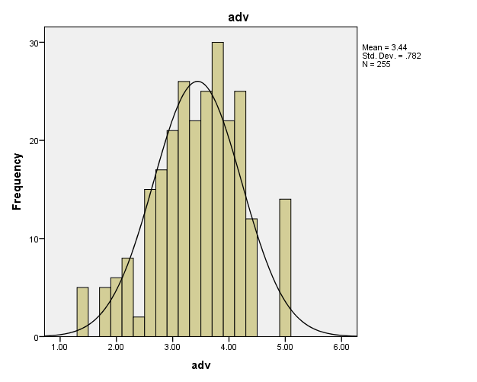

**Figure 2**

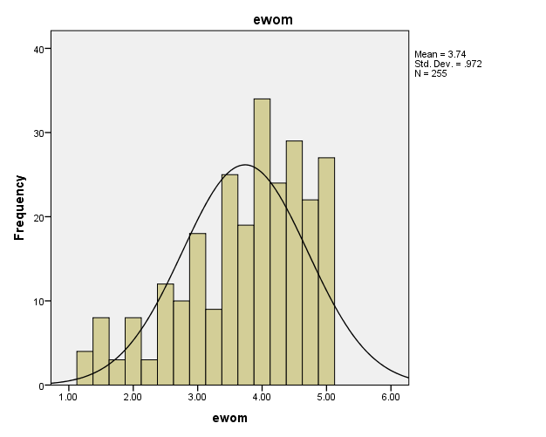

**Figure 3**

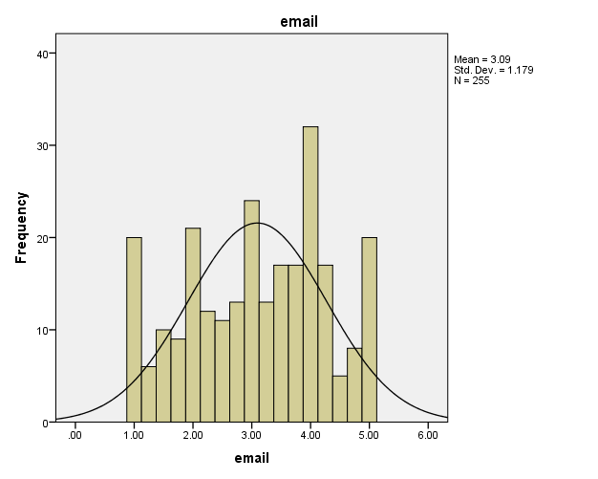

**Figure4**

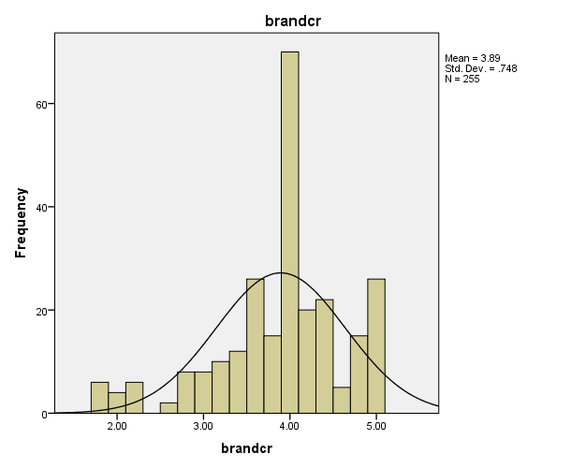

**Figure5**

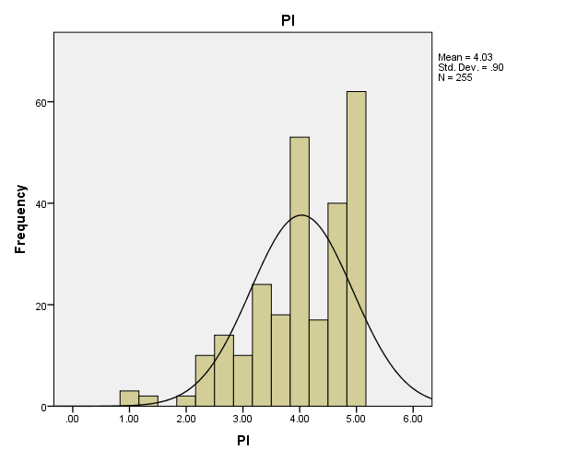

**P-P Plots**

**Figure 6:**

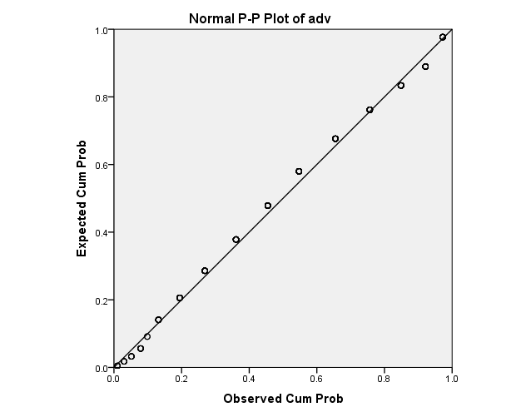

**Figure 7**

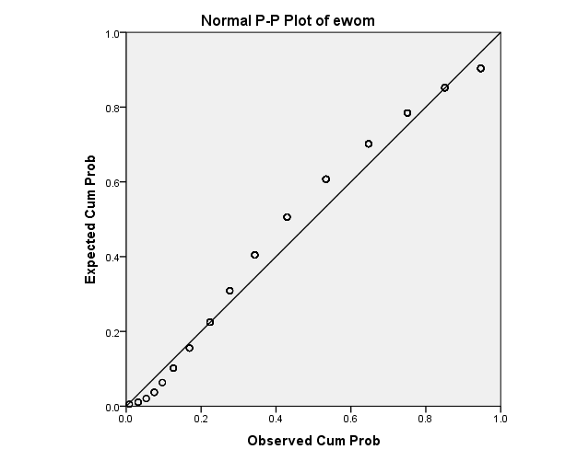

**Figure 8**

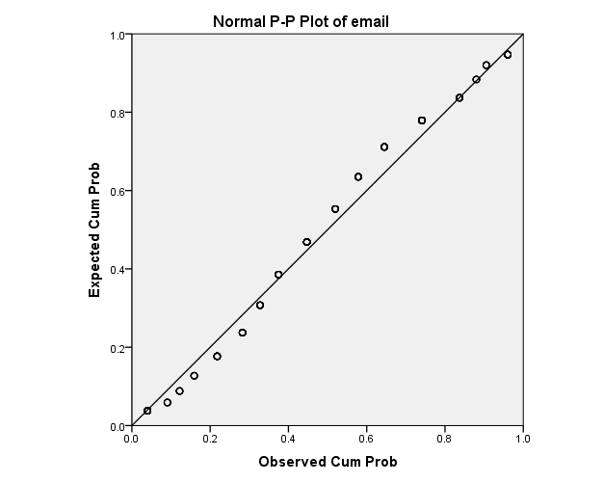

**Figure 9**

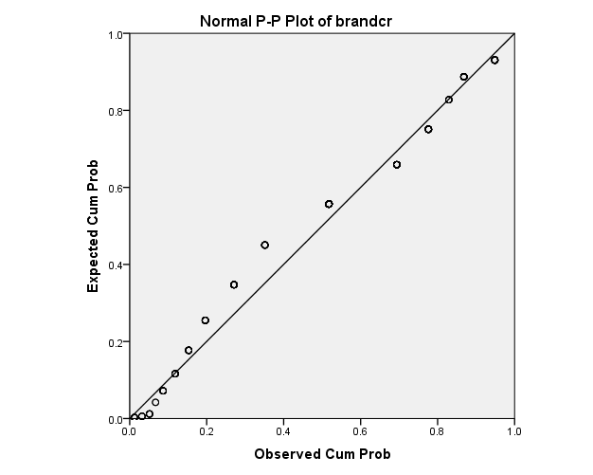

**Figure 10**

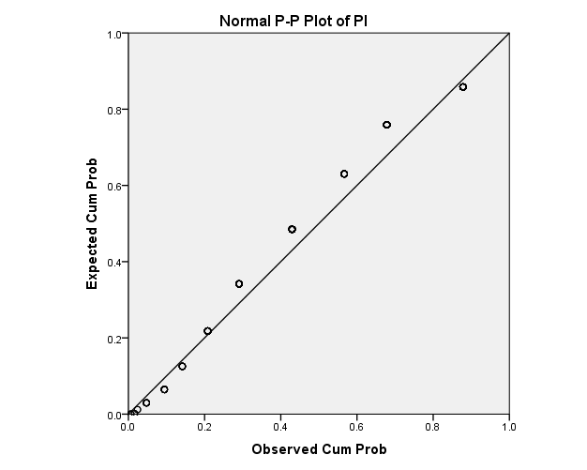

* + 1. **Linearity**

The most important condition for multivariate statistics is the presence of linearity in data. When the straight line exists in the relationship of variables, it is called the linearity. By generating the scatter plot for variables we can see as shown in figures (11 to17) that the variables are positively linearly related with each other.

**Figure 11**

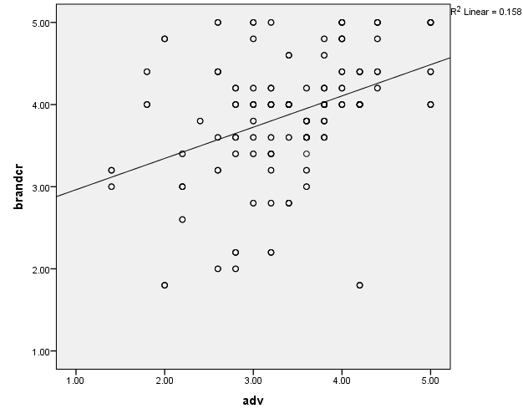

**Figure 12**

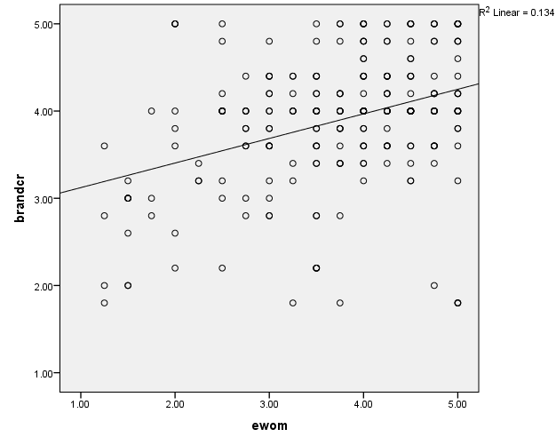

**Figure 13**

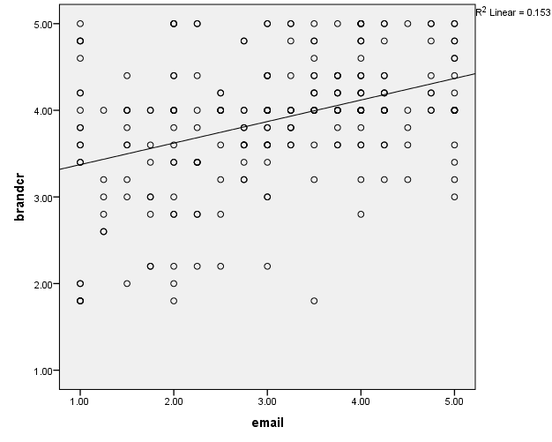

**Figure 14**

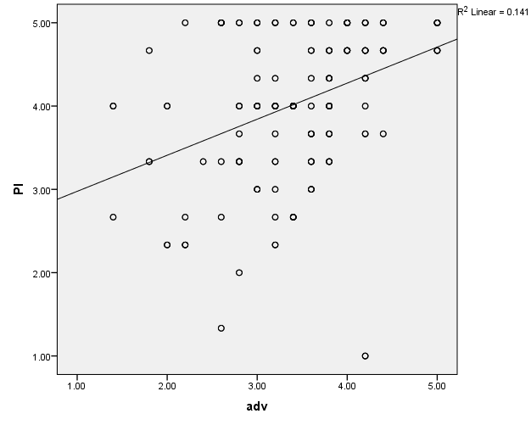

**Figure 15**

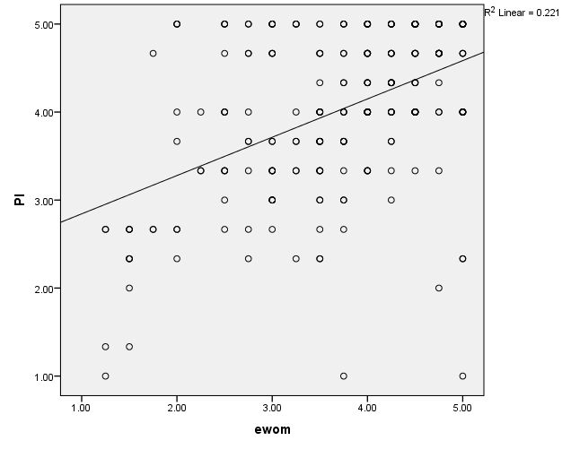

**Figure 16**

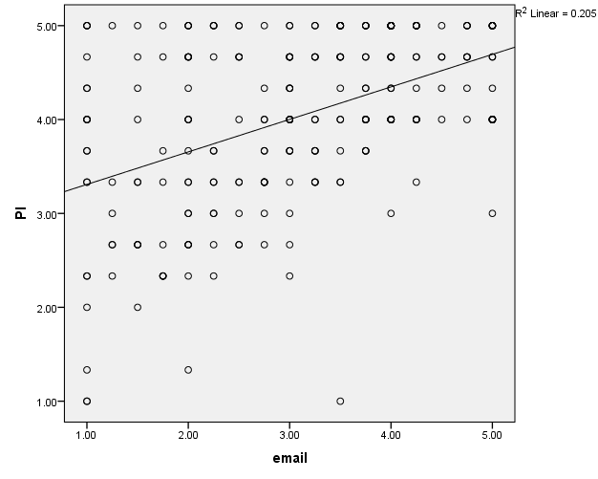

**Figure 17**

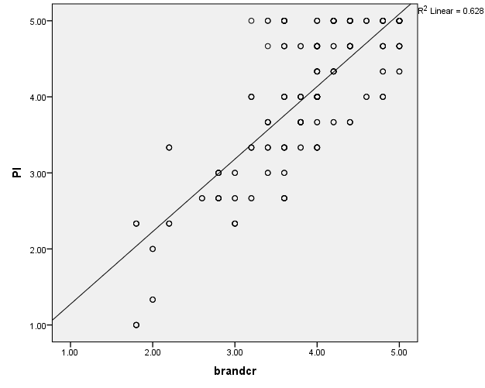

* + 1. **Homoscedasticity**

Homoscedasticity means that the variance of errors is the same across all levels of the Independent variable. When the variance of errors differs at different values of the IV, heteroscedasticity is indicated. According to Berry and Feldman (1985) and Tabachnick and Fidell (1996) slight heteroscedasticity has little effect on significance tests; however, when heteroscedasticity is marked it can lead to serious distortion of findings and seriously weaken the analysis thus increasing the possibility of a Type I error.

**Figure 18**

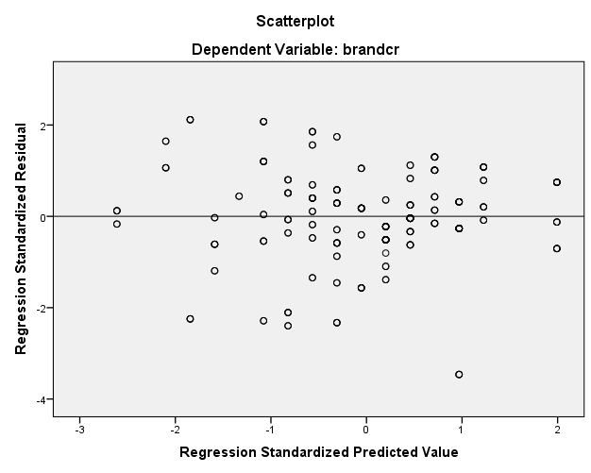

**Figure 19**

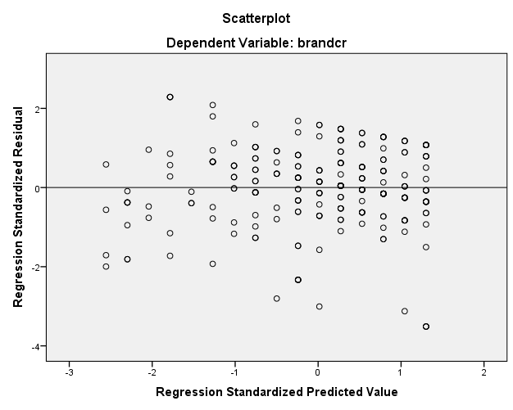

**Figure 20**

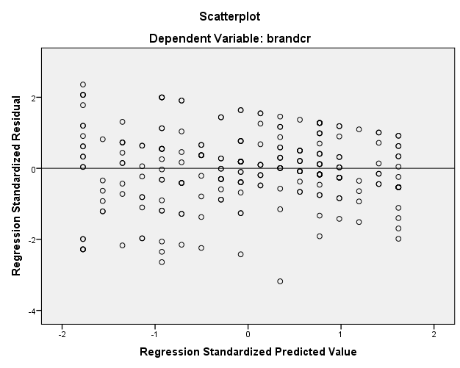

**Figure 21**

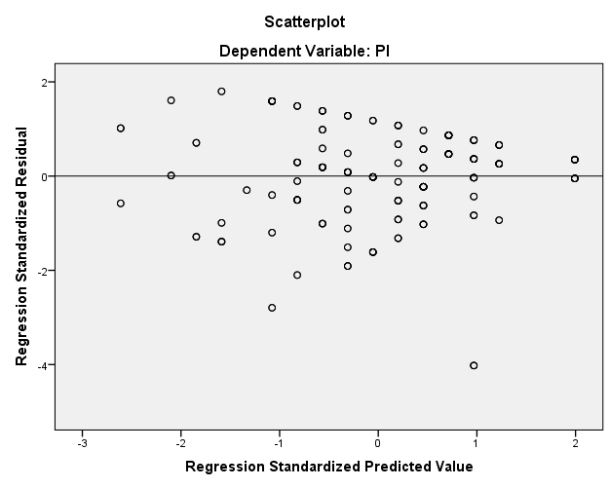

**Figure 22**

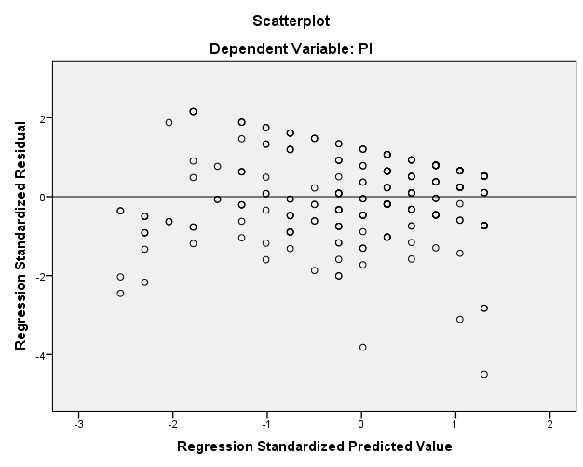

**Figure 23**

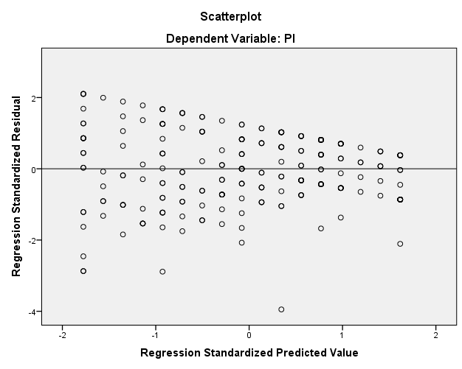

**Figure 24**

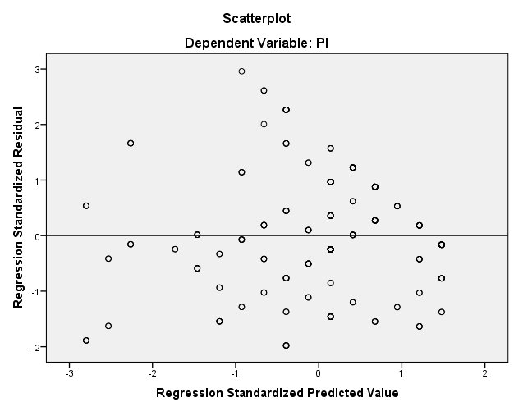

As shown in figures (10 to 24) residuals were randomly scattered around the (the horizontal line) providing the relative even distribution which showed the Homoscedasticity of the data. Therefore, all the four assumptions of regression were fulfilled linear regression analysis was performed.

* + 1. **Multi-Collinearity**

|  |  |  |  |
| --- | --- | --- | --- |
| **Coefficientsa**  **Table 4** | | | |
| **Model** | | **Collinearity Statistics** | |
| **Tolerance** | **VIF** |
| 1 | (Constant) |  |  |
| Adv | .948 | 1.055 |
| Ewom | .872 | 1.147 |
| Email | .881 | 1.135 |

As the values for VIF are below 10 so there was no multi Collinearity between the variables.

**CHAPTER 4**

1. **Results and analysis**
   1. **Descriptive Statistics**

**Descriptive Statistics (N=255)**

**Table 5**

|  |  |  |  |  |  |  |  |  |  |  |
| --- | --- | --- | --- | --- | --- | --- | --- | --- | --- | --- |
| **Descriptive Statistics** | | | | | | | | | | |
|  | **N** | **Minimum** | **Maximum** | **Mean** | **Std. Deviation** | **Variance** | **Skewness** | | **Kurtosis** | |
| **Statistic** | **Statistic** | **Statistic** | **Statistic** | **Statistic** | **Statistic** | **Statistic** | **Std. Error** | **Statistic** | **Std. Error** |
| ADV | 255 | 1.40 | 5.00 | 3.4424 | .78194 | .611 | -.302 | .153 | .043 | .304 |
| EWOM | 255 | 1.25 | 5.00 | 3.7353 | .97207 | .945 | -.743 | .153 | -.176 | .304 |
| EMKT | 255 | 1.00 | 5.00 | 3.0931 | 1.17884 | 1.390 | -.183 | .153 | -.981 | .304 |
| BRC | 255 | 1.80 | 5.00 | 3.8933 | .74828 | .560 | -.810 | .153 | .736 | .304 |
| PI | 255 | 1.00 | 5.00 | 4.0340 | .90041 | .811 | -.971 | .153 | .678 | .304 |

The mean value shows the center of data as many statistical analyses consider it as a standard measure of central distribution of data. In the above table of descriptive analysis the mean value of TV Advertising (3.44), Brand Credibility (3.91), EWOM (3.78), Email Marketing (3.084) and Purchase intention has the highest mean value among all variables which shows that respondents have positive response towards Purchase intention as the mean value of the variable shows the data tendency. AS the skewness values for TV ADV (-.302), Brand Credibility (-.833), Ewom (-760), Email Marketing (-1.78) and for Purchase intention it is (-.990). These values are within the acceptable range of skewness value. Similarly value of kurtosis for TV Advertising (.043), Brand Credibility (.0735), Ewom (-.056), Email Marketing (-.988) and for Purchase intention it is (.654).

* 1. **Correlation**

**Table 6**

|  |  |  |  |  |  |  |  |  |
| --- | --- | --- | --- | --- | --- | --- | --- | --- |
| ***Correlation*** | | | | | | | | |
|  |  | **ADV** | **EWOM** | **EMKT** | **BRC** | **PI** |  |
| ADV | | Pearson Correlation | 1 |  |  |  |  |  |
| EWOM | | Pearson Correlation | .165** | 1 |  |  |  |  |
| EMKT | | Pearson Correlation | .192 ** | . 296** | 1 |  |  |  |
| BRC | | Pearson Correlation | .391** | .324** | . 387** | 1 |  |  |
| PI | | Pearson Correlation | . 369** | . 443** | . 485** | . 763** | 1 |  |
|  | |  |  |  |  |  |  |  |
|  | |  |  |  |  |  |  |  |

The above table 6 of Pearson correlation shows the relationship among continuous variables of this research study. The values of correlation are always between -1 to +1. The above table shows positive correlating between all variables. Though the correlation between EOWM and TV Advertising is (.165), Email marketing and TV Advertising is comparatively weaker but Significant. Similarly correlation between Ewom and Email Marketing is also weak but significant correlation between Brand Credibility and TV Advertising (.391), Purchase Intention and TV advertising (.369) is Moderate. Similarly Correlation between Brand Credibility and EWOM (.324), Brand Credibility and Email Marketing (.387) is comparatively moderate correlation. Correlation of Purchase Intention with Ewom and Email Marketing is (.443) and (.485) which is relativity high than others. Purchase Intention has highest value (.763) of correlation among all the correlated values. According to the above table all the variables have significant positive relationship with each other.

* 1. **Hypotheses Testing** 
     1. **Linear Regression Analysis**

**Multiple Regression Analysis - Model Summary (H1- H3)**

**Table 7**

|  |  |  |  |  |  |  |
| --- | --- | --- | --- | --- | --- | --- |
| **Model** | | **Unstandardized Coefficients** | | **Standardized Coefficients** | **t** | **Sig.** |
| **B** | **Std. Error** | **Beta** |
| 1 | (Constant) | 1.725 | .217 |  | 7.934 | .000 |
| ADV | .296 | .052 | .309 | 5.725 | .000 |
| EWOM | .167 | .043 | .217 | 3.860 | .000 |
| EMKT | .170 | .036 | .268 | 4.786 | .000 |
| a. Dependent Variable: brand credeibility | | | | | | |

*N* = 255, *R* = .554, *R square* = .307, *adjusted R square* = .299; *F* = 37.11; *p*<0.05

To check the impact of independent variables on dependent variable, multiple linear regressions have been applied. The value of R Square tells us about the variance explained by Models. It shows how much variance is caused in dependent variable due to independent variables. In this Model 28.7% variance is caused by TV advertising, EWOM and Email Marketing in Brand credibility. The value of F shows the fitness of Model, for this model value of fitness is 33.68.In the above table the B value of advertising (.296) is highest among all independent variables which show that advertising has highest positive effect on brand credibility. Other independent values such as Email Marketing with B value (.174) and EWOM with B value (.151) has significant positive impact on brand credibility.

Hence the first three hypotheses H1, H2 and H3 are accepted.

**Multiple Regression Analysis - Model Summary (H5- H7*)***

**Table 8**

|  |  |  |  |  |  |  |
| --- | --- | --- | --- | --- | --- | --- |
| **Coefficientsa** | | | | | | |
| **Model** | | **Unstandardized Coefficients** | | **Standardized Coefficients** | **t** | **Sig.** |
| **B** | **Std. Error** | **Beta** |
| 1 | (Constant) | 1.179 | .246 |  | 4.785 | .000 |
| ADV | .300 | .059 | .261 | 5.131 | .000 |
| EWOM | .295 | .049 | .318 | 6.010 | .000 |
| EMKT | .233 | .040 | .305 | 5.780 | .000 |
| a. Dependent Variable: PI | | | | | | |

*N* = 255, *R* = .621, *R square* = .386, *adjusted R square* = .378; *F* = 52.52; *p*<0.05

To check the impact of independent variables on purchase intention which is dependent variable of research model, multiple linear regression tests was applied. The value of R square which is .395 shows that 39.5% variance has been explained by this model. Value of F is also significant which shows fitness of model.

Again TV Advertising has highest B value (.302) among all the variables which shows that TV Advertising has 30.2% impact on Purchase Intention. Other variables such as EWOM and Email Marketing also have significant B values (2.88) and (2.77) respectively. So here H5, H6 and H7 accepted.

**Simple Regression Analysis - Model Summary (H4)**

**Table 9**

|  |  |  |  |  |  |  |
| --- | --- | --- | --- | --- | --- | --- |
| **Coefficientsa** | | | | | | |
| **Model** | | **Unstandardized Coefficients** | | **Standardized Coefficients** | **t** | **Sig.** |
| **B** | **Std. Error** | **Beta** |
| 1 | (Constant) | .320 | .183 |  | 1.752 | .081 |
| BRC | .954 | .046 | .793 | 20.683 | .000 |
| a. Dependent Variable: PI | | | | | | |

*N* = 255, *R* = .793, *R square* = .628, *adjusted R square* = .628; *F* = 427.7; *p* < 0.05

The table 9 shows the relationship of Brand Credibility and Purchase Intention. As per value of R square, the model explains 58.2 % variation. The value of F is also very high. The B value of Brand Credibility which is (.943) shows very that Brand Credibility has very high positive effect on Purchase intention which is very significant.

So here H4 is accepted.

**ADV-BRC-PI**

**Table 10**

|  |  |  |  |  |  |  |  |  |  |  |  |
| --- | --- | --- | --- | --- | --- | --- | --- | --- | --- | --- | --- |
| **Path** | **Total Effect** | | **Direct Effect** | | **Indirect Effect** | | **95%CI** | | |  |  |
|  | B | Sig | B | Sig | B | Sig | Lower Level | | Upper Level | | |
| **ADV- BRC-PI** | 0.4409 | 0.000 | 0.1004 | 0.563 | 0.3404 | 0.000 |  | 0.256 |  | | 0.471 |
|  |  |  |  |  |  |  |  |  |  | |  |
|  |  |  |  |  |  |  |  |  |  | |  |
|  |  |  |  |  |  |  |  |  |  | |  |

*Note: RSQ=0.1365,R=0.3695, F=39.997,P=0.000*

To check the mediation of Brand Credibility, Preacher and Hayes process for mediation was used. As per table 4.8 the TV Advertising has positive but insignificant impact on Purchase Intention while the indirect impact of TV Advertising on Purchase Intention is positive and highly significant. The total effect of TV Advertising on Purchase intention is .04409 which is also highly significant.

As direct impact of TV Advertising on Purchase Intention has B value .1004 which is insignificant while with mediation of Brand Credibility its relationship with Purchase Intention is highly significant with B value .0418 so here it can be said that Brand Credibility fully mediates the relationship of TV Advertising on Purchase Intention. As per table 4.8 results, H8 is accepted.

**EWOM-BRC-IP**

**Table 11**

|  |  |  |  |  |  |  |  |  |  |  |  |
| --- | --- | --- | --- | --- | --- | --- | --- | --- | --- | --- | --- |
| **Path** | **Total Effect** | | **Direct Effect** | | **Indirect Effect** | | **95%CI** | | |  |  |
|  | B | Sig | B | Sig | B | Sig | Lower Level | | Upper Level | | |
| **ADV-BRC-PI** | 0.428 | 0.000 | 0.2116 | 0.000 | 0.2165 | 0.000 |  | 0.125 |  | | 0.2963 |

*Note: RSQ=0.1482,R=0.3849, F=44.003,P=0.000*

To check the mediation effect of Brand Credibility between EWOM and Purchase Intention, Preacher and Hayes process for mediation was used. The total impact of EWOM on Purchase Intention is 0.428 which is positive and significant. Direct impact is 0.2116 while indirect impact is 0.2165.Both, direct and indirect impacts are positive and significant. Here it can be said that Brand Credibility partially mediates the effect of EWOM on Purchase Intention.

So here H9 is accepted

**EMKT-BRC-PI**

**Table 11**

|  |  |  |  |  |  |  |  |  |  |  |  |
| --- | --- | --- | --- | --- | --- | --- | --- | --- | --- | --- | --- |
| **Path** | **Total Effect** | | **Direct Effect** | | **Indirect Effect** | | **95%CI** | | |  |  |
|  | B | Sig | B | Sig | B | Sig | Lower Level | | Upper Level | | |
| **EMKT-BRC-PI** | 0.3857 | 0.000 | 0.1777 | 0.000 | 0.2080 | 0.000 |  | 0.1367 |  | | 0.2848 |

Note: RSQ=0.2392,R=0.4891, F=79.5593,P=0.000

To check the mediation effect of Brand Credibility between Email Marketing and Purchase Intention, Preacher and Hayes mediation process was used. The total impact of Email Marketing on Purchase Intention is .3857 which is positive and significant. Direct effect of Email Marketing (0.1777) is also positive and significant but indirect effect (.2080) is more than direct effect.

Brand Credibility Partially mediates the relationship of Email Marketing and Purchase Intention. So here H10 is accepted.

**Discussion:**

As the main focus of this study was to test the Brand Credibility concept and its mediation impact, It is found very significant construct which increases the Purchase Intention of consumers. The results of Linear Regression proved TV Advertising, EWOM and Email Marketing, significant factors which increases the Brand Credibility as well as Purchase Intention of consumers. The simple regression table shows that Brand credibility is a very strong factor which has highly significant positive impact on Purchase Intention.

The proposed hypotheses H1, H2 and H3 are accepted .As per multiple regression analysis among all three factors TV Advertising has highest significant positive impact with B value of (2.96) on Brand Credibility. Other variables EWOM and Email Marketing also have positive significant impact on Brand Credibility (.151) and (1.74) respectively. As Chu and Kim, (2011), mentioned EWOM as powerful marketing strategy. Email Marketing as proved as significant tool for promotion of producst and building brand in the past studies (Roberts et al., 2001). Effect of TV Advertising, EWOM and Email Marketing on Purchase Intention has been shown in the table above. TV Advertising is again leading the other factors with B value of (o.302) which is positive and highly significant. Ansari et al, 2011, also found TV advertising as a significant to tool which consequently affects the purchase intention of consumers. In a recent study conducted in India by Ramsingh and Renganathan(2016), respondents ranked TV advertising as number one powerful advertising media. This present study also showed almost same results, as TV advertising has been found most significant media of communication Other factors EWOM and Email Marketing are also significant and positive with B value of (2.88) and (2.77) respectively.. This study confirms the relation of Email Marketing Purchase Intention as discussed in previous literature that Email Marketing positively affects the Purchase Intention(Merisavo and Raulas, 2004;Muller, Flores, Agrebi, & Chandon 2008).Similarly this study confirms the positive significant relation of EWOM and Purchase Intention mentioned in previous literature the( Jalilvand & samiei, 2012; Patel, 2015). As per results, it can be said that in the developing country such as Pakistan, TV Advertising has not lost its significance and it is still considered as most reliable and trustworthy way of getting information. Same thing mentioned by Abbatangelo-Gray, Byrd-Bredbenner, & Austin, (2008) though there are other effective sources of communication available but Television is still most powerful tool. As the descriptive statistics and frequency of sample shows that most of the research participants/respondents are between the age of 21-30 years so it can be said that TV advertising is appreciated and considered reliable among young females.

**Chapter5**

# Conclusion and Recommendations

## Managerial Implications:

This research study can be very beneficial for marketing managers specially for understanding the significance of brand credibility. This research can also help them to choose right marketing tool for their marketing campaign and activities. As the results of this study confirms that TV advertising is still most effective and significant factor which can lead consumers to purchase the brand. Even in this age of digitalization TV advertising is still leading the other effective factors. As in Pakistan, internet users are growing EWOM has become a source of information and consumers are relying on that. But the downside of EWOM is that it is hard for a brand to control it. As the study reveals EWOM a very effective source of information so brands should appreciate customers to promote positive EWOM and to avoid negative EWOM companies should keep a regular communication with their consumers.

Another very interesting finding of this study is significance of email marketing. Mangers can rely on email marketing to increase their brand credibility as it is very cost effective way to communicate with consumers but it would only increase the brand credibility if that certain brand is already having a positive image and reputation. As Cosmetic brands selected for this research by respondents are already having a very good reputation in Pakistan such as L'Oreal, Maybelline and Grainer etc. As Dufrene et al., (2005) also mentioned in their study that consumers like to receive emails from well reputated brands.

This study is more beneficial for marketing managers of cosmetic brands becuase cosmetic industry has been chosen for research and main focus of the research was females respondents of cosmetic brands.

## Academic Implications:

This study has contributed in Literature of brand credibility. As mentioned by Bougoure, Bennett, Hasan & Mortimer, (2016), that there is a need to test this variable in other than US. So this construct has been tested in Pakistan and found to be significant factor and a strong predictor of purchase intention. The effect of TV advertising and email marketing on brand credibility has not been empirically tested before so this study has great contribution to literature.

## Limitations and future directions:

Like every other social sciences research study also have some limitations.

The first limitation is sample size which is only 255 and it was collected from only two major cities of Pakistan, which may restrict its implacability. Other researcher may follow the same by taking larger samples from more major cities of Pakistan. This research focused only females, other researchers may consider both genders while doing research for cosmetic industry.

The second limitation is the industry and brands selected for research. Research only focused on Cosmetic industry and big brands. Other researchers may use this model but choose different industry and small brands.

Third limitation is ignoring the other factors which can have impact on the relationship of email marketing brand credibility with moderating effect of brand reputation or brand image.

## Conclusion:

On the basis of the above mentioned statistical results it is concluded that TV advertising EWOM and email marketing have strong positive and significant impact on brand credibility as well as on purchase intention. While brand credibility fully mediates the effect of TV advertising on purchase intention, It is also effective mediator between EWOM and purchase intention as well as between email marketing and purchase intention but in these two factor mediation impact is partial. Brand Credibility itself a very strong predictor of purchase intention which means that if brand credibility would be high people will have strong and positive purchase intention.

So this study confirms that a brand can achieve a higher brand credibility if it make investment in TV advertising, EWOM and email marketing and higher brand credibility will consequently increase the purchase intention to a significant level.

# References

Abdelhamied, H. H. (2011). Customers’ perceptions of floating restaurants in Egypt. Anatolia:*An International Journal of Tourism and Hospitality Research*, 22(1), 1–15.

Abbatangelo-Gray, J., Byrd-Bredbenner, C., & Austin, S. B. (2008). Health and nutrient content claims in food advertisements on Hispanic and mainstream prime-time television. *Journal of Nutrition Education and Behavior, 40*(6), 348-354.

Abdelhamied, H. H. (2011). Customers’ perceptions of floating restaurants in Egypt. Anatol: *An International Journal of Tourism and Hospitality Research, 22(*1), 1–15.

Ali, R., & Fatima, A. (2016). Social media, newspapers and political awareness of youth in *Pakistan. Pakistan Library & Information Science Journal, 47*(1), 321-371.

Alwitt, L. F., & Prabhaker, P. R. (1992). Functional and belief dimensions of attitudes to television advertising: Implications for copytesting. *Journal of Advertising Research*,*2*(3), 114-128.

Ansari, M. E., & Joloudar, S. Y. E. (2011). An investigation of TV advertisement effects on customers' purchasing and their satisfaction. *International Journal of Marketing Studies, 3*(4), 175.

Babić Rosario, A., Sotgiu, F., De Valck, K., & Bijmolt, T. H. (2016). The effect of electronic word of mouth on sales: A meta-analytic review of platform, product, and metric factors. *Journal of Marketing Research*, *53*(3), 297-318.

Bao, T. T., Chang, T. S., & Kim, A. J. (2016). The business impact and characteristics of children’s ewom in marketing communications. Presented at the 2016 Global Marketing Conference at Hong Kong.

Berger, I. E., & Mitchell, A. A. (1989). The effect of advertising on attitude accessibility, attitude confidence, and the attitude-behavior relationship. *Journal of Consumer Research*, *16*(3), 269-279.

Berger, J., & Iyengar, R. (2013).Communication Channels and Word of Mouth: How the Medium Shapes the Message. *Journal of Consumer Research, Inc, 40*(9), 567-579.

Bhakar, S., Bhakar, S., & Dubey, A. (2015). Analysis of the factors affecting customers’ purchase intention: The mediating role of customer knowledge and perceived value. *Advances in Social Sciences Research Journal,* *2*(1).

Bougoure, U. S., Russell-Bennett, R., Fazal-E-Hasan, S., & Mortimer, G. (2016). The impact of service failure on brand credibility. *Journal of Retailing and Consumer Services*, *31*, 62-71.

Brondmo, H. P., & Foreword By-Moore, G. (2000). *Engaged Customer: The New Rules of Internet Direct Marketing*.

Chaffey D, Mayer R, Johnston K, Ellis-Chadwick FE. Business-to-business Internet marketing. In: Chaffey D, editor. Internet marketing: strategy, implementation and practice. Harlow, Essex: Pearson Education – China Machine Press; 2003.

Chan. Y. Y., & Ngai, E.W.T. (2011). Conceptualising electronic word of mouth activity.An input-process-output perspective. *Marketing Intelligence & Planning, 29*(5), 488-516.

Chen, Q., & Wells, W. D. (1999). Attitude toward the site. *Journal of Advertising Research*, *39*(5), 27-38.

Cheung, C. M., & Lee, M. K. (2012). What drives consumers to spread electronic word of mouth in online consumer-opinion platforms. *Decision Support Systems*, *53*(1), 218-225.

Cheung, C. M., & Thadani, D. R. (2012). The impact of electronic word-of-mouth communication: A literature analysis and integrative model. *Decision support systems*, *54*(1), 461-470.

Cheung, C. M., Lee, M. K., & Rabjohn, N. (2008). The impact of electronic word-of-mouth: The adoption of online opinions in online customer communities. *Internet Research*, *18*(3), 229-247.

Cheung, M. Y., Luo, C., Sia, C. L., & Chen, H. (2009). Credibility of electronic word-of-mouth: Informational and normative determinants of on-line consumer recommendations. *International Journal of Electronic Commerce*, *13*(4), 9-38

Chevalier, J.A. and Mayzlin, D. (2006), The effect of word of mouth on sales: online book reviews, *Journal of Marketing Research*, *43*(3), 345-354.

Chittithaworn, C., Islam, M. A., & Thooksoon, O. (2011). Belief dimensions and viewer's attitude towards TV advertising in Thailand. I*nternational Journal of Marketing Studies, 3*(1), 95.

Chu, S.-C. and Kim, Y. (2011), Determinants of consumer engagement in electronic word-of-mouth(eWOM) in social networking sites, *International Journal of Advertising*, 1, 47-75.

Chu, S.C. and Kim, Y. (2011), Determinants of consumer engagement in electronic word-of-mouth (eWOM) in social networking sites, *International Journal of Advertising*, *30*(1), 47-75.

Chua, A.Y. and Banerjee, S. (2013), Customer knowledge management via social media: the case of Starbucks, *Journal of Knowledge Management*, *17*(2), 237-249.

Ciochetto, L. (2004). Advertising and globalization in India. *Media Asia*, *31*(3), 157-169.

DeWulf, V., & Vergult, C. (1998). Antecedents and Consequences of Irritation and Attitude towards Direct Mail in Consumer Markets. In *Direct Marketing Educators' Conference. San Francisc*.

Dholakia, U.M. and Durham, E. (2010), One café chain’s Facebook experiment, *Harvard Business Review*, *88*(3), 26.

Di Ianni, A. (2000), The E-business Enterprise and the 'Web-first' Principle of E-marketing,

Dichter, E. (1966). How word-of-mouth advertising works. *Harvard Business Review*, *44*(6), 14-160.

Dick, A. S., & Basu, K. (1994). Customer loyalty: toward an integrated conceptual framework. *Journal of the Academy of Marketing Science*, *22*(2), 99-113.

Doyle, P., & Saunders, J. (1990). Multiproduct advertising budgeting. *Marketing Science, 9(*2), 97-113.

Draganska, M., Hartmann, W. R., & Stanglein, G. (2014). Internet versus television advertising: A brand-building comparison. *Journal of Marketing Research, 51*(5), 578-590.

Ducoffe, R. H. (1995). How consumers assess the value of advertising. Journal of Current *Issues & Research in Advertising, 17*(1), 1-18.

Ducoffe, R. H. (1996). Advertising value and advertising on the web. *Journal of Advertising Research*, *36*(5), 21-21.

Dufrene DD, Engelland BT, Lehman CM, Pearson RA. (2005). Changes in consumer attitudes resulting from participation in a permission email campaign. *International Journal of consumer research, 27*(1), 65–77.

Elliott, S. 2006. Nike reaches deeper into new media to find young buyers. *Wall Street Journal,*

Elseidi, R. I., & El-Baz, D. (2016). Electronic word of mouth effects on consumers' brand attitudes, brand image and purchase intention: an empirical study in Egypt. *The Business & Management Review*, *7*(5), 268.

Erdem, T., & Swait, J. (2004). Brand credibility, brand consideration, and choice. *Journal of Consumer Research*, *31*(1), 191-198.

Erdem, T., Swait, J., & Louviere, J. (2002). The impact of brand credibility on consumer price sensitivity. *International Journal of Research in Marketing*, *19*, 1–19.

Etzel, M. J., Walker, B. J., Stanton, W. J., & Pandit, A. (2008). Marketing concepts and cases. *Delhi, Tata Mcgrawhill*.

Fatima, S., & Lodhi, S. (2015). Impact of Advertisement on Buying Behaviours of the Consumers: Study of Cosmetic Industry in Karachi City. *International Journal of Management Sciences and Business Research.*

Feick, L. F., & Price, L. L. (1987). The market maven: A diffuser of marketplace information. *The Journal of Marketing*, 83-97.

Fine, M. B., Fine, M. B., Gironda, J., Gironda, J., Petrescu, M., & Petrescu, M. (2017).

Prosumer motivations for electronic word-of-mouth communication behaviors. *Journal of Hospitality and Tourism Technology*, *8*(2), 280-295.

Gauzente, C. (2004). Web merchants’ privacy and security statements: how reassuring are they for consumers? A two-sided approach. *Journal of Electronic Commerce Research*, *5*(3), 181-198.

Gengler, C. E., & Reynolds, T. J. (1995). Consumer understanding and advertising strategy: analysis and strategic translation of laddering data. *Journal of Advertising Research*, *35*(4), 19-34.

Godin, S. (1999). *Permission marketing: Turning strangers into friends and friends into customers*. Simon and Schuster.

Grunert, K. G. (1996). Automatic and strategic processes in advertising effects. *The Journal of Marketing*, 88-101.

Helman, D., de Chernatony, L., Drury, S., & Segal-Horn, S. (1999). Exploring the development of lifestyle retail brands. *The Service Industries Journal*, *19*, 49–68.

Hennig-Thurau, T., Gwinner, K. P., Walsh, G., & Gremler, D. D. (2004). Electronic wordof- mouth via consumer-opinion platforms: What motivates consumers to articulate themselves on the internet? *Journal of Interactive Marketing, 18*(1), 38–52.

Henning-Thurau, T. (2004). Motive des lesens von kundenartikulationen im internet: theoretische und empirische analyse. *In* *Konsumentenverhalten im Internet*, 71-193.

Hogg, M. (2016). Children as food consumers: contrasting effectiveness of television advertisement to in-store activity and product packaging. Lille Catholic University.

Hudák, M., Kianičková, E., & Madleňák, R. (2017). The importance of e-mail marketing in e-commerce. *Procedia Engineering*, *192*, 342-347.

Hussain, S., Ahmed, W., Jafar, R. M. S., Rabnawaz, A., Akhtar, H., & Jianzhou, Y. (2016, October). Electronic word of mouth communications and consumer's information adoption on the Internet. In *Computer Communication and the Internet (ICCCI), 2016 IEEE International Conference on* (pp. 493-497). IEEE.

Hyun Baek, T., & Whitehill King, K. (2011). Exploring the consequences of brand credibility in services. *Journal of Services Marketing*, *25*(4), 260-272.

Hyun Baek, T., & Whitehill King, K. (2011). Exploring the consequences of brand credibility in services. *Journal of Services Marketing*, *25*(4), 260-272.

Irshad, M. (2014, August). Marketing of Fashion Related Products Among Pakistani Generation Y Through Social Networking Sites. In *Islamabad: Proceeding of the 6th South Asia Conference*.

Jackson, A. and DeCormier, R. (1999), E-mail Survey Response Rates: Targeting Increases Response, *Journal of Marketing Intelligence and Planning* , *17*(3), 135-139.

Jalilvand, M. R., Esfahani, S. S., & Samiei, N. (2011). Electronic word-of-mouth: Challenges and opportunities. *Procedia Computer Science*, *3*, 42-46.

Jalilvand, M.R. and Samiei, N. (2012a), The effect of electronic word of mouth on brand image and purchase intention: an empirical study in the automobile industry in Iran, *Marketing Intelligence* *& Planning*, 30(4) 460-476.

Jalilvand, M.R. and Samiei, N. (2012b), The impact of electronic word of mouth on a tourism destination choice: testing the theory of planned behavior (TPB), *Internet Research*, *22*(5), 591-612.

James, W. L., & Kover, A. J. (1992). Do overall attitudes toward advertising affect involvement with specific advertisements? Journal of Advertising Research.

Jeng, S. P. (2016). The influences of airline brand credibility on consumer purchase intentions. *Journal of Air Transport Management*, *55*, 1-8.

Jin, N., Lee, S., & Jun, J. H. (2015). The role of brand credibility in predicting consumers' behavioural intentions in luxury restaurants. *Anatolia*, *26*(3), 384-396.

*Journal of Interactive Marketing*, *2*(2), 158-170.

Kaplan Thaler, L., and R. Koval. 2003. Bang! Getting your message heard in a noisy world. New York: Currency.

Kavitha, G. (2006). A study on the effectiveness of the advertising techniques used in the personal care segment of women consumers. *Indian Journal of Marketing*, *36*(8).

Keller, K. L. (1993). Conceptualizing, measuring, and managing customer-based brand equity. *Journal of Marketing*, *57*(1), 1– 22..

Keller, K. L. (1993). Conceptualizing, measuring, and managing customer-based brand equity. Journal of Marketing, 57(1), 1– 22.

Keller, K. L. (2003). Understanding brands, branding and brand equity. *Interactive Marketing*, *5*(1), 7-20.

Kiley, D. 2005. Hey advertisers, TiVo is your friend. BusinessWeek, October 17, 97–8.

Kim, E.E.K., Lee, C.H. and Cobanoglu, C. (2015), How do consumers process online hotel reviews? The effects of eWOM consensus and sequence, *Journal of Hospitality and Tourism Technology*, 6(2), 113-126.

Kim, K.O. (2014), A little bluebird told me: social media conversation effects on businessoutcomes-evidence from the movie industry, *Dissertation, (Doctor of philosophy*), University of Texas, TX.

King, R. A., Racherla, P., & Bush, V. D. (2014). What we know and don't know about online word-of-mouth: A review and synthesis of the literature. *Journal of Interactive Marketing*, *28*(3), 167-183

Kirmani, A. (1990). The effect of perceived advertising costs on brand perceptions. *Journal of Consumer Research*, *17*(2), 160-171

Kirmani, A. (1990). The effect of perceived advertising costs on brand perceptions. *Journal of Consumer Research, 17*(2), 160-171

Klaassen, A. 2006. Major turnoff: McKinsey slam’s TV selling power. Advertising Age, August 7, 1, 33.

Kotler, P. (2009). Marketing management: A south Asian perspective: Pearson Education India.

Kotwal, N., Gupta, N., & Devi, A. (2008). Impact of TV advertisements on buying pattern of adolescent girls. *Journal of Social Science*, *16*(1), 51-55.

Kudeshia, C., Kudeshia, C., Kumar, A., & Kumar, A. (2017). Social eWOM: does it affect the brand attitude and purchase intention of brands?. *Management Research Review*, *40*(3), 310-330.

Kwon, O. and Wen, Y. (2010), An empirical study of the factors affecting social network service use, *Computers in Human Behavior*, 26(2) 254-263.

Latif, A., Saleem, S., & Abideen, Z. U. (2011). Influence of role model on Pakistani urban teenager’s purchase behavior. *European Journal of Economics, Finance and Administrative Sciences, 31*(3), 7-16.

Lee, J., Park, D.H. and Han, I. (2011), The different effects of online consumer reviews on consumers’s purchase intentions depending on trust in online shopping malls: an advertising perspective, *Internet Research*, *21*(2), 187-206.

Lee, W., Tyrrell, T. and Erdem, M. (2013), Exploring the behavioral aspects of adopting technology:meeting planners’ use of social network media and the impact of perceived critical mass, *Journal* *of Hospitality and Tourism Technology*, *4*(1), 6-22.

Lin, C., Wu, Y.S. and Chen, J.C.V. (2013), Electronic word-of-mouth: the moderating roles of product involvement and brand image, *Diversity, Technology, and Innovation for Operational* *Competitiveness: Proceedings of the International Conference on Technology Innovation andIndustrial Management*, 29-47.

Lopez, M. and Sicilia, M. (2014), eWOM as source of influence: the impact of participation in eWOM and perceived source trustworthiness on decision making, *Journal of Interactive Advertising*,14 (2), 86-97.

McCloskey, W. (2006). E-mail data source. *Retail White Paper, New York*

Meyer, R.J. and Sathi, A. (1985), “A multi attribute model of consumer choice during product learning”, *Marketing Science*, *4*(1), 41-61.

Mo Kwon, J.M., Bae, J. and Blum, S.C. (2013), “Mobile applications in the hospitality industry”, *Journal of Hospitality and Tourism Technology*, 4 (1), 81-92.

Moustakas, E., Ranganathan, C., & Duquenoy, P. (2006). E-mail marketing at the crossroads: A stakeholder analysis of unsolicited commercial e-mail (spam). *Internet Research*, *16*(1), 38-52.

Muskat, M., Muskat, B., Zehrer, A. and Johns, R. (2013), “Generation Y: evaluating services experiences through mobile ethnography”, *Tourism Review*, *68*(3), 55-71.

Nelson, P. (1974). Advertising as information. *Journal of Political Economy*, *82*(4), 729-754.

Pae, J. H., Samiee, S., & Tai, S. (2002). Global advertising strategy: The moderating role of brand familiarity and execution style. *International Marketing Review*, *19*(2), 176-189.

Park, D.H., Lee, J. and Han, I. (2007), The effect of on-line consumer reviews on consumer purchasing intention: the moderating role of involvement, *International Journal of Electronic Commerce*, *11*( 4), 125-148.

Patel, B. (2015). Word-Of-Mouth Marketing: A happy customer is the greatest endorsement any business could ask for. *Online binita patel photography,* Retrieved from http:// www.binitapatelblog.com/?postID=166&word-of-mouthmarketing.

Ramaswami, V.S. and Namakumari, S. (2004), Marketing Management, 3rd Edition, MACMILLAN, India.

Ramsingh, L. T., & Renganathan, R. (2016). A Study on buyers’ Attitude and opinion about TV advertisements. International Journal of Applied Engineering Research, 11(3), 1781-1786.

Rao, A. R., Qu, L., & Ruekert, R. W. (1999). Signaling unobservable product quality through a brand ally. *Journal of Marketing Research*, 258-268..

Rao, A. R., Qu, L., & Ruekert, R. W. (1999). Signaling unobservable product quality through a brand ally. *Journal of Marketing Research, 258-268*.

Reimer, T., & Benkenstein, M. (2016). When good WOM hurts and bad WOM gains: The effect of untrustworthy online reviews. *Journal of Business Research*, *69*(12), 5993-6001.

Roberts, S., Feit, M., & Bly, R. W. (2000). *Internet direct mail: The complete guide to successful E-mail marketing campaigns*. *McGraw Hill Professional.*

Rubinson, J. (2009). Empirical evidence of TV advertising effectiveness. *Journal of Advertisin Research*, *49*(2), 220-226.

Saleem, M. A., Zahra, S., & Yaseen, A. (2017). Impact of service quality and trust on repurchase intentions-the case of Pakistan airline industry. *Asia Pacific Journal of Marketing and Logistics*, *29*(1), 129-159.

Saxena, R. (2005). *Marketing management*. Tata McGraw-Hill Education.

Shah, K., & D’souza, A. (2008). Advertising Promotion, An IMC Perspection New Delhi.

Sheth, J. N., & Parvatlyar, A. (1995). Relationship marketing in consumer markets: antecedents and consequences. *Journal of the Academy of Marketing Science*, *23*(4), 255-271.

Shiue, Y.C., Chiu, C.M. and Chang, C.C. (2010), Exploring and mitigating social loafing in online communities, *Computers in Human Behavior*, *26* (4), 768-777.

Shukla, P. (2011), Impact of interpersonal influences, brand origin and brand attitude on luxury purchase intentions: measuring inter functional interactions and a cross-national comparison, *Journal of World Business*, 46 (2), 242-252.

Srinivasa, D. (2008). Advertisements Do They Match Consumer Preferences?. *Marketing Mastermind*, 59-62.

Stephen, A. T. (2016). The role of digital and social media marketing in consumer behavior. *Current Opinion in Psychology*, *10*, 17-21.

Story, L. (2007). Viewers fast-forwarding past ads? Not always. New York Times, February 16.

Sweeney, J., & Swait, J. (2008). The effects of brand credibility on customer loyalty. *Journal of Retailing and Consumer Services, 15*, 179–193.

Tariq, M. I., Nawaz, M. R., Nawaz, M. M., & Butt, H. A. (2013). Customer perceptions about branding and purchase intention: a study of FMCG in an emerging market. *Journal of Basic and Applied Scientific Research*, *3*(2), 340-347.

Tariq, M., Abbas, T., Abrar, M., & Iqbal, A. (2017). EWOM and brand awareness impact on consumer purchase intention: mediating role of brand image. *Pakistan Administrative Review*, *1*(1), 84-102.

Tezinde, T., Smith, B., & Murphy, J. (2002). Getting permission: Exploring factors affecting permission marketing. *Journal of Interactive Marketing*, *16*(4), 28-36.

Tirole, J. (1988), The Theory of Industrial Organization, MIT Press, Cambridge, MA.

Todor, R. D. (2016). Blending traditional and digital marketing. *Bulletin of the Transilvania University of Brasov. Economic Sciences. Series*  *9*(1), 51.

Wang, L., Law, R., Hung, K., & Guillet, B. D. (2014). Consumer trust in tourism and hospitality: A review of the literature. *Journal of Hospitality and Tourism Management*, *21*, 1-9.

Wang, X., & Yang, Z. (2010). The effect of brand credibility on consumers’ brand purchase intention in emerging economies: The moderating role of brand awareness and brand image. *Journal of Global Marketing*, *23*(3), 177-188.

Worthy, J., & Graham, N. (2002). Electronic marketing: New rules for electronic marketing—An obstacle to m-commerce?. *Computer Law & Security Review*, *18*(2), 106-108.

Wreden, N. (1999), Mapping the Frontiers on Email Marketing, *Harvard Management Communication Letter* , 9 January.

Yaylı, A. and Bayram, M. (2012), E-WOM: the effects of online consumer reviews on purchasing decisions, *International Journal of Internet Marketing and Advertising,* *7* (1), 51-64.

Ye, Q., Law, R., Gu, B. and Chen, W. (2011), The influence of user-generated content on traveler behavior: an empirical investigation on the effects of e-word-of-mouth to hotel online bookings,*Computers in Human Behavior*, 27, 634-639.

Zernigah, K. I., & Sohail, K. (2012). Consumers'attitude towards viral marketing in pakistan. *Management & Marketing*, *7*(4), 645.

Zhang, M., Hu, M., Guo, L., & Liu, W. (2017). Understanding relationships among customer experience, engagement, and word-of-mouth intention on online brand communities: The perspective of Service Ecosystem. *Internet Research*, *27*(4), 839–857