 | 
GUJARAT TECHNOLOGICAL UNIVERSITY
Sardar Vallabhbhai Patel Institute of Technology (SVIT), Vasad
PBL ACTIVITY 3:
COMPLEX PROBLEM SOLVING (CPS)
ReWear

Sustainable Clothing Reuse, Exchange and Donation Platform
Submitted in partial fulfilment of the requirement for the course
Web Application Development
Bachelor of Engineering — Computer Engineering
Submitted by:
Imdad.A Shaikh — 240410107173
Haard Joy Shankpal — 240410107175
Arsh Panchal — 250413107013
Internal Faculty Guide:
Nidhi Shah
SDGs Addressed:
SDG 12 — Responsible Consumption and Production (primary)
SDG 13 — Climate Action (secondary)

Academic Year 2026-27

Table of Contents
Acknowledgement 3
Abstract 3
1. Introduction 3
2. Problem Statement 4
2.1 Existing Problem 4
2.2 Why This Is a Complex Problem 4
3. Objectives 5
4. SDG Mapping 5
5. Proposed Solution 5
6. System Requirements 6
6.1 Hardware Requirements 6
6.2 Software Requirements 6
7. System Design 7
7.1 Overall Architecture 7
7.2 Technology Stack 7
7.3 User Roles 8
7.4 System Workflow 8
8. Functional Modules 9
8.1 Authentication and Registration 9
8.2 Clothing Listing 9
8.3 Browse, Search and Filtering 10
8.4 Donation System 10
8.5 Exchange System 10
8.6 Request Management 10
8.7 User Dashboard 11
8.8 Impact Tracking 11
8.9 Admin Dashboard 11
9. Database Design 12
9.1 User Model 12
9.2 Item Model 12
9.3 Request Model 12
9.4 Database Relationships / ER Diagram 12
10. System Implementation 13
10.1 Frontend Implementation 13
10.2 Backend Implementation 13
10.3 REST API 14
10.4 Authentication and Security 14
10.5 Image Upload and Validation 15
11. User Interface 15
11.1 Home Page 15
11.2 Authentication Pages 16
11.3 Browse and Search 16
11.4 Item Details 17
11.5 Add/Edit Item 17
11.6 Donation and Exchange Requests 18
11.7 User Dashboard 19
11.8 Impact Dashboard 19
11.9 Admin Dashboard 20
12. Testing 21
13. Challenges and Solutions 22
14. SDG Impact and Outcomes 22
15. Limitations 23
16. Future Scope 23
17. Conclusion 23
18. References 24

Acknowledgement
We would like to express our sincere gratitude to our Internal Faculty Guide, Nidhi Shah, for the valuable guidance, constant encouragement and constructive feedback provided throughout the development of this project.
We are also thankful to the Department of Computer Engineering, Sardar Vallabhbhai Patel Institute of Technology (SVIT), Vasad, and Gujarat Technological University for giving us the opportunity to carry out this Problem-Based Learning (PBL) activity. It allowed us to apply the concepts learned in the Web Application Development course to a practical problem related to sustainability.

Abstract
Clothing waste is a growing problem: garments that are still wearable are often discarded, while other people need affordable clothing. ReWear is a full-stack web application that provides a simple and transparent platform for clothing reuse, exchange and donation within a community. Registered users can create clothing listings with photographs, mark them as Donation or Exchange, and browse available items using keyword search and filters such as category, size, condition, gender, type and location. Users send donation or exchange requests and track each request through a server-enforced lifecycle: Pending, Accepted, Completed, Rejected or Cancelled. An administrator area allows moderation of users, items and requests, and the platform displays project-defined impact indicators, including an impact score defined as completed exchanges plus completed donations.
ReWear is built using React with Vite, Bootstrap 5 and Axios on the frontend, and Node.js, Express.js, MongoDB and Mongoose on the backend. Security is provided through JWT authentication, bcrypt password hashing, role-based access control and validated image uploads using Multer. A total of 62 backend/API and integration checks were executed against the running application, and all of them passed after the identified fixes. The project supports SDG 12 (Responsible Consumption and Production) as its primary goal and SDG 13 (Climate Action) as a secondary goal.

1. Introduction
Clothing is one of the most commonly used and most frequently replaced personal items. Many households own garments that are still in wearable condition but are no longer used because of a change in size, taste or season. Such clothes are often thrown away or left unused in cupboards, even though other people may need them and would benefit from them.
The main difficulty is that people who own unused clothes and people who need them have no convenient way to find each other. Conventional methods such as donation drives are occasional and one-directional, while informal exchange among friends is limited to a small circle. Commercial marketplaces are designed around selling, not around community reuse, and they add pricing, negotiation and complexity that are unnecessary for simple reuse.
ReWear addresses this need by providing a simple digital platform where users can list unused clothing either as a free Donation or as an Exchange, browse and search the items that are available, send requests, and follow the status of every request until it is completed. The platform applies full-stack web development concepts such as REST API design, authentication, role-based access control, database modelling, file upload handling and responsive user interface design to a sustainability-related problem.

2. Problem Statement
Clothing waste is a growing problem: people discard garments that are still wearable, while others need affordable clothing. The aim of this project is to design and build a full-stack web application where a community can exchange and donate clothing directly, with clear visibility of the status of every request and with administrative moderation of the platform.

2.1 Existing Problem
- Usable clothing is often discarded because the owner does not know who could use it.
- People who need affordable clothing have no simple way of discovering what is available nearby.
- Commercial marketplaces are profit-driven and are not specifically designed around community reuse.
- Donation drives are usually one-way and infrequent, and they offer no exchange option.
- Users need a simple exchange/donation workflow in which they can see the status of their requests.
- Administrators need tools to moderate users, listings and requests.

2.2 Why This Is a Complex Problem
Although the idea is simple, building a reliable platform for it involves several technical challenges:
- Multiple user roles: guests, registered users and administrators have different permissions, which must be enforced consistently on both the frontend and the backend.
- Authentication and authorization: the system must verify identity using JWT, hash passwords, block deactivated accounts and restrict admin-only operations.
- Ownership validation: only the owner may edit or delete an item, only the owner may accept or reject a request, and users must not request their own items.
- Request state transitions: a request moves through Pending, Accepted, Completed, Rejected and Cancelled states, and each change must also update the status of the related items correctly.
- Donation and exchange workflows: a donation involves one item, whereas an exchange requires the requester to offer one of their own available items, and completing it changes the status of both items.
- Image upload validation: uploaded files must be checked for type and size and stored safely with generated filenames.
- Moderation and impact tracking: administrators need an overview and control of the platform, and impact indicators must be calculated from completed requests rather than claimed.

3. Objectives
The ReWear project was carried out with the following objectives:
- To develop a full-stack web application for clothing reuse, exchange and donation with role-based access for guests, users and administrators.
- To allow users to list clothing with details and an optional image, and to browse, search and filter available items.
- To implement donation and exchange request workflows, where exchange requests must include one of the requester’s own available items.
- To enforce the request lifecycle (Pending, Accepted, Completed, Rejected, Cancelled) and all ownership rules on the server.
- To provide secure authentication using JWT and bcrypt, and safe image uploads with type and size validation.
- To provide users with dashboards for their listings, requests, exchanges and donations, together with project-defined impact indicators.
- To provide an admin area for platform statistics and moderation of users, items and requests.
- To build a responsive Bootstrap 5 interface with a consistent green sustainability theme.

4. SDG Mapping
Table 1: Mapping of ReWear to the Sustainable Development Goals
SDG / Target | Contribution of ReWear
SDG 12 — Responsible Consumption and Production (primary)  Target 12.5: reduce waste generation through prevention, reduction, recycling and reuse | ReWear promotes the reuse of clothing by letting users donate or exchange garments that they no longer need, instead of discarding them. Listings, search and request tracking make it easier for wearable clothes to reach people who can use them, which extends the life of each garment and encourages more responsible consumption.
SDG 13 — Climate Action (secondary, indirect) | By encouraging people to reuse existing garments, ReWear supports a sustainability-oriented habit that may reduce the demand for new clothing. This contribution is described qualitatively only. The platform does not calculate or claim any CO₂ or emission savings.

Note on the impact indicator: the impact score shown in ReWear is a project-defined indicator, calculated as impactScore = completedExchanges + completedDonations. It is a simple count of completed activities on the platform. It is not a scientific carbon or environmental calculation, and no CO₂ values are claimed in this report or in the application.

5. Proposed Solution
ReWear is proposed as a complete community platform that covers the whole journey of a garment from listing to completion of a donation or exchange. The solution works as follows:
- User registration and login: users create an account and log in to receive a JWT used for protected actions.
- Listing clothing: a user lists unused clothing with details and an optional image, as a Donation (free) or an Exchange (swap).
- Browsing: all users, including guests, can browse the available clothing items.
- Searching and filtering: items can be searched by keyword and filtered by category, size, condition, type, gender and location.
- Donation requests: a logged-in user can request a donated item that belongs to another user.
- Exchange requests: for an exchange, the requester must attach one of their own available items to the request.
- Acceptance or rejection: the item owner reviews each pending request and accepts or rejects it; the requester may cancel their own request.
- Completion: an accepted request is marked as completed by the requester or the owner.
- Item status updates: item status changes automatically (Requested, Available, Donated or Exchanged) as the request progresses.
- Impact tracking: users and visitors can see impact counters, including the project-defined impact score.
- Admin moderation: administrators view platform statistics, deactivate or reactivate users, remove items and view all requests.

6. System Requirements

6.1 Hardware Requirements
Table 2: Hardware requirements
Component | Requirement
Computer | Laptop or desktop computer
Memory (RAM) | Adequate RAM to run Node.js, MongoDB, the Vite development server and a web browser at the same time
Storage | Adequate free disk space for project files, installed dependencies, the database and uploaded item images
Network | Internet connection when installing dependencies; local network/localhost is sufficient while running the application

6.2 Software Requirements
Table 3: Software requirements
Software | Requirement
Operating system | Windows, Linux or macOS
Node.js | Runtime for the Express backend and the Vite/React build tools
npm | Package manager used to install dependencies and run scripts
MongoDB | Database server (local instance used during development, database name: rewear)
Web browser | Modern web browser such as Chrome, Edge or Firefox
Code editor | Code editor such as Visual Studio Code

7. System Design

7.1 Overall Architecture
ReWear follows a three-tier client–server architecture. The React single-page application (built with Vite) communicates with an Express REST API through Axios. Requests pass through middleware for authentication, admin authorization and file upload before reaching the controllers, which read and write data in MongoDB through Mongoose models. Item images are stored on the server and served as static files from the /uploads path.
React + Vite Frontend (SPA)
Bootstrap 5 UI · React Router guards (ProtectedRoute / AdminRoute) · AuthContext · port 5173
↓ Axios (Authorization: Bearer JWT · 401 response → automatic logout) ↓
Express REST API
All routes under /api/* · port 5000 · CORS (CLIENT_URL)
↓
Authentication middleware  protect / optionalAuth  JWT verification + isActive check | Admin authorization  adminOnly  role === admin | Multer upload  JPG/PNG/WEBP only  2 MB limit · generated filenames | Error handler  Central handler  Hides stack traces
↓
Controllers
Business logic: authentication, items, requests (state transitions, ownership checks), users, admin, impact
↓
MongoDB (database: rewear, port 27017)  Accessed through Mongoose models: User · Item · Request |  |  | Static image storage  /uploads (item images)
Figure 1: ReWear System Architecture

7.2 Technology Stack
Table 4: Technology stack of ReWear
Layer / Technology | Purpose
React (frontend) | Component-based single-page application; React 18 with route guards for protected and admin pages
Vite (frontend) | Development server and production build tool for the React application
Bootstrap 5 (frontend) | Responsive layout and UI components, with a green sustainability theme
Axios (frontend) | HTTP client for the REST API; attaches the JWT and logs the user out on a 401 response
Node.js (backend) | JavaScript runtime for the server
Express.js (backend) | REST API framework for routing, middleware and controllers
MongoDB (database) | NoSQL database storing users, items and requests
Mongoose (database) | Object data modelling library; defines schemas, validation and the password-hashing hook
JWT (security) | Token-based authentication for protected API routes
bcrypt (security) | Password hashing before storage
Multer (backend) | Handling of multipart image uploads with type and size validation

7.3 User Roles
Table 5: User roles and permissions
Role | Permitted actions
Guest (not logged in) | Browse available items and view item details  View the public impact page and information pages  Register and log in
User (registered) | Create listings and edit or delete own listings  Request donated items and request exchanges  Offer one of their own available items in an exchange  Accept, reject, cancel and complete requests according to the workflow  View dashboard, profile and personal impact
Admin | View platform statistics  View users and deactivate or reactivate accounts (a delete-user endpoint also exists)  View all items and remove items (soft removal)  View all requests

7.4 System Workflow
The authentication workflow is shown in Figure 2. After registration or login the server returns a JWT, which the Axios client attaches to every protected request. The authentication middleware verifies the token and checks that the account is active.
1. Register / Login  User submits details | → | 2. Validation  Duplicate email → 400; wrong password → 401 | → | 3. Password handling  bcrypt hash on registration; password never returned | → | 4. JWT issued  Token and user returned to the client
 |  |  |  |  |  | ↓
 |  | 7. Access result  Allowed; 401 (no/invalid token) or 403 (deactivated / not permitted) | ← | 6. Middleware check  Token valid and account active | ← | 5. Protected request  Axios sends Bearer token
Figure 2: User Registration and Authentication Workflow
The two main business workflows of ReWear are shown below. The state of every request is validated on the server, so a request can change status only through the allowed transitions listed in Section 8.6. If the owner rejects a request, or the requester cancels it, the item becomes Available again.
Donation workflow
1. User lists clothing as Donation | → | 2. Another user sends a donation request | → | 3. Owner reviews the request | → | 4. Owner chooses Accept / Reject
 |  |  |  |  |  | ↓
 |  | 7. Impact statistics update | ← | 6. Item becomes Donated | ← | 5. Accepted request is completed
Figure 3: Donation Workflow
Exchange workflow
1. User lists clothing as Exchange | → | 2. Another user selects their own available clothing | → | 3. Exchange request is created | → | 4. Owner reviews the request
 |  |  |  |  |  | ↓
8. Impact statistics update | ← | 7. Both items become Exchanged | ← | 6. Request is completed | ← | 5. Owner chooses Accept / Reject
Figure 4: Exchange Workflow

8. Functional Modules
This section describes the implemented modules of ReWear. Each module is summarised by its purpose, main functionality, important validation and result.

8.1 Authentication and Registration
Purpose | To let users create accounts and securely log in, and to identify the role of each user.
Main functionality | Registration with name, email and password; login that returns a JWT and user details; a "current user" endpoint; the frontend AuthContext stores the session and the Axios interceptor logs the user out automatically on a 401 response.
Important validation | Email must be unique (duplicate registration returns 400); wrong password returns 401; deactivated accounts receive 403; passwords are hashed with bcrypt and never included in responses.
Result | Only authenticated and active users can access protected features, and admin features are restricted to the admin role.

8.2 Clothing Listing
Purpose | To allow users to publish clothing that they want to donate or exchange.
Main functionality | Create, edit and delete listings with title, description, category, size, condition, gender, location, type (Donation or Exchange) and an optional image uploaded as multipart form data. Users can view their own listings.
Important validation | Only the owner can edit or delete an item (others receive 403); images must be JPG, JPEG, PNG or WEBP and not larger than 2 MB; new items start with status Available.
Result | Items appear in the public catalogue with an Available status and are linked to their owner.

8.3 Browse, Search and Filtering
Purpose | To help users quickly find suitable clothing.
Main functionality | A public browse page lists items and supports keyword search and filters for category, size, condition, type, gender and location. The selected filters are kept in the URL parameters and sent to the API as query parameters.
Important validation | Items with status Removed are hidden from public browsing and their detail page returns 404; an impossible filter combination returns an empty result.
Result | Users get a focused list of matching items instead of the entire catalogue.

8.4 Donation System
Purpose | To let users give clothing to others free of charge.
Main functionality | A user requests an item whose type is Donation, optionally with a message. The owner accepts or rejects the request, and the accepted donation is marked as completed.
Important validation | Users cannot request their own item; the item must be Available; a duplicate open request for the same item is rejected.
Result | On completion the request becomes Completed and the item becomes Donated; the donation is counted in the impact statistics.

8.5 Exchange System
Purpose | To let users swap clothing with each other.
Main functionality | The requester selects one of their own available items to offer in exchange for the owner’s item (the offeredItem field of the request). The owner can accept or reject, and either party can complete an accepted exchange.
Important validation | An exchange request without an offered item is rejected (400); the offered item must belong to the requester and be Available; a user cannot request their own item.
Result | On completion the request becomes Completed and both the requested item and the offered item become Exchanged.

8.6 Request Management
Requests are managed through the My Requests and Incoming Requests pages. All status changes are enforced by the server according to the state machine in Table 6, so the user interface cannot bypass the rules.
Table 6: Request state transitions enforced by the server
Action | Actor | Allowed from | Effect
Create | Requester (not the owner) | Item is Available | Request becomes Pending and item becomes Requested; an exchange needs an Available offeredItem of the requester; duplicate open requests are rejected
Accept | Item owner | Pending | Request becomes Accepted
Reject | Item owner | Pending | Request becomes Rejected and item becomes Available
Cancel | Requester | Pending or Accepted | Request becomes Cancelled and item becomes Available
Complete | Requester or owner | Accepted | Request becomes Completed; a donation sets the item to Donated; an exchange sets both items to Exchanged

8.7 User Dashboard
Purpose | To give each user one place to manage their activity.
Main functionality | Dashboard, profile (view and update name), My Listings, My Requests, Incoming Requests, My Exchanges and My Donations pages, together with the user’s impact counters.
Important validation | All these pages are protected routes; each user can only see and act on their own data, and request actions are shown according to the user’s role in the request.
Result | Users can track every listing and request without contacting anyone outside the platform.

8.8 Impact Tracking
Purpose | To make the contribution of the platform visible without making unsupported environmental claims.
Main functionality | A public Impact page shows platform counters returned by the impact API, and the user dashboard shows personal counters (listings, completed exchanges, completed donations). The impactScore is calculated as completedExchanges + completedDonations.
Important validation | Counters are calculated from completed requests in the database. The score is a project-defined indicator and not a scientific carbon calculation.
Result | Users and visitors can see how much reuse activity has actually been completed on ReWear.

8.9 Admin Dashboard
Purpose | To allow administrators to monitor and moderate the platform.
Main functionality | Platform statistics (users, items, requests, pending requests and impact score); a list of users with roles and listing counts, with deactivate/reactivate; a list of all items with removal of inappropriate items; and a list of all requests.
Important validation | Admin endpoints require the admin role (others receive 403); item removal is a soft removal that sets the status to Removed, and removing an already removed item returns 400.
Result | Administrators can control the quality of the platform while the data is preserved; a deactivated user can no longer log in.

9. Database Design
ReWear uses MongoDB with three Mongoose models: User, Item and Request. The tables below describe the fields of each model.

9.1 User Model
Table 7: User model
Field | Description
name | Name of the user
email | Email address; unique for every user and used for login
password | Stored as a bcrypt hash (hashed in a pre-save hook); removed from every JSON response
role | Role of the account: user or admin
isActive | Account status; a deactivated account (false) cannot log in and receives 403

9.2 Item Model
Table 8: Item model
Field | Description
owner | Reference to the User who listed the item
title, description | Name and details of the clothing item
category, size, condition, gender | Attributes used for display and for filtering
image | Path of the uploaded image stored under /uploads (optional)
location | Location of the item, used for filtering
type | Donation or Exchange
status | Available, Requested, Accepted, Exchanged, Donated or Removed

9.3 Request Model
Table 9: Request model
Field | Description
item | Reference to the requested Item
requester | Reference to the User who made the request
owner | Reference to the User who owns the requested item
type | Donation or Exchange
message | Optional message from the requester to the owner
offeredItem | Reference to the requester’s own Item; used for exchange requests
status | Pending, Accepted, Rejected, Cancelled or Completed

9.4 Database Relationships / ER Diagram
A User can own many Items, and every Item belongs to exactly one owner. A Request links one requested Item with the requester and the owner (both Users) and, for exchanges, with the offered Item. A User can therefore appear in many Requests as the requester or as the owner, and an Item can be part of many Requests over time (although only one open request is allowed for an item at a time).
USER  _id (PK)  name  email (unique)  password (bcrypt hash)  role (user | admin)  isActive | owns  1 ──────── N  (Item.owner → User) | ITEM  _id (PK)  owner (FK → User)  title, description  category, size, condition, gender  image, location  type (Donation | Exchange)  status
↓  1 : N  requester / owner |  | ↓  1 : N  item / offeredItem
REQUEST
_id (PK)
item (FK → Item) · requester (FK → User) · owner (FK → User)
offeredItem (FK → Item, used only for Exchange requests)
type (Donation | Exchange) · message
status (Pending | Accepted | Rejected | Cancelled | Completed)
Figure 5: ReWear Database ER Diagram

10. System Implementation

10.1 Frontend Implementation
The frontend is a React 18 single-page application created with Vite and styled with Bootstrap 5, using a consistent green sustainability theme and a responsive layout. It contains 22 routes:
- Public (9): Home, About, How It Works, Browse, Item Details, Impact, Login, Register and a 404 page.
- User, protected (9): Dashboard, Profile, My Listings, Add Item, Edit Item, My Requests, Incoming Requests, My Exchanges and My Donations.
- Admin, guarded (4): Admin Dashboard, Users, Items and Requests.
Protected routes are wrapped in ProtectedRoute and AdminRoute components. The AuthContext stores the logged-in user and token, and a central Axios instance attaches the JWT and logs the user out automatically when the server returns 401. Reusable components include the filter bar, item form (which submits images as FormData), request table and request modal. The production build of the frontend completed successfully (133 modules).

10.2 Backend Implementation
The backend is an Express.js application running on port 5000 with all routes under /api. Controllers contain the business logic and use Mongoose models to access the rewear database in MongoDB. Middleware handles authentication, admin authorization, image upload and error handling. A seed script prepares sample data (4 users, 12 items and 2 requests) so that the application can be demonstrated immediately.

10.3 REST API
The main endpoints are summarised in Table 10.
Table 10: Important REST API endpoints
Method | Endpoint | Access | Purpose
GET | /api/health | Public | Check that the API is running
GET | /api/impact | Public | Platform impact counters
POST | /api/auth/register | Public | Create a new account
POST | /api/auth/login | Public | Authenticate and receive a JWT
GET | /api/auth/me | Logged in | Get the current user
GET | /api/items | Public | List items with search and filters
GET | /api/items/:id | Public | Get item details
POST | /api/items | Logged in | Create an item (multipart image)
PUT | /api/items/:id | Owner | Update own item
DELETE | /api/items/:id | Owner | Delete own item
POST | /api/requests | Logged in | Create a donation or exchange request
GET | /api/requests/my | Logged in | Requests made by the user
GET | /api/requests/incoming | Logged in | Requests received for the user’s items
PUT | /api/requests/:id/accept | Item owner | Accept a pending request
PUT | /api/requests/:id/reject | Item owner | Reject a pending request
PUT | /api/requests/:id/cancel | Requester | Cancel a request
PUT | /api/requests/:id/complete | Requester or owner | Complete an accepted request
GET / PUT | /api/users/profile | Logged in | View or update the profile
GET | /api/users/impact | Logged in | Personal dashboard and impact counters
GET | /api/admin/stats | Admin | Platform statistics
GET | /api/admin/users | Admin | List all users
PUT | /api/admin/users/:id/toggle-status | Admin | Deactivate or reactivate a user
GET | /api/admin/items | Admin | List all items including removed items
DELETE | /api/admin/items/:id | Admin | Soft-remove an item
GET | /api/admin/requests | Admin | List all requests

10.4 Authentication and Security
The following security measures are implemented in ReWear:
- Password hashing: passwords are hashed with bcrypt, and the password field is removed from every JSON response.
- JWT authentication: protected routes require a valid bearer token.
- Active account check: deactivated accounts receive 403 even if they present a valid token or try to log in.
- Admin-only routes: admin endpoints require the admin role.
- Ownership checks: applied on item edit/delete and on every request transition.
- Safe file upload: only JPG, JPEG, PNG and WEBP images up to 2 MB are accepted, and filenames are generated by the server.
- Environment variables: secrets such as JWT_SECRET are kept in an .env file that is excluded from version control.
- CORS: the allowed client origin is configurable using CLIENT_URL.
- Centralized error handling: a single error handler returns consistent responses and hides stack traces.

10.5 Image Upload and Validation
Item images are uploaded as multipart form data and processed by Multer. The server accepts only JPG, JPEG, PNG and WEBP files, limits the size to 2 MB and saves each file under a generated filename in an uploads directory outside the client bundle. The saved path is stored in the item’s image field, and the image is served from the /uploads path. An invalid file type or an oversized file returns a clear HTTP 400 message (for example, "Only JPG, PNG and WEBP image files are allowed").

11. User Interface
This section presents the main screens of ReWear. Each screenshot placeholder should be replaced with the corresponding screenshot of the running application.

11.1 Home Page

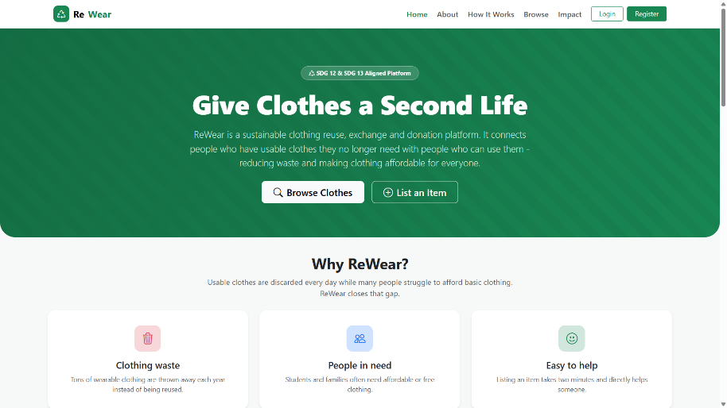
Figure 6: ReWear Home Page

The home page is the public entry point of ReWear. It introduces the platform and leads visitors to browsing, the How It Works page, login and registration.

11.2 Authentication Pages

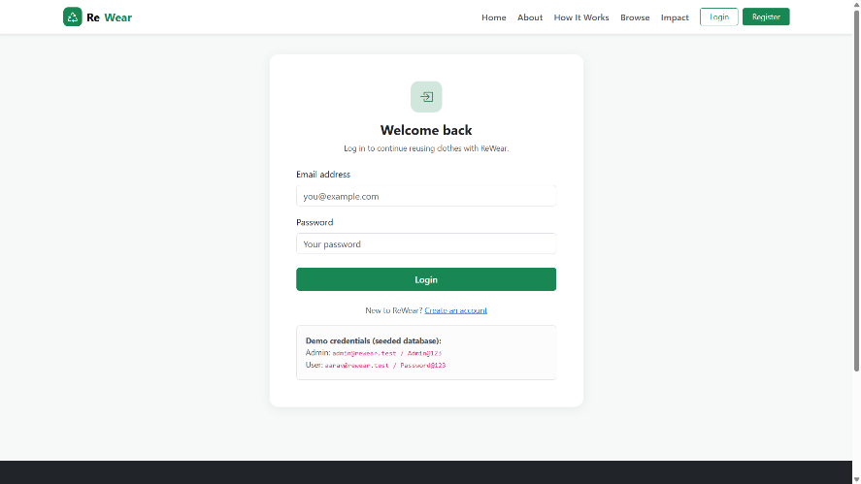
Figure 7: ReWear Login Page
The login page allows registered users and administrators to sign in. A successful login returns a JWT, and invalid credentials are rejected.
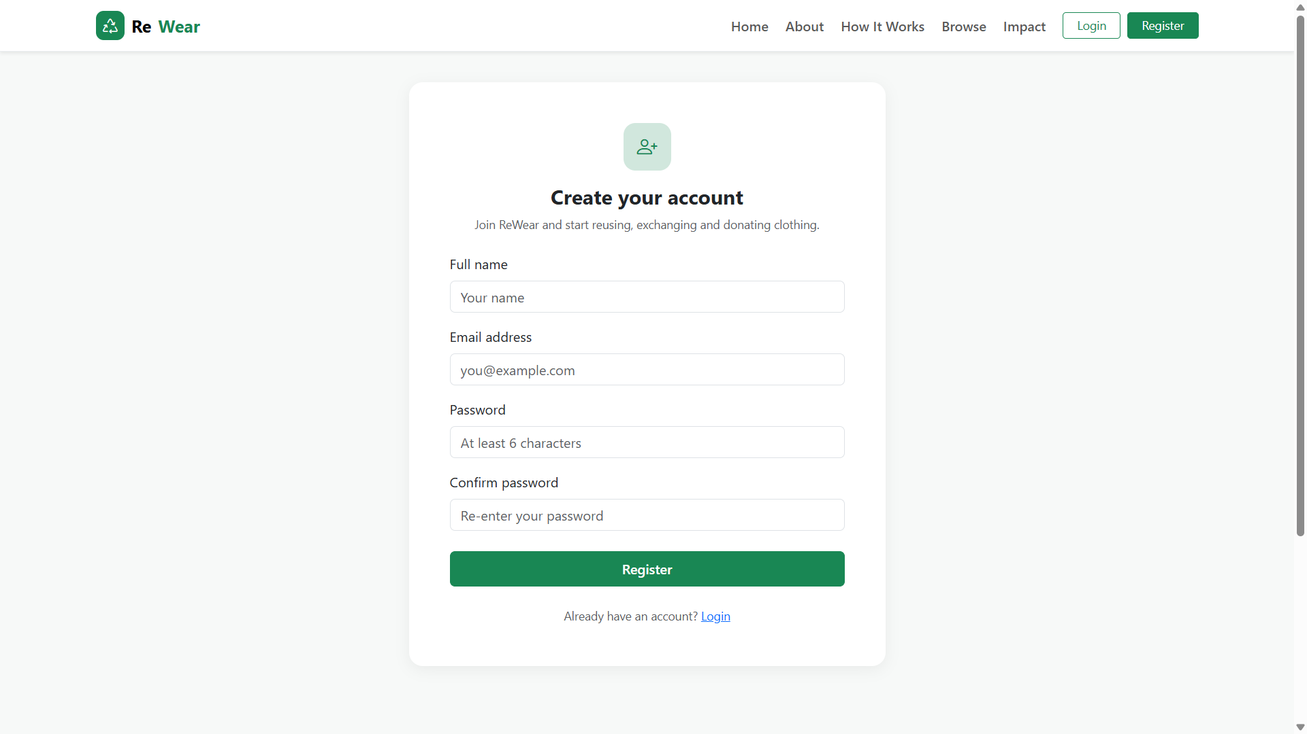
Figure 8: ReWear Registration Page
The registration page lets a new user create an account. Duplicate email addresses are rejected by the server.

11.3 Browse and Search

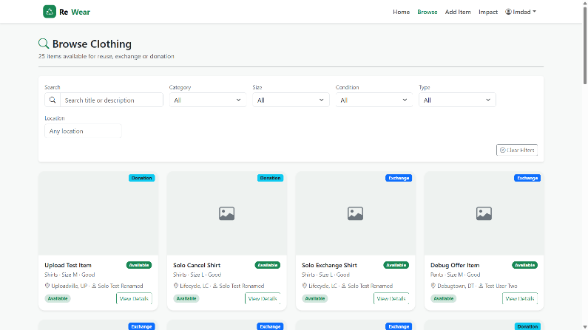
Figure 9: ReWear Browse Page
The browse page lists the available clothing items to all visitors. Removed items are not shown.
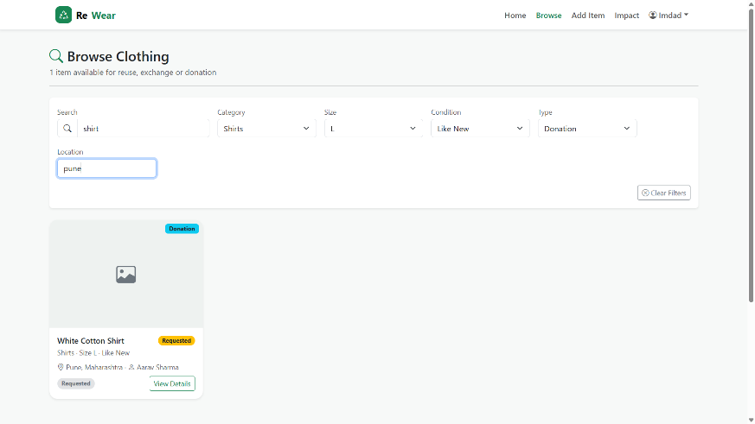
Figure 10: Search and Filter on the Browse Page
The filter bar allows users to search by keyword and to filter by category, size, condition, type, gender and location.

11.4 Item Details
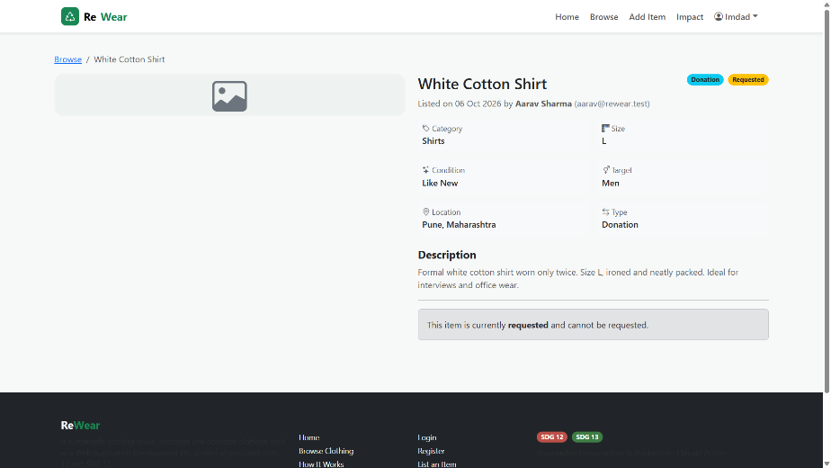
Figure 11: ReWear Item Details Page
The item details page shows the complete information of an item, including its owner, and allows a logged-in user to send a request.

11.5 Add/Edit Item
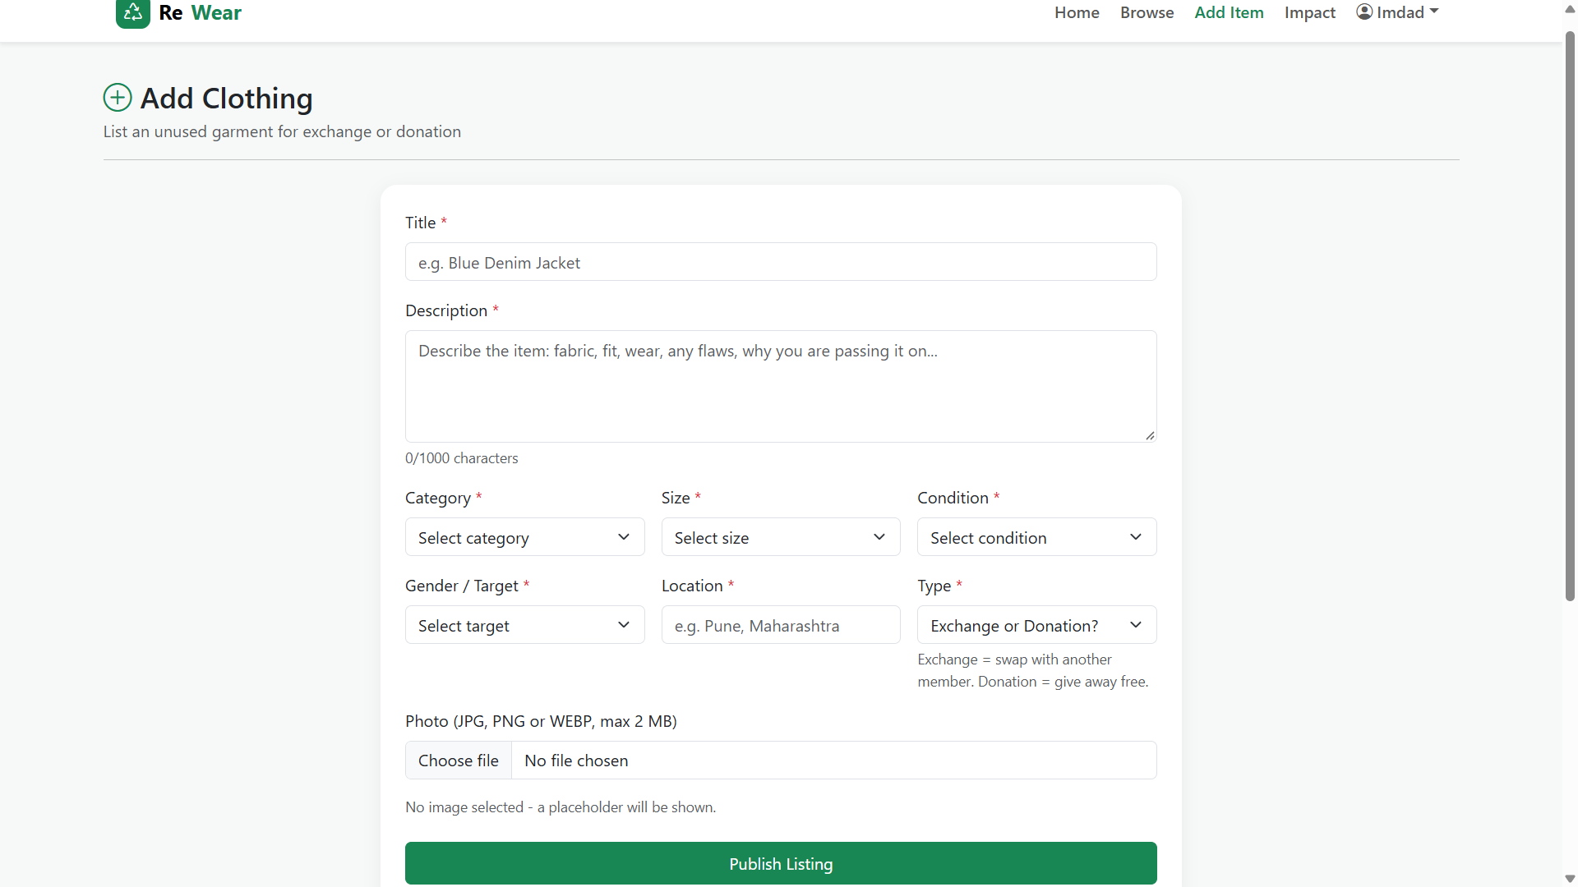
Figure 12: ReWear Add Item Page
The form used by a logged-in user to create a listing, including the optional image upload.
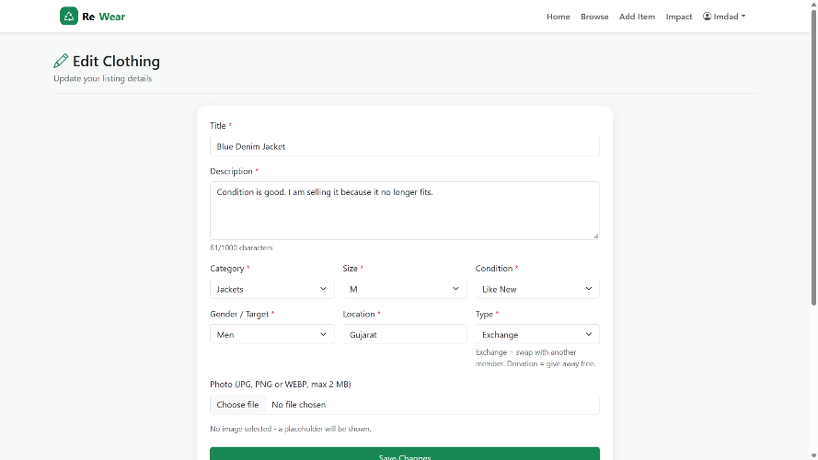
Figure 13: ReWear Edit Item Page
The owner can update the details of an existing listing; other users cannot edit it.

11.6 Donation and Exchange Requests
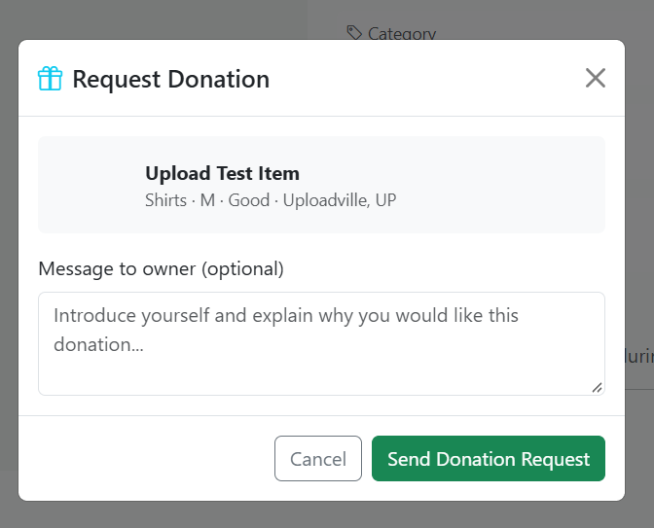
Figure 14: ReWear Donation Request
A user sends a donation request for an item, optionally with a message to the owner.
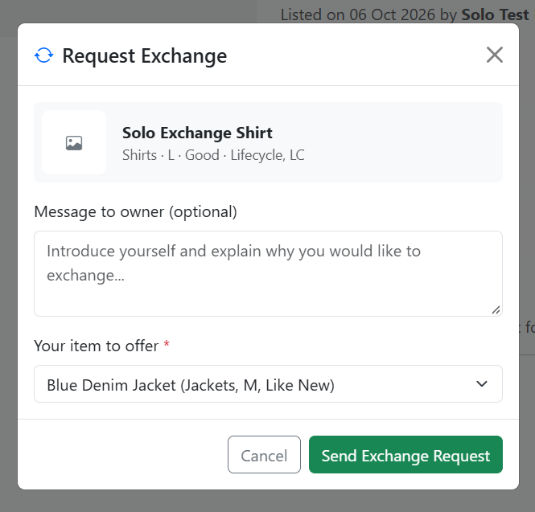
Figure 15: ReWear Exchange Request
For an exchange request, the user must select one of their own available items to offer.
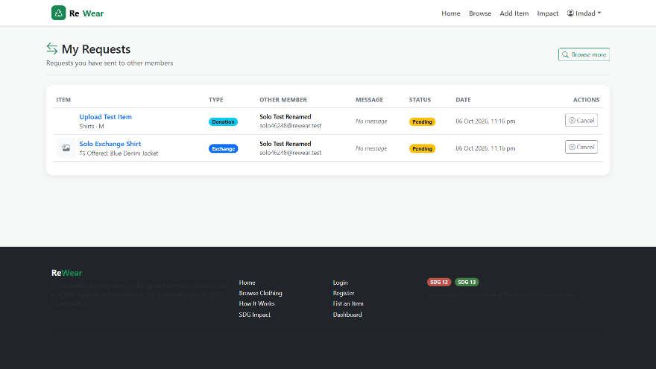
Figure 16: ReWear My Requests Page
The requests pages show the status of each request and the actions available to the current user (accept, reject, cancel or complete).

11.7 User Dashboard
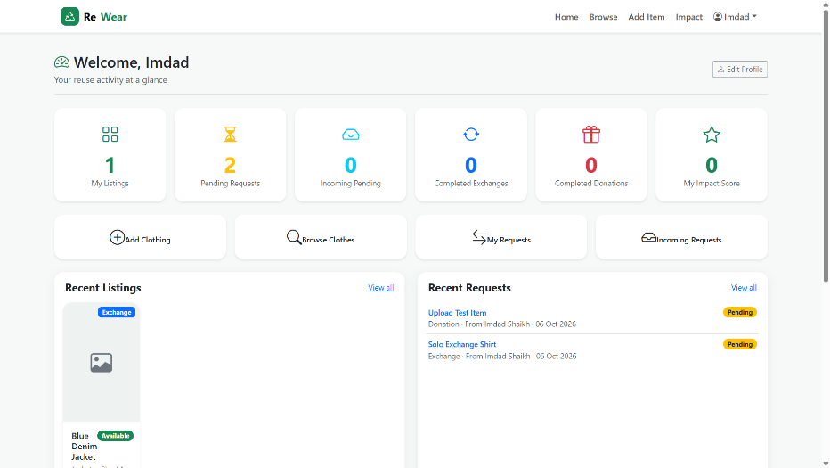
Figure 17: ReWear User Dashboard
The dashboard summarises the user’s listings, requests, exchanges and donations in one place.

11.8 Impact Dashboard
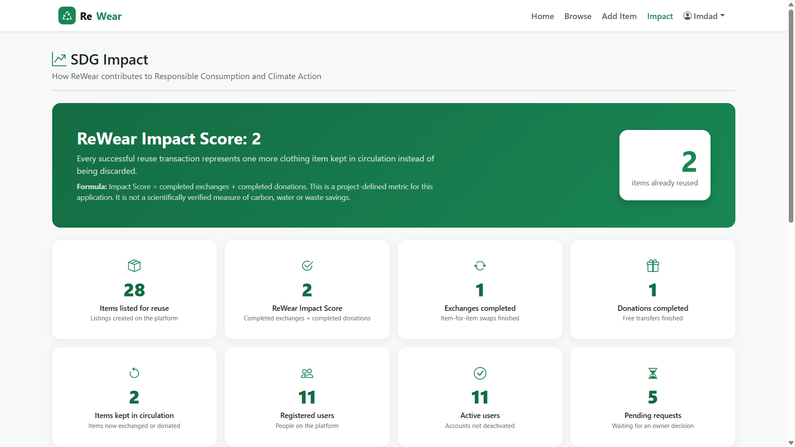
Figure 18: ReWear Impact Page
The impact page displays the project-defined counters, including the impact score (completed exchanges + completed donations).

11.9 Admin Dashboard
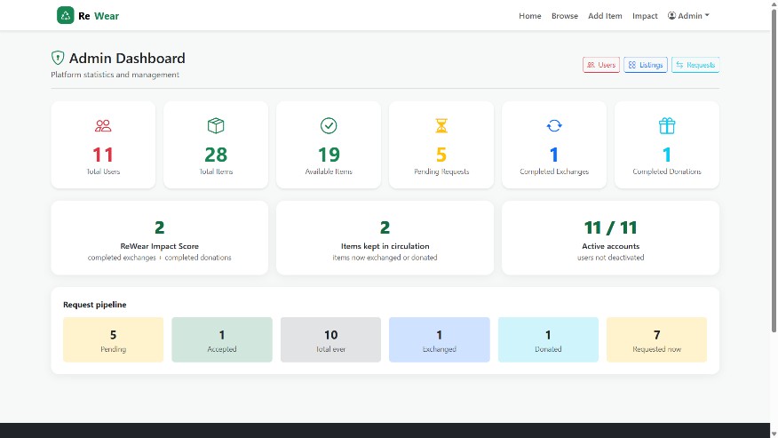
Figure 19: ReWear Admin Dashboard
The admin dashboard shows platform statistics such as the number of users, items, requests and pending requests.
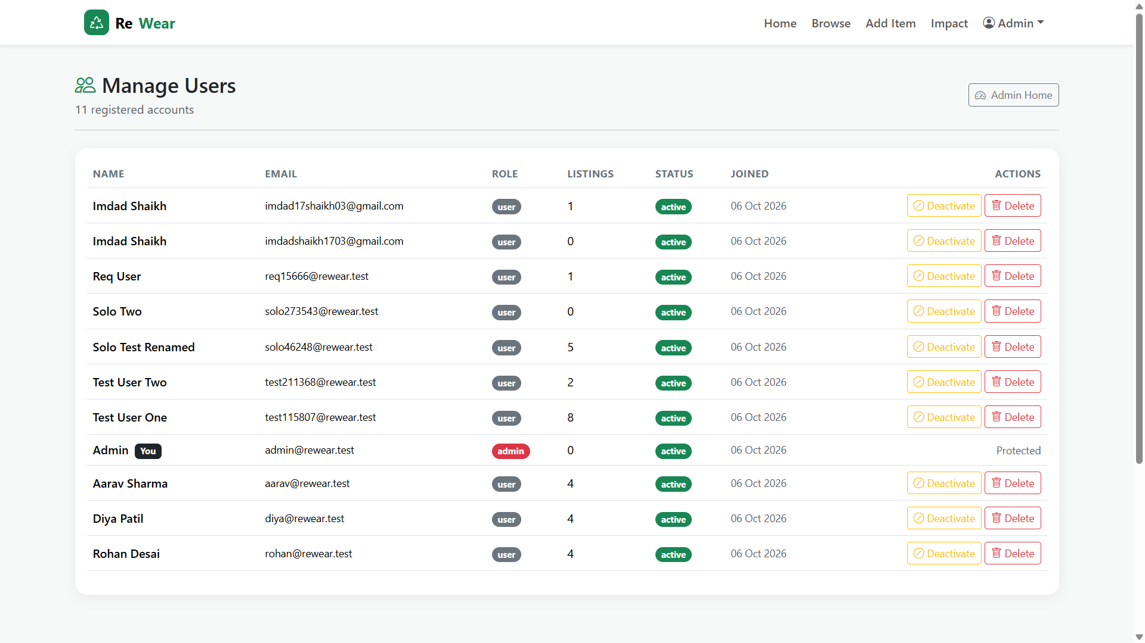
Figure 20: ReWear Admin Users Page
Administrators can view all users and deactivate or reactivate accounts.
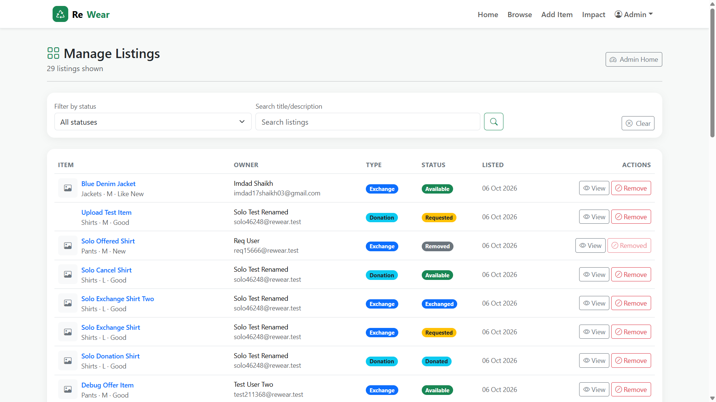
Figure 21: ReWear Admin Items Page
Administrators can view all items, including removed ones, and remove inappropriate items.
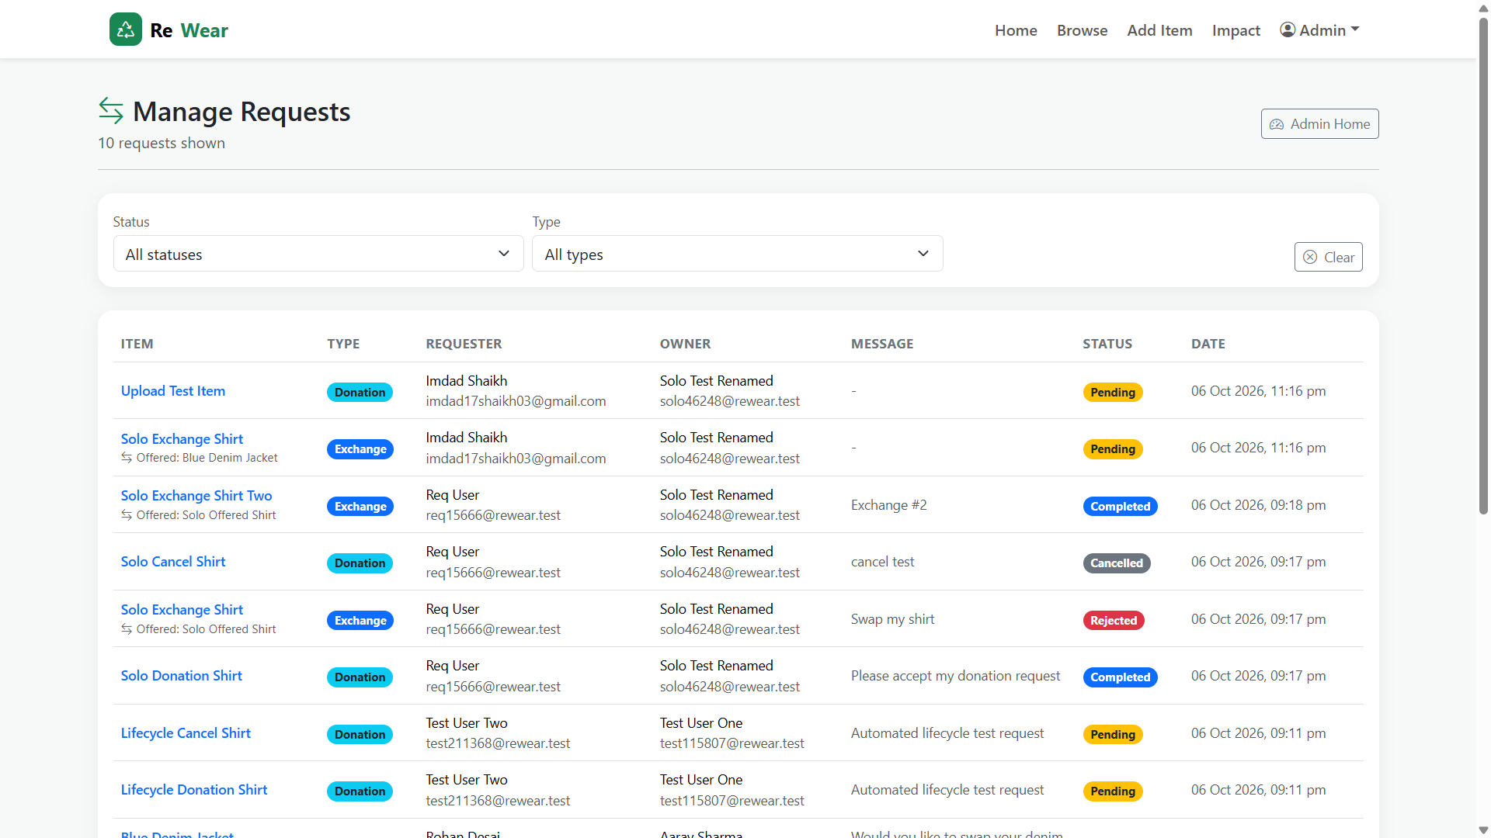
Figure 22: ReWear Admin Requests Page
Administrators can view all donation and exchange requests on the platform.

12. Testing
The backend API and the main workflows were tested against the running application (frontend production build, MongoDB connection, seeded data and live HTTP requests). Table 11 lists representative test cases. The complete set of checks covered authentication, item management and ownership, search and filters, the whole request lifecycle, the user dashboard, the admin area and file upload validation.
Table 11: Representative test cases
Test Case | Expected Result | Actual Result | Status
User registration with valid details | Account created and JWT returned | 201 returned with JWT | Pass
Registration with duplicate email | Request rejected | 400 returned | Pass
Login with correct credentials | Login succeeds | 200 with token and user | Pass
Login with incorrect password | Login rejected | 401 returned | Pass
Protected route without token | Access denied | 401 returned | Pass
Create item with image upload | Item saved with image | 201; image saved under /uploads; status Available | Pass
Upload a non-image (.txt) file | Upload rejected with a clear message | 400 with message (after fix; initially 500) | Pass
Search and filter items | Only matching items returned | Matching items returned; impossible combination gave 0 results | Pass
Create donation request | Request Pending, item Requested | 201 Pending; item Requested | Pass
Exchange request without offered item | Request rejected | 400 asking user to select an item to offer | Pass
Duplicate open request for same item | Request rejected | 400 returned | Pass
Non-owner tries to accept a request | Action forbidden | 403 returned | Pass
Complete accepted donation | Request Completed, item Donated | 200 Completed; item Donated | Pass
Complete accepted exchange | Both items Exchanged | 200 Completed; both items Exchanged | Pass
Non-admin calls admin endpoint | Access forbidden | 403 returned | Pass

62 executed backend/API and integration checks were performed against the running application, and all checks passed after the identified fixes.
Note: browser-based UI automation was not performed. The frontend was verified through a successful production build and review of the source code, and the screens shown in Section 11 are demonstrated manually.

13. Challenges and Solutions
Table 12: Challenges faced during development and their solutions
Challenge | Solution | Result
Request ownership comparison issue: accept, reject, cancel and complete actions always returned 403 because the owner and requester were populated objects and were compared as strings. | Helper functions ownerIdOf() and requesterIdOf() were added in the request controller to read the _id of populated documents. | Owner and requester checks work correctly and all request transitions passed testing.
Invalid file type returned HTTP 500: the Multer file filter rejected files with a plain error that the central error handler treated as an internal error. | The error was tagged with status code 400 in the upload middleware. | A non-image upload now returns 400 with a clear message.
Frontend build issue with emptyFilters: emptyFilters was exported from a component file, which broke the production build. | It was moved to the FilterBar component file, and RequestTable now derives each row’s perspective from currentUserId. | The production build completed successfully.

14. SDG Impact and Outcomes
ReWear contributes to SDG 12 and SDG 13 in the following ways, without making any unsupported environmental claims:
- Promotes clothing reuse: wearable garments are listed for others instead of being discarded.
- Supports exchange and donation: users can swap clothing or give it away free of charge.
- Encourages sustainable consumption: the platform makes reuse an easy alternative to buying new clothing.
- Improves transparency: every request has a visible status, and each change follows the rules enforced by the server.
- Allows users to track their activity: dashboards show listings, requests, exchanges and donations.
- Provides project-defined impact indicators: completed exchanges, completed donations and the impact score are shown on the Impact page.
- Provides administrative oversight: administrators can monitor statistics and moderate users, items and requests.

15. Limitations
- The application was run and tested in a local/development environment; it has not been deployed in production.
- There are no email notifications for request status changes.
- Uploaded images are not resized or optimised.
- Pagination for large browse and admin lists can be improved.
- There is no dedicated automated test suite (such as Jest or Vitest); testing was carried out through executed API checks.
- Browser-based UI automation was not performed.
- Production deployment over HTTPS with a production JWT secret and restricted client origin is future scope.
- The impact score is a simple project-defined count and not a scientific measure of environmental benefit.

16. Future Scope
The following improvements are possible in future versions. None of them is part of the current implementation.
- Email notifications for request status changes.
- Pagination for browse and admin lists.
- Automatic image resizing and optimisation on upload.
- Automated unit and integration tests using Jest or Vitest, to automate the executed checks.
- Deployment behind HTTPS with a production JWT secret and a restricted client origin.
- Additional improvements such as in-app messaging between users, ratings of users, and map-based location search.

17. Conclusion
ReWear demonstrates how full-stack web development can be applied to a real sustainability problem. The project combines a React and Vite frontend with an Express and MongoDB backend, JWT-based authentication with role-based access, validated image uploads and a server-enforced request lifecycle. It supports clothing reuse by allowing users to list, search, donate and exchange garments, and it provides transparent request management through dashboards and an admin area.
The project aligns with SDG 12 (Responsible Consumption and Production) by promoting reuse, and with SDG 13 (Climate Action) through a qualitative, sustainability-oriented contribution. All 62 executed backend/API and integration checks passed after the identified fixes. Although limitations remain, such as the lack of notifications, image optimisation and automated test suites, the project achieves its objectives and provides a solid base for future improvements.

18. References
- React Team, React Documentation. Available at: https://react.dev
- Vite, Vite Documentation. Available at: https://vite.dev/guide/
- OpenJS Foundation, Node.js Documentation. Available at: https://nodejs.org/docs/latest/api/
- OpenJS Foundation, Express.js Documentation. Available at: https://expressjs.com
- MongoDB, Inc., MongoDB Documentation. Available at: https://www.mongodb.com/docs/
- Mongoose, Mongoose Documentation. Available at: https://mongoosejs.com/docs/
- Bootstrap, Bootstrap 5 Documentation. Available at: https://getbootstrap.com/docs/5.3/
- Axios, Axios Documentation. Available at: https://axios-http.com/docs/intro
- Multer, Multer — Node.js middleware for handling multipart/form-data. Available at: https://github.com/expressjs/multer
- Jones, M., Bradley, J. and Sakimura, N., RFC 7519: JSON Web Token (JWT), IETF. Available at: https://www.rfc-editor.org/rfc/rfc7519
- Mozilla, MDN Web Docs. Available at: https://developer.mozilla.org
- OWASP Foundation, OWASP Top 10 and OWASP Cheat Sheet Series. Available at: https://owasp.org
- United Nations, Sustainable Development Goals (including Goal 12 and Goal 13). Available at: https://sdgs.un.org/goals

