Video url: https://www.youtube.com/watch?v=Dp2-dAftD1Q&t=558s

1. Download files from https://drive.google.com/drive/folders/1xf9EBHozaYgD4rrMYjgaFMkA-qyrAXZ9

2. unzip technical windows file

3. create java folder in c drive

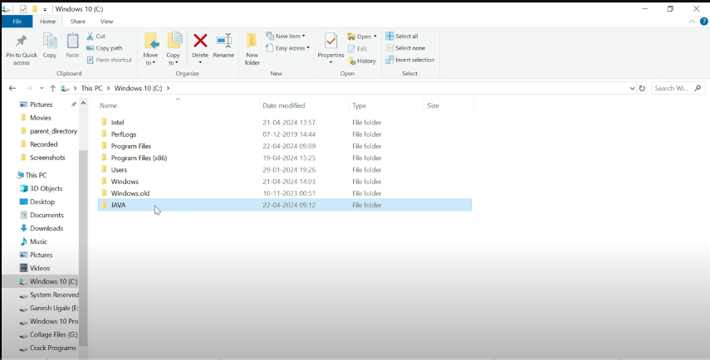

4. install Java from extracted files

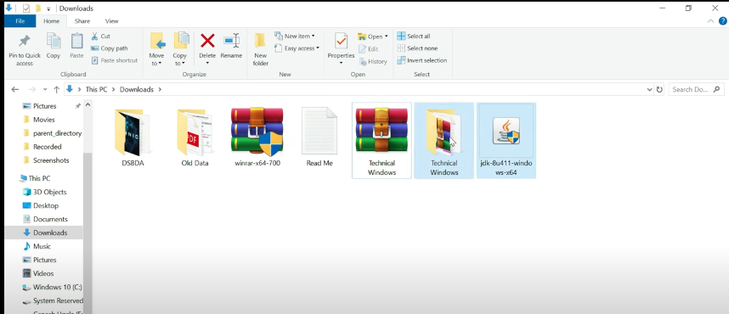

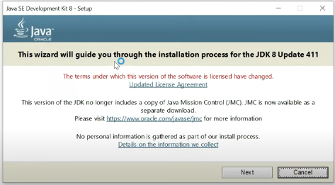

Click on next  
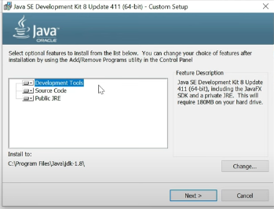

Click on next

Change installation path to C:\JAVA  
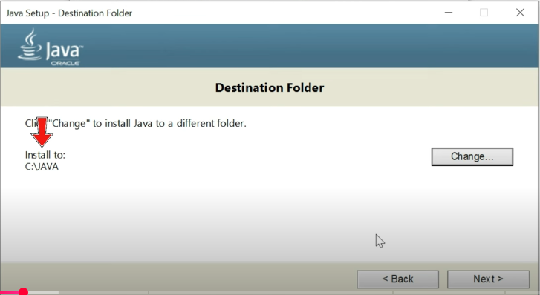

Now delete java folder from c drive as well as from program files  
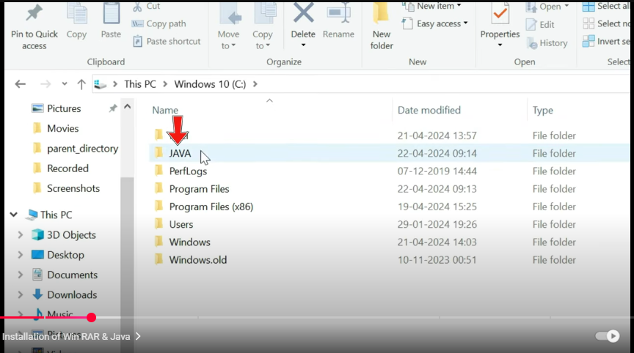

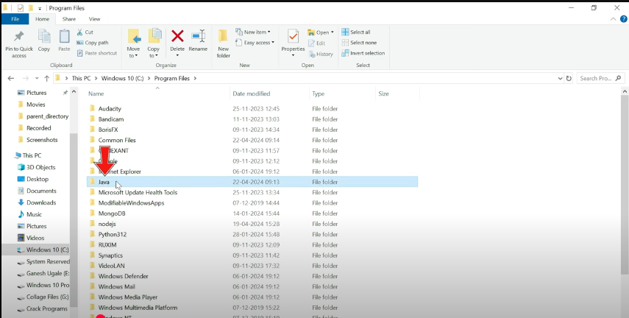

Now copy setup files zip file to c drive

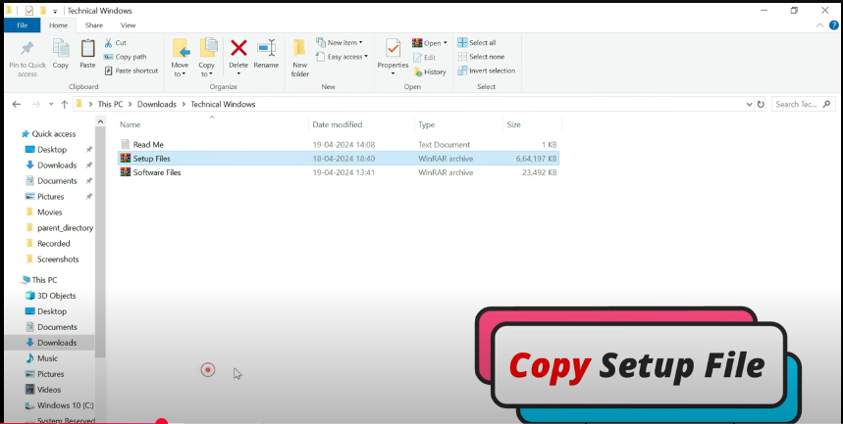

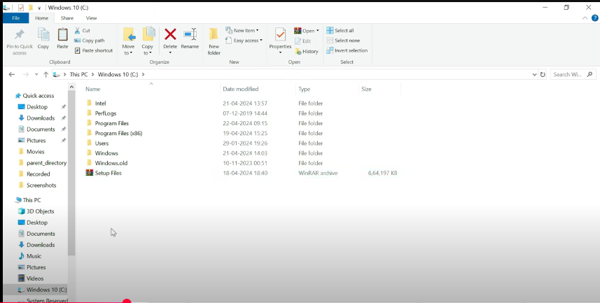

Now, Unzip setup files

And copy path of jdk bin  
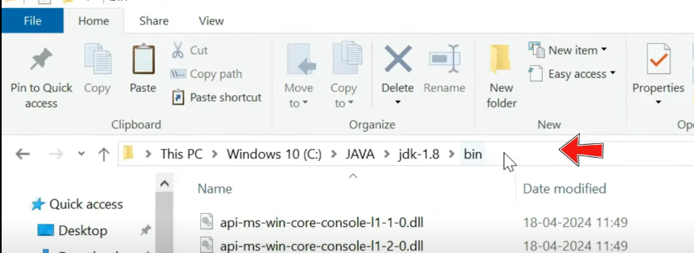

Add it in environment variable in User variable   
create a new variable named JAVA_HOME  
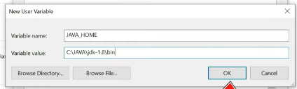

Now add path in System variable

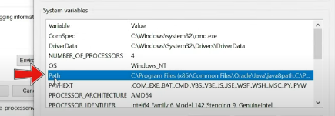

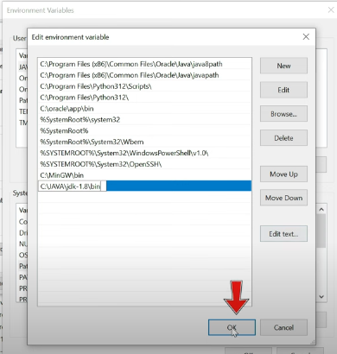

Copy Hadoop bin path

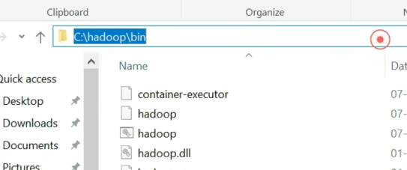

Now again create new variable as HADOOP_HOME  
and paste path  
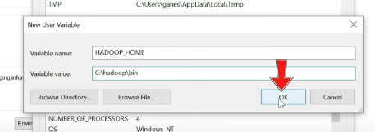

Now in system path variable paste below 3 paths

C:\hadoop\bin, C:\hadoop\sbin, and C:\hadoop  
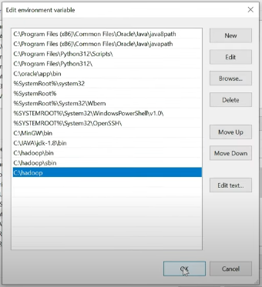

Now check version in cmd  
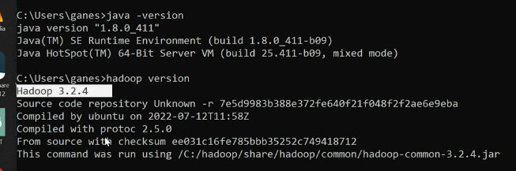

Now extract software files  
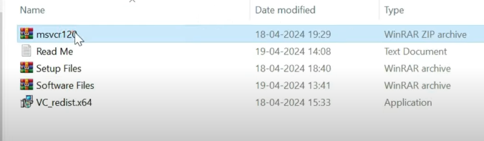

Install VC_redist.  
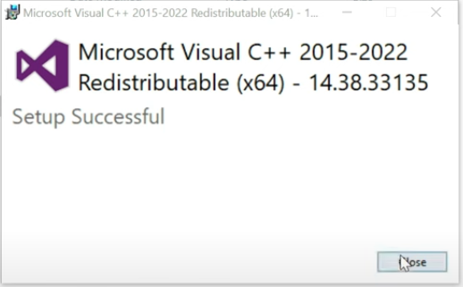

If you get error in installation then Search in apps for Microsoft Visual C++ and uninstall it and then again try

Now go in bin of Hadoop and run winutils application file

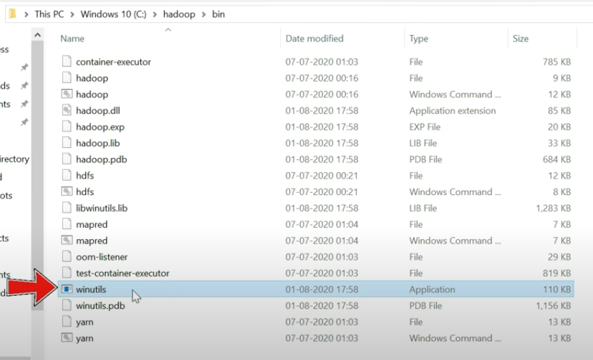

And if it closes instantly there is no error and if it shows missing files refer the video to install required dll files

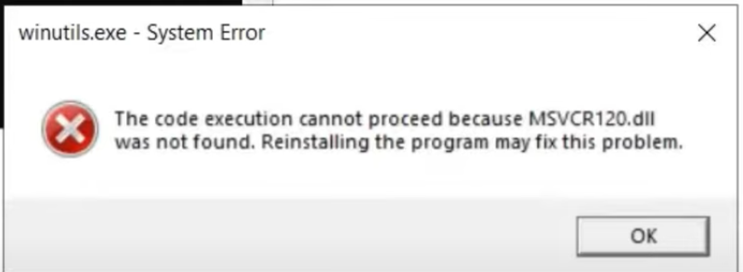

Now open cmd as administrator and format namenode  
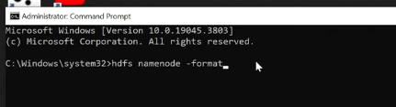

And now go to Hadoop/sbin folder and type following commands in the following order.

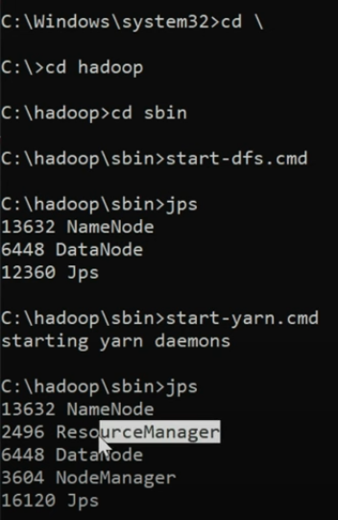

To check in another way whether Hadoop is running or not  
go to localhost:8088 and localhost:9870

