Contents

TABLE OF FIGURE 2

INTRODUCTION 3

WHAT IS PLANET? 3

THE NINE PLANET 4

MERCURY 4

VENUS 5

EARTH 6

Mars 7

JUPITER 8

SATURN 9

NEPTUNE 10

PLUTO 11

THE DWARF PLANET 12

RELATED EQUATIONS 13

COMPARISON OF ALL THE PLANET 13

REFERENCES 16

# TABLE OF FIGURE

Figure 1.1 6

Figure1.1 7

figure1.9 8

Figure 1.3 9

Figure1.4 10

Figure1.5 11

Figure1.7 12

Figure1.8 13

Table 1.0 1 14

figure 2.0- Variation of the Planet 1 15

## INTRODUCTION

The order of the planets in the solar system, starting nearest the [sun](https://www.space.com/58-the-sun-formation-facts-and-characteristics.html) and working outward is the following: [Mercury](https://www.space.com/36-mercury-the-suns-closest-planetary-neighbor.html), [Venus](https://www.space.com/44-venus-second-planet-from-the-sun-brightest-planet-in-solar-system.html), [Earth](https://www.space.com/54-earth-history-composition-and-atmosphere.html), [Mars](https://www.space.com/47-mars-the-red-planet-fourth-planet-from-the-sun.html), [Jupiter](https://www.space.com/7-jupiter-largest-planet-solar-system.html), [Saturn](https://www.space.com/48-saturn-the-solar-systems-major-ring-bearer.html), [Uranus](https://www.space.com/45-uranus-seventh-planet-in-earths-solar-system-was-first-discovered-planet.html), [Neptune](https://www.space.com/41-neptune-the-other-blue-planet-in-our-solar-system.html) and then the possible Planet Nine.

Ever since the discovery of [Pluto](https://www.space.com/43-pluto-the-ninth-planet-that-was-a-dwarf.html) in 1930, kids grew up learning that the solar system has nine planets. That all changed in the late 1990s when astronomers started arguing about whether Pluto was indeed a planet. In a highly controversial decision, the International Astronomical Union ultimately decided in 2006 to [designate Pluto as a "dwarf planet](https://www.space.com/why-pluto-is-not-a-planet.html)," reducing the list of the solar system's true planets to just eight.

If you insist on including Pluto, it would come after Neptune on the list. Pluto is truly way out there and on a wildly tilted, elliptical orbit (two of the several reasons it was demoted). ( Robert & Daisy , 2021)

Astronomers, however, are still hunting for another possible planet in our solar system, [a true ninth planet](https://www.space.com/31670-planet-nine-solar-system-discovery.html), after mathematical evidence of its existence was revealed on Jan. 20, 2016. The alleged "Planet Nine," also called "Planet X," is believed to be about 10 times the mass of Earth and 5,000 times the mass of Pluto.

# WHAT IS PLANET?

The [IAU defines](https://www.iau.org/public/themes/pluto/) a true planet as a body that circles the sun without being some other object's satellite; is large enough to be rounded by its own gravity (but not so big that it begins to undergo nuclear fusion, like a star); and has "cleared its neighborhood" of most other orbiting bodies. Yeah, it's a mouthful.

But that restrictive definition helped isolate what should and should not be considered a planet — a problem that arose as astronomers discovered more and more planet-like objects in the solar system. Pluto was among the bodies that didn't make the cut and was re-classified as a dwarf planet. The problem with Pluto, aside from its small size and offbeat orbit, is that it doesn't clear its neighborhood of debris — it shares its space with lots of other objects in the [Kuiper Belt](https://www.space.com/16144-kuiper-belt-objects.html). Still, the demotion of Pluto remains controversial.

The IAU planet definition also put other small, round worlds into the [dwarf planet](https://www.space.com/15216-dwarf-planets-facts-solar-system-sdcmp.html) category, including the Kuiper Belt objects [Eris](https://www.space.com/28379-eris-dwarf-planet.html), [Haumea](https://www.space.com/23091-haumea.html) and [Makemake](https://www.space.com/23122-makemake.html)

# THE NINE PLANET

## MERCURY

Zipping around the sun in only 88 days, Mercury is the closest planet to the sun, and it's also the smallest, only a little bit larger than Earth's moon. Because its so close to the sun (about two-fifths the distance between Earth and the sun), Mercury experiences dramatic changes in its day and night temperatures: [Mercury temperatures](https://www.space.com/18645-mercury-temperature.html) can reach a scorching 840 F (450 C) in the day, which is hot enough to melt lead. Meanwhile, on the night side, temperatures drop to minus 290 F (minus 180 C). Mercury has

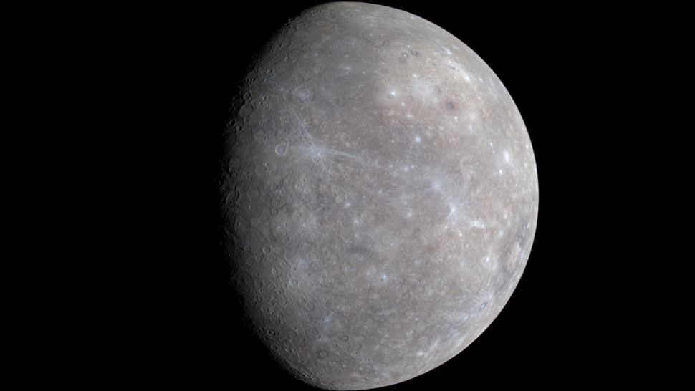

Figure 1.1

a very thin atmosphere of oxygen, sodium, hydrogen, helium and potassium and can't break-up incoming meteors, so its surface is pockmarked with craters, just like the moon. Over its four-year mission, NASA's [MESSENGER spacecraft](https://www.space.com/17795-mercury-messenger.html) revealed incredible new discoveries that challenged astronomers' expectations. Among those findings was the discovery of water ice and frozen organic compounds at Mercury's north pole and that volcanism played a major role in shaping the planet's surface.

## VENUS

The second planet from the sun, Venus is Earth's twin in size. Radar images beneath its atmosphere reveal that its surface has various mountains and volcanoes. But beyond that, the two planets couldn't be more different. Because of its thick, toxic atmosphere that's made of sulfuric acid clouds, Venus is an extreme example of the greenhouse effect. It's scorching-hot, even though Mercury is closer to the sun, Venus is the hottest planet in the solar system. The average temperature on Venus' surface is 900 F (465 C). At 92 bar, the pressure at the surface would crush and kill you. And oddly, Venus spins slowly from east to west, the opposite direction of most of the other planets.

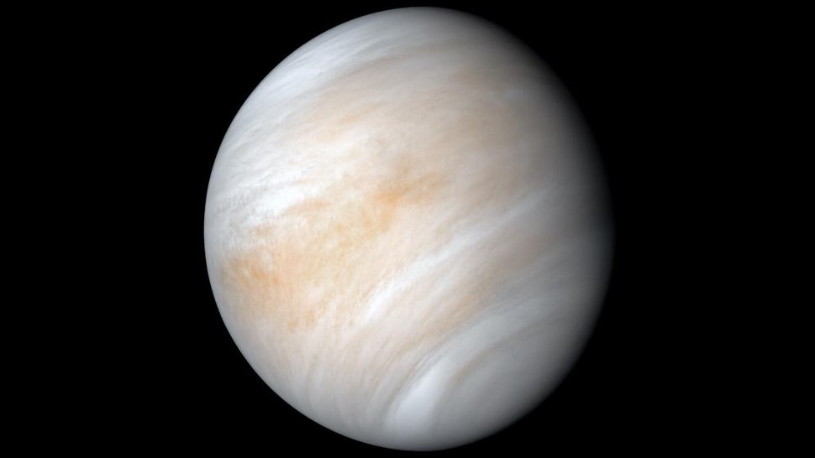

Figure1.1

The Greeks believed Venus was two different objects — one in the morning sky and another in the evening. Because it is often brighter than any other object in the sky, Venus has generated many UFO reports.

## EARTH

The third planet from the sun, Earth is a water world, with two-thirds of the planet covered by water. It's the only world known to harbor life. Earth's surface rotates about its axis at 1,532 feet per second (467 meters per second) — slightly more than 1,000 mph (1,600 kph) — at the equator. The planet zips around the sun at more than 18 miles per second (29 km per second). Earth's atmosphere is rich in nitrogen and oxygen.

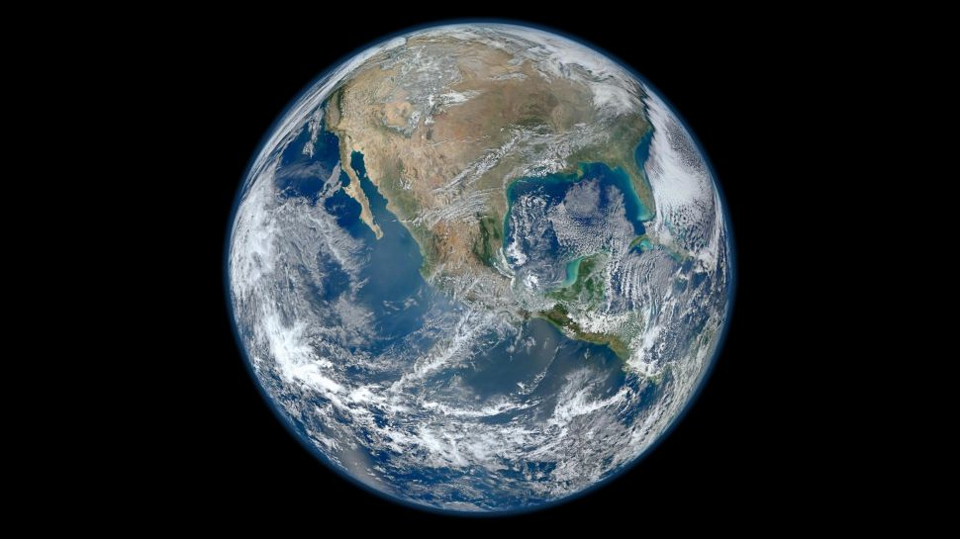

figure1.9

## Mars

The fourth planet from the sun is Mars, and it's a cold, desert-like place covered in dust. This dust is made of iron oxides, giving the planet its iconic red hue. Mars shares similarities with Earth: It is rocky, has mountains, valleys and canyons, and storm systems ranging from localized tornado-like dust devils to planet-engulfing dust storms.

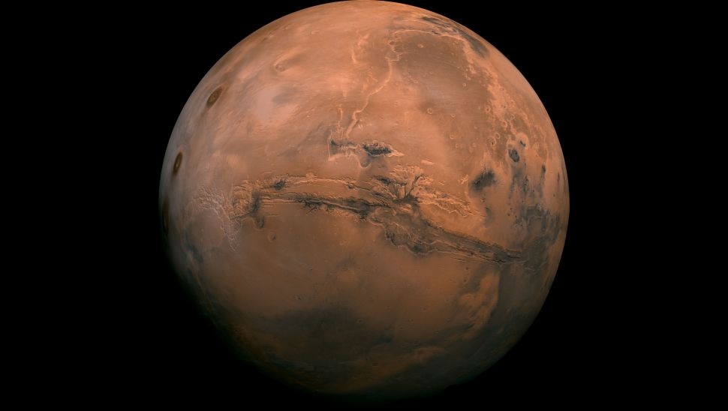

Figure 1.3

Substantial scientific evidence suggests that Mars at one point billions of years ago was a much warmer, wetter world. [Rivers and maybe even oceans existed](https://www.space.com/17048-water-on-mars.html). Although [Mars' atmosphere](https://www.space.com/16903-mars-atmosphere-climate-weather.html) is too thin for liquid water to exist on the surface for any length of time, remnants of that wetter Mars still exist today. Sheets of water ice the size of California lie beneath Mars' surface, and at both poles are ice caps made in part of frozen water. In July 2018, scientists revealed that they had found evidence of a liquid lake beneath the surface of the southern pole's ice cap. It's the first example of a persistent body of water on the Red Planet.

## JUPITER

The fifth planet from the sun, Jupiter is a giant gas world that is the most massive planet in our solar system — more than twice as massive as all the other planets combined, [according to NASA](https://solarsystem.nasa.gov/planets/jupiter/overview/). Its swirling clouds are colorful due to different types of trace gases.

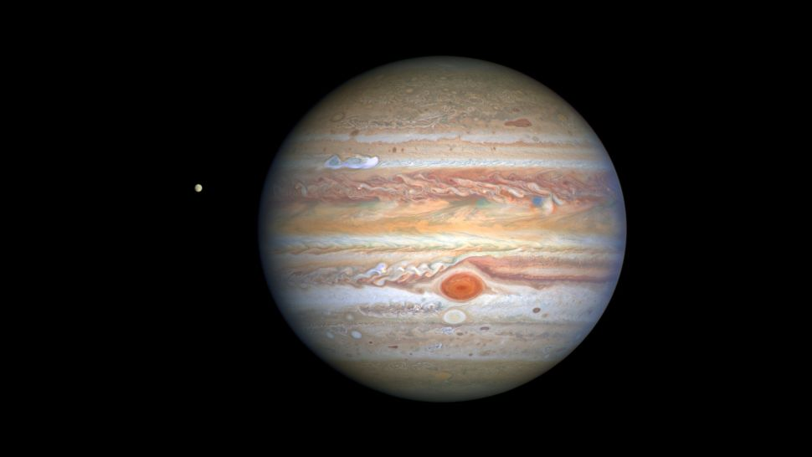

Figure1.4

And a major feature in its swirling clouds is the Great Red Spot, a giant storm more than 10,000 miles wide. It has raged at more than 400 mph for the last 150 years, at least. Jupiter has a strong magnetic field, and with 75 moons, it looks a bit like a miniature solar system.

## SATURN

The sixth planet from the sun, Saturn is known most for its [rings](https://www.space.com/10850-planet-saturn-moons-rings-cassini-spacecraft.html). When polymath [Galileo Galilei](https://www.space.com/15589-galileo-galilei.html) first studied Saturn in the early 1600s, he thought it was an object with three parts: a planet and two large moons on either side. Not knowing he was seeing a planet with rings, the stumped astronomer entered a small drawing — a symbol with one large circle and two smaller ones — in his notebook, as a noun in a sentence describing his discovery. More than 40 years later, [Christiaan Huygens](https://www.space.com/16070-christiaan-huygens.html) proposed that they were rings.

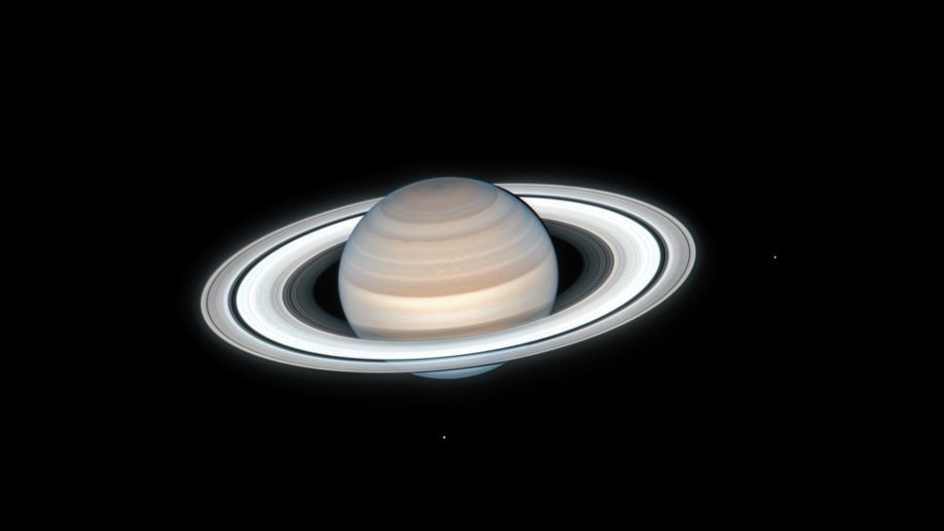

Figure1.5

## NEPTUNE

The eighth planet from the sun, Neptune is about the size of Uranus and is known for supersonic strong winds. Neptune is far out and cold. The planet is more than 30 times as far from the sun as Earth. Neptune was the first planet predicted to exist by using math, before it was visually detected. Irregularities in the orbit of Uranus led French astronomer Alexis Bouvard to suggest some other planet might be exerting a gravitational tug.

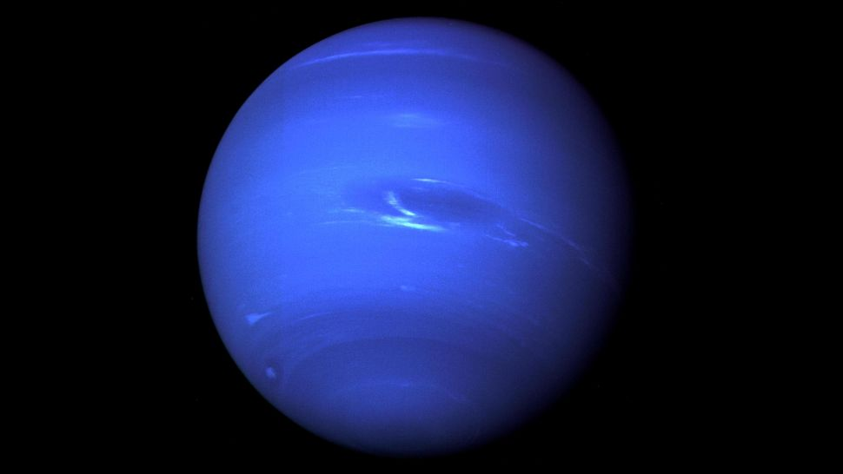

Figure1.7

German astronomer Johann Galle used calculations to help find Neptune in a telescope. Neptune is about 17 times as massive as Earth and has a rocky core.

## PLUTO

Once the ninth planet from the sun, Pluto is unlike other planets in many respects. It is smaller than Earth's moon; its orbit is highly elliptical, falling inside Neptune's orbit at some points and far beyond it at others; and Pluto's orbit doesn't fall on the same plane as all the other planets —  instead, it orbits 17.1 degrees above or below. From 1979 until early 1999, Pluto had actually been the eighth planet from the sun.

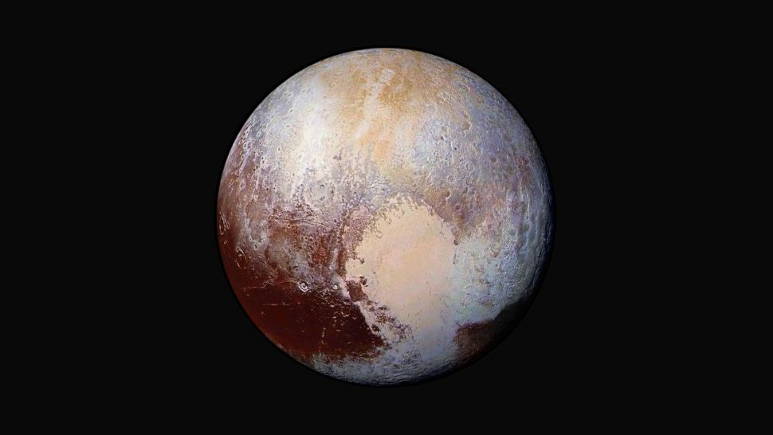

Figure1.8

Then, on Feb. 11, 1999, it crossed Neptune's path and once again became the solar system's most distant planet — until it was redefined as a dwarf planet. It's a cold, rocky world with a tenuous atmosphere.

# THE DWARF PLANET

To be a [dwarf planet](https://www.britannica.com/science/dwarf-planet) under the IAU definition, the object must meet the first two conditions described above; in addition, it must not have cleared its neighbourhood, and it must not be a [moon](https://www.britannica.com/science/moon-natural-satellite) of another body. Pluto falls into this category, as do the asteroid Ceres and the large Kuiper belt object [Eris](https://www.britannica.com/place/Eris-astronomy), which was discovered in 2005 beyond the orbit of Pluto. By contrast, [Charon](https://www.britannica.com/place/Charon-astronomy), by virtue of its being a moon of Pluto, is not a dwarf planet, even though its [diameter](https://www.britannica.com/dictionary/diameter) is more than half that of Pluto. The ranks of dwarf planets will likely be expanded as other objects known or yet to be discovered are determined to meet the conditions of the definition. In June 2008 the IAU created a new category, [plutoids](https://www.britannica.com/science/plutoid), within the dwarf planet category. Plutoids are dwarf planets that are farther from the Sun than Neptune; that is, they are the largest objects in the Kuiper belt. Two of the dwarf planets, Pluto and Eris, are plutoids; Ceres, because of its location in the asteroid belt, is not.

Of the eight currently recognized planets of the solar system, the inner four, from Mercury to [Mars](https://www.britannica.com/dictionary/Mars), are called [terrestrial planets](https://www.britannica.com/science/terrestrial-planet); those from Jupiter to Neptune are called [giant planets](https://www.britannica.com/science/giant-planet) or Jovian planets. Between these two main groups is a belt of numerous [small bodies](https://www.britannica.com/science/small-body) called [asteroids](https://www.britannica.com/science/asteroid). After Ceres and other larger asteroids were discovered in the early 19th century, the bodies in this class were also referred to as minor planets or planetoids, but the term asteroid is now used most widely. (Adam)

# 

# RELATED EQUATIONS

$$A=πr^{2}$$

A= Area of the Earth

r= D/2

$π$ =Pie

# COMPARISON OF ALL THE PLANET

|  |  |  |  |  |  |  |  |  |  |
| --- | --- | --- | --- | --- | --- | --- | --- | --- | --- |
| **PLANET**  **/VARIATION** | **MERCURY** | **VENUS** | **EARTH** | **MARS** | **JUPITER** | **SATURN** | **URANUS** | **NEPTUNE** | **PLUTO** |
| DIAMETER | 4,878 km | (4,878 km | 12,760 km | 6,787 km | 139,822 km | 51,120 km | 49,530 km | 2,301 km | 1122km |
| ORBIT | 88 Earth days | 225 days | 365.24 days | One earth | 11.9 yrs | 84yrs | 165 yrs | 248yrs | 234yrs |
| DAYS | 58.6 days | 241 days | 23 hrs, 56 min | 24 hrs, 37 min | 23hrs | 18 hrs | 19hrs | 6.4days | 1.4days |

Table 1.0 1

figure 2.0- Variation of the Planet 1

INDEX

Mars 8

NASA 9

Neptune 11

planets 13

Pluto 12

sun 10

THE DWARF PLANET 13

# REFERENCES

Robert , R. B., & Daisy , D. ( 2021, December 08). Solar system planets: Order of the 8 (or 9) planets. *Facts about our solar system's planets.*

Adam, M. (n.d.). The Solar System.