TEAM EVEREST
Sustainable Community Digital Twin
AI-powered civic reporting, sustainability quests, community action and measurable impact
Discover → Report → Verify → Solve → Earn → Measure Impact

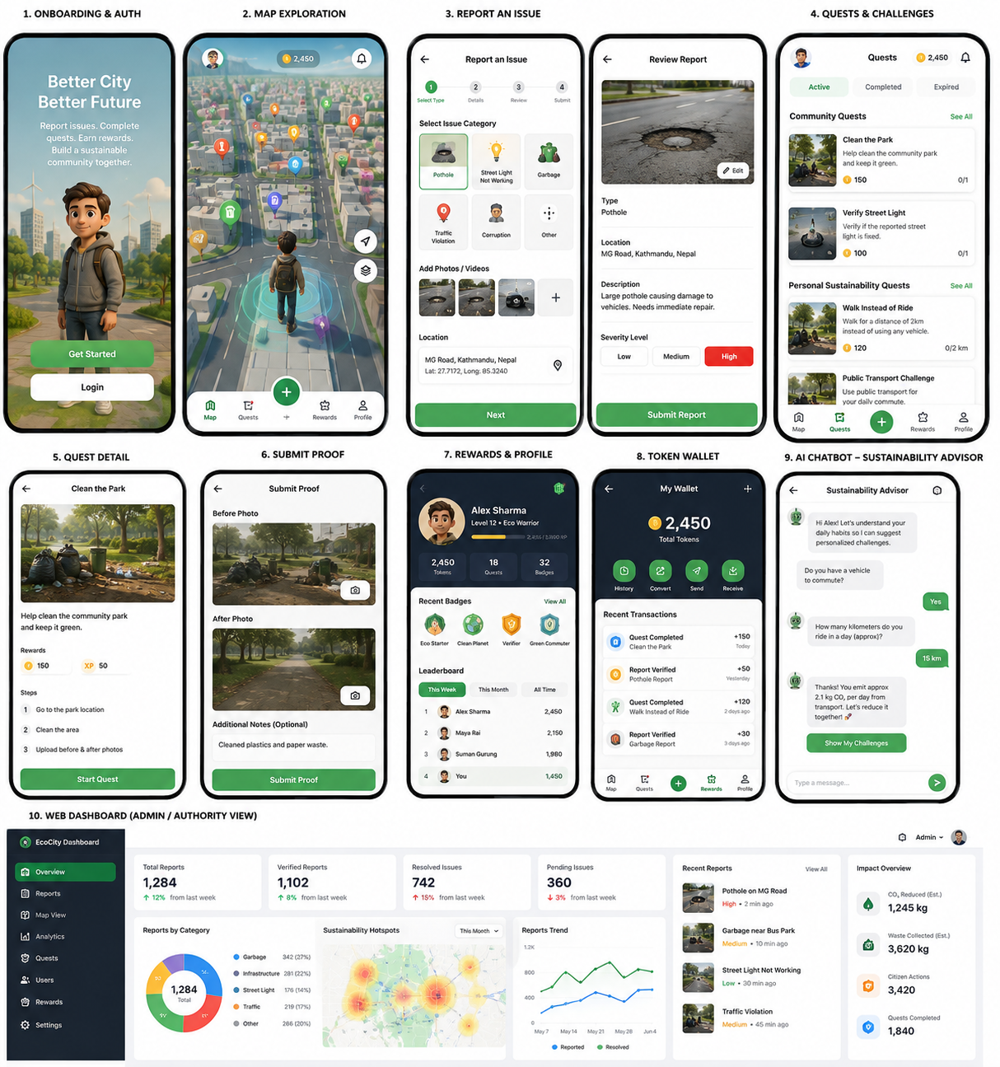
Concept UI: mobile experience and authority dashboard

1. Project Overview
The Sustainable Community Digital Twin is a gamified, AI-powered platform designed to help citizens actively improve their local community. It combines a 3D map, real-time location tracking, issue reporting, AI-assisted duplicate detection, community quests, personalized sustainability challenges, rewards, and an authority dashboard.
Instead of being only a complaint-reporting app, the platform creates a continuous participation loop in which people identify local problems, help verify or solve appropriate issues, complete sustainability challenges, and see the collective impact of those actions.
Core proposition: a game-like digital twin of the community where real-world problems and sustainability opportunities become visible, actionable and measurable.

2. Problem the Project Solves
- Citizens often notice potholes, garbage, broken streetlights, traffic violations and other local problems but lack an engaging, structured way to report and follow them.
- Multiple people may submit the same issue, creating duplicate complaints and inefficient data for authorities.
- Authorities need a clearer picture of where problems are concentrated, how severe they are and which ones should be prioritized.
- Most sustainability apps provide generic advice but do not connect personal behavior to local community action.
- Citizen participation usually drops because reporting systems feel passive and provide little feedback, motivation or visible impact.

3. Target Users
- Citizens and students who want to report or improve community issues.
- Municipalities, local authorities, NGOs and community organizations that need structured issue data.
- Environment-conscious users who want personalized sustainability challenges.
- Community volunteers who want to participate in verified, safe local improvement activities.

4. Mobile Application Experience

4.1 3D Map and Real-Time Avatar
The app uses Mapbox as the geographic foundation. The map is styled as a 3D, game-like environment similar in spirit to Pokémon GO. A user avatar represents the person on the map and follows the phone's real GPS movement.
- 3D buildings and tilted map camera.
- Real-time GPS location.
- Custom user avatar/3D character.
- Issue markers and quest markers around the user.
- Map camera following the user.
- Severity/category-specific icons and visual states.

4.2 Issue Reporting
When users encounter a local problem, they can select the location and submit evidence. A standard report includes:
- Issue category (pothole, garbage, streetlight, traffic, environmental, water, infrastructure or civic issue).
- Photo and/or video evidence.
- GPS coordinates.
- Short description.
- Severity: Low, Medium or High.
- Final review before submission.
Reports are stored in Supabase and become available to the authority dashboard and, after verification, as visible map objects.

5. AI-Assisted Duplicate Detection
Crowdsourced reporting can create many submissions for the same real-world issue. The project uses a multi-signal duplicate-detection approach to reduce this noise.
Signal | What is compared | Purpose
GPS proximity | Distance between report coordinates | Checks whether reports refer to the same nearby place
Text similarity | Meaning of report descriptions | Recognizes similar wording such as “garbage beside school” and “waste near school gate”
Image similarity | Visual features/embeddings from uploaded images | Checks whether different photos likely show the same issue
Instead of showing 30 independent pothole reports, the platform can represent one issue with multiple citizen confirmations, a severity level, first/last report time and current status.

6. Severity and Prioritization
Each report is categorized as Low, Medium or High severity. In a more advanced version, the app can compute a priority score using severity, number of confirmations, time unresolved, affected population and location context.
Example priority logic: Severity × Report Count × Time Unresolved × Potential Impact

7. Quest System
The quest system is the main bridge between civic reporting and sustainable development. It turns selected real-world issues and personal sustainability goals into actionable challenges.

7.1 Community Quests
- Clean a safe public area with accumulated litter.
- Verify whether a reported streetlight or pothole still exists.
- Participate in a community cleanup or environmental activity.
- Submit before/after evidence for an approved, safe task.
Safety rule: citizens should not be encouraged to repair dangerous infrastructure themselves. Electrical, road-repair and similar issues should become verification/escalation quests rather than DIY repair quests.

7.2 Personal Sustainability Quests
An AI sustainability assistant asks the user simple questions about transport, daily travel, electricity, water and waste habits. It then proposes realistic challenges tailored to the user.
- Walk instead of riding for a short trip.
- Use public transport for one journey.
- Complete a low-carbon travel day.
- Separate recyclable waste for several days.
- Reduce unnecessary energy use.
- Complete a water-saving challenge.

8. Proof, Verification and Rewards
For appropriate quests, the user submits evidence such as before/after photos, current GPS location and an optional note. AI and/or moderators can check whether the evidence is consistent with the quest.
- GPS consistency with quest location.
- Image comparison with the original report.
- Before/after change detection.
- Duplicate or reused image checks.
- Manual verification for uncertain cases.
Only verified actions should produce points or tokens. During the hackathon, tokens should function primarily as in-app points, XP, badges and leaderboard value rather than as cryptocurrency or guaranteed cash. Future rewards could be funded by municipalities, NGOs, sponsors or partner businesses.

9. Web Dashboard for Authorities
A separate web dashboard fetches structured data from Supabase and helps authorities or organizations understand what is happening across the community.
- Total, verified, pending and resolved reports.
- Reports by category and severity.
- Map-based issue hotspots.
- Recent reports and evidence.
- Resolution trends over time.
- Community quest participation.
- Estimated sustainability impact.

10. Sustainability Impact Metrics
The platform should focus not only on activity counts but also on outcomes. Suggested impact indicators include:
- Issues resolved.
- Citizen actions completed.
- Sustainability quests completed.
- Waste collected or diverted.
- Estimated CO₂ emissions reduced.
- Average issue resolution time.
- Number of verified community participants.
Environmental quantities such as CO₂ reduction should always be labeled as estimates and calculated with a transparent methodology.

11. Sustainable Development Alignment
SDG | Alignment | Connection to Project
SDG 11 | Very strong | Sustainable cities, safer infrastructure, citizen participation and community issue management.
SDG 12 | Strong | Waste reduction, recycling and responsible consumption challenges.
SDG 13 | Strong | Personal carbon-reduction and low-carbon transport quests.
SDG 9 | Supporting | Infrastructure reporting and data-driven maintenance prioritization.
SDG 16 | Supporting | Civic transparency and governance reporting; best kept as a secondary theme.

12. UI Concept
The following concept visual combines the main mobile flows and the authority dashboard into one system: onboarding, 3D map exploration, reporting, review, quests, proof submission, rewards, wallet, AI sustainability advisor and dashboard analytics.

Figure 1. Concept UI for the Sustainable Community Digital Twin.

12.1 3D Avatar Direction
The avatar gives the map a game-like identity while remaining tied to the user's real GPS position. A generated character can be converted to a 3D model, optimized in Blender, rigged with idle/walk animations, exported as GLB and used in the mobile map experience.
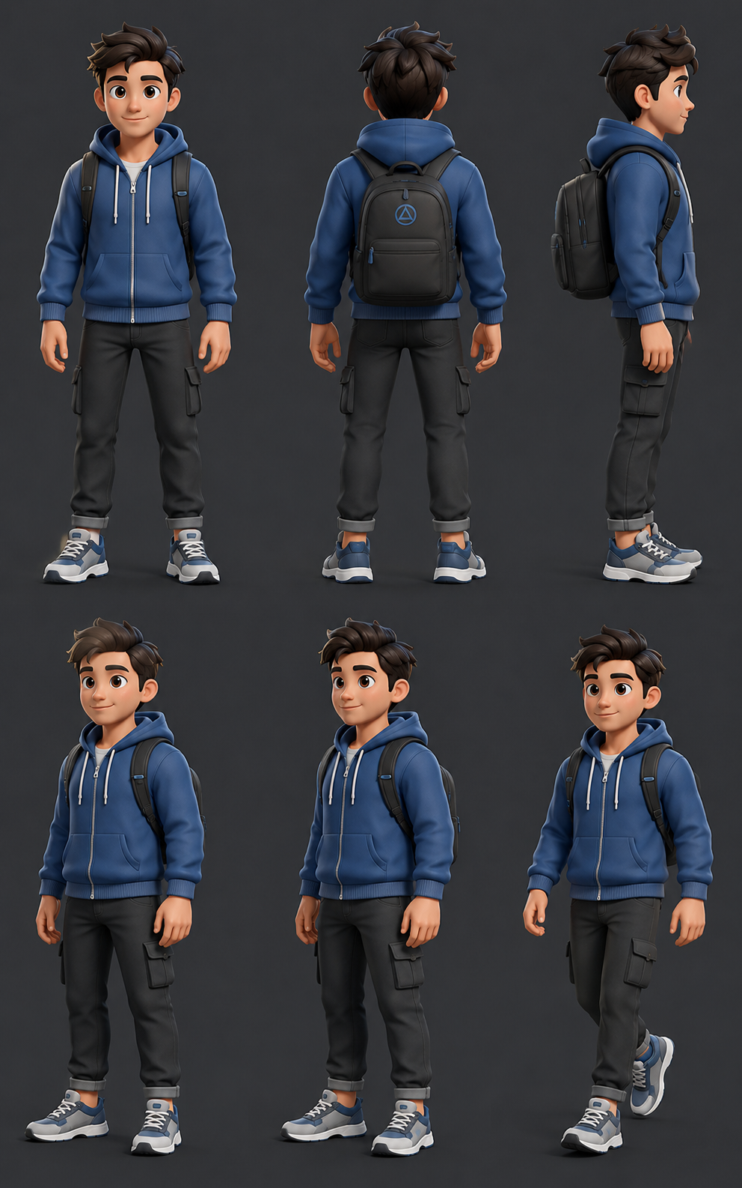
Figure 2. Character turnaround concept for 3D-model generation and rigging.

13. Proposed Technology Architecture
Mobile app: React Native + Expo development build
- Mapbox for 3D map, camera and geographic layers.
- Phone GPS for real-time location tracking.
- GLB/avatar assets for user representation.
- Supabase Auth, PostgreSQL and Storage for users, reports, quests, media and rewards.
AI layer
- GPS clustering for proximity.
- Text embeddings/similarity for descriptions.
- Image embeddings/similarity for visual duplicate detection.
- AI chatbot for sustainability profiling and quest generation.
- Optional image/proof verification models.
Web dashboard: React/Next.js + Supabase
- Authority analytics.
- Map hotspots.
- Report review and resolution status.
- Impact statistics.

14. Recommended Hackathon MVP
The full concept is ambitious. For the hackathon, the strongest strategy is to make one end-to-end flow work extremely well:
- Open the app and show the 3D map with the user avatar.
- Report a real issue with photo, GPS, description and severity.
- Run a duplicate-check demonstration.
- Show the issue immediately on the map and in the dashboard.
- Convert an appropriate issue into a community quest or verification quest.
- Submit proof and verify the action.
- Award points/tokens and update the user profile.
- Show the sustainability assistant generating a personalized quest.
- Update dashboard impact metrics.

15. Why the Project Stands Out
The project is not just a civic reporting app, a carbon tracker or a rewards app. Its differentiation comes from combining those systems into one feedback loop:
3D Community Map → Reports → AI Verification → Quests → Rewards → Impact Tracking → Authority Action

Final Project Definition
An AI-powered, gamified community digital twin that enables citizens to discover, report, verify and help resolve local sustainability issues while completing personalized environmental challenges and earning rewards for measurable positive impact.
Core message: Don’t just report your community’s problems. Participate in solving them.

