# Pausefest 2016 - Re-Building a (government website?) / (citizenship in the 21st Century?)

## What

* Saturday 13 February 2016, we packed into the ACMI cube with a group of willing participants, ready to help tackle some of the common problems we find with government websites and being to start redesigning the Neighbourhood Justice Centre's website to be citizen focused, from the ground up.
* Inspired by the DTO, the challenge was simple "What if a government website could be designed for its users, and by its users?"

## The problem

* Often government websites contain a sea of information, we like to believe that all the information is necessary and that we have structured it into a logical set of categories

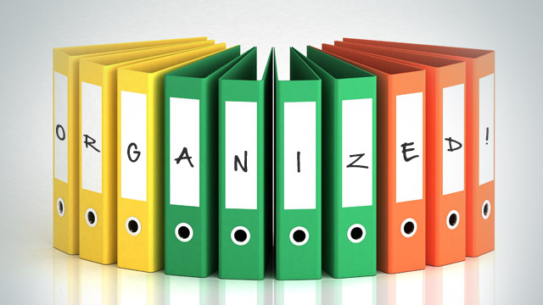

Governments perceives their web content as organised

* Unfortunately, for the end users this is often appears as nothing more than a difficult to navigate labyrinth of pdfs, links and dead ends.



In reality, government websites can be a maze

* One of the reasons for this, is that it is easy to leave out our users when we are designing a new service or website, leaving us to guess what kind of information they might actually need and what kind of services we can provide for them

## How

* Participants were divided into a series of groups and given a set of cards containing current information and services the NJC provides as well as some upcoming services
* Each group were also presented with a series of personas covering some of the community members the NJC interact with
* The participants were asked to first look over their cards and personas to begin to understand a some of the context different community members approach the NJC website from
* Next, within their group, they were asked to explore the cards, discard any they didnt like, add new cards where they thought appropriate and rewrite existing cards if they wanted to. The groups then clustered the cards togethor based on what they had learned about the personas, asking questions along the way and then to label each of these groups, the best they could.
* Finally, the participants were asked to focus on a key service, or area they had started to think about during the previous activity and sketch out this new service or website, focusing on what kind of community member it could serve, their needs and the outcomes this new service could have

## Next

* The results will be compiled and help form the basis for the new website IA
* The NJC are hoping to continue exploring ways to engage with their clients during this website redevelopment process and would love to get you involved