CodeInDNA

Coming soon :)

Documentation

Step by step  17-April-2021

Table of Contents

Frontend 2

GUI 2

Home Page 2

Sign Page or register Page 3

On next click 4

Login page 4

On Search click 5

Gig description Page 6

Dashboard (pending) 10

Flow Chart 11

# Frontend

## GUI

### Home Page

Signup

Login

About

Contact Us

categories

Portfolio

Gigs

Search

### Sign Page or register Page

Sign up with google

Next

Enter you email address

### On next click

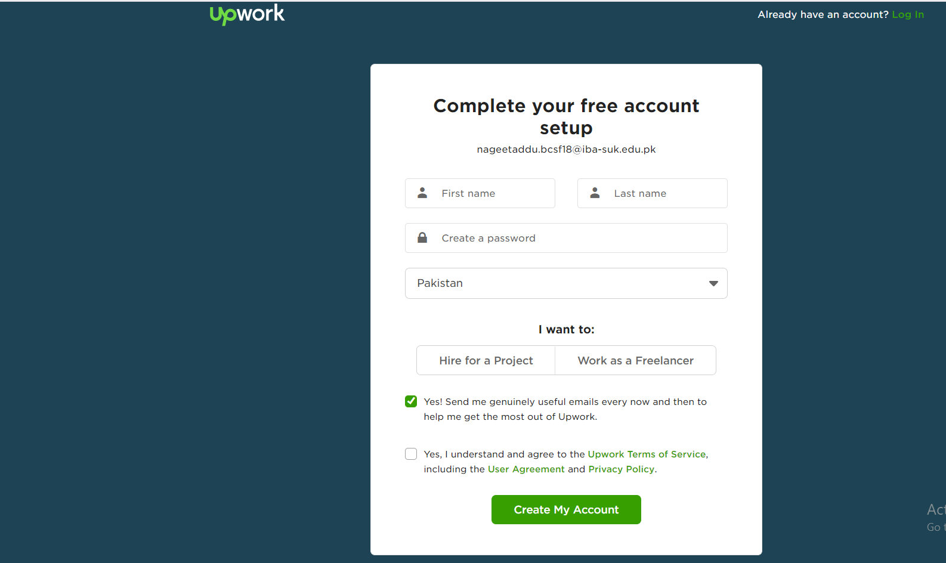

### Login page

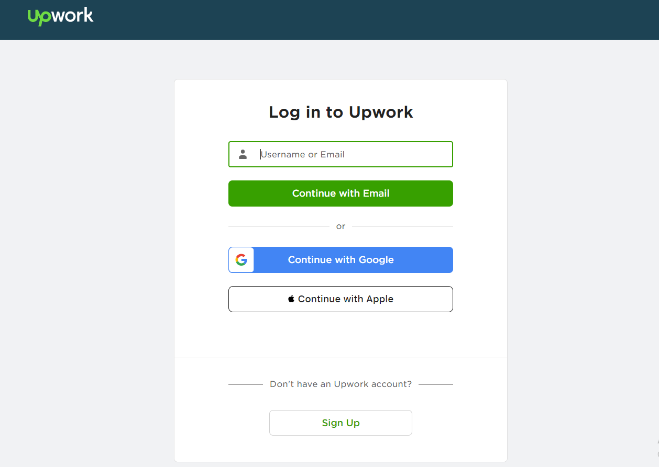

### On Search click

Search anything

Search

Contact

Post job

Dashboard

footer

Filter options (combo boxes) for categories

Filter options according to ratings/ budjet/time

It is a long established fact that a reader will be distracted by the readable content of a page when looking at its

****

It is a long established fact that a reader will be distracted by the readable content of a page when looking at its

****

Next

Previous

Sort

View

#

### Gig description Page

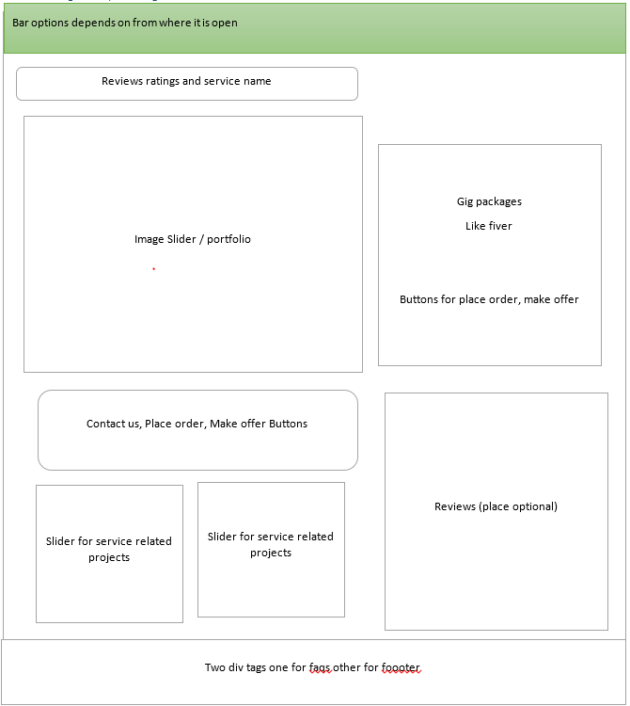

Place Order Button, Make offer, Buyer request Copied from fiver

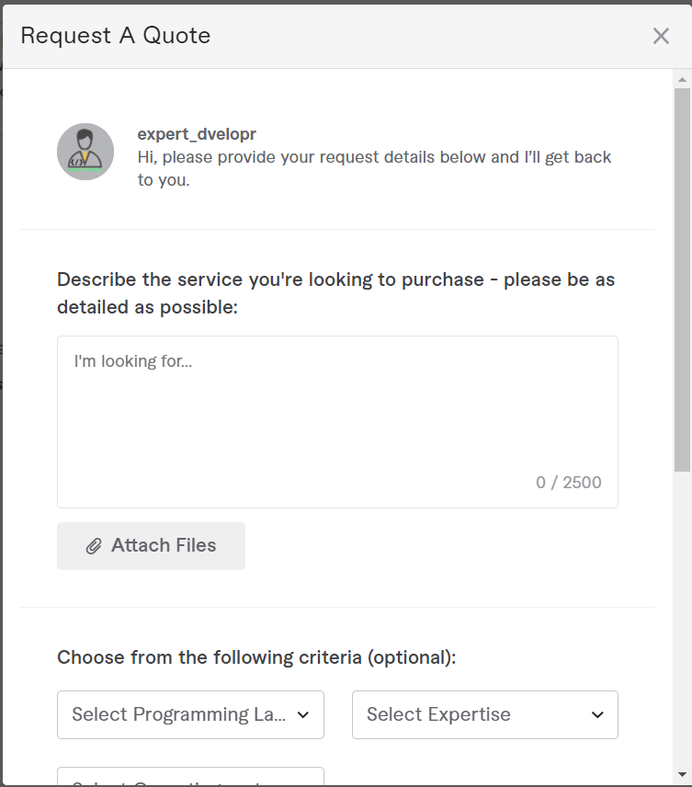

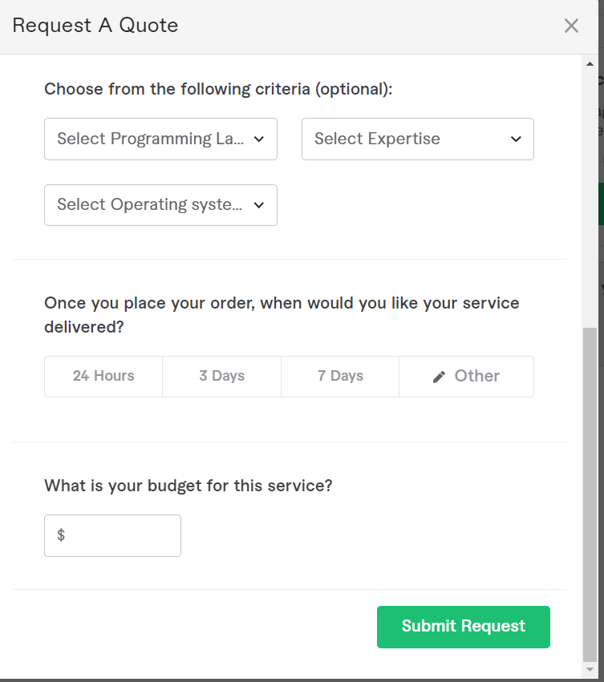

Post a request (make offer )

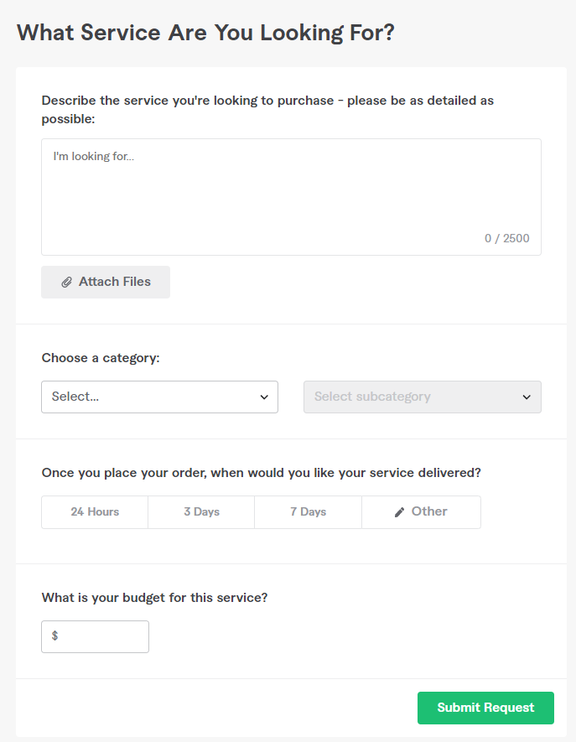

### Dashboard

Explore

States

Contact

Orders

Needs to decide

Edit profile

User Description or some details

# Flow Chart

Chat module

Node.js

Database

Database Manipulation/ testing

Responsive + GUI

Testing

Payment methods

Connect Backend with frontend

Fails