과목 : 객체지향 프로그래밍(가반)

교수 : 최지웅 교수

이름 : 김병준

학번 : 20162448

과제 #5

|  |  |  |  |  |  |
| --- | --- | --- | --- | --- | --- |
| 2 | 4 | 6 | 8 | 10 | 12 |
| O | O | O | O | O | O |

1. Circle.java

|  |
| --- |
| public class Circle {  private int x, y, radius;  private Circle(int x, int y, int radius) {  this.x = x;  this.y = y;  this.radius = radius;  }  public static void main(String[] args) {  Circle a = new Circle(2, 3, 5);  Circle b = new Circle(2, 3, 30);  System.out.println("원 a : " + a);  System.out.println("원 b : " + b);  if (a.equals(b)) System.out.println("같은 원");  else System.out.println("서로 다른 원");  }  public String toString() {  String information = "";  information += "Circle(" + this.x + ", " + this.y + ") 반지름 " + this.radius;  return information;  }  private boolean equals(Circle obj) {  return this.x == obj.x && this.y == obj.y;  }  } |

* 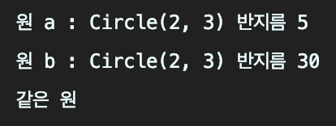Result

1. Package 활용

* File Tree

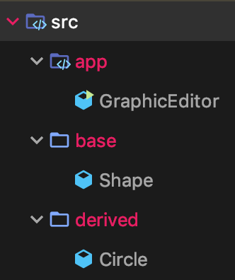

* app/GraphicEditor.java

|  |
| --- |
| package app;  import base.Shape;  import derived.Circle;  public class GraphicEditor {  public static void main(String[] args) {  Shape shape = new Circle();  shape.draw();  }  } |

* base/Shape.java

|  |
| --- |
| package base;  public class Shape {  public void draw() {  System.out.println("Shape");  }  } |

* derived/Circle.java

|  |
| --- |
| package derived;  import base.Shape;  public class Circle extends Shape {  public void draw() {  System.out.println("Circle");  }  } |

* Result



6. TimeMatchGame.java

|  |
| --- |
| import java.text.SimpleDateFormat;  import java.util.Calendar;  import java.util.Scanner;  class Player {  private String name;  private int time;  Player(String name) { this.name = name; }  void setTime(int time) { this.time = time; }  String getName() { return this.name; }  int getTime() { return this.time; }  public String toString() { return this.name + "의 결과 " + this.time; }  }  public class TimeMatchGame {  public static void main(String[] args) {  Scanner scanner = new Scanner(System.in);  Player[] player = new Player[2];  String[] name = {"황기태", "이재문"};  for (int i = 0; i < 2; i++)  player[i] = new Player(name[i]);  System.out.println("10초에 가까운 사람이 이기는 게임입니다.");  int count = 0;  int firsttime = 0;  int secondtime;  for (int i = 1; i <= 4; i++) {  if (i % 2 == 1) {  System.out.print(player[count].getName() + " 시작 <Enter> >>");  scanner.nextLine();  firsttime = Integer.parseInt(TimeMatchGame.getSecond());  System.out.println("현재 초 시간 = " + firsttime);  }  if (i % 2 == 0) {  System.out.print("10초 예상 후 <Enter>키 >>");  scanner.nextLine();  secondtime = Integer.parseInt(TimeMatchGame.getSecond());  System.out.println("현재 초 시간 = " + secondtime);  if (secondtime < firsttime) {  secondtime += 60;  }  int result = secondtime - firsttime;  player[count].setTime(result);  count++;  }  }  compareTime(player);  }  private static String getSecond() {  Calendar cal = Calendar.getInstance();  SimpleDateFormat timeout = new SimpleDateFormat("ss");  return timeout.format(cal.getTime());  }  private static void compareTime(Player[] player) {  int firstplayer = Math.abs(10 - player[0].getTime());  int secondplayer = Math.abs(10 - player[1].getTime());  if (firstplayer == secondplayer)  System.out.println(player[0] + ", " + player[1] + ", 무승부입니다.");  else if (firstplayer < secondplayer)  System.out.println(player[0] + ", " + player[1] + ", 승자는 " + player[0].getName());  else  System.out.println(player[0] + ", " + player[1] + ", 승자는 " + player[1].getName());  }  } |

* Result

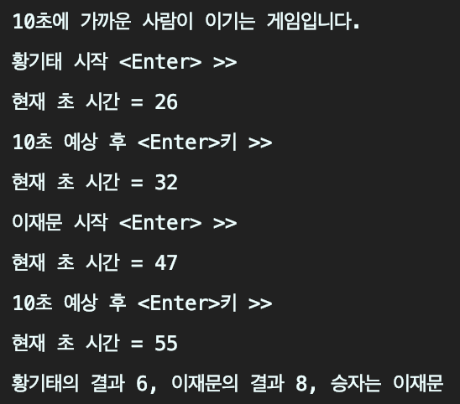

1. StringCycle.java

|  |
| --- |
| import java.util.Scanner;  public class StringCycle {  public static void main(String[] args) {  Scanner scanner = new Scanner(System.in);  System.out.println("문자열을 입력하세요. 빈칸이 있어도 되고, 영어 한글 모두 됩니다.");  String input = scanner.nextLine();  for (int i = 0; i < input.length(); i++)  input = StringCycle.Cycling(input);  }  private static String mergeString(String[] array) {  StringBuilder result = new StringBuilder();  for (String s : array)  result.append(s);  return result.toString();  }  private static String Cycling(String obj) {  String[] input = obj.split("");  String temp = input[0];  for (int i = 0; i < obj.length(); i++) {  try {  input[i] = input[i + 1];  } catch (ArrayIndexOutOfBoundsException e) {  input[i] = temp;  temp = mergeString(input);  }  }  System.out.println(temp);  return temp;  }  } |

* Result

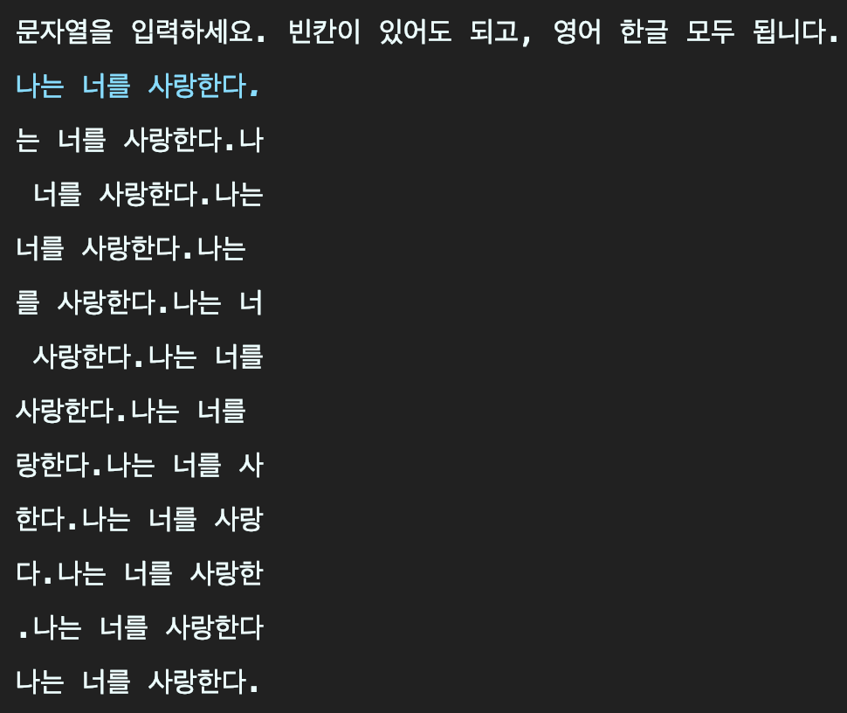

10~12. GamblingGame.java

|  |
| --- |
| import java.util.Scanner;  class Person {  private String name;  Person(String name) { this.name = name; }  String getName() { return this.name; }  }  public class GamblingGame {  public static void main(String[] args) {  Scanner scanner = new Scanner(System.in);  boolean result = false;  System.out.print("겜블링 게임에 참여할 선수 숫자 >> ");  int num = scanner.nextInt();  Person[] player = new Person[num];  for (int i = 0; i < num; i++) {  System.out.print((i+1) + "번째 선수 이름 >> ");  String name = scanner.next();  player[i] = new Person(name);  }  while (!result) result = Gambling(player);  }  private static boolean Gambling(Person[] player) {  Scanner scanner = new Scanner(System.in);  for (int i = 0; i < 3; i++) {  System.out.print("[" + player[i].getName() + "] : <Enter> ");  scanner.nextLine();  int first = (int) (Math.random() * 3) + 1;  int second = (int) (Math.random() * 3) + 1;  int third = (int) (Math.random() * 3) + 1;  if (first == second && second == third) {  System.out.println(first + " " + second + " " + third + " " + player[i].getName() + "님이 이겼습니다.");  return true;  } else System.out.println(first + " " + second + " " + third + " 아쉽군요!");  }  return false;  }  } |

* Result

