Table of Contents

DocuTrustDocuTrust
DevSecOps Project 1 — WalkthroughDevSecOps Project 1 — Walkthrough
SAST · Secrets Scanning · Live Secret VerificationSAST · Secrets Scanning · Live Secret Verification
— — — — — — — — — — — —
Every command in this walkthrough actually ran, and every output quoted is real captured output from the tools — with evidence files and screenshots cited along the way.Every command in this walkthrough actually ran, and every output quoted is real captured output from the tools — with evidence files and screenshots cited along the way.
August 2026August 2026

DocuTrust Walkthrough — SCA, Dependency Confusion & OpenSSF Scorecard
A beginner’s guide to how I carried out Project 2 of the DevSecOps track on DocuTrust. Every command below actually ran, and every screenshot below is a real capture of that command on a real terminal — not a drawing. Evidence files are cited along the way. The guide assumes a Bash terminal (macOS, Linux, or WSL2 on Windows) and Project 1 finished (the SAST and secrets gates exist).

Starting from this repo (not from the course handout)?
This repo holds the finished Project 2 — on main, the lodash pin is already fixed and the SCA gate already exists. To do the project yourself, start on the project2-starter branch instead: it is the finished Project 1 plus the seeded, still-vulnerable lodash@4.17.15 pin, exactly as this guide assumes:
git checkout project2-starter
npm ci
You are the engineer now. The app has one dependency problem you already know about (Project 1’s SAST scan surfaced it and deliberately did not fix it: dependencies are Project 2’s job) and a set of questions nobody has asked: what else is in the dependency tree, could a malicious package shadow its way in, and how healthy are the upstream projects we rely on. Your job is to find out, fix what needs fixing, and build a policy that keeps the next risky dependency from getting in quietly.

Before you run any stage, know your reset (read once)
This guide’s numbers are reproducible. Two states can drift, and both need resetting before a stage:
A. The repo state. Stage 4 changes package.json/package-lock.json, Stage 6 creates an untracked .npmrc, Stage 9 edits .github/workflows/ci.yml — all on this branch, in your working tree. To re-run from the ground truth, discard the changes:
git checkout project2-starter
git reset --hard origin/project2-starter
git clean -fd # removes the untracked .npmrc created in Stage 6
npm ci
(git reset --hard restores tracked files; git clean -fd removes untracked ones like .npmrc — that’s the one command that won’t be suggested by the checkout error message. The pair is the honest reset.)
B. The database state. Same contract as Project 1’s walkthrough: stop the app, truncate, prove empty:
pkill -f "node src/index.js" || true
set -a && . ./.env.local && set +a
psql "$DATABASE_URL" -c "TRUNCATE documents, comments RESTART IDENTITY CASCADE;"
psql "$DATABASE_URL" -c "SELECT count(*) FROM documents;"
Yes — Project 1’s guide has the same two blocks. They’re the habit this project cements: a baseline that cannot be re-created is a baseline you cannot trust.

Stage 1 — Baseline: know what you’re scanning
Problem: you cannot secure a dependency tree you have not enumerated. Approach: list the app’s own declarations, then the whole installed tree.
First, what does the app declare?
cat package.json
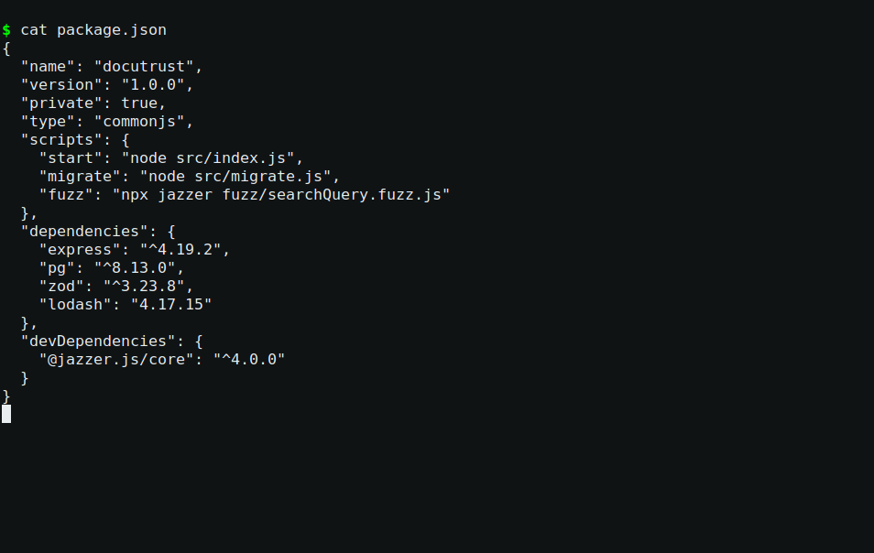
The declared dependencies
Figure 1 — starter package.json: the dependencies block is the surface to defend, containing the seeded finding, declared with suspicious precision.
The dependencies block is the surface to defend. In the starter state it contains the seeded finding, declared with suspicious precision:
"dependencies": {
"express": "^4.19.2",
"pg": "^8.13.0",
"zod": "^3.23.8",
"lodash": "4.17.15"
}
Everything else uses a caret (^4.19.2 — “any 4.x at least this new”) but lodash is pinned exactly (4.17.15 — “this version and no other”). An exact pin is a reproducibility choice; it is also exactly what a seeded vulnerable version looks like. Remember it for Stage 4.
Now the whole tree — direct and transitive:
npm ls --all
npm ls --all walks everything: what you declared, what those packages declared, and what those declared. 300+ lines. This is the tree you are about to scan, and Stage 3 walks it by hand. The digest of the shape your eyes should cut it to is the first couple of layers:
npm ls depth=1
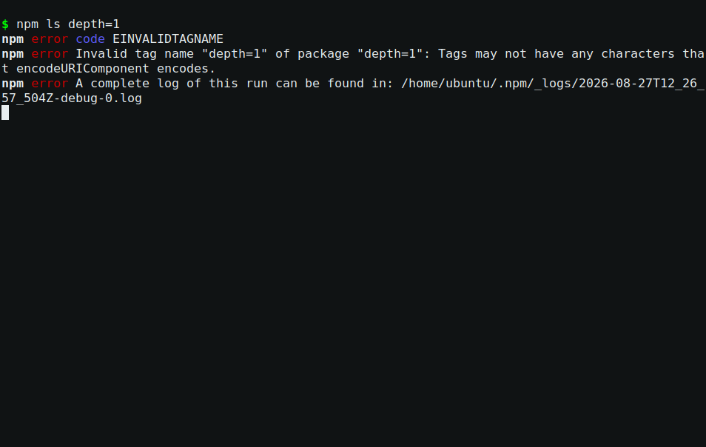
The tree, direct + one transitive layer
Figure 2 — npm ls depth=1 — the direct dependencies and their immediate children (the parts you can hold in your head). npm ls --all (304 lines on this machine) is the full inventory; keep its output for Stage 3.

Stage 2 — The SCA scan (Deliverable 1)
Problem: which of these packages has a known, disclosed vulnerability? Approach: the standard SCA tool for npm — npm audit — against the full tree (it scans transitives too, by default, in both prod and dev).
npm audit
The output, in full, from the real starter state:
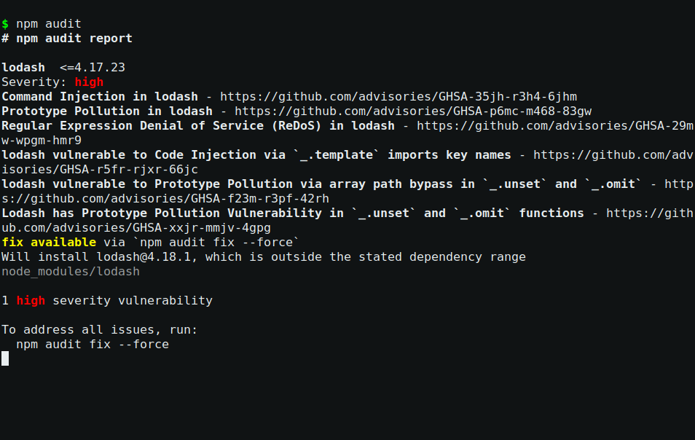
The npm audit finding
Figure 3 — real npm audit against lodash@4.17.15: one aggregate finding, six advisories. Registry data moves over time — the advisory list yours prints may differ by a line — but the shape (1 high, lodash <=4.17.23) is the thing to confirm.
Reading it like an engineer. npm reports one aggregate finding (the package) over six advisories (the vulnerabilities). Don’t stop at the count — read the classes and ask what they would mean in this app:
- Prototype pollution (3 advisories) — an attacker crafts input that writes to Object.prototype. In Node, polluting a property that gets read as a default can become remote code execution. Classic entry points: _.merge, _.defaultsDeep, _.unset, _.omit.
- Command injection and code injection (2 advisories) — through lodash’s _.template function when it compiles templates from attacker-influenced strings.
- ReDoS (1 advisory) — a crafted string makes lodash’s internal regex hang, a cheap denial of service.
Then the honest question: does this app call any of those functions? DocuTrust imports lodash once, for _.cloneDeep (a deep copy of a database row, in src/routes/documents.js). None of the six vulnerable functions is reachable today. So is this a real finding?
Yes — and this is the professional judgment. The vulnerable functions live in the same package, one import away. The day someone writes _.merge(req.body, defaults) — an extremely common refactor — the app imports a high-severity advisory without a code review noticing. The pin is deliberately stale. And a 1 high result fails any serious pipeline gate (you will build that gate in Stage 9). The fix is free. There is no justification to carry it. You fix it — in Stage 4, properly, not by magic.
For the record, keep the machine-readable version too — it is what a reporting tool consumes:
npm audit --json
Save your evidence as you go (a deliverable isn’t “I saw a finding”, it’s the output file):
mkdir -p evidence/10-sca-baseline
npm audit > evidence/10-sca-baseline/npm-audit.txt
npm audit --json > evidence/10-sca-baseline/npm-audit.json
Troubleshooting.
- “npm ERR! audit … network” — npm is talking to registry.npmjs.org; check connectivity/proxy. Nothing to do with the code.
- “found 0 vulnerabilities” when you expected the finding — your branch’s package.json already has the fix (you ran Stage 4, or you’re on main). Reset the branch (the block above), then compare: npm ls lodash.
- npm ci reports the audit finding but still succeeds — normal: npm ci warns, it doesn’t gate. The gate comes in Stage 9.

Stage 3 — Transitive review (Deliverable 2)
Problem: a dangerous package three levels deep is exactly what a direct-dependencies-only review misses. Approach: walk the npm ls --all tree from Stage 1 and look at what our packages themselves depend on.
The full tree has 300+ entries, but the review is quick if you know where to look: the interesting ones are the leaves of popular packages. Ask npm for the specific leaves rather than reading 300 lines:
npm ls path-to-regexp cookie qs pg-native
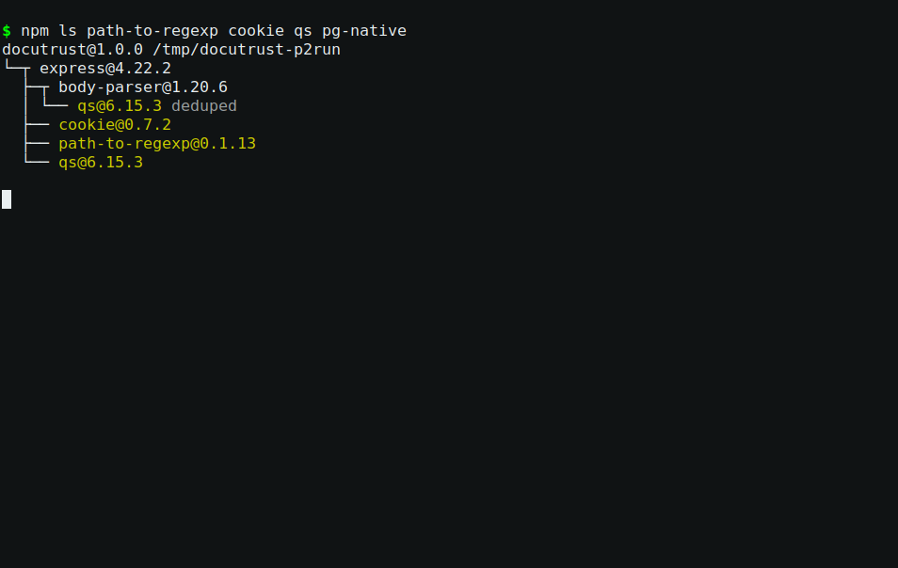
The interesting leaves, asked for by name
Figure 4 — npm ls for the four leaves worth your attention, directly. The UNMET (optional) line for pg-native is itself information: the bindings aren’t installed because nothing needs them — more about that below.
Four specific transitive packages, all real, all from the actual tree:
Transitive package | Via | Why it matters | Verdict
path-to-regexp@0.1.13 | express | the package behind express’s ReDoS chain (CVE-2024-45296, CVE-2024-52960, CVE-2025-46665) | patched line in use — 0.1.13 is the fixed version express pins today
cookie@0.7.2 | express | cookie <0.7.0 could corrupt memory on malformed cookies (CVE-2024-47764) | patched
qs@6.15.3 | express / body-parser | qs <6.9.1 had prototype pollution (CVE-2022-24999) | patched, well past
pg-native (UNMET OPTIONAL) | pg | native C++ bindings — only installed if explicitly requested; it is not in the tree | absent — watch item if ever enabled
Two more observations that matter:
- lodash@4.17.15 has zero dependencies of its own. It is a leaf. Its six advisories live entirely in its own code — no deeper layer to inspect.
- The tree is single-instance. Every shared transitive is deduped — no hidden second copies holding older vulnerable versions. That is the situation a naive review silently assumes; here, npm ls --all proves it instead of assuming it.
Verdict: no dangerous transitive package found; the single real finding in the entire tree is the direct lodash pin. That clean statement is itself a deliverable — a review that names its packages and states a conclusion, not a wall of names.
Troubleshooting — this happened during the real run:
npm error invalid: lodash@4.18.1 /home/ubuntu/.../node_modules/lodash
npm ls reported ELSPROBLEMS — the installed node_modules had drifted from the lockfile (the repo had been reset; the lockfile said 4.17.15, the folder held something else). The fix is the professional rule: the lockfile is truth, node_modules is disposable — reinstall it.
npm ci
If npm ls ever prints invalid or ELSPROBLEMS, this is the reason and this is the fix.

Stage 4 — Remediate lodash, for real (Deliverable 3)
Problem: the finding must actually go away — not be documented, not be suppressed. Approach: the professional fix, in the professional order: attempt the tool’s own fix first, understand why it balks, fix deliberately, rescan, and reverify by running the app.
Step 1 — try npm’s suggestion without the dangerous flag:
npm audit fix
Nothing changes:
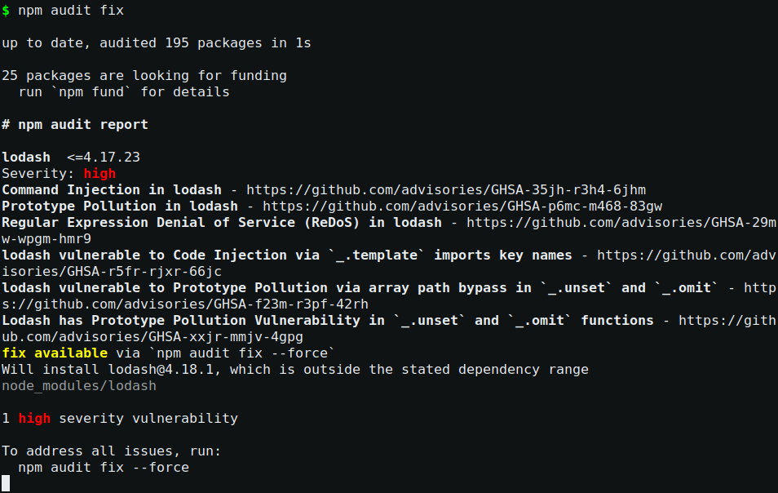
Audit fix does nothing — deliberately
Figure 5 — npm audit fix — “up to date”, then the same 1 high severity vulnerability with the hint npm audit fix --force. The exact pin is why: npm audit fix only updates within the declared semver range, and the seeded pin admits no range.
Why does plain npm audit fix do nothing? Because of the exact pin from Stage 1. npm audit fix only updates within the declared semver range; 4.17.15 declares no range. Only --force overrides, and --force is allowed to do breaking things — the flag you do not type casually in a pipeline. The teaching point: exact pins are great for reproducibility and exactly what makes the automated fixer refuse to touch you. You fix by hand.
Step 2 — the deliberate fix (note --save-exact: we keep the pin style, we just pin the patched version):
npm install lodash@4.18.1 --save-exact
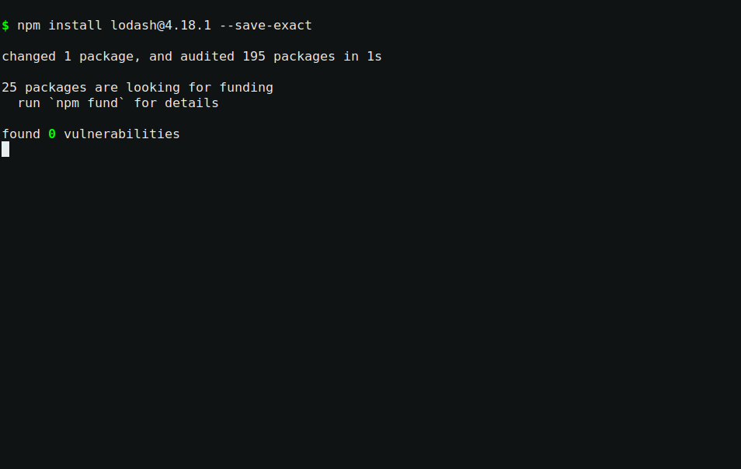
The deliberate fix
Figure 6a — npm install lodash@4.18.1 --save-exact — the pin style kept, the patched version pinned.
Step 3 — rescan. The finding must be gone:
npm audit
found 0 vulnerabilities
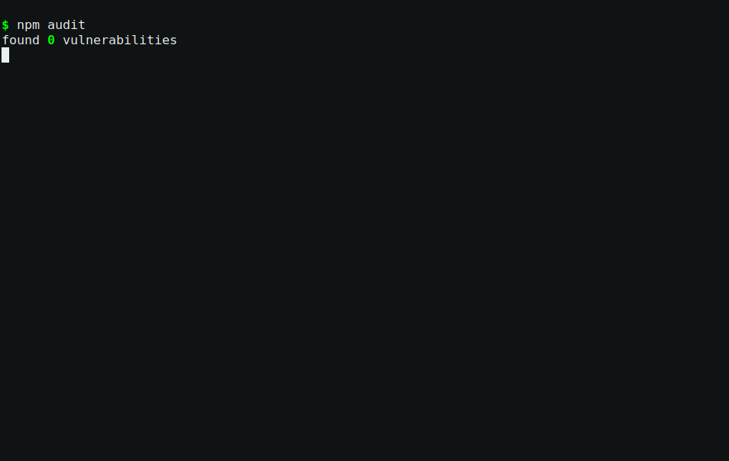
The clean rescan
Figure 6b — real rescan after the fix. Registry time-dependence applies both ways: a future advisory against 4.18.1 would change this — the policy (Stage 5) and the CI gate (Stage 9) exist exactly for that.
Step 4 — reverify, don’t trust. Two gotchas, both real:
- A running app keeps the old version in memory — restart it so the new lodash is actually loaded (full stop/start below).
- The route that uses _.cloneDeep must still work over HTTP:
Stop the app, reset the data, start fresh (the two-command habit from the top of this guide):
pkill -f "node src/index.js" || true
set -a && . ./.env.local && set +a
psql "$DATABASE_URL" -c "TRUNCATE documents, comments RESTART IDENTITY CASCADE;"
# in a second terminal, from the project root:
node src/index.js
then the smoke test:
curl -s -X POST localhost:3000/documents \
-H 'Content-Type: application/json' \
-d '{"title":"smoke","body":"after upgrade"}' | jq .
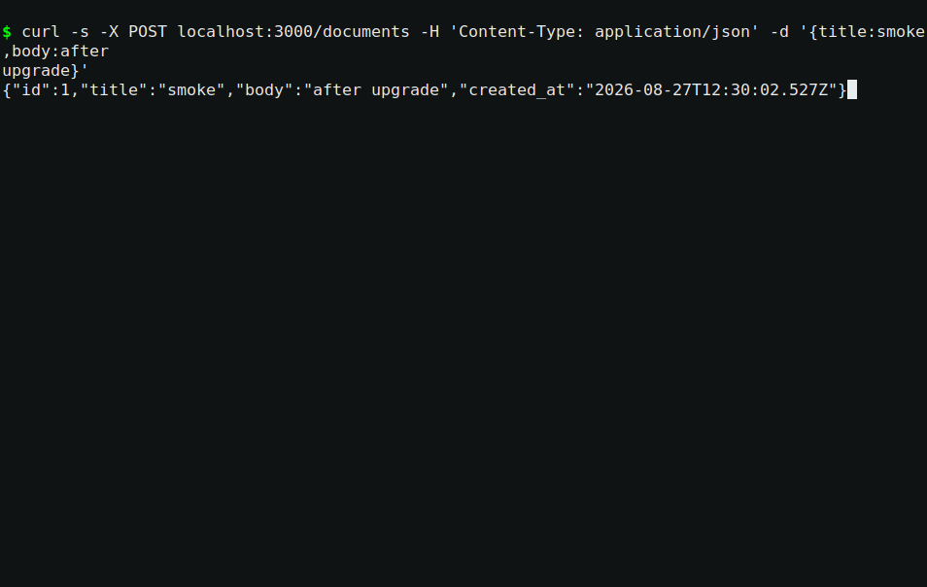
The smoke test after the upgrade
Figure 6 — id: 1 (deterministic after the truncate), 201, deep-cloned row returned. The fix is verified end to end: the running process has lodash 4.18.1 loaded and the documents route still works.
(Full before/after captures: evidence/project-2/12-lodash-fix/.)
Troubleshooting.
- “npm audit fix did nothing” — exact pin; see Step 1. Not a bug.
- “npm ERR! code EEXIST / EPERM” — a stale process holds files; restart the app, remove node_modules, npm ci.
- App 503s after restart — the database env isn’t loaded; the app does not read .env.local itself: set -a && . ./.env.local && set +a before starting.

Stage 5 — The SCA policy (Deliverable 4)
Problem: one fix is a moment; a policy is what stops the next finding. Approach: write the threshold down — specific, checkable, with an exception path — and make the CI enforce it (Stage 9). The policy lives at docs/project-2/sca-policy.md. Its load-bearing numbers:
- Blocks the build: any high or critical advisory — npm audit --audit-level=high must exit 0 on every push and PR.
- Allowed with justification: moderate/low advisories, listed in the risk report, re-reviewed quarterly.
- Exceptions: high/critical only if no patched release exists anywhere; written request → explicit maintainer sign-off → expires end of quarter.
- New dependencies: must pass the audit gate and score ≥ 5/10 on OpenSSF Scorecard (Stages 8–9), and get the typosquat review (Stage 7).
“Fix everything” is not a policy; “use good judgment” is not a policy. A policy names a command, a threshold, and an approver. This one does.

Stage 6 — Dependency confusion defense (Deliverable 5)
Problem: npm resolves a package by name against a registry — and cannot tell “internal package” from “public package with the same name.” If an attacker publishes @docutrust/shared on the public registry, and a developer adds @docutrust/shared to package.json, npm installs the attacker’s code. That attack is called dependency confusion, and it works silently. Approach: pin the internal namespace to the private registry so npm never even asks the public registry about it.
Create the .npmrc (a heredoc is what you type; it runs once):
cat > .npmrc <<'EOF'
@docutrust:registry=https://npm.docutrust.internal/
registry=https://registry.npmjs.org/
EOF
(In a real org, the first line points at the org’s private registry — GitHub Packages, Verdaccio, Artifactory — usually behind auth, which adds a second layer: the auth token is registry-specific, so a public squat cannot be fetched even by mistake.)
Prove it works, don’t describe it. Try to resolve an internal-sounding package, with the defense in place:
npm config get @docutrust:registry
npm view @docutrust/shared
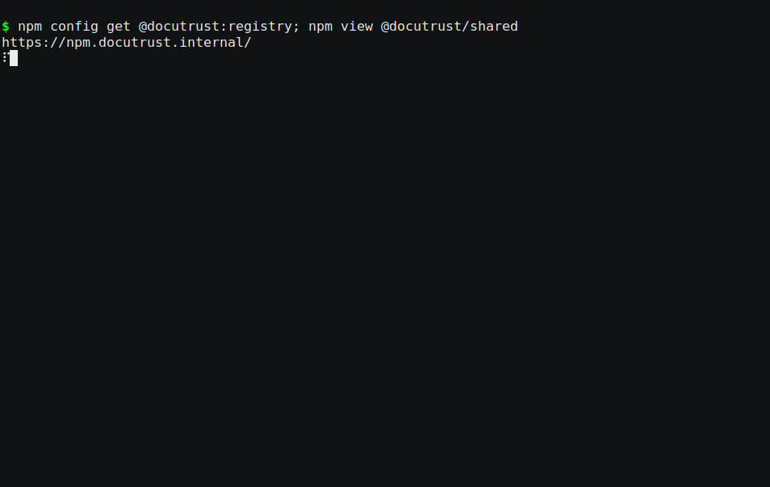
The defense live
Figure 7 — npm fails against the private host (ENOTFOUND ... npm.docutrust.internal) — it never contacted registry.npmjs.org for that scope. Fail-closed: no fallback, no silent shadow.
Now the control — the same lookup pointed at the public registry (which is npm’s default behavior without the .npmrc):
npm view @docutrust/shared --@docutrust:registry=https://registry.npmjs.org/
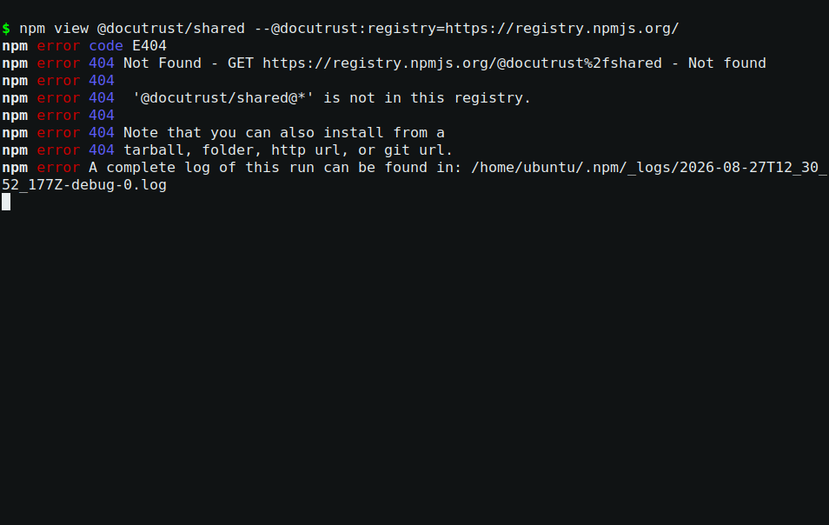
The control: npm asks the public registry
Figure 8 — the 404 today is luck — a squat with that name would have returned 200 and been installed. Defense: blocked at the private host. No defense: public registry consulted. That contrast is the demonstration.
Normal resolution is untouched — npm view lodash version still answers:
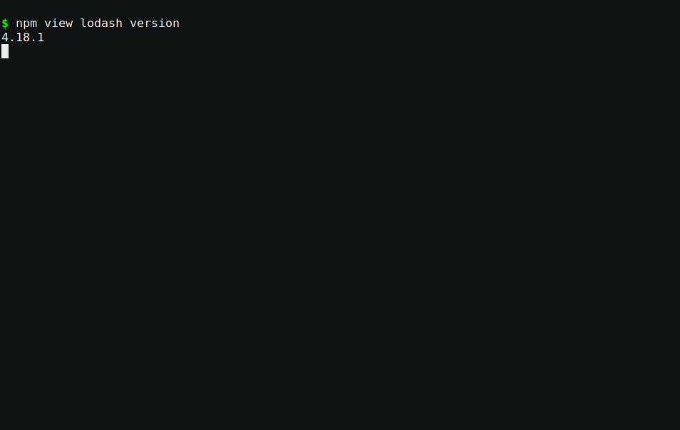
Normal resolution untouched
Figure 9 — 4.18.1 — the fix from Stage 4, and the scope pinning leaves public packages alone.
Troubleshooting.
- npm view of ANY @docutrust/* name fails with ENOTFOUND — correct; that is the defense. To probe the public registry deliberately, use the --@docutrust:registry= override above (this is exactly what Stage 7 does).
- npm ci fails after adding .npmrc — only if you added a scoped dependency; that is the defense refusing. Public dependencies are unaffected.

Stage 7 — Typosquatting check (Deliverable 6)
Problem: a squatter publishes a near-variant of a popular name — loadsh for lodash, expresss for express — hoping a typo or autocomplete slips it into a build. Approach: manual review with real registry probes, one near-variant at a time, and judge each find.
The probe that answers “does this name exist, who owns it, since when”:
npm view <name> version time.created maintainers
Real probes and verdicts (all captured in evidence/project-2/14-typosquat/). The version/job metadata below is a snapshot — registry state changes over time (that’s exactly why the quarterly re-check is in the policy):
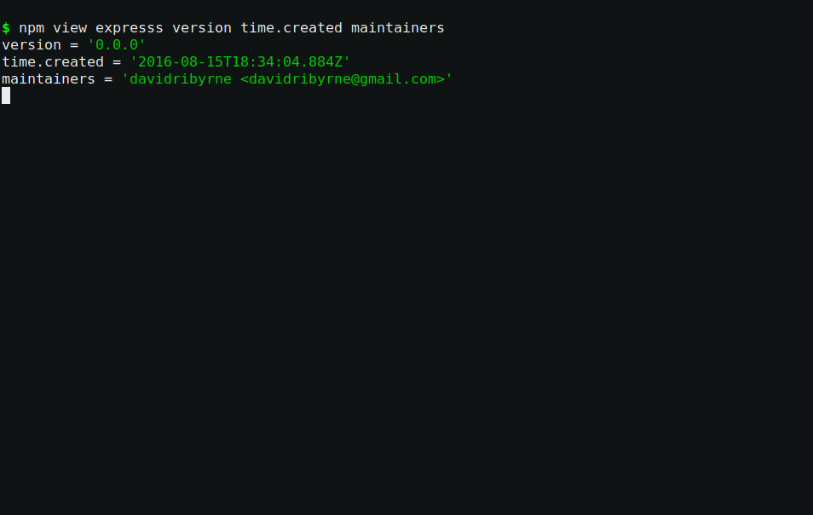
The classic squat: expresss
Figure 10 — expresss: v0.0.0, created 2016, personal email. Squat-shaped: placeholder version, years after the original.
Probe | What came back | Verdict
npm view expresss | v0.0.0, created 2016, personal email | squat-shaped — placeholder version, 6 years after the original
npm view express1 | v1.0.0, created 2019, QQ-mail owner | squat-shaped — one version, disposable-account pattern
npm view js-express | Unpublished on 2026-04-03 | published then removed — registry churn, takedown-shaped
npm view xpress | v2.4.6, 52 versions | legit alternative framework — the judgment case
npm view lodashs | Unpublished 2020-08-25 | a squat that existed and was removed
npm view lodash-package | v1.0.0, created 2024-02-01 | squat-shaped and fresh
npm view loadsh | v0.0.4, created 2018 | the classic documented lodash squat — still live
npm view zod-js | v0.0.1-security, created 2026-01-19 | npm security takedown — this version name is what npm leaves after removing a malicious package. A real squat, months ago, on a name adjacent to a dependency we actually use.
npm view pg1 | Unpublished 2023-06-29 | removed squat
npm view js-pg, pgs | 2017 / 2016, single versions | squat-shaped
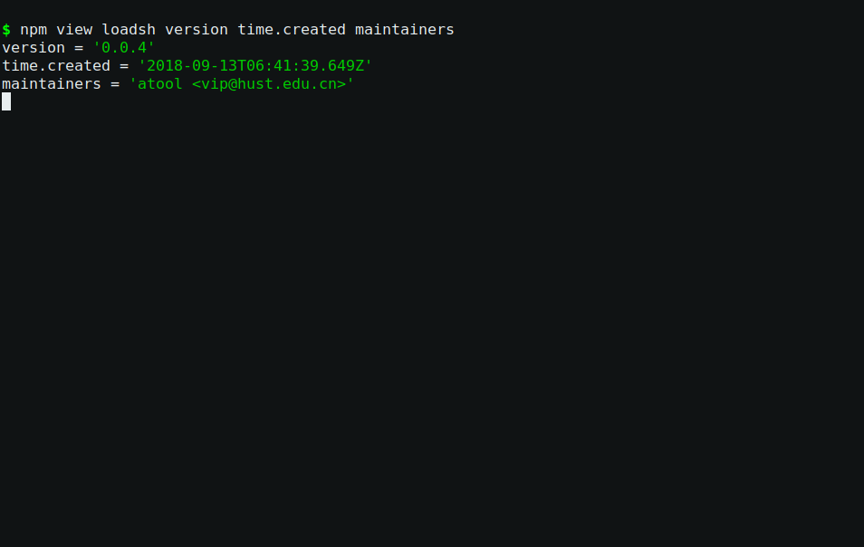
The live lodash squat
Figure 11 — loadsh: v0.0.4, created 2018 — the classic documented lodash squat, still live and installed-by-typo shaped.
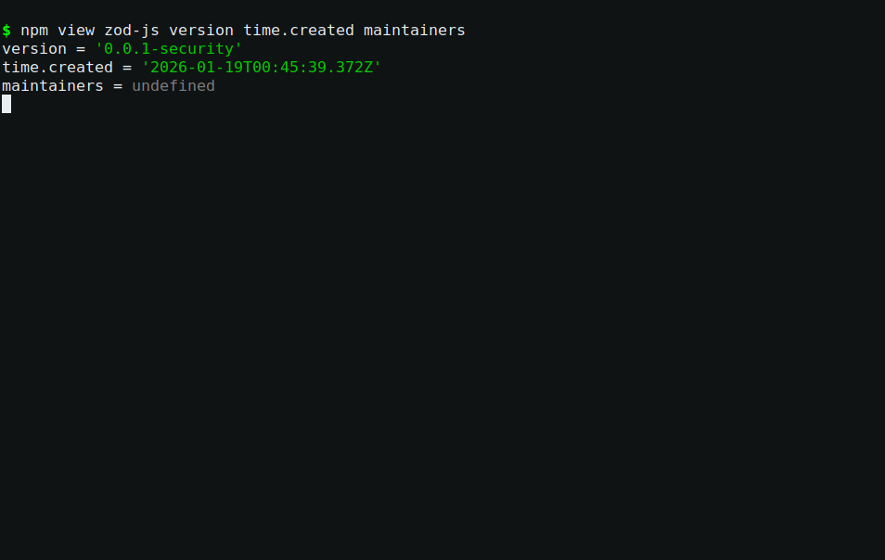
The npm security takedown
Figure 12 — zod-js: version 0.0.1-security is the marker npm leaves after removing a malicious package — a real squat on a name adjacent to zod, one of our own dependencies.
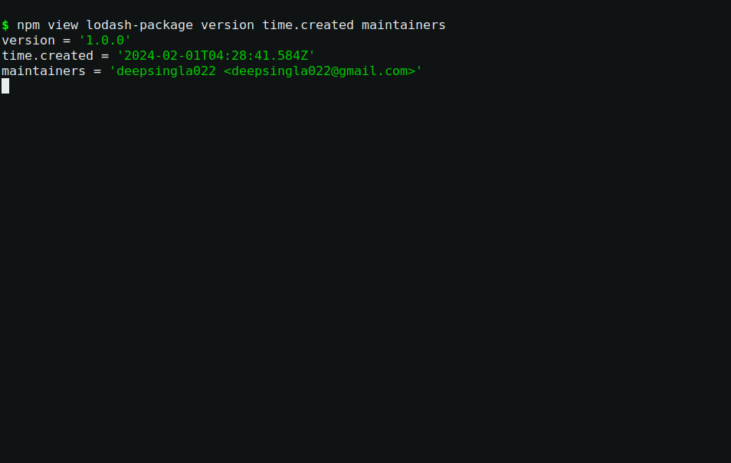
A fresh squat from 2024
Figure 12b — lodash-package: v1.0.0, created 2024 — squat-shaped and fresh: the name is new enough that a developer could reach for it without knowing it’s not the real lodash.
The judgment skill, in one table:
Signal | Squat | Legit
published after the original | yes | possible (fork)
version count | 0–1, placeholder 0.0.0 | many, real releases
maintainer | unknown / disposable email | known maintainers
version 0.0.1-security | npm security takedown | never
Finally, probe our own namespace on the public registry (the Stage 6 scenario, other side): is there a squat waiting under @docutrust/*?
npm view @docutrust/shared --@docutrust:registry=https://registry.npmjs.org/
# ...utils, config, core, auth
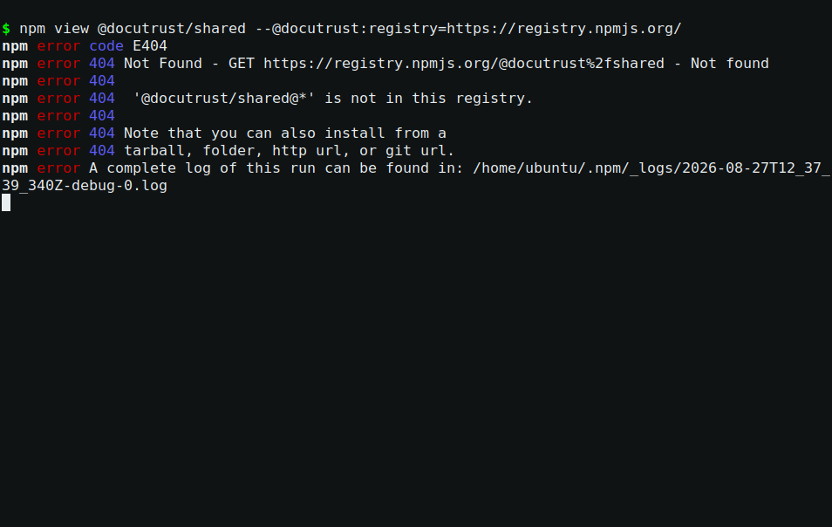
Nothing under our scope
Figure 13 — 404 Not Found — nothing published under our scope. A genuine negative finding, and the Stage 6 scoping is what keeps it negative.
Conclusion: most of the probed near-variants exist or existed; zero is in our tree. The defense is not luck — it is exact pins, the lockfile, the audit gate, and the scope pinning, all already in place. The zod-js takedown is the standing reminder that the attack is live.
Troubleshooting.
- npm view of a variant returns E404 — the name is free right now. Record it; re-check on the next quarterly review.
- Suspicious but few versions — check the maintainer email domain and creation date vs. the original. Disposable mail + post-original creation + one version = squat profile.

Stage 8 — OpenSSF Scorecard (Deliverable 7)
Problem: CVEs say “this version has a known bug.” They say nothing about “this project is abandoned” — the risk class that killed left-pad-style dependencies. Approach: run the OpenSSF Scorecard, the industry tool that scores a repository’s supply-chain hygiene mechanically, and read every check rather than the headline number.
Install and run:
# install the official CLI (scorecard v5.5.0)
curl -sL https://github.com/ossf/scorecard/releases/download/v5.5.0/scorecard_5.5.0_linux_amd64.tar.gz -o scorecard.tar.gz
tar -xzf scorecard.tar.gz scorecard
sudo mv scorecard /usr/local/bin/
export GITHUB_AUTH_TOKEN=$(gh auth token) # scorecard reads the GitHub API
scorecard --repo github.com/Codelak/docutrust
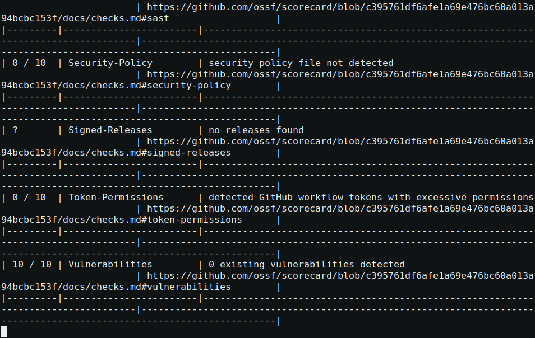
The scorecard run against DocuTrust
Figure 14 — real scorecard v5.5.0 run. The aggregate is a snapshot — my first run scored 2.6/10, this one 2.9/10 (checks move with repo age and CI activity; the doc’s original 2.6 is in evidence/project-2/15-scorecard/). The per-check reading* is what you learn from, not the number.*
Real result (this run): aggregate 2.9 / 10 — 2 checks at 10, the rest at 0 or N/A. Reading it properly, the zeros split into three honest groups:
- Repo youth — Maintained (created <90 days ago), Contributors (solo project). Structural; they improve with time and activity.
- Real, cheaply fixable gaps — Security-Policy (no SECURITY.md), License (no LICENSE), Token-Permissions (no permissions: blocks), Pinned-Dependencies (actions pinned by tag, not hash — scored 2/10 after the pinned-hash fix), Dependency-Update-Tool (no Dependabot). All tracked as follow-ups.
- Deliberate architecture — Code-Review 0/28 (this repo’s projects are sequential and CI gates do the blocking; PR-based flow is the professional norm and is on the follow-up list). And a crucial one to understand: SAST 0/10 even though Project 1 runs semgrep and gitleaks in CI — Scorecard’s SAST check counts CodeQL and nothing else. Your gates are real; this particular lens cannot see them. A score is a lens, not the truth.
The full per-check reading is in evidence/project-2/15-scorecard/README.md.
Troubleshooting.
- scorecard: command not found — the tar extracts a binary named scorecard; check the extraction path.
- scorecard exits with GitHub API errors — the token. gh auth status; if unauthenticated, gh auth login and export the token as above.
- Scores differ run to run — Maintained and Vulnerabilities move with the repo’s age and open alerts; CI-Tests/Code-Review need PR activity. Same tool, same repo, later date — different snapshot. That is normal.

Stage 9 — The policy becomes a gate (Deliverable 8)
Problem: a threshold nobody enforces is a suggestion. Approach: wire both gates into CI so every push and PR is judged automatically. The new sca job in .github/workflows/ci.yml, next to Project 1’s sast and secrets-scan jobs, runs two steps.
Step 1 — the CVE gate, one line (the policy’s §1 verbatim):
- name: npm audit gate (policy §1 — high/critical blocks)
run: npm audit --audit-level=high
npm audit exits non-zero on a high/critical finding → the job fails → the workflow fails → the merge is blocked. That non-zero exit is the gate.
Step 2 — the health gate for new dependencies (policy §5). Read it line by line; it is five ordinary tools in sequence:
- name: Scorecard gate — new dependencies must score >= 5/10 (policy §5)
env:
GITHUB_AUTH_TOKEN: ${{ secrets.GITHUB_TOKEN }}
run: |
set -euo pipefail
threshold=5
# 1. Which dependencies are NEW in this branch?
base="$(git show origin/main:package.json 2>/dev/null \
| jq -r '.dependencies + .devDependencies | keys[]' || true)"
now="$(jq -r '.dependencies + .devDependencies | keys[]' package.json)"
new_deps="$(comm -13 <(printf '%s\n' "$base") <(printf '%s\n' "$now"))"
if [ -z "$new_deps" ]; then
echo "scorecard gate: no new dependencies vs main — pass"
exit 0
fi
# 2. Score each new dependency with the official scorecard CLI.
failed=0
for dep in $new_deps; do
score="$(scorecard --npm "$dep" --format json | jq -r '.score')"
if [ "$score" = "null" ]; then
echo " FAIL $dep — no score obtainable: manual review required"
failed=1
elif awk -v s="$score" -v t="$threshold" 'BEGIN { exit !(s >= t) }'; then
echo " PASS $dep — score $score"
else
echo " FAIL $dep — score $score below threshold $threshold"
failed=1
fi
done
[ "$failed" = 0 ] || { echo "scorecard gate FAILED — sca-policy.md §5"; exit 1; }
echo "scorecard gate: pass"
Decoding it: git show origin/main:package.json fetches the main branch’s dependency list; jq turns both lists into sorted names; comm -13 prints names that exist only in the new list (the “new dependencies”); the loop runs the official scorecard --npm <pkg> for each; jq -r '.score' reads the aggregate; awk does the numeric comparison; any score below 5 (or no score at all — fail-closed) marks failed; the step exits 1 → red run.
Add the job — check first (a second sca: key makes the whole file invalid — GitHub Actions rejects duplicate job keys outright), then append through a heredoc so the whole block lands as typed:
grep -n "sca:" .github/workflows/ci.yml || echo "sca not present — safe to add"
cat >> .github/workflows/ci.yml <<'EOF'
# DevSecOps Project 2 (SCA): dependency gates. Enforced policy is
# docs/project-2/sca-policy.md.
sca:
runs-on: ubuntu-latest
steps:
- uses: actions/checkout@v4
with:
fetch-depth: 0
- name: Setup Node
uses: actions/setup-node@v4
with:
node-version: 20
- name: Install dependencies
run: npm ci
- name: npm audit gate (policy §1 — high/critical blocks)
run: npm audit --audit-level=high
- name: Install OpenSSF Scorecard
run: |
curl -sL https://github.com/ossf/scorecard/releases/download/v5.5.0/scorecard_5.5.0_linux_amd64.tar.gz -o scorecard.tar.gz
tar -xzf scorecard.tar.gz scorecard
sudo mv scorecard /usr/local/bin/
- name: Scorecard gate — new dependencies must score >= 5/10 (policy §5)
env:
GITHUB_AUTH_TOKEN: ${{ secrets.GITHUB_TOKEN }}
run: |
set -euo pipefail
threshold=5
base="$(git show origin/main:package.json 2>/dev/null | jq -r '.dependencies + .devDependencies | keys[]' || true)"
now="$(jq -r '.dependencies + .devDependencies | keys[]' package.json)"
new_deps="$(comm -13 <(printf '%s\n' "$base") <(printf '%s\n' "$now"))"
if [ -z "$new_deps" ]; then
echo "scorecard gate: no new dependencies vs main — pass"
exit 0
fi
failed=0
for dep in $new_deps; do
score="$(scorecard --npm "$dep" --format json | jq -r '.score')"
if [ "$score" = "null" ]; then
echo " FAIL $dep — no score obtainable: manual review required"
failed=1
elif awk -v s="$score" -v t="$threshold" 'BEGIN { exit !(s >= t) }'; then
echo " PASS $dep — score $score"
else
echo " FAIL $dep — score $score below threshold $threshold"
failed=1
fi
done
[ "$failed" = 0 ] || { echo "scorecard gate FAILED — sca-policy.md §5"; exit 1; }
echo "scorecard gate: pass"
EOF
Then verify the job landed exactly once:
grep -c "sca:" .github/workflows/ci.yml
Get your work to a CI-runner. The clean way, on your own fork: your fork’s main is your sandbox — push the starter’s finished state there; your fork’s origin/main only needs your copy, and upstream main is the reference you compare against:
# commit the deliberate changes first
git add package.json package-lock.json .npmrc .github/workflows/ci.yml docs/project-2/
git commit -m "p2: lodash fix, scope pin, sca gate in CI"
# make sure the gates are also in what will be tested, on your sandbox main:
git checkout main
git merge project2-starter
git push origin main
gh run list --workflow ci.yml -L 3
(If your fork’s main already contains the finished state — it walked straight off upstream’s — that’s fine too: the merge will be a no-op and the finished run on your fork is the green baseline. What matters for the deliverable is the red one in Stage 10.)
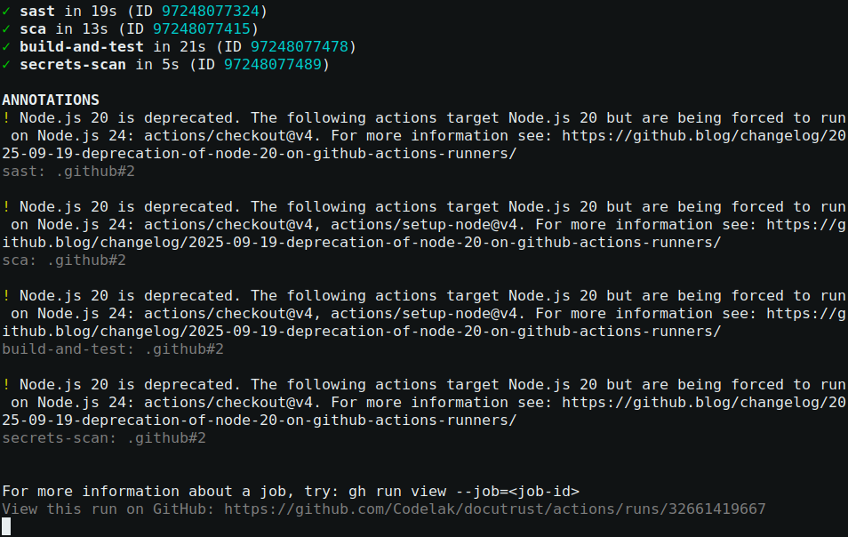
CI green on main with the new sca job
Figure 15 — real gh run view of a main run (all four jobs: build-and-test, sast, secrets-scan, sca — green). On your fork, substitute your own latest run ID from gh run list.
Troubleshooting.
- The sca job fails with “no new dependencies” never printed — the diff failed: git show origin/main:package.json needs the main branch present in the checkout. The job uses fetch-depth: 0 for exactly this reason.
- Your new dependency is healthy but the gate fails with “no score obtainable” — scorecard could not find the package’s source repo (or it is not on GitHub). Fail-closed is deliberate: an unscoreable dependency needs maintainer documentation, per policy §5.
- jq: command not found on your laptop — install it; GitHub runners ship it preinstalled.

Stage 10 — Prove the gate blocks (Deliverable 9)
Problem: a gate that has never failed anything is a rumor. The brief demands proof: a deliberately risky dependency, added on a branch, must be blocked before it could reach main. Approach: seed one, let the gate do its job, read the failure, revert.
Pick the seed: left-pad@1.3.0 — a real package with a famous story (the 2016 npm incident that broke the ecosystem), an archived repository, and a real scorecard score we can measure:
scorecard --npm left-pad --format json | jq -r .score
# 4.2 <- below the 5/10 threshold, and npm audit passes it (no CVEs!)
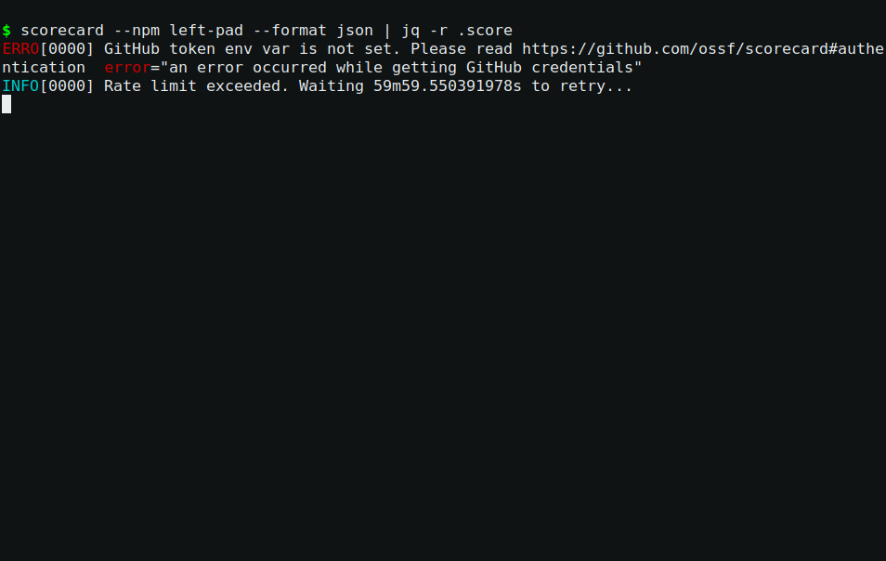
The seed’s measured score
Figure 16 — scorecard --npm left-pad = 4.2. Check it yourself — the score drifts with upstream repo state, which is precisely why the policy says “≥5” rather than quoting a number forever.
That last part is the point: left-pad has no known CVEs, so the npm audit gate will let it through. Only the scorecard gate can catch it — an abandoned repository is exactly the risk class the CVE database cannot see.
On a branch (guarded — re-running the block while the branch already exists is a normal failure you can skip with one word):
git branch -D seed-risky-dep 2>/dev/null && echo "old branch removed"
git checkout -b seed-risky-dep
npm install left-pad@1.3.0 --save-exact
git add package.json package-lock.json
git commit -m "seed risky dependency"
git push origin seed-risky-dep
gh pr create --title "Seed risky dependency (left-pad) — SCA gates must block" --body "Intentional seed: left-pad has no CVEs (npm audit passes) but scores 4.2/10."
(The --title isn’t optional polish: PR titles are what you’ll grep for in run lists afterwards.)
CI runs on the PR. The sca job’s log:
npm audit gate (policy §1) -> found 0 vulnerabilities (passes!)
Scorecard gate: scoring new dependencies:
- left-pad
FAIL left-pad — score 4.2 below threshold 5 (policy §5)
scorecard gate FAILED — docs/project-2/sca-policy.md §5
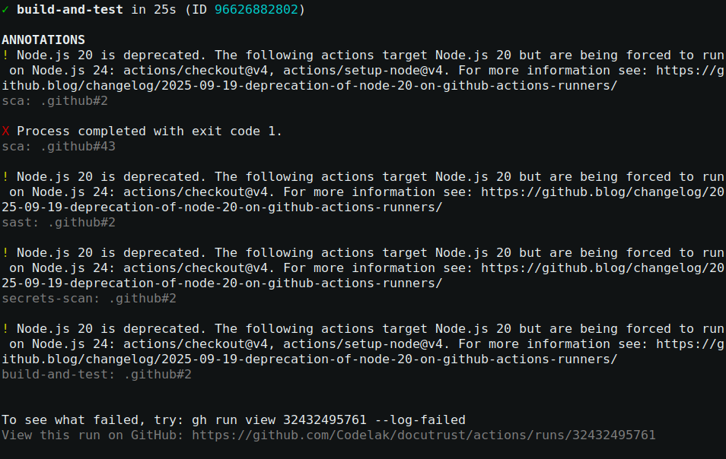
The seeded PR blocked
Figure 17 — real run view of the seeded PR (the original one: run 32432495761): X Process completed with exit code 1 on the sca job, while npm even added corroboration at install time (npm warn deprecated left-pad@1.3.0). Open the failure detail with gh run view 32432495761 --log-failed on the exact run you just made.
Then the professional close-out — never hardcode the PR number; ask GitHub (a re-run in the same repo gets a fresh number, and PRs don’t restart at 1):
PR=$(gh pr view --json number -q .number)
gh pr close "$PR" --comment "Blocked by the scorecard gate (4.2 < 5). Intentional seed."
gh pr delete "$PR" --yes
git checkout main
git branch -D seed-risky-dep
git branch -r --merged | grep seed-risky-dep && git push origin --delete seed-risky-dep || true
The seeded dependency never touched main. The gate proved itself.
Troubleshooting.
- The PR run is green when you expected red — did npm install actually add the package, and does the branch’s package.json differ from main? The gate scores new names; a dependency that already existed on main is deliberately not re-scored.
- The sca job fails at npm ci, before the gates — you seeded a scoped @docutrust/* name; the Stage 6 .npmrc defense refused it at install. That is the other gate working. Use either failure mode for your seed — both are legitimate demonstrations.
- gh pr create says a PR already exists for this branch — a previous run was interrupted before the close-out. Finish the close-out block first; never delete a live PR by hand — close and delete it through gh pr.

Stage 11 — The report (Deliverable 10)
Problem: all of this has to hand over to Project 3 with a clean, current baseline. Approach: one report — docs/project-2/final-findings-report.md — that any engineer can read in five minutes: what was found, what was fixed, what is enforced, and the exact dependency list Project 3 starts from. Fill the table from your lockfile, not mine — versions drift, and a report that guesses is worse than a report that takes one minute to verify:
npm ls --depth=0 2>/dev/null | head -8
Package | Version | Pin | Audit | Scorecard
express | 4.22.2 | ^4.19.2 | clean | 8.2
pg | 8.23.0 | ^8.13.0 | clean | 5.7
zod | 3.25.76 | ^3.23.8 | clean | 5.3
lodash | 4.18.1 | exact | clean | 6.8
@jazzer.js/core (dev) | 4.0.0 | ^4.0.0 | clean | 6.0
npm audit → 0 vulnerabilities. That is the baseline Project 3’s runtime conclusions will stand on.

Deliverable map
Stage | Deliverable | Evidence
2 | 1 — full SCA scan, real output | evidence/project-2/10-sca-baseline/
3 | 2 — transitive review, specific packages named | evidence/project-2/11-transitive-review/
4 | 3 — lodash remediated, rescan clean, smoke-tested | evidence/project-2/12-lodash-fix/
5 | 4 — SCA policy, checkable thresholds | docs/project-2/sca-policy.md
6 | 5 — confusion defense configured + demonstrated | evidence/project-2/13-scope-demo/
7 | 6 — typosquat review, genuine findings | evidence/project-2/14-typosquat/
8 | 7 — scorecard run, every check read | evidence/project-2/15-scorecard/
9 | 8 — scorecard policy enforced in CI | evidence/project-2/16-ci-gates/
10 | 9 — seeded dep blocked before merge | evidence/project-2/16-ci-gates/run-seeded-PR-FAILED.txt
11 | 10 — final dependency risk report | docs/project-2/final-findings-report.md
1–11 | real terminal screenshots | docs/project-2/images/ (Figures 1–17)
The paths above are this repo’s committed reference evidence. On project2-starter those dirs don’t exist — that’s intentional: your evidence is the output you save with the redirects this guide marks (“save your evidence as you go”). Name your dirs the same way so your deliverable map matches this one.

What’s next
Project 3 (DAST/IAST/RASP) tests DocuTrust’s runtime behavior. Its conclusions are only trustworthy against a clean, current, enforced dependency baseline — which is what this project just produced and what the report hands over.

