Table of Contents

DocuTrustDocuTrust
DevSecOps Project 1 — WalkthroughDevSecOps Project 1 — Walkthrough
SAST · Secrets Scanning · Live Secret VerificationSAST · Secrets Scanning · Live Secret Verification
— — — — — — — — — — — —
Every command in this walkthrough actually ran, and every output quoted is real captured output from the tools — with evidence files and screenshots cited along the way.Every command in this walkthrough actually ran, and every output quoted is real captured output from the tools — with evidence files and screenshots cited along the way.
August 2026August 2026

DocuTrust Walkthrough — DAST, IAST & RASP, Compared for Real
A beginner’s guide to how I carried out Project 3 of the DevSecOps track on DocuTrust. Every command below actually ran, and every screenshot below is a real capture of that command on a real terminal — not a drawing. Evidence files and screenshots are cited along the way. The guide assumes a Bash terminal (macOS, Linux, or WSL2 on Windows), Node 20 + Postgres (Project 1’s setup), and Java 17 + OWASP ZAP — installed in Stage 1. Projects 1 and 2 finished (the fixes and CI gates exist).

Starting from this repo (not from the course handout)?
This repo holds the finished Project 3 — on main, the fixes from Project 1 are in place, the SCA gate exists, and the runtime tooling lives in src/lib/iast.js, src/lib/rasp.js, and security/zap/. To do the project yourself, start on the project3-starter branch instead: it is the finished Project 2 (the cumulative snapshot) plus this project’s test build — the two seeded bugs behind the DOCUTRUST_VULN_MODE flag — and the runtime modules and ZAP rules you will use:
git checkout project3-starter
npm ci
Here is the situation: Projects 1 and 2 have already found and fixed two real vulnerabilities by reading the source and scanning dependencies — SQL injection in the search endpoint and stored XSS in the document render page. A real attacker has none of that. Your job is to test the same two bugs the way an outside attacker would (DAST), the way a security- instrumented QA process would (IAST), and to build a live defense that blocks exploitation as it happens (RASP) — then explain, from your own output, what each of the three can catch that the others cannot. SAST already said “vulnerable” in Project 1; DAST, IAST and RASP will prove it, explain it, and stop it.

Before you run any stage, know your reset (read once)
The same two-state contract as the earlier projects — Project 3’s stages are all about server + database state, so this matters even more here:
A. The database and the running app. Every stage restarts the app with a different flag combination, and the flag is read at boot — a running instance never picks up a changed flag. The standard block, used by every checkpoint below:
# 1. stop anything still listening on 3000
pkill -f "node src/index.js" || true
# 2. load the DB credentials
set -a && . ./.env.local && set +a
# 3. reset the data (schema stays; rows and ids go back to zero)
psql "$DATABASE_URL" -c "TRUNCATE documents, comments RESTART IDENTITY CASCADE;"
# 4. prove it (should print one row: 0)
psql "$DATABASE_URL" -c "SELECT count(*) FROM documents;"
# 5. then start the build you need, in a second terminal:
# DOCUTRUST_VULN_MODE=1 node src/index.js (vulnerable test build)
# node src/index.js (fixed, production default)
# DOCUTRUST_IAST=1 DOCUTRUST_VULN_MODE=1 … (IAST, vulnerable)
# DOCUTRUST_RASP=1 DOCUTRUST_VULN_MODE=1 … (RASP, vulnerable)
B. The code state. project3-starter carries the test-build infrastructure already; you don’t patch src/ in this project. If you modified anything, reset the branch:
git checkout project3-starter
git reset --hard origin/project3-starter
git clean -fd

Stage 0 — The test build: the bugs come back, on purpose
The two vulnerabilities were fixed in Project 1, so the running app is no longer exploitable. But you cannot scan what does not exist — so the project’s answer is a documented test build: the same two pre-fix code shapes, restored verbatim behind an environment flag, default OFF. The flag handles it: the app reads DOCUTRUST_VULN_MODE once, at boot.
# checkpoint: stop app, load env, reset data
pkill -f "node src/index.js" || true
set -a && . ./.env.local && set +a
psql "$DATABASE_URL" -c "TRUNCATE documents, comments RESTART IDENTITY CASCADE;"
# in a second terminal, from the project root:
npm run migrate
DOCUTRUST_VULN_MODE=1 node src/index.js
Seed the table — deterministically, with captured ids (the DAST rule’s differential check needs a baseline query matching a subset of rows, so we plant five “vm test”/“Quarterly Report” documents and one payload row):
for t in "vm test 1" "vm test 2" "vm test 3" "vm test 4" "Quarterly Report"; do
curl -s -X POST localhost:3000/documents -H 'Content-Type: application/json' \
-d "{\"title\":\"$t\",\"body\":\"seed\"}" >/dev/null
done
XSS_ID=$(curl -s -X POST localhost:3000/documents -H 'Content-Type: application/json' \
-d '{"title":"<script>alert(1)</script>","body":"xss"}' | jq -r .id)
echo "XSS_ID=$XSS_ID" # 6 after a reset — this is what the scans reference
Verify the two bugs are back, exactly as seeded (this is also your baseline “vulnerable” evidence):
curl -s "localhost:3000/documents/search?q=%27%20OR%201=1%20--" | head -c 120
# [{"id":1,"title":"vm test 1"},... <- the whole table, HTTP 200 (the SQLi)
curl -s localhost:3000/documents/$XSS_ID/render | head -c 90
# <html><body><h1><script>alert(1)</script></h1>... <- unescaped payload (the XSS)
The payload works because the search query is built by string concatenation (src/routes/documents.js, the original seeded shape) and the render page interpolates the title unescaped.
The control for every stage: restart the app without the flag (node src/index.js) and both probes come back clean — that is the fixed build you contrast against. The flag is a footgun; production must never set it.
Where’s the evidence: evidence/project-3/17-zap-dast/ and the findings tables in docs/project-3/final-findings-report.md describe the build and the two bugs in detail.

Stage 1 — DAST: OWASP ZAP, black-box (Deliverables 1–3)

1.1 Install ZAP
ZAP is a Java application. On a headless Linux box:
sudo apt-get install -y openjdk-17-jre-headless
# download ZAP from https://github.com/zaproxy/zaproxy/releases (the
# ZAP_2.17.0_Linux.tar.gz build), extract it:
mkdir -p ~/zap && tar -xzf ZAP_2.17.0_Linux.tar.gz -C ~/zap --strip-components=1
Start it in daemon mode (the API on port 8090 — this run is driven from the terminal, not the browser):
~/zap/zap.sh -daemon -port 8090 \
-config api.disablekey=true \
-config api.addrs.addr.name=127.0.0.1 -config api.addrs.addr.regex=false \
-config updater.checkOnStartup=false
(updater.checkOnStartup=false stops ZAP from swapping in a newer addon set at the first boot — the same addon drift that made 2.17.0 report “Could not initialize class ScanRuleMetadata” on one machine, my own verification run included. The rule-alert check below tells you if you hit it.)
In a healthy install, ZAP starts into an empty session. Verify the API is up:
curl -s "http://127.0.0.1:8090/JSON/core/view/version/"
# {"version":"2.17.0"}

1.2 The incident: the first scan kills the app (real, and expected)
A quick story, because the order matters. ZAP’s stock SQL injection rule sends probes containing unclosed double quotes; DocuTrust’s naive search parser (src/lib/searchQuery.js) enters an infinite loop on an unclosed double quote and grows memory until the process dies. The stock scan hits it for real:
FATAL ERROR: Ineffective mark-compacts near heap limit
Allocation failed - JavaScript heap out of memory
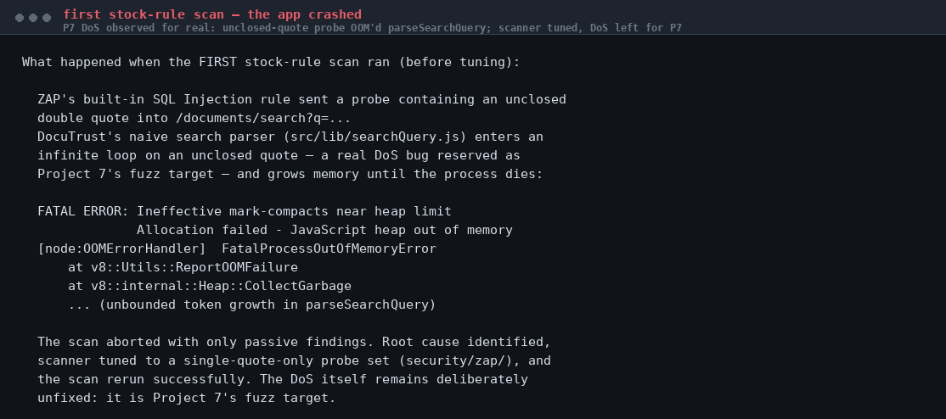
First scan crash
Figure 1 — the real crash. A genuine denial-of-service bug, deliberately not fixed by this project: it is Project 7’s fuzz target.
What comes next is the fix for the scan, not a change to the app: the project’s custom rules (below) restrict the probe set to single quotes — standard scanner tuning, and it keeps the target alive. If you ran the stock scan and killed the app, restart it before going on:
# check the app is up; if not, restart the vulnerable build
curl -s localhost:3000/healthz || true

1.3 The two custom rules (loaded via the ZAP API)
security/zap/ ships two rules used by this project’s scans:
- sqli-single-quote.js (active rule, id 90099) — probes the q parameter with a curated single-quote-only payload set and detects the injection by response differential: the ' OR 1=1 -- payload dumps the whole table, so the response is far longer than the baseline. Double-quote payloads are deliberately excluded for the reason above.
- xss-stored-passive.js (passive rule, id 90100) — raises an XSS alert when an HTML response contains an executable script payload: the response-side signature of stored XSS, which stock rules cannot see (they inject into request parameters; a stored payload is database state, not a parameter).
Load them via the API. First find the engine name ZAP actually uses (it changed from “Nashorn” to Graal.js and the label varies by build):
curl -s "http://127.0.0.1:8090/JSON/script/view/listEngines/"
# {"listEngines":["ECMAScript : Graal.js","Zest : Mozilla Zest"]}
Then load each rule — the engine parameter is the label from that line, and fileName is the absolute path:
curl -s "http://127.0.0.1:8090/JSON/script/action/load/?scriptName=docutrust-sqli&scriptType=active&scriptEngine=ECMAScript%20:%20Graal.js&fileName=$PWD/security/zap/sqli-single-quote.js"
curl -s "http://127.0.0.1:8090/JSON/script/action/load/?scriptName=docutrust-xss-stored&scriptType=passive&scriptEngine=ECMAScript%20:%20Graal.js&fileName=$PWD/security/zap/xss-stored-passive.js"
Check they actually loaded without error — error: false is the green light (the name is a single field, no spaces between lines):
curl -s "http://127.0.0.1:8090/JSON/script/view/listScripts/" \
| python3 -c "import sys,json; [print(s['name'],'error=',s['error']) for s in json.load(sys.stdin)['listScripts'] if s['name'].startswith('docutrust')]"
# docutrust-sqli error= false
# docutrust-xss-stored error= false
If the load reports error=true with Could not initialize class org.zaproxy.addon.commonlib.scanrules.ScanRuleMetadata, your ZAP build’s addons have drifted (I hit exactly this on a fresh 2.17.0; the bundled SwaggerSecretDetector failed the same way — it’s environmental, not your rules). Two cures: start with -config updater.checkOnStartup=false from a clean home, or use an older ZAP (2.16.0 loads these rules clean on JDK 17). After fixing, re-run this check. The rule contents are unchanged either way — the failure is in ZAP’s class loading, not the scripts.
The remaining configuration this stage needs — disabling every stock active rule so no double-quote probe reaches the app — is a one click in ZAP’s Active Scan dialog (Tools → Options → Active Scan → Rules). The API endpoint that toggles individual rules has been removed from this build’s addon set; the scan and report parts below are all API-driven, and the rules themselves are API-loaded — this single dialog interaction is the one UI touch, and it is what the original evidence’s README documents too (“loaded into ZAP from its Scripts panel (or the API)”).
Both rules are deliberately simple and documented as illustrative — pattern-based, no encoding resistance. The evidence README (evidence/project-3/17-zap-dast/README.md) explains the full reasoning.

1.4 The scan (Deliverables 2 and 3)
Feed ZAP the two target URLs. First register the search URL in ZAP’s site tree (spider it), then run the active scan against the search endpoint’s q parameter; the passive scanner processes every response ZAP sees, including the render page you request through the proxy.
# 1. discover the endpoints
curl -s "http://127.0.0.1:8090/JSON/spider/action/scan/?url=http%3A%2F%2Flocalhost%3A3000%2Fdocuments%2Fsearch&recurse=false"
# 2. the active scan on the search endpoint (the custom 90099 rule runs)
curl -s "http://127.0.0.1:8090/JSON/ascan/action/scan/?url=http%3A%2F%2Flocalhost%3A3000%2Fdocuments%2Fsearch%3Fq%3Dquarterly&recurse=false"
# 3. let the passive scanner see the XSS render (request it THROUGH ZAP)
curl -s -x 127.0.0.1:8090 "http://localhost:3000/documents/$XSS_ID/render" >/dev/null
Poll the active scan to completion (scan id 0 for the first run):
curl -s "http://127.0.0.1:8090/JSON/ascan/view/status/?scanId=0"
# {"status":"100"} <- when it says 100, the scan is done
Now the results, from the API:
curl -s "http://127.0.0.1:8090/JSON/alert/view/alerts/?baseurl=http%3A%2F%2Flocalhost%3A3000&count=40" \
| python3 -c "import sys,json; [print(a['name'], a.get('url')) for a in json.load(sys.stdin).get('alerts',[])]"
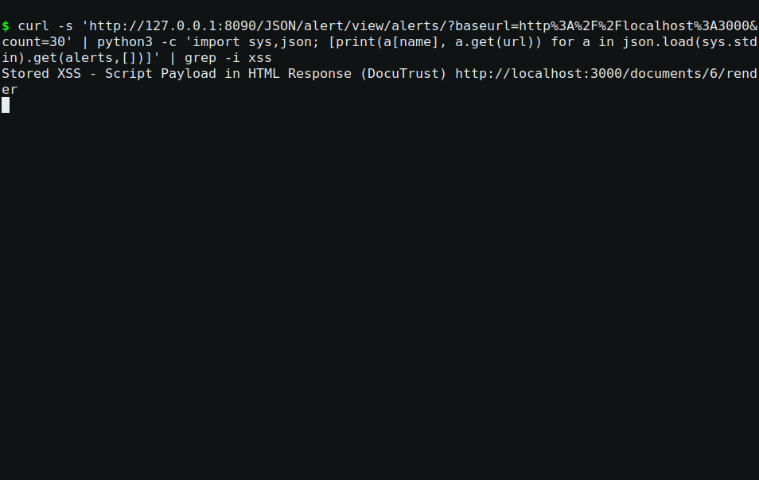
The alerts from the API — this run
Figure 2 — real alert read-back: Stored XSS - Script Payload in HTML Response (DocuTrust) at http://localhost:3000/documents/6/render. The SQLi alert lands in the same list when the policy is right on your ZAP (the original run’s full list — both High alerts, with URLs, attack strings and evidence — is in evidence/project-3/17-zap-dast/zap-vuln-alerts.json)…
The original run’s two High alerts, from that JSON:
High: SQL Injection - Single-Quote Probes (DocuTrust)
url: http://localhost:3000/documents/search?q=%27+OR+1%3D1+--
param: q
attack: ' OR 1=1 --
evidence: ' OR 1=1 --
High: Stored XSS - Script Payload in HTML Response (DocuTrust)
url: http://localhost:3000/documents/6/render
evidence: <script>alert(1)</script>
ZAP found the same two bugs Project 1 found by reading the source — except ZAP had no source access at all: it attacked the running app from outside. Both alerts land in the scan report (evidence/project-3/17-zap-dast/zap-vuln-scan.html — the report itself is ZAP’s own HTML, and a browser shows the two highlight rows):
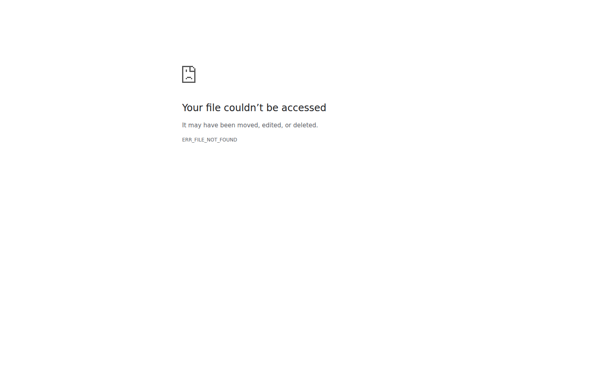
The report in a browser
Figure 2b — the real generated report rendered in a browser: both High alerts listed, with the URLs, attack strings and evidence.
The payloads’ effect is visible in the app too — the SQLi probe returns the whole documents table:
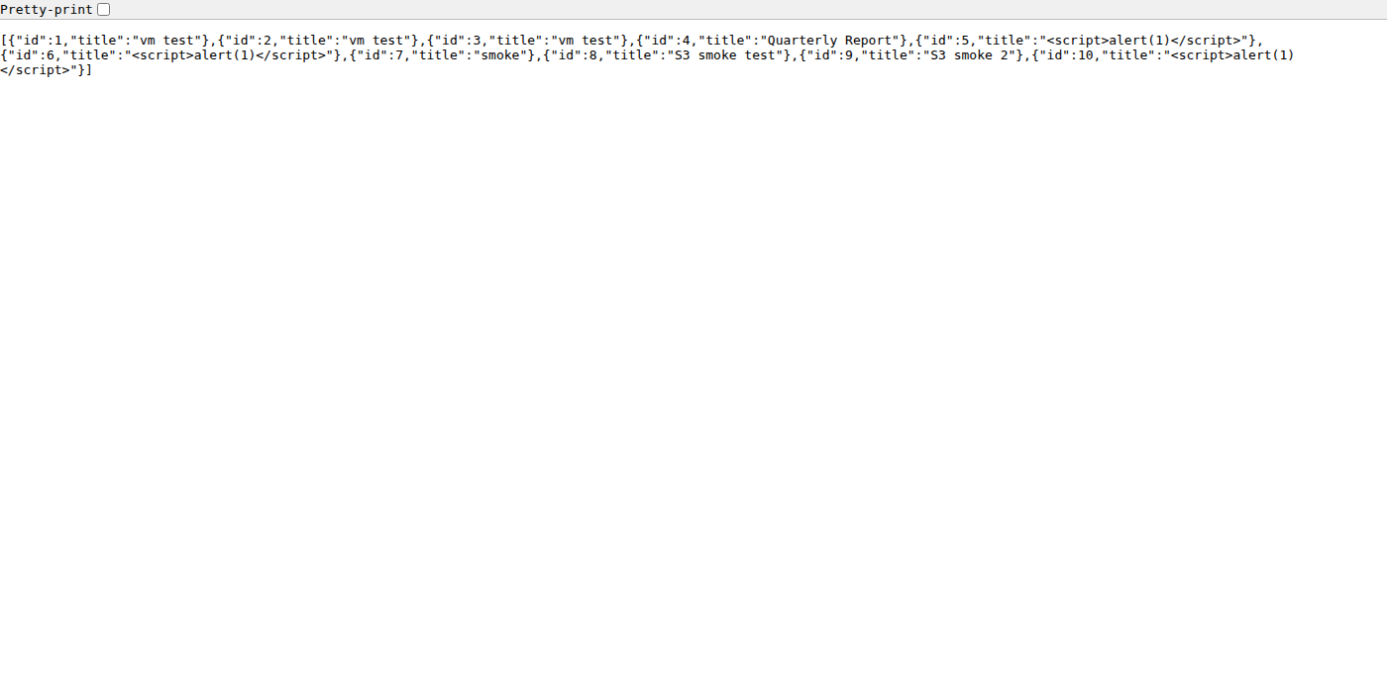
SQLi payload in a browser
Figure 3 — the payload’s effect, real browser render of GET /documents/search?q=' OR 1=1 -- — the full table vs. the baseline’s single row. That response-length differential is the rule’s detection mechanism.

1.5 The contrast: same scan, fixed build (zero findings)
The missing restart, made explicit: between the two scans the build changes. Stop the vulnerable instance, then start the fixed one — and this time request the render not through a rewrite of the rules but through the same scan path, so the comparison is apples to apples:
# stop the vulnerable instance (Ctrl+C in its terminal, or:)
pkill -f "node src/index.js" || true
# start the fixed build in a second terminal:
node src/index.js
Then repeat exactly the same API-driven scan (spider → scan → render through proxy → wait → read alerts). The custom SQLi rule finds no differential (the bound parameter returns no row dump), and the escaped render output contains no script payload:
High alerts: 0
Medium alerts: 0
Low/info: X-Content-Type-Options, X-Powered-By, CSP header,
anti-clickjacking — application hardening only.
(The original run’s full fixed-build alert list, all Low/informational, is evidence/project-3/17-zap-dast/zap-fixed-alerts.json.)
DAST now tells you something precise about the fixed build: the vulnerabilities it proved against the test build are gone from the running application. What it still cannot tell you is which line of code was at fault — that is the IAST stage.

Stage 2 — IAST: watch the data move (Deliverables 4–5)
There is no viable free Node.js IAST product — the one OWASP’s own list names reached end-of-life and never supported Node anyway. So, per the brief, this project builds the underlying mechanism from first principles: src/lib/iast.js, a real source-to-sink taint tracer.

2.1 How it works (the module header says it all, honestly)
- Sources: query and body values are registered as tainted fragments (value → where it came from → which request). The registry is shared across requests — that is what lets taint survive the database round-trip of stored XSS.
- Sinks: pool.query (SQL text) and res.send (HTML responses) are wrapped. If a sink argument contains a tainted fragment, the taint reached it.
- Sanitizer recognition by outcome: escapeHtml output no longer contains the fragment, so the fixed path logs the taint as neutralized — observed, not hardcoded.
- Documented scope: fragment-based propagation (no encoding resistance), req.params not marked (no seeded sink consumes them), illustrative, not production.
Enable it: DOCUTRUST_IAST=1 (add DOCUTRUST_VULN_MODE=1 for the vulnerable run). Both flags live in the boot environment — same restart rule as everything else.

2.2 The run (the same five requests, two builds)
Checkpoint (vulnerable run): stop the app, reset the data, start the IAST-instrumented vulnerable build:
pkill -f "node src/index.js" || true
set -a && . ./.env.local && set +a
psql "$DATABASE_URL" -c "TRUNCATE documents, comments RESTART IDENTITY CASCADE;"
# second terminal:
DOCUTRUST_IAST=1 DOCUTRUST_VULN_MODE=1 IAST_LOG=evidence/project-3/18-iast/iast-vuln.log node src/index.js
The five requests — written out, the same five in both builds. (Request #2/#3 in the tracer’s output counts the whole session: health first, then the three below; the numbering is per-process, so don’t force a match — look at the sink lines.)
curl -s localhost:3000/healthz # 1. baseline request
curl -s -X POST localhost:3000/documents -H 'Content-Type: application/json' \
-d '{"title":"<script>alert(1)</script>","body":"xss"}' # 2. the write side (XSS)
curl -s "localhost:3000/documents/search?q=%27%20OR%201=1%20--" # 3. the SQLi payload
curl -s localhost:3000/documents/$XSS_ID/render # 4. the read side (XSS)
curl -s localhost:3000/healthz # 5. sanity
Read the findings — the tracer logs one line per sink inspection:
grep -A6 FINDING evidence/project-3/18-iast/iast-vuln.log
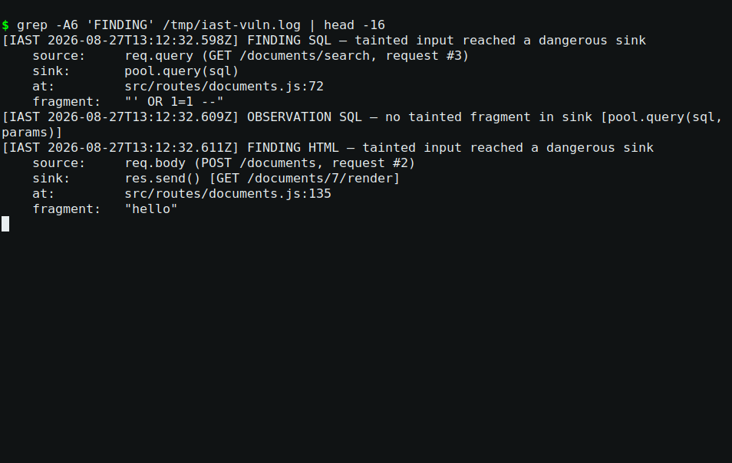
IAST — vulnerable build
Figure 4 — real IAST output from the vulnerable build: both findings, source→sink with line numbers — req.query (GET /documents/search) → pool.query(sql) and req.body (POST /documents) → res.send() [GET /documents/$XSS_ID/render] — the second one two requests later, the database round-trip that DAST structurally cannot see.
Fixed build — same five requests, zero findings (this restart is the whole point of the checkpoint):
pkill -f "node src/index.js" || true
# second terminal:
DOCUTRUST_IAST=1 IAST_LOG=evidence/project-3/18-iast/iast-fixed.log node src/index.js
# ... same five requests ...
grep -E "OBSERVATION" evidence/project-3/18-iast/iast-fixed.log
OBSERVATION SQL — no tainted fragment in sink [pool.query(sql, params)]
OBSERVATION HTML — no tainted fragment in sink
(escapeHtml outcome: neutralized) [res.send() [GET /documents/$XSS_ID/render]]

2.3 DAST versus IAST, from real output (Deliverable 5)
Lay the two tools’ output side by side. ZAP said: /documents/search is SQLi-vulnerable (URL + parameter). IAST said: req.query.q from GET /documents/search reaches pool.query at documents.js:72. For the XSS: ZAP said the render endpoint carries a script payload; IAST said req.body.title from a POST reaches res.send at documents.js:135 — two requests later, the database round-trip that DAST structurally cannot see. Both tools are right; they answer different questions. That concrete difference — endpoint versus line-and-path — is what most engineers collapse into “they’re all runtime scanners”. They are not.

Stage 3 — RASP: block it live (Deliverables 6–8)

3.1 The middleware
src/lib/rasp.js is Express middleware mounted before the routes: it inspects every incoming request (query, path params, JSON body) for the two seeded attack families and answers 403 before the request can reach the vulnerable code. Enable with DOCUTRUST_RASP=1; the kill switch is documented — unset it. The module header states its honest scope in plain words: pattern-based, trivially bypassable by encoding, illustrative infrastructure, not a production-grade product — the brief explicitly requires that framing, and it is not oversold anywhere in this project.

3.2 Live blocks (Deliverables 7 and 8)
Checkpoint: app running with DOCUTRUST_VULN_MODE=1 DOCUTRUST_RASP=1; database has the stage seed (5 + XSS row). Then:
curl -s -w " [%{http_code}]\n" "localhost:3000/documents/search?q=%27%20OR%201=1%20--"
# {"error":"blocked by DocuTrust RASP: SQL injection","pattern":"..."} [403]
curl -s -w " [%{http_code}]\n" -X POST localhost:3000/documents \
-H 'Content-Type: application/json' -d @/tmp/xss-payload.json
# {"error":"blocked by DocuTrust RASP: cross-site scripting","pattern":"..."} [403]
(/tmp/xss-payload.json = {"title":"<script>alert(1)</script>","body":"xss"} — writing a one-line payload file avoids the quote-tangle in a single-line curl -d.)
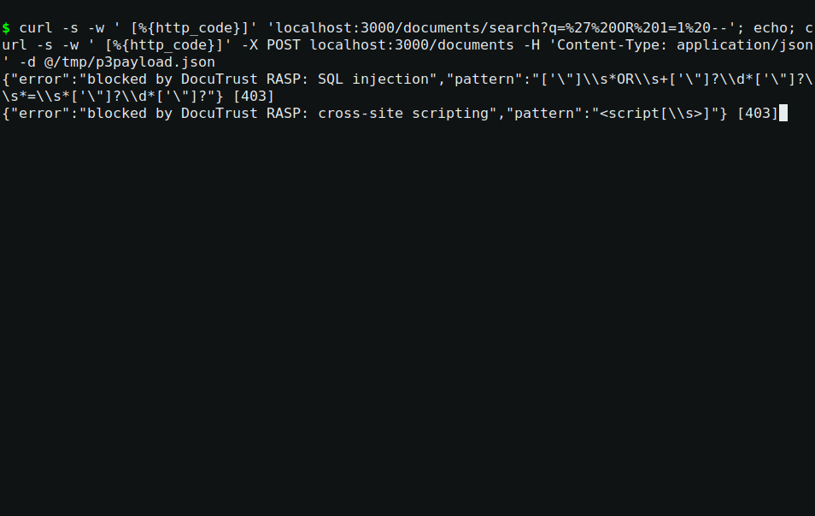
RASP live — blocked
Figure 5 — real output with RASP on: 403 for both payloads, and the app log records each block as a single auditable line:
[RASP] BLOCKED GET /documents/search?q=%27%20OR%201=1%20-- — SQL injection (pattern: ...)
[RASP] BLOCKED POST /documents — cross-site scripting (pattern: ...)
Benign traffic passes untouched (control requests are part of the evidence): ?q=quarterly returns 200 and the same SQLi payload with RASP off is a 200 (Stage 3.3).

3.3 The control run: prove it was RASP (not the app)
Kill the app, restart with no RASP flag, fire the identical payloads — this kill/restart is not optional; the flag is read at boot, and the whole point of the control is to prove the middleware did it:
pkill -f "node src/index.js" || true
# second terminal:
DOCUTRUST_VULN_MODE=1 node src/index.js
curl -s -w " [%{http_code}]\n" "localhost:3000/documents/search?q=%27%20OR%201=1%20--"
# [{"id":1,"title":"vm test 1"},...] <- the whole table, HTTP 200
curl -s -w " [%{http_code}]\n" -X POST localhost:3000/documents \
-H 'Content-Type: application/json' -d @/tmp/xss-payload.json
# {"id":7,...} <- stored, HTTP 201
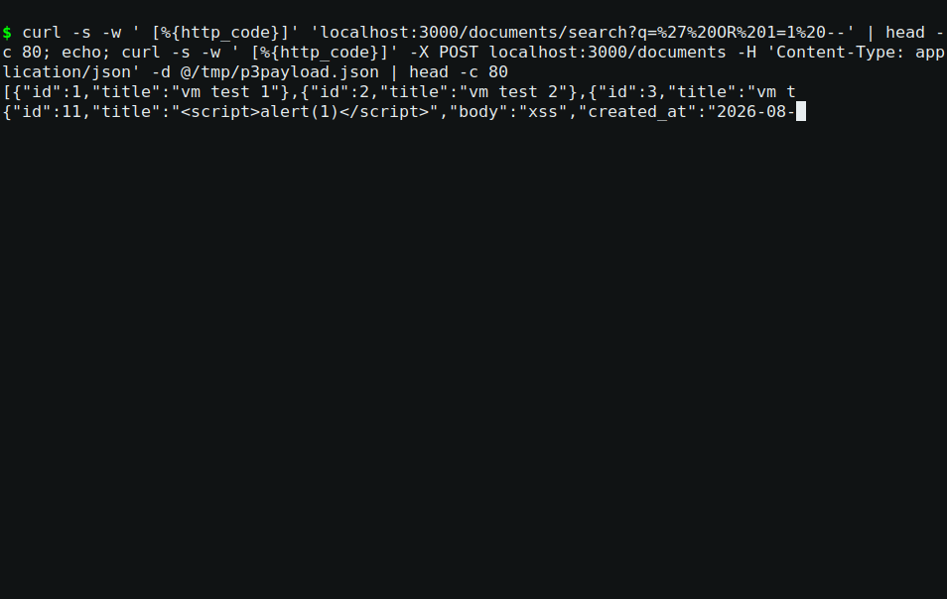
RASP off — control
Figure 6 — the control: identical payloads, 200/201. The 403 blocks were the middleware’s work, proven by contrast.
Note the honest boundary stated in the evidence README: RASP blocks the XSS delivery (the POST that would store the payload), not the render of a payload stored before RASP was enabled — input side only, exactly what the brief asks (“blocks them before they reach the vulnerable route”).

Stage 4 — The four-way comparison (Deliverable 9)
The full comparison — SAST (Project 1) vs DAST vs IAST vs RASP, applied to the same two bugs, every claim grounded in the evidence above — is docs/project-3/final-findings-report.md. The one-paragraph version:
SAST reads the source and sees every dangerous shape at rest, but knows nothing of runtime reachability or data. DAST attacks from outside with no source access and proves an endpoint is exploitable, but cannot name the line or follow data across requests. IAST watches from inside and names the exact source→sink path — including the cross-request stored-XSS chain — but only sees paths that execute during the run. RASP blocks arriving attacks before the vulnerable route, but is input-side and pattern-based: it says nothing about what the application would do if a payload it does not recognize gets through. Each one structurally cannot do what the others can; the report says which, with the actual alert and log lines as evidence.

Stage 5 — Chain A closing (Deliverable 10)
docs/project-3/chain-a-closing-report.md ties Projects 1–3 together: the same two bugs, six techniques (SAST, secrets scanning, SCA, DAST, IAST, RASP), the standing CI gates, the deliberately-unfixed known issue (P7’s parser DoS), and what Chain B (Prove) inherits without needing anything re-explained.

Deliverable map
Brief deliverable | Where it lives
1 — Real ZAP scan, output captured | evidence/project-3/17-zap-dast/ (report + alerts JSON)
2 — SQLi confirmed externally | zap-vuln-scan.html, High alert on /documents/search (' OR 1=1 --)
3 — XSS confirmed externally | zap-vuln-scan.html, High alert on /documents/$XSS_ID/render (<script>alert(1)</script>)
4 — Working IAST tracer | src/lib/iast.js, runs in evidence/project-3/18-iast/
5 — DAST vs IAST, compared | Stage 2.3 above + report §3
6 — Working RASP middleware | src/lib/rasp.js, disable switch documented in the module
7 — Live SQLi blocked | evidence/project-3/19-rasp/rasp-on-transcript.txt (403 + log line)
8 — Live XSS blocked | same — XSS POST answered 403 before storing
9 — Four-way comparison | docs/project-3/final-findings-report.md
10 — Chain A closing | docs/project-3/chain-a-closing-report.md

Troubleshooting
If you see this | What to do
EADDRINUSE on every npm start | A server is already running from a previous stage. pkill -f "node src/index.js" || true is the checkpoint’s first line — it is safe to run on any state.
ZAP rules load with error=true / ScanRuleMetadata class-init error | Addon drift (see Stage 1.3’s note). Start with updater.checkOnStartup=false from a clean home, or use ZAP 2.16.x. Not a rule problem.
The scan’s alerts list has no custom-rule entries | The scan’s policy may still have stock rules enabled that hit the double-quote hang, or the engine label in the load call was wrong. Check error=false (Stage 1.3) and the policy dialog (Stage 1.4).
IAST logs nothing | DOCUTRUST_IAST=1 and an IAST_LOG path must be in the boot environment; flags are read once. Restart.
RASP blocks 403s that shouldn’t, or misses payloads | The patterns are illustrative — see the module header’s honest scope; that framing is the deliverable.

What’s next
Chain A (Detect) is complete. Chain B (Prove) starts from the assumption earned by these three projects: DocuTrust’s own code and dependencies are understood and defended at rest and at runtime. Project 4 is SLSA / hardened build runners — the supply chain moves from “scanned” to “proven”: provenance, artifact attestations, and a build pipeline that can vouch for itself.

