# Guide for People who have Learning Disabilities

This guide describes accessibility features built into Windows and Microsoft Office, as well as different types of [assistive technology products](http://www.microsoft.com/en-us/Accessibility/assistive-technology-partners) that are designed for individuals who have learning disabilities. Note that some sections of this guide may be useful to individuals with different types of disabilities such as vision or cognitive.

Microsoft wants to provide the best possible experience for all our customers. If you have a disability or have questions related to accessibility, please contact the [Microsoft Disability Answer Desk](https://support.microsoft.com/en-us/accessibility/disability-answer-desk) for technical assistance. The Disability Answer Desk support team is trained in using many popular assistive technologies and can offer assistance in English, Spanish, French, and American Sign Language. Please go to the Microsoft Disability Answer Desk site to find out the contact details for your region. If you are a government, commercial, or enterprise user, please contact the [Enterprise Disability Answer Desk.](https://support.microsoft.com/en-us/accessibility/enterprise-answer-desk)

At Microsoft, our mission is to empower every person and organization on the planet to achieve more. We are committed to delivering great experiences to people with disabilities. If you have feedback to offer, or requests to make of us, we encourage you to let us know through the [Microsoft Accessibility Forum](https://microsoftaccessibility.uservoice.com/forums/307429-microsoft-accessibility-feedback). If you are looking for information on accessibility in education, please visit the Microsoft Education’s [Accessibility tools: Meeting the needs of diverse learners](https://education.microsoft.com/gettrained/accessibility) course.

## In this Guide:

**Setup Accessibility Options in Windows**

**Make Accessible Documents with Office**

**Use Features in Office**

**Browse the Accessibility Features of Edge and Internet Explorer**

**Find Assistive Technology for People who have learning disabilities**

## Setup Accessibility Options in Windows

**Ease of Access** is a location where you can set up accessibility settings and programs available in Windows.

[Learn more about Ease of Access](https://support.microsoft.com/en-us/help/17180/windows-10-make-your-pc-easier-to-use)

### Turn on Ease of Access options

With Windows you can access commonly used accessibility options right from the sign-in screen. Press the **Windows Logo Key** Start logo icon+ **U** to access the **Ease of Access** settings at the sign-in screen. On many keyboards, the Windows Logo Key is located on the bottom row of keys, to the left or right of the **Alt** key. There you can turn on or off **Narrator**, **Magnifier**, **On-Screen Keyboard, High Contrast, Sticky Keys,** or **Filter Keys**.

Caption 1: Ease of Access options on the Windows sign-in screen

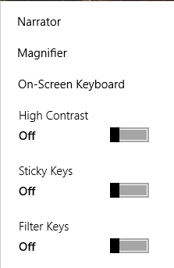

After you log on, you can open Ease of Access settings by pressing the **Windows Logo Key** Windows logo key icon+ **U.**

To open Ease of Access settings on a touch-enabled device, swipe in from the right edge of the screen and select **All Settings** > **Ease of Access**.

#### Hear text read aloud with Narrator

Some users may prefer text read aloud to them. **Narrator** is the built-in screen reader that reads text on your screen aloud. To start or stop **Narrator**, press the **Windows Logo Key**Windows logo key icon + **Enter**. On Windows Mobile devices, press **Windows Logo Key Image of Windows Logo** + **Volume UP** key to toggle **Narrator** on/off.

[Learn more about Narrator](https://support.microsoft.com/en-us/help/22798/windows-10-narrator-get-started)

*Caption 2: Ease of Access settings with Narrator section selected.*

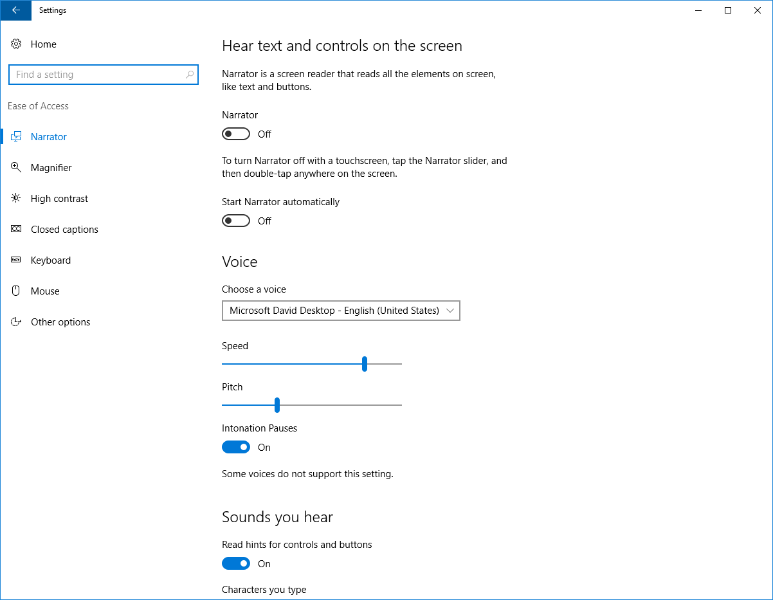

#### Reduce visual distractions in Ease of Access

To reduce distractions in Windows you can change whether animations or the Windows background are displayed. To do so, press **Windows Logo Key The Windows Logo** + **U** to open the **Ease of Access**. Then select **Other options**. You can also use darker and larger visual feedback for when you touch your screen.

*Caption 3: An example of some visual and touch options in Ease of Access*

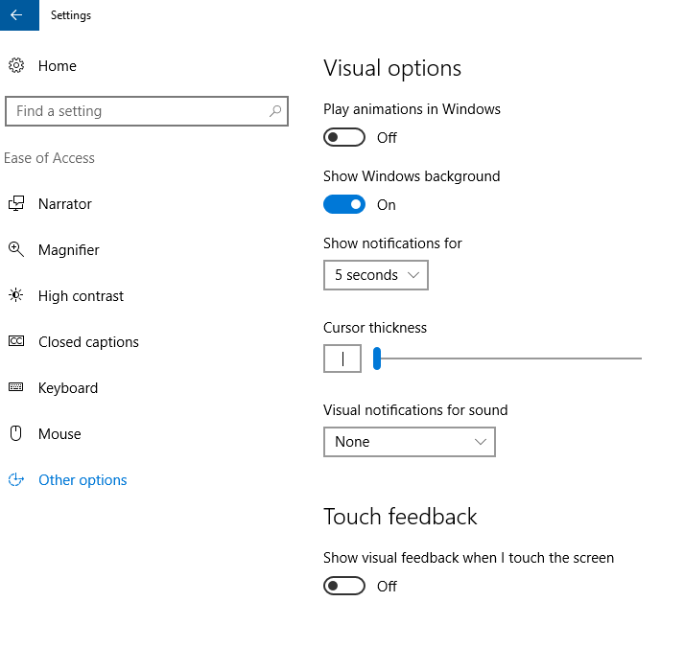

#### Get Notifications when you turn Settings on

To get a warning message or sound from features such as **Sticky Keys**, you can go to **Ease of Access.**

1. Press the **Windows Logo Key ""** + **U**
2. Select **Keyboard**.
3. In the **Other Settings** section toggle on or off these features:

* Have keys make sounds for when a setting is turned on or off with a keyboard shortcut
* Displaying a warning message for when a setting is turned on or off with a keyboard shortcut

### Use the Touch keyboard

The Touch keyboard has **Word Prediction** and **Handwriting**, which can be useful for interacting with a touch device.

#### Word Prediction

As you type on the keyboard suggested words will show up at the top of the keyboard. Use this tool to find the words you are looking for.

1. In the notification area select **Touch keyboard** .

#### Handwriting

The **Handwriting** option lets you write with a stylus (such as a Surface Pen) or your finger. That option can also be a good tool for learning cursive or signatures.

1. In the notification area select **Touch keyboard** .
2. Choose the **Handwriting**  option.

*Caption 4: An example of the Handwriting feature on the Touch keyboard.*

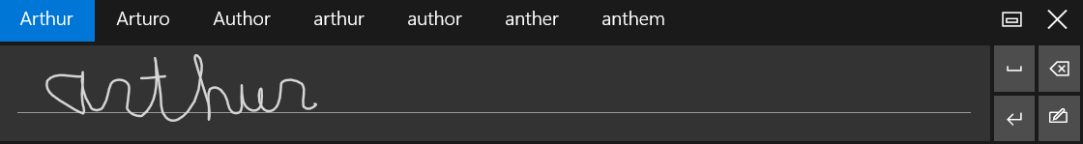

[Learn more about touch keyboard](https://support.microsoft.com/en-us/instantanswers/cb27c627-aca5-db03-1f8f-f3833aab8757/open-the-touch-keyboard)

### Use Speech Recognition

Windows Speech Recognition allows you to dictate text instead of typing on a keyboard. Press the **Windows Logo Key** "" and then type **Windows Speech Recognition** and select it from the results. Complete the **Set up Speech Recognition** tutorial.

*Caption 5: You can train your computer to recognize your voice once the setup tutorial is complete.*

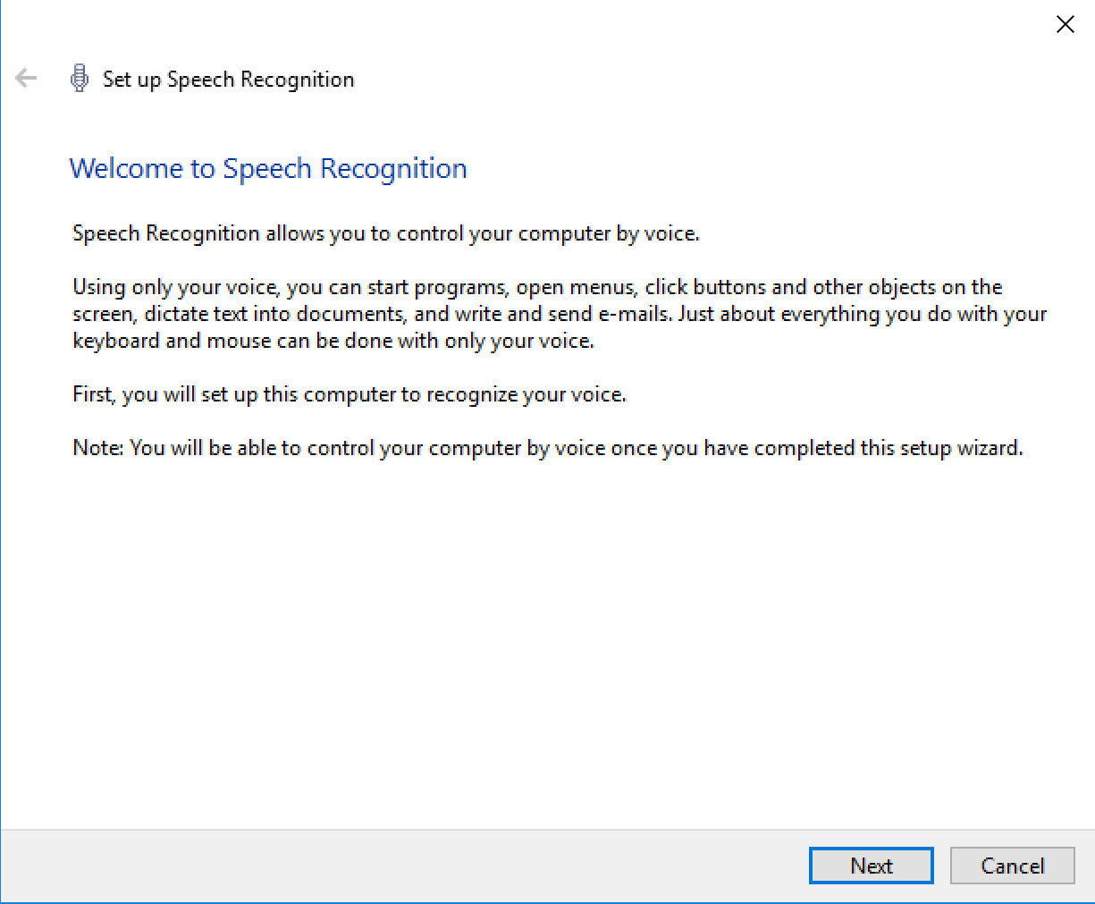

Additionally, you can press the **Windows Logo Key ""**, and type **Control Panel** then select it from the list of results. Then select **Ease of Access** > **Speech Recognition** to get additional configuration options for speech recognition.

[Equal Entry video on Using Cortana and Speech Recognition Together on Windows 10](https://www.youtube.com/embed/xuiKfUgEvfo?autoplay=1)

[Learn more about Speech Recognition](https://support.microsoft.com/en-us/help/17208)

[Learn commands for Windows Speech Recognition](https://support.microsoft.com/en-us/help/12427/windows-speech-recognition-commands)

### Additional Options in Ease of Access Center

For additional customization options, you can navigate to the **Ease of Access Center**.

1. Press **Windows Logo Key ""**
2. Type **Ease of Access Center** and select it from the results.

### Customize sign-in settings

You can customize sign-in settings, so that accessibility features start automatically when you sign in, after you sign in, or both. To customize sign-in settings:

1. Press **Windows Logo Key** Image of Windows Logo to open **Start**.
2. Type **Ease of Access Center** and select **Ease of Access Center** from the results.
3. Select **Change sign-in settings**.
4. Select the checkboxes for the options you would like to use and then select **OK**.

*Caption 6: A list of sign-in settings you can change in the Ease of Access Center.*

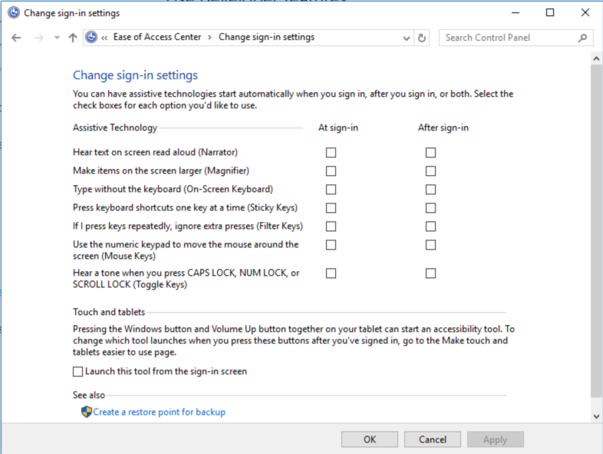

## Make Accessible Documents with Office

Built-in features in Microsoft Office can help you make your documents, spreadsheets, and presentations accessible to individuals who have learning disabilities. For more information on how to make your content accessible, please visit the [Office Accessibility Center](https://support.office.com/en-us/article/Office-Accessibility-Center-ecab0fcf-d143-4fe8-a2ff-6cd596bddc6d?ui=en-US&rs=en-US&ad=US) and [Accessibility in Office 2016 and Windows 10](https://support.office.com/en-US/article/Accessibility-in-Office-2016-and-Windows-10-5df36873-d574-4d07-b21d-2dc4e61384ac). Check back regularly as we frequently add new articles and product tutorials.

### Accessibility Checker

Word, Excel, PowerPoint, and OneNote include an **Accessibility Checker** that identify some content that might be inaccessible to individuals with disabilities. You can use the **Accessibility Checker** while you author to inspect errors as they occur and learn how to fix issues.

**To Open the Accessibility Checker:**

1. Open **File** (**Alt** + **F**).
2. Select **Info**.
3. Select **Check for Issues**.
4. Select **Check Accessibility**.

*Caption 7: An example of some issues found in the Accessibility Checker.*

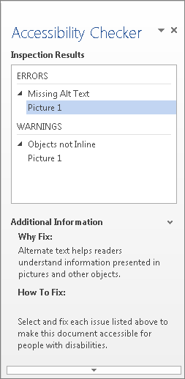

[Learn more about the Accessibility Checker](https://support.office.com/en-us/article/Use-the-Accessibility-Checker-on-your-Windows-desktop-to-find-accessibility-issues-A16F6DE0-2F39-4A2B-8BD8-5AD801426C7F?ui=en-US&rs=en-US&ad=US)

[Learn more about the Accessibility Checker on the Mac](https://support.office.com/en-US/article/Use-the-Accessibility-Checker-on-your-Mac-to-find-and-resolve-accessibility-issues-3b84295e-d55b-49f1-b443-523ec45a5232?ui=en-US&rs=en-US&ad=US)

## Use Features in Office

Microsoft Office comes with built-in features designed for individuals who have learning disabilities. You can also customize options in Office to meet your individual needs and preferences.

### Use the Speak Command for Text-to-speech

The **Speak** command in Office uses text-to-speech (TTS), which is the ability of your computer to play back written text as spoken words. Depending upon your configuration and installed TTS engines, you can hear most text that appears on your screen in Word, Outlook, PowerPoint, and other programs in Microsoft Office.

You can add the **Speak** command to the **Quick Access Toolbar**.

1. Open **File (Alt** + **F)**.
2. Select **Options**.
3. Select **Quick Access Toolbar**.
4. Choose **Commands Not in the Ribbon**.
5. Select **Speak**.
6. Select **Add**.
7. Select **OK**.

*Caption 8: Word Options dialog box where the Speak command is selected to add to the Quick Access Toolbar.*

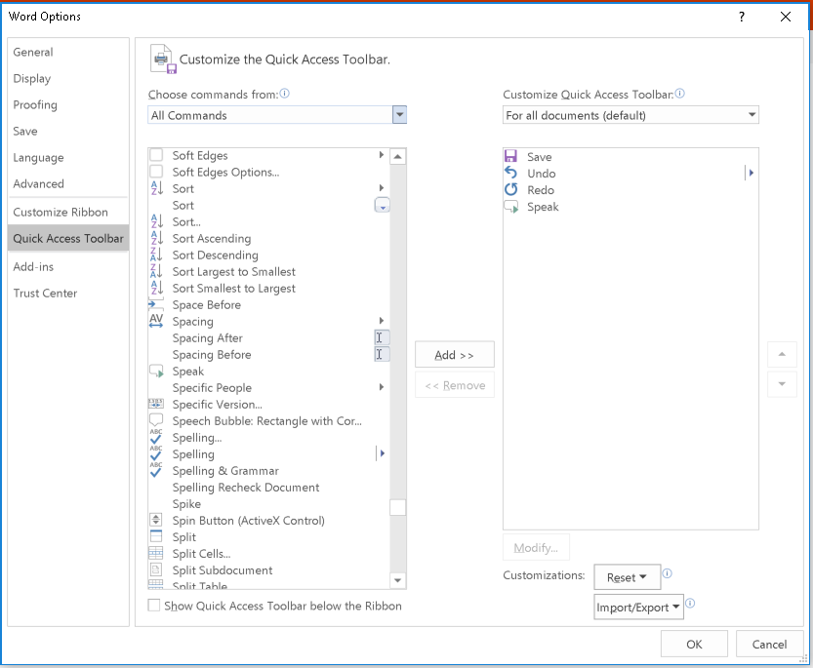

Now, you can quickly hear selected text.

1. Select the text in the document you want to hear.
2. Select the new **Speak** button in the **Quick Access Toolbar**.

*Caption 9: Quick Access Toolbar with the Speak button activated.*

Here is the Quick Access Toolbar in Word 2016 with the Speak command selected.  

[Learn more about text-to-speech](https://support.office.com/en-us/article/Accessibility-features-in-Office-2016-be8d4909-d025-4049-9e1c-ac608ec53edb?ui=en-US&rs=en-US&ad=US)

### Check Spelling and Grammar in Office

All Microsoft Office programs can check the spelling and grammar of your files. In Microsoft Word 2016, start the **Spelling and Grammar** checker by selecting **Review** > **Spelling and Grammar**.

Additionally, you can go to **File** > **Options** > **Proofing** to customize your options for **Spelling and Grammar** in Microsoft Office programs.

*Caption 10: Screen shot of Spelling and Grammar Proofing options in Word 2016*

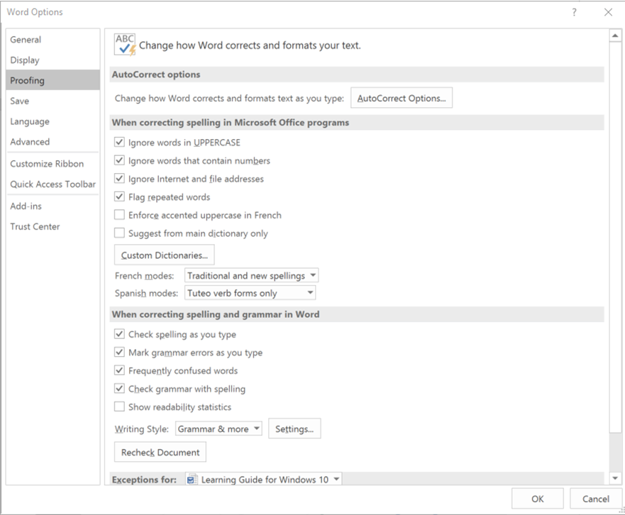

### Use Editor in Office

**Editor** is a personal writing assistant that helps you write better documents and e-mails. It gives you spelling and grammar suggestions by using different visual cues for certain kinds of edits. **Editor** uses a red squiggle for suggested spelling edits, a blue double underline for grammar, and a gold dotted line for writing style.

*Caption 11: Here is an example of a spelling edit in Editor.*

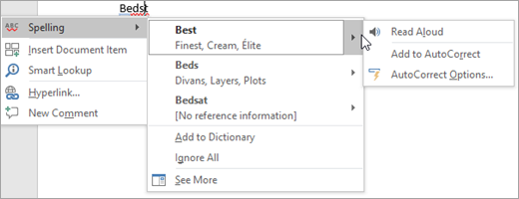

[Learn more about Editor in Office](https://support.office.com/en-us/article/Editor-your-writing-assistant-91ecbe1b-d021-4e9e-a82e-abc4cd7163d7?ui=en-US&rs=en-US&ad=US)

### Researcher in Microsoft Word

**Researcher** is a unique resource in Microsoft Word that helps you find reliable sources and content for your documents. This feature uses **Bing** to help pull appropriate content from the web. To use Research and add content with citations to your document:

1. On the **References** tab, in the **Research** group, choose **Researcher**.
2. In the search box, type a keyword for the topic you are researching and press **Enter**.
3. Choose a topic in the **Results** pane to explore in detail.
4. Select the text in the source and do one of the following:

* Choose **Add** to add only text to your document.
* Choose **Add and Cite** to add text and also include citation for your source.

*Caption 12: Screenshot of “My Research” pane open with the research cited in the document.*

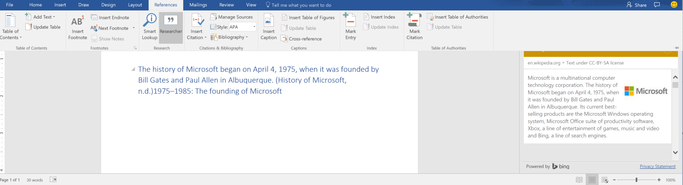

[Learn more about Researcher in Word 2016](https://support.office.com/en-us/article/Research-for-your-paper-easily-within-Word-1728f286-8702-4d72-8169-ab7677ca0e1f?ui=en-US&rs=en-US&ad=US)

### Do Things Quickly with Tell Me in Office 2016

You might have noticed a new text box on the Ribbon in Office 2016. This is **Tell Me**, where you can enter words or phrases about what you want to do next and quickly get to features in Office 2016.

1. Press **Alt** + **Q**.
2. Start typing something like “insert table” or “Accessibility Checker.”
3. Select what you want to do from the list of suggestions.

[Learn more about Tell Me](https://support.office.com/en-US/article/Do-things-quickly-with-Tell-Me-f20d2198-17b8-4b09-a3e5-007a337f1e4e)

### Use Read Mode to reduce distractions

**Read Mode** hides most of the buttons and tools so you can get absorbed in your reading without distractions. It disables edit options and allows you to read page by page. To open **Read Mode**, select **View** > **Read Mode.** Additionally, you can press **Alt** + **W** + **F**. To exit **Read Mode** press **Esc**. To move from page to page in a document, do one of the following:

* Click the arrows on the left and right sides of the pages.
* Press **PgUp** and **PgDn** or the **spacebar** and **backspace** on the keyboard.
* Use the **arrow keys** on the keyboard or the **scroll wheel** on your mouse.
* If you're on a touch device, **swipe left or right** with your finger.

*Caption 13: Document in Read Mode of Microsoft Word 2016*

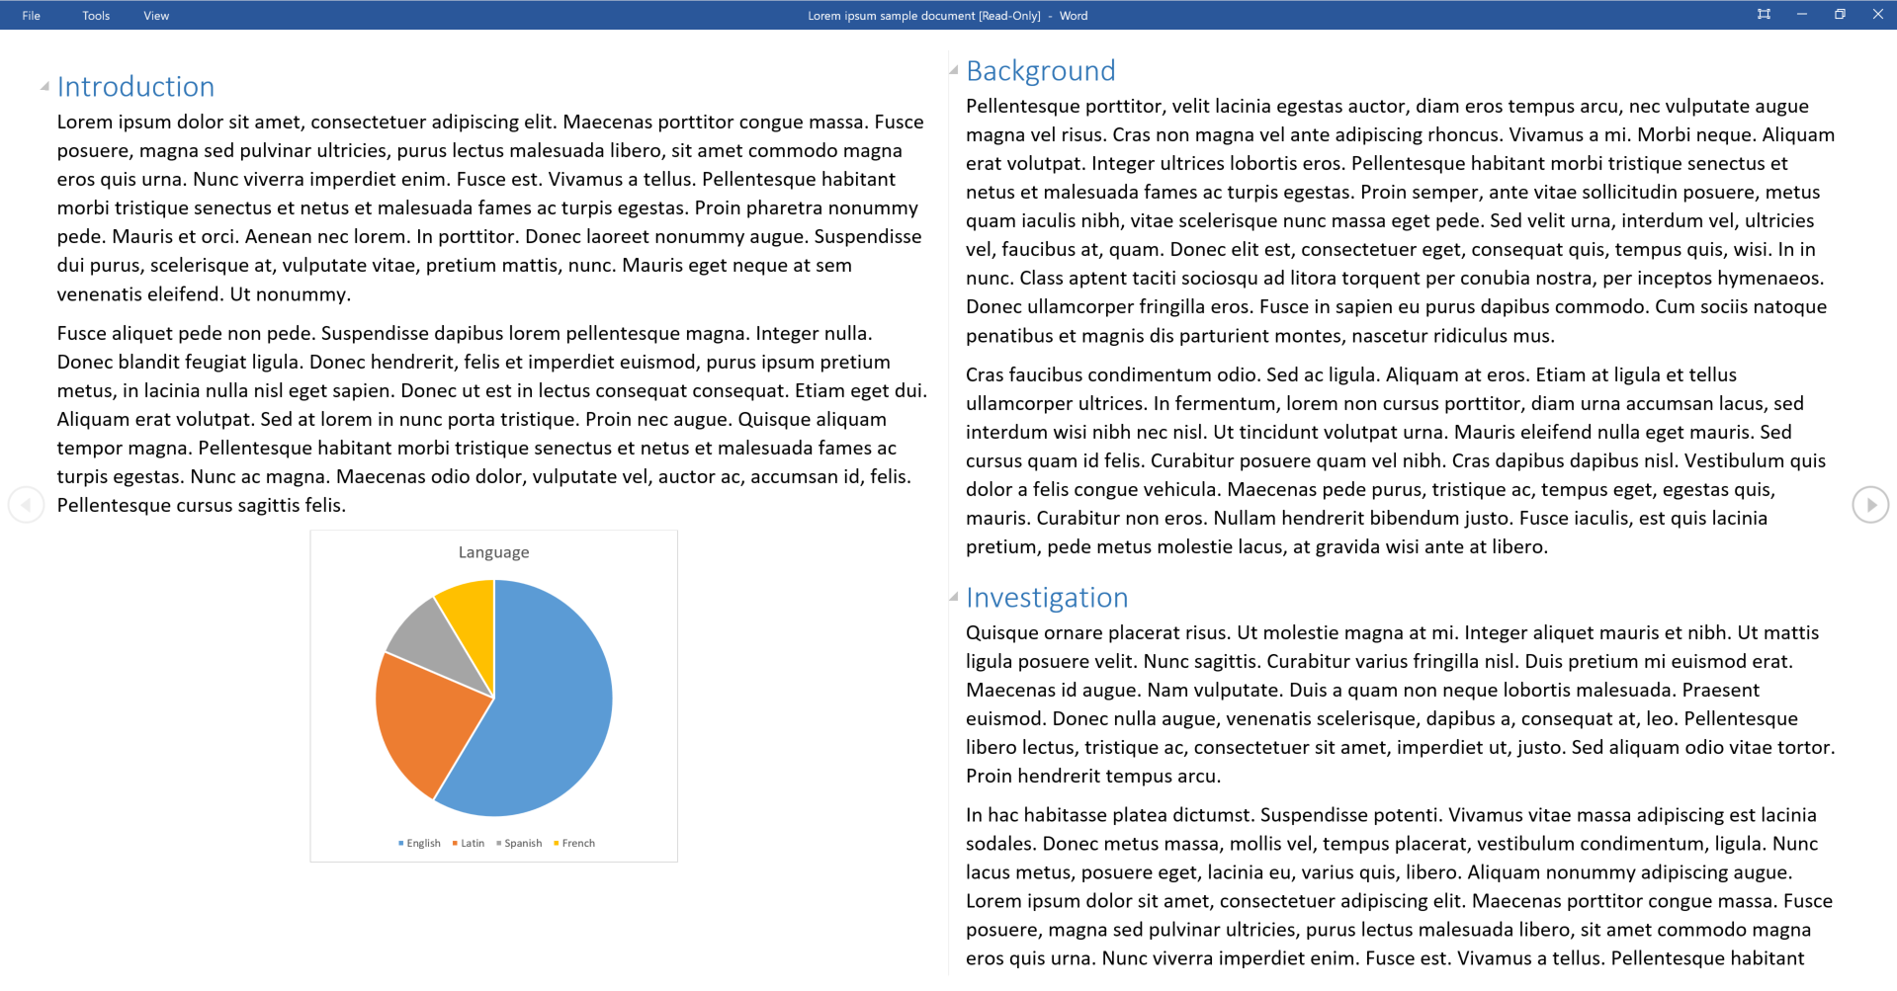

[Learn more about reading documents in Microsoft Word](https://support.office.com/en-US/article/Read-documents-in-Word-55A0EA5C-22D7-4776-9ABB-73791619BACC)

### Office Learning Tools

Learning Tools are available in a growing number of Office applications. Here are some examples of how Learning Tools can help you focus on the content in your documents:

* **Read Aloud** reads text out loud with simultaneous highlighting which improves decoding, fluency, and comprehension while sustaining focus and attention.
* **Text Spacing** optimizes font spacing in a narrow column view to improve reading fluency.
* **Syllable** shows the breaks between syllables to improve word recognition and decoding.

#### Learning Tools for One Note

The Learning Tools for OneNote is an add-in that will add a new tab to your Ribbon in the OneNote desktop application, which includes the **Immersive Reader** and **Dictate.**

The **Immersive Reader** tool recognizes text from images, and highlights words as they are read aloud. Additionally, there are options to control grammar and syntax highlighting such as **Syl-la-bles**, which enables words to be placed into syllables and displayed on the screen.

There’s also a **Dictate** feature in Learning Tools. This allows you to talk directly to your computer, or input your text directly into OneNote.

[Learn more about learning tools in OneNote](https://support.office.com/en-us/article/Learning-Tools-for-OneNote-Getting-Started-and-Frequently-Asked-Questions-f304e897-4985-43b6-b6cd-8f64bb11df90?ui=en-US&rs=en-US&ad=US)

#### Learning Tools in Word

**Learning Tools** are now included in Office 365 version of Word 2016 desktop and online applications.

To use **Learning Tools** in Word 2016:

1. Open any Microsoft Word document.
2. On the **View** tab, in the **Views** group, select **Read Mode**
3. From the **View** menu, adjust any one or all of the following:
   * **Page Settings (Page Color, Column Width, Layout)**
   * **Text Settings (Syllables, Text Spacing)**
   * **Read Aloud**

[Learn more about Learning Tools in Word](https://support.office.com/en-us/article/Learning-Tools-in-Word-29efa413-e2da-4cac-b2a5-2defc6d34fd9?ui=en-US&rs=en-US&ad=US)

[Learn more about Learning Tools in Word Online](https://support.office.com/en-us/article/Learning-Tools-in-Word-Online-a857949f-c91e-4c97-977c-a4efcaf9b3c1)

#### Office Lens

**Office Lens** is a free download on [Windows](https://www.microsoft.com/en-us/store/p/office-lens/9wzdncrfj3t8), [Apple](https://itunes.apple.com/us/app/office-lens/id975925059?mt=8), and [Android](https://play.google.com/store/apps/details?id=com.microsoft.office.officelens&hl=en) devices. You can snap pictures of text and the application automatically trims and enhances them, making them more readable. You can export to OneNote, OneDrive, Word, PowerPoint, Outlook, and PDF. Additionally, with **Office Lens** on iOS you can export to **Immersive Reader**, which is now built directly into **Office Lens**.

The **Immersive Reader** helps users to easily scan and read content, helping them move from the physical to digital world.

[Learn more about Immersive Reader for Office Lens](https://blogs.office.com/2016/11/10/immersive-reader-and-frame-guide-come-to-office-lens-offering-built-in-accessibility/)

[Learn more about Office Lens Accessibility for iOS](https://support.office.com/en-US/article/Accessibility-in-Office-Lens-for-iPhone-9a6cb4e2-6ceb-438d-829e-b3c7e977b5d8)

### Get Keyboard Shortcuts and Steps for Using Assistive Technology with Office

Office for Windows, Online, Mac, iOS, Android, and Windows Mobile provides support for assistive technologies like screen readers. You can read about the accessibility features for your specific environment at the **Office Accessibility Center**. There you can get all the latest accessibility information on products such as Word, PowerPoint, Excel, Outlook, and even others outside of the Office Suite such as Skype or OneDrive.

1. Visit the [Office Accessibility Center](https://support.office.com/en-us/article/Office-Accessibility-Center-ecab0fcf-d143-4fe8-a2ff-6cd596bddc6d?ui=en-US&rs=en-US&ad=US).
2. Select the app you want to learn about.
3. Navigate to the section for your device.

## Browse the Accessibility Features of Edge and Internet Explorer

Microsoft browsers come with built-in accessibility features designed for individuals who have learning disabilities. You can also customize options in Internet Explorer and Edge to meet your individual needs and preferences.

### Save Content to Reading List in Edge

The Reading list in Microsoft Edge gives you a place to save and organize content you want to read later. Here is how you can add articles and other content to what you want to save for later.

1. Select **Add to favorites or reading list**
2. Select **Reading list** > **Add**.
3. When you’re ready to read, select **Hub** > **Reading list**.

Additionally, you can right-click any link and select **Add to reading list** without even visiting the page.

*Caption 14: A Reading List in Microsoft Edge*

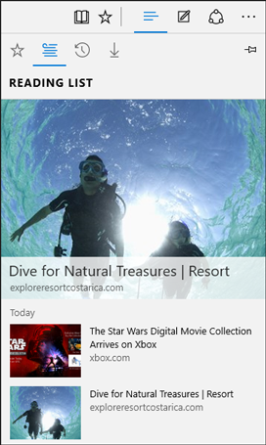

### Change Your Reading View Style in Edge

You can choose the Reading view style that best meets your individual needs and preferences. This way you can read documents in Edge with fewer distractions and a simpler layout.

1. Select **More**.
2. Select **Settings**.
3. Choose a **Reading view style**.

[Learn more about the Reading view in Edge](https://support.microsoft.com/en-us/help/17204/windows-10-take-your-reading-with-you)

### Accessibility Resources with Microsoft Edge

There are several additional accessibility resources that have been developed for Microsoft Edge. [Learn more about Accessibility in Microsoft Edge](https://blogs.windows.com/msedgedev/2015/09/25/accessibility-towards-a-more-inclusive-web-with-microsoft-edge-and-windows-10/#BlhSpJEYd6k04bo9.97).

### Change the Font Size, Formatting, and Colors on Webpages with Internet Explorer

You can change the font type and size, and the foreground and background colors that are used to display webpages. You can also specify the color used for links in webpages and override colors used on webpages.

1. Press **Alt** + **T**.
2. Select **Internet Options**.
3. Select one of the following options.

* **Fonts**—to change the font type and size used on webpages
* **Colors**—to change the font colors used on webpages
* **Accessibility**—to make Internet Explorer ignore colors, font styles, and font sizes used on webpages, or to format webpages by using your own style sheet

*Caption 15: Internet Options in Internet Explorer 11.*

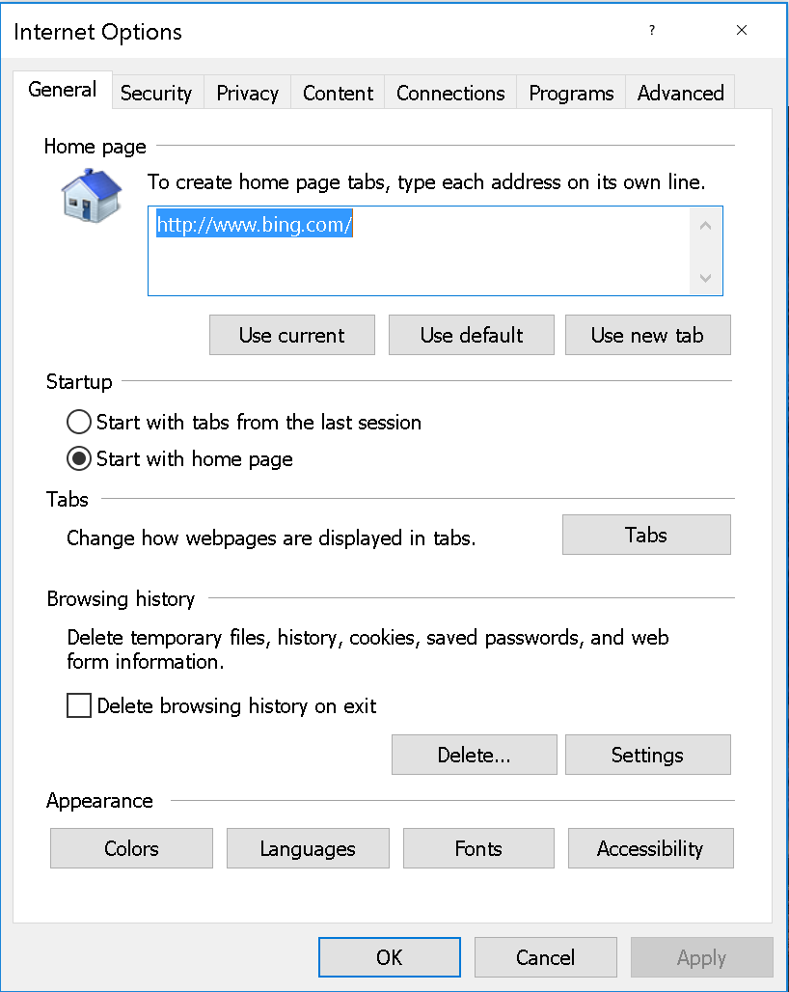

## Find assistive technology for People with Learning disabilities

People who have learning disabilities may be interested in the following:

* **Word prediction programs** allow the user to select a desired word from an on-screen list located in the prediction window. The program predicts words from the first one or two letters typed by the user. The word can then be selected from the list and inserted into the text by typing a number, clicking the mouse, or scanning with a switch.
* **Reading tools and learning disabilities programs** include software designed to make text-based materials more accessible for people with reading disabilities. Options can include scanning, reformatting, navigating, or speaking text out loud.
* **Speech synthesizers** (also known as text-to-speech (TTS) systems) speak information aloud in a computerized voice.
* **Speech recognition programs**, (also called voice recognition), allow computer navigation by voice rather than entering data by keyboard or mouse. You can still use a mouse and keyboard as well as voice, to enter data, write text, and navigate applications.

[Learn more about Assistive Technology products for Windows](http://www.microsoft.com/en-us/Accessibility/assistive-technology-partners)

Guide last updated on 2/7/2017.