MOps Onboarding Project

Request for Proposal: RadSat

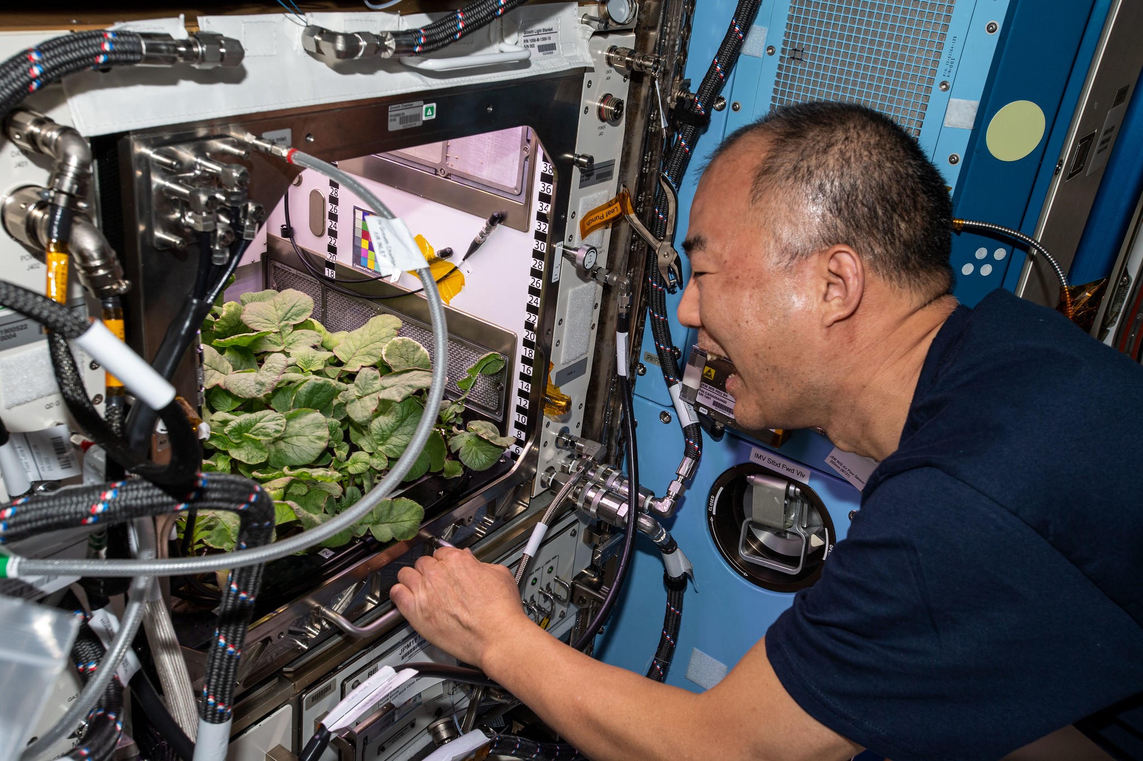
Radishes being grown on the ISS

As a member of the prestigious WashU Satellite Mission Operations (MOps) Team, you have been selected to submit a mission proposal for a NASA Request for Proposal (RFP) chosen by the WashU Satellite Business Team. The Business Team unfortunately found the RFP last minute, and now you only have 3 weeks to complete it! Luckily, your chief engineer (CE) has gone ahead and started working on the proposal to give you a head start.

This RFP seeks a mission proposal for a CubeSat that can successfully grow a radish in low-earth orbit (LEO). In order to generate a complete proposal, you will have to perform research, create trade studies, analyze data, and become familiar with key satellite and aerospace principles. The process is meant to be a fun challenge that introduces you to the work you will be doing on the Mission Operations subteam. It will also expose you to a lot of things you may not be doing on the Mission Operations subteam.

WashU Satellite is a design team, not a physics or math or engineering or computer science team. On top of that, the nature of mission design requires MOps to work interdisciplinarily to analyze missions as a whole. You will find yourself getting out of the scope of your classes in your work; In a later section, a data science major is going to find themselves analyzing the phase diagram for water. Embrace this process! College teaches you how to think, it does not teach you how to do the job you will have in the future. Use the scientific method and the skills you have learned in your class to tackle problems.
At the end of three weeks, your proposals will be reviewed and scored by the exec team following the criteria provided below. The winning proposal will receive a prize.
The use of generative AI in generating your proposal is prohibited. Some people find value in learning from AI, when done properly, so you are not prohibited from using it in general.

Note:
The typical proposal will be created over the course of a year or longer. They are usually extremely comprehensive and detail exactly how the satellite is going to perform in space. As your proposal will be created in 3 weeks, you are not expected to have the same level of detail as proposals you may find online.
I have tried to provide clarifications, notes, and explanations to guide you where I can, and have provided examples, tutorials, and choices for you to make.

Design Requirements and Constraints
Budget
As a university club team, your budget is not unlimited. Your satellite might cost anywhere from $50,000 to $250,000. Because I don’t know exactly what you might choose for your components, there is no flat restriction on your budget. However, you will still need to consider the cost of the components you put on your satellite. Do you need to have super fancy star-trackers AND a super fancy GPS? Probably not. At the end, you will come up with an expected cost of your CubeSat.

Timeline
If accepted, the schedule for a launch opportunity will be between 2027-2030. The lifetime of the mission needs to be the time it takes for at least 1 radish to grow.

Orbit
The proposed CubeSat mission must be compatible with a deployment orbit within at least one of the following options:
- Deployment from the International Space Station (ISS)
  - Inclination 51.6 degrees
  - Altitude ~ 400 km
- Deployment into a Sun Synchronous Orbit (SSO)
  - Inclination within 1 degree of an ideal SSO
  - You may require a maximum and minimum altitude spanning at least 50 km with sufficient justification.
- Deployment into a non-SSO orbit
  - Inclination between 44 and 136 degrees
  - You may require a maximum and minimum altitude spanning at least 50 km with sufficient justification.

Evaluation
Your proposal will be evaluated not only on its quality but also the quality of your solution. Could a radish actually be grown in space using your design?

Where to get started?
- First, skim the template below so you get an idea of the kind of information you should include in your proposal.
- Search the internet! There are plenty of examples online that should stimulate your thinking and get you started. Assess what has already been done, what technology these existing systems use, and what questions you have when reading other’s work. There are also a variety of references provided that I used to put this document together.
- Start with Section 1, Mission Description. Working through this section will give you the necessary foundation for the rest of the proposal.
  - Before moving onto Subsection 1.3, go to the bottom of this document and work through a baseline Science Traceability Matrix (STM) and Mission Traceability Matrix (MTM).
  - Once you finish the MTM, you will have some initial requirements that you can now turn into technical requirements. These should be Level 1 Requirements, meaning they refer to the system (satellite) as a whole, not subsystems or components.
  - For Subsection 1.3, ConOps, use your best judgement for the modes that the satellite will need. I’ve started you with SAFE and NORMAL, does the mission require additional modes?
    - Try researching the ConOps and mode-management of other Cubesat missions. How do they compare?
    - Consider: when is it beneficial to have the satellite move into a separate mode versus staying in NORMAL operations but executing a new behavior?
- Its time to build the satellite! To do this, you will use 2.2 Subsystems Design Definition and 2.3 System Budgets, Relevant Margins, and Accuracy to balance different components. You’ve been given some initial components in your satellite, and choices for the other necessary subsystems. You will need to use system budgets in order to decide which to use for your mission.
  - When moving through this section, be sure to reference back to your work in Section 1 and make sure that the satellite you are building is satisfying the requirements of your mission!
  - Start with working to define your payload subsystem, because this is the reason the satellite is going to space, and will influence the other systems on your satellite.
  - Bounce back and forth between picking components and your budgets!
- Don’t worry about getting everything right the first time, or at all. Make decisions based on the information you have and justify them!

Useful References
- NASA State-of-the-Art Small Spacecraft Technology
- ESA Fly Your Satellite Proposal Template
- CubeSat info
- UNP CONOPS & Experiment Plan
- ConOps Planning and Autonomy
- NASA Mission Inception
Below is the work your CE already got started on before he handed it off to you, and a template to organize your proposal. You are not required to use the work provided, nor are you required to follow the provided template if you do not wish to.
- Descriptions/notes provided should be deleted before final submission.
- The work provided by the CE has been marked in red to differentiate it from the rest of the document.
My References
- Phoenix Sat Proposal
- OwlSat Proposal
- OwlSat CSLI Application
- 3UCubed Proposal
- 3U Platform for Plant Growth Experiments
- Botany in Orbit Satellite
- Plant Growth in a High-Altitude Balloon
- C.R.O.P.P. Proposal
- A Guide to CubeSat Mission and Bus Design
- CubeSat Design for LEO-Based Atmospheric Science Mission
- Fly Your Satellite WUSAT-3 CubeSat Proposal
- SatCatalog
- CubeSat mission design for in-orbit environment characterisation
- Mission and system design for the EarthNext Cubesat VLEO mission

Fall 2026 MOps Onboarding Project

RadSat Proposal Template

Abstract
Briefly summarize your mission, including: information on the team, the mission objectives, a basic description of your CubeSat, the expected outcome, and its possible future applications. The abstract should be self-explanatory and should not contain figures or references. Usually best to do this at the end.

1 Mission Description

1.1 Mission Statement and Objectives
In this section, you will formulate a mission statement, mission objectives, and success criteria for your satellite.

Mission Statement
A good mission statement gives you purpose to point back to and guides the overall goals of the team. It should follow a general format as follows:
“Demonstrate/characterize/test/other action verb + (insert tech or science phenomenon) + in order to/for + (insert purpose or reason it matters).”
For this project, what kind of outcomes stem from growing a radish in space? What kind of science are you demonstrating?

Mission Objectives
Mission objectives further delineate what the goals of the mission are. It adds specificity and metrics to the mission statement. Good objectives are specific, are meaningful, and are tied to concrete data products or results.
Good objective example: “Identify debris in orbit within an image with 90% accuracy”
- Is specific about the subject of the images (debris in orbit)
- Implies meaningfulness of 90% accuracy
- Directly ties to data products
Bad objective example: “Take pictures of stuff in orbit”
- Vague
- Is not executable
- Do not have clear paths for fulfillment

Ask yourself: do these objectives I’ve made give me clear enough direction to go off and do this? If so, they are ready!

For our mission, the objectives should be relatively easy to obtain. For starters, we want to grow a radish. You could further specify that an objective is to grow a radish of a particular size or weight. Maybe another objective could be related to the amount of time taken to grow a radish.
Success Criteria
Success criteria quantifies your objectives and assigns meaningfulness thresholds. We break up success criteria into minimum success criteria, full success criteria, and stretch criteria.

Minimum success criteria defines the capability that must be demonstrated in order for the mission to be a success. Full success criteria describes the capability that must be demonstrated to be fully successful, i.e. what the system is designed to accomplish. Stretch criteria are those that are unlikely to succeed for some reason or another, but would be awesome if it worked.

For this project, what is the bare minimum that could be considered a “success”? This is largely personal, so I’ll let you think through that. For the full success criteria, think about the perfect outcome, whatever that is.

1.1.1 Mission Data Products
Write a description of the anticipated scientific or technical data of a successful mission, what scientific/technological questions will be answered, what knowledge gaps will be filled, and/or what services will be provided.

With this section, start simple and then get more specific. Think about what questions the mission answers, and then try to think about what kind of data would need to be recorded to get those answers. You will probably want to come back to this section once you have gone into more detail about what kind of components exist on the satellite.

1.1.2 End-Data Users
List the specific and concrete end-data users anticipated by the mission. Explain if/how end-users are embedded into the project or if there are any collaboration schemes with organizations that will make potential use of the mission data products.

By end-data users, this means people/organizations that might be able to use your data. There is no right answer here, you can even speculate about who might be interested in your data. I’m sure you can come up with a few ideas.
To get you started, I hinted earlier that radishes are a good plant to be grown in space. In fact, they’ve been grown in space before. A radish grown in a CubeSat could then be compared to a radish grown on the ISS. That would be neat, right?

1.1.3 Business or Downstream Applications
If there are any potential for business or downstream applications, these should be described in this section.

Space-radish business? Pitch it, I’ll invest.

1.2 Mission Constraints
Mission constraints are those that impose restrictions or design choices on the entire mission. They are not intended to be extremely specific, e.g. “the ball bearings in the reaction wheels must weigh at least 1 g.” They are meant to be at a high level, e.g. “The payload must cost less than $10,000” or “The satellite requires a sun-synchronous orbit (SSO) because it must image the same location on repeated orbits.” Take into consideration the requirements provided to you by both NASA and WashU Satellite when writing your mission constraints.

The main constraints will usually involve schedule, resource availability, and budget, but there may be others, such as those provided by your stakeholders, customers, etc. Some of the questions to ask when making constraints:
- What is the overall project budget? Are there limitations on funding?
  - In the case of a student organization, this is a critical factor. You will have to tailor your proposals to the needs of our club, so budget needs to be reasonable.
- When does the project need to be completed?
  - You’ve been given a deadline for your launch if the proposal is completed. Does this timeline impact your design?
- What resources are required to meet mission need?
  - For example, a telescope mission might require a very specific camera or a camera with very specific properties. This is a major constraint! What is its lead time? What is its cost? Can we afford to have a prototype, or can we only afford a flight version?
- What is the most dominant constraint? What is flexible?
  - Essentially, determine what limits you and what doesn’t.

Some example trades to identify technical design drivers:
- Is analysis done on board the spacecraft or on the ground?
  - This means, how much computing (calculations, analysis, etc.) needs to be done onboard versus on the ground. There are trade-offs either way.
  - If you do more analysis onboard, that reduces the amount of data the satellite needs to transmit each pass, because rather than transmitting a bunch of raw data, you are interpreting collected raw data and transmitting results or specific data that needs to be sent to ground. However, this increases the computational needs of your onboard computer, because now its not just recording data but its also analyzing it.
  - If you don’t want to do a lot of analysis onboard and want to transmit that all to happen on ground, that reduces the computational needs of your onboard computer. However, it also means that now all of this raw data needs to be stored somewhere in the satellite and then transmitted during passes.
  - You likely won’t have the necessary information to make this decision right away, but at a first pass think about what kind of data you will be recording, and how much of it needs to be cleaned up/analyzed before being sent down to earth.
- Does timeliness of downlink matter?
  - How often do we need to send down data? This will be influenced by the link budget in a later section.
- Does orbit matter?
  - You will not be familiar with orbital parameters when starting this project, but there is a big difference different orbits have on your satellite. Some key considerations:
    - At lower altitudes, your satellite will burn up faster. Around 500km, your satellite will burn up after around a year. Around 600km, your satellite will burn up after around 10-15 years.
    - Different inclinations will affect thermals, communications, and power. Here is a good introduction to some of those ideas. You will also see the affects of different orbits when doing your budgets in later sections.

Take your constraints and design drivers, and summarize them and how they affect your mission design. Once your mission constraints have been created, you might be able to perform some high-level mission analysis to determine if the mission is feasible. You will also likely realize later down the line that something has become a constraint, and will need to come back up here and add it in.

1.3 Concept of Operations (ConOps)
Give a description of how the mission will work in practice to meet mission objectives, meeting mission constraints, and the system characteristics form an operational perspective. This could include information about operations modes, on-board autonomy, mission planning, scheduling (e.g. payload activation and data recollection, activation by telecommand, etc.), attitude control and mission analysis, strategies for onboard data generation, storage, and downlink.

ConOps is one of our major tasks on MOps, because its a living document that will be updated many times while preparing for an upcoming mission. In a proposal, the ConOps provides a high-level overview of how the satellite will accomplish its mission from an operations perspective. To do this, first break up the mission into phases and modes.
Phases describe the different stages of the mission. Below is an example of some phases you might have in your mission.
- Launch preparation: All the things that need to happen before launch as it relates to operations. This might mean testing communications, setting up ground station networks, etc.
- Launch and Early Orbit Phase (LEOP): This is one of the most critical phases the satellite will experience. Imagine the satellite being shot out of a rocket and into the vacuum of space. What happens in the first few hours after that? Well, for starters, every satellite will need to detumble, because it will be shot out at crazy angular velocity, meaning we can’t talk to it.
After a satellite is deployed, to find it we will wait for NORAD (yes, that NORAD) to find it first and start recording exactly where it is through Two-Line Element Sets (TLEs) that they provide. Once we find it, we track it, and then we try to talk to it.
The satellite may have to spend ~2 weeks without receiving communications from Earth while we try to find it. What does it do during that time? Does it need to deploy solar panels or the antenna? Should it try to do anything while it waits?
  - Calibration?
  - Deployment?
  - Maneuvers?
  - Detumble?
- Nominal operations: This phase is the normal operations of your satellite. What happens during this time?
  - Experiment A
  - Experiment B
  - Thing A
  - Thing B
- Post-mission: Describe what happens after normal operations are complete (i.e. the mission has been fulfilled).
  - Disposal (i.e. burning in the atmosphere).

Modes: Describe the actual state of the vehicle. During a phase, the satellite might change between many modes. If you want to learn more about setting up modes, talk to Elias Dahl. Some typical modes:
- Safe/Survival: This could be the mode the satellite sits in while it waits for Earth to find it, or when something goes wrong on the satellite. Maybe the satellite stops all power-hungry processes, tries to conserve power, etc.
- Full operational: Normal operations!

Identify and briefly describe all mission phases and durations, including end-of-life disposal; e.g. launch preparation, launch and early operations phase (LEOP), in-orbit commissioning, operational phase, post-mission phase.

Describe all CubeSat operational modes (e.g. full operational, safe mode, etc) within each mission phase including their purpose (i.e. circumstances under which they shall be used), which subsystems are active, and their operational constraints. Include a diagram of all relevant modes and the transitions between them. See Fig. 1.1 for an example.
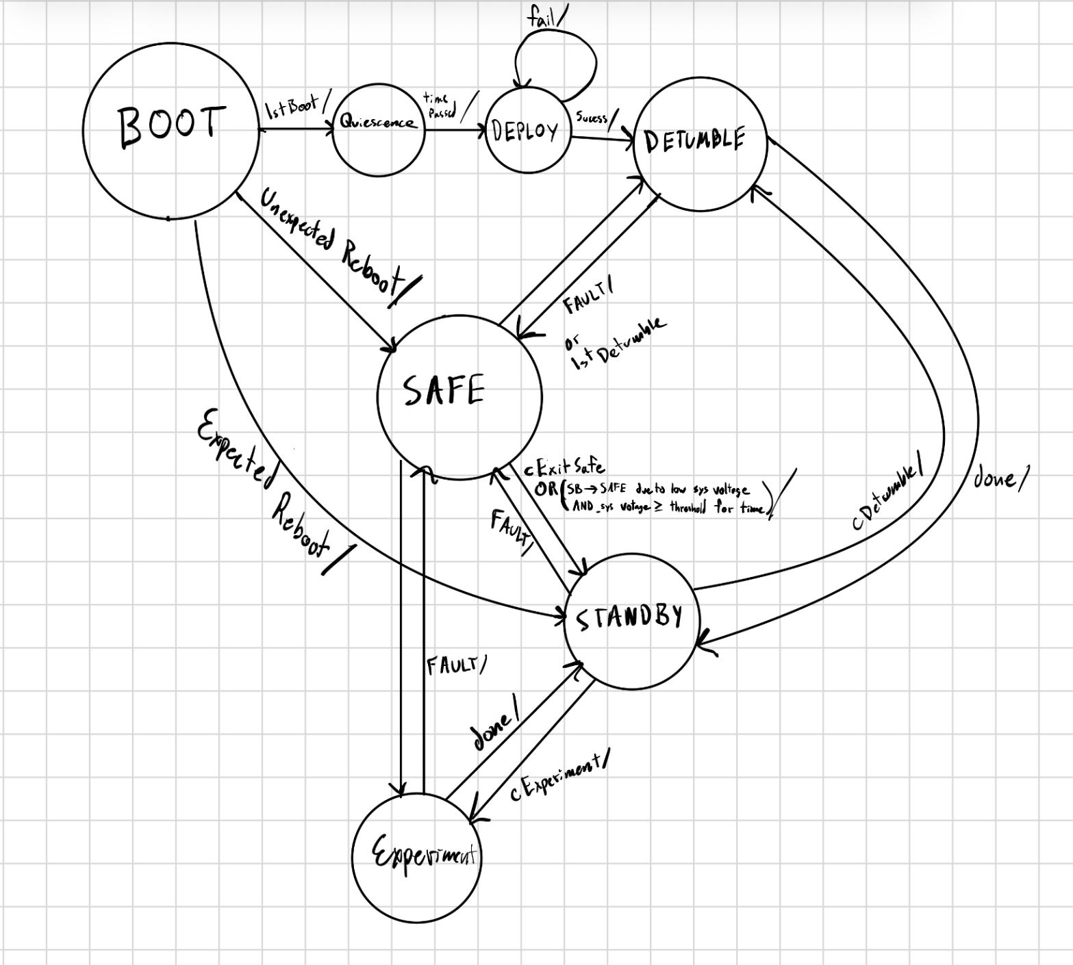
Figure 1.1: Example of a CubeSat Mode Diagram made for SCALAR.
For the purposes of this RFP, this is the maximum level of detail expected

For our radishes, consider what kind of behaviors might need to occur during an orbit, and whether the different stages of radish development would be suitable reasons to break those behaviors into different modes.

2 Design Definition

2.1 Subsystems Design Definition
This section will describe the subsystems, including payload(s), of the CubeSat. Where possible, include figures, block diagrams, and schematic descriptions of key features and interfaces. Each subsystem description should include its capabilities and a short justification for the chosen design.

2.1.1 Payload(s)
The payload subsystem is the specific set of instruments, sensors, and equipment designed to carry out the satellite's primary mission.

In our case, our payload is the radishes. What will our plants need to survive? In this subsystem, you will make the majority of the choices yourselves. For all later subsystems, some choices with trade-offs will be provided for you to choose from.

Water Supply
We will need a supply of water in order to grow our radishes. I’ve found some examples online of cubesat propulsion systems that use water as propellant. Water is stored in an elastic bladder that is pressurized using gas. You will need to determine what size bladder to use based on the amount of water radishes will require. You may remember from chemistry that water will change phase based on its pressure and temperature. In order to keep our water as liquid in orbit, we will need to keep it in the liquid state. Using a diagram like the one below, determine what pressure and temperature the water must be maintained at. This is a constraint on the design of your system.
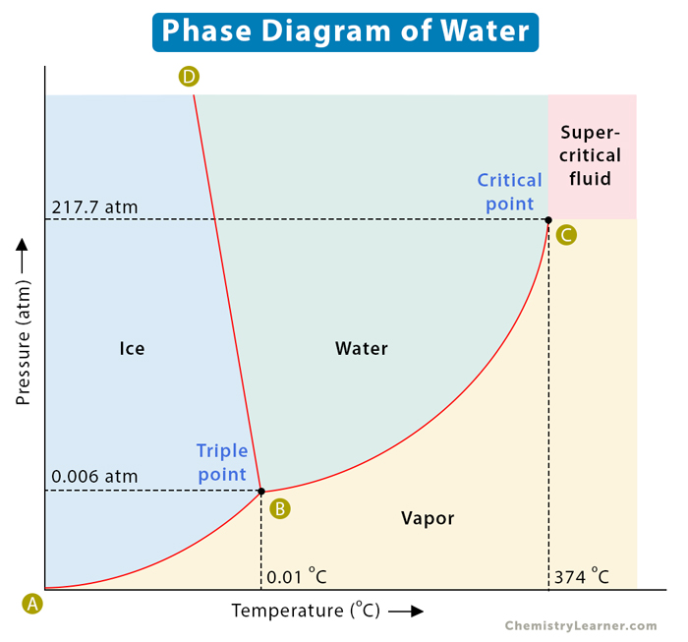
To regulate the temperature of the water, consider the use of something similar to this.

Gasses
The growing chamber will need to be pressurized using gasses representative of Earth’s atmosphere, specifically Oxygen, Carbon Dioxide, and Nitrogen, to promote healthy plant growth. You will need to determine how to store all three of these gasses in your satellite and, at a high-level, how they will be used to pressurize the growth chamber. Specifically, what ratio of O₂, CO₂, and N will your chamber be kept at? What sensors will you use to measure the concentration?
You should also include a system to circulate air through the chamber, and be able to exhaust air when necessary. This is because radishes may release Volatile Organic Compounds (VOCs) during growth that we don’t want staying in our satellite forever.

Light
Plants need light to grow! Our radishes will be enclosed in a satellite, so they need artificial light to act as the sun. Luckily, indoor plant systems have a variety of options available. Determine the light requirements of your radishes. A crucial part of this will be simulating the day/night cycle on Earth. Plants probably won’t enjoy 24 hours of light followed by 24 hours of dark, nor will they appreciate strobe lighting. Also consider: part of the satellite orbit will be in eclipse, where the solar panels are not bringing in power to supply the batteries. You will need to balance the power required to light the plants with the amount of battery available. You will use your power budget to do this. It may lead you back to modifying your ConOps with a new mode or requirements on when these lights can be active.

Soil
Plants need soil to grow! You will need a supply of dirt (or equivalent substance) to grow radishes in. Important consideration: lack of gravity in orbit affects the way roots and soil will accumulate water. This problem has been studied by Butz, I. and Herring, A in their article, Growing Plants in Space: Manipulating Medium Wettability to Create Different Saturation Conditions. You may wish to incorporate your findings into your design.

Temperature Control
Like the water supply, the growing chamber itself needs to be maintained at a temperature radishes can grow in. Determine what this temperature requirement is, and devise a system to regulate it.

Camera
How do we know if the radishes have been grown? Does the payload include a camera to take photographs of our crops?

Chamber structure
Lastly, now that you’ve determined all of the necessary pieces of the payload system, how do you bring it all together? What kind of chamber will the plants live in? What is it made out of? How big is it? For this, you don’t need to get into very specific features such as fasteners or really granular details, but you should be able to layout what your chamber design is and explain your choice!

2.1.2 Attitude Determination and Control Subsystem (ADCS)
ADCS uses sensors and actuators to orient the satellite and record related data. In this section, layout the specific sensors and actuators your satellite will use.

There are many factors to take into account when deciding on the ADCS subsystem. Firstly, how important is it to be able to make quick and accurate pointing adjustments? For something like the Roman Telescope, it might be a crucial feature, but what about RadSat?
For the ADCS subsystem, you have three choices for your ADCS configuration.

- Magnetorquers
A magnetorquer is an electromagnetic coil that generates a magnetic field when electrical current flows through it. This magnetic field interacts with Earth’s magnetic field to produce a torque on the satellite.
Advantages:
- lightweight
- reliable (no moving parts)
- compact
- energy-efficient
- cheap
Disadvantages:
- slow to turn
- imprecise attitude control
- dependent on Earth’s magnetic field. Torque can only be generated when the torque rods are perpendicular to Earth’s magnetic field vector, so 3-axis control is impossible.
Magnetorquers are great when accurate and quick skewing isn’t required. Below are some options to choose from when selecting magnetorquers for your satellite.
You can calculate the amount of torque the satellite will generate by the equation
𝛕 = m x B
where m is the magnetic dipole vector and B is the magnetic field vector (Earth’s magnetic field). The max torque happens when the dipole vector is perpendicular to the Earth’s magnetic field. Find a value for B online to find 𝛕. That will give you an idea of how fast each dipole makes the satellite spin.

Available Options
- AAC Clyde Space MTW800
- CubeSpace Satellite Systems CubeTorquer CR00__
- GomSpace Nano Torque GST-600
- ISISPACE Magnetorquer Board
- NanoAvionics MTQ3X

- Reaction Wheels
Reaction wheels provide torque and momentum along the wheel spin axis, causing the satellite to counter-rotate about the center of mass due to conservation of angular momentum. They are great for stabilization and for quick skewing of a spacecraft. However, if a reaction wheel reaches its maximum speed, it becomes “saturated” and needs to be “desaturated” before it can store any more momentum or provide torque along an axis. This is usually done by onboard thrusters or magnetorquers. Reaction wheels can be a common failure mode, so backup wheels are often included.

Available Options:
- AAC Clyde Space RW210
- Astrofein RW25
- Berlin Space Technologies RWA05
- Blue Canyon Technologies RW1
- Comat RW20

- Integrated Units
Integrated units typically combine all the necessary sensors and actuators into one component that also comes with onboard processing and software capabilities. They are a one-stop shop for ADCS.

Available Options:
- AAC Clyde Space iADCS-200
- Arcsec Arcus ADC
- Berlin Space Technologies IADCS-100
- Blue Canyon Technologies XACT-15

Now that you’ve selected which actuators your using, unless you’ve chosen the integrated option, you need to include attitude sensors. There are 6 types of sensors you can have on your satellite. Typically you will want a combination of them. If you have just magnetorquers, you can get away with just having some sun sensors and magnetometers. If you’ve got a reaction wheel, you’ll need some inertial sensors on top of that. Also consider what kind of data you want to generate from your payload - do you need any of the information collected by these sensors?

- Star Trackers
Star trackers provide an estimate of the absolute 3-axis attitude by comparing a digital image to an onboard star catalog several times per second. They are simple in concept but among the most expensive small satellite components. They are also somewhat large.

Available Options:
- Blue Canyon Standard NST
- Redwire Space Star Tracker
- Rocket Lab ST-16RT2
- Space Micro uSTAR
- Terma T1, T3

- Magnetometers
Magnetometers measure the local magnetic field relative to the satellite. Commonly, they are built into an onboard IMU. Using other sources of measurements (like a sun sensor), they can be used to provide 3-axis attitude information. Magnetometers are required when using magnetorquers in order to determine what current to supply to the torquers.
Note: magnetometers don’t distinguish between your magnetorquer and Earth’s magnetic field. If you put a magnetorquer next to a magnetometer, you will get some crazy readings.

Available Options:
- Exobotics XO-SENSE-MAG
- MEISEI 3-axis Magnetometer for Small Satellite
- ZARM Technik AMR-D-100-EFRS485

- Sun Sensors
These are used to estimate the direction of the sun relative to the satellite. Similar to magnetometers, at least one additional independent source of attitude information is required to obtain a three-axis attitude estimate. There are many types of sun sensors, specifically:
Cosine Detectors: The output is the current generated by the cell, which is proportional to the cosine of the angle between the sensor and the Sun. These are inexpensive, low-mass, simple, and reliable, but they aren’t super accurate. Sensitive to albedo effects.
- Redwire Space Coarse Sun Sensor (Cosine Type)
- Space Micro CSS-01, CSS-02
Quadrant Detectors: Sunlight shines through a square window onto a 2x2 array of photodiodes. The current generated by each is a function of the direction of the Sun relative to the sensor. More accurate than cosine, but sensitive to albedo effects.
- Space Micro MSS-01
Digital Sun Sensor: Sunlight passes through a narrow slit with a number of photodiodes behind a coded bit mask. Certain angles will cause certain photodiodes to be illuminated. Complicated.
- Redwire Space Digital Sun Sensor
Sun Camera: Literally a camera that images the sun. Super accurate.
- Redwire Space Fine Pointing Sun Sensor

- Inertial Sensing
These include gyroscopes for measuring angular change and accelerometers for measuring velocity change.

Available Options:
- Emcore QRS11
- Emcore QRS28
- Honeywell HG1700
- L3 CIRUS
- Northrop Grumman LN-200S

- GPS Receivers
For LEO satellites, GPS receivers are the primary method for performing orbit determination (i.e. where is my satellite), replacing ground-based tracking methods. You could also use them for orbit determination, but it doesn’t work super great.

Available Options:
- APL Frontier Radio Lite
- General Dynamics Explorer
- General Dynamics Viceroy-4

2.1.3 Electrical Power Subsystem (EPS)
EPS is regulates, distributes, and switches power to satellite components.

In this section, describe the EPS by describing the power generation and power storage components of your satellite. To make your decisions regarding which components to use, you’ll want to start by determining how much power every other subsystem in your satellite will require. This information will be fed into the power budget, where you can then add in solar panel and battery information, to see if the power budget closes or not.

- Power Generation - Solar Panels
More than 90% of all SmallSats use solar panels and rechargeable batteries. Solar panels are great, everyone uses them. But, there are also some limitations.
- No power during eclipses (when there is no sun on the satellite)
- Performance degrades over time (usually due to radiation)
- Large surface areas need to be dedicated to solar panels

Options:
- AAC Clyde Space Photon
- 2NDSpace CORE-01
- EnduroSat Solar Panel/Array
- Exobotics XO-PANEL
- ExoTerra Resource Fold Out Solar Arrays (FOSA)
- ISISPACE Smallsat Solar Panels
- Lockheed Martin SmallSat Solar Panels

- Energy Storage - Batteries
Solar energy will not always be available during operations, so we need to store some energy, typically via batteries.
Some choices:
- AAC Clyde Space Optimus
- LG Chem INR18650
- Argotech ELEKTRA
- ISISPACE PBP-2S1P
- Space Dynamics Laboratory SDL 12V Battery Pack

2.1.4 Command and Data Handling (CDH) and Software Architecture
CDH is the brain of the satellite by managing and storing data, implementing commands, and processing information from sensors.

For this project, you will select an onboard computer board (OBC) that integrates all the necessary CDH components onto a single board. When selecting your OBC, consider your data budget and how much data you will have to handle and how much data you will need to store at one time.

Available Options:
Xiphos Systems Corporation - Q8
Kongsberg NanoAvionics - SatBus 3C2
AAC Clyde Space - SIRIUS OBC LEON3FT
Berlin Space Technologies - OBC-100, ACC-100
SPUTNIX SXC-MB-04-ADC
Spaceteq OBC-GR712
ISISPACE IOBC
Aphelion Orbitals Integrated EPS/OBC Bus Module

2.1.5 Communications (Comms) Subsystem
Communications is how the satellite and ground station communicate.

This section should describe how the satellite will communicate with the WashU ground station (GS-2). This subsystem consists of at least one antenna and typically a transceiver PCB. The transceiver is the brain of the comms subsystem and creates the necessary RF signals to be transmitted by the antenna. For this proposal, we are going to use the same transceiver board that is on SCALAR, because we know that it is compatible with GS-2. Below are the details on the radio module that exits on the antenna board.
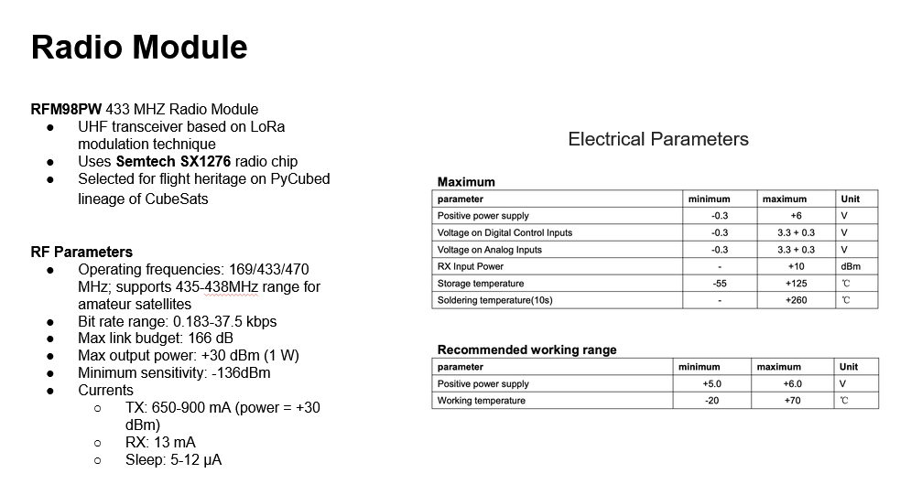
You also know that the antenna board weighs 42.93g.

The choice you will have to make is on your antenna itself.
- Monopole
  - Gain: 2.15 dBi
  - Beamwidth: 156.2 deg
- Dipole
  - Gain: 2.15 dBi
  - Beamwidth: 156.2 deg
- Canted Turnstyle
  - Gain: 0.5 dBi
  - Beamwidth: 180 deg
- Quadrifilar Helix, ½ loop
  - Gain: 4.0 dBi
  - Beamwidth: 150 deg
- Patch
  - Gain: 6 dBi
  - Beamwidth: 90 deg
- Parabolic Reflector
  - Gain: 25.3 dBi
  - Beamwidth: 8.9 deg
- Bent Dipole
  - Gain: 2.5 dBi
  - Beamwidth: 360 deg

2.1.6 Structures and Mechanisms
Structures is the shell the rest of the satellite lives in. It protects and fixes all of the components. Mechanisms refers to any deployables or other mechanical systems that the satellite employs.
Based on all of the components of your satellite, what will it look like? A rough sketch is appropriate, but you do not need to do a CAD of anything, even though a typical proposal would feature many. It should point to where each subsystem will be located in the structure. Make sure everything fits inside!

2.1.7 Thermal Control
Include any relevant thermal control details in this section, if they exist.

In this subsection, I’m referring to any other thermal control systems OUTSIDE of the payload subsystem. If you don’t have any of those, delete this subsection.

2.1.9 Ground Segment
Uplink and downlink for RadSat will be done through WashU Satellite’s Ground Station, GS-2. The system currently supports only UHF band communications. GS-2 is located on the roof of the Crow Observatory on the Washington University in St. Louis Danforth Campus, 1 Brookings Drive, St. Louis, MO, 63130.
Latitude: 38 deg, 38 min, 56 sec N
Longitude: 90 deg, 18 min, 19 sec W
Table 2-1 summarizes the characteristics of GS-2.

Parameter | GS-2 Uplink  (Earth to Space) | GS-2 Downlink  (Space to Earth)
Transmitter Power | 30.0 dBm | 30.0 dBm
Polarization | RHCP | Linear
Receiver System Noise Temperature | 1455.0 K | 1489.0 K
Antenna Gain | 13.0 dBiC | 2.5 dBi
Beamwidth | 42.0° | 360°
EIRP | 10.3 dBW | 1.8 dBW
Bandwidth | 125 kHz | 125 kHz
Table 7-1: UHF-Band GS-2 Supporting SCALAR Operation

2.2 System Budgets, Relevant Margins, and Accuracy
Report the following system budgets:

We call these “budgets” because they are calculations of the parameters for your satellite. They should be used for trade-offs between different designs and should be updated as you play with different designs. For this proposal, you will use a University Nanosatellite Program budget template. While the template would not be enough for concrete budgets, they are a great first step. Each of you will have a budget template in your respective folder in Drive. Below is a breakdown on how to go about completing it.
Orbit Info
Here you can adjust the orbit altitude of the satellite. This will affect your budgets significantly. Start with the provided 550 km, but try adjusting it to see what it does.

Data Budget
The data budget will breakdown, in one day, the amount of data the satellite will generate. Before even getting started, complete the following table (leave the table in the proposal). This will be the starting point to get to concrete numbers, by determining each subsystem/component as being high, medium, or low in the following columns.

Subsystem | Component | Estimated Data Size | Update Frequency
CDH | On-Board Computer | Medium | High
Comms | Receiver | Low | Medium
Comms | Transmitter | High | High
Payload | Temperature Sensors | Low | Low
 | Grow Lights | Low | Low
 | Camera | - | -

Then use the following lookup tables to fill in the data budget on the provided spreadsheet:

Data Size:
Low: 1-2 Bytes
Medium: 3-4 Bytes
High: 5-8+ Bytes

Sample Rate:
Low: 0.01-0.05 Hz
Medium: 0.1-1 Hz
High: 1-5+ Hz

You will take this information, and input it into the Data Budget tab of your onboarding budget.

Don’t worry about sample overhead, that goes into a whole thing about packets.
If your payload includes a camera, use this equation to calculate number of bytes:
Raw bits = Horizontal pixels × Vertical pixels × Bit depth × Color channels

Example monochrome, 12-bit photo:
2048 × 1536 × 12 bits = 37,748,736 bits = 4,718,592 bytes

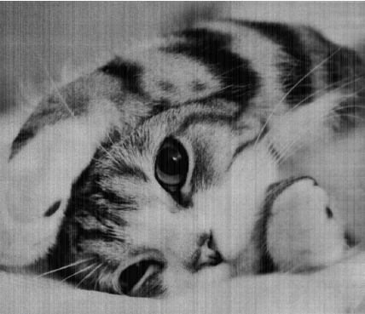
Figure 2.2.1, Example of a 12-bit Monochrome Photo

Storage Over Time
This sheet lets you visualize how data moves from satellite to ground, and how much stays leftover on the satellite. You can tweak the equations in inputs to see how different parameters affect your storage over time in the graph.

Pointing Budget
Only really useful if pointing is an essential part of your mission.

Link Budget, Downlink & Uplink
Link budgets are awesome, because they let you know if your satellite and ground station can even talk to each other before launch. “Downlink” refers to satellite -> ground transmissions. Typically, this involves sending down data results and state of health (SoH) information such as battery life, attitude/position data, etc. “Uplink” refers to ground -> satellite transmissions. Typically this is a set of commands to execute, plus a sprinkle of data such as TLEs. Most of the stuff in here, you don’t have to play with. The only stuff you will need to mess with is related to the antenna you select from the options under Comms above. I’ve provided you with the information for GS-2 where its needed.

Power Draw
This is where you input all the things that draw power on your satellite. On the right hand side, you will input power consumption by spacecraft mode. You will input the modes you’ve implemented from your ConOps, and quantify how much power should be delivered to each component/subsystem on the satellite while in that mode.

Power Generated
This is where you will determine how much power your satellite can generate from it’s solar panels, as well as the capabilities of your battery.

Energy Balance
This shows the battery capacity in one day in a handy plot. You can change the mode-switching table to change when the satellite goes into each mode.

Mass Budget
This is where you add up all the stuff in your satellite by mass and see how much it weighs. Don’t need to get super duper specific with this, just do your best to estimate.

2.2.1 Mass Budget
Report the mass budget.

2.2.2 Power Budget
Report the power budget.

2.2.3 Data Budget
Report the data budget.

2.2.4 Link Budget
Report the link budget.

2.3 List of Components
Record all of the components to produce the CubeSat, according to the example given in the table below.

Component Name | Model Number | Description | Manufacturer (Name, Country) | TRL
CubeSat solar panel | ABC-123 | solar panels  1000 V  23.5 Wh | Panels R Us  USA | COTS

2.4 Technical Challenges
Identify the major criticalities to the technical performance, safety of the system, project schedule, and an assessment of the follow-up actions.

2.5 Expected Cost
Do your best guess here based on the design choices you’ve made!

3 Major Risks
Give a list of the major risks to the project both in technical and managerial terms, and an assessment of the follow-up actions/mitigation plans. Risks may be linked to reliability, radiation, single point failures, lack of funding, project schedule, procurement delays, manpower, student turnovers, lack of experience, etc.

Appendices

Appendix A Technical Requirements Specification
List all the technical requirements, including:
- Requirement Identification: All requirements should be identified with a unique identifier.
- Requirement Text: Definition of the requirement.
This can be attached in any format.
Requirements are easy to understand statements that express clear needs of the satellite to achieve its mission. They flow down from the mission objectives, are inherited from control documents such as the UNP User Guide, and must follow constraints.
Requirements should be VALID:
Verifiable: possible to ascertain whether the requirement has been met.
Achievable: realistic given technology, cost, schedule, etc.
Logical: make sense, consistent with other requirements.
Integral: necessary to the success of the system.
Definitive: specific, unambiguous

Verification methodologies outlines how the requirement will be validated. Some requirements may have more than one methodology apply. Each capture different level of thoroughness that may be required.
Test: A rigorous set of runs of the system or component that test all edge cases, worst cases, etc. Used for the most critical performances.
Analyze: Performed through calculations, simulations, etc.
Demonstrate: Perform runs of the system or component in a few example cases.
Inspect: It either is or it isn’t.

Through your work through the previous parts of this document, you should have a decent understand of the technical requirements of your mission, enough to list them in the following table.

Req ID | Requirement text

Appendix B Science Traceability Matrix (STM)
The STM shows how science goals and objectives “trace” (flow down) to instrument and mission requirements. It answers these questions:
- Does the science address WashU Satellite goals?
- Does the investigation address the science?
- Does the instrument/mission implement the investigation robustly?
A compelling STM is critical to proposal success, and live or die based on how well the STM is crafted and explained. STMs require three fundamental models for each investigation to flow up and down between column groupings:
- Science Model
- Measurement/Experiment Model
- Instrument Performance Model
Each model must be developed and explained well in the proposal (this is hard!). Use the provided STM template. Below it are explanations regarding each column.
Typically,

Mission  Statement | Mission  Objectives | Measurement Requirements |  | Instrument Performance |  |  | Mission  Requirements  (Top Level)
Mission  Statement | Mission  Objectives | Physical Parameters | Observables | Parameter | Requirement | Projected | Mission  Requirements  (Top Level)
Advance the understanding of urban heat island impacts on energy and water sustainability, air pollution and greenhouse gas emissions, and health. | Objective 1: Identify short timescale variations in the thermal properties of urban environments.  Objective 2:  Characterize influence of human activity on UHI | Surface Temperature | Thermal Infrared Flux | Temperature Resolution | 200 mK | 77 mK * this is actually BETTER than 200 mK | Uncooled long-wavelength IR imager
 |  |  |  | Minimum Temp | -10 deg C | -20 deg C | Uncooled long-wavelength IR imager
 |  | Size of Features | Cities, suburbs, towns, large buildings | Ground footprint | 30 km | 45 km | Narrow field of view optics
 |  |  |  | Spatial resolution | 200 m | 68 m | Narrow field of view optics

Columns 1 and 2 will be filled in using the work above, Mission Statement & Objectives.
Columns 3 and 4 summarize the measured observables that will be used to determine/infer physical parameters of the body under investigation, and to quantify how well those parameters need to be determined to meet your science objectives.
Columns 5, 6, and 7 indicate what instruments will be measuring, and what functional requirement exists for each measurement. Predicted Performance shows instrument capability from a subsystem level (current best guess). The performance margin is the difference between capability and requirement.
Column 8 details the mission requirements driven by the science objectives traced from left to right.

Appendix C Mission Traceability Matrix (MTM)
Mission  Requirements | Mission Design Requirements | Spacecraft Requirements |  | Ground System Requirements |  |  | Operations Requirements
Uncooled long-wavelength IR imager  Narrow field of view optics | Mission length:  Minimum requirement of 3 month, target duration of 1 year.  Orbit altitude:  Minimum orbit altitude of 350 km to ensure minimum mission length.  Geographic coverage:  Daily passes over STL for communication and science. | Stabilization: Active stabilization for nadir and off-nadir imaging.  Mass:  2716 g  Power:  4W orbit average  Volume:  3U CubeSat  798.05 cm³  Data Rate:  2.5 MB per day  Temperature range  0 to 100 deg C  Pointing Control  1 degree accuracy for ground footprint target. Stable over 5 minutes for targeting. No jitter on millisecond time scales of the imager.  Detector radiation shielding:  Metal enclosure around imager to reduce cosmic ray artifacts. Thickness in mm range. |  | Passes Per Day and Duration:  Minimum of 2 passes per day with an average 169 seconds duration based on a 51.6 degree inclined orbit.  Assumed Antenna Size:  6 meter parabolic reflector and/or high-gain (>15 dB) Yagi.  Data Volume Per Day:  2.5 MB/day (up to 8.2 MB/day)  Transmit Frequency:  437.5 MHz  Power Available for Comms:  1 W  Downlink Data Rate:  30 kbps (up to 115 kbps)  Number of data dumps per day:  2 (up to 4)  Spacecraft Data Destination:  Mission Ops center at WashU  Science Data Destination:  Mission Ops center at WashU |  |  | General Spacecraft Maneuver Requirements and Frequency:  Detumble following orbit insertion.  One time.  Target pointing up to 30 degrees off-nadir with 1 degree accuracy.  Once per orbit.  Optimal solar panel power orientation. Once per orbit following image targeting.  Nadir pointing for downlink. Twice per day.  Special Maneuvers Requirements:  None.  Rationale for Maneuvers  Target pointing increases sampling rate to meet science requirements.  Maximal solar power pointing maintains battery levels.

Appendix D Pictures
Pictures of satellite subsystems, components, antennas, and ground station. Include in the caption which model (FM, EM, prototype) is shown in the picture.

Other Appendices

References

COTS = Commercial Off-The-Shelf: “ready-made hardware, software, or services that are sold to the general public and used as-is without custom development.”
TRL = Technology Readiness Level: Pick either new development (experimental), flight heritage (been in space before),
Interestingly, radishes are a good choice for space.
See this reference for an in-depth look at one of these systems.
Why might an elastic bladder be a good choice for holding water over a rigid system?
When considering the use of adhesives, be sure to consider any outgassing effects! You should be able to find the material or adhesive used in a NASA or equivalent database online.
This claim is supported by various sources.
Also consider the effect of exhausting these gasses from the satellite, which may be defined as a propulsion system depending on how your system operates.
This is a very basic introduction to requirements at a high level. Developing good requirements is not your job on WashU Satellite, as we have a team dedicated to doing that (ahem, systems).
If the project needs it, we will find the money. However, when budgeting for expensive components, consider where other components can be made cheaper, either by in-house manufacturer, cheaper design choices, etc., while still fulfilling the needs of the mission.
A transceiver is one board capable of transmitting and receiving data. Could also be two boards.
While writing this section in Mallinckrodt, the same mosquito bit me four times before I could kill it.
Take your best guess. For example, if my satellite is in safe mode, then my science payload would not be active.
Transceivers use frequency modulation to encode data onto carrier waves. GS-2 uses Long-Range (LoRa) modulation, so we want RadSat to use LoRa modulation too for simplicity.

