**Smart Shop: Self Service Price Checker/ Product**

**Locator with Barcode Scanner**

**Abellanosa, Leo Mark S.**

**Capili, Renier Jake C.**

**Mandamiento, Javenn L.**

**Nabong, Jericho C.**

**Tion, Jhyvriel Ian C.**

**An Object Oriented Programming Project**

Department of Information Technology

College of Engineering and Technology

University of Science and Technology of Southern Philippines – Claveria Campus

Claveria Misamis Oriental, 9004 Philippines

December 13, 2024

**I. Background of the Study**

Shopping can often be a frustrating experience, especially when assistance is unavailable or when social interactions are undesirable. Customers may find themselves wasting time and energy trying to locate products or determine their prices. This is particularly challenging for individuals with social anxiety, limited time, or communication difficulties. Small business owners face similar challenges, as they often lack sufficient staff to assist every customer effectively.

To address these issues, advancements in technology, such as barcode scanning and self-service tools, have emerged as solutions. These tools allow customers to independently find product information, including prices and locations, through intuitive and user-friendly systems. Such innovations not only enhance the shopping experience for customers but also alleviate the workload on business owners, allowing them to manage resources more efficiently. By prioritizing convenience, accessibility, and independence, this study aims to modernize the retail experience and address common pain points faced by both shoppers and retailers.

**II. Objectives**

In today’s fast-paced world, shopping convenience is essential. This study introduces a self-service system integrating barcode scanning and database technology, enabling customers to quickly access product prices and locations while helping businesses efficiently manage inventory. This innovation aims to modernize the shopping experience for both customers and retailers. These are the following objectives in mind;

1. **To enhance customer convenience:** Provide shoppers with a self-service tool that allows them to independently check product prices and locations without relying on store staff.
2. **To improve efficiency in retail settings:** Streamline the shopping process by integrating a barcode scanner, product locator, and database to ensure accurate and real-time information retrieval.
3. **To support small business owners:** Assist businesses with limited staff by offering a system that minimizes the need for direct customer assistance and ensures smooth database-driven operations for inventory management.
4. **To promote accessibility and inclusivity:** Create a user-friendly interface that caters to individuals of varying tech proficiency, including those with social anxiety or communication challenges.
5. **To modernize the shopping experience:** Leverage technology, including database integration, to align in-store shopping with the expectations of tech-savvy consumers, enhancing customer satisfaction and retention.
6. **To ensure accurate and up-to-date information:** Utilize a centralized database to maintain accurate records of product details, prices, and locations, minimizing errors and inconsistencies.
7. **To provide secure and flexible management tools:** Enable business owners to manage product data seamlessly, including adding, updating, or removing product details, through a secure and intuitive admin interface.
8. **To support scalability and growth:** Design a database structure that can handle increasing product entries and accommodate future expansions or upgrades in the system.

**III. Scope and Delimitation of the Study**

**Within the Scopes of the Study;**

1. **Price Checking:** Provide accurate and up-to-date pricing information for products available in the store through a centralized database.
2. **Product Locator:** Offer real-time information on product locations, including aisle and shelf details, by retrieving data stored in the database.
3. **User Interface Design:** Create a user-friendly, intuitive interface seamlessly integrated with the database to ensure smooth navigation and data access for customers of all tech proficiency levels.
4. **Self-Service Focus:** Emphasize independence by enabling customers to directly query the database for product details without interacting with store staff.
5. **Database Management:** Maintain a robust and secure database to store product details, prices, and locations, allowing real-time updates and easy data management for store administrators.
6. **Data Accuracy and Consistency:** Use the database to centralize information, minimizing errors and ensuring all users access the latest product details.
7. **Quick Product Inquiry**: Utilize a barcode scanner to fetch product information instantly from the database, ensuring accuracy and speed.

**Delimitations of the Study;**

1. **Adding barcode via scanning:** Adding a barcode via scanning in add products is still worked on.
2. **Searching Errors and Bugs:** Searching product names that has multiple iteration/multiple types, is still a problem and causes bugs and errors.

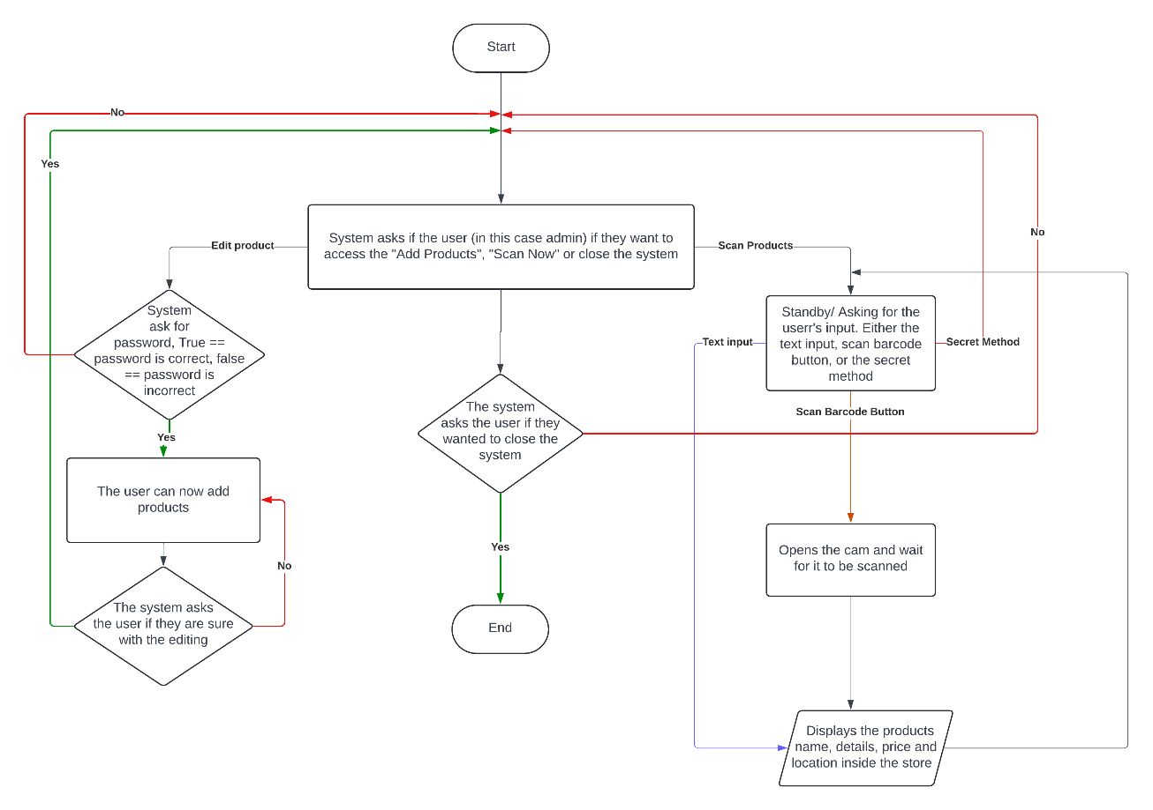**IV. Flowchart**

This flowchart outlines the processes involved in a system where users (primarily administrators) interact with options like adding products, scanning products, or closing the system. Here is a detailed description:

1. **Start:** The process begins at the "Start" node.

2. **“The Main Menu”:**  The system gives the user (admin) the choices to go:

* Add Products- add product to the database
* Scan Now- scan for products.
* Close the System

3. **Add Products Flow:**

* If the user selects "Add Products," the system prompts for a password.
* If the password is incorrect, the process loops back to the options query.
* If the password is correct, the user gains access to add products.
* After adding products, the system confirms with the user whether they are sure about the changes.
* If the user confirms, the changes are saved, and the process loops back to the initial options.

4**. Scan Products Flow**

* If the user selects "Scan Now," the system enters standby mode, awaiting input.
* The user can choose between:
  + Text Input: To manually input the product details.
  + Scan Barcode Button: To initiate the scanning process via the camera.
* Secret Method: An additional method to scan or access product information.
* For barcode scanning:
  + The system opens the camera and waits for a barcode to be scanned.
  + Once scanned, the system displays the product’s name, details, price, and location within the store.
  + After completing this task, the system loops back to the initial query.

5. **Close System:**

* If the user opts to close the system, the system confirms the decision.
* If confirmed, the process ends.

6. **End:** The system concludes its operation if the user confirms the closure.

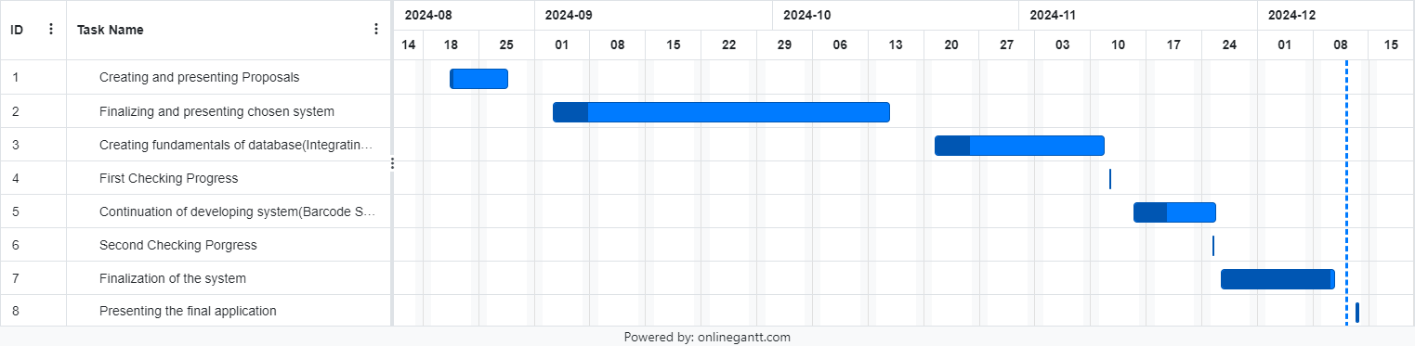**V. Gantt Chart**

This are the detailed timeline and description of our project’s development phases from proposal creation to the final application presentation. This is the steps we have undertaken to ensure the project’s success.

1. **Creating and presenting the proposal**

* In august 21 we began by drafting a comprehensive project proposal.
* August 28 the proposal was presented and approve by the body.

1. **Finalizing and presenting the chosen system**

* In October 15 after evaluating various options, we finalized the system to be implemented and presented.

1. **Creating fundamentals of the system (Integrating database)**

* In august 21 to November 11, we focused on creating the core fundamentals of the system. This phase included designing the UI and implement the database.

1. **First checking progress**

* November 12 system progress checked and received feedback from MS. Trisha posadas.

1. **Continuation of developing system (Barcode Scanner)**

* In November 15 to November 25, we expanded the system capabilities by adding features, such as a barcode scanner to enhance functionality.

1. **Second checking progress**

* In November system progress checked and received feedback from MS. Trisha Posadas

1. **Finalization of the system**

* In November 26 to December 10, we focused on finalizing the system and overall app functionalities.

1. **Presenting the final application**

* December 12, we present the final and completed applications with all planned functionalities and known delimitations.

**VI. System Design**

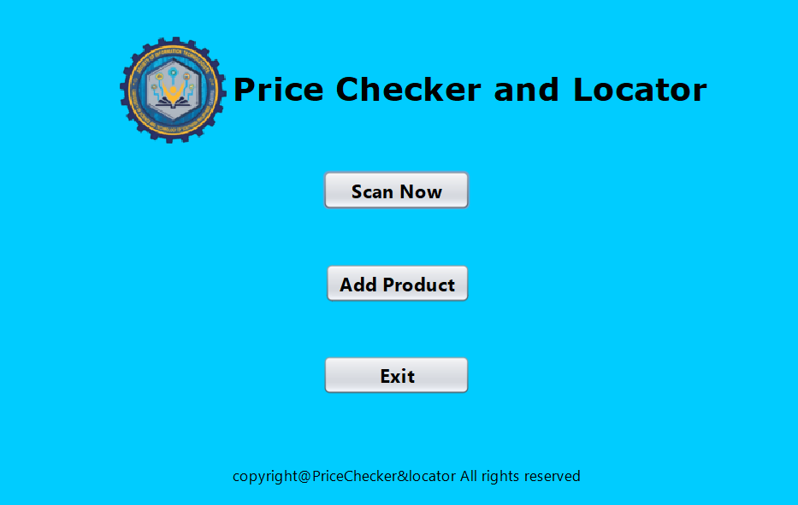This is the “Main Interface”, this is the first window you will se in opening the code.

**Scan Now button path:**

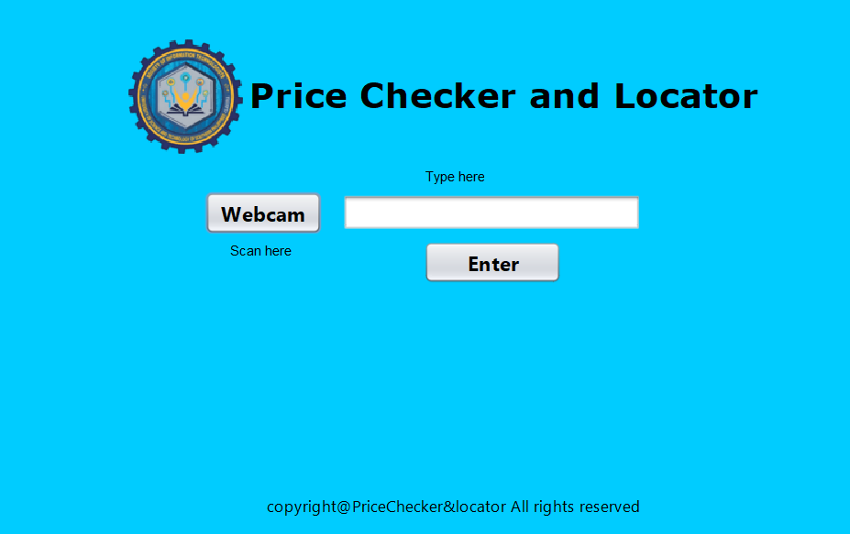When the "Scan Now" button is clicked, this GUI will be displayed. This interface is also what customers should see and serves as the "default" view when the system is in the storefront. Clicking the BSIT icon ten (10) times will return to the “Main Interface”, this is the “Secret Method”

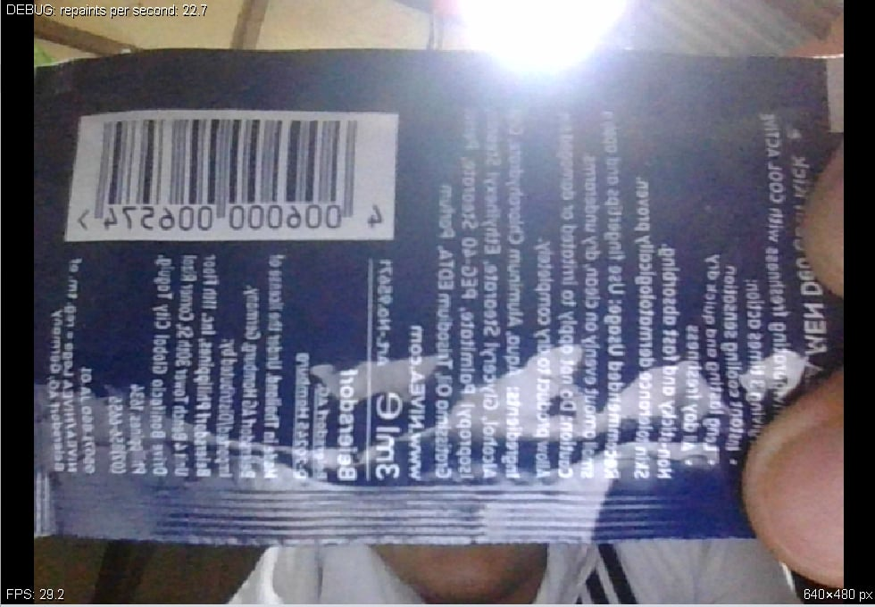 Upon clicking the “Webcam” button, this should be the GUI that appears.

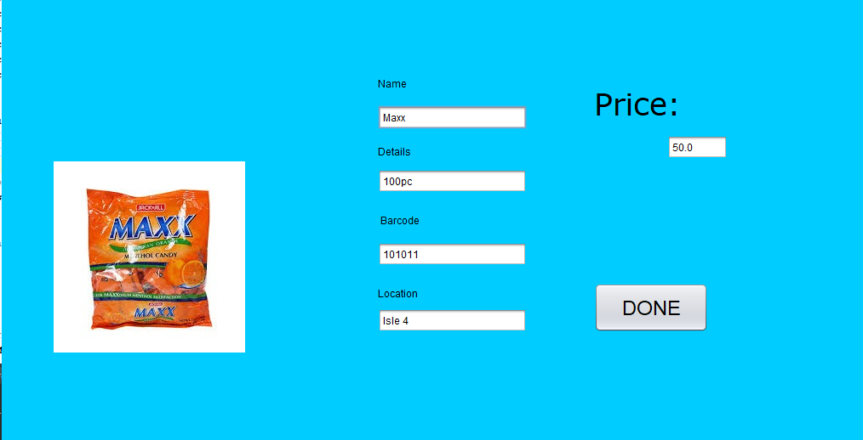When the barcode or the product name is entered or scanned by the barcode scanner, the product with the same barcode or product name is showed in this manner:

**Add Product button path:**

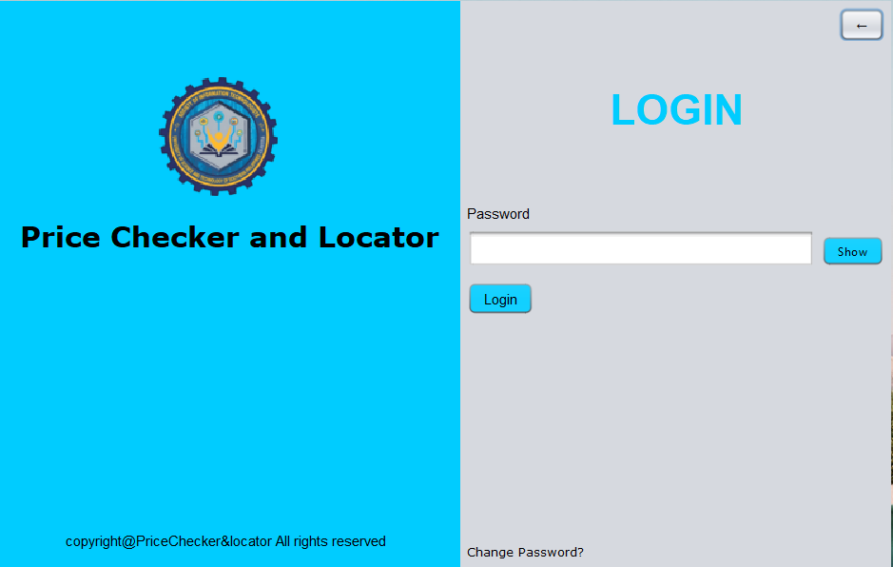When “Add Product” button is clicked, the user can’t proceed to the access of the editing of the products. The user must enter first the password.

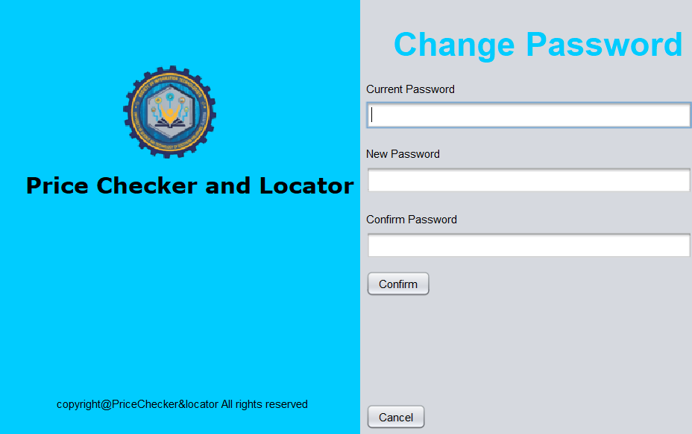When the user wants to change the password, he can do so.

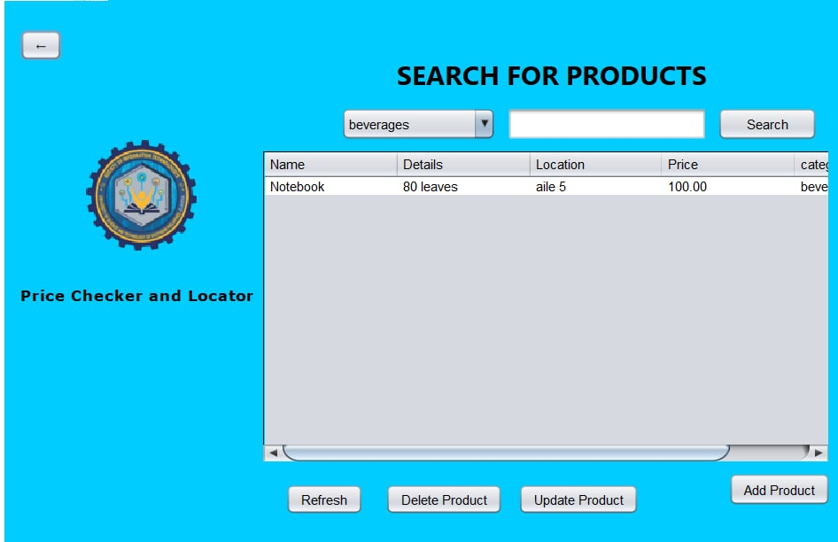When the correct password is entered, the user can now see the products in this GUI.

In this panel, the user can search by category, delete a product, and edit a product.

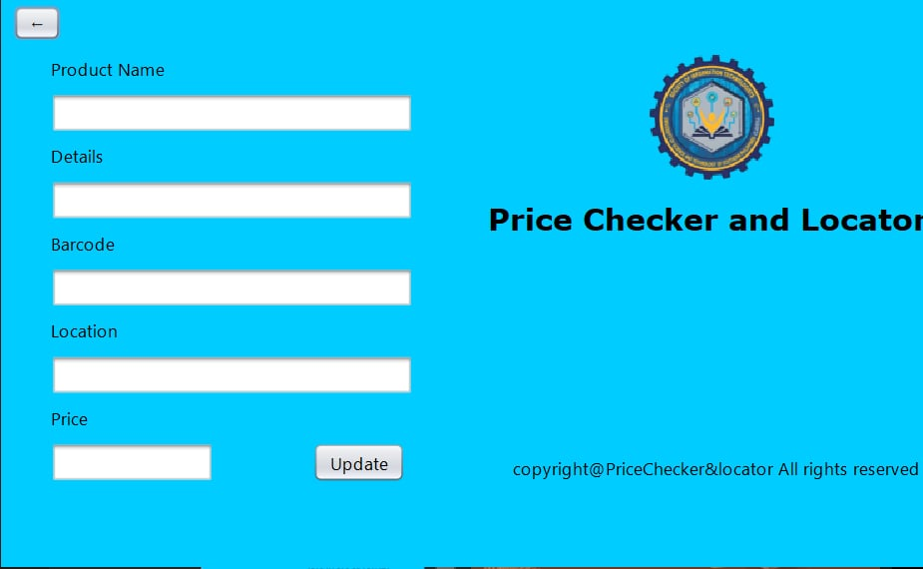By clicking “Edit Product” you can edit products via this UI:

This feature is still in Alpha phase and will be updated.

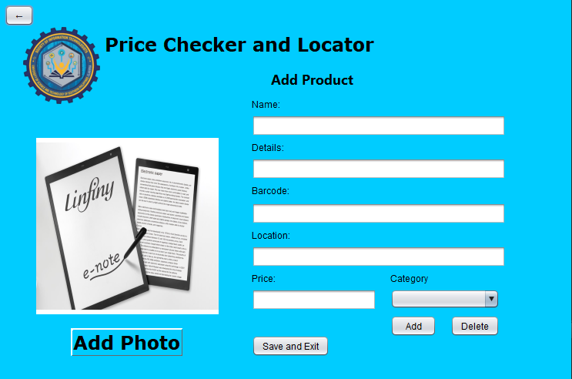By clicking “Add Product” you can add products via this UI:

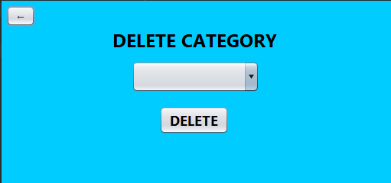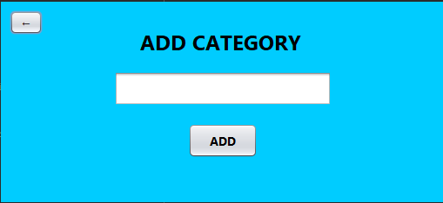The user can also add or delete product by these manner:

**Exit Button Path:**

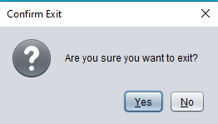And lastly, when the user wahts to exit the application, the system asks if the user is sure.

**VII. Conclusion**

The Smart Shop system enhances the shopping experience by providing a self-service tool that integrates barcode scanning and a centralized database for real-time product information. It reduces dependency on staff, benefits small businesses, and offers a user-friendly, inclusive interface while supporting scalability for future growth.

Despite its benefits, the system has limitations, including incomplete CRUD functionalities, barcode scanning challenges, and search bugs. Addressing these issues will further optimize its performance, making it a more efficient and reliable tool for modern retail needs.

**VIII. Recommendation**

1. **More functionality of barcode:**
   1. **Scan-to-Add:** Allows scanning a barcode to add it to the database instead of manually encoding it.
   2. **Faster scanning:** The current scanning feature is slow and clunky. Optimizing it will make the process faster and more efficient.
2. **Improving the customization of the database:**
   1. **Improving Update:** Improving this functionality will make the update process more straightforward and the database more customizable.
   2. **Optimizing database:** As for now, the database is messy. Finding a way to organize this database will make customization efficient.
3. **Improving search:** We still have the problem in this field. When entering a similar name (e.g. Both products are Nescafe with different grams) the system will only display one. If this is fixed, both products should be displayed.