INIT: INDOOR HEAT INDEX TRACKER
An IoT-Based Classroom Heat Index Monitoring System
PHYSICAL SCIENCE / INFORMATION TECHNOLOGY
Researchers:
John Michael A. Ompad
Jelhay C. Pangatungan
Mark Jacob G. Butaya
Adviser:
Arvin C. Trangia
Abuno High School
Draft 2026-11-04

Chapter 1
Introduction
I. Rationale of the Study
Classrooms in the Philippines are often hot, and the heat is expected to be stronger in an El Niño year. A study of more than 730,000 students in Cambodia, a neighbouring Southeast Asian country, found that sustained heat exposure significantly reduces examination performance (Tzintzun et al., 2026). That paper is a working paper, that is, research in progress, so its findings are evidence to consider and not a final result. A controlled experiment with 53 undergraduate students at 20 °C and 27 °C, which used Arduino-based temperature and humidity sensors, also found that thermal satisfaction and grade point average together explained 23.15 % of the variance in student grades (Kirkil, 2025). That study was short and done at a university in Türkiye, so it does not show the same effect in a Philippine classroom. Still, these studies support a simple idea: a school should know how hot a room really is.
Air temperature alone does not tell how hot a person feels. The heat index combines temperature and humidity into an "apparent temperature" and is built on Steadman's model of human thermoregulation (Lu & Romps, 2022). For practical use the National Weather Service uses a polynomial fit to that model (Lu & Romps, 2022), although extrapolating such polynomial fits to hotter and more humid air has no basis in physiology, and the original index is undefined for some hot, humid conditions (Lu & Romps, 2022). In the Philippines, PAGASA, the national weather bureau, uses a four-tier, effect-based heat index classification, and it advises that school heads and local governments keep the final say on decisions such as class arrangements (Philippine Atmospheric, Geophysical and Astronomical Services Administration [PAGASA], 2024).
Low-cost sensors and Wi-Fi microcontrollers make room monitoring possible without expensive equipment. An earlier classroom study used a DHT22 temperature and humidity sensor on an ESP8266 or ESP32 board and sent the readings to a cloud database (Widjaja et al., 2022). That work centred on logging temperature and humidity and on modelling a cooling system. This study builds on that idea and adds the heat index with its PAGASA level and a public web page. The product is named "Init" (Tagalog for "heat"): a room monitor and a web app that show temperature, humidity and the heat index of one classroom, and tells at a glance whether the room is in a PAGASA caution, extreme caution, danger or extreme danger level.
The system also has limits that the study states openly. The sensor was not yet compared with a reference thermometer. This matters because another ESP32 and DHT22 monitoring system, tested in a greenhouse against a thermo-hygrometer, had a root mean square error of 1.48 °C for temperature and 3.18 % for humidity (Wardani et al., 2023), which is larger than the manufacturer's stated ±0.5 °C and ±2 %RH. The device needs a Wi-Fi connection (a phone hotspot or pocket router) because the classroom has no Wi-Fi. The power bank used to run the device switches itself off if the device does not draw current regularly, which shaped the design (Decision D-027).
II. Statement of the Problem
This study aims to design, build and test "Init", a low-cost Internet-of-Things (IoT) room monitor and web app that measures the temperature and relative humidity of a classroom, computes the heat index, and shows it to the public in real time with the matching PAGASA level.
Specifically, the study sought to answer the following questions:
1. What hardware and software components are needed to measure, send, store and show the heat index of a classroom, and how are they connected?
2. Does the computed heat index agree with a published reference table of expected values?
3. How reliably does the device send readings over 24 hours when powered by a USB power bank, in terms of (a) the number of readings recorded, (b) the longest gaps between readings and (c) the drop in power bank charge?
4. What were the temperature, relative humidity and heat index in the monitored room over the 24-hour run, and in which PAGASA level did the room spend its time?
5. Does the system show the room as offline when the device stops sending, and how soon?
6. Can the web app be read by any visitor on a phone while only an authorised administrator can change settings?
III. Scope and Limitations
The study covers one device in one room, read-only public viewing, free-tier hosting and a power bank as the only power source (Decision D-003). It does not claim sensor accuracy, because no reference thermometer or hygrometer was available yet, and it does not claim that the measured values apply to other rooms or seasons. The measured data come from a single 24-hour run on a test project of the database. Alerts to phones (push notifications), a physical wake button for the screen and over-the-air firmware updates are planned but not yet built.

Chapter 2
Research Methodology
2.1 Research Design
This study used an engineering design and experimental approach. The product was built in small steps (phases). Anything with a known correct answer, such as the heat index calculation, was written test-first: the test was run and seen failing before the code was written. After each step the result was checked on the real device or the running web page, and not only by automated tests. The independent variable of the main experiment was time of day (a 24-hour run); the measured variables were temperature, relative humidity, heat index, the number of readings and the power bank charge.
2.2 Research Environment
The device was run in the researchers' test room with the Wi-Fi provided by a mobile phone hotspot. Data were stored in a cloud database located in Singapore, and the web page was hosted on a free static hosting service. Local time is Philippine time (Asia/Manila, UTC+8). [School and room details to be added by the researchers.]
2.3 Research Instruments and Materials
Table 1. Hardware and software used
Item | Purpose | Notes
ESP32 DevKit, 38-pin, Type-C | Microcontroller with Wi-Fi | Decision D-017; firmware written in the Arduino framework with PlatformIO
DHT22 (AM2302), 4-pin | Temperature and relative humidity sensor | DATA on GPIO 4 with a 4.7 to 10 kΩ pull-up to 3.3 V; read at most once every 2 s
OLED 0.96 in, SSD1306, 128 x 64 | Shows the room, readings and status | I2C on GPIO 21 (SDA) and GPIO 22 (SCL), address 0x3C
USB power bank, ROMOSS Sense 8P+, 30 000 mAh | Power | 5 V into the board USB-C port; replaced the original battery and converter design (D-008)
Pocket router or phone hotspot | Internet | The classroom has no Wi-Fi (D-004)
Supabase (PostgreSQL) | Database, upload function, sign-in | Free tier; public read, device-only upload
Vercel | Hosting of the web app | Free Hobby plan, non-commercial use only (D-030)
React 19, Vite 8, Tabler | Web app framework and styles | Open-source (MIT); installable as a phone app (PWA)
Node.js test runner, Playwright (Chromium) | Automated tests and page checks | Pixel comparison of the page against approved mock-ups

2.3.1 Hardware Specifications
Table 2 lists the specifications of each hardware part. Values marked "datasheet" are the manufacturer’s published figures and were not measured in this study (the sensor accuracy was not compared with a reference thermometer and hygrometer in this study). The other values come from the project’s own build and tests.
Table 2. Hardware specifications
Part | Specification | Source
ESP32 DevKit, 38-pin, Type-C (ESP32 chip) | Two Xtensa 32-bit LX6 cores at up to 240 MHz; 520 KB SRAM; 2.4 GHz Wi-Fi 802.11 b/g/n; chip operating voltage 2.3 to 3.6 V (the board regulates the 5 V USB input) | Espressif ESP32 datasheet v5.3
ESP32 firmware size | About 77 % of the program flash and about 19 % of the RAM used by the finished firmware | Build report (project)
DHT22 (AM2302), 4-pin | Supply 3.3 to 5.5 V; temperature -40 to 80 °C, accuracy ±0.5 °C, resolution 0.1 °C; humidity 0 to 100 %RH, accuracy ±2 %RH (maximum ±5 %RH), resolution 0.1 %RH; one-wire digital output | Manufacturer datasheet
DHT22 use in the project | DATA on GPIO 4 with a 4.7 to 10 kΩ pull-up to 3.3 V; read at most once every 2 s (the firmware reads every 5 s) | Project wiring
OLED 0.96 in, SSD1306 | 128 x 64 pixels, monochrome; I2C, SDA on GPIO 21, SCL on GPIO 22, address 0x3C; 5 x 7 pixel font; always on | Project wiring and design (D-025)
USB power bank, ROMOSS Sense 8P+ | 30 000 mAh; outputs 5 V 3 A, 9 V 2 A, 12 V 1.5 A; the project uses the 5 V output into the board USB-C port; switches itself off if the board does not draw Wi-Fi-level current about once a minute (upload every 60 s) | Owner’s confirmation (D-012) and bench tests (D-027)
Network | Phone hotspot or pocket 4G router (the classroom has no Wi-Fi); credentials saved in the board flash, set from a phone through the Init-Setup page | Project (D-004, D-011)

2.3.2 Technology Stack
Table 3 lists the software the system is built from, by layer, with the exact versions that were pinned so that a rebuild gives the same result. All are free; the web libraries are open source.
Table 3. Technology stack
Layer | Technology (version) | Role
Device firmware | C++ with the Arduino framework on PlatformIO; platform espressif32 6.9.0 | Reads the sensor, draws the OLED, queues and uploads readings
Device libraries | Adafruit DHT sensor library 1.4.7; Adafruit Unified Sensor 1.1.15; Adafruit SSD1306 2.5.17; Adafruit GFX 1.13.0; Adafruit BusIO 1.17.4 | DHT22 reading and OLED drawing
Device security | HTTPS (TLS) with built-in root certificates; a per-device key | Checks the server certificate; proves which device is uploading
Database and API | Supabase: PostgreSQL database with a REST interface and email sign-in; SQL functions for upload, history, school day and admin changes; row-level security | Stores readings and settings; enforces who may read and write
Web app | JavaScript with React 19.3.1, Vite 8.3.5 (@vitejs/plugin-react 6.1.2) and Tabler Core 1.7.3 (CSS); plain fetch calls to the database | Live card, offline badge, history charts, readings table, school-day view, admin page, guide
Installable app | Web app manifest and a service worker that keeps only the page files, never readings | Add to the phone home screen; the page shell opens offline
Hosting | Vercel Hobby plan (free, non-commercial); content security policy set in vercel.json | Serves the web app
Testing | Node.js built-in test runner; Playwright 1.49.1 (Chromium) for pixel-by-pixel page checks; C++ tests built on the PC for the firmware logic | Test-first checks of the heat index, database rules, pages and OLED screens
Paper and diagrams | Node.js with docx 9.5.0; Chromium prints the PDF | Builds this paper in Word and PDF form

2.4 Hardware Design
The room monitor is an ESP32 board with a DHT22 sensor and an OLED screen, powered by a USB power bank. Figure 1 shows the whole system and Figure 2 the wiring. The first design used two 18650 cells and a converter; it was replaced by a power bank because there is nothing to build on the power side and the protection is inside the bank (D-008). An early bench test showed that the bank switched off whenever the board went to deep sleep, so deep sleep was dropped and the board stays awake (D-018).
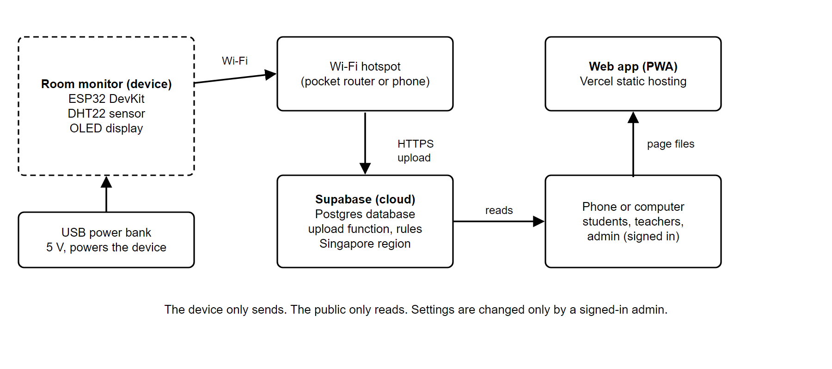
Figure 1. System block diagram of Init
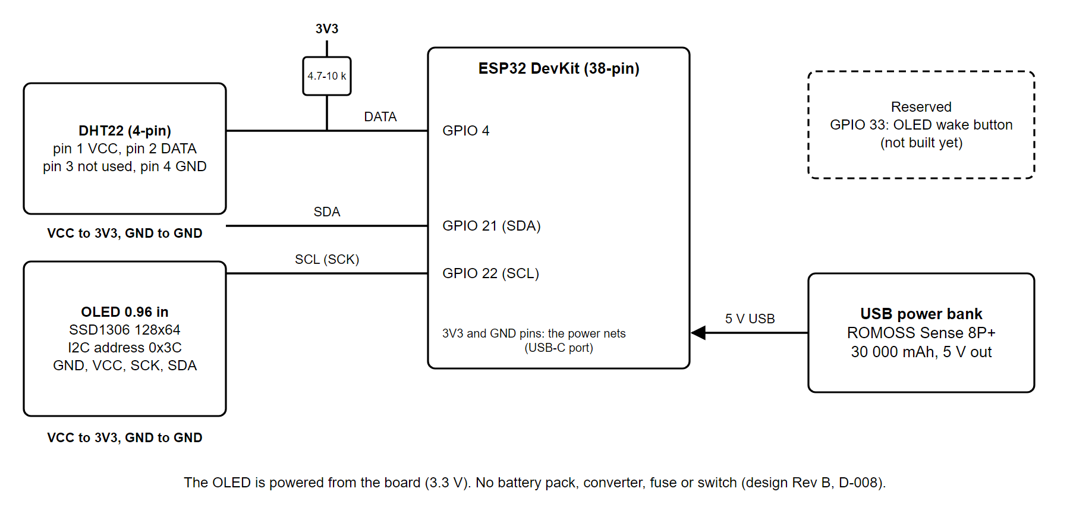
Figure 2. Wiring schematic of the room monitor (Rev B)
2.5 Software Design
The firmware (Figure 3) reads the sensor every 5 seconds, shows the values, keeps unsent readings in a queue of up to 300 (the oldest are dropped first) and sends them in batches of up to 50 over HTTPS about once a minute. It checks the server certificate against built-in root certificates, so a wrong server is refused. The device holds only a secret device key; the server returns the upload interval and the room name in its reply. If no saved Wi-Fi works within 20 seconds, the device opens its own setup page ("Init-Setup") so that a teacher can enter the school Wi-Fi from a phone, and the Wi-Fi password is never stored in the web app (D-011).
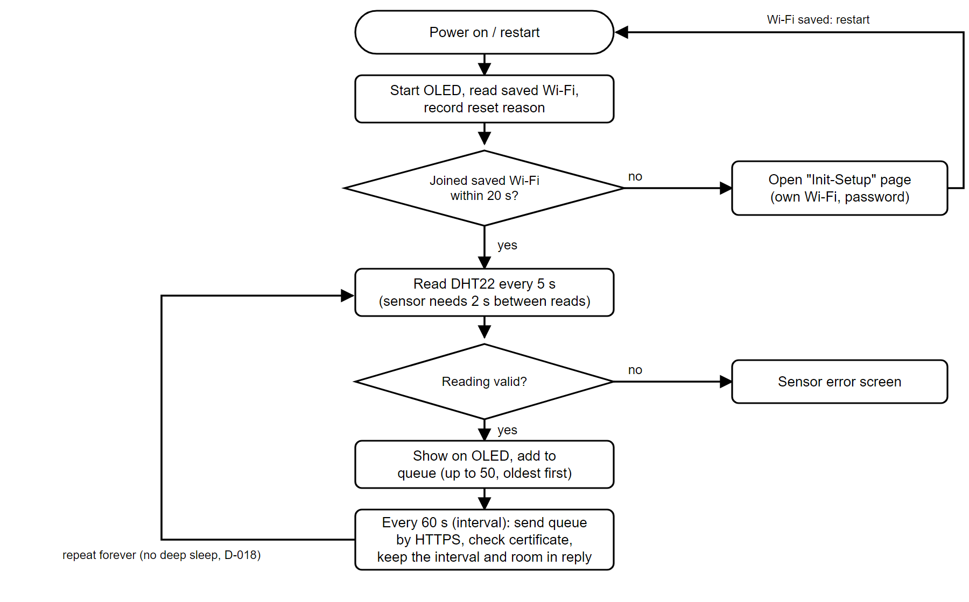
Figure 3. Firmware flowchart
The server side (Figure 4) accepts readings only through one database function. The function checks the device key, the number of readings per call (1 to 50), the ranges (temperature 0 to 60 °C, humidity 0 to 100 %) and the call rate. A bad call is rejected as a whole. The server adds calibration offsets and computes the heat index itself, so a number worked out by the device is never trusted (D-023). Figure 5 shows the tables.
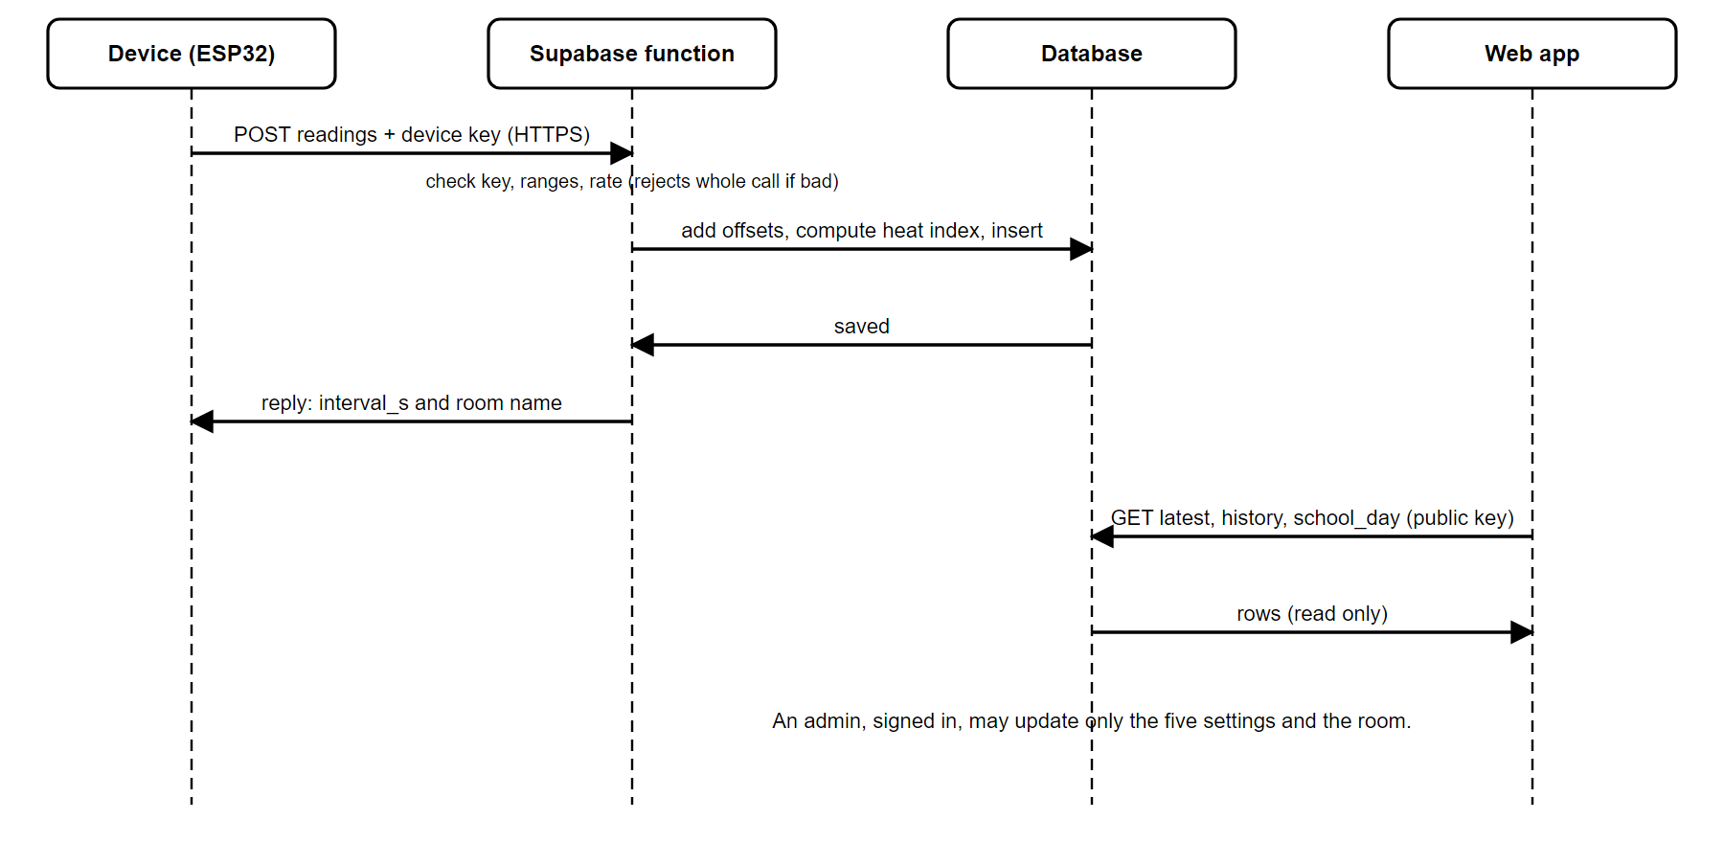
Figure 4. Upload and read sequence between device, cloud and web app
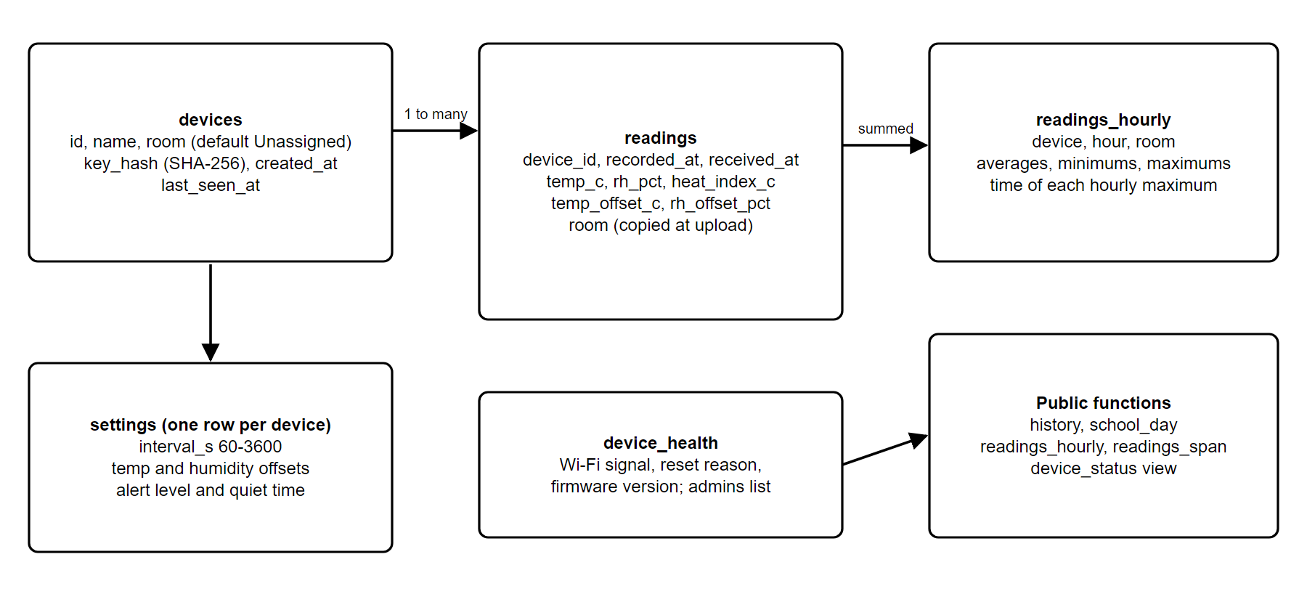
Figure 5. Database tables and functions
The web app (Figure 6) is a single page that anyone can open on a phone. It shows the live card with the PAGASA level and an online/offline badge (offline when the newest reading is more than 120 seconds old), history charts for 24 hours and 7 days, and a school-day summary. Under the history charts, a readings table lets a visitor pick a From and a To day on a calendar (only days that have readings can be picked) and see hourly averages of temperature, humidity and heat index with the PAGASA level, 500 rows at a time, and download the same rows as a CSV file (F-24). The database function that serves it caps one call at 500 rows so that the free tier is not overloaded. The admin page requires sign-in; the server, not the page, decides who may change settings. The admin can type a room name or press Reset, which puts the default name Unassigned in the box; Save writes it (F-23). A device with no room assigned shows Unassigned on the web page and on its own screen.
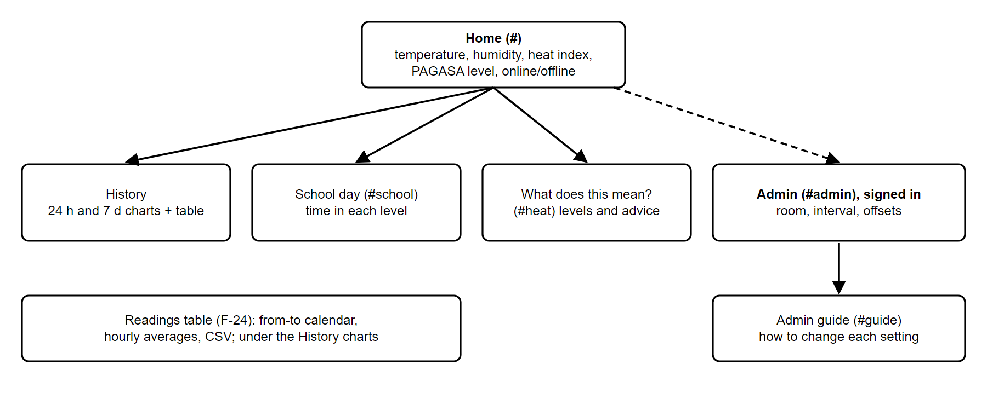
Figure 6. Pages of the web app
2.6 Computing the Heat Index
The heat index is computed from the temperature and relative humidity with the National Weather Service polynomial approach, using the range rule of that method; below the range of the method the value is left empty (D-015, D-020). PAGASA levels are applied to the heat index rounded to a whole degree Celsius: Caution 27 to 32 °C, Extreme caution 33 to 41 °C, Danger 42 to 51 °C and Extreme danger 52 °C and above (Petaca, 2026; D-019). The formula exists in three languages, JavaScript, C++ for the device and SQL for the database, and all three are tested against the same file of expected values.
2.7 Research Procedure
1. Bench bring-up: the DHT22 and OLED were wired to the ESP32 and tested with a throw-away sketch.
2. The heat index function was written test-first and checked against the shared reference table.
3. The database, the secure upload function and the public read rules were built and tested on a separate test project; a "stranger" probe checks that a visitor with only the public key cannot write or read secrets.
4. The firmware was built in steps: upload, OLED screens, offline queue, room name from the server, Wi-Fi setup page and device health report.
5. The web app was built in steps: live card, offline badge, history charts, installable app, school-day view, admin page and guide. Each page was checked against an approved mock-up and then on the hosted page and a phone.
6. A 24-hour run (P03-07) was done on the power bank. The device uploaded about once a minute; the charge of the bank was written down at the start, halfway and the end.
7. The offline rule was checked by unplugging the device and photographing the phone screen after two minutes.
2.8 Research Treatment of Data
Readings were counted and summarised with the minimum, mean and maximum. The expected number of readings in 24 hours at one per minute is 1,440. Gaps are the time between two consecutive readings; any gap over 90 seconds was listed. Hourly means were computed in Philippine time. The share of readings in each PAGASA level was computed from the heat index rounded to a whole degree. No statistical test was applied because there is a single device and a single run.

Chapter 3
Presentation, Analysis, and Interpretation of Data
I. Verification of the Heat Index Calculation
The heat index function was checked in JavaScript, C++ and SQL against one shared reference file. As of the latest full run (3 November 2026, session 27), the full test suite passed 204 of 204 tests, of which the backend tests are 80 of 80. The stranger probe, which acts as a visitor with only the public key, passed 21 of 21 checks against the test project in session 26 and has not been re-run since the two new read-only functions were added. [These numbers are refreshed each session; see Appendix C.]
II. The 24-Hour Run on the Power Bank
The run started on 2 November 2026 at 18:03 Philippine time with the power bank at 100 % and ended on 3 November 2026 at 18:03. It was done in two legs of about 12 hours with a short break between them. The server recorded 1,429 readings of about 1,440 expected (99.2 % of the expected number). The power bank went from 100 % to 95 % and then to 90 %.
Table 4. Summary of the 24-hour run (test project, one device)
Measure | Minimum | Mean | Maximum
Temperature (°C) | 26.6 | 30.1 | 33.0
Relative humidity (%) | 51.0 | 65.9 | 77.4
Heat index (°C) | 27.9 | 34.7 | 43.8

Table 5. Time in each PAGASA level during the run (number of one-minute readings)
PAGASA level (heat index, rounded) | Readings | Share
Caution (27 to 32 °C) | 376 | 26.3 %
Extreme caution (33 to 41 °C) | 1024 | 71.7 %
Danger (42 to 51 °C) | 29 | 2.0 %
Extreme danger (52 °C and above) | 0 | 0.0 %

Most of the time the room was in the extreme caution level (71.7 % of readings) and 29 readings (2.0 %) reached the danger level. The highest heat index was 43.8 °C. Figure 7 and the hourly values (Table 6) show how the room changed through the day: the highest heat index of an hour reached 43.8 °C at 09:00 and the room was coolest between 11 PM and 2 AM. The last hour of the run holds only 4 readings, so it is in Table 6 but not drawn in Figure 7. In Figure 7 the lines of the two top series are different in style so that they can be told apart in a black-and-white print, and the humidity is drawn in a separate panel because it has a different unit.
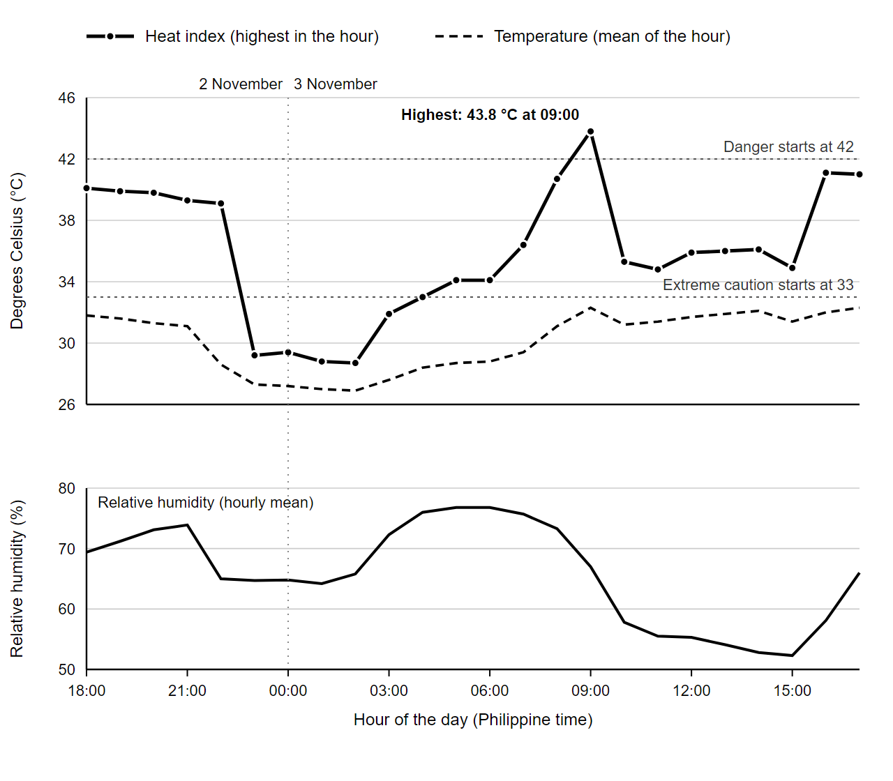
Figure 7. Heat index, temperature and relative humidity in the 24-hour run (hourly values, 2 to 3 November 2026)
Table 6. Hourly values of the 24-hour run (Philippine time)
Hour | Readings | Mean temp (°C) | Mean humidity (%) | Highest heat index (°C)
2026-11-02 18:00 | 56 | 31.8 | 69.4 | 40.1
2026-11-02 19:00 | 59 | 31.6 | 71.2 | 39.9
2026-11-02 20:00 | 60 | 31.3 | 73.1 | 39.8
2026-11-02 21:00 | 60 | 31.1 | 73.9 | 39.3
2026-11-02 22:00 | 60 | 28.6 | 65.0 | 39.1
2026-11-02 23:00 | 60 | 27.3 | 64.7 | 29.2
2026-11-03 00:00 | 57 | 27.2 | 64.8 | 29.4
2026-11-03 01:00 | 60 | 27.0 | 64.2 | 28.8
2026-11-03 02:00 | 60 | 26.9 | 65.8 | 28.7
2026-11-03 03:00 | 60 | 27.6 | 72.3 | 31.9
2026-11-03 04:00 | 60 | 28.4 | 76.0 | 33.0
2026-11-03 05:00 | 60 | 28.7 | 76.8 | 34.1
2026-11-03 06:00 | 54 | 28.8 | 76.8 | 34.1
2026-11-03 07:00 | 60 | 29.4 | 75.7 | 36.4
2026-11-03 08:00 | 60 | 31.1 | 73.3 | 40.7
2026-11-03 09:00 | 60 | 32.3 | 67.0 | 43.8
2026-11-03 10:00 | 60 | 31.2 | 57.8 | 35.3
2026-11-03 11:00 | 60 | 31.4 | 55.5 | 34.8
2026-11-03 12:00 | 60 | 31.7 | 55.3 | 35.9
2026-11-03 13:00 | 60 | 31.9 | 54.1 | 36.0
2026-11-03 14:00 | 60 | 32.1 | 52.8 | 36.1
2026-11-03 15:00 | 59 | 31.4 | 52.3 | 34.9
2026-11-03 16:00 | 60 | 32.0 | 58.1 | 41.1
2026-11-03 17:00 | 60 | 32.3 | 66.0 | 41.0
2026-11-03 18:00 | 4 | 31.9 | 68.0 | 39.5

Only 2 gaps longer than 90 seconds were found: 220 seconds and 385 seconds. The 385-second gap is the break between the two legs. The cause of the other gap has not yet been found; the firmware now reports why it restarted (power-on, brown-out, crash or watchdog) so that the next run can show it (P03-07 follow-up).
III. Offline Check and Power Bank Behaviour
When the device was unplugged, the hosted page showed "Offline: no reading for 2 min" in the owner's phone screenshot taken at two minutes. In an earlier test on the power bank, uploads every 90 seconds made the bank switch itself off after about a minute, while uploads every 60 seconds ran for 10 minutes and then for the full 24 hours. For this bank the interval therefore has to stay at 60 seconds (D-027).
IV. Features Built and Verified
Table 7. Progress of the project by phase (project table, 3 November 2026)
Phase | Done / Total | %
P00 Kickoff and decisions | 13 / 13 | 100
P01 Heat index core and bench bring-up | 7 / 7 | 100
P02 Backend and secure upload | 7 / 7 | 100
P03 Device firmware | 10 / 10 | 100
P04 Web app core | 12 / 13 (+1 partly) | 92
P05 Admin, alerts and device health | 3 / 7 (+3 partly) | 43
P06 Display and sharing extras | 0 / 5 | 0
P07 Field trial and hardening | 0 / 7 | 0
P08 Over-the-air updates (optional) | 0 / 3 | 0
Whole project | 52 / 72 | 72

V. Not Yet Done
• Comparison of the DHT22 with a reference thermometer and hygrometer (sensor accuracy).
• Push alerts to phones and the live-project admin account.
• The calendar readings table (F-24) is built and tested; the owner confirmed on 3 November 2026 that on the hosted page it picks days, shows hourly rows and downloads a CSV. The live project has no readings yet, so the table there says "No readings yet".
• Reset room to Unassigned (F-23) was seen working on 3 November 2026: an admin saved a room name, the page and the OLED showed it, then Reset and Save put the room back to Unassigned on both (screenshots by the owner). The firmware default Unassigned is flashed on the board.
• A school day with several levels seen on a phone, and the installed app on an iPhone.
• The cause of the 220-second gap in the run, and a run in a real classroom (phase P07).

References
• Kirkil, G. (2025). Effects of classroom temperature and humidity on student learning performance: an experimental study using sensor-based monitoring. Frontiers in Built Environment, 11, Article 1678438. https://doi.org/10.3389/fbuil.2025.1678438
• Lu, Y.-C., & Romps, D. M. (2022). Extending the Heat Index. Journal of Applied Meteorology and Climatology, 61(10), 1367-1383. https://doi.org/10.1175/JAMC-D-22-0021.1
• Petaca, M. A. (2026, April 22). Heat index monitoring and early warning system of DOST-PAGASA [Slide presentation]. DOST-PAGASA, Climatology and Agrometeorology Division. https://pubfiles.pagasa.dost.gov.ph/climps/climateforum/special_lecture.pdf
• Philippine Atmospheric, Geophysical and Astronomical Services Administration. (2024, April 12). Official statement on creating extreme heat protocol [Press release]. DOST-PAGASA. https://www.pagasa.dost.gov.ph/index.php/press-release/155
• Tzintzun, I., Schwarz, L., Lawrence, A., & Thomas, M. (2026). Effects of extreme temperature exposure on learning (ADB Economics Working Paper Series No. 866). Asian Development Bank. https://www.adb.org/sites/default/files/publication/1185876/ewp-866-extreme-temperature-exposure-learning.pdf
• Wardani, I. K., Ichniarsyah, A. N., Telaumbanua, M., Priyonggo, B., Fil’aini, R., Mufidah, Z., & Dewangga, D. A. (2023). The feasibility study: Accuracy and precision of DHT 22 in measuring the temperature and humidity in the greenhouse. IOP Conference Series: Earth and Environmental Science, 1230(1), Article 012146. https://doi.org/10.1088/1755-1315/1230/1/012146
• Widjaja, M., Halim, D. K., & Andarini, R. (2022). The development of an IoT-based indoor air monitoring system towards smart energy efficient classroom. Ultima Computing: Jurnal Sistem Komputer, 14(1), 28-35. https://doi.org/10.31937/sk.v14i1.2565

Appendices
undefined
Appendix A. Pin list of the room monitor
Table A1. Connections
ESP32 pin | Connected to | Note
3V3 | DHT22 pin 1 (VCC) | and the pull-up resistor
GPIO 4 | DHT22 pin 2 (DATA) | 4.7 to 10 kΩ pull-up to 3V3
GPIO 21 | OLED SDA | I2C
GPIO 22 | OLED SCL (SCK) | I2C
GND | DHT22 pin 4, OLED GND
GPIO 33 | reserved | OLED wake button, not built
USB-C | USB power bank | 5 V

Appendix B. Database settings and limits
Table B1. Settings the admin can change
Setting | Allowed range
Upload interval | 60 to 3600 s (60 s for the power bank)
Temperature offset | -5.0 to +5.0 °C
Humidity offset | -10.0 to +10.0 %
Alert heat index | 27 to 60 °C
Alert quiet time | 10 to 1440 min
Room name | up to 12 characters

Appendix C. Tests and checks
• Full suite (3 November 2026): 204 of 204 passed; backend tests 80 of 80; stranger probe 21 of 21 on the test project (session 26). The numbers are refreshed each session.
• Page checks compare the built page with approved mock-ups pixel by pixel in Chromium at phone width, in light and dark mode.
• The 24-hour data in Chapter 3 are saved in the project folder paper/data as JSON files.
Appendix D. Project decisions
The numbered decisions (D-001 to D-034) referred to in this paper are kept in the project file documentation/DECISIONS.md with the date and the reason for each.

