Exercises-2 (Divide and Conquer)
- Write a Java program using the divide-and-conquer approach to find the maximum element in an array, ensuring that the algorithm has a time complexity of O(n). The program should use recursion to break the problem into smaller subproblems and return the largest element. Test your program with a sample array.

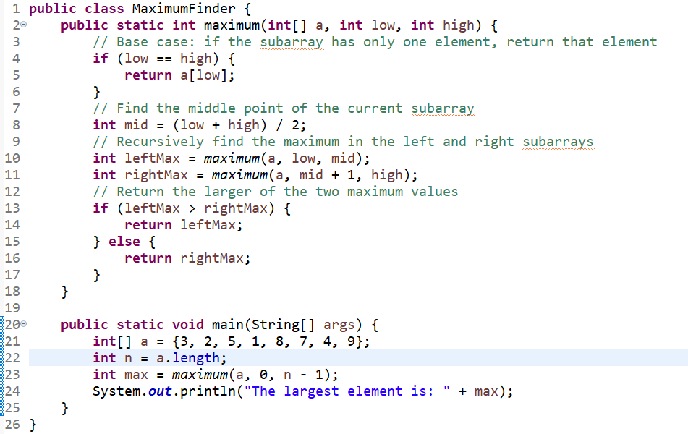

- Write a Java program using the divide-and-conquer approach to find a peak element in an array. A peak element is one that is greater than its neighbors. If there are multiple peak elements, return any one of them. Your program should have a time complexity of O(log n). Implement the solution using recursion and divide the array into halves. Test your program with different input arrays to verify the correctness of the peak element.

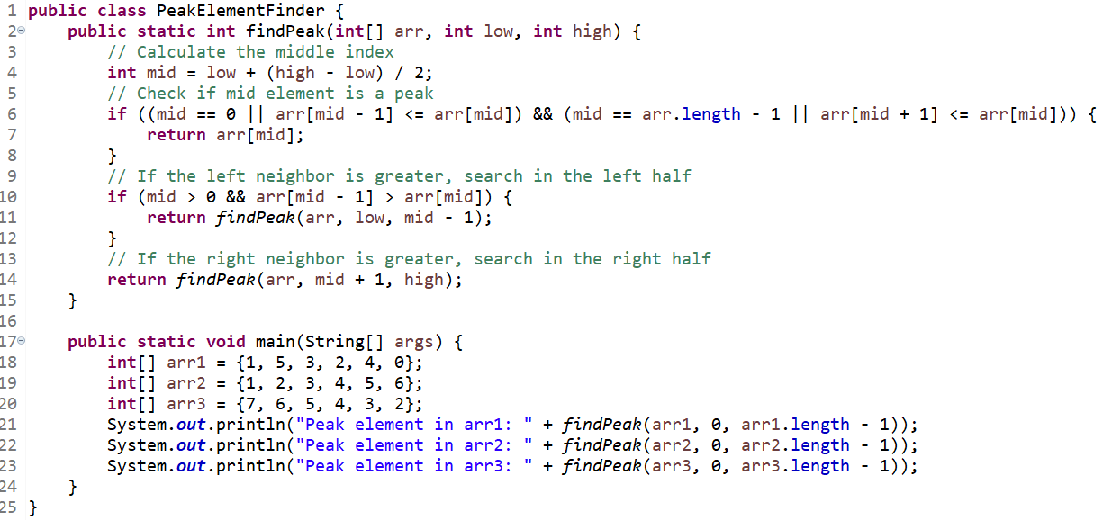

- Write a Java program using a divide-and-conquer approach to find the maximum difference between any two elements in a given array of n numbers (not necessarily distinct). The program should run in O(n) time.

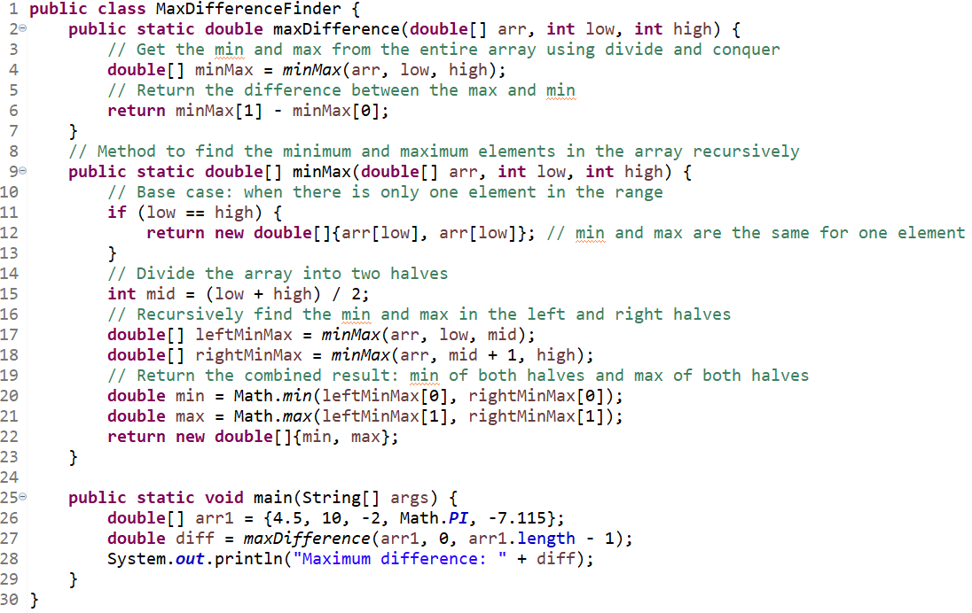

- Write a Java program to find the kth smallest element in an unsorted array of integers. The algorithm must run in O(n) in the average case, not O(n log n) or O(k log n). The algorithm can be inspired by the Quick Sort algorithm.

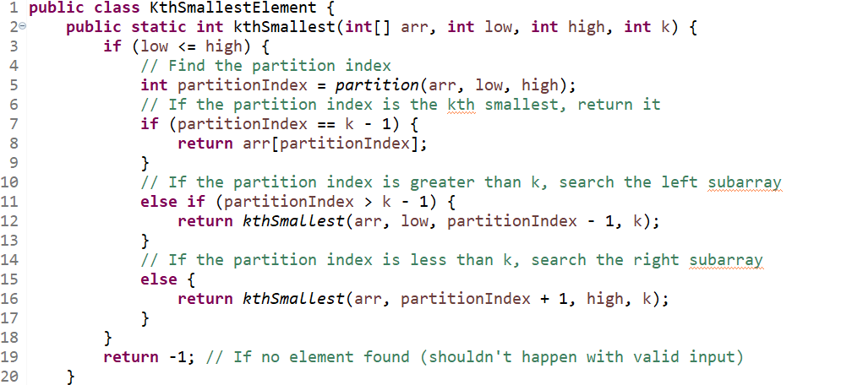
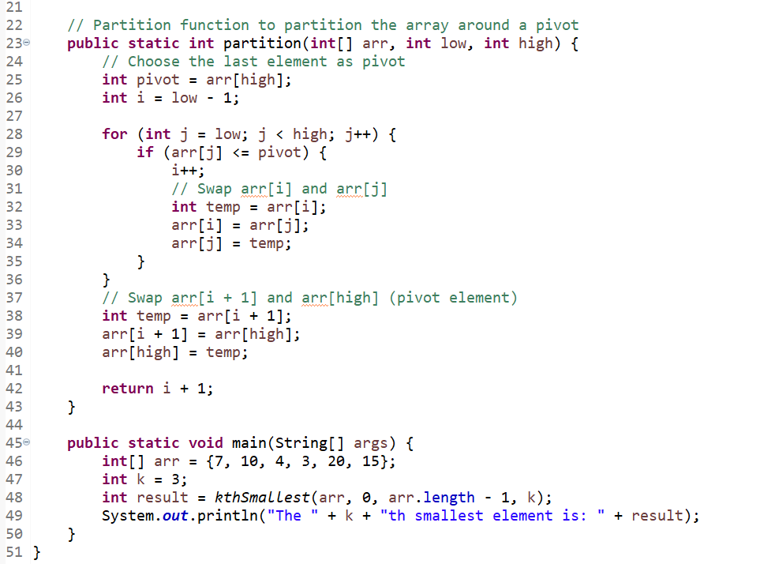

- Write a Java program that searches a sorted list of n items by dividing it into three sublists of almost n/3 items. The algorithm finds the sublist that might contain the given item and divides it into three smaller sublists of almost equal size. The algorithm repeats this process until it finds the item or concludes that the item is not in the list. The Java program and the corresponding function(s) should be flexible enough to deal with different cases and example data should be provided in the main function of this Java program to check its correctness. You must use the divide and conquer strategy to solve this problem. Hints (for example): The algorithm that will find the location of the search key (e.g., key) in ‘Array’ must return 0 if the key is not in the Array. If the key is in the Array, the function will return its location.

