**UNIVERSITY OF HERTFORDSHIRE**

**School of Physics, Engineering and Computer Science**

**Week 1: Roles Allocation and Initial Setup (Commencing 08/04)**

**Role Allocation:**

Programmer: Alvin

Tester: Aarya

Documenter: Hritik

Designer:Sahil

**Week 1: Initial Setup and Development (Commencing 08/04)**

**Tasks:**

Alvin: Create the fundamental project framework.

Aarya: Make the first test cases for the fundamental functionality that has been implemented.

Hritik: Make a GitHub file and begin recording the project's needs and set up a Kanban board.

Sahil: Create initial user interface designs.

**Documentation:**

**Communication:**

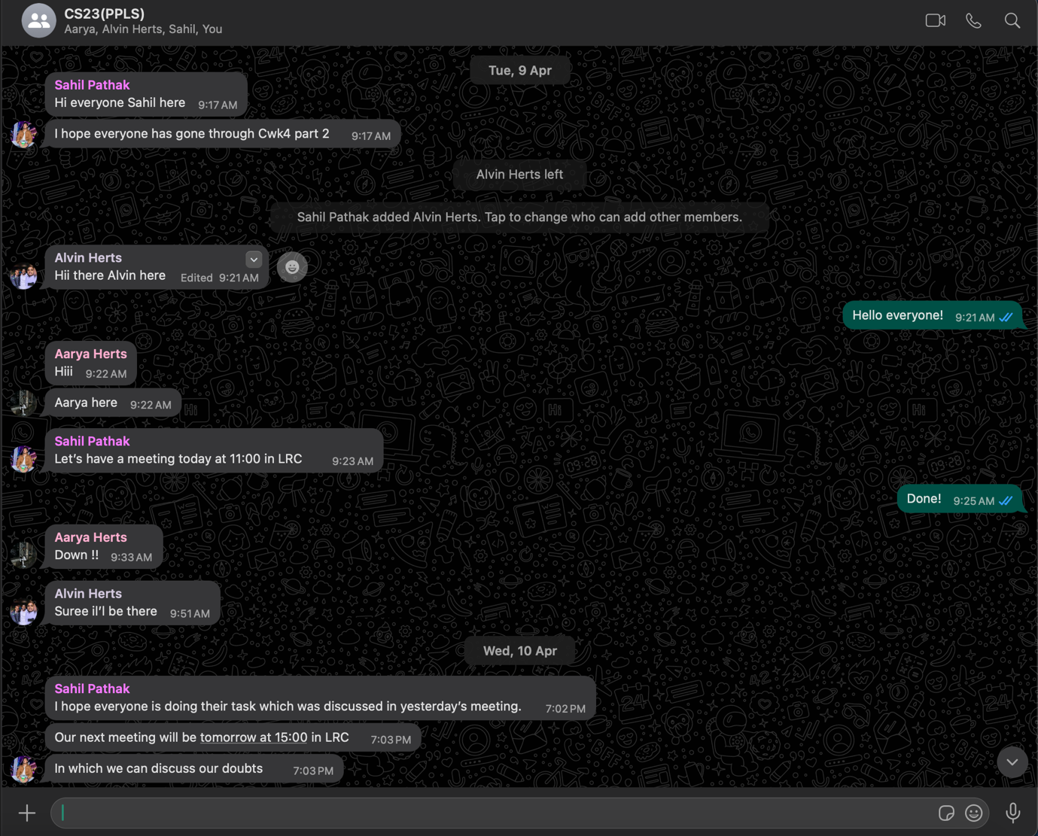

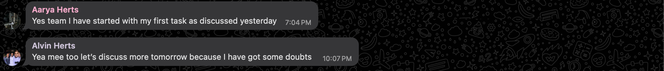Figure 1 - Screenshot of a conversation where the team discussed.

**Kanban:**

Figure 2 - Screenshot of the Kanban board showing tasks assigned for Week 1.

**Repository:**

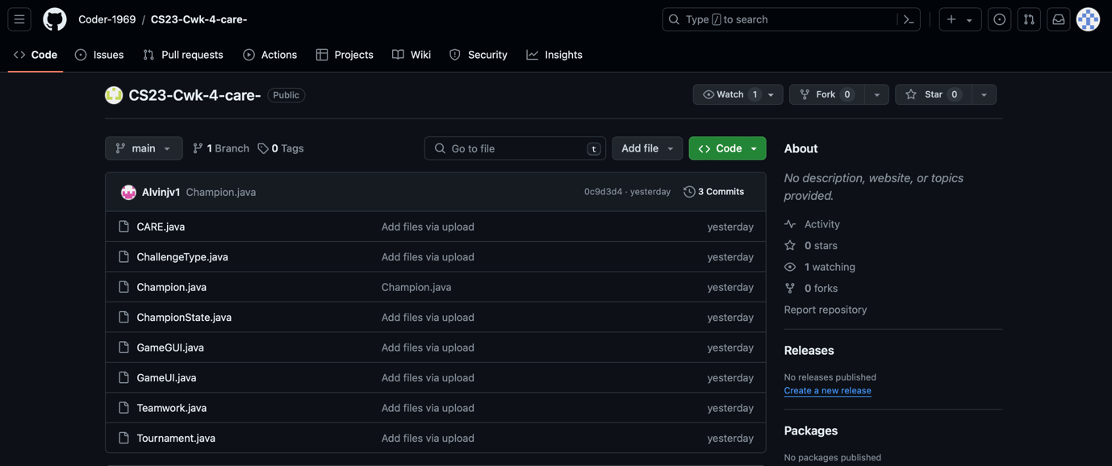

Figure 3: Screenshot of the repository showing commits by team members.

**Week 2: Development and Progress (Commencing 15/04)**

**Tasks:**

Alvin: Add extra features in accordance with the initial configuration.

Aarya: Perform testing on the newly implemented features and cooperate for coding.

Hritik: Update project documentation to reflect new functions and changes and interact for GUI.

Sahil: Complete the GUI designs based on the input from the first week.

**Documentation:**

**Communication:**

Figure 4: Screenshot of a team discussion on progress and challenges.

**Kanban:**

Figure 5: Updated screenshot of the Kanban board showing progress.

**Week 3: Finalization and Review (Commencing 22/04)**

**Tasks:**

Alvin: Complete the coding and make sure every feature is applied properly.

Aarya: Conduct final testing to confirm that the project satisfies the specifications.

Hritik: Complete all project documentation.

Sahil: Give the finished design assets and make sure they are applied properly.

**Documentation:**

**Communication:**

Final screenshot of team communication discussing project completion.

**Kanban:**

Figure 6: Final screenshot of the Kanban board showing completed tasks.