**MONGODB-COMMANDS-**

**3. CRUD Operations**

* Create (InsertOne Student,Course)

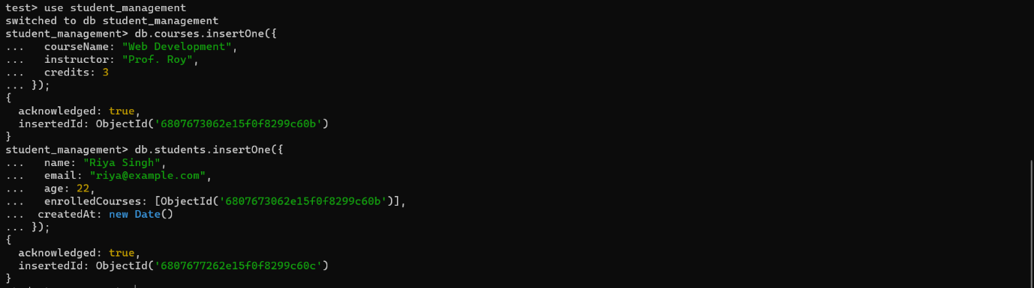

* Read

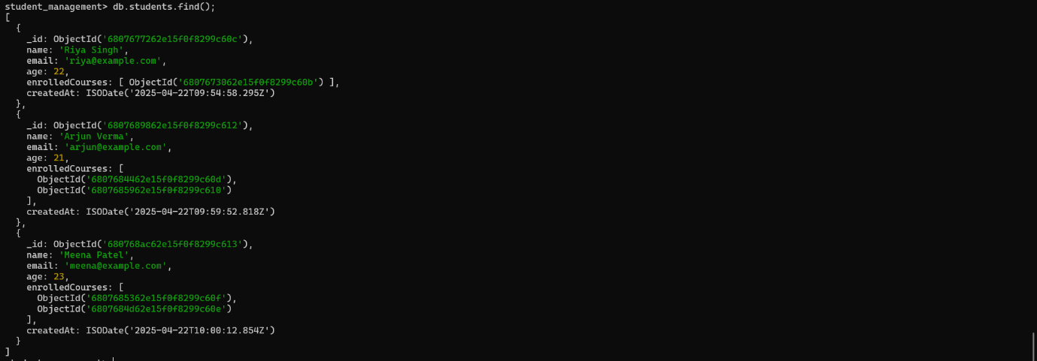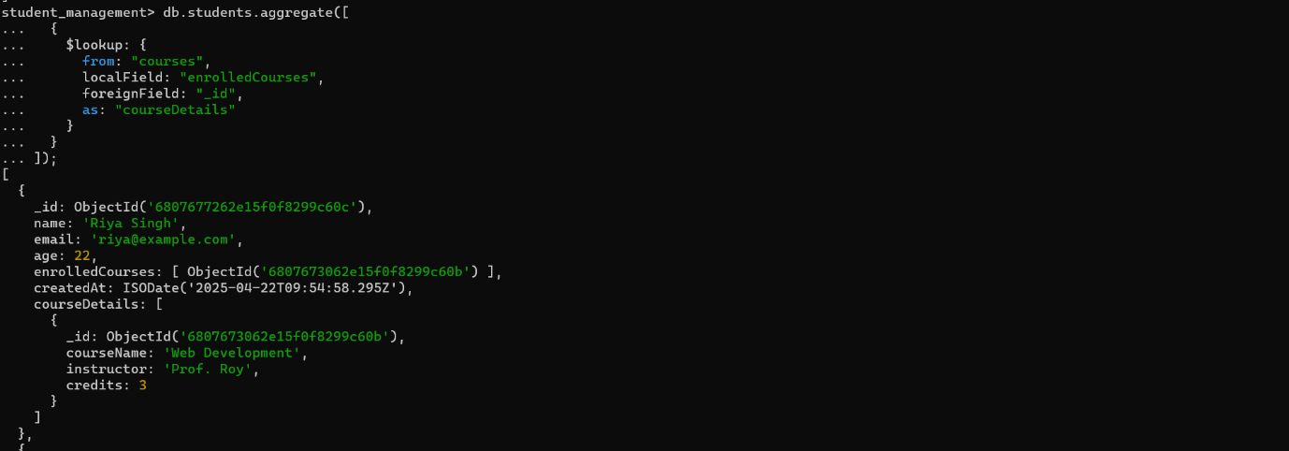

* Update

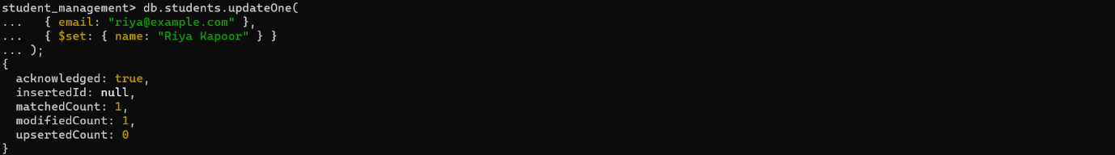

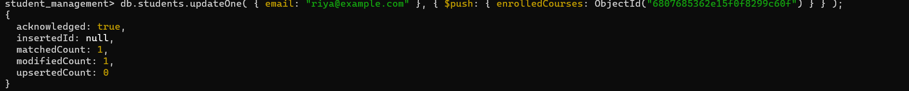

* Delete



**4. INDEXING**



**5.RELATIONSHIPS**



