**VIT-AP UNIVERSITY, ANDHRA PRADESH**

**CSE3003 – Computer Networks - Lab Sheet: 11**

**Academic year:** 2023-2024  **Branch/ Class:** B.Tech

**Semester:** Fall  **Date:**

**Faculty Name:** Prof. S.Gopikrishnan  **School:** SCOPE

**Student name:Aman Sahu Reg. no.:22BCE7224**

**SMTP Server**

**Q1:**

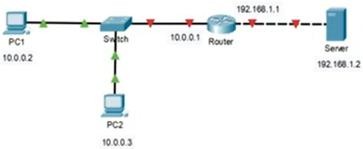

**Objectives:**

1. Design a network as given in the figure.
2. Configure all the routers with any routing scheme.
3. Configure all the servers.
4. Verify the SMTP server is working.

**Verification and expected output:**

1. Send a text email from PC1 to PC2 and Vice versa.
2. Take the screenshot of SMTP EMAIL configuration

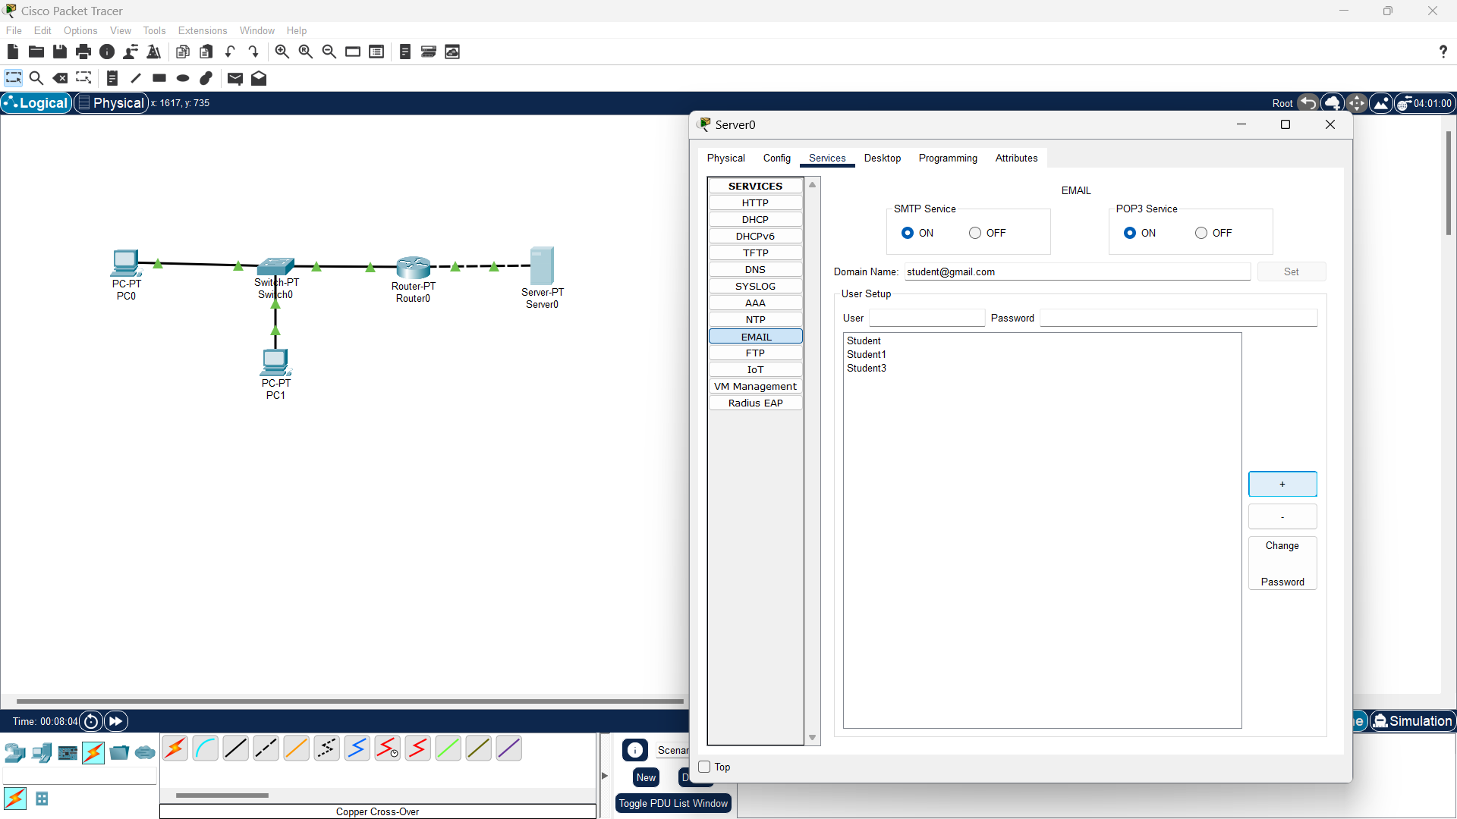

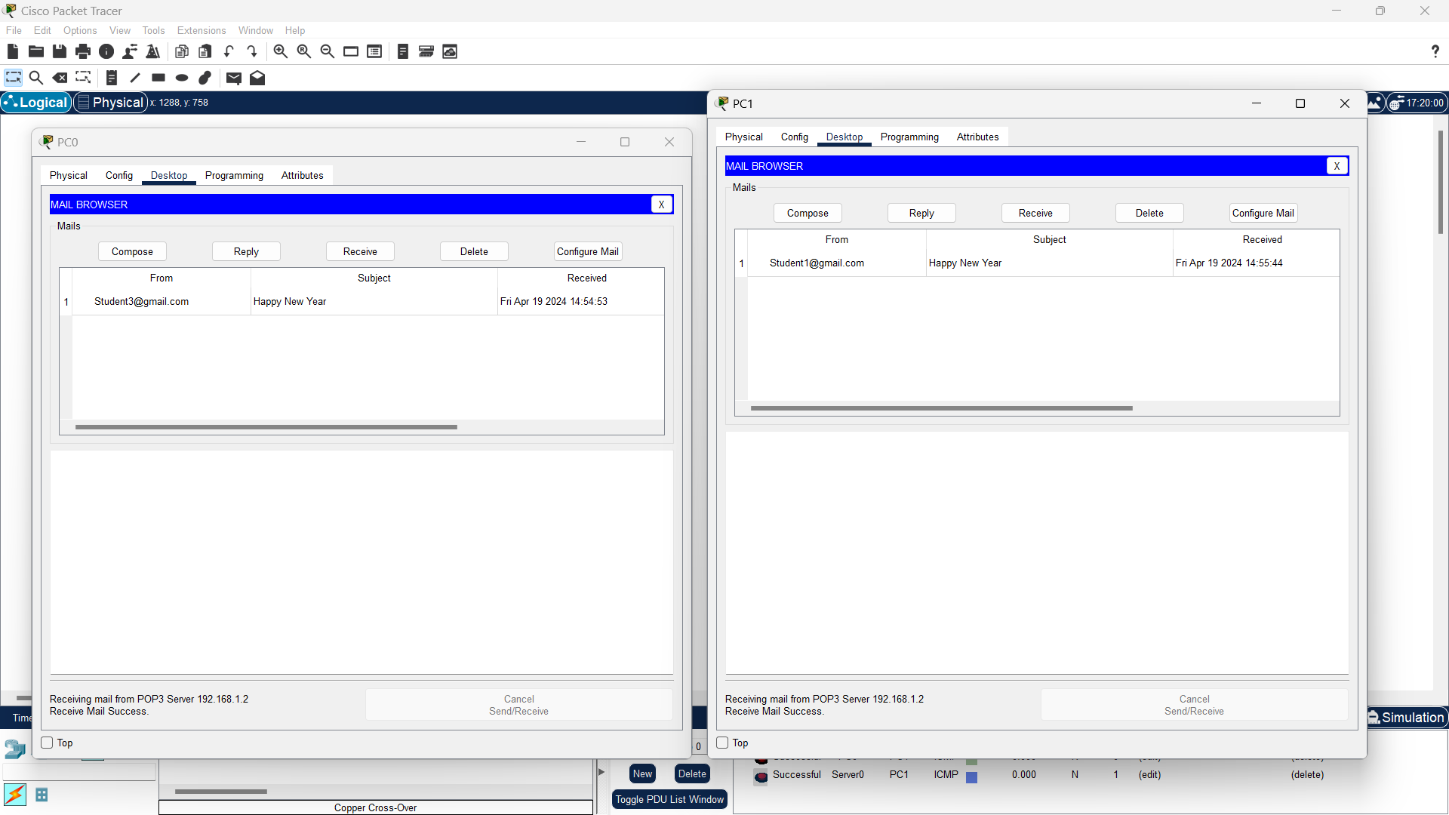

**Tunnelling**

**Q2:**

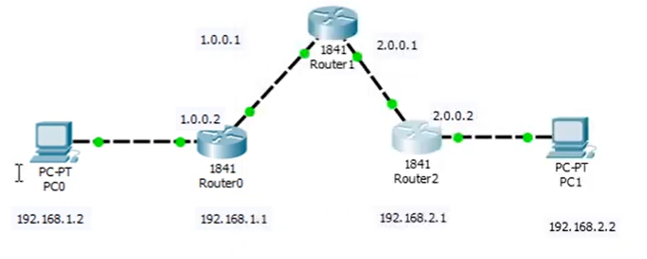

**Objectives:**

1. Design a network as given in the figure.
2. Configure all the routers with any routing scheme.
3. Configure all the servers.
4. Verify the Tunnelling is working.

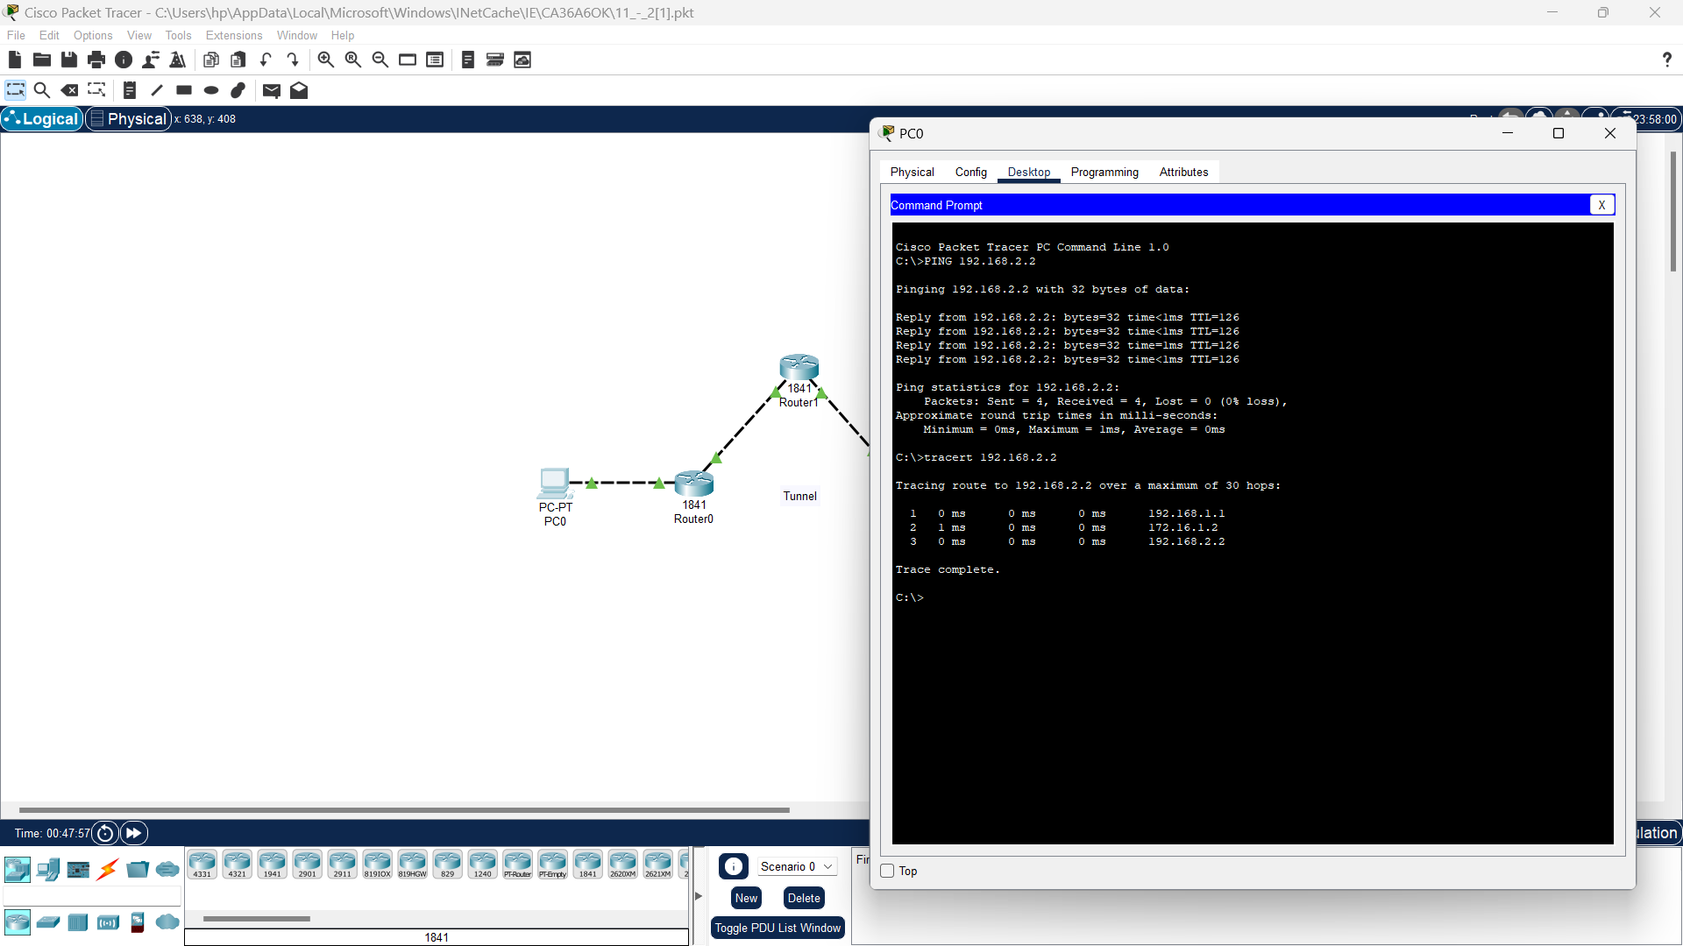

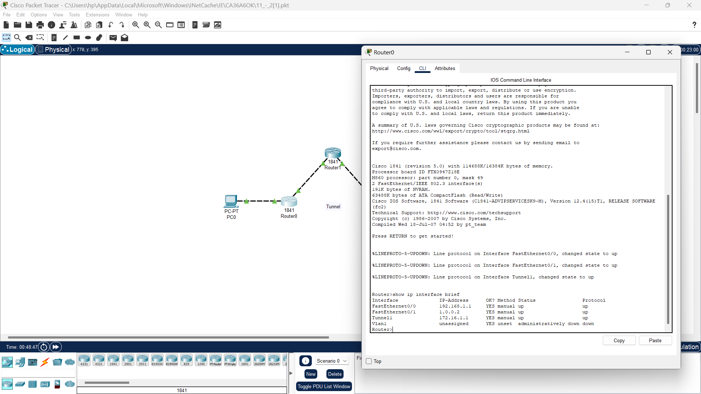

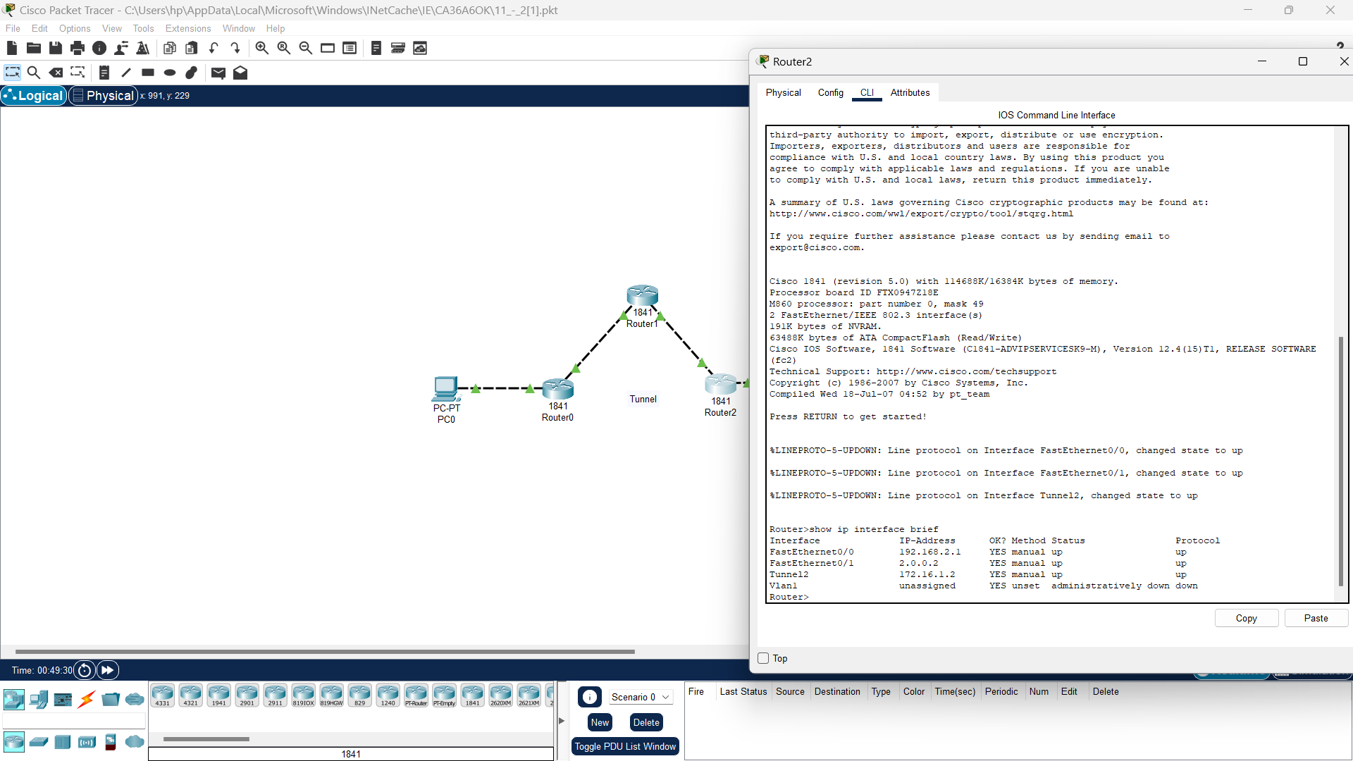

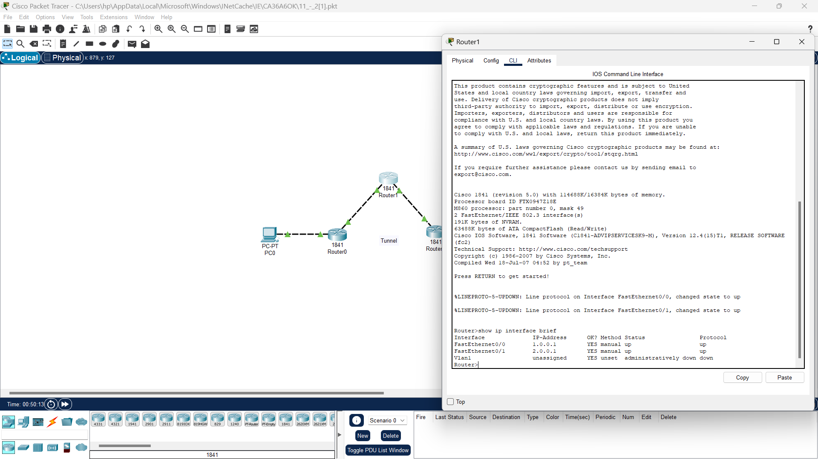

**IPSec VPN**

**Q3:**

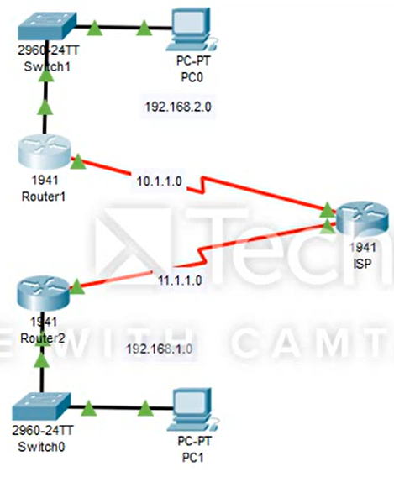

**Objectives:**

1. Design a network as given in the figure.
2. Configure all the routers with any routing scheme.
3. Configure all the servers.
4. Verify the IPSec VPN is working.

