**VIT-AP UNIVERSITY, ANDHRA PRADESH**

**CSE3003 – Computer Networks - Lab Sheet: 2**

**Academic year:** 2023-2024  **Branch/ Class:** B.Tech

**Semester:** Fall  **Date:** 19.01.24

**Faculty Name:** Prof. S.Gopikrishnan  **School:** SCOPE

**Student name:** Aman Sahu **Reg. no.:** 22BCE7224

**LAB 2**

1. **Design a LAN network using a Single Switch.**

Objectives:

1. Design a LAN using two switches with four PCs.

2. Verify the connectivity.

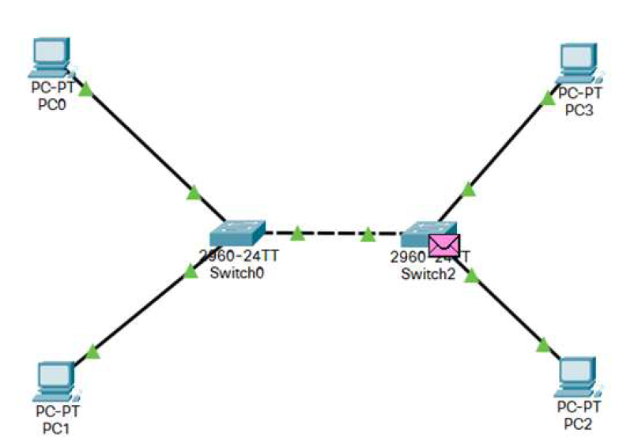

**Addressing Table:**

|  |  |  |  |
| --- | --- | --- | --- |
| **Device** | **Interface** | **IP Address** | **Subnet Mask** |
| PC0 | NIC | 192.172.16.1 | 255.255.255.0 |
| PC1 | NIC | 192.172.16.2 | 255.255.255.0 |
| PC2 | NIC | 192.172.16.3 | 255.255.255.0 |
| PC3 | NIC | 192.172.16.4 | 255.255.255.0 |
| PC4 | NIC | 192.172.16.5 | 255.255.255.0 |

**Procedure:**

* Take 4 Pc’s and two switches and connect them with a copper straight-Through and then connect the both Switches with Copper Cross-Over.
* Now configure each pc with their IP address
* Now send a packet from onside of the switch to the other side of the switch.
* Now run the simulation.

**Solution:**

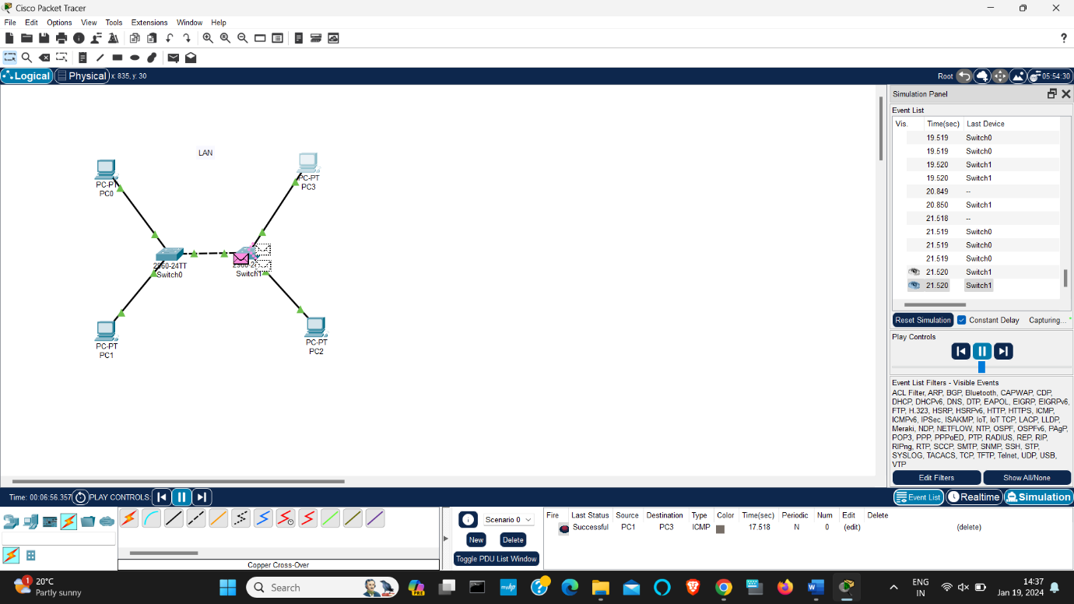

1. **Design a MAN network using a Single Router and Configure Router with CLI Mode.**

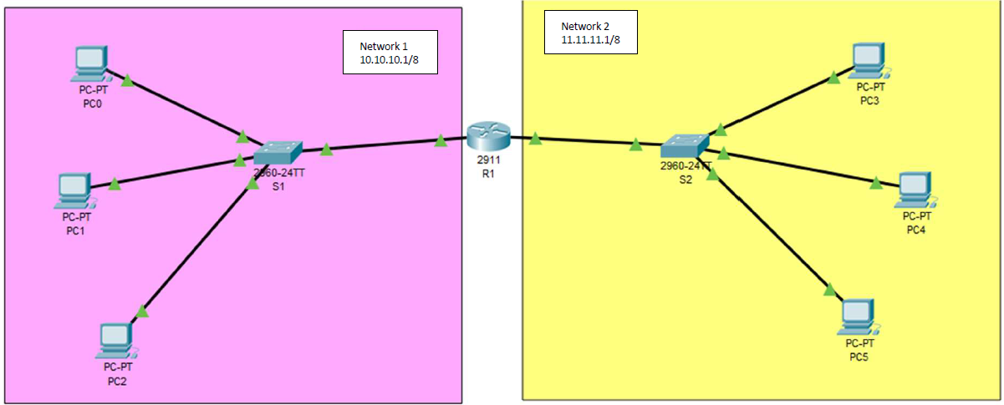

**Objectives:**

1. Design two LAN using two switches with three PCs each.

2. Add one Router to connect two LAN networks

3. Verify the connectivity.

**Addressing Table:**

|  |  |  |  |
| --- | --- | --- | --- |
| **Device** | **Interface** | **IP Address** | **Subnet Mask** |
| PC0 | NIC | 10.10.10.2 | 255.0.0.0 |
| PC1 | NIC | 10.10.10.3 | 255.0.0.0 |
| PC2 | NIC | 10.10.10.4 | 255.0.0.0 |
| PC3 | NIC | 11.11.11.2 | 255.0.0.0 |
| PC4 | NIC | 11.11.11.3 | 255.0.0.0 |
| PC5 | NIC | 11.11.11.4 | 255.0.0.0 |
| Router 1 (LAN 1) | NIC | 10.10.10.1 | 255.0.0.0 |
| Router 1 (LAN 2) | NIC | 11.11.11.1 | 255.0.0.0 |
| LAN1 | NIC | 10.10.10.0 | 255.0.0.0 |
| LAN2 | NIC | 11.11.11.0 | 255.0.0.0 |

**Procedure:**

* Consider 5 PC’s and 5 Switches
* Connect them as shown in figure.
* No configure each PC as shown in addressing table.
* Now send the packet from one end to the other node of the terminal.

**Solution;**

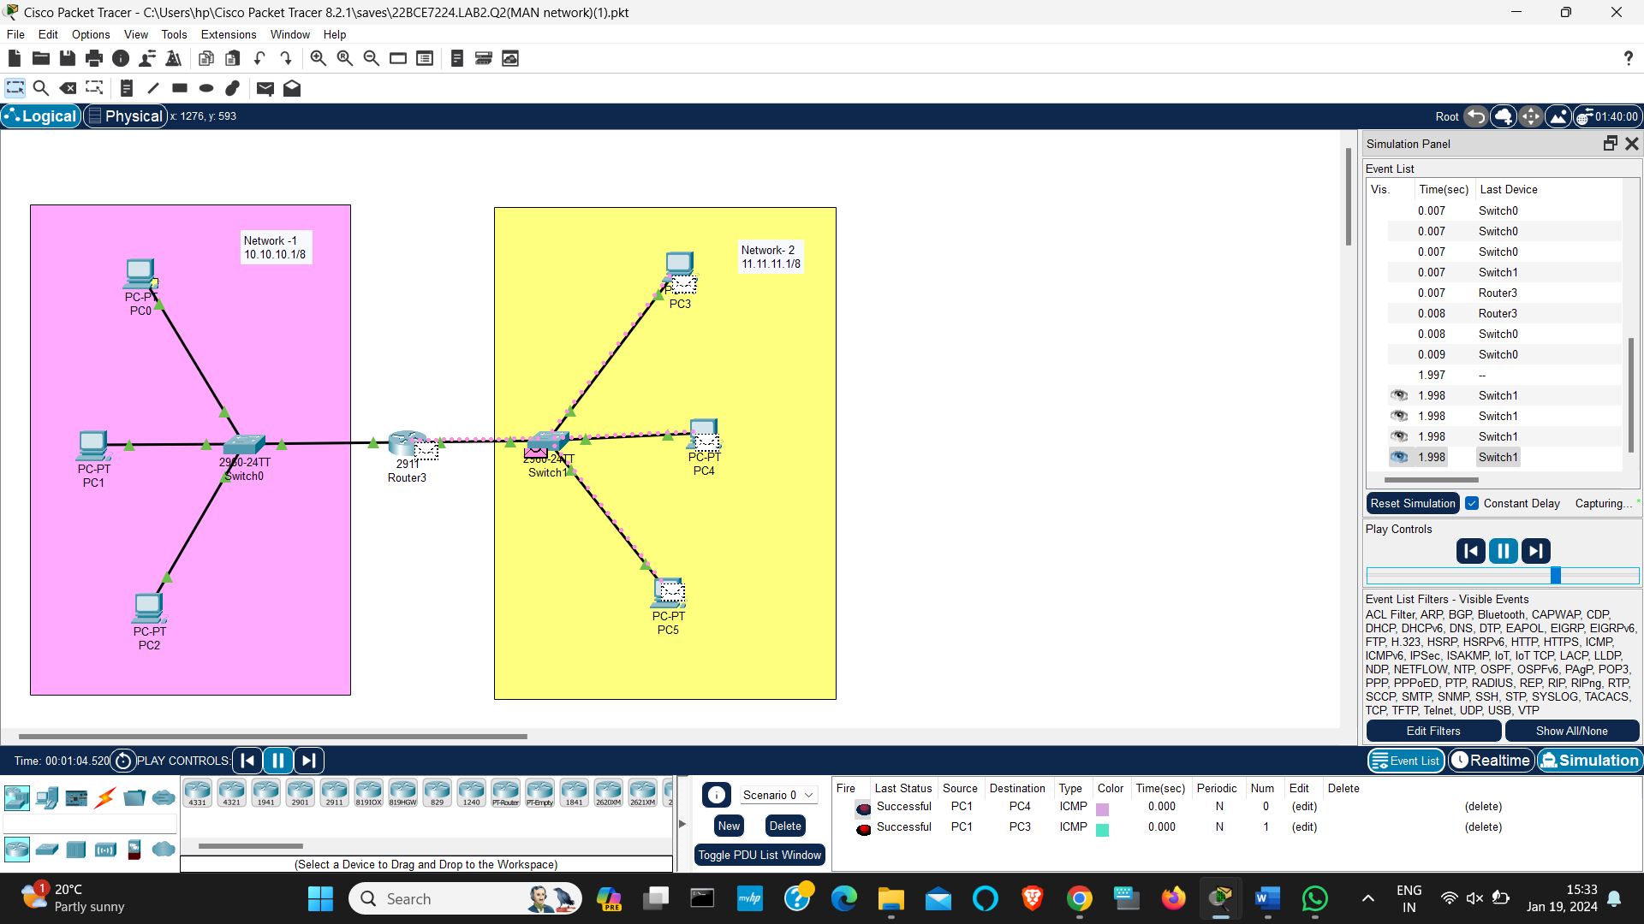

1. **Design a LAN network using DNS & Web Server.**

**Objectives:**

1. Design a LAN using switches with PCs (Wired and Wireless).
2. Connect LAN with routers
3. Host a web server and DNS Server
4. Create a website for vit.ac.in in PC4 and access it from PC2

**Addressing Table:**

|  |  |  |  |
| --- | --- | --- | --- |
| **Device** | **Interface** | **IP Address** | **Subnet Mask** |
| PC0 | NIC | 192.168.10.1 | 255.255.255.0 |
| PC1 | NIC | 192.168.10.2 | 255.255.255.0 |
| PC2 | NIC | 192.168.10.3 | 255.255.255.0 |
| PC3 | NIC | 192.168.20.1 | 255.255.255.0 |
| PC4 | NIC | 192.168.20.2 | 255.255.255.0 |
| PC5 | NIC | 192.168.20.3 | 255.255.255.0 |
| WebServer | NIC | 192.168.30.1 | 255.255.255.0 |
| DNS | NIC | 192.168.40.1 | 255.255.255.0 |

Solution:

