**CSE2007 DBMS LAB**

**SLOT: L39+L40**

**NAME - AMAN SAHU**

**REG. NO – 22BCE7224**

**EXERICE NO.-10**

1.Develop PL/SQL procedures to find the following:

i. Is given number Palindrome or not.(The procedure should return True or False)

declare

n number;

m number;

temp number:=0;

rem number;

begin

n:=5432112345;

m:=n;

while n>0

loop

rem:=mod(n,10);

temp:=(temp*10)+rem;

n:=trunc(n/10);

end loop;

if m = temp

then

dbms_output.put_line('true');

else

dbms_output.put_line('false');

end if;

end;

/

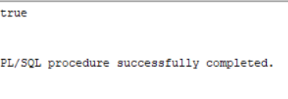

ii. Sum of N natural numbers.(The Procedure should return sum)

DECLARE

sumVal NUMBER;

n NUMBER;

i NUMBER;

FUNCTION Findmax(n IN NUMBER)

RETURN NUMBER

IS

sums NUMBER := 0;

BEGIN

FOR i IN 1..n

LOOP

sums := sums + i*(i+1)/2;

END LOOP;

RETURN sums;

END;

BEGIN

n := 8;

sumVal := findmax(n);

dbms_output.Put_line('Sum of natural numbers is ' || sumVal);

END;

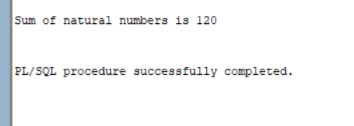

iii. Fibonacci Series.(The procedure should return last number in the series)

declare

first number := 0;

second number := 1;

temp number;

n number := 5;

i number;

begin

dbms_output.put_line('Series:');

dbms_output.put_line(first);

dbms_output.put_line(second);

for i in 2..n

loop

temp:=first+second;

first := second;

second := temp;

dbms_output.put_line(temp);

end loop;

end;

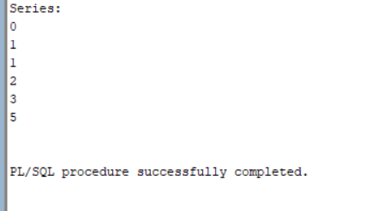

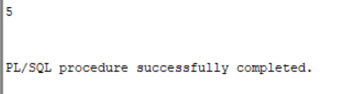

iv. Is a number perfect or not.(The procedure should return True or False)

SET SERVEROUTPUT ON

DECLARE

n NUMBER := &input_number;

tot NUMBER := 0;

BEGIN

FOR i IN 1..n/2 LOOP

IF MOD(n, i) = 0 THEN

tot := tot + i;

END IF;

END LOOP;

IF tot = n THEN

DBMS_OUTPUT.PUT_LINE('True');

ELSE

DBMS_OUTPUT.PUT_LINE('False');

END IF;

END;

/

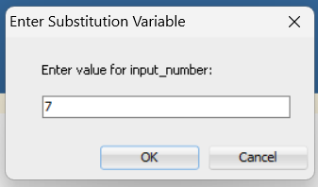

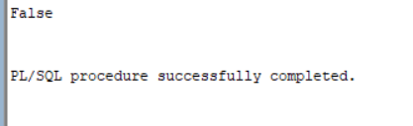

v. Calculate the net salary and year salary if DA is 30% of basic, HRA is 10% of basic and PF is 7% if basic salary is less than 8000, PF is 10% if basic salary between 8000 to 160000.Basic salary is available in employee table.

DECLARE

v_da NUMBER(7,2);

v_hra NUMBER(7,2);

v_pf NUMBER(7,2);

v_net_salary NUMBER(7,2);

v_year_salary NUMBER(10,2);

v_basic_salary NUMBER(7,2);

BEGIN

FOR rec IN (SELECT SAL FROM emp)

LOOP

v_basic_salary := rec.sal;

v_da := v_basic_salary * 0.3;

v_hra := v_basic_salary * 0.1;

IF v_basic_salary < 8000 THEN

v_pf := v_basic_salary * 0.07;

ELSE

v_pf := v_basic_salary * 0.1;

END IF;

v_net_salary := v_basic_salary + v_da + v_hra - v_pf;

v_year_salary := v_net_salary * 12;

DBMS_OUTPUT.PUT_LINE('Employee Number: ' || rec.sal);

DBMS_OUTPUT.PUT_LINE('Net Salary: ' || v_net_salary);

DBMS_OUTPUT.PUT_LINE('Year Salary: ' || v_year_salary);

END LOOP;

END;

/

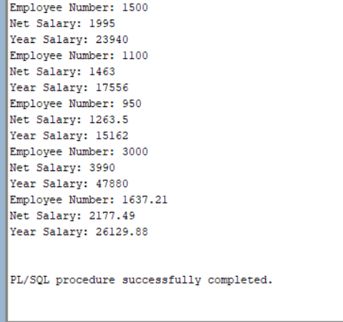

2.Develop PL/SQL functions to do the following:

i. Factorial of a Number.

declare

fac number :=1;

n number := &1;

begin

while n > 0 loop

fac:=n*fac;

n:=n-1;

end loop;

dbms_output.put_line(fac);

end;

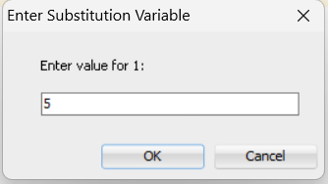

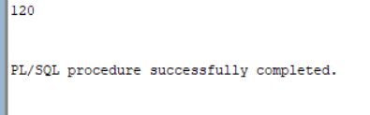

ii. n C r

CREATE OR REPLACE FUNCTION combination(n IN NUMBER, r IN NUMBER)

RETURN NUMBER IS

fact_n NUMBER := 1;

fact_r NUMBER := 1;

fact_nr NUMBER := 1;

result NUMBER;

BEGIN

FOR i IN 1..n LOOP

fact_n := fact_n * i;

END LOOP;

FOR i IN 1..r LOOP

fact_r := fact_r * i;

END LOOP;

FOR i IN 1..(n-r) LOOP

fact_nr := fact_nr * i;

END LOOP;

result := fact_n / (fact_r * fact_nr);

RETURN result;

END;

/

DECLARE

n NUMBER := 5;

r NUMBER := 2;

comb NUMBER;

BEGIN

comb := combination(n, r);

DBMS_OUTPUT.PUT_LINE('Combination of ' || n || ' and ' || r || ' is ' || comb);

END;

/

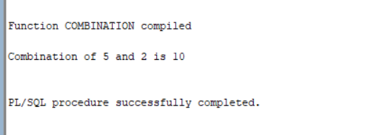

iii. GCD of two numbers.

DECLARE

num1 INTEGER;

num2 INTEGER;

t INTEGER;

BEGIN

num1 := 8;

num2 := 48;

WHILE MOD(num2, num1) != 0 LOOP

t := MOD(num2, num1);

num2 := num1;

num1 := t;

END LOOP;

dbms_output.Put_line('GCD of '

||num1

||' and '

||num2

||' is '

||num1);

END;

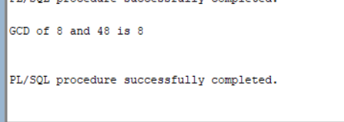

iv. Accept date of birth as ‘dd-mm-yyyy’ and sum all digits till you get a single digit number to show it as user’s lucky number.

DECLARE

l_input VARCHAR2(20) := '31/01/1978';

l_output INT;

BEGIN

LOOP

DBMS_OUTPUT.PUT_LINE('------------------');

DBMS_OUTPUT.PUT_LINE('l_input=' || l_input);

l_output := 0;

FOR i IN 1 .. LENGTH(l_input)

LOOP

IF SUBSTR(l_input, i, 1) BETWEEN '0' AND '9' THEN

l_output := l_output + TO_NUMBER(SUBSTR(l_input, i, 1));

END IF;

END LOOP;

DBMS_OUTPUT.PUT_LINE('l_output=' || l_output);

EXIT WHEN l_output < 10;

l_input := TO_CHAR(l_output);

END LOOP;

DBMS_OUTPUT.PUT_LINE('------------------');

DBMS_OUTPUT.PUT_LINE('Lucky=' || l_output);

END;

/

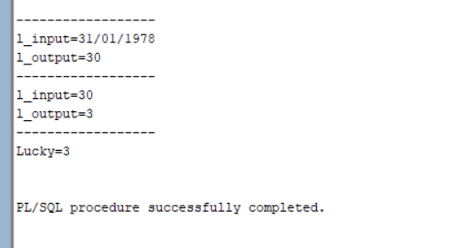

3.Develop math package to include all mathematical procedures and functions implemented in the above two questions and utilize them in other blocks and queries.

CREATE OR REPLACE PACKAGE math_pkg AS

-- Procedure to check if a number is palindrome

PROCEDURE is_palindrome (p_num IN NUMBER, p_result OUT BOOLEAN);

-- Function to find the sum of N natural numbers

FUNCTION sum_natural_numbers (p_n IN NUMBER) RETURN NUMBER;

-- Procedure to generate Fibonacci series

PROCEDURE fibonacci_series (p_n IN NUMBER);

-- Procedure to check if a number is perfect

PROCEDURE is_perfect_number (p_num IN NUMBER, p_result OUT BOOLEAN);

-- Function to calculate net salary and year salary

FUNCTION calculate_salary (p_salary IN NUMBER) RETURN NUMBER;

-- Function to calculate the factorial of a number

FUNCTION factorial (p_num IN NUMBER) RETURN NUMBER;

-- Function to calculate nCr

FUNCTION combination (p_n IN NUMBER, p_r IN NUMBER) RETURN NUMBER;

-- Function to calculate the GCD of two numbers

FUNCTION gcd (p_num1 IN INTEGER, p_num2 IN INTEGER) RETURN INTEGER;

-- Procedure to calculate the lucky number

PROCEDURE calculate_lucky_number (p_dob IN DATE, p_lucky_number OUT NUMBER);

END math_pkg;

/

