**CSE2007 DBMS LAB**

**SLOT: L39+L40**

**NAME - AMAN SAHU**

**REG. NO – 22BCE7224**

**EXPERIMENT NO.-1**

1. create following tables:

i. bonus:

-----

Name Null? Type

-------------------------------- -------- ----------------------

ENAME VARCHAR2(10 CHAR)

JOB VARCHAR2(9 CHAR)

SAL NUMBER

COMM NUMBER

CODE-

CREATE TABLE bonus(ENAME varchar2(10),JOB varchar2(9),SAL number(9),COMM number(9));

OUTPUT-

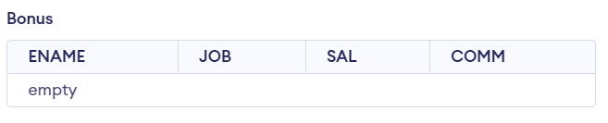

ii. emp:

----

Name Null? Type

-------------------------------- -------- ----------------------

EMPNO NOT NULL NUMBER(4)

ENAME VARCHAR2(10 CHAR)

JOB VARCHAR2(9 CHAR)

MGR NUMBER(4)

HIREDATE DATE

SAL NUMBER(7,2)

COMM NUMBER(7,2)

DEPTNO NUMBER(2)

CODE-

CREATE TABLE emp(EMPNO number(4) not null,ENAME varchar(10),JOB varchar2(9),MGR number(4),HIREDATE date,SAL number(7,2),COMM number(7,2),DEPTNO number(2));

OUTPUT-

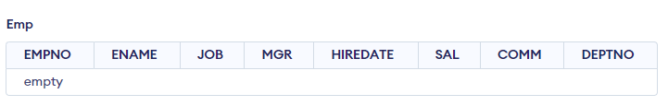

iii. dept:

----

Name Null? Type

-------------------------------- -------- ----------------------

DEPTNO NOT NULL NUMBER(2)

DNAME VARCHAR2(14 CHAR)

LOC VARCHAR2(13 CHAR)

CODE-

CREATE TABLE dept(DEPTNO number(2) not null,DNAME varchar2(14),LOC varchar2(13));

OUTPUT-

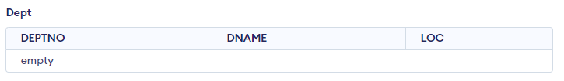

iv. salgrade:

--------

Name Null? Type

-------------------------------- -------- ----------------------

GRADE NOT NULL NUMBER

LOSAL NUMBER

HISAL NUMBER

CODE-

CREATE TABLE salgrade(GRADE number not null,LOSAL number,HISAL number);

OUTPUT-

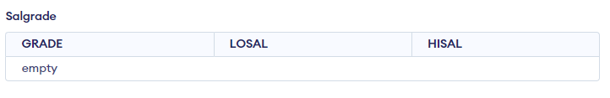

2. Insert the following data into tables:

emp table:

EMPNO ENAME JOB MGR HIREDATE SAL COMM DEPTNO

---------- ---------- --------- ---------- ----------- ---------- ---------- ----------

7369 SMITH CLERK 7902 17-DEC-1980 800 20

7499 ALLEN SALESMAN 7698 20-FEB-1981 1600 300 30

7521 WARD SALESMAN 7698 22-FEB-1981 1250 500 30

7566 JONES MANAGER 7839 02-APR-1981 2975 20

7654 MARTIN SALESMAN 7698 28-SEP-1981 1250 1400 30

7698 BLAKE MANAGER 7839 01-MAY-1981 2850 30

7782 CLARK MANAGER 7839 09-JUN-1981 2450 10

7788 SCOTT ANALYST 7566 19-APR-1987 3000 20

7839 KING PRESIDENT 17-NOV-1981 5000 10

7844 TURNER SALESMAN 7698 08-SEP-1981 1500 0 30

7876 ADAMS CLERK 7788 23-MAY-1987 1100 20

7900 JAMES CLERK 7698 03-DEC-1981 950 30

7902 FORD ANALYST 7566 03-DEC-1981 3000 20

7934 MILLER CLERK 7782 23-JAN-1982 1300 10

CODE-

CREATE TABLE emp(EMPNO number(4) not null,ENAME varchar(10),JOB varchar2(9),MGR number(4),HIREDATE date,SAL number(7,2),COMM number(7,2),DEPTNO number(2));

INSERT INTO emp (EMPNO, ENAME, JOB, MGR, HIREDATE, SAL, COMM, DEPTNO)

VALUES

  (7369, 'SMITH', 'CLERK', 7902,'17-DEC-1980', 800, NULL, 20),

  (7499, 'ALLEN', 'SALESMAN', 7698, '20-FEB-1981', 1600, 300, 30),

  (7521, 'WARD', 'SALESMAN', 7698,  '22-FEB-1981', 1250, 500, 30),

  (7566, 'JONES', 'MANAGER', 7839, '02-APR-1981', 2975, NULL, 20),

  (7654, 'MARTIN', 'SALESMAN', 7698,  '28-SEP-1981', 1250, 1400, 30),

  (7698, 'BLAKE', 'MANAGER', 7839,  '01-MAY-1981', 2850, NULL, 30),

  (7782, 'CLARK', 'MANAGER', 7839, '09-JUN-1981', 2450, NULL, 10),

  (7788, 'SCOTT', 'ANALYST', 7566,  '19-APR-1987', 3000, NULL, 20),

  (7839, 'KING', 'PRESIDENT', NULL,  '17-NOV-1981', 5000, NULL, 10),

  (7844, 'TURNER', 'SALESMAN', 7698,  '08-SEP-1981', 1500, 0, 30),

  (7876, 'ADAMS', 'CLERK', 7788,  '23-MAY-1987', 1100, NULL, 20),

  (7900, 'JAMES', 'CLERK', 7698,  '03-DEC-1981', 950, NULL, 30),

  (7902, 'FORD', 'ANALYST', 7566,  '03-DEC-1981', 3000, NULL, 20),

  (7934, 'MILLER', 'CLERK', 7782,  '23-JAN-1982', 1300, NULL, 10);

OUTPUT-

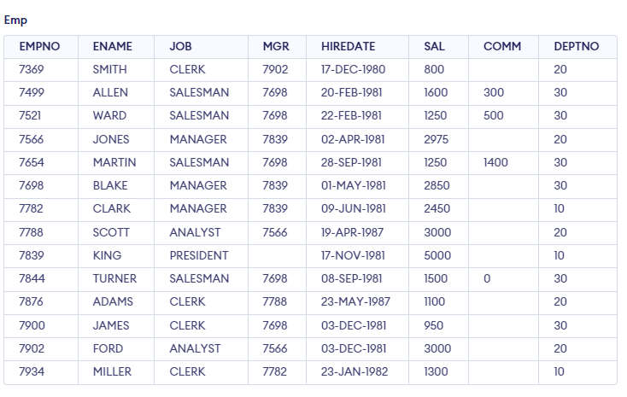

dept table:

DEPTNO DNAME LOC

---------- -------------- -------------

10 ACCOUNTING NEW YORK

20 RESEARCH DALLAS

30 SALES CHICAGO

40 OPERATIONS BOSTON

CODE-

CREATE TABLE dept(DEPTNO number(2) not null,DNAME varchar2(14),LOC varchar2(13));

INSERT INTO dept(DEPTNO, DNAME,LOC)

VALUES

(10, 'ACCOUNTING', 'NEW YORK'),

(20, 'RESEARCH' ,'DALLAS'),

(30, 'SALES', 'CHICAGO'),

(40, 'OPERATIONS','BOSTON');

OUTPUT-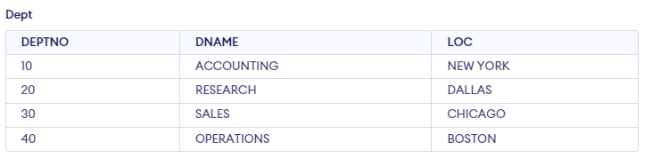

salgrade table:

GRADE LOSAL HISAL

---------- ---------- ----------

1 700 1200

2 1201 1400

3 1401 2000

4 2001 3000

5 3001 9999

CODE-

CREATE TABLE salgrade(GRADE number not null,LOSAL number,HISAL number);

INSERT INTO salgrade(GRADE,LOSAL,HISAL)

VALUES

(1,700,1200),

(2,1201,1400),

(3,1401,2000),

(4,2001,3000),

(5,3001,9999);

OUTPUT-

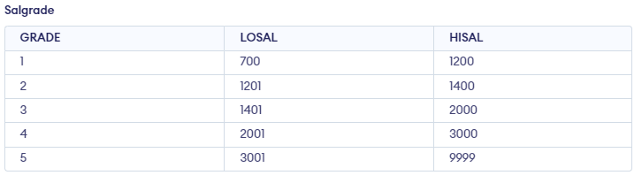

Answer the following queries:

0. describe all table structures and data in inserted order.

Ans0.

DESCRIBE bonus;

DESCRIBE emp;

DESCRIBE dept;

DESCRIBE salgrade;

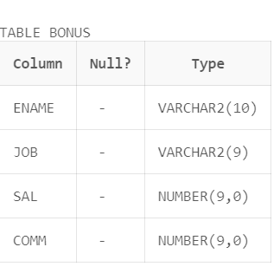

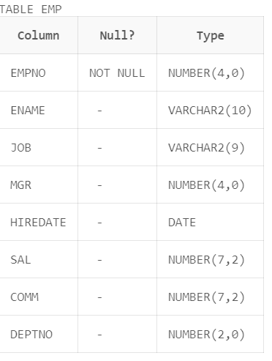

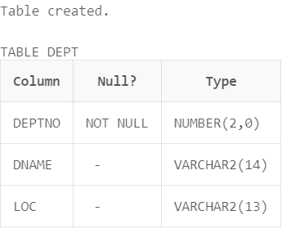

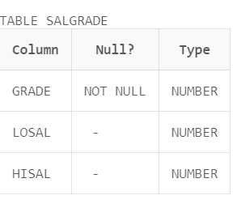

SELECT * FROM bonus ORDER BY ENAME;

SELECT * FROM emp ORDER BY EMPNO;

SELECT * FROM dept ORDER BY DEPTNO;

SELECT * FROM salgrade ORDER BY GRADE;

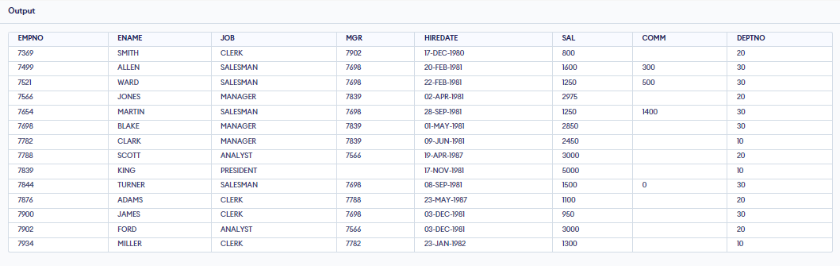

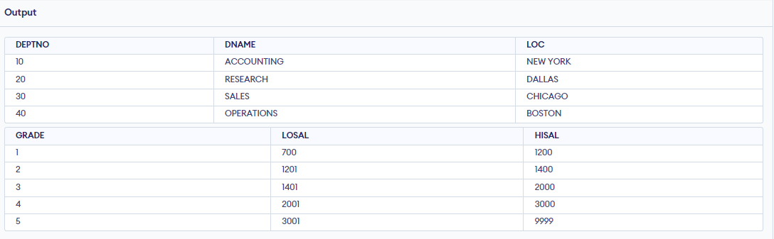

1. select all the information from the emp table.

Ans.

SELECT * FROM emp;

2. Display ename, job, hiredate from emp table.

Ans.

SELECT ENAME, JOB, HIREDATE FROM emp;

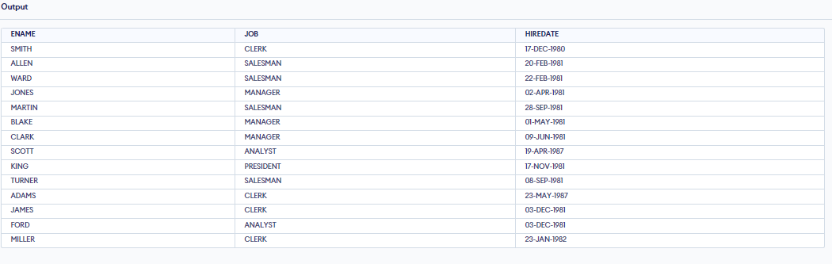

3. select all employees whose salary between 1000 and 2000.

Ans.

SELECT * FROM emp WHERE SAL BETWEEN 1000 AND 2000;

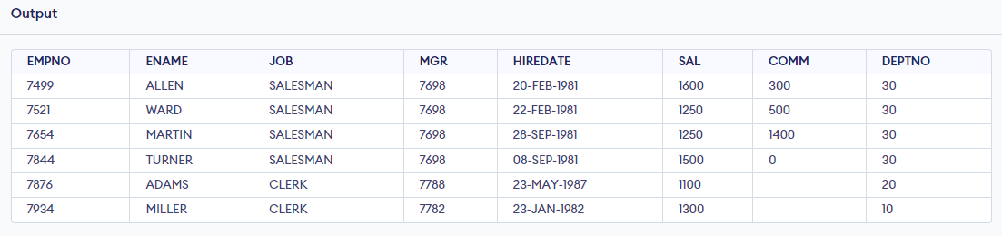

4. List department names and numbers in the department name order

Ans.

SELECT DNAME, DEPTNO FROM dept ORDER BY DNAME;

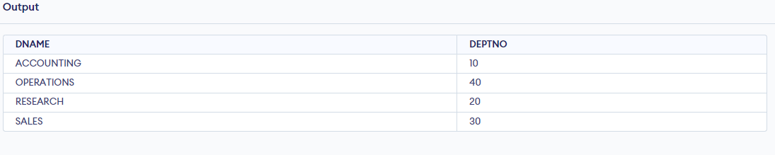

5. List the details of the employees in dept 10 and 20 in alphabetical order of names.

Ans.

SELECT * FROM emp WHERE DEPTNO IN (10, 20) ORDER BY ENAME;

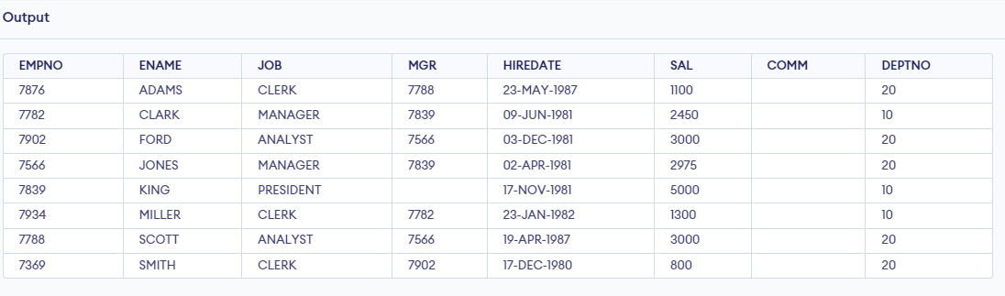

6. List the names of all clerks in dept 20.

Ans.

SELECT ENAME FROM emp WHERE JOB = 'CLERK' AND DEPTNO = 20;

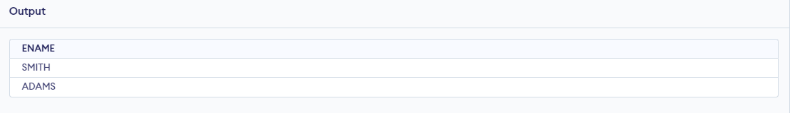

3.

Create the following tables:

i) client_master

columnname datatype size

client_no varchar2 6

name varchar2 20

address1 varchar2 30

address2 varchar2 30

city varchar2 15

state varchar2 15

pincode number 6

bal_due number 10,2

CODE-

CREATE TABLE client_master (

  client_no  varchar2(6) not null,

  name       varchar2(20),

  address1   varchar2(30),

  address2   varchar2(30),

  city       varchar2(15),

  state      varchar2(15),

  pincode    number(6),

  bal_due    number(10,2)

);

OUTPUT-

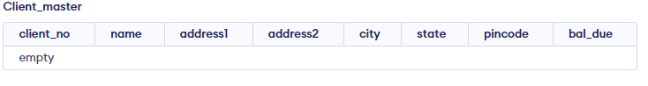

ii) Product_master

Columnname datatype size

Product_no varchar2

Description varchar2

Profit_percent number

Unit_measure varchar2

Qty_on_hand number

Reoder_lvl number

Sell_price number

Cost_price number

CODE-

CREATE TABLE product_master (

  Product_no   varchar2(20),

  Description  varchar2(20),

  Profit_percent  number,

  Unit_measure   varchar2(20),

  Qty_on_hand   number,

  Reorder_lvl   number,

  Sell_price   number,

  Cost_price   number

);

OUTPUT-



4. Insert the following data

Clientno Name city pincode state bal_due

0001 Ivan Bombay 400054 Maharashtra 15000

0002 Vandana Madras 780001 Tamilnadu 0

0003 Pramada Bombay 400057 Maharashtra 5000

0004 Basu Bombay 400056 Maharashtra 0

0005 Ravi Delhi 100001 2000

0006 Rukmini Bombay 400050 Maharashtra 0

CODE-

INSERT INTO client_master (client_no, name, city, pincode, state, bal_due)

VALUES

  ('0001', 'Ivan', 'Bombay', 400054, 'Maharashtra', 15000),

  ('0002', 'Vandana', 'Madras', 780001, 'Tamilnadu', 0),

  ('0003', 'Pramada', 'Bombay', 400057, 'Maharashtra', 5000),

  ('0004', 'Basu', 'Bombay', 400056, 'Maharashtra', 0),

  ('0005', 'Ravi', 'Delhi', 100001, NULL, 2000),

  ('0006', 'Rukmini', 'Bombay', 400050, 'Maharashtra', 0);

OUTPUT-

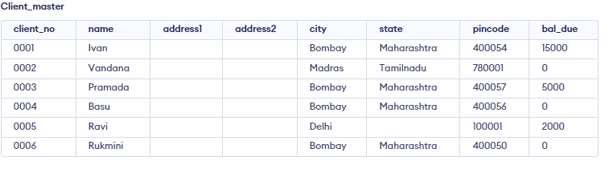

Product No. Desciption Profit Unit Qty Reorder Sell Cost

Percent measured on hand lvl price price

P00001 1.44floppies 5 piece 100 20 525 500

P03453 Monitors 6 piece 10 3 12000 11200

P06734 Mouse 5 piece 20 5 1050 500

P07865 1.22 floppies 5 piece 100 20 525 500

P07868 Keyboards 2 piece 10 3 3150 3050

P07885 CD Drive 2.5 piece 10 3 5250 5100

P07965 540 HDD 4 piece 10 3 8400 8000

P07975 1.44 Drive 5 piece 10 3 1050 1000

P08865 1.22 Drive 5 piece 2 3 1050 1000

CODE-

INSERT INTO product_master (Product_no, Description, Profit_percent, Unit_measure, Qty_on_hand, Reorder_lvl, Sell_price, Cost_price)

VALUES

  ('P00001','1.44floppies', 5, 'piece', 100, 20, 525, 500),

  ('P03453', 'Monitors', 6, 'piece', 10, 3, 12000, 11200),

  ('P06734', 'Mouse', 5, 'piece', 20, 5, 1050, 500),

  ('P07865', '1.22 floppies', 5, 'piece', 100, 20, 525, 500),

  ('P07868', 'Keyboards', 2, 'piece', 10, 3, 3150, 3050),

  ('P07885', 'CD Drive', 2.5, 'piece', 10, 3, 5250, 5100),

  ('P07965', '540 HDD', 4, 'piece', 10, 3, 8400, 8000),

  ('P07975', '1.44 Drive', 5, 'piece', 10, 3, 1050, 1000),

  ('P08865', '1.22 Drive', 5, 'piece', 2, 3, 1050, 1000);

OUTPUT-

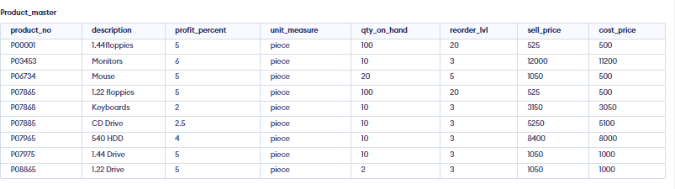

Answer the queries:

i) Find out the names of all the clients.

Ans.

SELECT name FROM client_master;

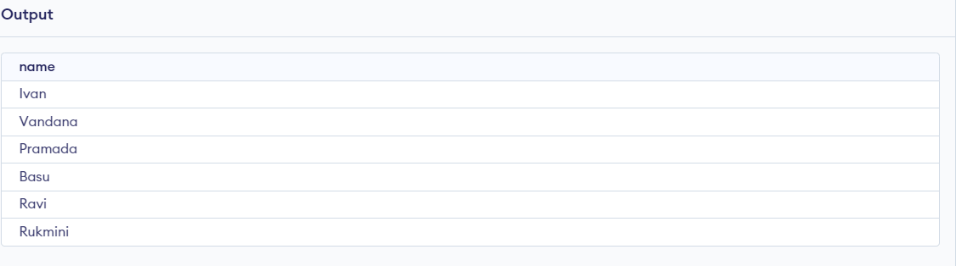

ii) Retrieve the list of names and cities of all the clients.

Ans.

SELECT name, city FROM client_master;

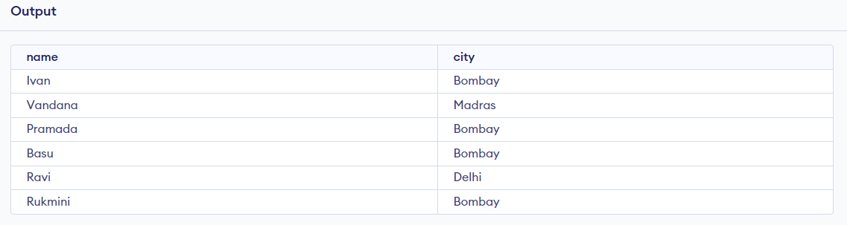

iii) List the various products available from the product_master table.

Ans.

SELECT * FROM Product_master;

iv) List all the clients who are located in Bombay.

Ans.

SELECT * FROM client_master WHERE city = 'Bombay';

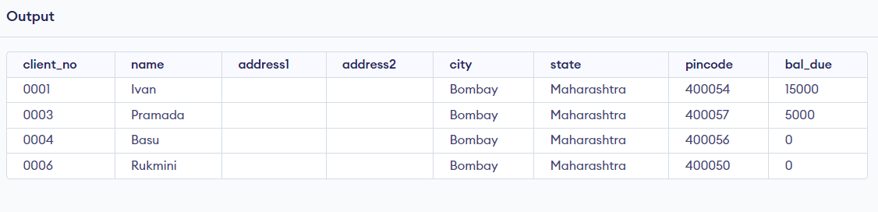

v) Display the information for client no 0001 and 0002.

Ans.

SELECT * FROM client_master WHERE client_no IN ('0001', '0002');

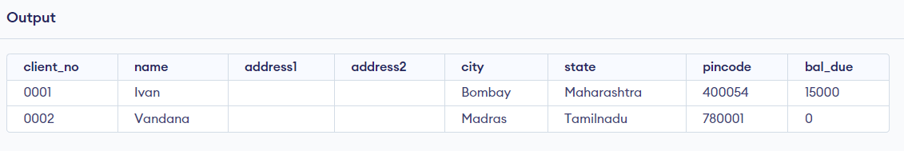

vi) Find the products with description as ‘1.44 drive’ and ‘1.22 Drive’.

Ans.

SELECT * FROM Product_master WHERE Description IN ('1.44 Drive', '1.22 Drive');

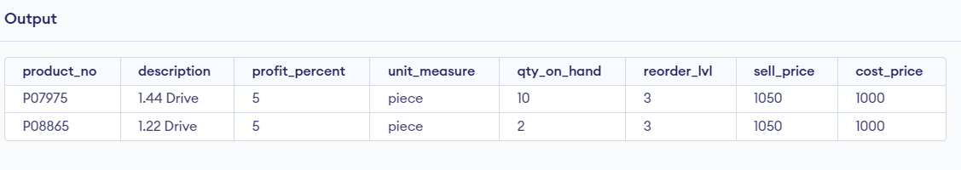

vii) Find all the products whose sell price is greater then 5000.

Ans.

SELECT * FROM Product_master WHERE Sell_price > 5000;

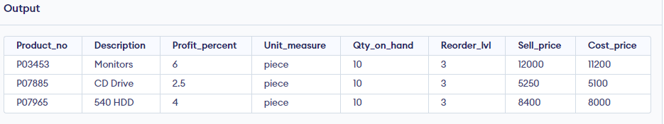

viii) Find the list of all clients who stay in in city ‘Bombay’ or city ‘Delhi’ or

‘Madras’.

Ans.

SELECT * FROM client_master WHERE city IN ('Bombay', 'Delhi', 'Madras');

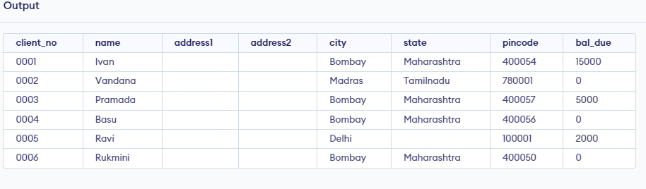

ix) Find the product whose selling price is greater than 2000 and less than or

equal to 5000.

Ans.

SELECT * FROM Product_master WHERE Sell_price BETWEEN 2000 AND 5000

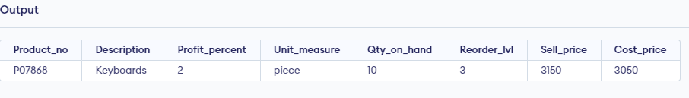

x) List the name, city and state of clients not in the state of ‘Maharashtra’.

Ans.

SELECT name, city, state FROM client_master WHERE state != 'Maharashtra';

