**CSE2007 DBMS LAB**

**SLOT: L39+L40**

**NAME - AMAN SAHU**

**REG. NO – 22BCE7224**

**EXPERIMENT NO.-2**

1. create following tables:

bonus:

-----

Name Null? Type

-------------------------------- -------- ----------------------

ENAME VARCHAR2(10 CHAR)

JOB VARCHAR2(9 CHAR)

SAL NUMBER

COMM NUMBER

CODE-

CREATE TABLE bonus(ENAME varchar2(10),JOB varchar2(9),SAL number(9),COMM number(9));

OUTPUT-

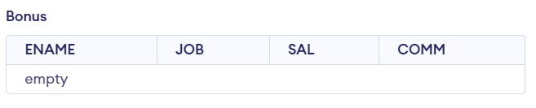

emp:

----

Name Null? Type

-------------------------------- -------- ----------------------

EMPNO NOT NULL NUMBER(4)

ENAME VARCHAR2(10 CHAR)

JOB VARCHAR2(9 CHAR)

MGR NUMBER(4)

HIREDATE DATE

SAL NUMBER(7,2)

COMM NUMBER(7,2)

DEPTNO NUMBER(2)

CODE-

CREATE TABLE emp(EMPNO number(4) not null,ENAME varchar(10),JOB varchar2(9),MGR number(4),HIREDATE date,SAL number(7,2),COMM number(7,2),DEPTNO number(2));

OUTPUT-

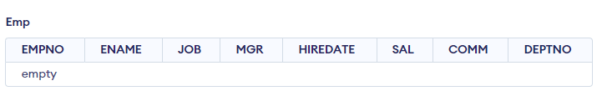

dept:

----

Name Null? Type

-------------------------------- -------- ----------------------

DEPTNO NOT NULL NUMBER(2)

DNAME VARCHAR2(14 CHAR)

LOC VARCHAR2(13 CHAR)

CODE-

CREATE TABLE dept(DEPTNO number(2) not null,DNAME varchar2(14),LOC varchar2(13));

OUTPUT-

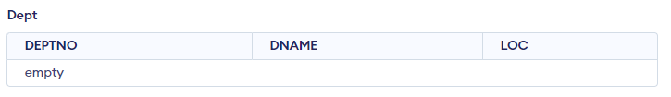

salgrade:

--------

Name Null? Type

-------------------------------- -------- ----------------------

GRADE NOT NULL NUMBER

LOSAL NUMBER

HISAL NUMBER

CODE-

CREATE TABLE salgrade(GRADE number not null,LOSAL number,HISAL number);

OUTPUT-

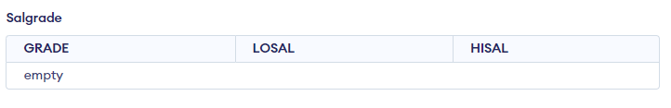

2. Insert the following data into tables:

emp table:

EMPNO ENAME JOB MGR HIREDATE SAL COMM DEPTNO

---------- ---------- --------- ---------- ----------- ---------- ---------- ----------

7369 SMITH CLERK 7902 17-DEC-1980 800 20

7499 ALLEN SALESMAN 7698 20-FEB-1981 1600 300 30

7521 WARD SALESMAN 7698 22-FEB-1981 1250 500 30

7566 JONES MANAGER 7839 02-APR-1981 2975 20

7654 MARTIN SALESMAN 7698 28-SEP-1981 1250 1400 30

7698 BLAKE MANAGER 7839 01-MAY-1981 2850 30

7782 CLARK MANAGER 7839 09-JUN-1981 2450 10

7788 SCOTT ANALYST 7566 19-APR-1987 3000 20

7839 KING PRESIDENT 17-NOV-1981 5000 10

7844 TURNER SALESMAN 7698 08-SEP-1981 1500 0 30

7876 ADAMS CLERK 7788 23-MAY-1987 1100 20

7900 JAMES CLERK 7698 03-DEC-1981 950 30

7902 FORD ANALYST 7566 03-DEC-1981 3000 20

7934 MILLER CLERK 7782 23-JAN-1982 1300 10

CODE-

CREATE TABLE emp(EMPNO number(4) not null,ENAME varchar(10),JOB varchar2(9),MGR number(4),HIREDATE date,SAL number(7,2),COMM number(7,2),DEPTNO number(2));

INSERT INTO emp (EMPNO, ENAME, JOB, MGR, HIREDATE, SAL, COMM, DEPTNO)

VALUES

  (7369, 'SMITH', 'CLERK', 7902,'17-DEC-1980', 800, NULL, 20),

  (7499, 'ALLEN', 'SALESMAN', 7698, '20-FEB-1981', 1600, 300, 30),

  (7521, 'WARD', 'SALESMAN', 7698,  '22-FEB-1981', 1250, 500, 30),

  (7566, 'JONES', 'MANAGER', 7839, '02-APR-1981', 2975, NULL, 20),

  (7654, 'MARTIN', 'SALESMAN', 7698,  '28-SEP-1981', 1250, 1400, 30),

  (7698, 'BLAKE', 'MANAGER', 7839,  '01-MAY-1981', 2850, NULL, 30),

  (7782, 'CLARK', 'MANAGER', 7839, '09-JUN-1981', 2450, NULL, 10),

  (7788, 'SCOTT', 'ANALYST', 7566,  '19-APR-1987', 3000, NULL, 20),

  (7839, 'KING', 'PRESIDENT', NULL,  '17-NOV-1981', 5000, NULL, 10),

  (7844, 'TURNER', 'SALESMAN', 7698,  '08-SEP-1981', 1500, 0, 30),

  (7876, 'ADAMS', 'CLERK', 7788,  '23-MAY-1987', 1100, NULL, 20),

  (7900, 'JAMES', 'CLERK', 7698,  '03-DEC-1981', 950, NULL, 30),

  (7902, 'FORD', 'ANALYST', 7566,  '03-DEC-1981', 3000, NULL, 20),

  (7934, 'MILLER', 'CLERK', 7782,  '23-JAN-1982', 1300, NULL, 10);

OUTPUT-

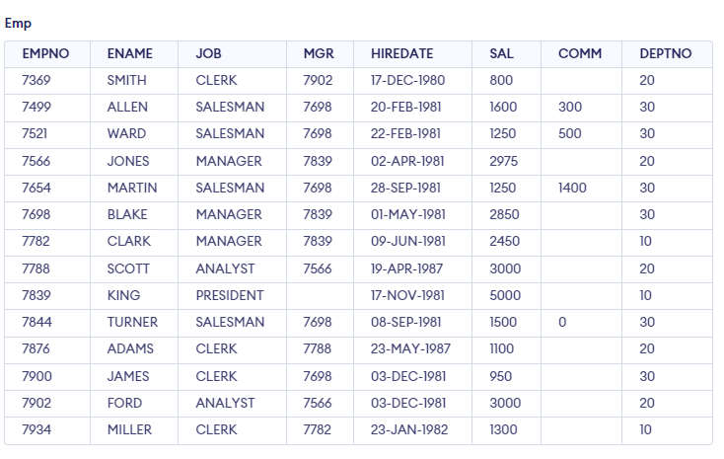

dept table:

DEPTNO DNAME LOC

---------- -------------- -------------

10 ACCOUNTING NEW YORK

20 RESEARCH DALLAS

30 SALES CHICAGO

40 OPERATIONS BOSTON

CODE-

CREATE TABLE dept(DEPTNO number(2) not null,DNAME varchar2(14),LOC varchar2(13));

INSERT INTO dept(DEPTNO, DNAME,LOC)

VALUES

(10, 'ACCOUNTING', 'NEW YORK'),

(20, 'RESEARCH' ,'DALLAS'),

(30, 'SALES', 'CHICAGO'),

(40, 'OPERATIONS','BOSTON');

OUTPUT-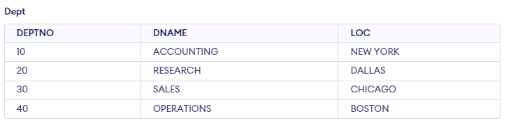

salgrade table:

GRADE LOSAL HISAL

---------- ---------- ----------

1 700 1200

2 1201 1400

3 1401 2000

4 2001 3000

5 3001 9999

CODE-

CREATE TABLE salgrade(GRADE number not null,LOSAL number,HISAL number);

INSERT INTO salgrade(GRADE,LOSAL,HISAL)

VALUES

(1,700,1200),

(2,1201,1400),

(3,1401,2000),

(4,2001,3000),

(5,3001,9999);

OUTPUT-

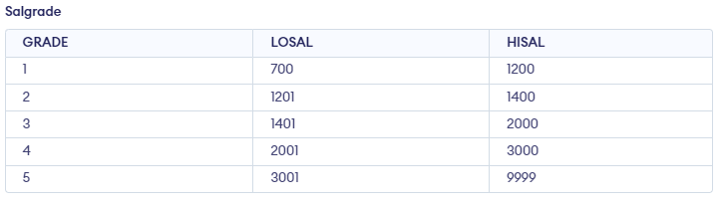

Answer the following queries:

0. describe all table structures and data in inserted order.

Ans0.

DESCRIBE bonus;

DESCRIBE emp;

DESCRIBE dept;

DESCRIBE salgrade;

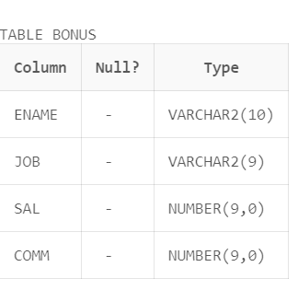

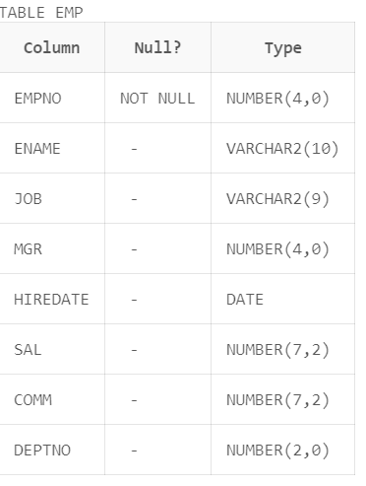

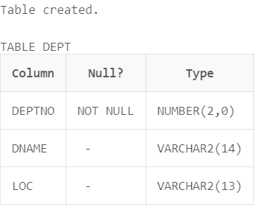

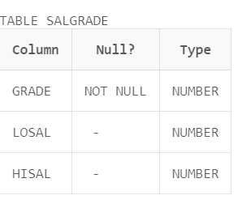

SELECT * FROM bonus ORDER BY ENAME;

SELECT * FROM emp ORDER BY EMPNO;

SELECT * FROM dept ORDER BY DEPTNO;

SELECT * FROM salgrade ORDER BY GRADE;

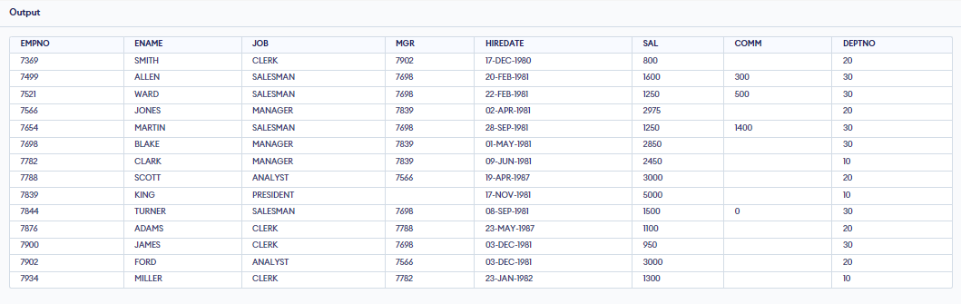

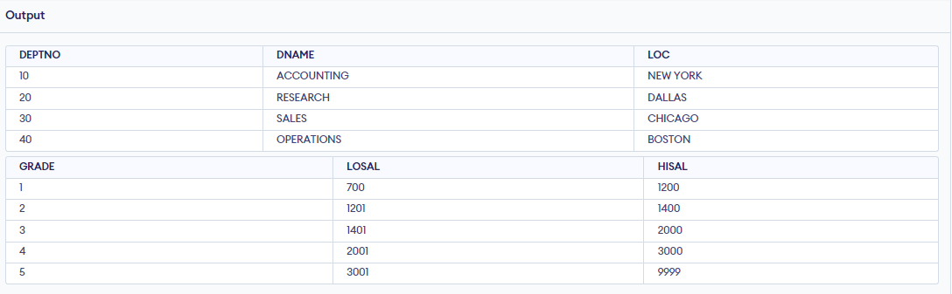

1. select all the information from the emp table.

Ans.

SELECT * FROM emp;

2. Display ename, job, hiredate from emp table.

Ans.

SELECT ENAME, JOB, HIREDATE FROM emp;

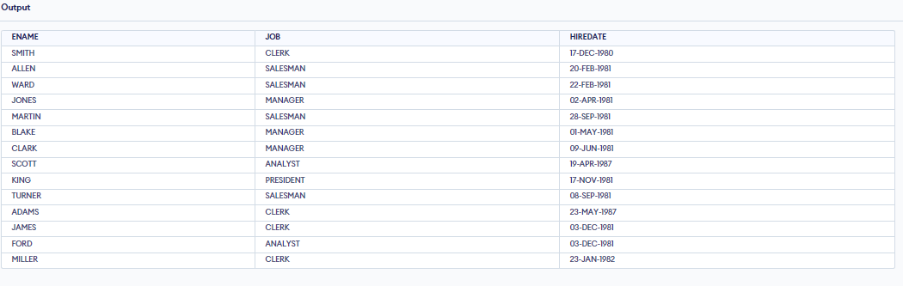

3. select all employees whose salary between 1000 and 2000.

Ans.

SELECT * FROM emp WHERE SAL BETWEEN 1000 AND 2000;

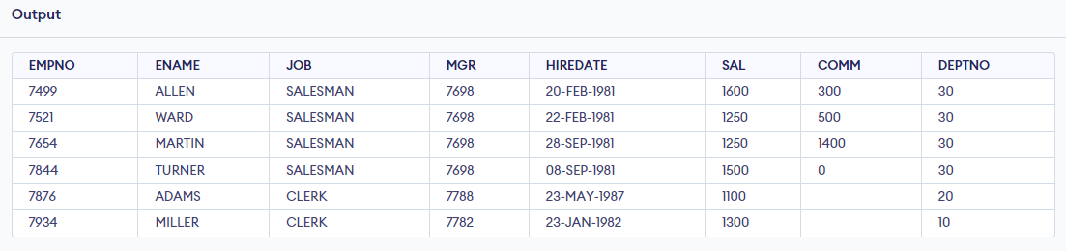

4. List department names and numbers in the department name order

Ans.

SELECT DNAME, DEPTNO FROM dept ORDER BY DNAME;

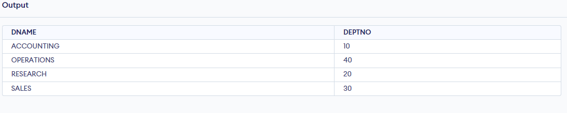

5. List the details of the employees in dept 10 and 20 in alphabetical order of names.

Ans.

SELECT * FROM emp WHERE DEPTNO IN (10, 20) ORDER BY ENAME;

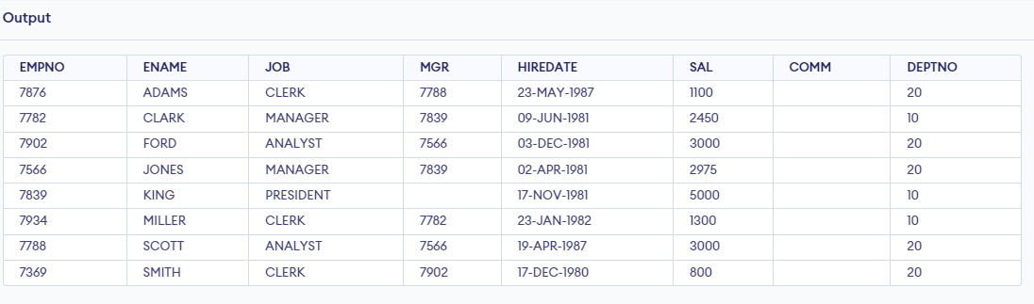

6. List the names of all clerks in dept 20.

Ans.

SELECT ENAME FROM emp WHERE JOB = 'CLERK' AND DEPTNO = 20;

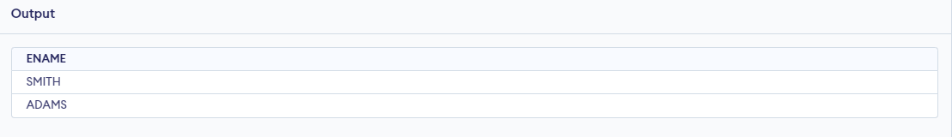

7. List the employee number,name,job,title and hiredate of employee in department 10?

Code-

SELECT empno, ename, job, hiredate FROM emp WHERE DEPTNO = 10;

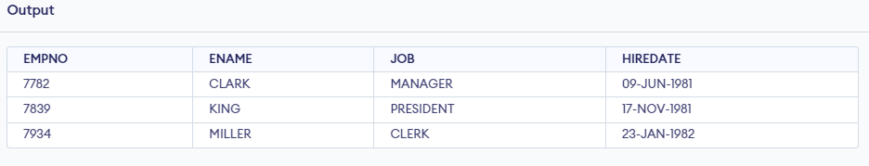

8. Select the name and salary of all employee who are clerks?

Code-

SELECT ename, sal FROM emp WHERE job = 'CLERK';

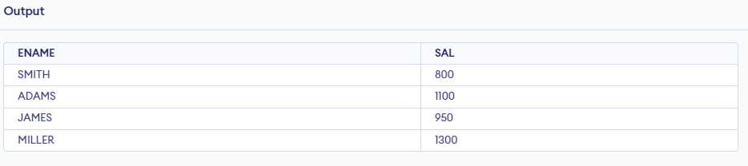

9. Select the name and annual salary of all employees?

Code-

SELECT ename, sal * 12 AS annual_salary FROM emp;

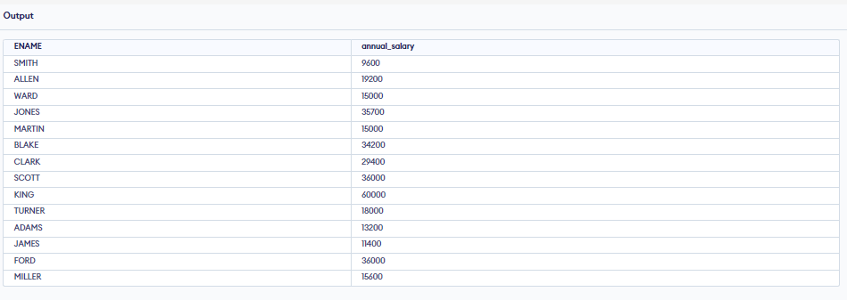

10. List the name,job,salary of everyone hired on december 17,1980?

Code-

SELECT ename, job, sal FROM emp WHERE hiredate = '17-DEC-1980';

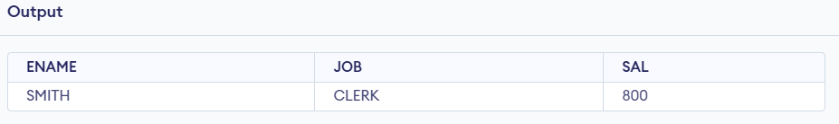

11. List the department name and department number for departments with numbers greater than or equal to 20?

Code-

SELECT dname, deptno FROM dept WHERE deptno>=20;

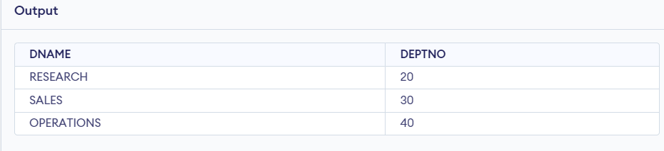

12. List the names of employees whose salaries are less than 2500?

Code-

SELECT ename FROM emp WHERE sal<2500;

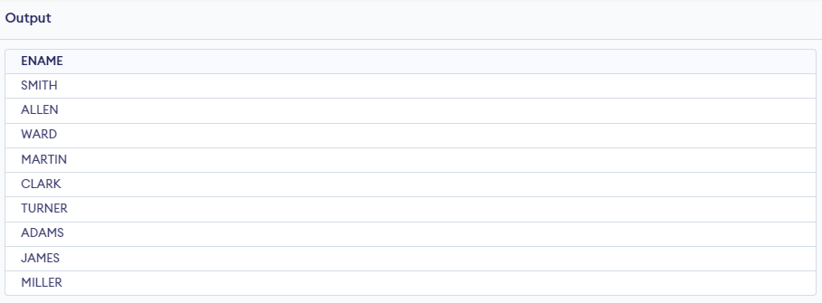

13. Display the name, monthly salary and daily salary and hourly salary for employees assume that the sal column in the table is the monthly salary, that there are 22 working days in a month,and that there are 8 working hours in a day. rename the columns as monthly,daily,hourly?

Code-

SELECT ename,sal AS monthly,sal / 22 AS daily,sal / 22 / 8 AS hourly FROM emp;

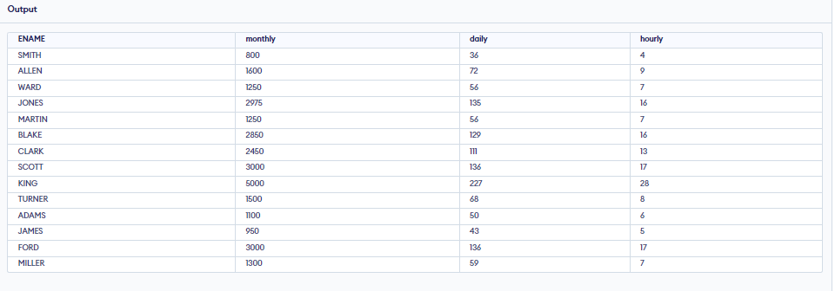

14. List the names and employer s numbers of managers who earn more than 2600 display in alphabetic order by name?

Code-

SELECT ename,empno FROM emp WHERE job = 'MANAGER' AND sal > 2600 ORDER BY ename;

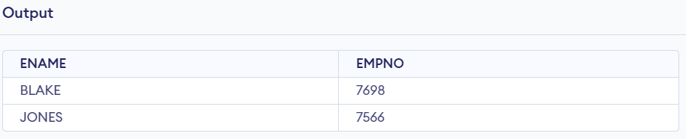

15. Display all employee names who have 'TH' or 'LL' in them?

Code-

SELECT ename FROM emp WHERE ename LIKE '%TH%' OR ename LIKE '%LL%';

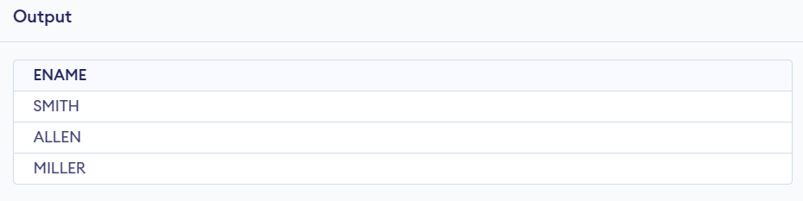

16. List the details of employees in departments 10 and 20 in alphabtical order of name?

Code-

SELECT * FROM emp WHERE deptno=10 OR deptno=20 ORDER BY ename;

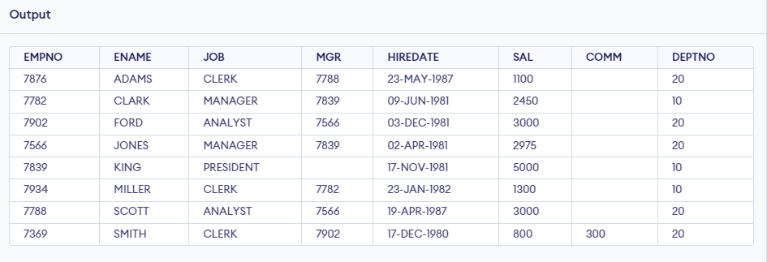

17. Select the information about manager and the president from the column job in the table emp. Order the result by department number?

Code-

SELECT * FROM emp WHERE job='MANAGER' OR job='PRESIDENT' ORDER BY deptno;

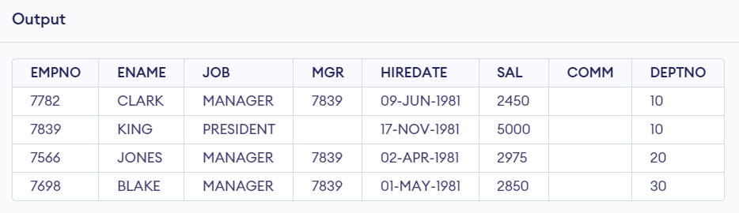

18. List the employee name that do not end with S ?

Code-

SELECT ename FROM emp WHERE ename NOT LIKE '%S';

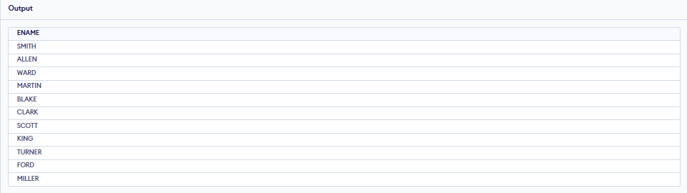

19. List the employee name that start with C ?

Code-

SELECT ename FROM emp WHERE ename LIKE 'C%';

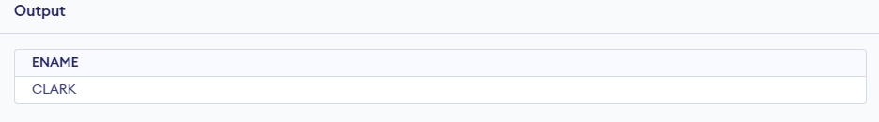

20. List the name,job and department of everyone whose name falls in the alphabetic range C to F ?

Code-

SELECT ename, job, deptno FROM emp WHERE ename BETWEEN 'C' AND 'F' ORDER BY ename;

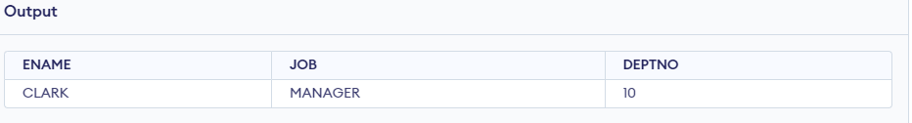

21. List employee details working in department 20,30 or 40?

Code-

SELECT * FROM emp WHERE deptno=20 OR deptno=30 OR deptno=40;

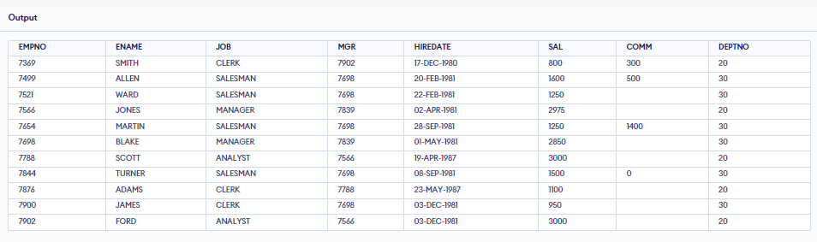

22. List of employees whose names start with M and end with R ?

Code-

SELECT ename FROM emp WHERE ename LIKE 'M%R';

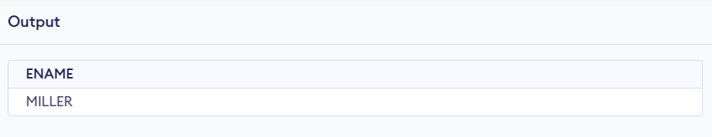

23. Display all employee who were hired during 1983?

Code-

SELECT * FROM emp WHERE hiredate BETWEEN '1-JAN-1983' AND '31-DEC-1983';

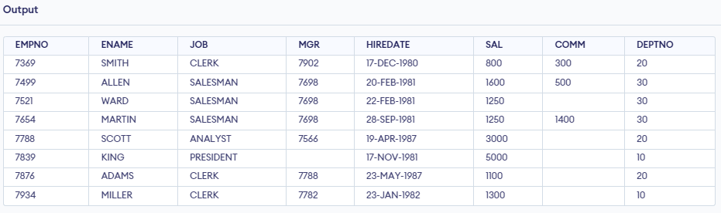

24. Display the data as shown below:

Smith has held the position of clerk in department 20 since 10 june 83.

Allen has held the position of salesman in department 30since 13 june 1983.

Ward has held position of salesman in department 30 since 13 june 1983.

Code-

SELECT ENAME || ' has held the position of ' || JOB || ' in department ' || DEPTNO || ' since ' || HIREDATE AS formatted_data FROM emp WHERE ENAME IN ('SMITH', 'ALLEN', 'WARD');

