**CSE2007 DBMS LAB**

**SLOT: L39+L40**

**NAME - AMAN SAHU**

**REG. NO – 22BCE7224**

**EXPERIMENT NO.-3**

1. List all rows from emp table ,by comverting the null values in comm column to 0?*

Code-

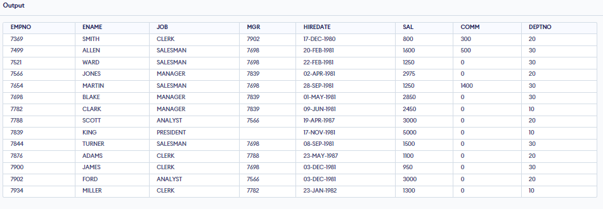SELECT EMPNO, ENAME, JOB, MGR, HIREDATE, SAL, COALESCE(COMM, 0) AS COMM, DEPTNO FROM emp;

1. List all managers and salesman with salaries over 1500?*

Code-

SELECT * FROM emp WHERE JOB IN ('MANAGER', 'SALESMAN') AND SAL > 1500;

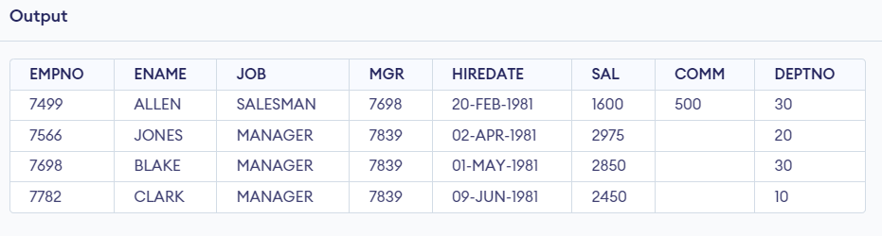

1. Write a query that will accept a given job title and salary. Display all records according to that title and salary?*

Code-

SELECT * FROM emp

WHERE JOB = 'your_job_title' AND SAL = your_salary;

EX-

SELECT * FROM emp

WHERE JOB = 'SALESMAN' AND SAL = 1250;

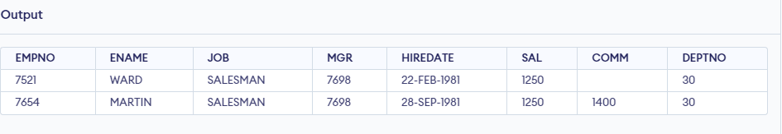

1. List all employees who do not get any commission?*

Code-

SELECT * FROM emp WHERE COMM IS NULL;

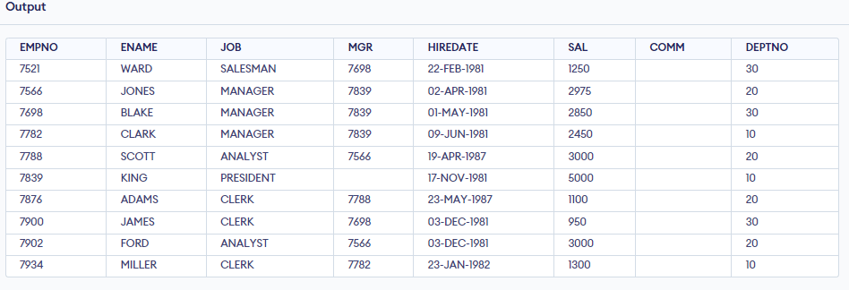

1. List the names and hiredate of the employees in dept 20.Display hire date formatted as ’12/03/84′?

Code-

SELECT ENAME, TO_CHAR(HIREDATE, 'DD/MM/YY') AS FORMATTED_HIREDATE

FROM emp

WHERE DEPTNO = 20;

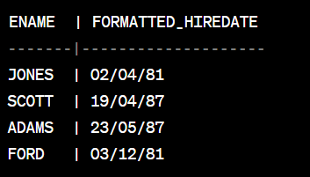

1. How many months has the president worked for the company? Round to the nearest whole number of months?

CODE-

SELECT ENAME, ROUND(MONTHS_BETWEEN(SYSDATE, HIREDATE)) AS MONTHS_WORKED

FROM emp

WHERE JOB = 'PRESIDENT';

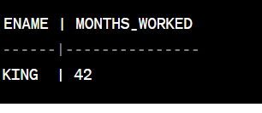

1. List the names of all employees whose hire date anniversary is in the month of december?

Code-

SELECT ENAME

FROM emp

WHERE TO_CHAR(HIREDATE, 'MM') = '12';

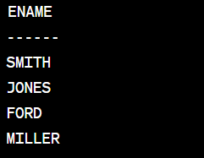

1. Give sql command to find the average salary per job in each dept?**

Code-

SELECT JOB, DEPTNO, AVG(SAL) AS AVG_SALARY FROM emp GROUP BY JOB, DEPTNO;

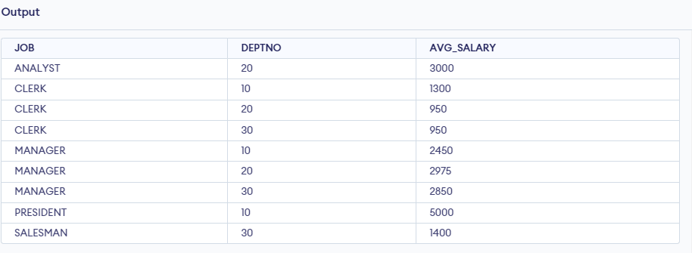

1. Write a query to count the number of people in dept 30 who can receive a salary and the number of people who receive a commission?

Code-

SELECT DEPTNO, COUNT(*) AS TOTAL, SUM(CASE WHEN COMM IS NOT NULL THEN 1 ELSE 0 END) AS WITH_COMM, SUM(CASE WHEN COMM IS NULL THEN 1 ELSE 0 END) AS WITHOUT_COMM

FROM emp

WHERE DEPTNO = 30

GROUP BY DEPTNO;

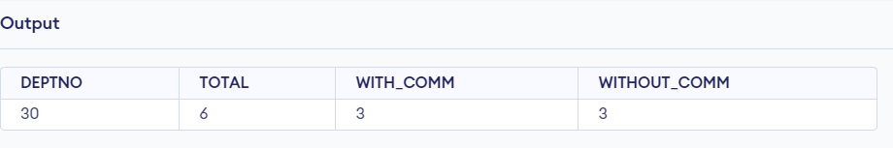

1. Compute the average, minimum, and maximum salaries of the employees having the job is clerk or manager?

Code-

SELECT JOB, AVG(SAL) AS AVG_SALARY, MIN(SAL) AS MIN_SALARY, MAX(SAL) AS MAX_SALARY FROM emp WHERE JOB IN ('CLERK', 'MANAGER') GROUP BY JOB;

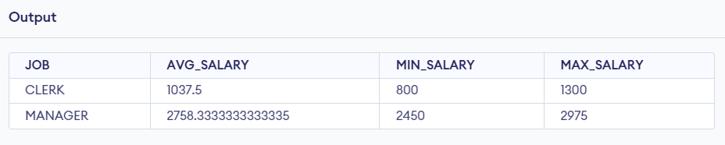

1. Calculate the total compensation expense for each dept. for one year. The comm figures in the emp table are for each month. Assume that employees who do not earn a commission receive non-monetary benefits that are worth $100 a month?

Code-

SELECT DEPTNO, SUM(SAL + NVL(COMM, 100) * 12) AS TOTAL_COMPENSATION

FROM emp

GROUP BY DEPTNO;

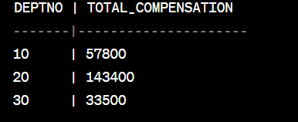

1. Write a query to do a case insensitive search for a list of employees with a job that a user enters(e.g. clerk)?

Code-

SELECT * FROM EMP WHERE LOWER(JOB) = LOWER('clerk');

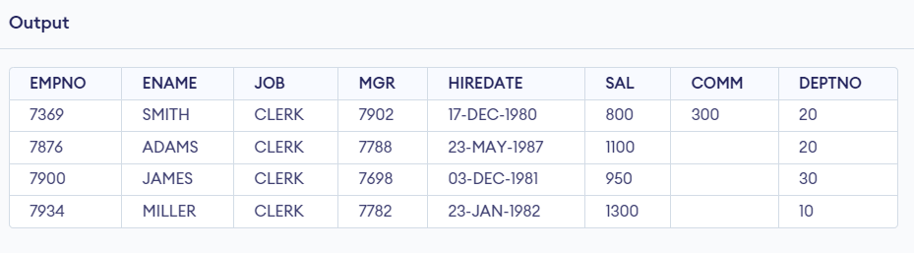

13. Write a query to produce the following output: smith(clerk)

Code-

SELECT ENAME || '(' || JOB || ')' AS OUTPUT FROM emp WHERE ENAME = ‘SMITH';

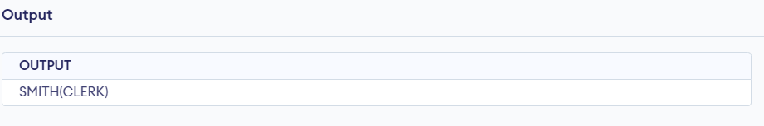

14.Write a query to find the employees who earn less than 30% to the president’s salary?

Code-

SELECT ENAME FROM emp WHERE SAL < (SELECT 0.3*SAL FROM emp WHERE JOB = 'PRESIDENT');

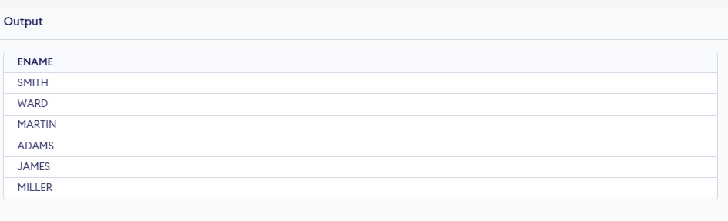

15. Display the average monthly salary bill for each job type within a department?

Code-

SELECT JOB, DEPTNO, AVG(SAL / 12) AS AVG_MONTHLY_SALARY FROM emp GROUP BY JOB, DEPTNO;

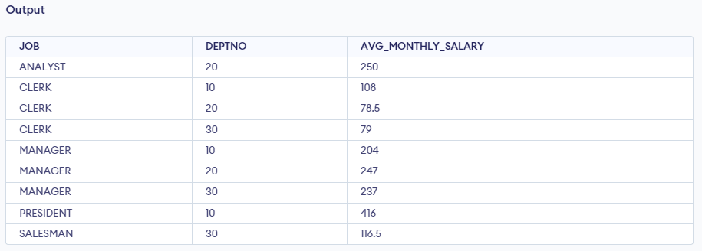

16. Find out the difference between highest and lowest salaries across job types, depts, and all?

Code-

SELECT MAX(SAL) - MIN(SAL) AS SALARY_DIFFERENCE FROM emp;

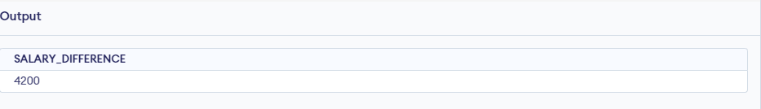

17. Find all departments which have more than 3 employees?*

Code-

SELECT DEPTNO, COUNT(*) AS EMP_COUNT FROM EMP GROUP BY DEPTNO HAVING COUNT(*) > 3;

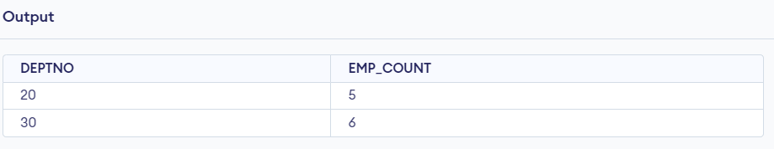

18. Check whether all employees ids are indeed unique?

Code-

SELECT COUNT(*) AS EMP_COUNT, COUNT(DISTINCT EMPNO) AS UNIQUE_EMP_COUNT FROM EMP;

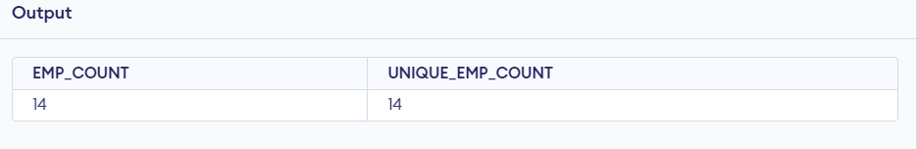

19. List all employees who were paid less than his manager?

Code-

SELECT e1.* FROM emp e1 JOIN emp e2 ON e1.MGR = e2.EMPNO WHERE e1.SAL < e2.SAL;

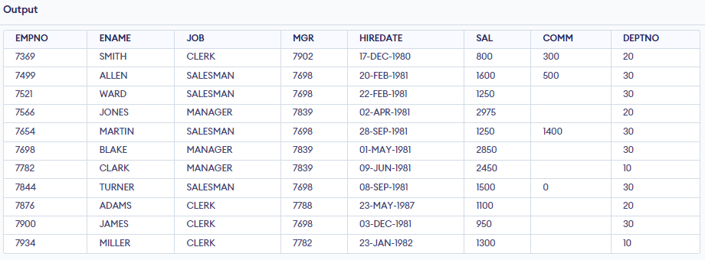

20. Display all employee names and their department names in department order?

Code-

SELECT E.ENAME, D.DNAME FROM EMP E JOIN DEPT D ON E.DEPTNO = D.DEPTNO ORDER BY D.DEPTNO;

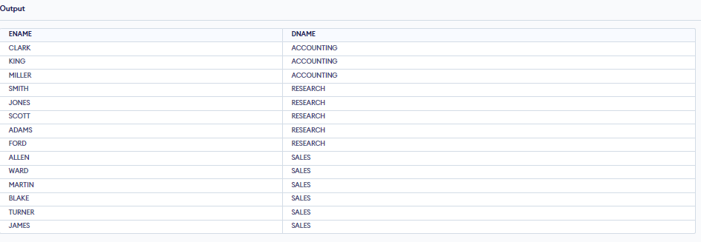

21. Display all employee name, department number and name?*

Code-

SELECT E.ENAME, E.DEPTNO, D.DNAME

FROM EMP E

JOIN DEPT D ON E.DEPTNO = D.DEPTNO;

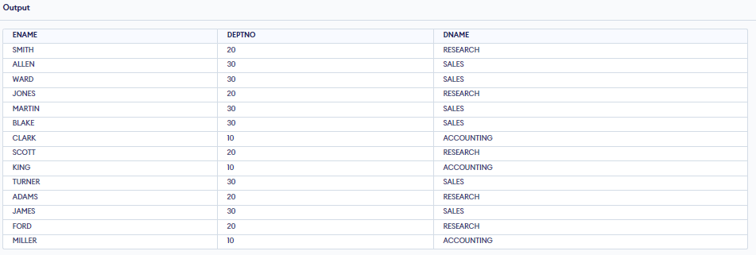

22. Display the department that has TWO employees?

Code-

SELECT D.DEPTNO, D.DNAME, COUNT(*) AS EMP_COUNT FROM EMP E JOIN DEPT D ON E.DEPTNO = D.DEPTNO GROUP BY D.DEPTNO, D.DNAME HAVING COUNT(*) = 2;

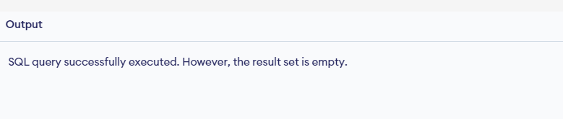

23. Find all employees who joined the company before their manager?

Code-

SELECT e1.*

FROM emp e1

JOIN emp e2 ON e1.MGR = e2.EMPNO

WHERE e1.HIREDATE < e2.HIREDATE;

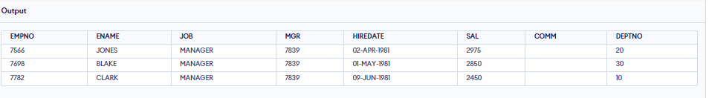

24. Display minimum salary department wise or of specific department.

Code-

SELECT DEPTNO, MIN(SAL) AS MIN_SALARY FROM emp GROUP BY DEPTNO;

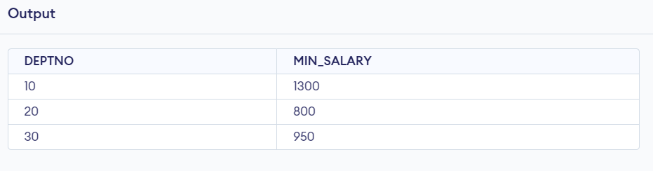

25. Display employees who earn more than lowest salary in dept 30?*

Code-

SELECT * FROM emp WHERE SAL > (SELECT MIN(SAL) FROM emp WHERE DEPTNO = 30);

