**CSE2007 DBMS LAB**

**SLOT: L39+L40**

**NAME - AMAN SAHU**

**REG. NO – 22BCE7224**

**EXPERIMENT NO.-4**

1. Find employees who earn more than every employee in dept 30?*

Code-

SELECT * FROM emp WHERE DEPTNO=30;

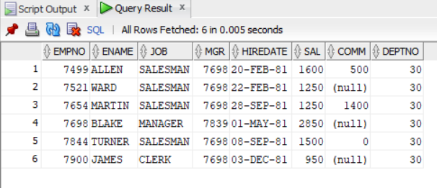

2. Find the job with the highest average salary?

Code-

SELECT JOB FROM emp WHERE SAL=(SELECT MAX(SAL) FROM emp);

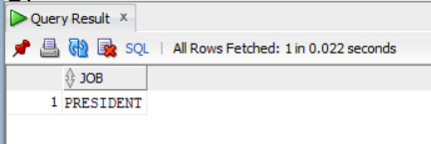

3. Display the name,job,hiredate for employees whose salary is greater than the highest salary in the sales department?

Code-

SELECT ENAME,JOB,HIREDATE FROM emp WHERE SAL>(SELECT MAX(SAL) FROM emp WHERE DEPTNO=30);

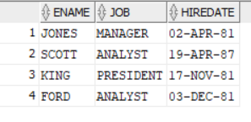

4. Copy all information on dept10 into the D10 table?*

CREATE TABLE D10 AS SELECT * FROM emp WHERE DEPTNO = 10;

SELECT * FROM D10;

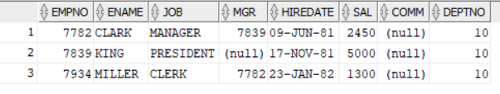

5. Delete all information on dept10 from emp table?

Code-

DELETE FROM emp WHERE DEPTNO = 10;

SELECT * FROM emp;

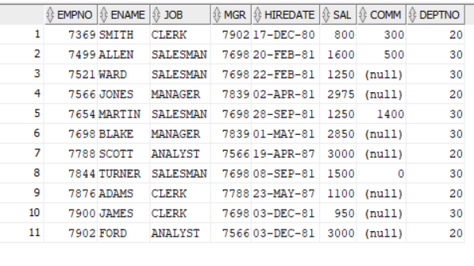

6. Delete rows from dept table of those dept numbers do not have matching rows in the emp table?

Code-

DELETE FROM dept WHERE deptno NOT IN (SELECT deptno FROM emp);

SELECT * FROM dept;

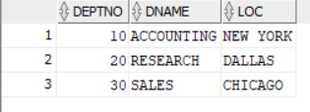

7. List the emp name & salary increased by 15% and expressed as whole no of dollars?

Code-

SELECT ENAME, ROUND(SAL * 1.15) AS INCREASED_SALARY FROM emp;

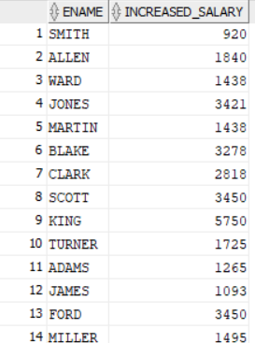

8. Display each employee name with hiredate & review date. Assume review date is one year after hiredate. Order output in assending review date order?

Code-

SELECT ENAME, HIREDATE, HIREDATE + INTERVAL '1' YEAR AS REVIEW_DATE

FROM emp

ORDER BY REVIEW_DATE;

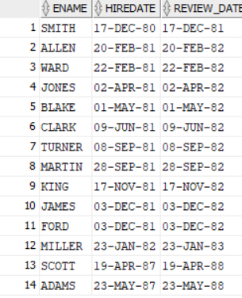

9. Write query which will return the day of the week,for any date entered in the format DD.MM.YY?

Code-

SELECT TO_CHAR(TO_DATE('15.02.22', 'DD.MM.YY'), 'Day') AS DAY_OF_WEEK

FROM dual;



10. List the min & max salary for each job type?*

Code-

SELECT JOB, MIN(SAL) AS MIN_SALARY, MAX(SAL) AS MAX_SALARY

FROM emp

GROUP BY JOB;

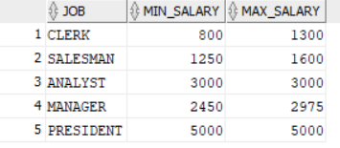

11. Find avg salary & avg total remunation for each job title. Remember salesman earn commision?

Code-

SELECT JOB, AVG(SAL) AS AVG_SALARY, AVG(SAL + NVL(COMM, 0)) AS AVG_TOTAL_REMUNERATION

FROM emp

GROUP BY JOB;

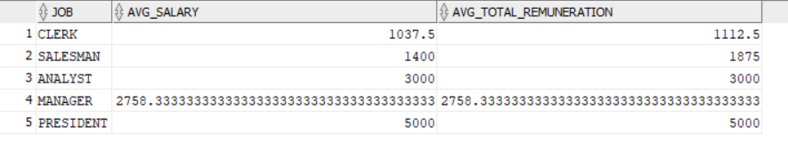

12. Find all dept’s which have more than 3 employees?

Code-

SELECT DEPTNO

FROM emp

GROUP BY DEPTNO

HAVING COUNT(*) > 3;

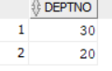

13. List the employee name, job, salary, grade, dept name for every one in the company except clerks. Sort on salary displaying the highest salary first?

Code-

SELECT ENAME, JOB, SAL, dname

FROM emp

JOIN dept ON emp.DEPTNO = dept.DEPTNO

WHERE JOB <> 'CLERK'

ORDER BY SAL DESC;

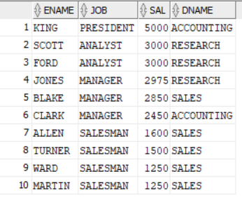

14. List the ename,job,annual salary,deptno,dname,grade of employees who earn $36000 a year or who are clerks?

Code-

SELECT ENAME, JOB, SAL * 12 AS ANNUAL_SALARY, emp.DEPTNO, dname

FROM emp

JOIN dept ON emp.DEPTNO = dept.DEPTNO

WHERE SAL = 3000 OR JOB = 'CLERK';

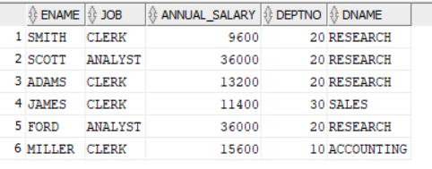

15. Show name,salary,deptno for any employee who earns a salary greater than the average for their dept. Sort in dept order?

Code-

SELECT ENAME, SAL, emp.deptno

FROM emp

WHERE SAL > (SELECT AVG(SAL) FROM emp,dept WHERE emp.deptno = dept.deptno)

ORDER BY emp.deptno;

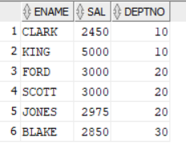

16. Find all employees whose dept is not in the dept table?

Code-

SELECT *

FROM emp

WHERE DEPTNO NOT IN (SELECT DEPTNO FROM dept);



17. Who are the top 3 earners in the company. Display their name and salary?

Code-

SELECT ENAME, SAL

FROM emp

ORDER BY SAL DESC

FETCH FIRST 3 ROWS ONLY;

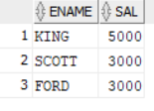

18. List employees with either the same job as jones or a salary greater than or equal to ford’s, order by job and salary?

Code-

SELECT ENAME, JOB, SAL

FROM emp

WHERE JOB = (SELECT JOB FROM emp WHERE ENAME = 'JONES')

OR SAL >= (SELECT SAL FROM emp WHERE ENAME = 'FORD')

ORDER BY JOB, SAL;

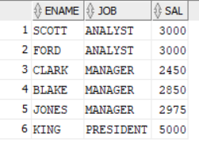

19. List employees in deptno 10 with the same job as anyone in the sales dept?

Code-

SELECT ENAME, JOB

FROM emp

WHERE DEPTNO = 10

AND JOB IN (SELECT JOB FROM emp WHERE DEPTNO = (SELECT DEPTNO FROM dept WHERE DNAME = 'SALES'));

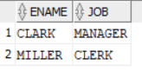

20. List the employees having the same job as employees located in chicago?

Code-

SELECT ENAME, JOB

FROM emp

WHERE JOB IN (SELECT JOB FROM emp WHERE DEPTNO = (SELECT DEPTNO FROM dept WHERE DNAME = 'CHICAGO'));

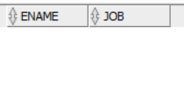

21. List employee whose salary is equal to that of SCOTT or WARD?

Code-

SELECT ENAME, JOB, SAL

FROM emp

WHERE SAL = (SELECT SAL FROM emp WHERE ENAME IN ('SCOTT', 'WARD'));

22. Delete all employees with the same job as jones and jones should not be deleted?

Code-

DELETE FROM emp

WHERE JOB = (SELECT JOB FROM emp WHERE ENAME = 'JONES') AND ENAME <> 'JONES';

SELECT * FROM emp;

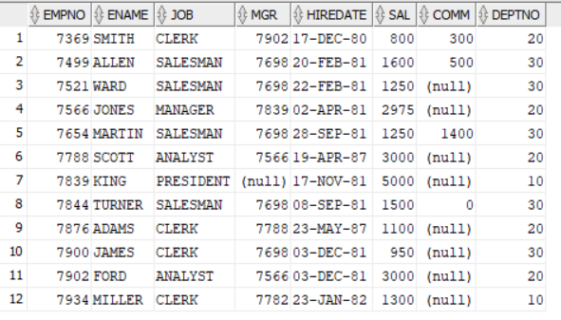

23. Write a query to delete the Duplicate rows for Emp table?

Code-

DELETE FROM emp

WHERE ROWID NOT IN (SELECT MIN(ROWID) FROM emp GROUP BY EMPNO, ENAME, JOB, MGR, HIREDATE, SAL, COMM, DEPTNO);

SELECT * FROM emp;

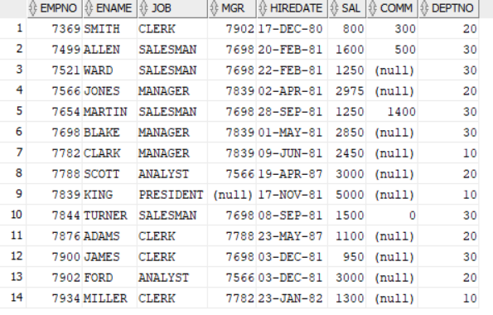

24. Write a query to display 5th row to 7th row of Emp Table?

Code-

SELECT *

FROM (SELECT e.*, ROWNUM rnum FROM emp e WHERE ROWNUM <= 7)

WHERE rnum >= 5;

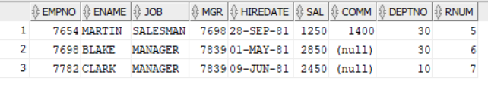

25. Write a query to display the 2nd Max Salary earning employee?

Code-

SELECT *

FROM (SELECT ENAME, SAL, RANK() OVER (ORDER BY SAL DESC) AS salary_rank

FROM emp)

WHERE salary_rank = 2;

