**CSE2007 DBMS LAB**

**SLOT: L39+L40**

**NAME - AMAN SAHU**

**REG. NO – 22BCE7224**

**EXPERIMENT NO.-5**

Create the following tables and populate with following data:

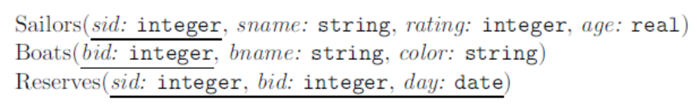

CREATE table Sailors(sid number(3),sname varchar(10),rating number(2),age number(3,1))

CREATE table Boats(bid number,bname varchar(10),color varchar(10))

CREATE table Reserves(sid number,bid number,day date)

Sailors:

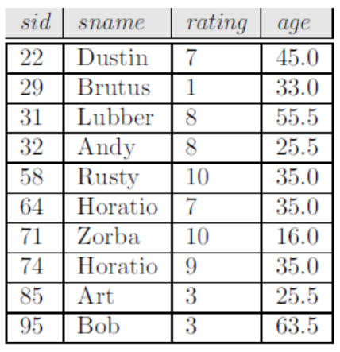

Insert into Sailors values(22,'Dustin',7,45.0);

Insert into Sailors values(29,'Brutus',1,33.0);

Insert into Sailors values(31,'Lubber',8,55.5);

Insert into Sailors values(32,'Andy',8,25.5);

Insert into Sailors values(58,'Rusty',10,35.0);

Insert into Sailors values(64,'Hozatio',7,35.00);

Insert into Sailors values(71,'Zorba',10,16);

Insert into Sailors values(74,'Horatio',9,35);

Insert into Sailors values(83,'Art',3,25.5);

Insert into Sailors values(95,'Bob',3,63.5);

Boats:

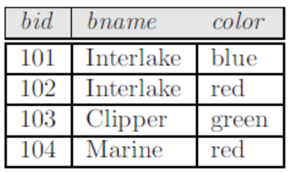

Insert into Boats values(101,'Interlake','blue');

Insert into Boats values(102,'Interlake','red');

Insert into Boats values(103,'Clipper','green');

Insert into Boats values(104,'Marine','red');

CREATE TABLE Boats(bid number(3),bname varchar(12),color varchar(10))

Reserves:

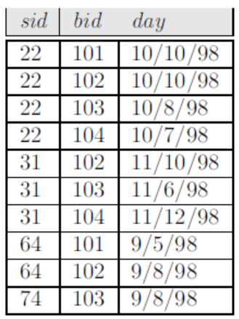

Create Table Reserves(sid number(3),bid number(3),day date)

Select * from Reserves;

INSERT INTO Reserves values(22,101,'10-oct-98');

INSERT INTO Reserves values(22,102,'10-oct-98');

INSERT INTO Reserves values(22,103,'10-AUG-98');

INSERT INTO Reserves values(22,104,'10-JUL-98');

INSERT INTO Reserves values(31,102,'11-oct-98');

INSERT INTO Reserves values(31,103,'11-jun-98');

INSERT INTO Reserves values(31,104,'11-dec-98');

INSERT INTO Reserves values(64,101,'9-may-98');

INSERT INTO Reserves values(64,102,'9-aug-98');

INSERT INTO Reserves values(74,103,'9-aug-98');

**Write SQL Queries for the following:**

1. Find the names and ages of all sailors.

SELECT sname, age FROM Sailors;

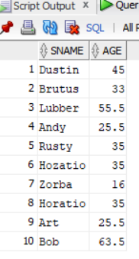

2. Find all sailors with a rating above 7.

SELECT * FROM Sailors WHERE rating>7;

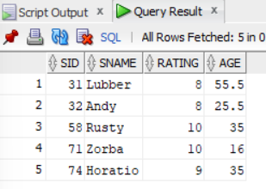

3. Find the names of sailors who have reserved boat number 103.

SELECT sname FROM Sailors WHERE sid IN (SELECT sid FROM Reserves WHERE bid = 103);

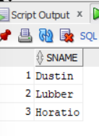

4. Find the sids of sailors who have reserved a red boat.

SELECT sid FROM Reserves WHERE bid IN (SELECT bid FROM Boats WHERE color = 'red');

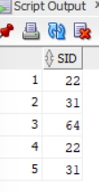

5. Find the names of sailors who have reserved a red boat.

SELECT sname FROM Sailors WHERE sid IN (SELECT sid FROM Reserves WHERE bid IN (SELECT bid FROM Boats WHERE color = 'red'));

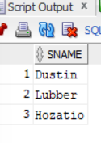

6. Find the colors of boats reserved by Lubber.

SELECT color FROM Boats WHERE bid IN (SELECT bid FROM Reserves WHERE sid IN (SELECT sid FROM Sailors WHERE sname = 'Lubber'));

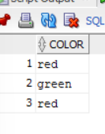

7. Find the names of sailors who have reserved at least one boat.

SELECT sname FROM Sailors WHERE sid IN (SELECT sid FROM Reserves);

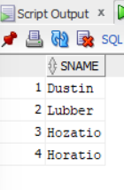

8. Compute increments for the ratings of persons who have sailed two different boats on the same day.

Select R1.sid, R1.day, R1.bid as bid1, R2.bid as bid2, R1.bid - R2.bid as RatingDiff

From Reserves R1 Join Reserves R2 on R1.sid = R2.sid and R1.day = R2.day and R1.bid <> R2.bid

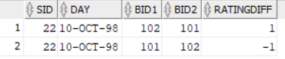

9. Find the ages of sailors whose name begins and ends with B and has at least three characters.

SELECT age FROM Sailors WHERE sname LIKE 'B%B' AND LENGTH(sname) >= 3;

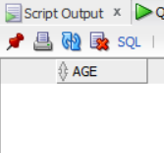

10. Find the names of sailors who have reserved a red or a green boat.

SELECT sname FROM Sailors WHERE sid IN (SELECT sid FROM Reserves WHERE bid IN (SELECT bid FROM Boats WHERE color IN ('red', 'green')));

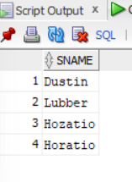

11. Find the names of sailors who have reserved both a red and a green boat.

SELECT sname FROM Sailors WHERE sid IN (SELECT sid FROM Reserves WHERE bid IN (SELECT bid FROM Boats WHERE color = 'red') AND sid IN (SELECT sid FROM Reserves WHERE bid IN (SELECT bid FROM Boats WHERE color = 'green')));

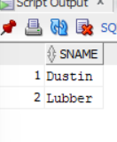

12. Find the names of sailors who have reserved a red or a green boat with set operators.

SELECT sname FROM Sailors WHERE sid IN (SELECT sid FROM Reserves WHERE bid IN (SELECT bid FROM Boats WHERE color IN ('red', 'green')));

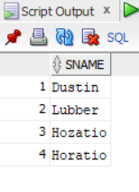

13. Find the names of sailors who have reserved both a red and a green boat with set operators.

SELECT sname FROM Sailors WHERE sid IN (SELECT sid FROM Reserves WHERE bid IN (SELECT bid FROM Boats WHERE color = 'red') AND sid IN (SELECT sid FROM Reserves WHERE bid IN (SELECT bid FROM Boats WHERE color = 'green')));

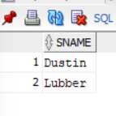

14. Find the sids of all sailors who have reserved red boats but not green boats.

Select distinct sid from Reserves where bid in (select bid from Boats where color = 'red') and sid not in (select sid from Reserves where bid in (select bid from Boats where color = 'green'))

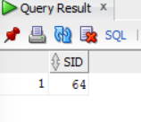

15. Find all sids of sailors who have a rating of 10 or reserved boat 104.

SELECT DISTINCT sid

FROM Sailors

WHERE rating = 10

OR sid IN (SELECT sid FROM Reserves WHERE bid = 104);

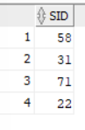

16. Find the names of sailors who have reserved boat 103 using subquery.

SELECT sname

FROM Sailors

WHERE sid IN (SELECT sid FROM Reserves WHERE bid = 103);

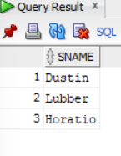

17. Find the names of sailors who have reserved a red boat using subquery.

Select sname from Sailors where sid in (select sid from Reserves where bid in (select bid from Boats where color = 'red'))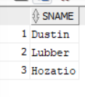

18. Find the names of sailors who have not reserved a red boat.

Select sname from Sailors where sid not in (select sid from Reserves where bid in (select bid from Boats where color = 'red'))

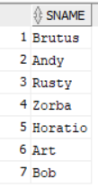

19. Find sailors whose rating is better than some sailor called Horatio.

Select sname from Sailors where rating > (Select rating from Sailors where sname = 'Horatio')

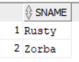

20. Find sailors whose rating is better than every sailor called Horatio.

Select sname from Sailors S where rating > ALL (Select rating from Sailors where sname = 'Horatio')

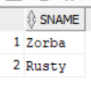

21. Find the sailors with the highest rating.

SELECT sname

FROM Sailors

WHERE rating = (SELECT MAX(rating) FROM Sailors);

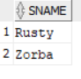

22. Find the names of sailors who have reserved all boats.

SELECT sname

FROM Sailors

WHERE NOT EXISTS (SELECT DISTINCT bid FROM Boats

MINUS

SELECT DISTINCT bid FROM Reserves WHERE sid = Sailors.sid);

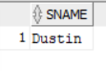

23. Find the average age of all sailors.

Select AVG(age) from Sailors



24. Find the average age of sailors with a rating of 10.

Select avg(age) from Sailors where rating = 10



25. Find the name and age of the oldest sailor.

Select sname, age from Sailors where age = (Select max(age) from Sailors)

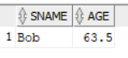

26. Count the number of sailors.

Select count(*) from Sailors



27. Count the number of different sailor names.

Select count(distinct sname) from Sailors



28. Find the names of sailors who are older than the oldest sailor with a rating of 10.

Select sname, age from Sailors where age > (Select max(age) from Sailors where rating = 10)

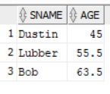

29. Find the age of the youngest sailor for each rating level.

Select rating, min(age) as youngest from Sailors group by rating

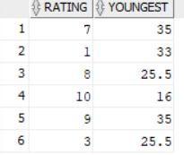

30. Find the age of the youngest sailor who is eligible to vote (i.e., is at least 18 years old) for each rating level with at least two such sailors.

Select rating, min(age) as youngest from Sailors where age >= 18 group by rating having count(*) > 1

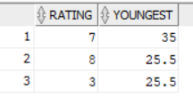

31. For each red boat, find the number of reservations for this boat.

SELECT b.bid AS boat_id, b.bname AS boat_name, COUNT(r.sid) AS num_reservations

FROM Boats b

JOIN Reserves r ON b.bid = r.bid

WHERE b.color = 'red'

GROUP BY b.bid, b.bname;

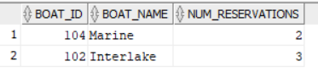

32. Find the average age of sailors for each rating level that has at least two sailors.

SELECT rating, AVG(age) AS avg_age

FROM Sailors

GROUP BY rating

HAVING COUNT(sid) >= 2;

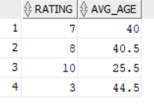

33. Find the average age of sailors who are of voting age (i.e., at least 18 years old) for each rating level that has at least two sailors.

SELECT rating, AVG(age) AS avg_age

FROM Sailors

WHERE age >= 18

GROUP BY rating

HAVING COUNT(sid) >= 2;

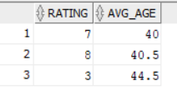

34. Find those ratings for which **the average age of sailors is the minimum** over, all ratings.

Select S.rating, avg(S.age) as AvgAge From Sailors S Group by S.rating Order by AvgAge Fetch First 1 Row Only

