**CSE2007 DBMS LAB**

**SLOT: L39+L40**

**NAME - AMAN SAHU**

**REG. NO – 22BCE7224**

**EXPERIMENT NO.-8**

1.

a. Write a PL/SQL program to swap two numbers.

set serveroutput on

DECLARE

num1 NUMBER := 5;

num2 NUMBER := 7;

temp NUMBER;

BEGIN

DBMS_OUTPUT.PUT_LINE('Before swapping: num1 = ' || num1 || ', num2 = ' || num2);

temp := num1;

num1 := num2;

num2 := temp;

DBMS_OUTPUT.PUT_LINE('After swapping: num1 = ' || num1 || ', num2 = ' || num2);

END;

/

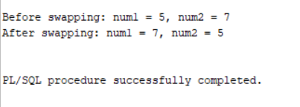

b. Write a PL/SQL program to find the largest of three numbers.

DECLARE

num1 NUMBER := 5;

num2 NUMBER := 100;

num3 NUMBER := 50;

largest NUMBER;

BEGIN

largest := num1;

IF num2 > largest THEN

largest := num2;

END IF;

IF num3 > largest THEN

largest := num3;

END IF;

DBMS_OUTPUT.PUT_LINE('The largest number is: ' || largest);

END;

/

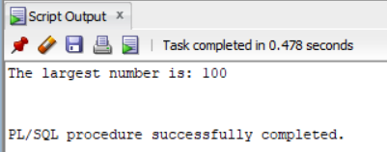

2.

a.Write a PL/SQL program to find the total and average of 6 subjects and display the grade.

DECLARE

s1 number :=89;

s2 number :=85;

s3 number :=95;

s4 number :=99;

s5 number :=81;

s6 number :=94;

total NUMBER;

average NUMBER;

BEGIN

total := s1+s2+s3+s4+s5+s6;

average := total / 6;

DBMS_OUTPUT.PUT_LINE('Total marks: ' || total);

DBMS_OUTPUT.PUT_LINE('Average marks: ' || average);

IF average >= 90 THEN

DBMS_OUTPUT.PUT_LINE('Grade: S');

ELSIF average >= 80 THEN

DBMS_OUTPUT.PUT_LINE('Grade: A');

ELSIF average >= 70 THEN

DBMS_OUTPUT.PUT_LINE('Grade: B');

ELSIF average >= 60 THEN

DBMS_OUTPUT.PUT_LINE('Grade: C');

ELSE

DBMS_OUTPUT.PUT_LINE('Grade: D');

END IF;

END;

/

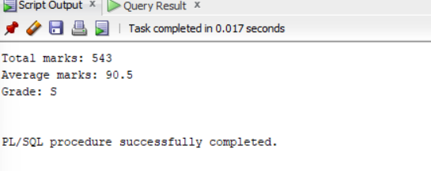

b. Write a PL/SQL program to print a student information along with his marks and grade and also update the grade in the student database. Input to be fetched from a student table.

Initial Table-

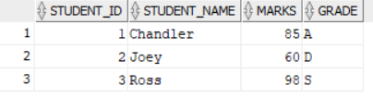

SET SERVEROUTPUT ON;

DECLARE

v_student_id student1.student_id%TYPE;

v_student_name student1.student_name%TYPE;

v_marks student1.marks%TYPE;

v_grade student1.grade%TYPE;

BEGIN

FOR student_rec IN (SELECT * FROM student1) LOOP

v_student_id := student_rec.student_id;

v_student_name := student_rec.student_name;

v_marks := student_rec.marks;

v_grade := student_rec.grade;

DBMS_OUTPUT.PUT_LINE('Student ID: ' || v_student_id || ', Student Name: ' || v_student_name || ', Marks: ' || v_marks || ', Grade: ' || v_grade)

IF v_marks >= 90 THEN

v_grade := 'S'; -- Outstanding

ELSIF v_marks >= 80 THEN

v_grade := 'A'; -- Excellent

ELSIF v_marks >= 70 THEN

v_grade := 'B'; -- Good

ELSIF v_marks >= 60 THEN

v_grade := 'C'; -- Satisfactory

ELSE

v_grade := 'D'; -- Needs improvement

END IF;

UPDATE student1

SET grade = v_grade

WHERE student_id = v_student_id;

END LOOP;

END;

/

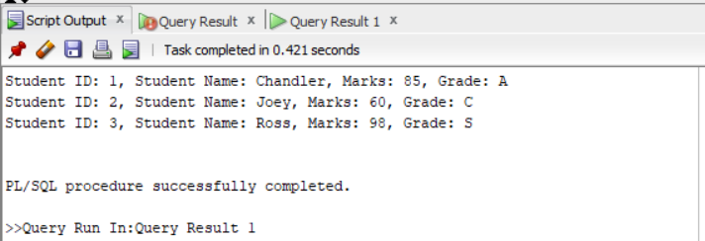

3.

a. Write a PL/SQL program to take two numbers and a choice(1/2/3/4). Based on the choice the program to be performed addition/subtraction/multiplication/division of given two numbers.

set serveroutput on

DECLARE

num1 NUMBER;

num2 NUMBER;

choice NUMBER;

result NUMBER;

BEGIN

num1 := 100;

num2 := 5;

DBMS_OUTPUT.PUT_LINE('Enter your choice: 1) Addition, 2) Subtraction, 3) Multiplication, 4) Division');

DBMS_OUTPUT.PUT_LINE('Your choice: ');

choice := &choice;

IF choice = 1 THEN

result := num1 + num2;

DBMS_OUTPUT.PUT_LINE('The result is: ' || result);

ELSIF choice = 2 THEN

result := num1 - num2;

DBMS_OUTPUT.PUT_LINE('The result is: ' || result);

ELSIF choice = 3 THEN

result := num1 * num2;

DBMS_OUTPUT.PUT_LINE('The result is: ' || result);

ELSIF choice = 4 THEN

IF num2 = 0 THEN

DBMS_OUTPUT.PUT_LINE('Division by zero is not allowed');

ELSE

result := num1 / num2;

DBMS_OUTPUT.PUT_LINE('The result is: ' || result);

END IF;

ELSE

DBMS_OUTPUT.PUT_LINE('Invalid choice');

END IF;

END;

/

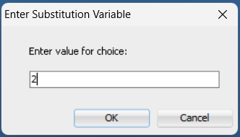

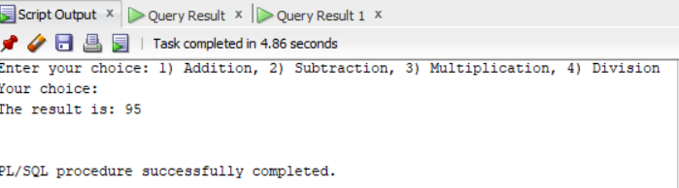

b. Write a PL/SQL program to take two strings and a choice. Based on the choice, you need to perform different string operations on given strings.(Ex: LTRIM, RTRIM, LENGTH, SUBSTR, LPAD, RPAD, etc.,)

DECLARE

str1 VARCHAR2(100) := ' Hello, World! ';

str2 VARCHAR2(100) := 'Database Management System';

choice NUMBER;

result VARCHAR2(100);

BEGIN

DBMS_OUTPUT.PUT_LINE('Enter your choice: 1) LTRIM, 2) RTRIM, 3) LENGTH, 4) SUBSTR, 5) LPAD, 6) RPAD');

DBMS_OUTPUT.PUT_LINE('Your choice: ');

choice := &choice;

IF choice = 1 THEN

result := LTRIM(str1);

DBMS_OUTPUT.PUT_LINE('The result is: ' || result);

ELSIF choice = 2 THEN

result := RTRIM(str1);

DBMS_OUTPUT.PUT_LINE('The result is: ' || result);

ELSIF choice = 3 THEN

result := TO_CHAR(LENGTH(str1));

DBMS_OUTPUT.PUT_LINE('The length of the string is: ' || result);

ELSIF choice = 4 THEN

result := SUBSTR(str1, 1, 5);

DBMS_OUTPUT.PUT_LINE('The substring is: ' || result);

ELSIF choice = 5 THEN

result := LPAD(str1, 15, '*');

DBMS_OUTPUT.PUT_LINE('The result is: ' || result);

ELSIF choice = 6 THEN

result := RPAD(str1, 15, '*');

DBMS_OUTPUT.PUT_LINE('The result is: ' || result);

ELSE

DBMS_OUTPUT.PUT_LINE('Invalid choice');

END IF;

END;

/

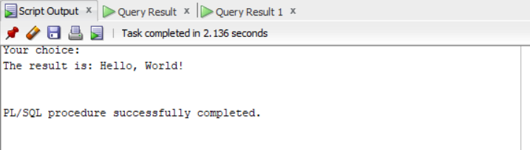

4.

a.Write a PL/SQL code block to calculate the area of a circle for a value of radius given by the user. Store the radius and the corresponding values of calculated area in a table named areas, consisting of two columns radius and area.

CREATE TABLE areas (

radius NUMBER(5,2),

area NUMBER(10,4)

);

DECLARE

radius_input NUMBER;

area_calc NUMBER;

BEGIN

radius_input := &radius;

area_calc := 3.14 * radius_input * radius_input;

INSERT INTO areas (radius, area) VALUES (radius_input, area_calc);

DBMS_OUTPUT.PUT_LINE('Area calculated and stored successfully for radius: ' || radius_input);

COMMIT;

END;

/

Select * from areas;

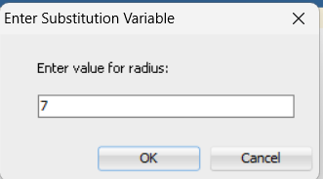

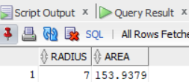

b.Write a PL/SQL code to update the salary and commission of employee as per the input given by user.

DECLARE

v_salary NUMBER(8,2);

v_commission NUMBER(8,2);

v_employee_id NUMBER(6);

BEGIN

DBMS_OUTPUT.PUT_LINE('Enter the employee ID: ');

v_employee_id := &input_employee_id;

DBMS_OUTPUT.PUT_LINE('Enter the new salary: ');

v_salary := &input_salary;

DBMS_OUTPUT.PUT_LINE('Enter the new commission: ');

v_commission := &input_commission;

UPDATE emp

SET sal = v_salary,

comm = v_commission

WHERE empno = v_employee_id;

COMMIT;

DBMS_OUTPUT.PUT_LINE('Salary and commission updated for employee ID: ' || v_employee_id);

END;

/

SELECT * FROM emp;

