**CSE2007 DBMS LAB**

**SLOT: L39+L40**

**NAME - AMAN SAHU**

**REG. NO – 22BCE7224**

**EXPERIMENT NO.-9**

1.Write a PL/SQL program to find the sum of digits in a given number.

DECLARE

num NUMBER := 12345;

total_sum NUMBER := 0;

digit NUMBER;

BEGIN

WHILE num > 0 LOOP

digit := MOD(num, 10);

total_sum := total_sum + digit;

num := num / 10;

END LOOP;

DBMS_OUTPUT.PUT_LINE('Sum of digits: ' || total_sum);

END;

/

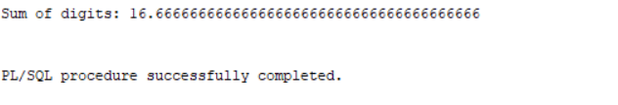

2. Write a PL / SQL program to check whether the given number is prime or not.

DECLARE

num NUMBER := 7;

isPrime BOOLEAN := TRUE;

i NUMBER := 2;

BEGIN

IF num <= 1 THEN

isPrime := FALSE;

ELSE

WHILE i <= SQRT(num) LOOP

IF MOD(num, i) = 0 THEN

isPrime := FALSE;

EXIT;

END IF;

i := i + 1;

END LOOP;

END IF;

IF isPrime THEN

DBMS_OUTPUT.PUT_LINE(num || ' is a prime number.');

ELSE

DBMS_OUTPUT.PUT_LINE(num || ' is not a prime number.');

END IF;

END;

/

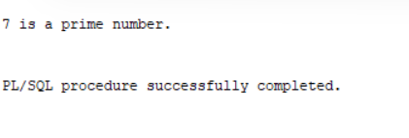

3. Write a PL/SQL code block to calculate the area of a circle for a value of radius varying

from 3 to 7. Store the radius and the corresponding values of calculated area in an empty

table named areas, consisting of two columns radius and area.

CREATE TABLE c_areas (

radius NUMBER,

area NUMBER

);

DECLARE

radius_val NUMBER;

area_val NUMBER;

BEGIN

FOR radius_val IN 3..7 LOOP

area_val := 3.14 * radius_val * radius_val;

INSERT INTO c_areas VALUES (radius_val, area_val);

END LOOP;

COMMIT;

END;

/

SELECT * From c_areas;

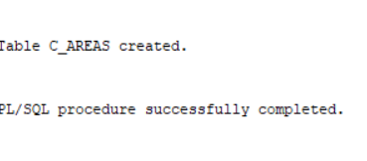

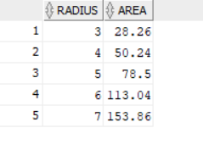

4. Write a PL/SQL program to accept a number and a divisor. Make sure the divisor is

less than or equal to 10. Else display an error message. Otherwise Display the remainder

in words.

DECLARE

v_number NUMBER := 11;

v_divisor NUMBER := 6;

v_remainder NUMBER;

v_remainder_word VARCHAR2(20);

BEGIN

IF v_divisor > 10 THEN

DBMS_OUTPUT.PUT_LINE('Error: Divisor should be less than or equal to 10');

ELSE

v_remainder := MOD(v_number, v_divisor);

CASE v_remainder

WHEN 0 THEN v_remainder_word := 'Zero';

WHEN 1 THEN v_remainder_word := 'One';

WHEN 2 THEN v_remainder_word := 'Two';

WHEN 3 THEN v_remainder_word := 'Three';

WHEN 4 THEN v_remainder_word := 'Four';

WHEN 5 THEN v_remainder_word := 'Five';

WHEN 6 THEN v_remainder_word := 'Six';

WHEN 7 THEN v_remainder_word := 'Seven';

WHEN 8 THEN v_remainder_word := 'Eight';

WHEN 9 THEN v_remainder_word := 'Nine';

END CASE;

DBMS_OUTPUT.PUT_LINE('Remainder in words: ' || v_remainder_word);

END IF;

END;

/

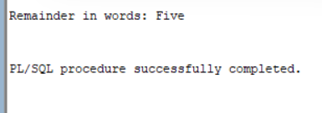

5. Write a PL/SQL block that will display the name, dept no, salary of highest paid

employees.

set serveroutput on

DECLARE

v_ename emp.ename%TYPE;

v_sal emp.sal%TYPE;

v_deptno emp.deptno%TYPE;

v_maxsal emp.sal%TYPE;

BEGIN

SELECT MAX(sal) INTO v_maxsal FROM emp;

FOR cur IN (SELECT ename, sal, deptno FROM emp WHERE sal = v_maxsal)

LOOP

v_ename := cur.ename;

v_sal := cur.sal;

v_deptno := cur.deptno;

DBMS_OUTPUT.PUT_LINE('Employee Name: ' || v_ename);

DBMS_OUTPUT.PUT_LINE('Department Number: ' || v_deptno);

DBMS_OUTPUT.PUT_LINE('Salary: ' || v_sal);

END LOOP;

END;

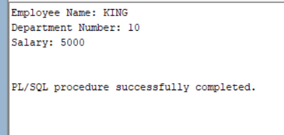

6. Write a PL/SQL block to update the salaries of employees of department number is 30

by 10 percent and display the number of records is updated.

DECLARE

v_cnt NUMBER(4);

BEGIN

UPDATE emp

SET sal = sal * 1.10

WHERE deptno = 30;

SELECT COUNT(*) INTO v_cnt FROM emp WHERE deptno = 30;

DBMS_OUTPUT.PUT_LINE('Number of records updated: ' || v_cnt);

END;

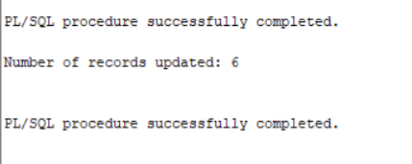

7. Write a PL/SQL block to update the salaries of employees by ‘K’ percent of specific

department mentioned by user input. Hint: Parameterized Cursors.

DECLARE

-- Declare variables

v_deptno emp.DEPTNO%TYPE;

v_percent NUMBER(5,2); -- Percentage increase/decrease

BEGIN

-- Accept user input for department number and percentage

v_deptno := &deptno; -- User input for department number

v_percent := &percent; -- User input for percentage

-- Open cursor to fetch employees in the specified department

FOR emp_rec IN (SELECT * FROM emp WHERE DEPTNO = v_deptno) LOOP

-- Update salary with the specified percentage

UPDATE emp

SET SAL = SAL * (1 + v_percent / 100)

WHERE EMPNO = emp_rec.EMPNO;

END LOOP;

-- Commit the changes

COMMIT;

-- Display success message

DBMS_OUTPUT.PUT_LINE('Salaries updated successfully for department ' || v_deptno || ' by ' || v_percent || '%');

EXCEPTION

WHEN OTHERS THEN

-- Display error message if any exception occurs

DBMS_OUTPUT.PUT_LINE('Error: ' || SQLERRM);

ROLLBACK; -- Rollback changes if an error occurs

END;

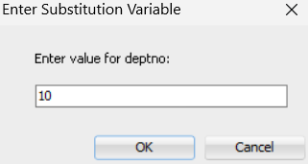

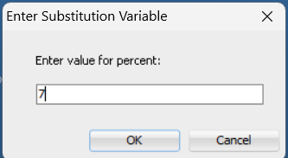

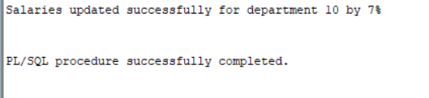

8. Write a PL/SQL block to display the employee records of specific department using

Cursor for loop.

DECLARE

DEPT_ID NUMBER := 10; -- You can change this to the department number you want

CURSOR emp_cur IS SELECT * FROM emp WHERE DEPTNO = DEPT_ID;

BEGIN

FOR emp_rec IN emp_cur LOOP

DBMS_OUTPUT.PUT_LINE('Employee Number: ' || emp_rec.EMPNO);

DBMS_OUTPUT.PUT_LINE('Employee Name: ' || emp_rec.ENAME);

DBMS_OUTPUT.PUT_LINE('Job: ' || emp_rec.JOB);

DBMS_OUTPUT.PUT_LINE('Manager: ' || emp_rec.MGR);

DBMS_OUTPUT.PUT_LINE('Hire Date: ' || emp_rec.HIREDATE);

DBMS_OUTPUT.PUT_LINE('Salary: ' || emp_rec.SAL);

DBMS_OUTPUT.PUT_LINE('Commission: ' || emp_rec.COMM);

DBMS_OUTPUT.PUT_LINE('Department Number: ' || emp_rec.DEPTNO);

DBMS_OUTPUT.PUT_LINE('-------------------------');

END LOOP;

END;

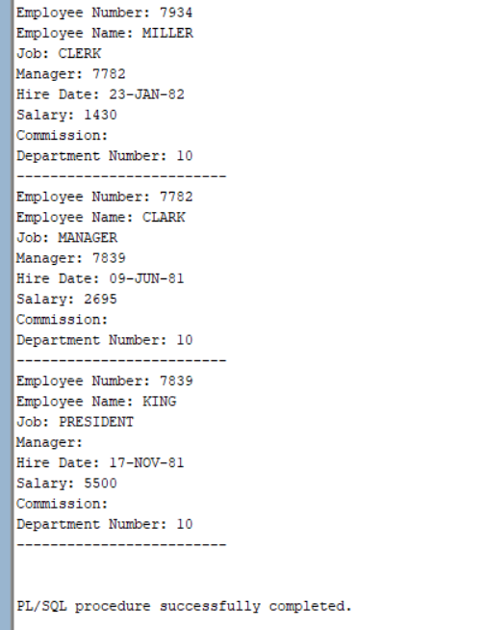

9. Write a PL/SQL block to display all employees and their department names using

Cursors.

DECLARE

CURSOR cur_emp IS

SELECT e.ename, d.dname

FROM emp e

JOIN dept d ON e.deptno = d.deptno;

v_ename emp.ename%TYPE;

v_dname dept.dname%TYPE;

BEGIN

FOR cur IN cur_emp

LOOP

v_ename := cur.ename;

v_dname := cur.dname;

DBMS_OUTPUT.PUT_LINE('Employee Name: ' || v_ename);

DBMS_OUTPUT.PUT_LINE('Department Name: ' || v_dname);

END LOOP;

END;

