8898887276

kkhansare@gmail.com



Mandir Mochi Galli Tatanagar G**ovandi** Mumbai-400043

Visite : <https://kanhaiyaresume.herokuapp.com/>

KANHAIYA KHANSARE

** IT SKILL**

**CAREER OBJECTIVE**

* **Programming Language**:

Python , C++ , Core Java & C#.

* **Web Programming**

HTML , CSS , Java script , Bootstrap & Git / Github

* **Framework**

Django , Flask , Asp.net , Eclipse & NetBeans.

* **Database**

MYSQL , MS-SQL , Oracle , RDBMS & Sqlite

* **Hardware Systems**

PC Assembling , Formatting & Troubleshooting . Installation & Networking , Routing Configuration.

* **Operating System** : Windows- 10 , Windows 7 , Windows XP And Ubuntu .

“Looking for a challenging role in a reputable organization to utilize my technical, database, and management skills for the growth of the organization as well as to enhance my knowledge about new and emerging trends in the IT sector”

 **QUALIFICATION**

|  |  |  |
| --- | --- | --- |
| STD | BOARD | PASSED YEAR |
| M.SC ( IT ) ( Artificial Intelligence) | University Of Mumbai | Pursuing |
| B.SC ( Information Technology ) | University Of Mumbai | Passed **(2017)** |
| 12 TH (Science) | HSC (Mumbai) | Passed **(2012)** |
| 10TH | SSC (Mumbai) | Passed **(2010)** |

­

 **KEY LEARNING**

**HOBBIES**



**M.SC. ( Information Technology ) Final Year Project**

**Topic : “Share Market Prediction” (using Machine leaning )**

**Location :** Mumbai University

**Summary :** The aim is to predict the future value of the financial stocks of a

company. The recent trend in stock market prediction

technologies the use of machine learning which makes

predictions based on the values of current stock market indices

by training on their company values.

 **CERTIFICATE COURSES**

**B.SC ( Information Technology ) Final Year Project**

**Topic : “E-Courier Application in ASP.Net with C#”**

**Location :** Mumbai University

**Date :** 20/07/2016

**Summary :** e-Courier is an end-to-end cloud-based software that helps

ambitious last mile couriers operate and grow their business.

**★ Software Testing Course [2017].**

**{ Garware Institute of Career Education and Development Mumbai University }.**

**I. Manual Testing.**

**II. Automation testing (selenium Web driver ).**

**★ M.S Office (2010) [ Anubhav Institute ].**

**★ MSCIT (2010) [ Anubhav Institute ].**

**★** Diploma in MS-office , Automation with Flash (2010) [ **Anubhav** I**nstitute ]**

Marathi

Hindi

English

**LANGUAGES KNOWN**

* Data Science
* Big Data Analysis
* Modern Networking
* Applied Artificial Intelligence
* Deep Learning
* Machine Learning
* Robotic Process Automation
* Natural Language Processing
* Human Computer Interaction

** STRENGTHS :-** Team Player , Hardworking , Loyal , Energetic , Caring And Accepting

** WEAKNESS :-** I Am Very Possessive About My Work .

** PERSONAL INFORMATION**

|  |
| --- |
| * Full Name :- KANHAIYA SUKHLAL KHANSARE |
| * Date of Birth :- 26th -April - 1993 |
| * Place of Birth :- Mumbai |
| * Gender :- Male |
| * Nationality :- Indian |
| * Marital status :- Single |

**OTHER LINKS :-**

** :-** [**https://github.com/Coder-Erro404**](https://github.com/Coder-Erro404)

[](https://www.linkedin.com/in/kanhaiya-khansare-47a26a102/) **:-** [**https://www.linkedin.com/in/kanhaiya-khansare-47a26a102/**](https://www.linkedin.com/in/kanhaiya-khansare-47a26a102/)

**[](https://medium.com/@kkhansare) :-** [**https://medium.com/@kkhansare**](https://medium.com/@kkhansare)

**[](https://stackoverflow.com/users/10698145/kunal-khansare) :-** [**https://stackoverflow.com/users/10698145/codererror404**](https://stackoverflow.com/users/10698145/codererror404)

**[](https://twitter.com/kkhansare) :-** [**https://twitter.com/kkhansare**](https://twitter.com/kkhansare)

**DECLARATION :-**

I hereby declare that the above information given is true to the best of my knowledge and believe.

**Reference By :-**

**Date :-**

**Place :-**

( **KANHAIYA SUKHLAL KHANSARE** )

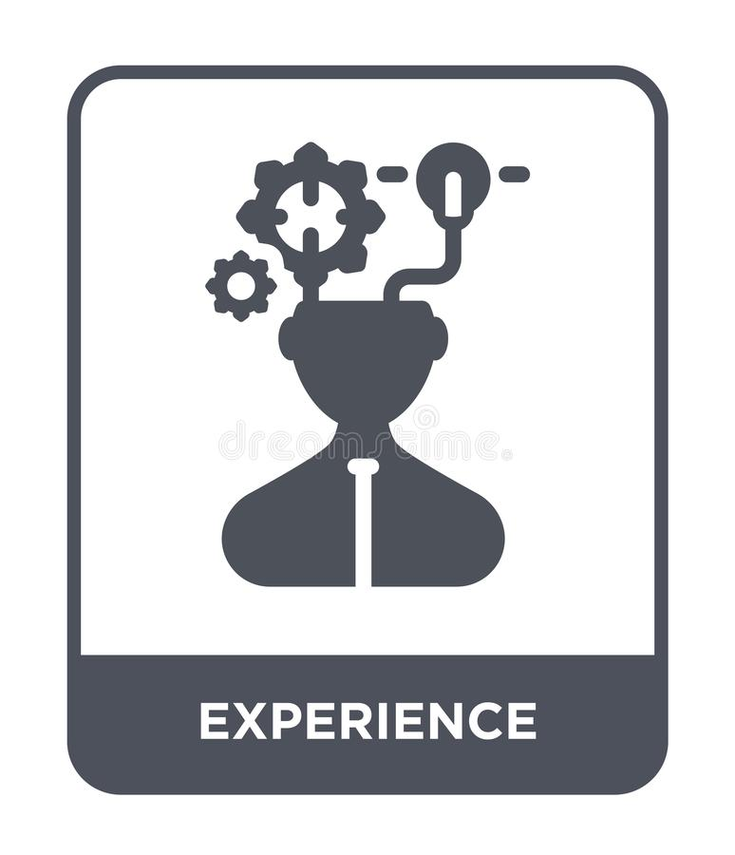 **EXPERIENCE**

1. I worked as a software test engineer for 10 months in the company for "**ADNAC BUSINESS SOLUTIONS LLP**".

(**20 Sep 2018 to 20 July 2019**) **(** Manual Testing and Automation Testing **).]**

* **Tested software :-**

**( I have best Test case Excel format and Bug / Defect report Excel Format to easy understand)**

1. I worked in Freshmenu ( Food Vista Pvt Ltd ) as a delivery executive for 4 months. ( **Dec 2017 To April 2018**)
2. I worked at Grocers Food Company as a billing process desk for 6 months (DO) (**Oct-2016 to April-2017** )

1. I worked as a Data Operator in Reliance Fresh Private Limited Company for the 9th month.

( **Nov-2012 to Sept-2013**)

* MACIL ( Web only )
* Polymath ( Mobile )
* NuTock ( Mobile and Web ) Hotel Application.
* HR Fast ( Mobile / Web )
* DDSM ( Mobile and Web )
* Pragya jewellery ( Web only )
* Kara jewellery ( Web only )