BHOOMISYNC
Prompt 2 Technical Walkthrough: Drone Data Ingestion & Continuous Cloud Pipeline
Continuous Streaming Ingestion, Metadata Extractors, Deduplication, Processing Queues & GIS Footprints
Release: Prompt 2 Verified • Date: August 2026
📌 MANDATORY ARCHITECTURAL SCOPE RESTRICTION
DRONE FLIGHT CONTROL IS STRICTLY OUT OF SCOPE AND NOT IMPLEMENTED.
BhoomiSync contains no MAVLink, ArduPilot, PX4, ROS 2, autonomous waypoint navigation, or drone flight controls. BhoomiSync is exclusively a Data Acquisition, Ingestion, Cloud Storage, AI Segmentation, and GIS Cadastral Platform.

1. Prompt 2 Executive Summary & Architecture
Prompt 2 establishes the end-to-end Drone Data Ingestion & Cloud Pipeline for BhoomiSync. The module continuously receives multi-sensor data collected from survey drones (High-Resolution Nadir Cameras, 3D LiDAR, and RTK/GNSS positioning), extracts rich spatial metadata without modifying raw bytes, enforces cryptographic SHA-256 deduplication, maintains upload session state machines, and automatically triggers downstream modular processing job queues.

2. Sensor Payloads & Metadata Extraction Engines
The ingestion architecture is strictly hardware-agnostic. In the current prototype, data flows via ESP32 -> Surveyor Mobile App -> Cloud. In future in-house drone hardware, data will stream directly from an Onboard Companion Computer (NVIDIA Jetson / Industrial ARM). The backend requires zero refactoring.
Sensor Payload | Supported File Formats | Extracted Geolocation & Metadata | Downstream Processing Job
Nadir Camera Photos | JPEG, PNG, TIFF, DNG | GPS Lat/Lon/Alt, EXIF timestamp, Camera Make/Model, Focal Length, ISO, Shutter | IMAGE_PREPROCESSING
3D LiDAR Point Clouds | LAS, LAZ, PLY, PCD, CSV | Point Count, 3D Bounding Box [X/Y/Z min & max], Coordinate System, Elevation Span | LIDAR_PREPROCESSING
RTK / GNSS Trajectory | RINEX, NMEA ($GNGGA), JSON, CSV | Fixed/Float RTK fix status, Horizontal/Vertical Precision (cm), Satellites, Epochs | GEOREFERENCING

3. Session State Machines & Cryptographic Integrity
• Upload Session State Machine: CREATED ──> UPLOADING ──> COMPLETED / PARTIAL / FAILED / CANCELLED
• File Lifecycle State Machine: PENDING ──> UPLOADING ──> UPLOADED ──> VALIDATED ──> QUEUED ──> PROCESSING ──> PROCESSED / FAILED
• Cryptographic Deduplication: Automatically computes SHA-256 hashes upon upload. If a file was already ingested, it is flagged as is_duplicate=True, avoiding redundant storage while maintaining survey references.

4. Visual Walkthrough & Interface Verification

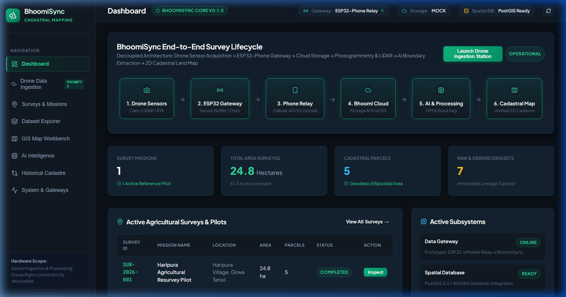
Figure 1: BhoomiSync Main Operations Dashboard with 'Launch Drone Ingestion Station' trigger.

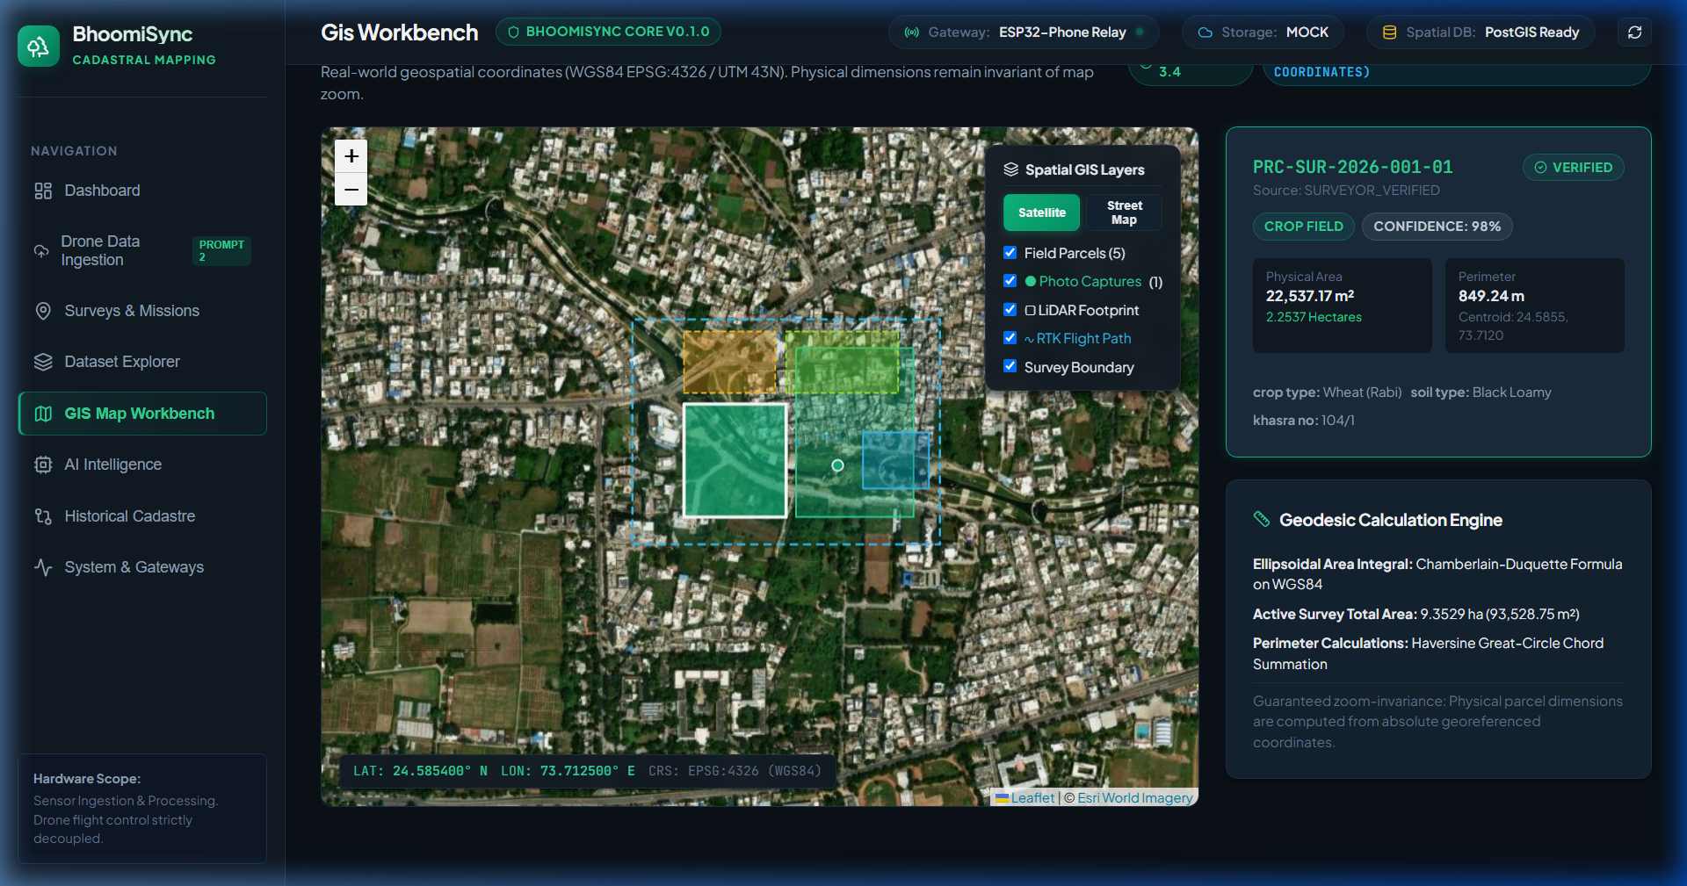
Figure 2: Interactive GIS Map Workbench rendering real-time photo capture points (green), LiDAR footprint (purple), and RTK flight trajectory (cyan).

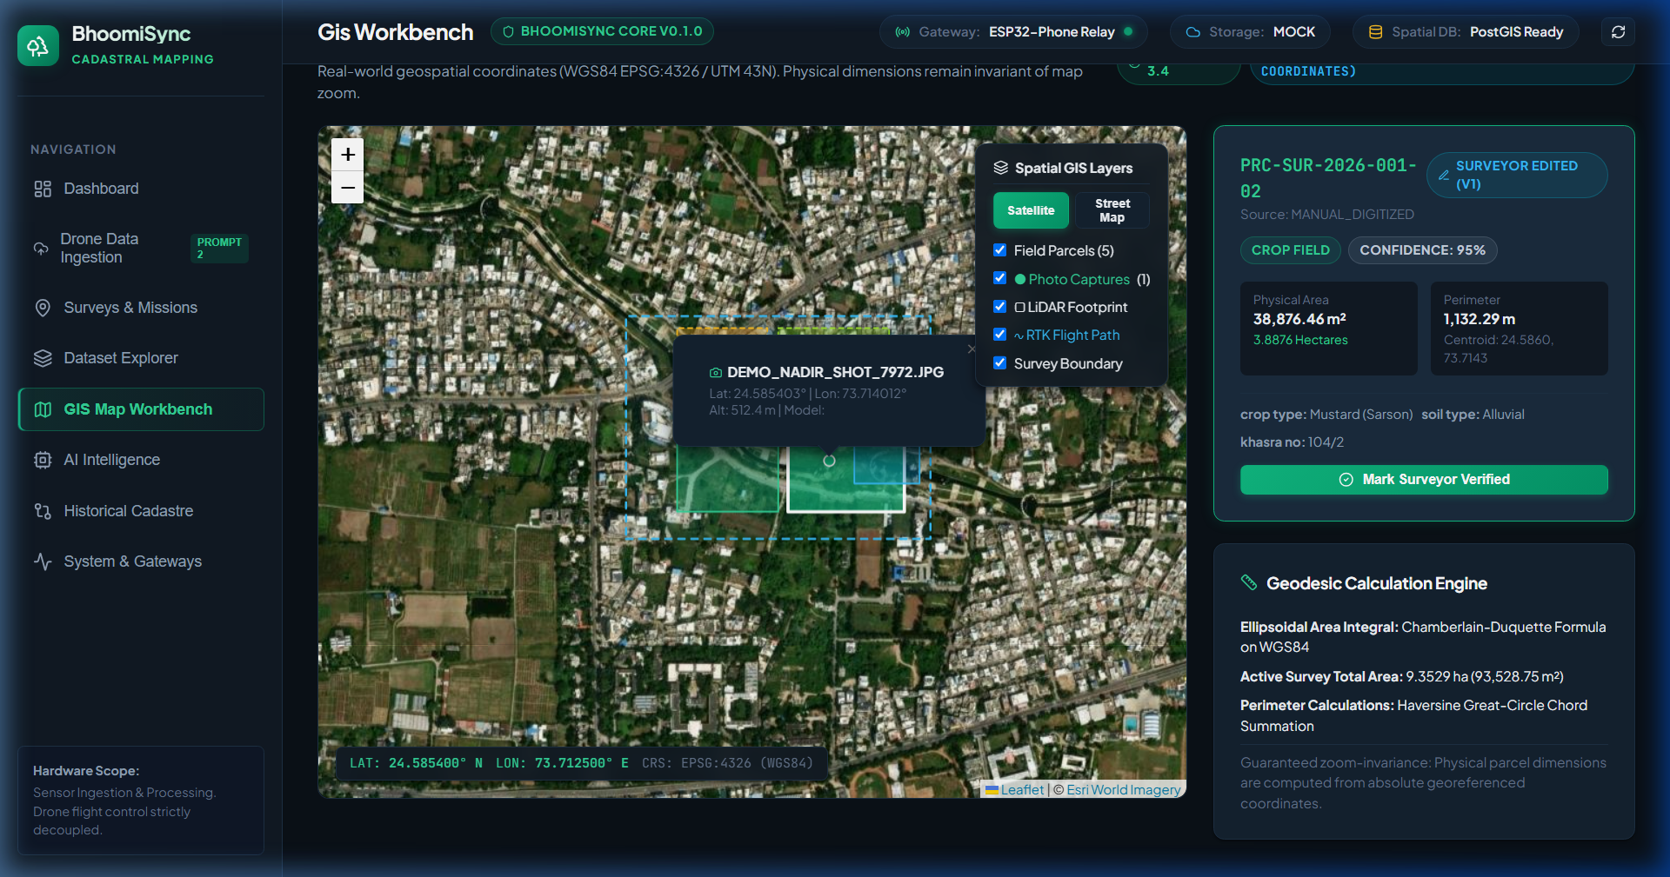
Figure 3: Georeferenced Camera Photo popup inspector displaying altitude, coordinates HUD, and camera parameters over satellite tiles.

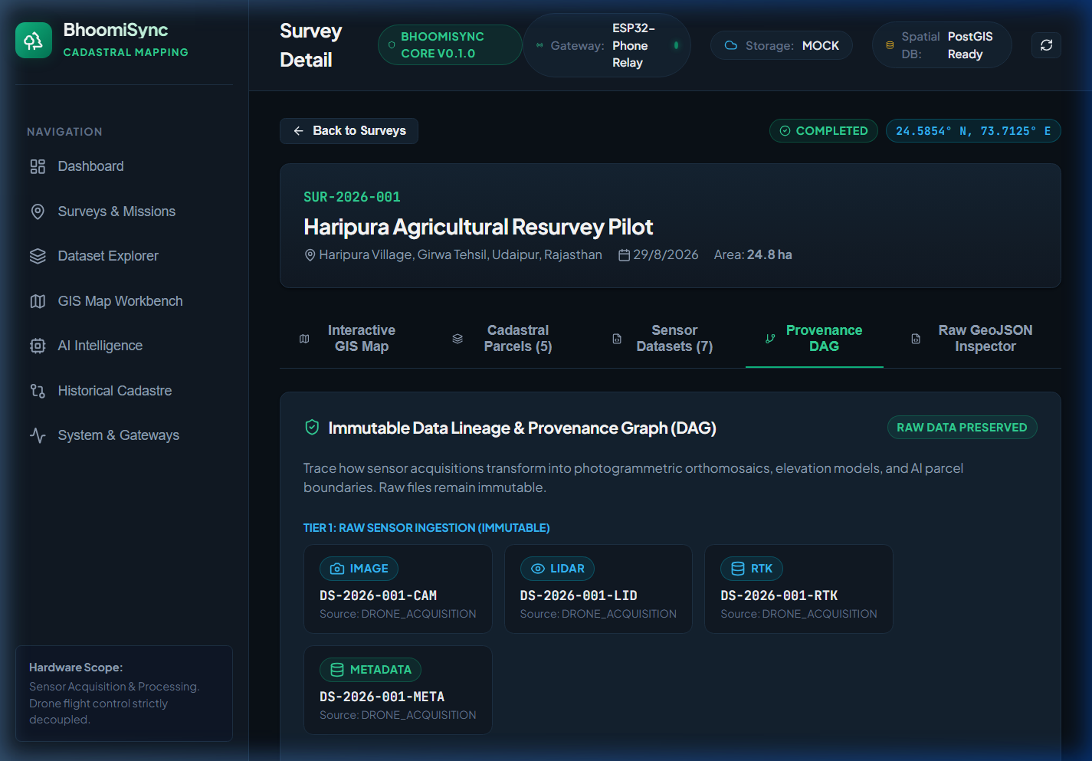
Figure 4: Immutable Provenance DAG Graph tracking Tiers 1-3 dataset transformations.

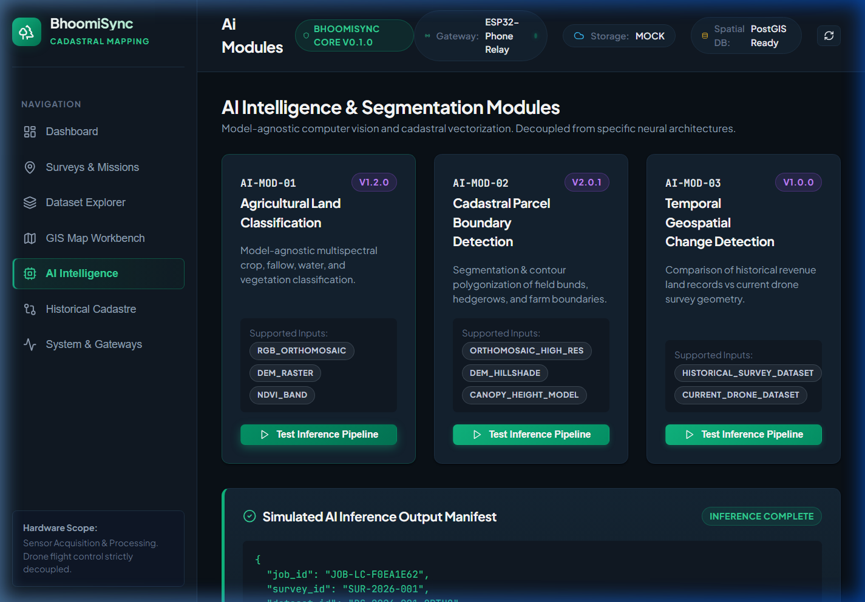
Figure 5: AI Intelligence Workbench executing model-agnostic cadastral boundary segmentation inference.

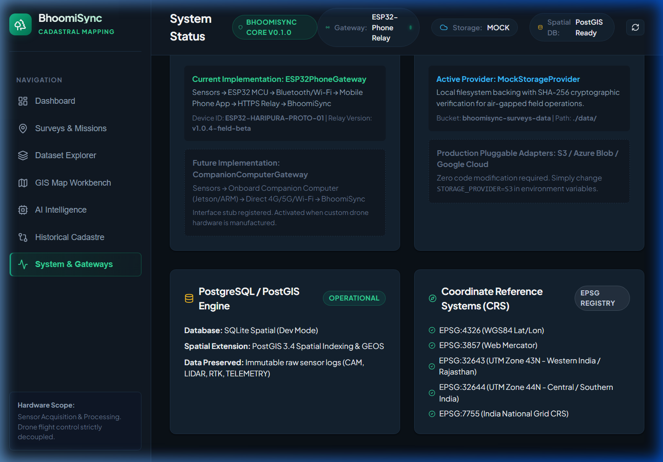
Figure 6: System Architecture Monitor tracking ESP32PhoneGateway, MockStorageProvider, and PostGIS health.

5. Canonical REST API Catalog (/api/v1/)
Method | Canonical Endpoint (/api/v1/) | Functional Description
GET | /api/v1/health | Platform health, PostGIS status, storage provider, and active gateway type.
GET | /api/v1/sensors | List registered drone sensor payloads (Camera, LiDAR, RTK GNSS).
POST | /api/v1/surveys/{id}/upload-sessions | Initialize continuous / batched ingestion sync session.
POST | /api/v1/surveys/{id}/upload | Multipart continuous sensor file upload with EXIF/LiDAR parsing & dedup.
GET | /api/v1/files/{file_id} | Retrieve stored file metadata, EXIF parameters, and storage keys.
POST | /api/v1/files/{file_id}/retry | Retry failed file validation or requeue downstream processing job.
GET | /api/v1/surveys/{id}/spatial-footprint | GeoJSON FeatureCollections of photo points, LiDAR bounds, RTK tracks.
GET | /api/v1/processing/jobs | Monitor modular processing job queue.
GET | /api/v1/surveys | List all agricultural survey missions with pagination and summary stats.
GET | /api/v1/surveys/{id}/parcels | Retrieve all parcel boundaries with calculated geodesic area & perimeter.

6. Testing, Demo Mode & Verification Results
• Demo Simulation Testing: Click 'Drone Data Ingestion' -> 'Demo Simulator Mode' -> 'Trigger Full Drone Ingestion Batch Simulation'. The system ingests synthetic geotagged camera photos, a Livox LiDAR strip, and RTK GNSS logs, and renders them instantly on the GIS Map.
• Pytest Backend Test Suite: 27/27 unit and integration tests passed in 0.95s.
• Frontend Production Build: Vite & TypeScript build completed in 1.45s with 0 errors.
• Browser End-to-End Verification: Complete browser workflow recorded to drone_ingestion_pipeline_demo_1788158199234.webp.

