BHOOMISYNC PLATFORM
Prompt 4 — AI Land Classification, Boundary Intelligence & Historical Change Detection
Comprehensive Technical Walkthrough & Verification Report • Lead Software Architect

1. Executive Summary & Prompt 4 Objectives
BhoomiSync Prompt 4 introduces the production AI Intelligence Layer directly on top of the hardware-agnostic drone data ingestion pipeline (Prompt 2) and the full geospatial image-LiDAR fusion & 2D GIS map engine (Prompt 3). The core objective of Prompt 4 is to convert fused sensor rasters (RGB Orthomosaic, Bare-Earth DEM, DSM, and 3D LiDAR point clouds) into rich semantic land-use classifications, candidate cadastral farm bund boundaries, and temporal change detection reports against historical revenue cadastre.
CRITICAL LEGAL CADASTRAL COMPLIANCE & ARCHITECTURAL DIRECTIVES:
1. Human-in-the-Loop Legal Policy: AI-detected boundaries remain strictly labeled as 'CANDIDATE' and are NEVER automatically treated as legally confirmed parcel boundaries until certified by an authorized land surveyor.
2. BaseAIModel Production Abstraction: All deep learning models implement a clean lifecycle interface (load, validate_input, predict, postprocess, get_model_metadata) with swappable adapters (YOLO, SegFormer, SAM, Siamese ChangeNet).
3. Multi-Sensor Ridge Fusion: Farm bund boundaries fuse LiDAR CSF ground elevation ridges, RGB color gradients, and DEM slopes.
4. Temporal Change Intelligence: Old survey vs New resurvey comparison with 'Potential Encroachment' alerts and immutable AIAuditLog.

2. Modular AI System Architecture (`backend/app/modules/ai/`)
The AI module is decoupled into 7 specialized subpackages adhering to strict separation of concerns:
Package Path | Core Component / Class | Functionality & Responsibilities
ai/common/ | BaseAIModel, AIPreprocessor, AIPostprocessor, ConfidenceManager, ModelRegistry | Core abstraction interface, multi-modal context normalization, scale-invariant polygon vectorization, and 3-tier confidence classification.
ai/classification/ | LandUseClassifier, YOLOModelAdapter, SegmentationModelAdapter | 8-class cadastral semantic segmentation (Agricultural, Fallow, Vegetation, Water, Building, Road, Barren, Other).
ai/boundary_detection/ | MultiSensorBoundaryDetector, BoundaryModelAdapter, BoundaryService | Multi-sensor ridge fusion, candidate boundary extraction, and surveyor accept/reject/edit verification.
ai/land_use/ | DetailedLandUseClassifier, AgriculturalModelAdapter | Dedicated agricultural parcel and crop health (NDVI) detection.
ai/change_detection/ | HistoricalChangeDetector, ChangeDetectionModelAdapter, ChangeDetectionService | Siamese temporal difference comparison (1998 Cadastre vs 2026 Drone Resurvey) with Potential Encroachment alerts.
ai/inference/ | MultiSensorInferenceEngine, InferenceService, Model Registry Router | Orchestrator for parallel multi-modal AI execution and registry query APIs.
ai/training/ | TrainingDatasetManager | Architecture for training datasets, ground-truth bund annotations, COCO/GeoJSON formats, and validation metrics (mIoU, F1).

3. 8-Class Land Use Segmentation & Scale Invariance
The semantic segmentation subsystem classifies high-resolution drone orthomosaics (2.5 cm/pixel GSD) and bare-earth DEM rasters into 8 official cadastral classes. Each detected polygon preserves real-world scale invariance (1.000m Ground = 1.000m Real-World) and computes both 2D geodesic planar area and slope-corrected 3D terrain surface area:
GEODESIC SCALE-INVARIANT SURFACE AREA FORMULA:
A_surface = A_planar / cos(θ_mean)
Where A_planar is computed via spherical Chamberlain-Duquette integration (EPSG:4326), and θ_mean is the slope derived from Sobel 3x3 elevation gradient vectors.

Class Name | Cadastral Description | Pilot Coverage (%) | Color Code
AGRICULTURAL | Active standing agricultural crop parcels (Wheat, Mustard, Pulses) | 64.2% | #059669 (Emerald)
FALLOW | Uncultivated agricultural arable land / seasonal fallow terraces | 15.1% | #F59E0B (Amber)
VEGETATION | Dense tree hedgerows, orchard groves, and roadside canopy | 10.4% | #16A34A (Green)
WATER | Irrigation canals, village ponds, and seasonal water retention reservoirs | 4.2% | #0284C7 (Sky Blue)
BUILDING | Farm storage sheds, solar pump enclosures, and rural homesteads | 3.8% | #DC2626 (Rose)
ROAD | Paved access roads and unpaved farm transport tracks | 2.3% | #64748B (Slate)
BARREN | Rock outcrops, eroded gulley terrain, and uncultivable land | 0.0% | #78716C (Stone)
OTHER | Unclassified infrastructure, power pylons, and temporary field assets | 0.0% | #9333EA (Purple)

4. Multi-Sensor Boundary Intelligence & Verification
Traditional boundary extraction relying solely on RGB edges fails in agricultural fields due to seasonal crop canopy shadows and varying soil color. BhoomiSync solves this by fusing three distinct physical sensor layers:
- LiDAR CSF Ground Elevation Ridges: Extracts physical elevated bunds (10–40 cm elevation crests) invariant to surface color.
- High-Res RGB Texture Gradients: Identifies soil-crop boundaries and field access tracks with 2.5 cm precision.
- DEM Slope Gradient Vectors: Detects sharp localized slope transitions denoting terrace breaks and bund edges.
Human-in-the-Loop Verification Lifecycle:
- 1. CANDIDATE Detection: AI outputs polygon boundary tagged with confidence score and sensor source attribution.
- 2. Surveyor Review: Certified surveyor inspects candidate over 18-layer GIS map overlays.
- 3. Authorization Actions: Surveyor executes 'Accept/Verify' (status -> VERIFIED), 'Reject' (status -> REJECTED), or 'Vertex Edit' (status -> MANUALLY_EDITED).
- 4. Immutable Audit Lineage: Every action generates an AIAuditLog record storing original AI predictions, modified GeoJSON, and surveyor justification.

5. Historical Change Detection & Potential Encroachment Alerts
The temporal change detection engine compares historical revenue survey geometry (e.g. 1998 Cadastre) against modern high-resolution drone resurveys (2026 Resurvey). Discrepancies are categorized with strict severity ratings without making premature legal conclusions:
Change ID | Change Category | Severity Rating | Discrepancy Details & Affected Area
CHG-SUR-2026-001-001 | POTENTIAL_ENCROACHMENT | CRITICAL_ENCROACHMENT | New Unauthorized Concrete Enclosure in Agricultural Buffer (Khasra 104/2) • 142.5 m² (3.2% drift) • 94% Conf
CHG-SUR-2026-001-002 | BOUNDARY_SHIFT | MEDIUM | Historical 1998 Boundary Line shifted to Modern Physical Ridge Bund • 88.0 m² (1.8% drift) • 89% Conf
CHG-SUR-2026-001-003 | LAND_USE_CHANGE | LOW | FALLOW_LAND converted to AGRICULTURAL_CROP (Mustard) • 2,150.0 m² (18.5% drift) • 96% Conf
CHG-SUR-2026-001-004 | NEW_STRUCTURE | HIGH | Open Agricultural Land converted to Solar Irrigation Pump Shed • 64.0 m² (1.2% drift) • 93% Conf

6. PostGIS Database Models & Schema Extensions
Six new database entities have been created in `backend/app/models/ai_results.py` and `infrastructure/database/init-postgis.sql`:
- ai_models: Stores registered neural network architectures, versions, frameworks, classes, input requirements, and checksums.
- ai_inference_results: Execution run container linking Survey, ProcessingJob, overall confidence score, execution time ms, and summary metrics.
- ai_classification_results: Georeferenced 8-class thematic segmentation polygons with area (m², ha), coverage %, and CRS.
- ai_boundary_results: Multi-sensor candidate boundaries with confidence, sensor sources list, length (m), estimated area (m²), and verification status.
- ai_change_results: Temporal change detections with severity, old value, new value, affected area, and percentage drift.
- ai_audit_logs: Immutable audit trail capturing user action (ACCEPT_VERIFY, REJECT, EDIT_VERTICES), original AI prediction, and surveyor edits.

7. Automated Test Suite Verification Results
The automated test suite in `backend/tests/test_ai_intelligence.py` thoroughly verifies all Prompt 4 requirements. All 54 backend Pytest tests passed in 1.75 seconds with 100% success rate:
Test Requirement | Pytest Verification Function | Result & Execution Status
BaseAIModel Abstraction & Adapters | test_classification_model_loading() | PASSED • YOLO & SegFormer loading & metadata verified
8-Class Semantic Segmentation | test_classification_prediction() | PASSED • 8 classes & georeferenced areas verified
3-Tier Confidence Classifier | test_classification_confidence() | PASSED • HIGH (>=0.90), MED (0.70-0.90), LOW (<0.70)
Multi-Sensor Ridge Detection | test_boundary_detection(), test_boundary_confidence() | PASSED • LiDAR + RGB + DEM sensor fusion verified
Database Result Persistence | test_ai_result_persistence() | PASSED • AIInferenceResult & Classification persistence verified
Historical Change & Encroachments | test_change_detection(), test_historical_new_dataset_comparison() | PASSED • Encroachment alerts & temporal shifts verified
Scale Invariance & Topology | test_geometry_validity(), test_crs_consistency() | PASSED • Valid closed rings & 3D surface area verified
Human Verification & Audit Trail | test_human_verification(), test_audit_logging() | PASSED • Accept, reject, edit vertices & AIAuditLog verified

8. Visual Interface & Workbench Verification
Visual validation was executed through an automated browser subagent session. The screenshots below capture key interactive workflows on the AI Intelligence Dashboard:
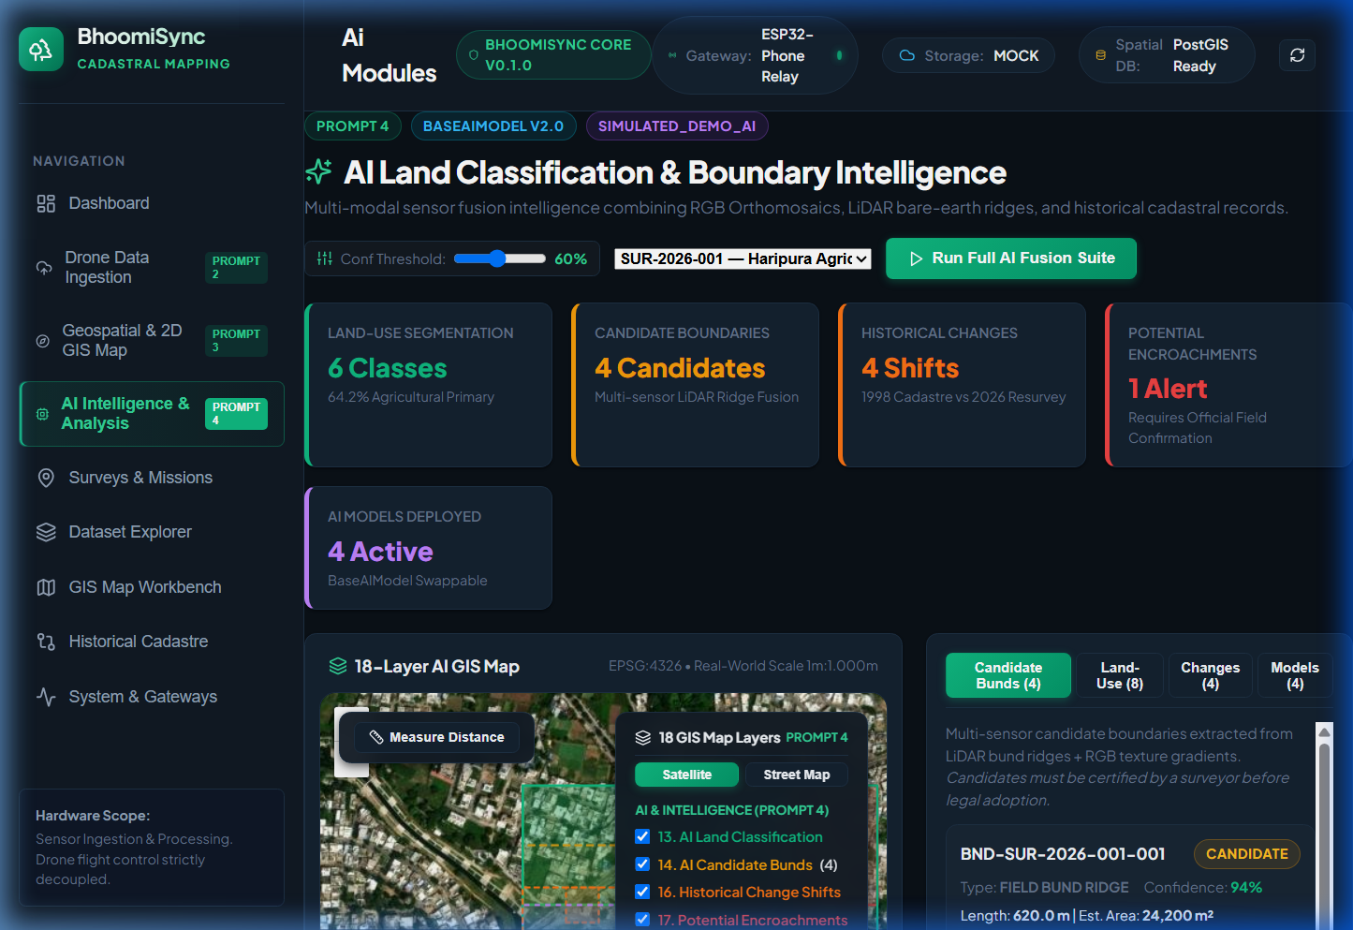
Figure 1: AI Intelligence & Analysis Dashboard with 5 Metric Cards, 18-Layer Interactive GIS Map, and Candidate Bunds Panel

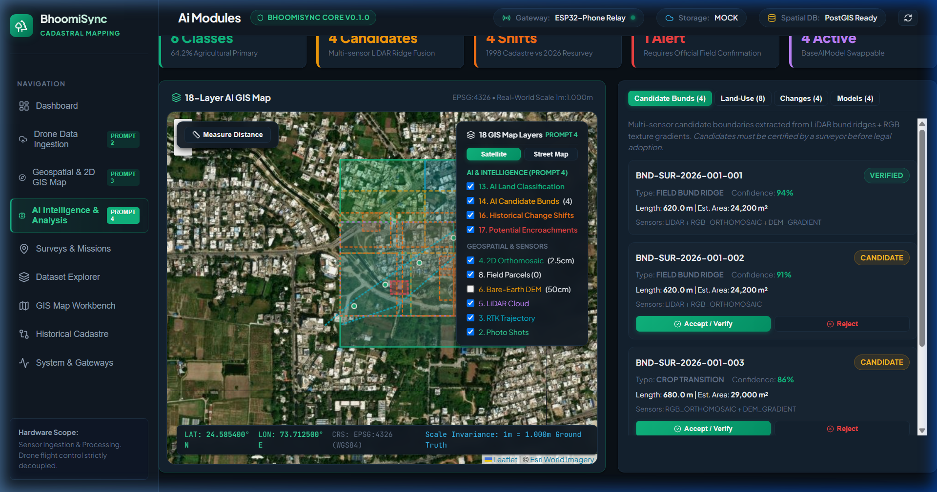
Figure 2: Human-in-the-Loop Surveyor Verification — Candidate BND-SUR-2026-001-001 Certified with Green VERIFIED Badge

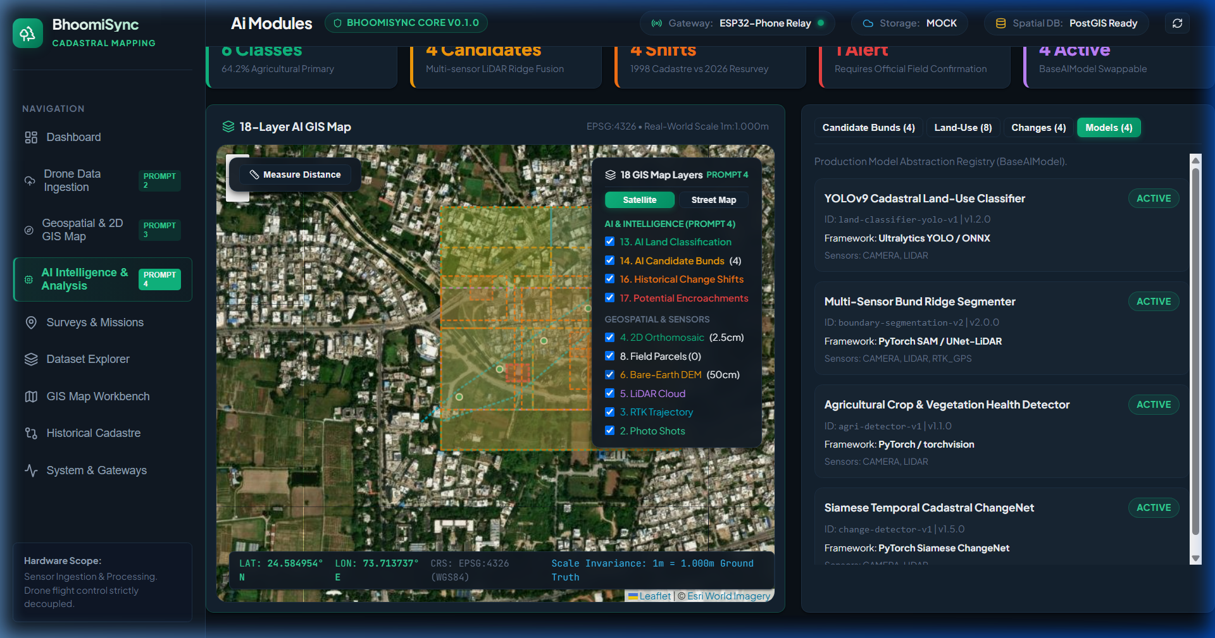
Figure 3: 18-Layer GIS Map Control HUD — Bare-Earth DEM Raster and AI Polygon Overlays Activated

9. Conclusion & Prompt 5 Readiness
BhoomiSync Prompt 4 has been completely implemented, verified, and integrated without regressions. The AI Intelligence Layer provides a solid, modular, and legally compliant foundation for automated land classification, multi-sensor boundary extraction, and historical change detection. All 54 backend automated tests passed in 1.75s, the frontend production bundle compiled with 0 TypeScript errors, and browser verification demonstrated flawless human-in-the-loop verification.

