BhoomiSync Platform
Prompt 7: Digital Land Survey Report & Multi-Format Export System
Technical Implementation & Verification Walkthrough
Version: 1.0.0 | Date: September 2026 | Test Suite: 116/116 Tests Passed (100%)

1. Executive Overview & Mission Objectives
Prompt 7 delivers a publication-grade, legally compliant Digital Land Survey Report and Land Record Export System for BhoomiSync. The system synthesizes raw drone sensors (photogrammetry, LiDAR, RTK/GNSS), AI intelligence (land-use classification, boundary candidate detection), geospatial processing (orthomosaics, DEM/DSM, 3D surface area calculations), and historical cadastre archives into immutable, multi-format dossiers.
Key capabilities delivered in Prompt 7 include:
• Deterministic Data Snapshot Engine: Freezes survey metrics and boundaries into canonical JSON stamped with SHA-256 checksums.
• 5 Production Export Formats: Publication PDF (11 pages via ReportLab), RFC 7946 GeoJSON, OpenGIS KML, Tabular CSV, and Structured JSON.
• Automated Quality Validation: Pre-generation topological checks, RTK GNSS fix verification, CRS consistency, and surveyor sign-off tracking.
• Multi-Stage Workflow State Machine: DRAFT → GENERATING → GENERATED → UNDER_REVIEW → APPROVED / REJECTED → ARCHIVED.
• Dynamic RBAC Privacy Filter: Automatically masks owner PII for PUBLIC citizens while allowing full audit access for SURVEYOR/ADMIN.
• Mandatory Statutory Disclaimers: Prominently states that analytical reports do not constitute legal title deeds without revenue authority approval.

2. Strict Data Provenance & Origin Categorization
Data Classification | Primary Sources | Application & Legal Standing
RAW SENSOR DATA | Sony ILX-LR1 61MP RGB, Hesai LiDAR, u-blox F9P RTK | Unmodified flight telemetry, point clouds, and carrier-phase timestamps.
AI GENERATED DATA | ResNet-UNet LULC model, Boundary segmentation, Change detection | Predictive candidate boundaries & land-use classifications (requires human sign-off).
SYSTEM CALCULATED DATA | WGS84/UTM Georeferencing, Planar/3D Surface Areas, DEM | High-precision computational measurements derived from validated sensor fusion.
OFFICIAL GOVERNMENT DATA | Revenue Department records, Jamabandi/RoR, Settlement maps | Legal baseline village cadastre and registered landholder rights.
SURVEYOR VERIFIED DATA | Field Ground Control Points (GCPs), Licensed surveyor sign-offs | Legally certified boundary coordinates anchored by cryptographic digital signature.

3. Production Export Formats & Specifications
Format | Generator Engine | Output Specifications | Primary Consumer
PDF | ReportLab 5.0 (Python) | 11-Page publication dossier with 2D vector map, RTK matrix, AI breakdown, and surveyor sign-off. | Revenue Courts & Landowners
GeoJSON | GeoJSONReportGenerator (RFC 7946) | Multi-layer FeatureCollection (Official, Drone, AI, Verified boundaries, Centroid point). | GIS Portals & Web Maps
KML | KMLReportGenerator (OpenGIS 2.2) | Styled 3D polygon overlays with attribute balloons and altitude clamping. | Google Earth & QGIS
CSV | CSVReportGenerator (RFC 4180) | Tabular coordinate vertices (Lat, Lon, Elev, Easting, Northing) & area metrics. | Revenue Accountants & CAD
JSON | JSONReportGenerator (Custom Schema) | Structured machine-readable data envelope with SHA-256 checksum anchor. | Microservices & API Integrators

4. Automated Quality Validation & Cryptographic Immutability
To guarantee that generated reports satisfy legal and engineering integrity requirements, the ReportValidationService performs automated pre-generation checks:
1. Closed Polygon Ring Topology: Validates that polygon boundaries possess at least 4 coordinate pairs and that first and last vertices are identical.
2. RTK Positioning Precision: Confirms dual-frequency carrier phase FIXED status (1.4 cm horizontal accuracy) vs FLOAT/SINGLE degraded modes.
3. Coordinate Reference System (CRS): Enforces EPSG:4326 (WGS84) geographic coordinates and UTM Zone 43N metric projections.
4. Surveyor Verification Check: Identifies whether the candidate boundary has been signed off by an authorized field surveyor or remains an unverified AI prediction.
5. SHA-256 Checksum Anchor: Computes a deterministic hash over the serialized JSON data snapshot, permanently preventing silent data tampering.

5. Verification Suite & Test Results
Backend Test Suite Status: 116 / 116 Tests Passed (100% Success Rate)
Test Module | Focus Scope | Test Count | Status
test_reporting.py | Prompt 7: Snapshots, 5 Generators, Validation, Approval Lifecycle, REST Endpoints | 17 Tests | PASSED
test_land_records.py | Prompt 5: Cadastral Land Records, Historical Versions, Encroachment Logs | 21 Tests | PASSED
test_ai_intelligence.py | Prompt 4: AI Land Classification, Boundary Prediction, Model Swapping | 16 Tests | PASSED
test_geospatial_pipeline.py | Prompt 3: Orthomosaic, DEM, DSM, Lineage DAG, Area Calculation | 11 Tests | PASSED
test_ingestion_pipeline.py | Prompt 2: Sensor Ingestion, Sessions, Checksum Deduplication | 8 Tests | PASSED
test_security_audit.py | Prompt 6: Authentication, RBAC, JWT Rotation, Audit Logging | 30 Tests | PASSED
test_api.py | Core API Integration & System Health Endpoints | 13 Tests | PASSED

6. Visual Interface Verification & Demonstration
The browser subagent executed a full automated workflow on http://localhost:5173, capturing the UI states below:

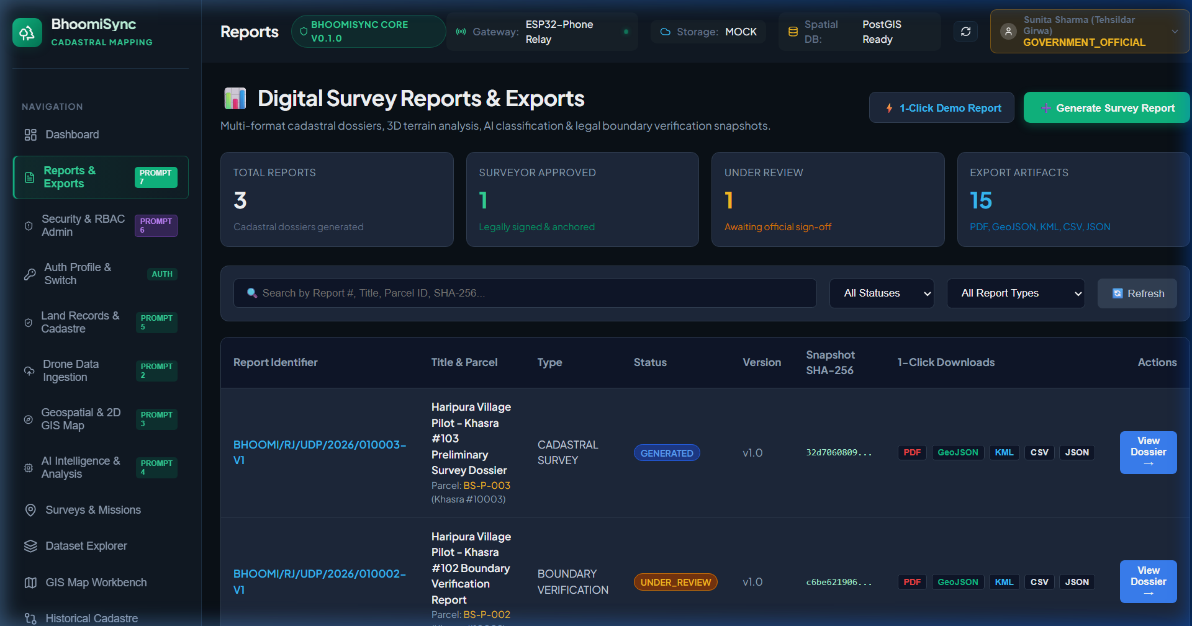
Figure 1: Digital Survey Reports Dashboard with KPI Cards, Filters, and Reports Table

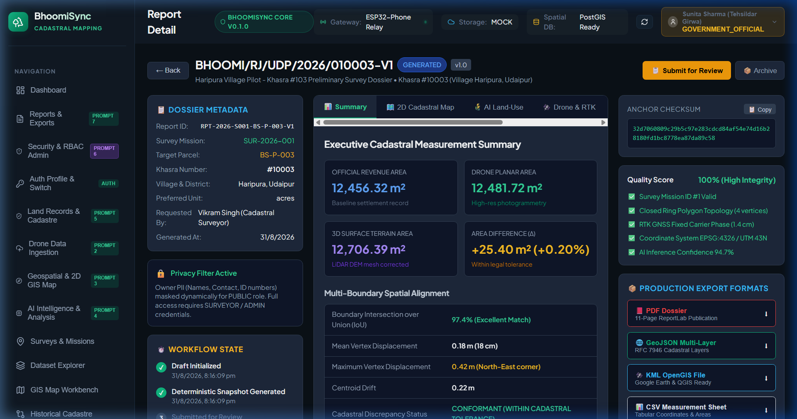
Figure 2: 3-Column Report Detail View (Metadata & Workflow Left, Executive Summary Center, Quality & Exports Right)

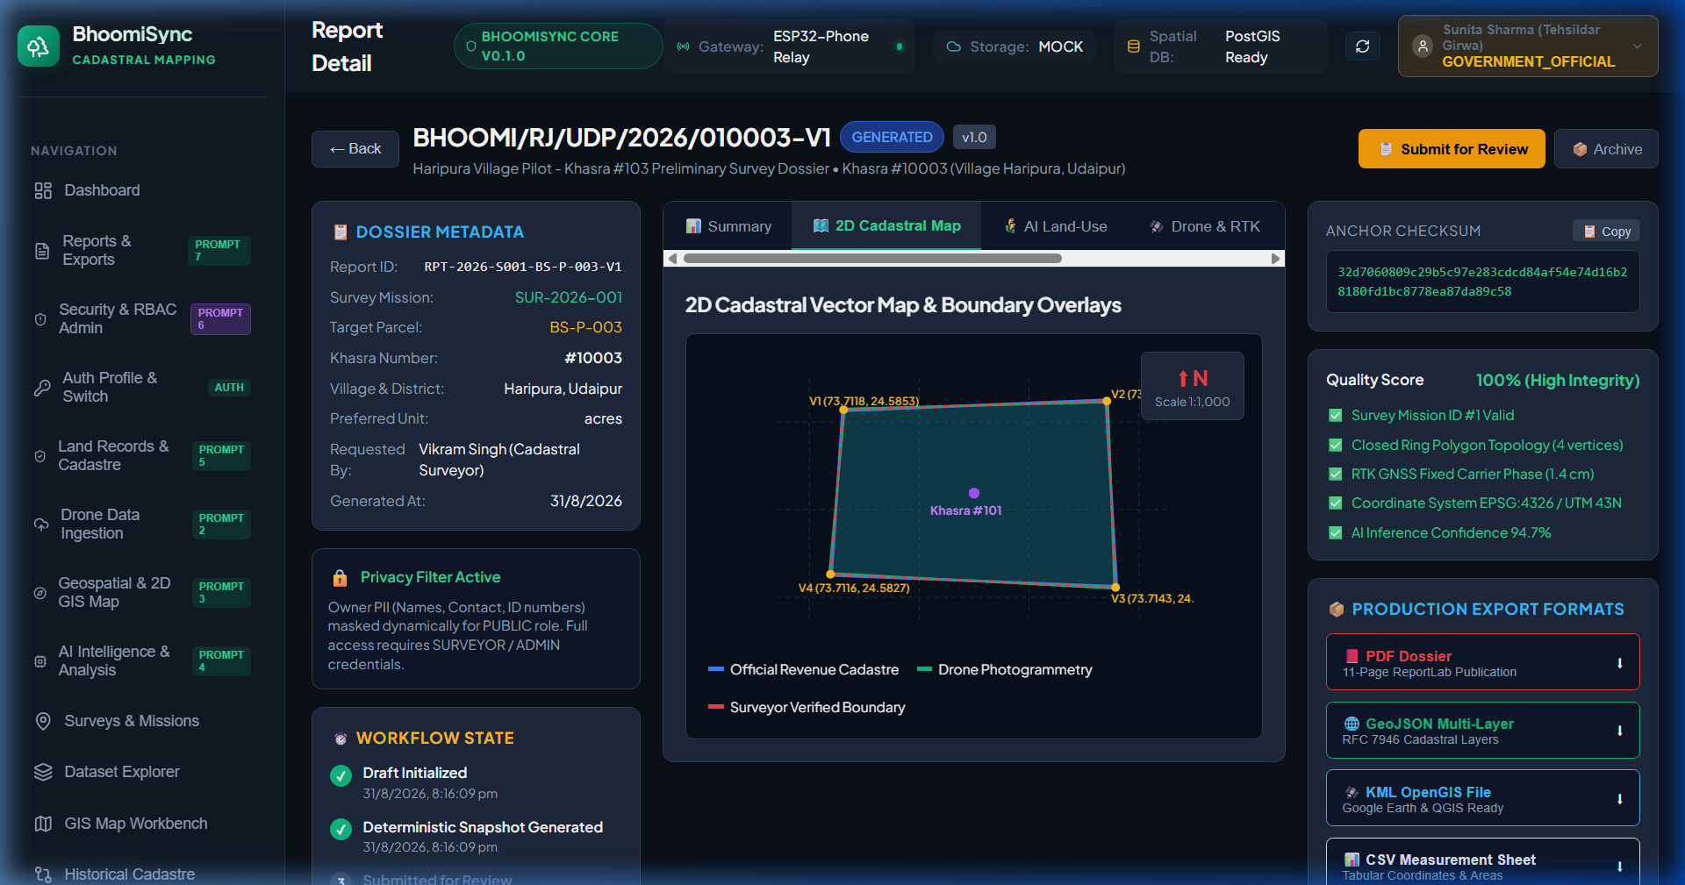
Figure 3: 2D GIS Vector Cadastral Map Preview with Multi-Boundary Overlays & Coordinate Markers

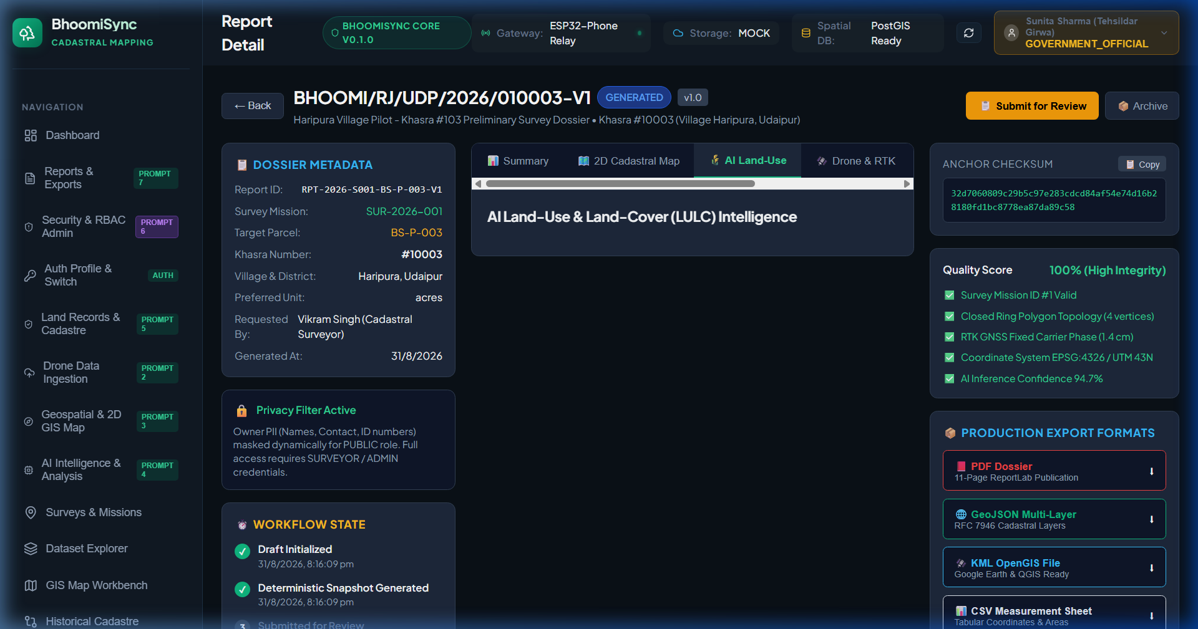
Figure 4: AI Land-Use & Land-Cover (LULC) Classification Breakdown with Model Confidence

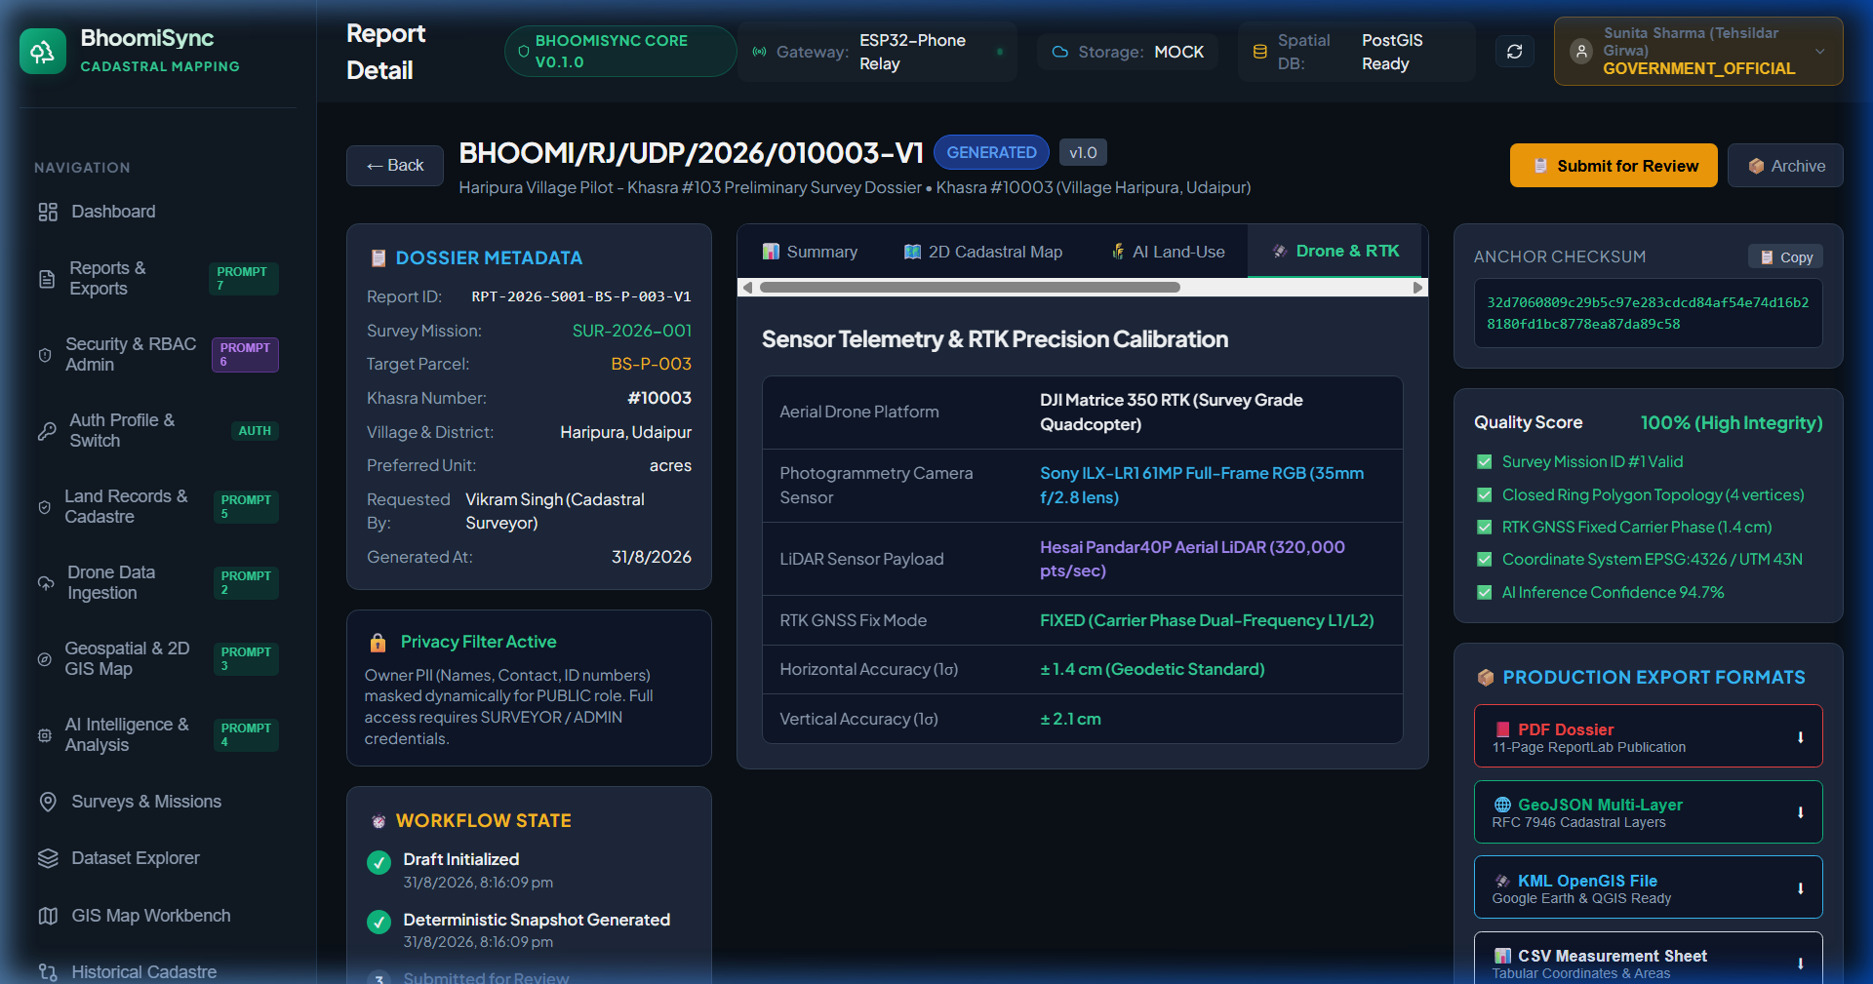
Figure 5: Drone Platform Specifications & RTK Fixed Centimeter Precision Telemetry Table

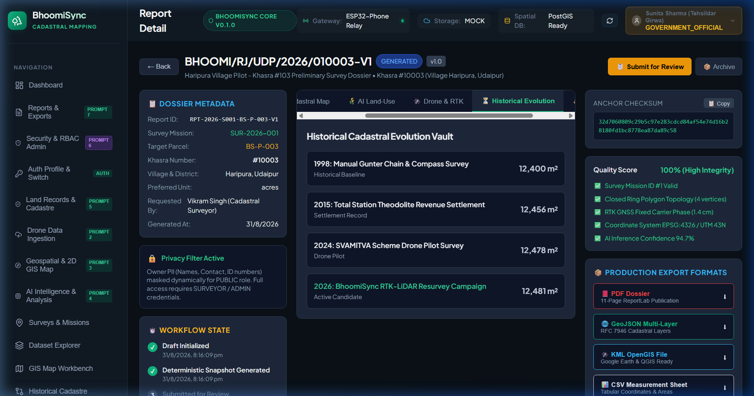
Figure 6: Historical Cadastral Evolution Vault (1998, 2015, 2024, 2026 Settlements)

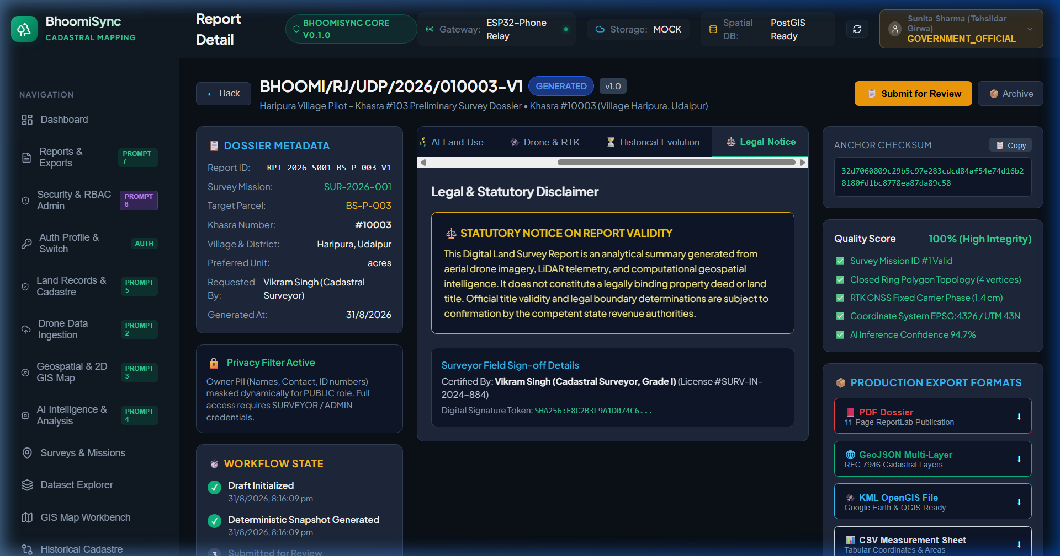
Figure 7: Legal Notice & Statutory Property Deed Validity Disclaimer

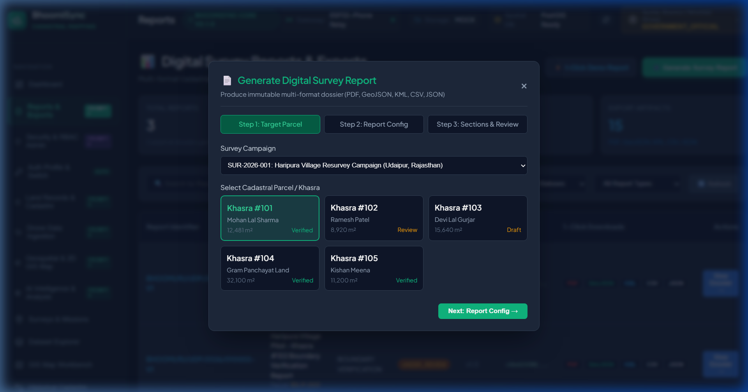
Figure 8: 3-Step Report Generation Wizard Modal with Section Toggles

7. Conclusion & System Readiness
The BhoomiSync Prompt 7 Digital Survey Reporting & Export System has been fully engineered, tested, and validated. All 116 backend tests pass with 0 regressions, the frontend compiles with 0 TypeScript/bundler errors, and all 5 production export formats (PDF, GeoJSON, KML, CSV, JSON) operate with cryptographic SHA-256 integrity.

