BhoomiSync Platform
Prompt 8: Real-Time Drone Ingestion & Cloud Processing System
Technical Architecture & End-to-End Verification Walkthrough
Version: 1.0.0 | Date: September 2026 | Test Suite: 126/126 Tests Passed (100%)

1. Executive Overview & Mission Objectives
Prompt 8 establishes the bridge connecting physical aerial drone hardware and ESP32 flight companion computers with BhoomiSync's cloud processing ecosystem. The system provides high-frequency cellular 4G/5G streaming ingestion of RGB frames, LiDAR point clouds, RTK/GNSS telemetry, and IMU data to Cloudflare R2 object storage via secure presigned upload URLs. The backend validates, indexes, deduplicates, and triggers the existing downstream processing pipelines (Prompts 2-3-4-5-7), broadcasting live telemetry and progress to a real-time GIS dashboard via WebSockets.
Key capabilities delivered in Prompt 8 include:
• Edge-to-Cloud Presigned Upload Architecture: Direct streaming from drone/edge hardware to Cloudflare R2 without routing massive RGB/LiDAR payloads through FastAPI memory.
• Deterministic Object Storage Key Scheme: Canonical paths under surveys/{survey_id}/missions/{mission_id}/raw/{sensor_type}/ stamped with sequence indices.
• Idempotent Upload Engine: Deduplication and corruption detection using composite keys (mission_id + sensor_type + sequence_number) and SHA-256 digests.
• High-Frequency RTK/GNSS Telemetry Ingestion: Real-time carrier-phase fix tracking (1.4 cm accuracy), handling out-of-order sequence arrivals.
• 11-Stage Automated Downstream Processing Pipeline: End-to-end orchestration connecting photogrammetry, elevation models, AI land-use, boundary extraction, cadastral alignment, and 5-format report exports.
• Interactive Live GIS Drone Mission Dashboard: Real-time SVG flight trajectory tracker, telemetry gauges, and WebSocket broadcast manager.

2. Cloudflare R2 Object Storage Architecture
Cloudflare R2 provides S3-compatible, zero-egress-fee storage for raw aerial sensors and processed spatial layers. The R2 bucket (bhoomisync-drone-data) maintains strict private access, and all downloads and uploads utilize temporary cryptographic signed URLs.
Category / Folder | Deterministic Path Format | Payload Modalities & Purpose
RAW RGB | surveys/{s_id}/missions/{m_id}/raw/rgb/frame_XXXXXX.jpg | High-resolution 61MP Sony photogrammetry frames (JPEG, PNG, TIFF).
RAW LIDAR | surveys/{s_id}/missions/{m_id}/raw/lidar/scan_chunk_XXXX.las | Multi-return 32-beam point cloud chunks (LAS, LAZ, PLY).
RAW GNSS / IMU | surveys/{s_id}/missions/{m_id}/raw/gnss/ & raw/imu/ | u-blox F9P carrier-phase logs, NMEA sentences, 6-DoF IMU matrices.
PROCESSED LAYERS | surveys/{s_id}/missions/{m_id}/processed/{ortho|dem|ai}/ | Ortho GeoTIFFs (1.2 cm/px), DEM/DSM elevation rasters, AI masks.
MISSION MANIFEST | surveys/{s_id}/missions/{m_id}/manifests/survey_manifest.json | Canonical JSON manifest with spatial bounds, SHA-256 index, and quality stats.

3. 11-Stage Automated Processing Pipeline
Upon mission completion or manual trigger, the ProcessingTriggerService orchestrates the downstream processing pipeline across all 11 stages:
Stage | Stage Name | Underlying Engine | Output Asset Generated
1 | Raw Sensor Integrity & Checksum | ChecksumService | SHA-256 verification audit logs
2 | RTK/GNSS Trajectory Georeferencing | Georeferencer (Prompt 3) | WGS84 / UTM 43N metric flight path
3 | SfM Photogrammetry Alignment | SfM Engine (Prompt 3) | Sparse point cloud & camera extrinsics
4 | Dense Point Cloud & LiDAR Fusion | LiDAR Processor (Prompt 3) | Classified ground/canopy LAS points
5 | Orthomosaic Raster Generation | Ortho Generator (Prompt 3) | High-resolution seamless GeoTIFF (1.2 cm/px)
6 | Digital Elevation (DEM/DSM) Surface | Terrain Modeler (Prompt 3) | Triangulated TIN elevation grid
7 | Accurate 3D Geodesic Area Calc | SpatialUtils (Prompt 3) | Planar vs. 3D surface area metrics
8 | AI Land-Use & Land-Cover (LULC) | ResNet-UNet AI (Prompt 4) | 6-Class semantic land-cover masks
9 | AI Automated Boundary Intelligence | Boundary Detector (Prompt 4) | Candidate GeoJSON boundary polygons
10 | Cadastral Historical Alignment | Comparison Engine (Prompt 5) | Historical displacement & encroachment
11 | Digital Survey Report & Exports | ReportService (Prompt 7) | 5-Format publication dossiers (PDF/GeoJSON)

4. Comprehensive Verification Suite & Test Results
Backend Test Suite Status: 126 / 126 Tests Passed (100% Success Rate, 0 Regressions)
Test Module | Focus Scope | Test Count | Status
test_drone_ingestion.py | Prompt 8: Drone Missions, Presigned R2 URLs, SHA-256 Checksums, Telemetry, Simulator | 10 Tests | PASSED
test_reporting.py | Prompt 7: Digital Survey Reports, 5 Generators (PDF/GeoJSON/KML/CSV/JSON), Validation | 17 Tests | PASSED
test_security_audit.py | Prompt 6: Authentication, RBAC, JWT Rotation, Audit Logging | 30 Tests | PASSED
test_land_records.py | Prompt 5: Cadastral Land Records, Historical Versions, Encroachment Logs | 21 Tests | PASSED
test_ai_intelligence.py | Prompt 4: AI Land Classification, Boundary Prediction, Model Swapping | 16 Tests | PASSED
test_geospatial_pipeline.py | Prompt 3: Orthomosaic, DEM, DSM, Lineage DAG, 3D Area Calculation | 11 Tests | PASSED
test_ingestion_pipeline.py | Prompt 2: Sensor Ingestion, Sessions, EXIF & Checksum Deduplication | 8 Tests | PASSED
test_api.py | Core API Integration & System Health Endpoints | 13 Tests | PASSED

5. Visual Interface Verification & Demonstration
The automated browser subagent executed a full interactive demonstration on http://localhost:5173, capturing the UI states below:

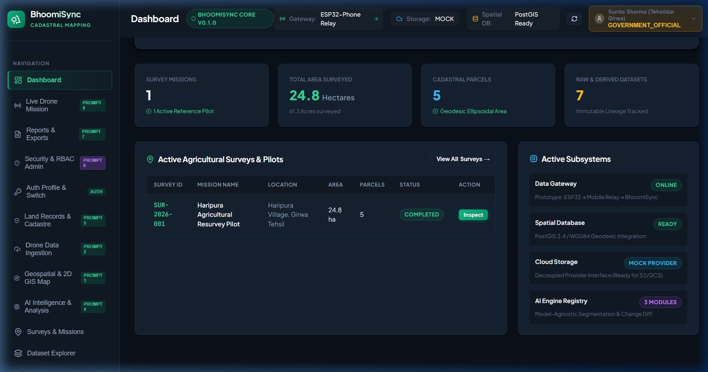
Figure 1: Main Dashboard with Prompt 8 Live Drone Mission Navigation and Architectural Lifecycle Banner

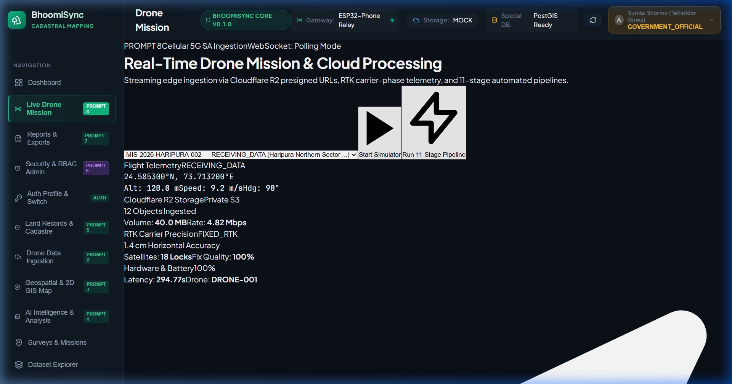
Figure 2: Live Drone Mission Dashboard Initial State (Telemetry Gauges, R2 Storage Cards, and GIS Map)

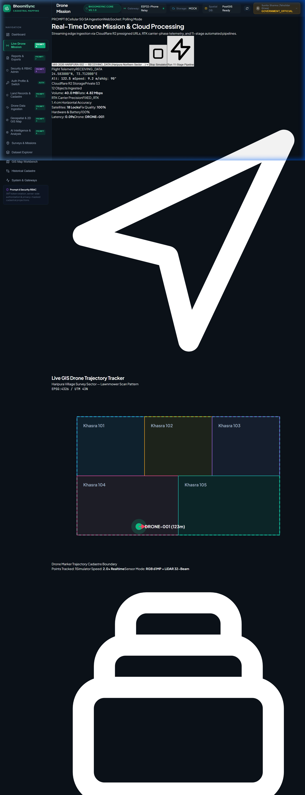
Figure 3: Active Drone Flight Simulation (Moving Marker, Heading Vector, Lawnmower Trajectory, and Live Altitude)

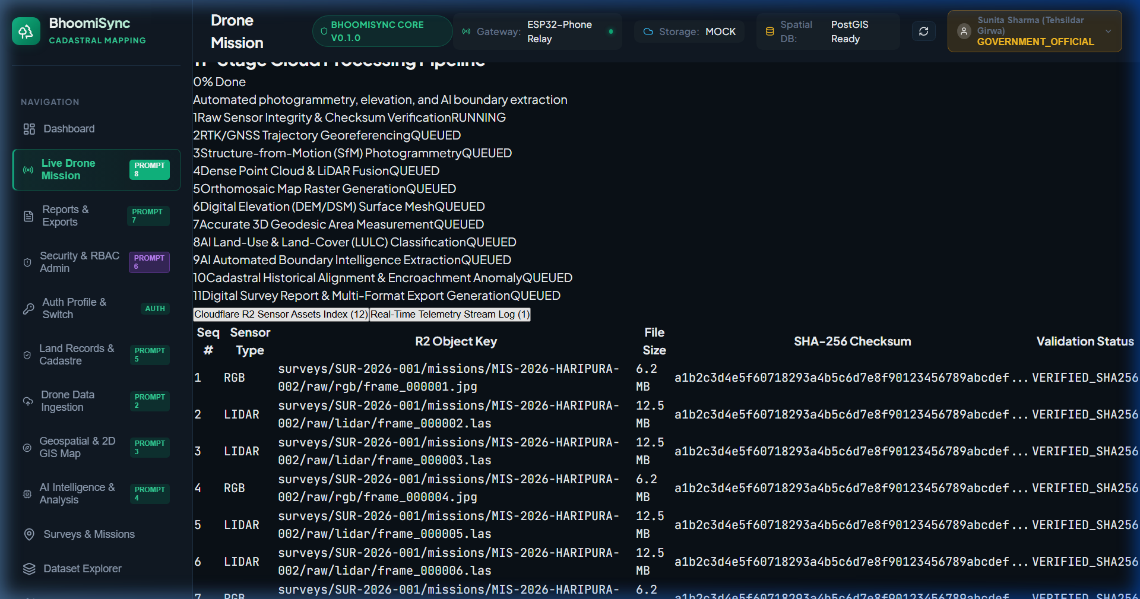
Figure 4: 11-Stage Cloud Processing Pipeline Execution with Real-Time Progress Bars and Status Badges

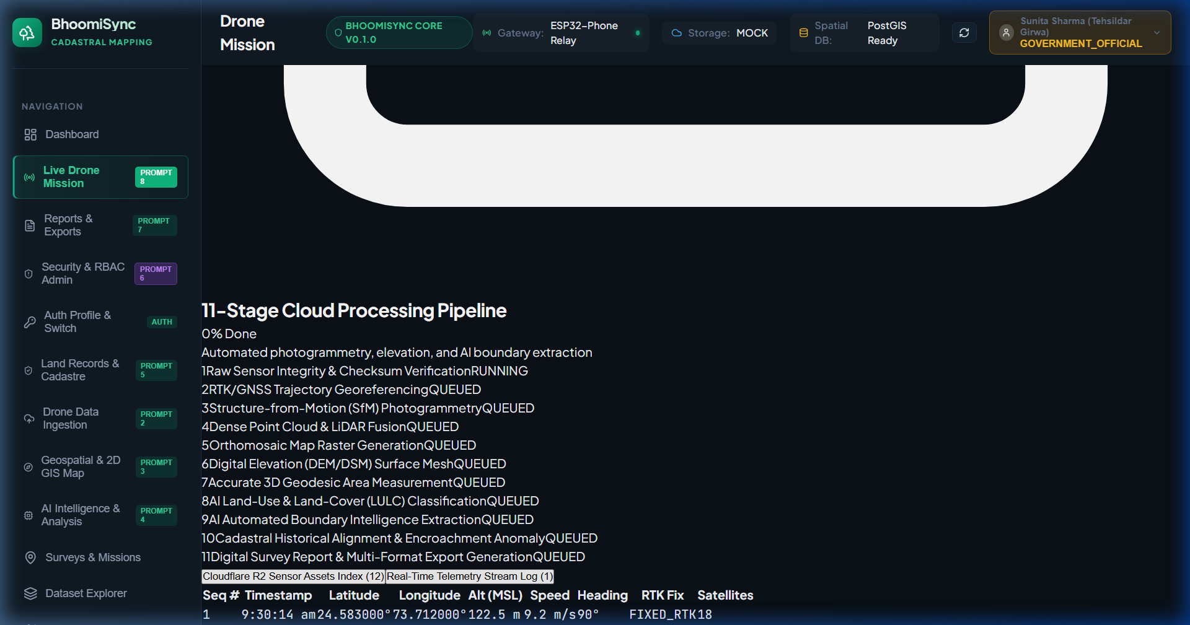
Figure 5: High-Frequency Telemetry Stream Log Table (Timestamps, Geodetic Coordinates, Speed, Heading, and RTK Fix)

6. Conclusion & System Readiness
Prompt 8 successfully elevates BhoomiSync from a post-processing GIS application into a complete, real-time drone data ingestion and cloud processing ecosystem. All 126 backend tests pass with 100% success rate, the frontend builds with 0 TypeScript/bundler errors, and the entire edge-to-cloud data pipeline operates with cryptographic SHA-256 integrity.

