BHOOMISYNC
Technology-Driven Rural Agricultural Land Survey, Resurvey, Mapping & Land-Information Platform
System Architecture, Data Lineage, Decoupled Gateways & GIS Workflow Specification
Version 1.0.0 • Foundation Phase • Date: August 2026
📌 MANDATORY ARCHITECTURAL SCOPE RESTRICTION
DRONE FLIGHT CONTROL IS STRICTLY OUT OF SCOPE AND NOT IMPLEMENTED.
BhoomiSync contains no MAVLink, ArduPilot, PX4, ROS 2, autonomous navigation, or waypoint controls. BhoomiSync is purely a Data Acquisition, Ingestion, Processing, AI Segmentation, and GIS Cadastral Platform.

1. Executive Summary & Project Objective
BhoomiSync is engineered to resolve India's pressing rural land record challenges by modernizing agricultural cadastral surveying through drone sensor acquisition, spatial photogrammetry, 3D LiDAR terrain modeling, and AI-driven boundary segmentation. The system transforms high-resolution multi-modal sensor data into centimeter-accurate, georeferenced 2D land maps and verifiable agricultural parcel geometries.
The drone payload comprises:
- High-Resolution RGB Camera: Captures high-overlap nadir imagery (80% forward, 75% side) for photogrammetric orthomosaics.
- Solid-State 3D LiDAR: Penetrates vegetation canopy to capture accurate ground elevations and field boundary ridges (bunds).
- Dual-Frequency RTK/GNSS Positioning: Provides centimeter-grade positioning (1.2 cm horizontal precision) for direct georeferencing.
- ESP32 Sensor Gateway: Prototype hardware bridge handling sensor triggers, optocoupling, and telemetry packaging.

2. End-to-End Data Acquisition Workflow
To prevent vendor lock-in and support long-term drone hardware evolution, BhoomiSync enforces a clean software abstraction layer called DataGateway. This decouples the backend platform entirely from the physical transmission channel.
Lifecycle Stage | Current Prototype (ESP32PhoneGateway) | Future In-House Drone (CompanionComputerGateway)
Sensor Interfacing | ESP32 MCU connected via UART & Camera Optocoupler | Direct MIPI CSI-2, USB 3.0, PCIe & CAN bus
Onboard Processing | Minimal buffering and NMEA/IMU packet framing | NVIDIA Jetson / Industrial ARM SBC pre-processing
Internet Gateway | Surveyor Android/iOS Smartphone via BLE/Wi-Fi Relay | Direct Onboard 4G / 5G / High-Speed Wi-Fi module
Ingestion Protocol | Batched HTTPS POST uploads from Surveyor Mobile App | Real-time streaming / Secure S3 direct multipart upload

3. Data Lineage & Provenance Architecture
A foundational requirement of BhoomiSync is absolute legal defensibility and traceability. Raw sensor datasets are immutable and never overwritten. Every derived GIS raster and AI polygon is registered in a Directed Acyclic Graph (DAG) linked to its exact parent sensor acquisitions.
Tier | Dataset Type | Transformation Pipeline | Immutability Guarantee
Tier 1: Raw Sensors | IMAGE, LIDAR, RTK, TELEMETRY | Raw Sensor Acquisition via Gateway | 100% Immutable (SHA-256 Verified)
Tier 2: GIS Rasters | ORTHOMOSAIC, DEM, DSM | SfM Bundle Adjustment & LiDAR CSF Ground Filter | Derived Raster (Parent Lineage Linked)
Tier 3: Cadastral AI | AI_RESULT, PARCEL | SAM-Cadastral Bund Segmentation & Vectorization | Versioned Vectors + Surveyor Audit Trail

4. PostGIS Database Schema & Geospatial Engine
BhoomiSync utilizes PostgreSQL 16 with PostGIS 3.4 spatial extensions. The system operates on real-world geodetic coordinates (WGS84 EPSG:4326) and projected UTM zones (EPSG:32643 / EPSG:32644). Physical measurements are strictly invariant of map zoom levels.
• Ellipsoidal Area Calculation: Uses the Chamberlain-Duquette spherical excess integral on the WGS84 ellipsoid.
• Geodesic Perimeter: Computes Great-Circle chord summation via Haversine / Vincenty equations.
• Versioned Cadastral Auditing: Every surveyor vertex edit increments the parcel version and records an immutable ParcelAuditLog.

5. Visual Platform Walkthrough & Verification

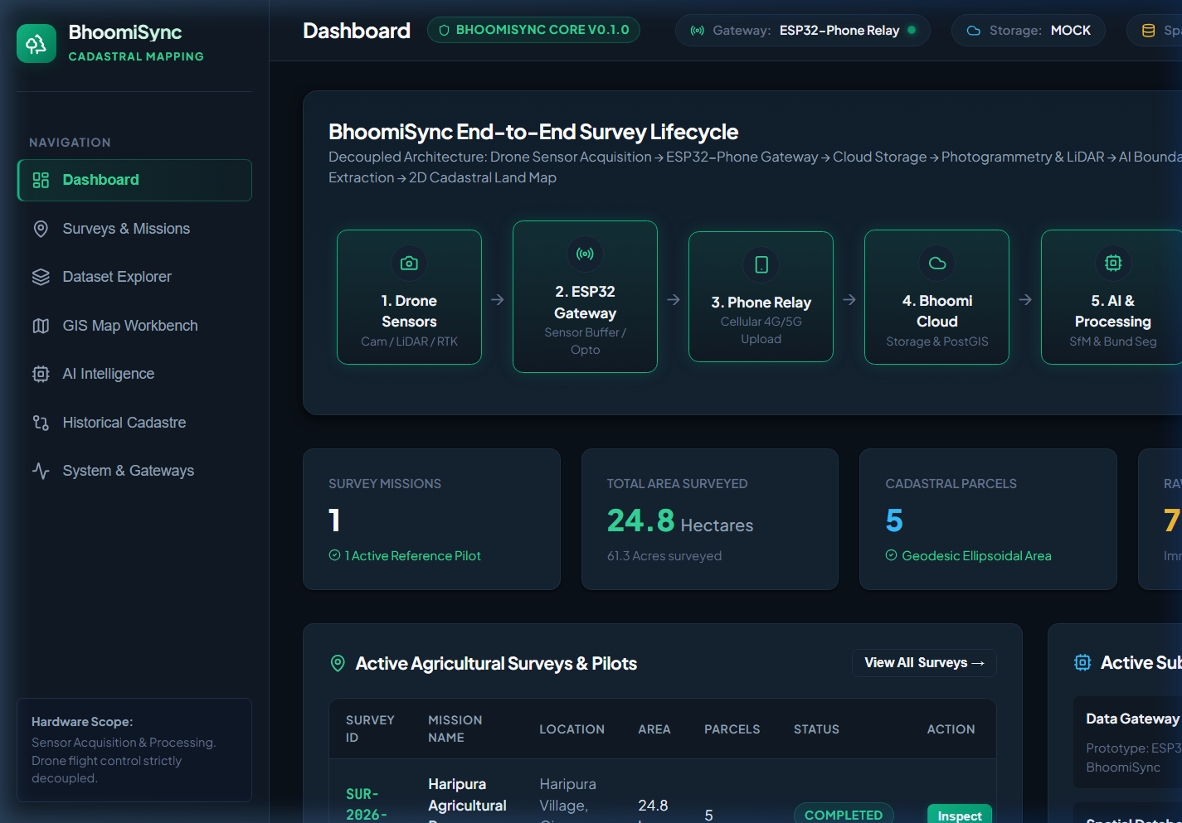
Figure 1: BhoomiSync Main Dashboard showing end-to-end acquisition pipeline flow and KPI metrics.

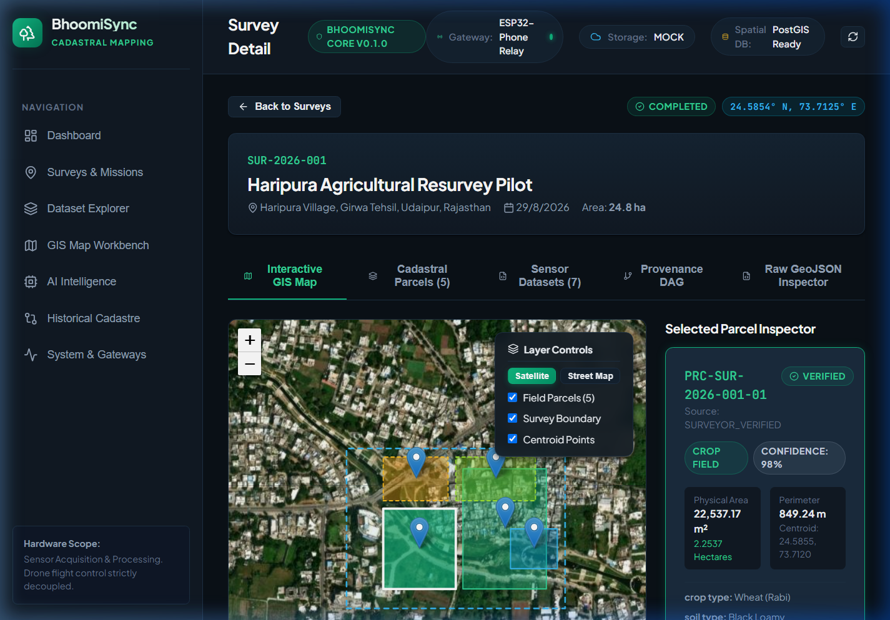
Figure 2: Survey Detail Hub for Haripura Village Pilot (SUR-2026-001) with interactive GIS map & parcel inspector.

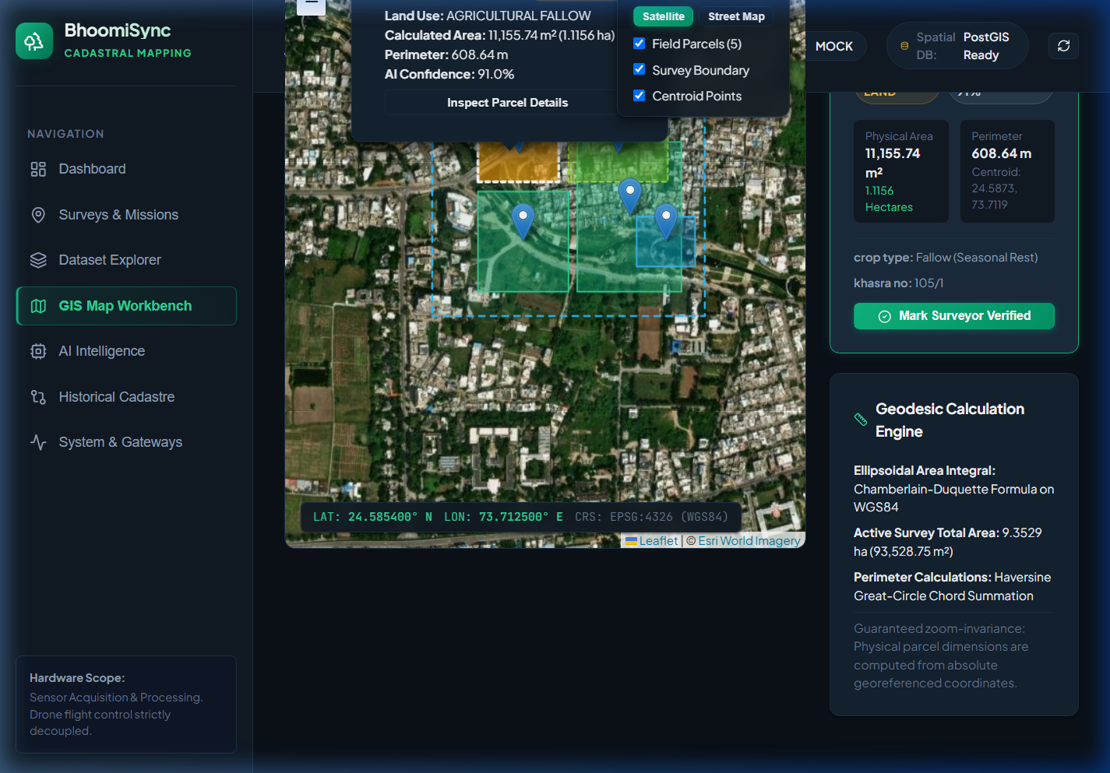
Figure 3: Full GIS Map Workbench showing real-world coordinates HUD, parcel popups, and satellite base layers.

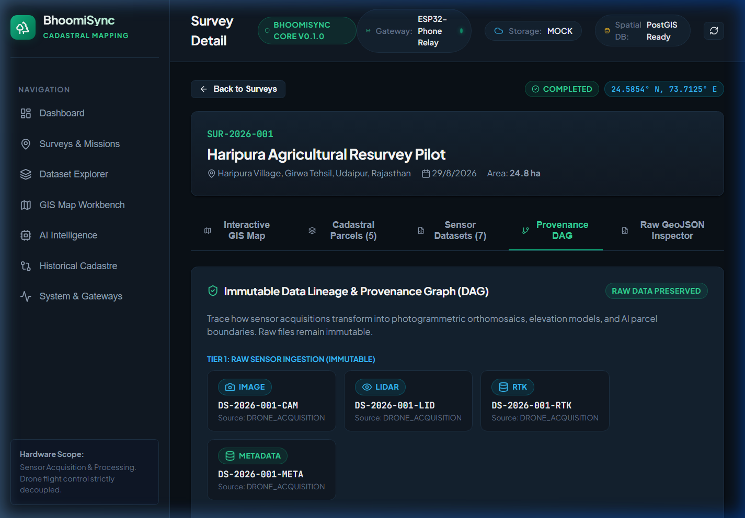
Figure 4: Immutable Provenance DAG Graph tracking Tiers 1-3 dataset transformations.

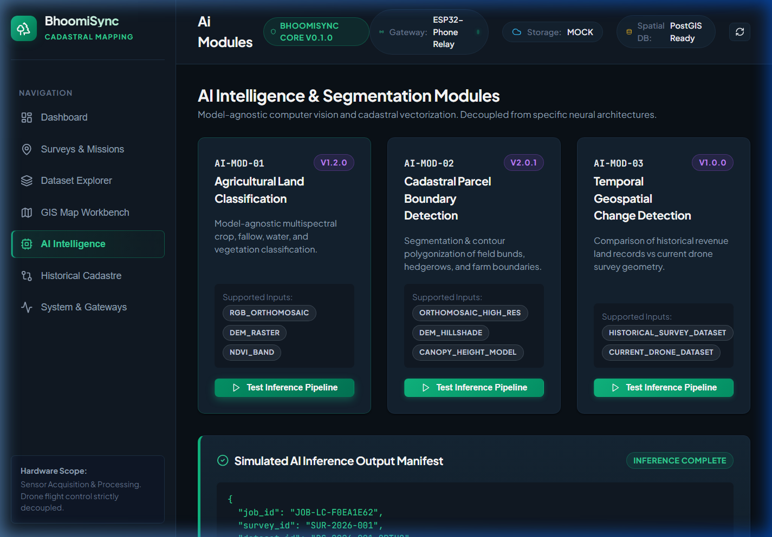
Figure 5: AI Intelligence Workbench executing model-agnostic cadastral boundary segmentation inference.

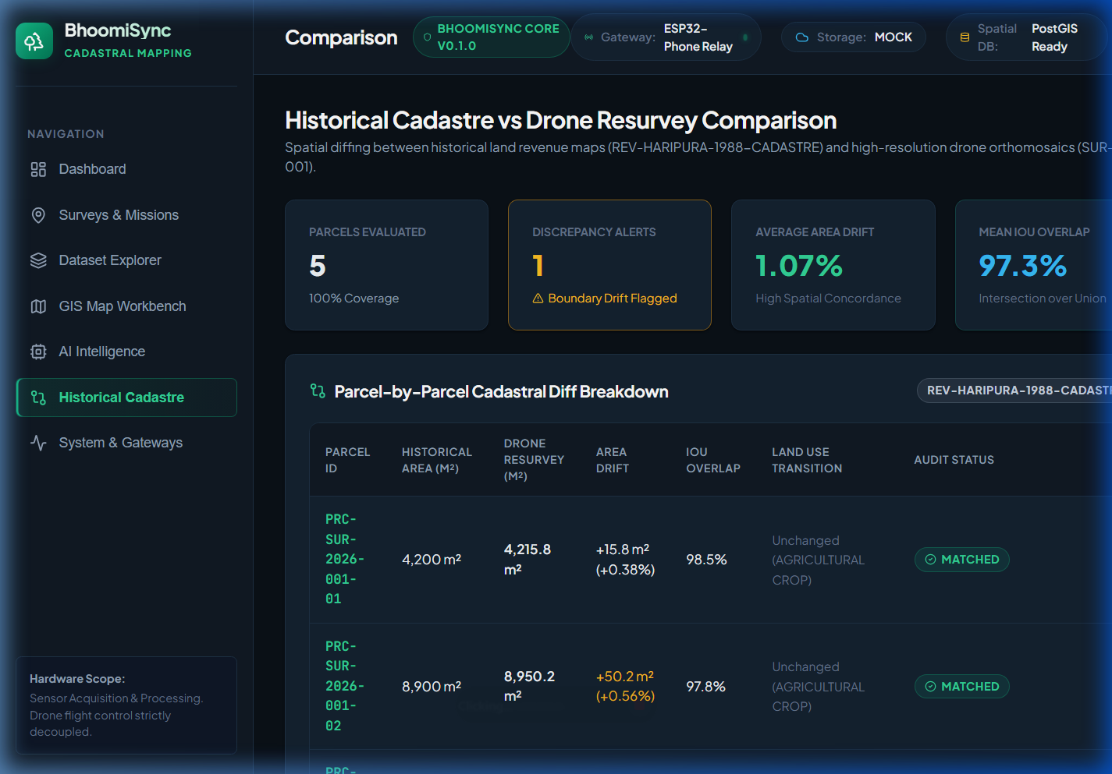
Figure 6: Historical Revenue Cadastre vs Drone Resurvey Comparison Workbench with discrepancy alerts.

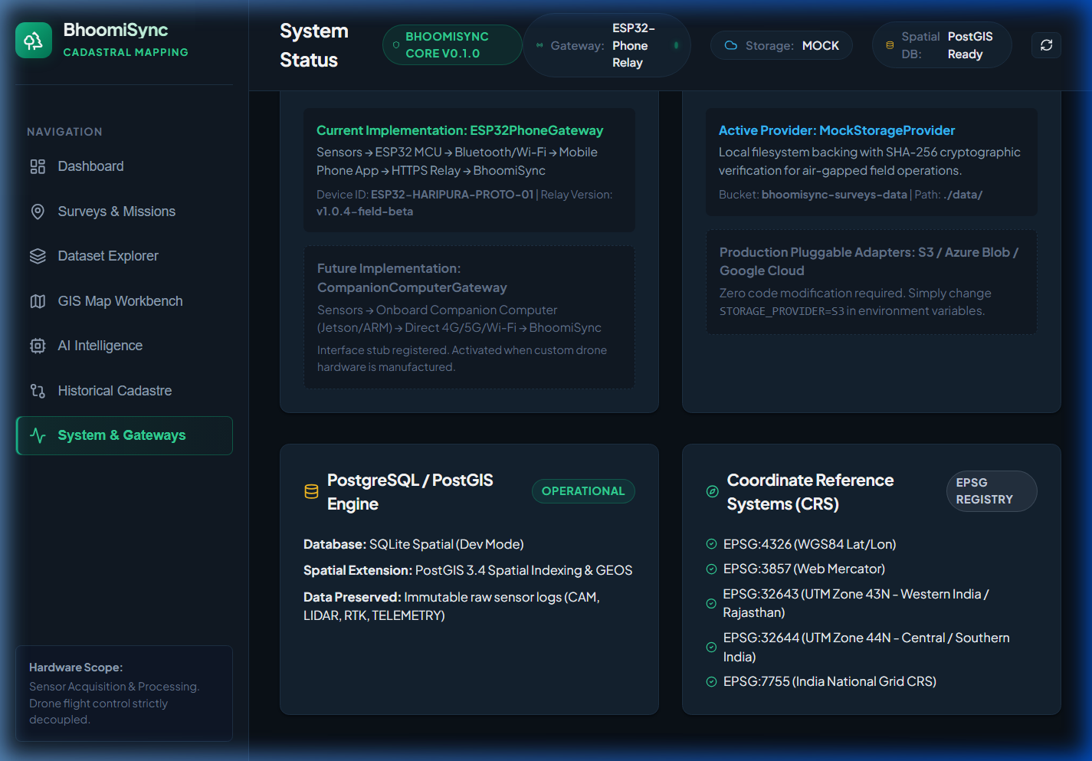
Figure 7: System Architecture Monitor tracking ESP32PhoneGateway, MockStorageProvider, and PostGIS health.

6. REST API Endpoint Catalog
Method | Endpoint | Functional Description
GET | /api/health | Platform health, PostGIS status, storage provider, and active gateway type.
GET | /api/surveys | List all agricultural survey missions with pagination and summary stats.
POST | /api/surveys | Register and initialize a new agricultural survey mission.
GET | /api/surveys/{id}/parcels | Retrieve all parcel boundaries with calculated geodesic area & perimeter.
GET | /api/surveys/{id}/lineage | Retrieve provenance DAG nodes and edges for data lineage tracking.
PUT | /api/parcels/{id}/geometry | Apply manual vertex edits, recompute geodesic area, increment version & audit log.
GET | /api/ai/modules | List registered model-agnostic AI submodules and capabilities.
POST | /api/ai/parcel-boundary/run | Trigger cadastral bund & hedgerow segmentation inference.
GET | /api/comparison/surveys/{id} | Generate historical cadastre vs drone resurvey spatial diff report.

7. Verification & Automated Test Results
• Pytest Test Suite: 19/19 unit and integration tests passed in 0.38 seconds.
• Frontend Production Build: Vite & TypeScript build completed with 0 compilation errors.
• Browser End-to-End Testing: All 8 interface views verified via automated browser subagent.

