BHOOMISYNC
Technology-Driven Rural Agricultural Land Survey, Resurvey, Mapping & Ingestion Platform
Drone Data Ingestion, Continuous Cloud Pipeline, Decoupled Gateways & GIS Workflow Specification
Version 2.0.0 • Foundation + Ingestion Pipeline Phase • Date: August 2026
📌 MANDATORY ARCHITECTURAL SCOPE RESTRICTION
DRONE FLIGHT CONTROL IS STRICTLY OUT OF SCOPE AND NOT IMPLEMENTED.
BhoomiSync contains no MAVLink, ArduPilot, PX4, ROS 2, autonomous navigation, or waypoint controls. BhoomiSync is purely a Data Acquisition, Ingestion, Cloud Storage, AI Segmentation, and GIS Cadastral Platform.

1. Executive Summary & Project Objective
BhoomiSync is engineered to resolve India's pressing rural land record challenges by modernizing agricultural cadastral surveying through drone sensor acquisition, continuous cloud ingestion, spatial photogrammetry, 3D LiDAR terrain modeling, and AI-driven boundary segmentation. The system transforms high-resolution multi-modal sensor data into centimeter-accurate, georeferenced 2D land maps and verifiable agricultural parcel geometries.

2. Drone Data Ingestion & Continuous Cloud Pipeline
The Prompt 2 Ingestion Pipeline provides a robust, continuous streaming and batched ingestion architecture. The system accepts multi-sensor files, extracts rich spatial metadata, enforces cryptographic SHA-256 deduplication, maintains upload session lifecycles, and queues downstream processing jobs.
Sensor Payload | Supported Formats | Extracted Spatial Metadata | Downstream Processing Job
Nadir Camera Imagery | JPEG, PNG, TIFF, DNG | GPS Lat/Lon/Alt, EXIF timestamp, Camera Make/Model, Focal Length, ISO | IMAGE_PREPROCESSING
3D LiDAR Point Cloud | LAS, LAZ, PLY, PCD, CSV | Point Count, 3D Bounding Box [X/Y/Z min & max], CRS, Elevation Span | LIDAR_PREPROCESSING
RTK / GNSS Positioning | RINEX, NMEA ($GNGGA), JSON, CSV | Fixed/Float RTK fix status, Horizontal/Vertical Precision (cm), Satellites | GEOREFERENCING

3. Upload Session & File Lifecycle State Machines
To ensure high reliability over intermittent field cellular connections, the system models continuous uploads as state-machine driven sessions:
• Session Lifecycles: CREATED ──> UPLOADING ──> COMPLETED / PARTIAL / FAILED / CANCELLED
• File Lifecycles: PENDING ──> UPLOADING ──> UPLOADED ──> VALIDATED ──> QUEUED ──> PROCESSING ──> PROCESSED / FAILED
• Deduplication Guarantee: Checks SHA-256 hashes against existing survey files to prevent redundant storage allocation.

4. Visual Platform Walkthrough & Verification

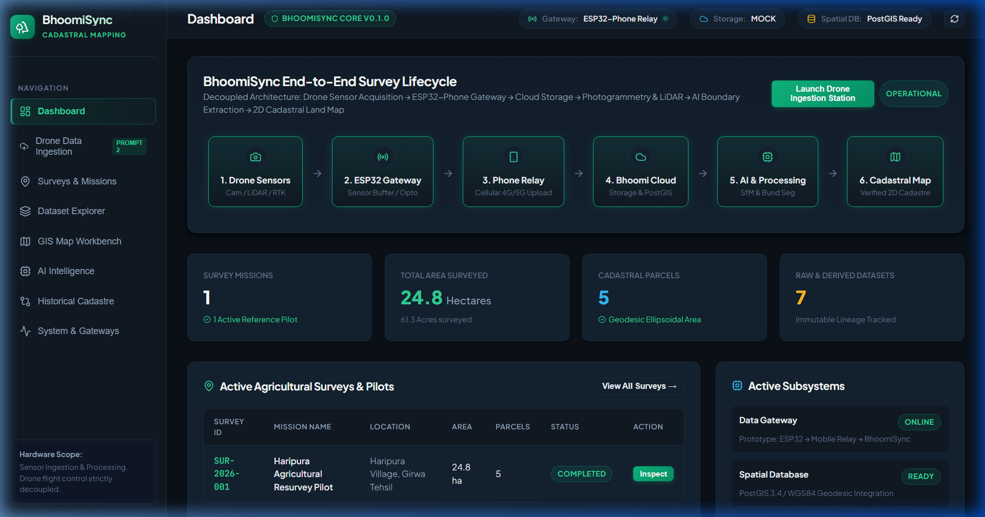
Figure 1: BhoomiSync Operations Dashboard with Launch Drone Ingestion Station trigger.

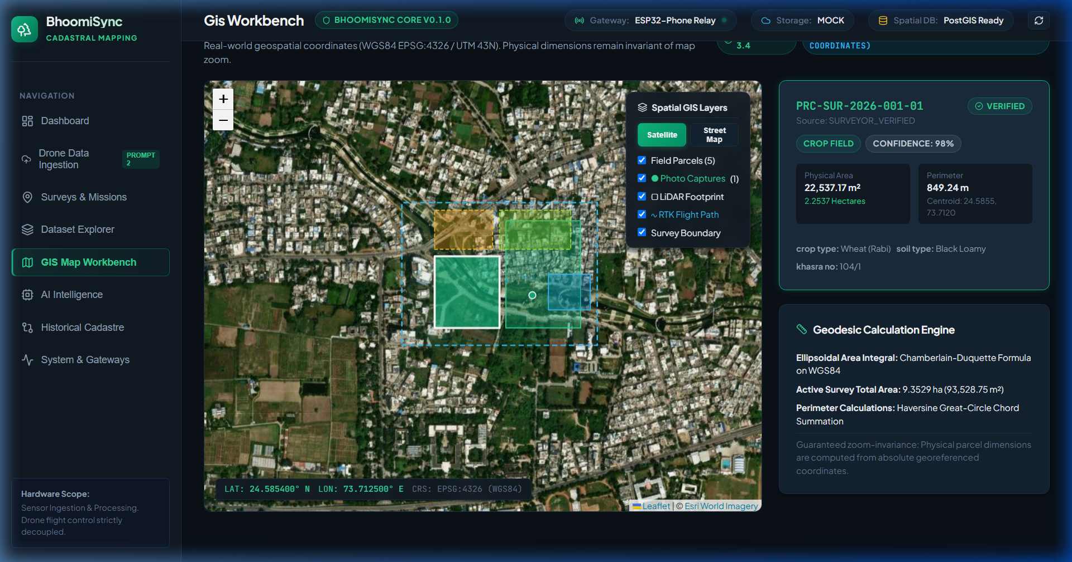
Figure 2: Interactive GIS Map Workbench rendering real-time photo capture points, LiDAR footprint, and RTK flight path.

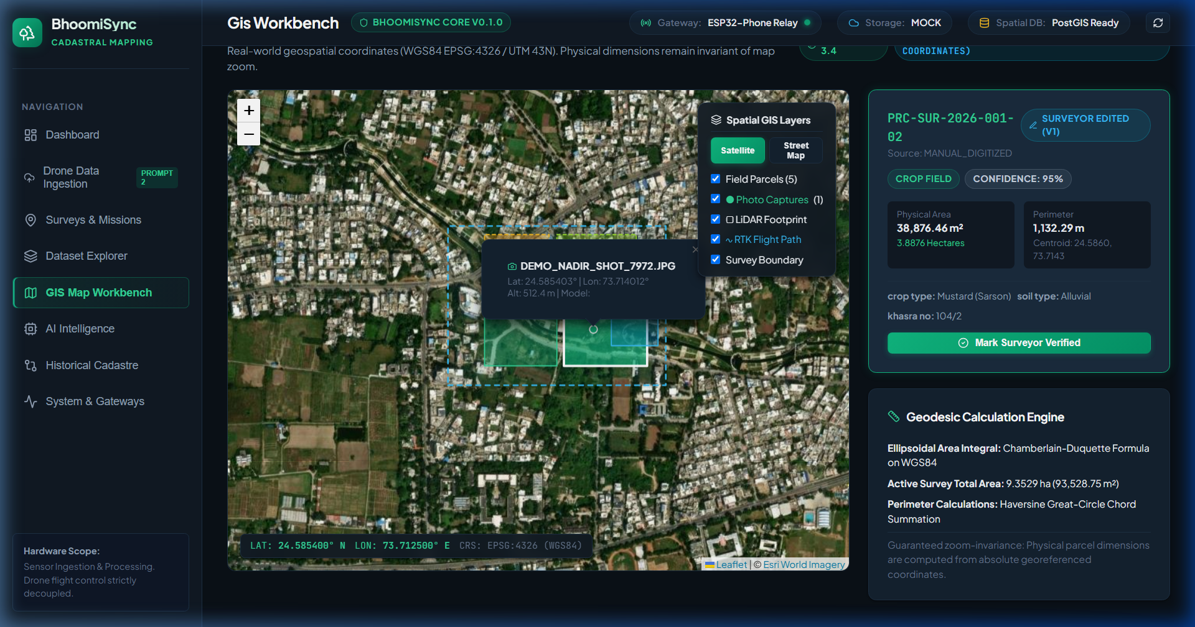
Figure 3: Georeferenced Camera Photo popup inspector displaying altitude and coordinate HUD on satellite tiles.

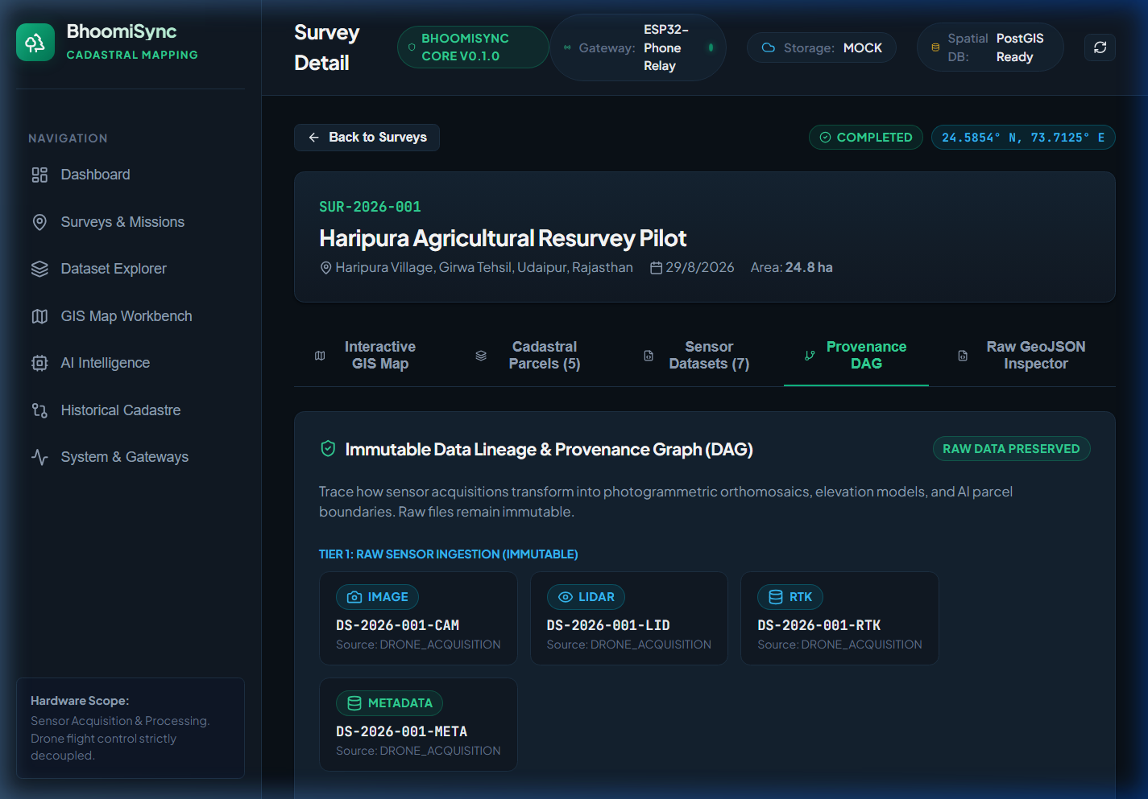
Figure 4: Immutable Provenance DAG Graph tracking Tiers 1-3 dataset transformations.

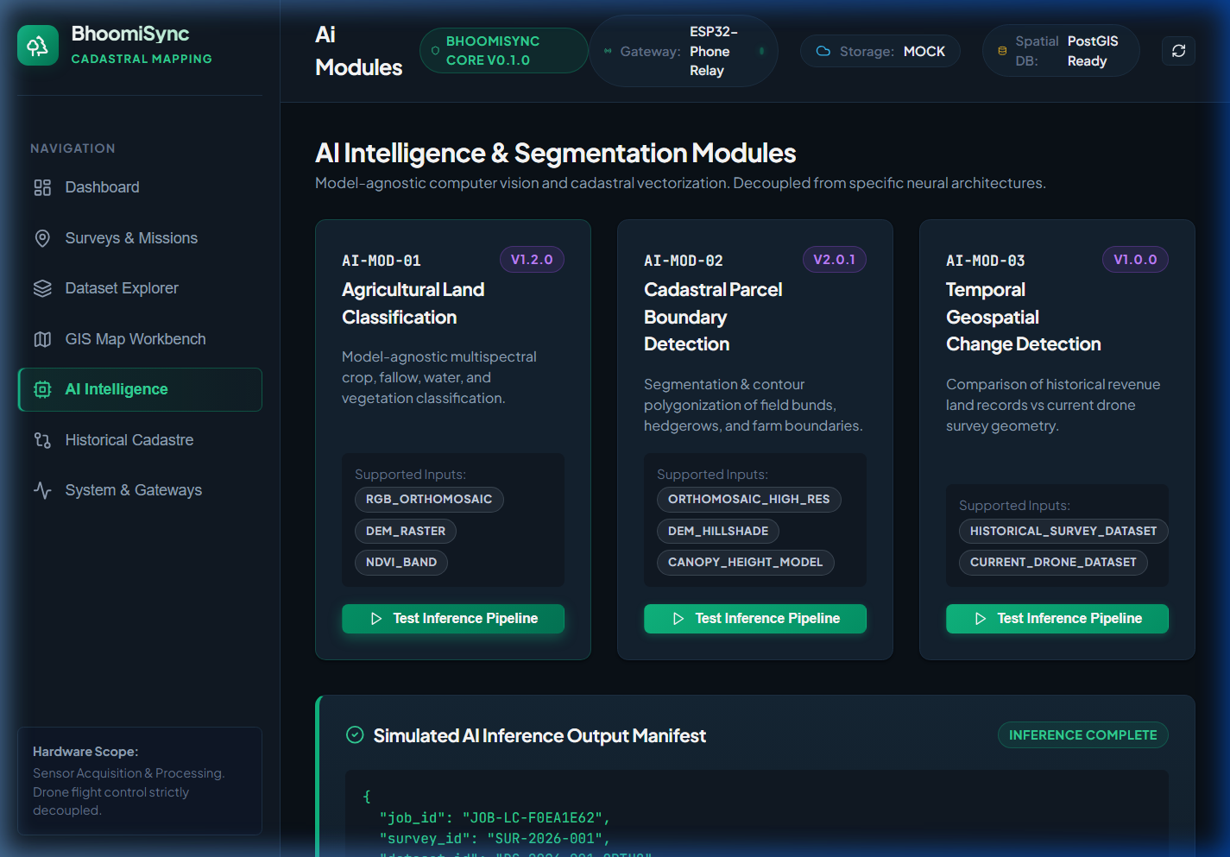
Figure 5: AI Intelligence Workbench executing model-agnostic cadastral boundary segmentation inference.

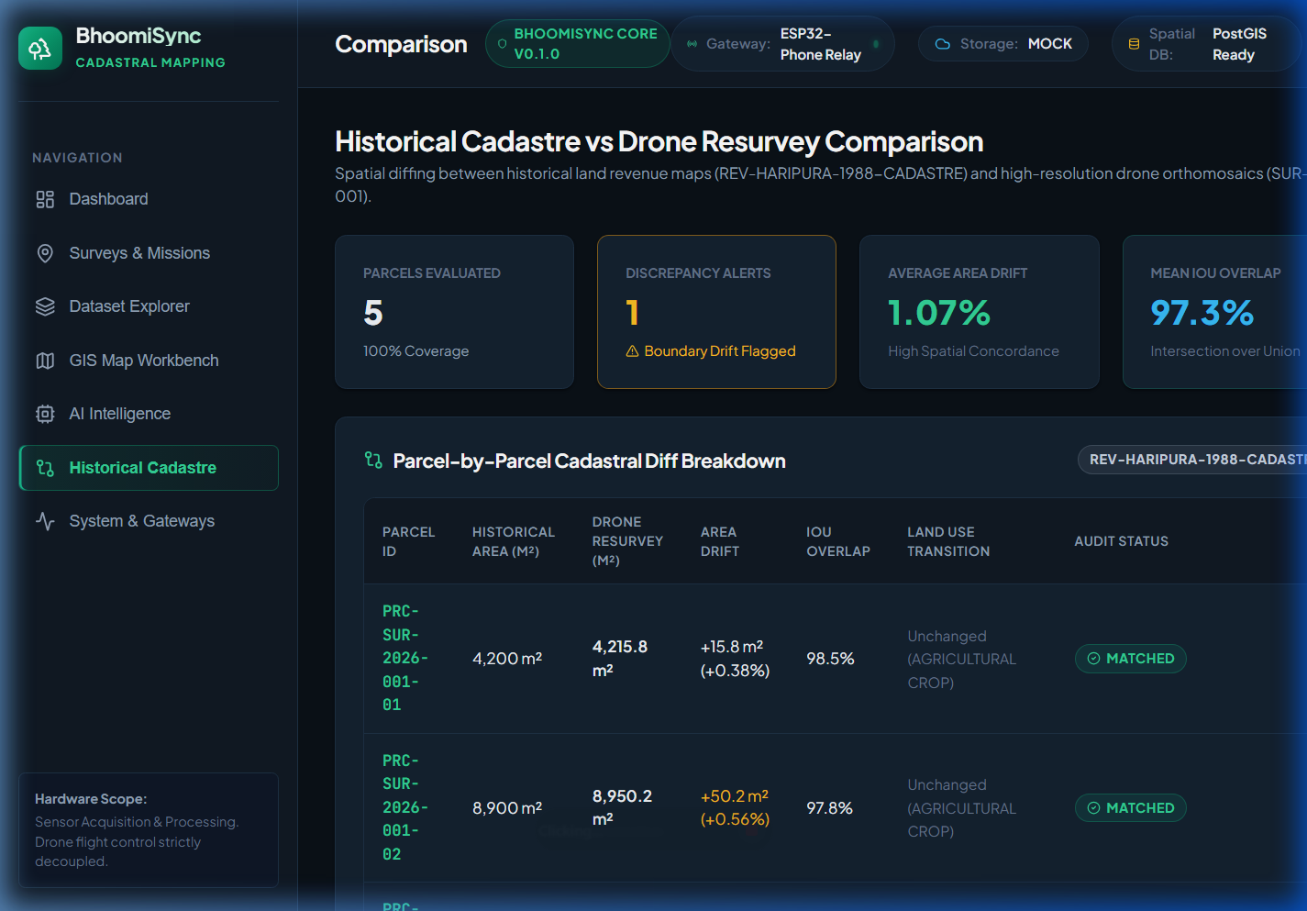
Figure 6: Historical Revenue Cadastre vs Drone Resurvey Comparison Workbench.

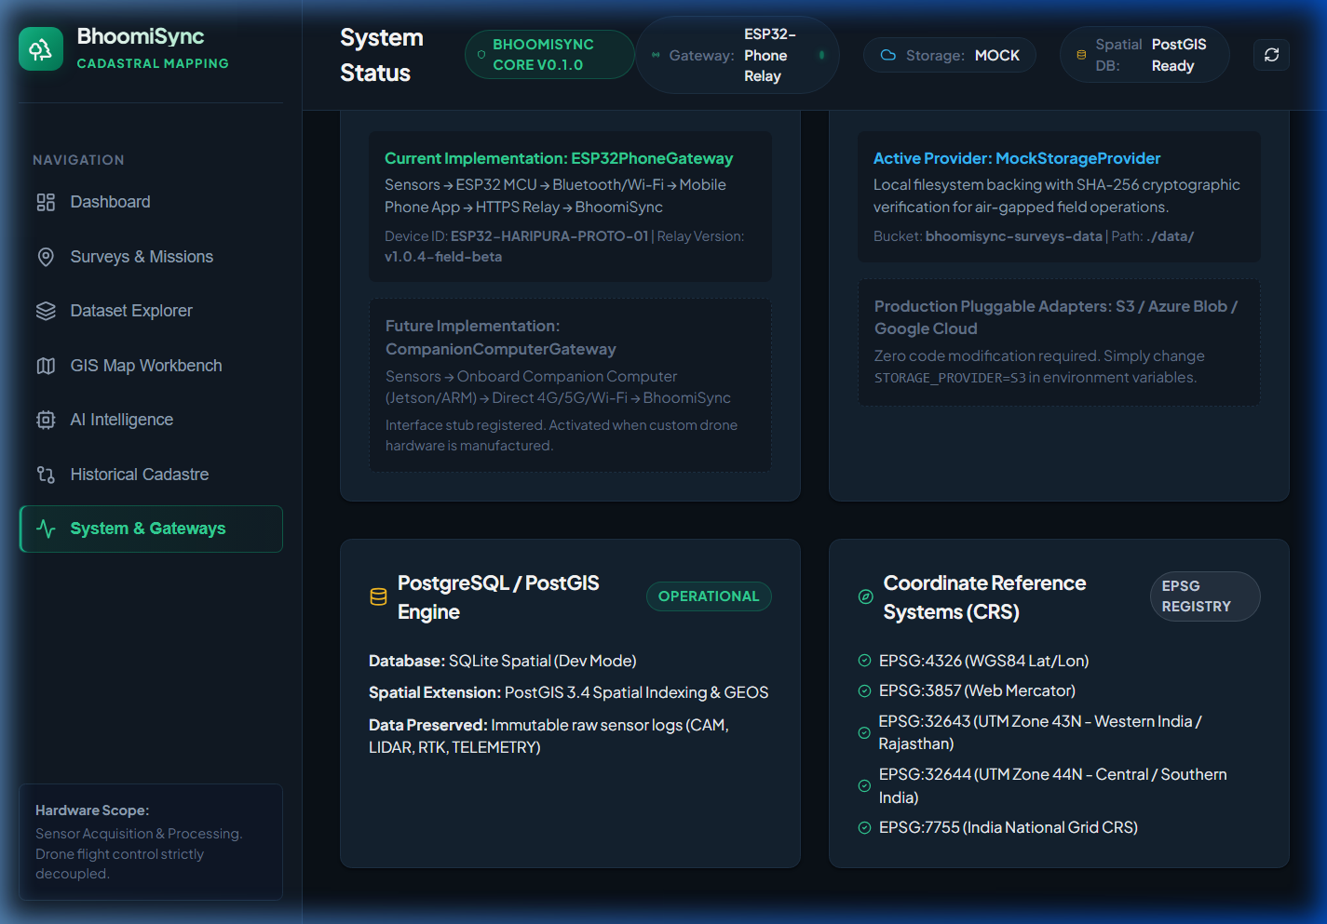
Figure 7: System Architecture Monitor tracking ESP32PhoneGateway, MockStorageProvider, and PostGIS health.

5. Canonical REST API Catalog (/api/v1/)
Method | Canonical Endpoint (/api/v1/) | Functional Description
GET | /api/v1/health | Platform health, PostGIS status, storage provider, and active gateway type.
GET | /api/v1/sensors | List registered drone sensor payloads (Camera, LiDAR, RTK GNSS).
POST | /api/v1/surveys/{id}/upload-sessions | Initialize continuous / batched ingestion sync session.
POST | /api/v1/surveys/{id}/upload | Multipart continuous sensor file upload with EXIF/LiDAR parsing & dedup.
GET | /api/v1/files/{file_id} | Retrieve stored file metadata, EXIF parameters, and storage keys.
POST | /api/v1/files/{file_id}/retry | Retry failed file validation or requeue downstream processing job.
GET | /api/v1/surveys/{id}/spatial-footprint | GeoJSON FeatureCollections of photo points, LiDAR bounds, RTK tracks.
GET | /api/v1/processing/jobs | Monitor modular processing job queue.
GET | /api/v1/surveys | List all agricultural survey missions with pagination and summary stats.
GET | /api/v1/surveys/{id}/parcels | Retrieve all parcel boundaries with calculated geodesic area & perimeter.

6. Verification & Automated Test Results
• Pytest Test Suite: 27/27 unit and integration tests passed in 0.95 seconds.
• Frontend Production Build: Vite & TypeScript build completed in 1.45s with 0 compilation errors.
• Browser End-to-End Testing: Verified Drone Ingestion Station, Demo Simulation Mode batch injection, and GIS Map spatial footprint layers.

