**Iamneo | Rest API with Spring Boot and JPA**

**Objective**

To build a complete REST API backend

**Day 1 | Class Exercise Lab 1 | Introduction to REST API**

In this Lab, we will create three services using proper URIs and HTTP methods:

1. *@GetMapping("/"):*

*Return a string message “Welcome to REST API”*

*API Endpoint uri – /welcome*

1. *@GetMapping("/student"):*

*Retrieve all the students*

*API Endpoint uri - /students.*

1. *@GetMapping("/students/{studentId}"):*

*Retrieve specific student*

*API Endpoint uri - /students/{studentId}.*

**What will you learn?**

You will learn

* What is a REST Service?
* How to bootstrap a Rest Service application with Spring Initializr?
* How to create a Get REST Service for retrieving the courses that a student registered for?
* How to create a Post REST Service for registering a course for student?
* How to execute Rest Services from Postman?

**User Story #1 | Tools and Setup**

You should be able to install the following tools in the system

* Maven 3.0+ is your build tool

* Your favourite IDE. We use Eclipse.

* JDK 17

* Postman or Swagger

**User Story #2 | Bootstrap a Rest Service application with Spring Initializr**

You should be able to bootstrap the REST Services with Spring Initializr. To do this, click [https://start.spring.io/]. Spring Initializr [http://start.spring.io/] is great tool to bootstrap your Spring Boot projects.

* Launch Spring Initializr and choose the following

* Choose com.iamneo.springboot as Group

* Choose student-services as Artifact

* Choose the following dependencies

* Web
* Actuator
* DevTools

* Check if maven and Jdk 17 are selected.

* Click Generate Project.

* Import the project into Eclipse. File -> Import -> Existing Maven Project.

Output Screenshot:

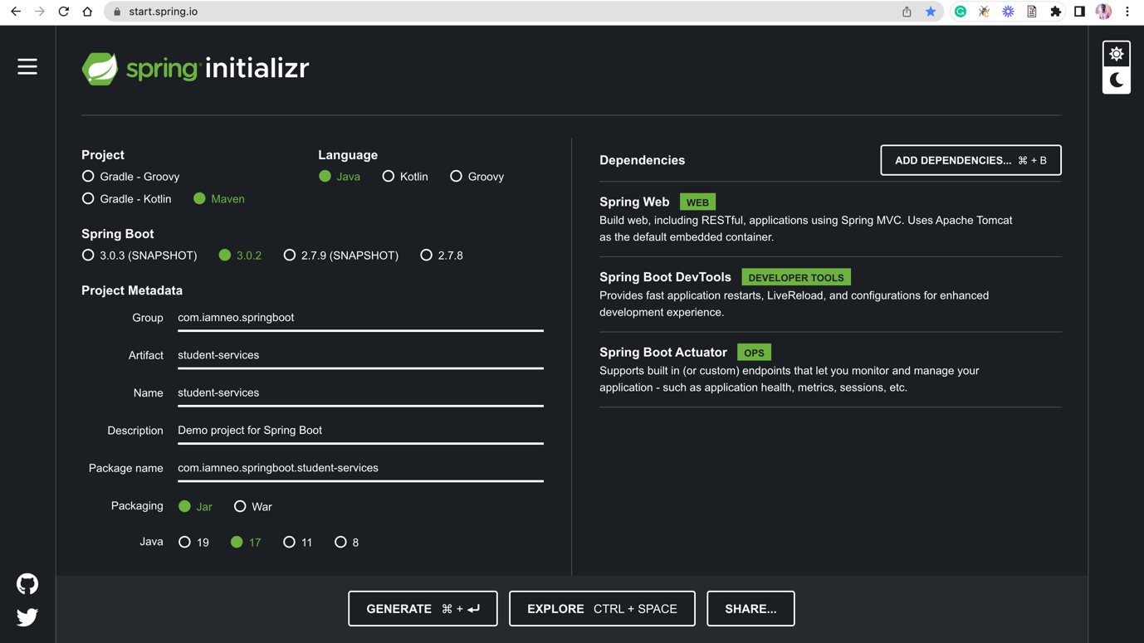

**User Story #3 | Create the project structure**

Reference Project Structure

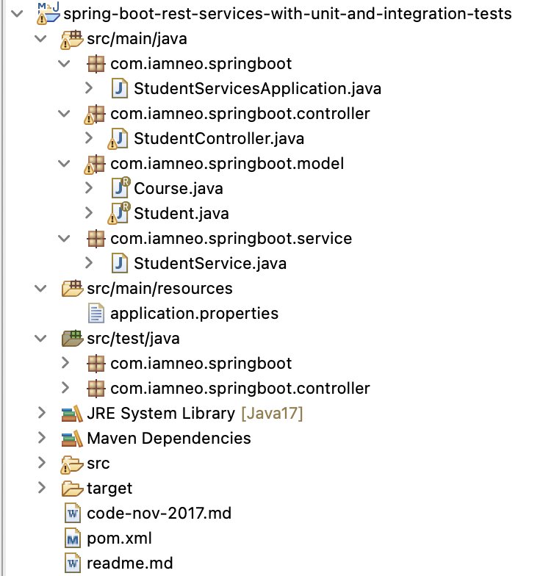

A few details:

StudentController.java - Rest controller exposing all three service methods discussed above.

Course.java, Student.java, StudentService.java - Business Logic for the application. StudentService exposes a couple of methods we would consume from our Rest Controller.

StudentServicesApplication.java - Launcher for the Spring Boot Application. To run the application, just launch this file as Java Application.

pom.xml - Contains all the dependencies needed to build this project. We will use Spring Boot Starter Web.

**Implement the Model Classes**

A student can take multiple courses. A course has an id, name, description and a list of steps you need to complete to finish the course. A student has an id, name, description and a list of courses he/she is currently registered for.

**User Story #4 | Create a Model Class Student.java**

Create a record class called Student.java inside com.iamneo.springboot.model and define the attributes

**Student.java**

public record Student{String id,

String name,

String description,

List<Course> courses

}

**Implement the Business Layer**

**User Story #5 | Create a class called StudentService.java and implement the following methods**

* public String getMessage() – Retrieve a string message “*Welcome to REST API”*
* public List<Student> retrieveAllStudents() - Retrieve details for all students
* public Student retrieveStudent(String studentId) - Retrieve a specific student details

**Implement the REST Controller**

**Adding a couple of GET Rest Services**

**User Story #6 | Implement the StudentController.java**

The Rest Service StudentController exposes a couple of get services.

* @Autowired private StudentService studentService : We are using Spring Autowiring to wire the student service into the StudentController.
* @GetMapping("/welcome "): Exposing a Get Service
* @GetMapping("/students "): Exposing a Get Service
* @GetMapping("/students/{studentId}"): Exposing a Get Service for retrieving specific student.

**User Story #7 | Executing the Http Get Operation Using Postman**

We will access a request to <http://localhost:8080/students/welcome> to test the service.