Technical Festival – Proposed Events

Date Created: 4.01.2016 Version: 1.5

Following document outlines the events to be organized at Nodal Level during the first week of March, 2016. The events have been described mostly at the principle level. A more detailed description with all the rules and regulations is expected to be unveiled soon.

*Note: This document may also serve as reference guide for zonal centers for organizing events at their level.*

Summary

|  |  |  |  |  |
| --- | --- | --- | --- | --- |
| Sr. No. | Event Name | Concerned Branches* | Level of Difficulty | Students per team |
| 2. | Circuit Design (Logitronix) | Electronics and Electrical related branches | Easy to moderate | 3 |
| 1. | Algorithm design and coding (Code Rush) | Computer Science, Electronics and Electrical related branches | Easy to difficult (depending upon the problem) | 2 |
| 3. | Designing using AutoCAD (Mechanical Design) | Mechanical and Civil related branches | Moderate | 2 |
| 4. | Line follower and maze solving (Maze Solver) | Mechanical, Computer Science, Electronics and Electrical related branches | Moderate to difficult | 3 |
| 5. | Manual robotics (Road Rash) | Mechanical, Computer Science, Electronics and Electrical related branches | Easy to moderate | 3 |

* This parameter is mostly advisory in nature. Almost every event is very generic in nature. Students from any branch can participate in any of the event.

Circuit Design: Logitronix

**Objective:** Participants are expected to design and implement a 4 bit input-output digital logic circuit using standard Logic Gate ICs and transistors within a stipulated time on solder-less breadboards. Only below mentioned components are permitted to be used:

|  |  |  |
| --- | --- | --- |
| Logic Gate IC | Transistors | Passive components |
| 1. 7400 2. 7402 3. 7404 4. 7421 5. 7432 | 1. BC547 2. BC557 | 1. Resistors 2. Capacitors |

**Description**: The designed logic circuit should be able to verify a truth table having up-to 16 input and output combinations. The truth table will be generated on the spot either randomly or in consultation with the participants. Please see appendix – A for an illustrative problem. In addition following general set of conditions are to be met:

1. Use of circuit simulation software is not allowed.
2. Participants should bring their own set of components (as mentioned above) and other tools and accessories (breadboards and connector wires).
3. They are advised to carry each component in sufficient numbers so as to be able to design circuits of reasonable complexity.
4. Participants are also expected to bring their own 5 Volts power supply.
5. Organizers will only provide working space and easy access to AC mains power socket.

**Marking and Winning Criteria**: Participants who have been able to implement maximum number of combinations from the truth table will be declared winner. In case of two or more than two participants end up tied, preference will be given to those who have used minimum number of gates. Gates created by making use of transistors will not be counted as gate (for the purpose of judging this event). In other words participants are encouraged to use maximum number of transistors to design their circuit. Even after the application of the above mentioned tie-breaker two or more than two teams end up tied, than the team clocking least time for completing the circuit design and implementation will be given preference.

Coding and Algorithm Design: Code Rush

**Objective**: Participants are expected to solve few real life coding problems by making use of computer programming (C/C++/Java).

**Description**: The fully online contest will be conducted with assistance from a third party. The third party will design the problem statements and will also provide access to their online programming platform (Online Integrated Development Environment). The problem statement will become available at the stipulated time. Participants are expected to solve the problems by making use of the online programming platform only (the platform will include an online code editor and compiler) and submit the solution through the same platform within the stipulated duration.

The problem set may have 7 problems. The participants are expected to solve these problems within 3 hours. For a reference set of problems please see the following resource: <https://code.google.com/codejam/contests.html>

**Marking and winning criteria**: In general the winner will be decided by the ability to handle all the test conditions and efficiency of the program (in terms of time and space complexity). The third party will solely be responsible for design and implementation of the judging criteria.

AutoCAD: Mechanical Design

**Objective**: Participants are expected to make 3D model of an object with the help of three standard views (front, top and side views) of the same object. The participants are expected to use AutoCAD software.

**Description**: Desktop computers with the required software will be provided by the organizers. It is to be noted that the three views will be provided in printed format. A sample problem followed by its solution is given for reference.

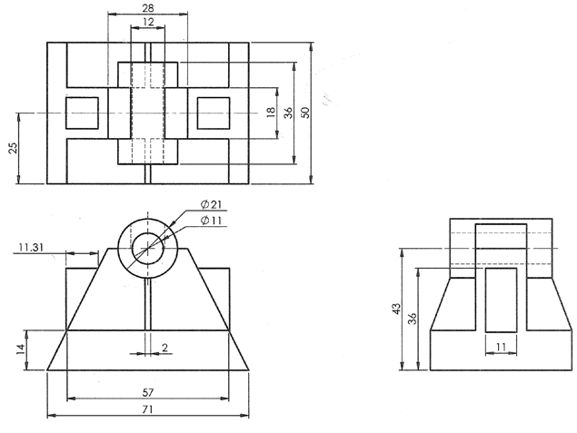**Marking and winning criteria**: Winner will be decided based on time taken and number of steps taken to complete the design.



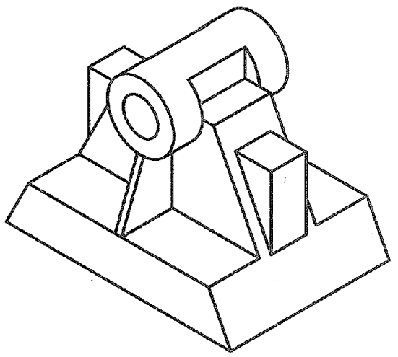



Autonomous Robot: Maze Runner

**Objective**: The participants are expected to build a robot that should traverse a maze consisting of black lines printed on white flex sheet. The teams are expected to build the robot from scratch. However they can use open source prototyping boards like Arduino and Raspberry Pi.

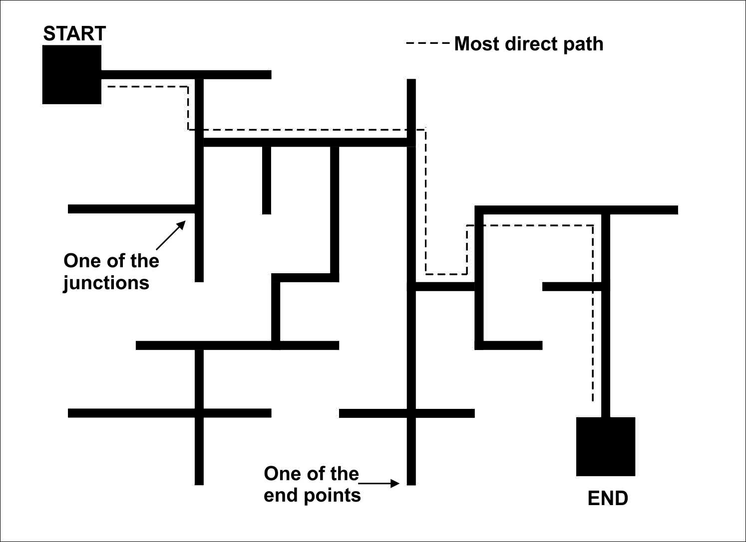**Arena description**: The arena will consist of maze made up of black lines (30 mm wide) printed on white flex sheet (see figure). The maze is guaranteed to be without loops. The distance between any two parallel lines will not be less than 200 mm.

**Description**: Each robot will be given two runs. During the first run the robot should start from the black square (marked as start) and should ultimately reach the other black square (marked as end) covering each part of the maze. During the second run the robot should return to the starting point passing through the most direct route possible.

**Marking scheme and winning criteria**: During the first run, for each end point visited, the robot will be awarded 10 points and will be penalized by 5 points for missing any. It is to be noted that there are 17 end points. During the second run the robot will be awarded 10 marks for crossing each junction falling in the most direct path and will be penalized by 10 points for touching any end point. It is to be noted that there are 7 junctions falling in the most direct path. The team having maximum score will be declared winner. If two teams are tied at the end of the game, the team clocking less time during the second run will be declared winner.

Manual Robot Competition: Road Rash

**Objective**: Two manual robots will be racing against each other in a circular race track having some minor obstacles. The winner will be decided upon the ability of the robot to outrun the opponent without falling off the edge of the arena.

**Arena Description**: The arena will be a 400 mm wide circular racing track made up of ordinary plywood. The inner diameter of the track will be 4000 mm. Arena will be parallel to the ground but fixed at a height of 300 mm from it. It will be made up of ordinary plywood. There will be two obstacles located diametrically opposite to each other. The obstacles will be stainless steel rod (10 mm diameter) fixed at a height of 20 mm from the surface of the racing track (as shown in figure).

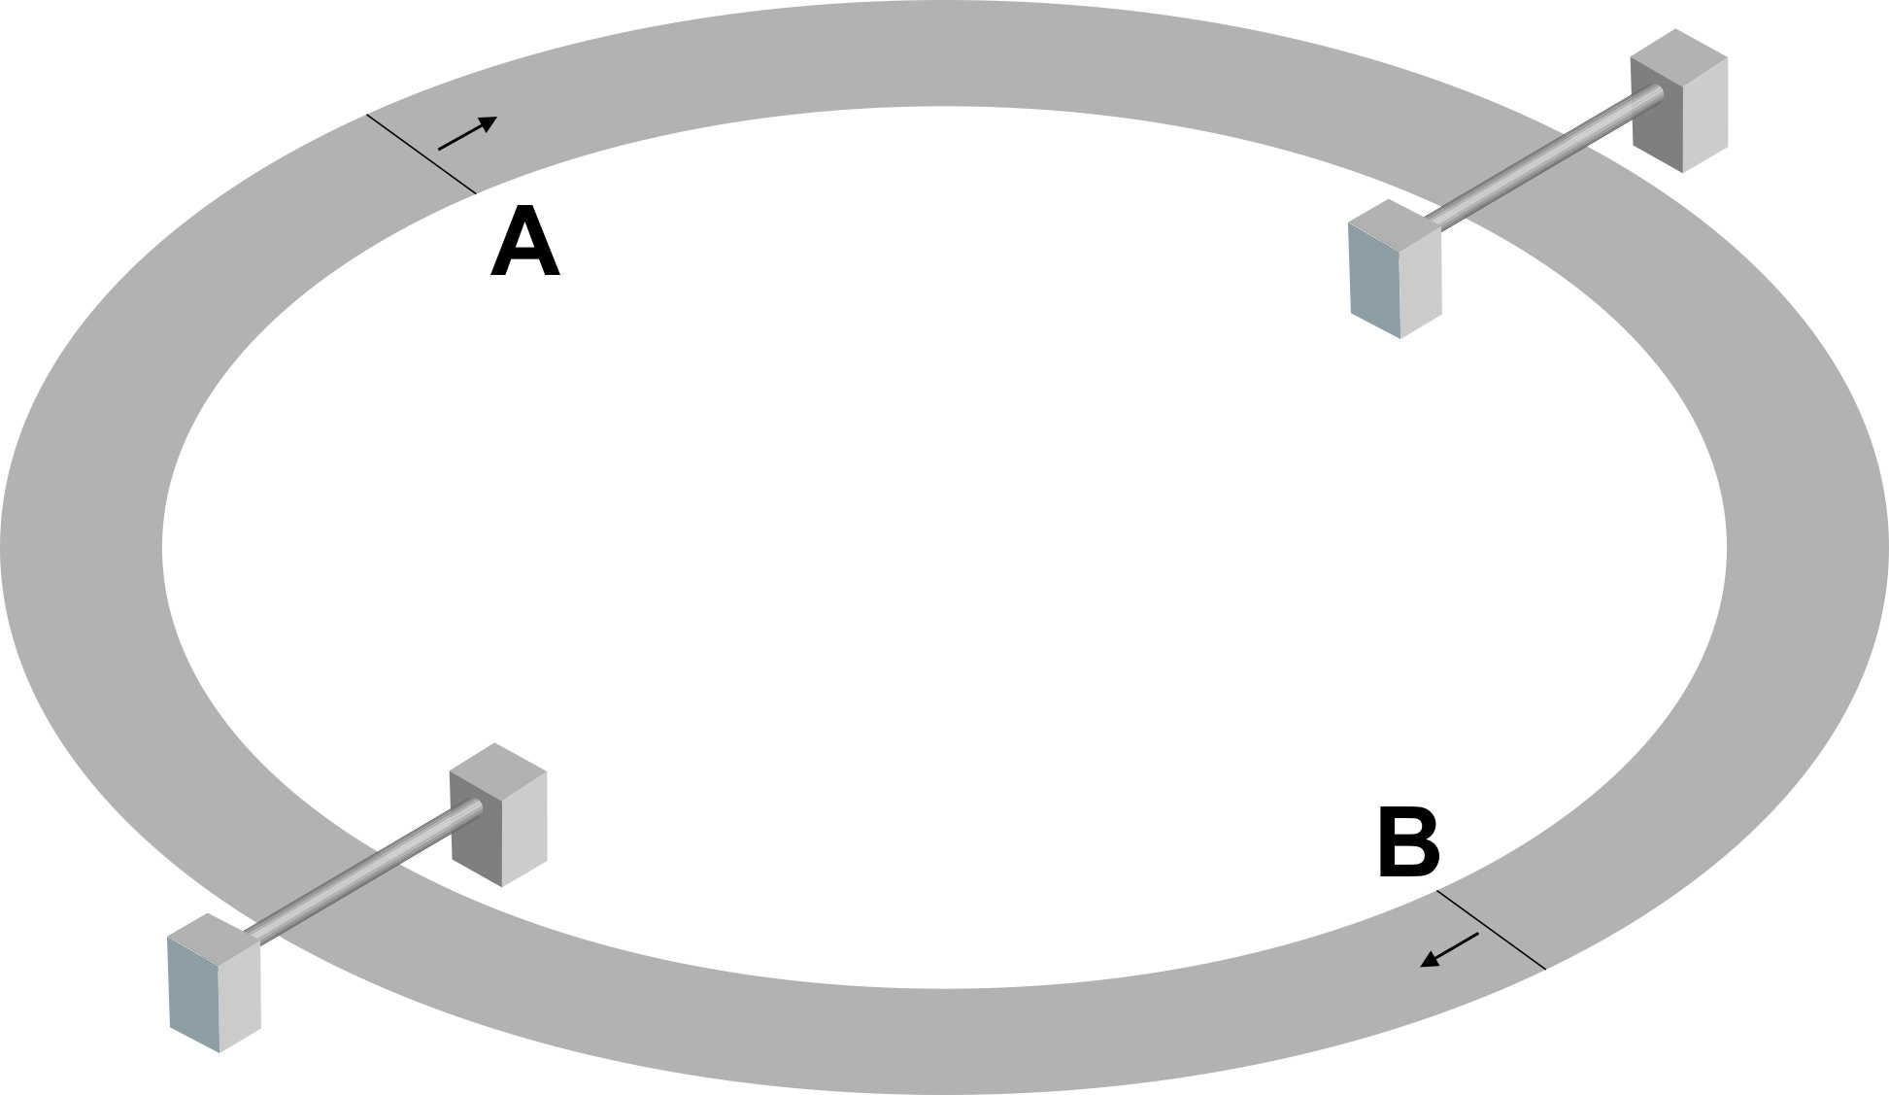

**Description**: The robots will start from the starting positions (marked as A and B) and both of them will move in the same sense (shown by arrows). The robots are expected to chase and approach the other robot from behind. Any dimension of the robot should not be less than 200 mm during all time of the game.

**Marking and Winning Criteria**: There will be three rounds of 3 minutes each. Each round will end with the fulfillment of any one of the following conditions:

1. A robot successfully chases its opponent and touches it from behind. The chaser will be declared winner of the round and will be awarded 10 points.
2. If a robot falls of the racing track. The opponent will be declared winner of the round and will be awarded 10 points.
3. The round will get over with the expiry of 3 minutes. None of the robots will be awarded any point.

At the end of the three rounds robot scoring maximum points will be declared winner. In case both the robot end up tied the game may be extended by another round of 3 minutes.

If the winner is undecided even by the end of the fourth round, the robot closest to its opponent (measured from head of the robot to the tail of the opponent and measured along the circular track) will be declared winner.

Appendix A

Following is a sample truth table for which the participants are expected to design a digital logic circuit. Though the following table contains only 5 input and output combinations, the truth table generated at the time of the actual event may contain more than 5 (up-to 16) input and output combinations.

|  |  |  |  |  |  |  |  |
| --- | --- | --- | --- | --- | --- | --- | --- |
| Input bits | | | | Output bits | | | |
| A0 | A1 | A2 | A3 | B0 | B1 | B2 | B3 |
| 0 | 0 | 0 | 0 | 0 | 0 | 0 | 1 |
| 0 | 0 | 0 | 1 | 0 | 0 | 1 | 0 |
| 1 | 1 | 0 | 0 | 1 | 1 | 0 | 0 |
| 1 | 1 | 1 | 0 | 1 | 1 | 1 | 0 |
| 1 | 1 | 1 | 1 | 1 | 0 | 0 | 0 |