Game Design Document

Fill up the following document

1. Write the title of your project.

Ans: Space Runner

1. What is the goal of the game?

Ans: To increase the eye concentration of the player

1. Write a brief story of your game.

Ans: A rocket has been launched to jupiter and now it is crossing the astroid belt. Help the driver of the rocket to escape the astroid belt and reach Jupiter.

1. Which are the playing characters of this game?

* Playing characters are the ones who respond to the user based on the input from the user.
* Cars, monkeys, dinos, wizards, etc., are the playing characters in the game.

|  |  |  |
| --- | --- | --- |
| Number | Character Name | What can this character do? |
| 1 | Rocket | This character has controls to move left and right for avoiding the astroids. |

1. Which are the Non-Playing Characters of this game?

* Non-Playing characters are the ones that don't have an action or behavior when the user interacts with the game.
* Hurdles, stones, bananas, coins, etc., are non-playing characters in the game.

|  |  |  |
| --- | --- | --- |
| Number | Character Name | What can this character do? |
| 1 | Astroids | If rocket touches the astroids the rocket will be destroyed. |
| 2 | Fuel Tanks | At certain places there will be fuel tanks to increase the fuel and reach Jupiter successfully. |

Draw your imagination of this game. What does this game look like?

* Draw the game either on your computer or on paper.
* Add images of the game scenes to show each of the playing and non-playing characters at least once.

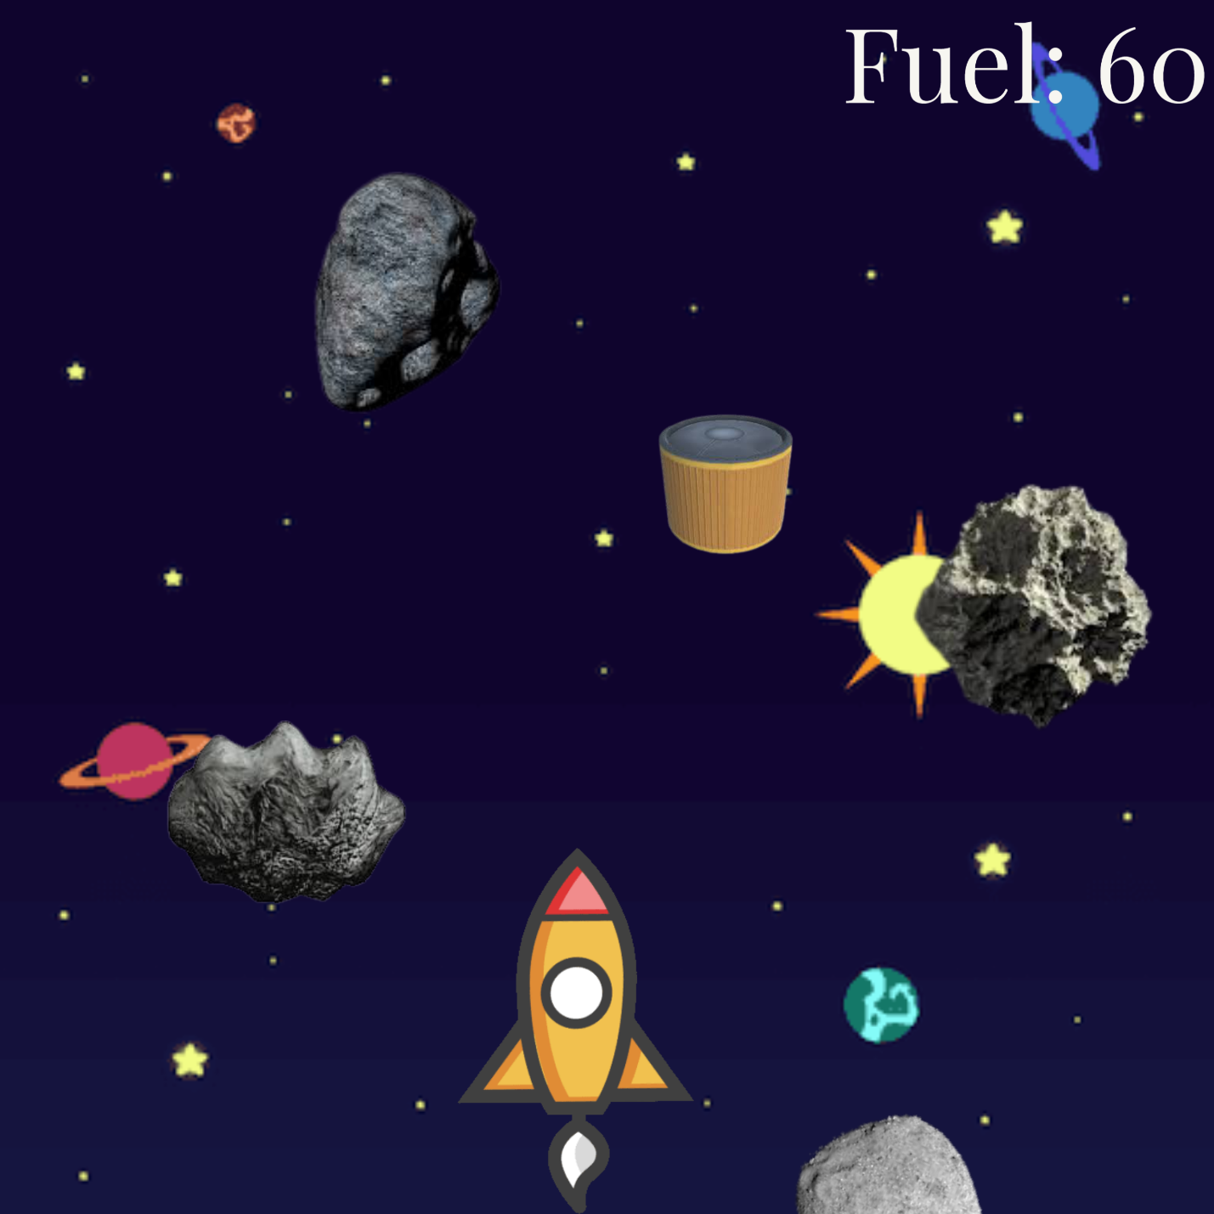

How do you plan to make your game engaging?

Ans:The positions of the astroids will be random so player has to be focussed and also fuel tanks function will make the game more exciting.