Game Design Document

Fill up the following document

1. Write the title of your project.

Debunk

1. What is the goal of the game?

Reching the end of the canvas without being destroyed by the obstacles.

1. Write a brief story of your game.

There will be a player object and some obstacles. The player has to avoid the obstacles and reach the end of the canvas. After reaching the end of the canvas a new and more difficult and challenging level will start followed by the same game object and story.

1. Which are the playing characters of this game?

* Playing characters are the ones who respond to the user based on the input from the user.
* Cars, monkeys, dinos, wizards, etc., are the playing characters in the game.

|  |  |  |
| --- | --- | --- |
| Number | Character Name | What can this character do? |
| 1 | Player Object | Move vertically |
| 2 |  |  |
| 3 |  |  |
| 4 |  |  |
| 5 |  |  |
| 6 |  |  |
| 7 |  |  |
| 8 |  |  |

1. Which are the Non-Playing Characters of this game?

* Non-Playing characters are the ones that don't have an action or behavior when the user interacts with the game.
* Hurdles, stones, bananas, coins, etc., are non-playing characters in the game.

|  |  |  |
| --- | --- | --- |
| Number | Character Name | What can this character do? |
| 1 | Obstacles | Stops the player from reaching the end |
| 2 |  |  |
| 3 |  |  |
| 4 |  |  |
| 5 |  |  |
| 6 |  |  |
| 7 |  |  |
| 8 |  |  |

Draw your imagination of this game. What does this game look like?

* Draw the game either on your computer or on paper.
* Add images of the game scenes to show each of the playing and non-playing characters at least once.

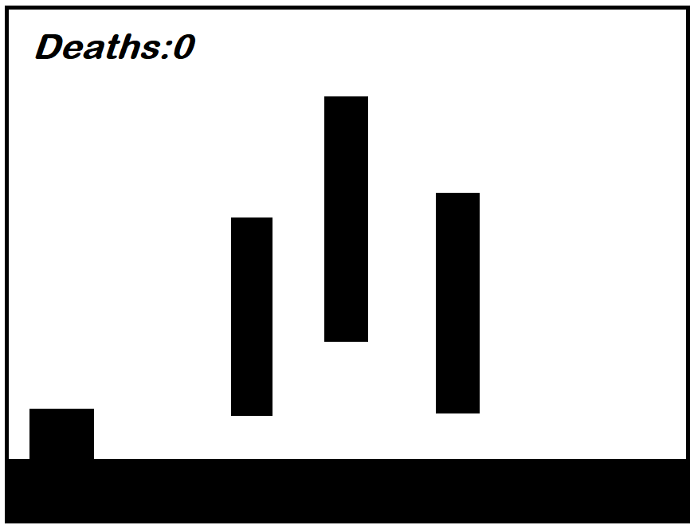

How do you plan to make your game engaging?

By give more challenging and difficult levels.