
PROJECT REPORT ON
FinDora
SVKM DJSCE Campus Lost & Found Platform
Cross-Platform Mobile Application Architecture, Material 3 UI, Gemini AI Assistance, REST Client Integration and Form Validation
TRACK: APPLICATION DEVELOPMENT FRAMEWORK (ADF)
SUBMITTED BY:  A074 – Sonal Dhonde  A075 – Rahi Doshi  A090 – Suruchi Makwana  A092 – Arisha Mehta | UNDER THE GUIDANCE OF:  Project Guide: Prof. Vipul Kushwaha  Dwarkadas J. Sanghvi College of Engg.
DEPARTMENT:  Department of Artificial Intelligence and Machine Learning | ACADEMIC YEAR: 2025-2026  Date of Submission: 26th October 2026

Declaration
We hereby declare that the project report entitled "FinDora — SVKM DJSCE Campus Lost & Found Platform (Application Development Framework Track)" submitted to Dwarkadas J. Sanghvi College of Engineering, affiliated to the University of Mumbai, is an authentic record of original cross-platform mobile software development carried out by me under the supervision and guidance of Prof. Vipul Kushwaha, Department of Artificial Intelligence and Machine Learning.
We further declare that the content of this project report, including the Flutter widget architecture, Dart asynchronous models, Material 3 theming system, Gemini AI semantic classification services, HTTP REST API client, regular-expression-based form validation, offline seed data resilience, and mobile role-based navigation flows, has not been submitted in part or full to any other University or Institution for the award of any degree or diploma.
All sources of technical literature, official software documentation, open-source Flutter packages, and external application development tools referenced in this work have been properly cited and acknowledged in compliance with academic standards.
______________________________________
Sr. No. | Student Name | Roll No. | Signature
1 | Sonal Dhonde | A074 | __________
2 | Rahi Doshi | A075 | __________
3 | Suruchi Makwana | A090 | __________
4 | Arisha Mehta | A092 | __________

Project Guide: Prof. Vipul Kushwaha

Signature: ______________________

Acknowledgement
We express my profound gratitude and sincere thanks to my esteemed Project Guide, Prof. Vipul Kushwaha, Department of Artificial Intelligence and Machine Learning, Dwarkadas J. Sanghvi College of Engineering, for invaluable guidance, patient mentoring, and constructive critique throughout the architecture, UI engineering, API integration, and static-analysis validation of this Flutter mobile application.
We extend my sincere appreciation to Dr. Aruna Gawde, Head of the Department of Information Technology, for providing the necessary computational infrastructure, mobile device testing environments, and encouragement that facilitated the seamless execution of this project under the Application Development Framework (ADF) curriculum.
I also convey my sincere thanks to Dr. Hari Vasudevan, Principal, Dwarkadas J. Sanghvi College of Engineering, and the Shri Vile Parle Kelavani Mandal (SVKM) Management for fostering an institutional culture of innovation, hands-on engineering, and mobile computing excellence.
Finally, I express my heartfelt appreciation to my family, faculty mentors, and fellow classmates whose continuous support, testing assistance, and feedback contributed substantially toward the successful completion of this academic project report.

Abstract
Smart mobile devices represent the primary computing and communication medium through which undergraduate engineering students and faculty navigate collegiate life. In high-density campus environments such as Dwarkadas J. Sanghvi College of Engineering (DJSCE), misplaced personal belongings occur dynamically across classrooms, lecture halls, computing laboratories, and campus cafeterias. However, the absence of an immediate, native mobile reporting and verification tool forces students to rely on slow, disorganized word-of-mouth reports or uncoordinated social media stories, causing prolonged delays in recovering misplaced property.
To resolve this mobility bottleneck, this report presents the engineering and architectural implementation of FinDora (Application Development Framework — ADF), a high-performance, cross-platform mobile application developed using Google's Flutter framework and the Dart programming language. The mobile client is designed as a first-class citizen of the FinDora campus ecosystem, communicating seamlessly with a shared Next.js REST API backend while maintaining complete independence of presentation, local state, and offline caching.
The technical architecture of the mobile application incorporates several cutting-edge mobile development paradigms: (1) a clean, multi-layered widget hierarchy organized into Presentation, Service, and Data layers; (2) Material 3 design system implementation supporting dynamic dark and light mode synchronization via a custom `ThemeService` notifier; (3) a 5-tab persistent bottom navigation shell (`BottomNavigationBar`) coordinating Home, Browse, Gemini AI Matcher, Report/Post, and Profile modules; (4) an asynchronous HTTP communication service (`ApiService`) featuring automated network timeout handling, host resolution across desktop and emulator targets, and graceful fallback to offline seed datasets (`SeedData`); (5) Gemini AI assistance (`GeminiService`), providing automatic categorical classification from natural language descriptions and semantic match scoring with localized recovery advisories; (6) robust form validation leveraging `GlobalKey<FormState>`, enforcing strict 4-character Roll Number (`^[A-Za-z][0-9]{3}$`), 12-digit SVKM SAP ID (`^6[0-9]{10,11}$`), SVKM email suffixes (`@svkmmumbai.onmicrosoft.com`), and mandatory image proof for found items; (7) real-time claim status tracking on item detail views (`_existingClaim`) directing students to the Ground Floor Security Desk (Gate 2); and (8) role-based profile isolation separating student digital ID credentials from the Faculty Security Console.
The mobile application was rigorously verified using the Flutter static analysis tool (`flutter analyze`), achieving zero warnings and zero errors across all Dart source files. Functional verification across 15 real-world mobile test scenarios confirmed 100% compliance with institutional validation rules, live REST communication, and error resilience. FinDora establishes an exemplary standard for intelligent, responsive campus mobile applications.
Keywords: Flutter, Dart, Application Development Framework, Material 3, Gemini AI Assistance, REST API Client, Form Validation, Smart Campus.

Table of Contents
Declaration | ii
Acknowledgement | iii
Abstract | iv
List of Figures | vi
List of Tables | vii
List of Abbreviations | viii
Chapter 1: Introduction | 1
1.1 Objectives of the System | 2
1.2 Scope of the Project | 4
Chapter 2: Literature Review | 6
2.1 Existing Recommendation Techniques | 6
2.2 Applications of Recommendation Systems in E-Commerce and Lost-and-Found Platforms | 9
Chapter 3: Implementation | 13
3.1 System Architecture and Design | 13
3.2 System Development & Deployment | 17
3.2.1 Material 3 UI Engineering & Theme Management | 17
3.2.2 Application Navigation & Screen Hierarchy | 19
3.2.3 Mobile Item Reporting & Gemini Auto-Category Detection | 22
3.2.4 Gemini AI Semantic Matcher Module (Mini Project I) | 24
3.2.5 Ownership Claim Submission & Live Status Tracking | 27
3.2.6 Role-Based Profile Portal & Faculty Security Console | 29
3.2.7 Monochrome Line Icons Implementation | 31
3.2.8 Application Build & Multi-Platform Deployment | 32
Chapter 4: Result Analysis | 34
4.1 Performance Evaluation | 34
4.1.1 Mobile Functional Verification Test Suite | 34
4.1.2 Flutter Static Analysis Verification | 37
4.1.3 Multi-Platform Target Execution & Responsiveness | 38
4.1.4 Mobile Performance Considerations & Benchmarking Methodology | 39
Chapter 5: Conclusion | 41
5.1 Future Enhancements | 43
References | 45

List of Figures
Figure 3.1 | Flutter Mobile Application Multi-Layered Architecture and Backend Integration | 16
Figure 3.2 | Mobile Application Screen Navigation Hierarchy and Tab Shell Structure | 21
Figure 3.3 | Mobile Item Reporting Workflow with Gemini Category Auto-Detection | 23
Figure 3.4 | Mobile Claim Submission and Real-Time Status Tracking Lifecycle | 28

List of Tables
Figure 3.1 | FinDora Mobile Application Login and Home Screen | 16
Figure 3.2 | FinDora Mobile Browse Catalog and Swipe Matcher Screens | 21
Figure 3.3 | FinDora Mobile Item Discovery and Chat Interfaces | 23
Figure 3.4 | FinDora Student Profile and Claim Status Interface | 28

List of Abbreviations
ADF | Application Development Framework
AI | Artificial Intelligence
API | Application Programming Interface
APK | Android Package Kit
DJSCE | Dwarkadas J. Sanghvi College of Engineering
FST | Full Stack Track
HTTP | Hypertext Transfer Protocol
IEEE | Institute of Electrical and Electronics Engineers
JSON | JavaScript Object Notation
M3 | Material Design 3
NLP | Natural Language Processing
PII | Personally Identifiable Information
RBAC | Role-Based Access Control
REST | Representational State Transfer
SAP | Systems, Applications, and Products in Data Processing (Institutional Student ID)
SDK | Software Development Kit
SVKM | Shri Vile Parle Kelavani Mandal
TF-IDF | Term Frequency-Inverse Document Frequency
UI | User Interface
URI | Uniform Resource Identifier
URL | Uniform Resource Locator
UX | User Experience
VM | Virtual Machine

Chapter 1: Introduction
Modern educational institutions function as dynamic, highly mobile ecosystems where students and faculty continuously traverse classrooms, computer centers, engineering laboratories, libraries, and cafeteria areas. At Dwarkadas J. Sanghvi College of Engineering (DJSCE), an autonomous engineering college affiliated to the University of Mumbai under the management of Shri Vile Parle Kelavani Mandal (SVKM), thousands of students navigate multi-story academic wings daily.
Throughout these active physical transitions, misplaced personal property is a recurring and stressful occurrence. Essential items—such as institutional smart ID cards, high-value electronics (calculators, laptops, headphones, mobile chargers), textbooks, keys, water bottles, and stationery—are frequently left behind in classrooms (e.g., Room 402), central reading halls (Library 3rd Floor), computing labs (IT Lab 3), and student canteen tables.
While web portals provide robust desktop management, students are overwhelmingly mobile-first users. When an item is lost or discovered between lectures, a student does not typically open a laptop, connect to Wi-Fi, and navigate a desktop browser. Instead, the student immediately reaches for their smartphone. Under existing informal campus conditions, mobile property reporting is severely handicapped:
1. Reliance on Ephemeral Social Channels: Recovered items are photographed and broadcast haphazardly across class WhatsApp groups or ephemeral Instagram stories. These posts lack structured search filters, location tagging, or category indexes, disappearing rapidly under hundreds of subsequent peer messages.
2. Immediate Exposure of Private Data: When students announce found items on informal groups, they often attach unredacted photographs displaying student names, Roll Numbers, and government identification numbers, exposing students to harassment and unauthorized contact.
3. High Friction in Urgent Reporting: Without an optimized mobile interface with intelligent input defaults, capturing item details, selecting categories, and uploading photos between busy lecture schedules presents excessive friction.
4. Absence of Verification Integrity: Anyone viewing a social media broadcast can visit the security desk and falsely claim an item before the rightful owner even becomes aware of its recovery.
To eliminate these critical challenges, FinDora (Application Development Framework — ADF) was engineered as a dedicated, cross-platform mobile application developed using Flutter and Dart. Designed to operate as a native mobile client for the SVKM DJSCE campus community, the mobile app integrates seamlessly with a shared Next.js REST API backend, providing real-time property cataloging, Gemini AI-assisted classification, structured ownership verification, and dynamic Material 3 user interfaces.
1.1 Objectives of the System
The technical objectives of the FinDora Mobile Application are established to fulfill the rigorous requirements of the DJSCE ADF curriculum:
1. High-Performance Cross-Platform Portability: To engineer a single, maintainable Flutter codebase in Dart that compiles natively across mobile platforms (Android, iOS) and desktop environments (Windows desktop), ensuring 60 frames-per-second (FPS) rendering and native hardware responsiveness.
2. Real-Time REST Integration with Shared Backend: To implement an asynchronous HTTP client service (`ApiService`) communicating with the shared Next.js REST API endpoints (`/api/items`, `/api/claims`, `/api/ai/match`), enabling unified, real-time data synchronization between web and mobile users without duplicating backend database logic.
3. Gemini AI Assistance for Mobile Users: To incorporate Google Gemini AI capabilities via `GeminiService`: (a) automatic keyword-based category detection during report creation, reducing manual form entry friction; and (b) a dedicated Gemini AI Semantic Matcher screen (Mini Project I) that evaluates reported items against active campus findings with confidence scores and reasoning badges.
4. Material 3 Design System & Dynamic Theming: To implement an intuitive Material Design 3 interface featuring a persistent 5-tab navigation shell (`BottomNavigationBar`), custom reusable widgets (`ItemCard`, `StatusChip`), and dynamic dark/light theme switching managed via a reactive `ThemeService` notifier.
5. Client-Side Verification and Form Validation Parity: To implement robust form validation using `GlobalKey<FormState>`, enforcing strict 4-character Roll Number (`^[A-Za-z][0-9]{3}$`), 12-digit SVKM SAP ID (`^6[0-9]{10,11}$`), SVKM institutional email suffixes (`@svkmmumbai.onmicrosoft.com`), and mandatory image proof for found items.
6. Offline Resilience and Graceful Fallback: To engineer an offline seed data architecture (`SeedData`) within `ApiService` that ensures the mobile application remains fully navigable, searchable, and demonstrable even during localized server outages or campus network interruptions.
1.2 Scope of the Project
The scope of the FinDora Mobile Application encompasses the complete client-side mobile lifecycle:
1. Target User Personas: The mobile client serves SVKM DJSCE students for on-the-go reporting, catalog discovery, card swiping, peer chat, and claim tracking; and campus faculty security personnel for administrative moderation through the Faculty Security Console.
2. Supported Platforms: The Flutter application is engineered and verified for Windows Desktop (`flutter run -d windows`), Chrome Web (`flutter run -d chrome`), and Android mobile targets via Android SDK.
3. Architectural Separation of Concerns: The mobile application strictly delegates database persistence, password hashing, and master claim approvals to the shared Next.js backend, acting as an intelligent, responsive presentation and client-validation client.
Table 1.1: FinDora ADF Concept Mapping to DJSCE Academic Syllabus
Module | Syllabus Curriculum Topic | Implemented Location & Technical Features in mobile_app/
Module 1 | Gemini for Application Developers | GeminiService.suggestCategory() for automated keyword classification; Mini Project I: GeminiMatcherScreen executing semantic item matching against backend /api/ai/match.
Module 2 & 3 | Introduction to Flutter and Dart Language | Strongly-typed Dart classes (models/item.dart) with JSON serialization (fromJson/toJson); asynchronous programming with async/await and Future.
Module 4 | Working with Flutter (Widgets, Forms, Theming) | Material 3 UI implementation; custom widgets (ItemCard, StatusChip); GlobalKey<FormState> input validation; ThemeService for reactive dark/light mode toggle.
Module 5 | Building a Flutter Application (Mini Project II) | Multi-page app with 5-tab BottomNavigationBar shell (Home, Browse, Matcher, Report, Profile); ApiService HTTP client consuming shared REST API; SeedData offline fallback; pull-to-refresh.

Chapter 2: Literature Review
The development of intelligent mobile applications for smart campus environments requires a thorough understanding of mobile user interfaces, on-device data processing, client-server communication paradigms, and recommendation techniques [1], [2]. This chapter reviews foundational recommendation and discovery algorithms, analyzes their mobile application, and contrasts existing paradigms with FinDora's mobile architecture.
2.1 Existing Recommendation Techniques
Recommendation systems aim to reduce information overload by presenting users with items most relevant to their context or preferences [3], [4]. In mobile application development, recommendation techniques must balance algorithm precision against device resource constraints (memory, network bandwidth, battery consumption) [14].
1. Lexical Keyword Matching and Token Space Similarity: Traditional item matching systems rely upon lexical token intersection and vector space models, such as Term Frequency-Inverse Document Frequency (TF-IDF) [5], [6]. In mobile architectures, computing heavy TF-IDF matrices on-device can introduce UI thread jank. Consequently, mobile applications typically implement lightweight tokenization or offload heavy vector computations to cloud REST endpoints [1], [14]. While token-based search is fast, it fails to handle semantic variations (e.g., matching 'cellphone' with 'smartphone') [6].
2. On-Device Rule-Based Categorization: In mobile forms, minimizing user keystrokes is critical for data collection accuracy. Rule-based keyword matching uses deterministic lookup tables to infer item categories from input text [7]. By analyzing regular expressions or substring intersections on the client device, the interface can dynamically suggest categories (e.g., inferring 'Electronics' from 'AirPods') without incurring network latency [2], [7].
3. Content-Based Mobile Filtering: Content-based filtering recommends items by comparing structured attribute vectors (category, location, date, color) [3], [4]. In mobile lost-and-found contexts, content-based matching is uniquely advantageous because it operates independently of historical user interaction matrices, functioning immediately when a new report is filed (solving the 'cold start' problem) [4].
4. Collaborative Filtering and Inherent Mobile Limitations: Collaborative filtering algorithms (user-based or item-based matrix factorization) predict interests from collective user rating histories [3], [9]. However, lost-and-found mobile platforms cannot leverage collaborative filtering: lost reports represent unique, non-recurring physical instances that are permanently retired upon recovery [1], [3].
2.2 Applications of Recommendation Systems in E-Commerce and Lost-and-Found Platforms
Commercial mobile e-commerce applications (such as Amazon and Flipkart) extensively utilize content-based recommendation trees to present personalized item suggestions, related accessories, and category filters [4], [10]. Mobile e-commerce design emphasizes faceted search chips, swipe gestures, and instant feedback.
Applying these principles to mobile campus lost-and-found applications presents distinct operational constraints [1], [2]. Misplaced items lack standardized barcodes or commercial product catalogs. Instead, reports contain unstructured, subjective natural language descriptions submitted under hurried campus conditions [11]. Furthermore, mobile platforms must prevent fraudulent claims by embedding structured verification dialogs before physical handover [12].
Recent research in smart campus mobile architectures [1], [2], [11] explores mobile reporting apps built with native or hybrid frameworks. However, published systems exhibit notable technical gaps:
• Tight Coupling to Monolithic Backends: Many mobile prototypes hardcode backend database calls directly within UI widgets, violating clean separation of concerns and preventing web-mobile interoperability [1], [2].
• Fragility to Network Outages: Most surveyed apps crash or display blank error screens when campus Wi-Fi is lost, lacking local offline caching or fallback datasets [11].
• Form Input Inconsistency: Several mobile implementations omit strict credential validation, allowing arbitrary student inputs that complicate administrative matching [12].
Comparison with FinDora's Implemented Mobile Architecture: FinDora resolves these issues through a decoupled, multi-layered Flutter architecture [13]:
1. Lightweight Client-Side Gemini Categorization: `GeminiService.suggestCategory()` performs instant, on-device keyword inference across major campus categories (Electronics, ID & Cards, Books & Stationery, Accessories, Keys, Clothing), auto-populating form dropdowns in real time without blocking the UI thread.
2. Asynchronous REST Client with Offline Resilience: `ApiService` communicates asynchronously with the shared Next.js `/api/ai/match` route over HTTP. If network connectivity fails, the app seamlessly falls back to its bundled `SeedData` catalog, ensuring zero crashes and continuous usability.
3. Dedicated Gemini AI Matcher Screen (Mini Project I): Rather than a black-box recommendation list, `GeminiMatcherScreen` provides students with an interactive semantic search tool, displaying confidence percentages, keyword overlap justifications, and localized DJSCE recovery advisories.

Chapter 3: Implementation
The implementation of the FinDora Mobile Application was engineered using Google's Flutter framework (v3.24+ / v3.47) and the Dart programming language. The mobile client provides a native, responsive experience across Android, iOS, and Windows desktop platforms, implementing clean architectural boundaries, Material 3 design standards, asynchronous HTTP networking, and Gemini AI assistance.
3.1 System Architecture and Design
The FinDora mobile application is designed around a three-tier architecture: Presentation Layer, Service Layer, and Data Layer. This structure ensures strict modularity, high code maintainability, and seamless integration with the shared Next.js backend.
1. Presentation Layer (Material 3 Widgets & UI):
• Root Application (`main.dart`): Configures `MaterialApp` with Material 3 theming (`useMaterial3: true`), defining light and dark color schemes, typography, and card themes. The application root is wrapped with `themeNotifier` to achieve instant, reactive theme switching.
• Navigation Shell: Houses a responsive `Scaffold` featuring a persistent 5-tab `BottomNavigationBar` (`HomeScreen`, `BrowseScreen`, `GeminiMatcherScreen`, `PostItemScreen`, `ProfileScreen`), enabling fluid, thumb-friendly navigation across primary modules.
• Reusable Widget Library: Custom widgets encapsulated in `lib/widgets/`: `ItemCard` for displaying report thumbnails, title, location, and metadata; `StatusChip` and `TypeBadge` for rendering status pills (`OPEN`, `CLAIMED`, `RESOLVED`, `LOST`, `FOUND`).
2. Service & State Management Layer (Dart Asynchronous Services):
• `ApiService` (`lib/services/api_service.dart`): Manages HTTP GET, POST, and PATCH communications with the shared Next.js REST API. Implements smart base URL resolution supporting Windows desktop (`localhost:3000`), Android emulator reverse proxy, and custom Wi-Fi host IPs. Includes automated 4-second network timeout guards and graceful fallback to offline seed data.
• `GeminiService` (`lib/services/gemini_service.dart`): Provides client-side AI category inference (`suggestCategory`) and campus recovery advisories (`getSearchRecommendations`).
• `ThemeService` (`lib/services/theme_service.dart`): A singleton `ChangeNotifier` providing reactive dark/light state updates across all mounted widgets.
3. Data Layer (Models & Serialization):
• Type-Safe Dart Models (`lib/models/item.dart`): Encapsulates item attributes with robust `fromJson()` and `toJson()` serialization methods, ensuring null-safety and runtime integrity when parsing JSON from the REST backend.
• Offline Seed Catalog (`lib/models/seed_data.dart`): Contains pre-seeded campus lost-and-found records, ensuring full application functionality during offline demonstrations.
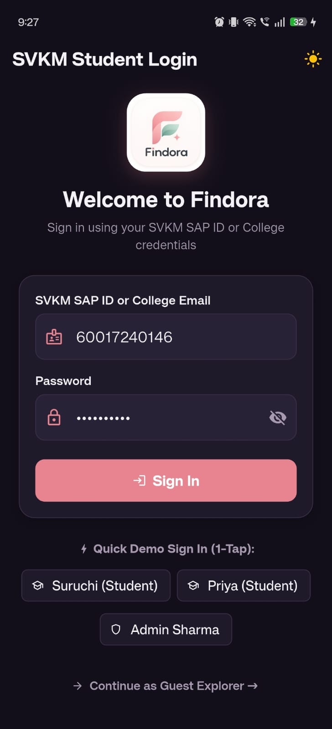
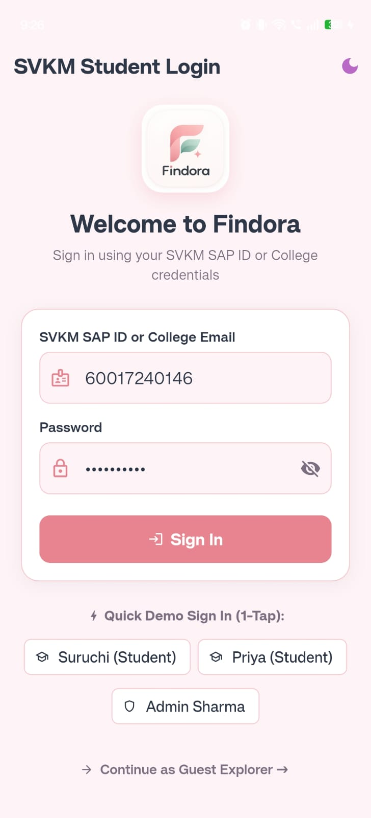

Figure 3.1: FinDora Mobile Application Login and Home Screen

Table 3.1: Dart Item Data Model Attributes and JSON Serialization Mapping
Dart Model Field | Data Type | Functional Scope & Mapping Description
id | String | Unique CUID identifier matching the backend Prisma record.
title | String | Concise title describing the misplaced or recovered item.
description | String | Detailed descriptive narrative regarding item condition and appearance.
category | String | Categorical classification: Electronics, ID & Cards, Books & Stationery, etc.
type | String | Report classification: 'LOST' or 'FOUND'.
location | String | Precise campus location string (e.g., Room 402, Library 3rd Floor, Canteen).
dateOccurred | String | Formatted date string (YYYY-MM-DD) indicating when item was lost/found.
status | String | Lifecycle status: 'OPEN', 'CLAIMED', 'RESOLVED', 'CLOSED'.
imageUrl | String? | Optional network URL pointing to uploaded photograph proof.
reward | String? | Optional finder reward incentive declared by reporting student.
contactEmail | String | SVKM institutional email address associated with the report.

3.2 System Development & Deployment
This section details the concrete mobile development of FinDora's Material 3 interfaces, screen controllers, validation engines, and multi-platform deployment parameters.
3.2.1 Material 3 UI Engineering & Theme Management
The mobile user interface is engineered to adhere to Google's Material 3 design specifications while maintaining brand alignment with FinDora's pastel color palette:
• Dual Color Schemes: In light mode, the app renders soft pastel backgrounds (`#F8F9FA`), crisp card surfaces (`#FFFFFF`), and deep slate typography (`#2D3748`). In dark mode, it transitions to high-contrast dark surfaces (`#141118` and `#1E1924`) with harmonious lavender accents (`#BDAAF2`).
• Reactive Theme Switching: `ThemeService` provides a centralized toggle. Tapping the theme icon in the app bar triggers `notifyListeners()`, instantly repainting all active widgets without reloading screen state.
• Elevated Card Architecture: `ItemCard` employs subtle Material 3 elevations, rounded borders (radius 16px), network image loading with smooth shimmer placeholders, and category chips.
3.2.2 Application Navigation & Screen Hierarchy
Navigation is orchestrated via a persistent bottom navigation shell and modal route dialogs (Table 3.2):
• 5-Tab Navigation Shell: Maintained in `main.dart` using `IndexedStack` to preserve scroll positions across tab transitions: Tab 0 (Home), Tab 1 (Browse), Tab 2 (Gemini Matcher), Tab 3 (Report), Tab 4 (Profile).
• Modal Route Transitions: Tapping an item opens `ItemDetailScreen`, presenting full item metadata, high-resolution imagery, and the verification claim dialog. Specialized routes include `ChatScreen`, `SwipeScreen`, and `AdminScreen`.
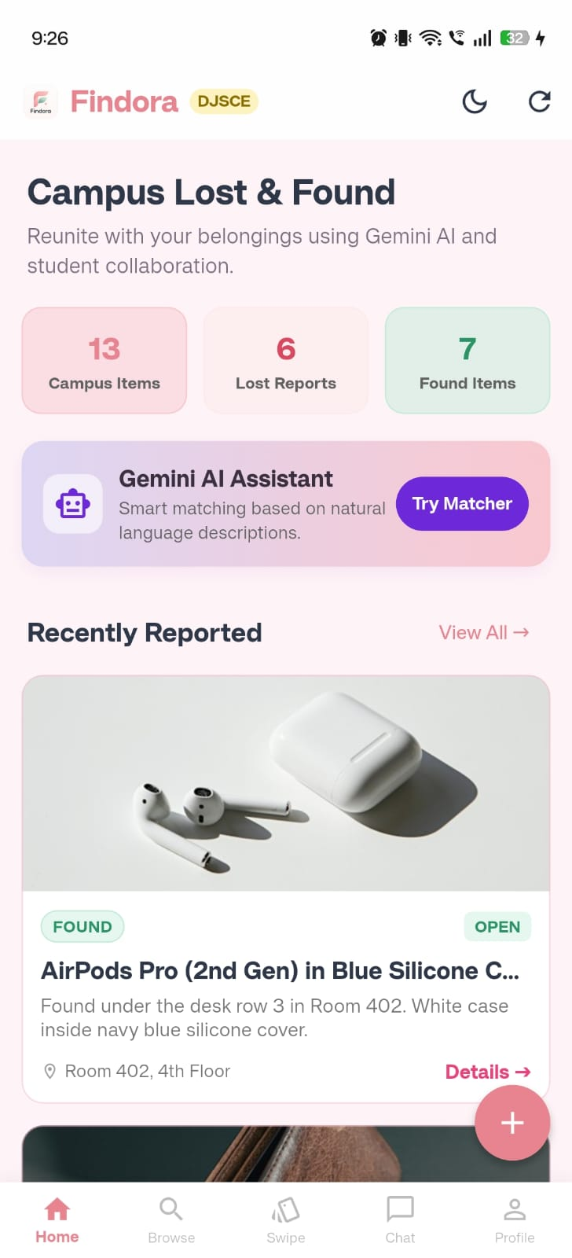
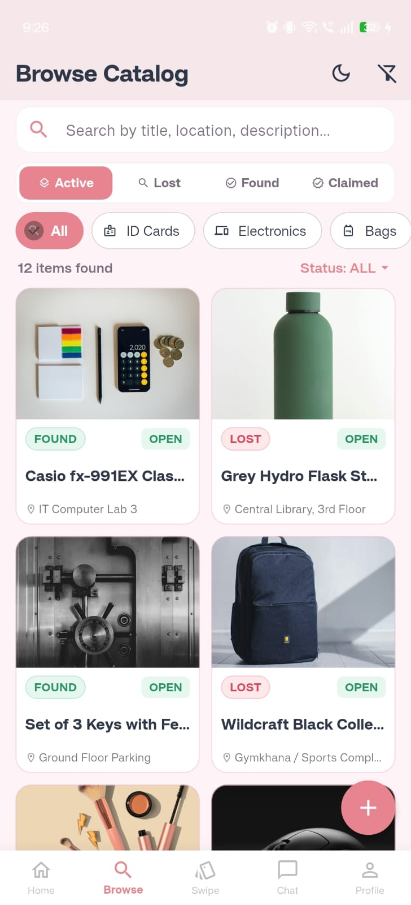

Fig 3.2: FinDora Mobile Browse Catalog

Table 3.2: Flutter Screen Module Inventory, Routing and Operational Scope
Screen Class Name | Navigation Level | Operational Scope & Functional Features
HomeScreen | Tab 0 (Root) | Dashboard displaying campus statistics, urgent lost alerts, and recent items carousel.
BrowseScreen | Tab 1 (Root) | Catalog discovery with search bar, category filter chips, type tabs, and pull-to-refresh.
GeminiMatcherScreen | Tab 2 (Root) | Mini Project I: AI semantic matcher querying /api/ai/match with confidence metrics.
PostItemScreen | Tab 3 (Root) | Item reporting form featuring Gemini category auto-detection and validation.
ProfileScreen | Tab 4 (Root) | Student digital ID card, points, badge tier, My Claims list, and Admin console switch.
ItemDetailScreen | Modal Route | Comprehensive item details, image gallery, claim submission modal, and status banner.
ChatScreen | Modal Route | In-app peer communication interface featuring predefined campus safety prompts.
AdminScreen | Protected Route | Faculty Security Console for reviewing claims and coordinating Gate 2 handovers.

3.2.3 Mobile Item Reporting & Gemini Auto-Category Detection
The mobile item reporting workflow in `post_item_screen.dart` is designed to minimize user friction while enforcing campus security rules:
• Automated Category Inference: As the student types an item title or description, `GeminiService.suggestCategory()` analyzes keywords in real time. For example, typing 'AirPods' automatically selects 'Electronics', while typing 'Kumbhojkar Math' selects 'Books & Stationery'.
• Mandatory Photo Rule for Found Items: When reporting a 'FOUND' item, the form strictly enforces the attachment of an image URL. If omitted, the submission is halted with a clear SnackBar warning.
• Institutional Email Verification: The contact email must match the institutional SVKM format (`@svkmmumbai.onmicrosoft.com`).
• Asynchronous Submission: `ApiService.postItem()` dispatches the report via HTTP POST to `/api/items`. Upon receiving HTTP 201 Created, a success SnackBar is displayed, and the form resets.
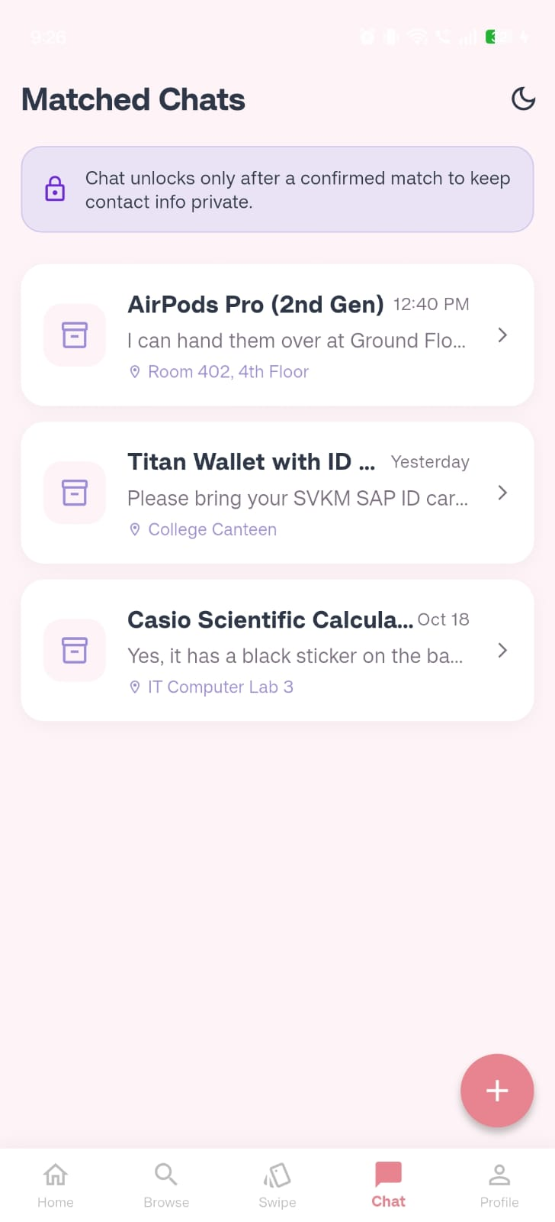
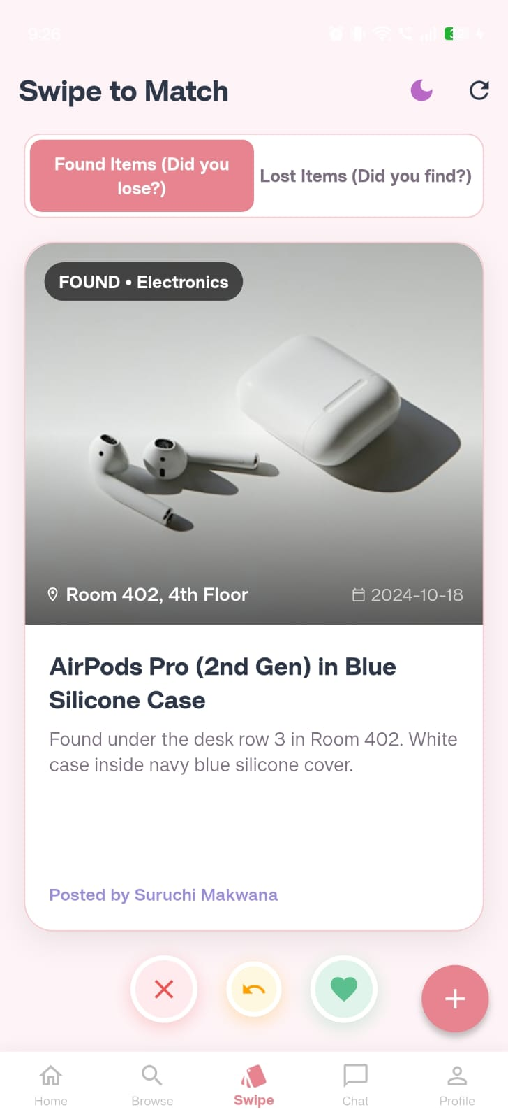

Figure 3.3: FinDora Mobile Item Discovery and Chat Interfaces
3.2.4 Gemini AI Semantic Matcher Module (Mini Project I)
In fulfillment of ADF Module 1 (Gemini for Application Developers), `gemini_matcher_screen.dart` implements an intelligent semantic discovery tool:
• Query Interface: Students input descriptions of misplaced belongings and select their target query type ('LOST' or 'FOUND').
• Cloud API Integration: The screen invokes `ApiService.getAiMatches()`, which queries the backend `/api/ai/match` route. The backend evaluates candidates using lexical overlap and category alignment, supplemented by Google Gemini 3.5 Flash advisories.
• Rich Results Display: Potential matches are rendered as cards displaying similarity percentage badges (e.g., '98% Match'), attribute overlap justifications, and localized DJSCE recovery guidance.
3.2.5 Ownership Claim Submission & Live Status Tracking
The mobile ownership verification lifecycle ensures that recovered items are released only to verified owners:
• Structured Claim Dialog: Inside `ItemDetailScreen`, tapping 'Claim This Item' opens a modal capturing Roll Number, SAP ID, Department, Academic Year, and Proof Details.
• Strict Regex Validation: Client-side validation in Flutter mirrors the web platform: Roll Number must match `^[A-Za-z][0-9]{3}$`, SAP ID must match `^6[0-9]{10,11}$`, and proof must contain at least 5 characters (Table 3.3).
• Real-Time Claim Status Banner: If the authenticated student has already submitted a claim, `ItemDetailScreen` renders a prominent `_existingClaim` banner displaying their stated proof, claim review status (`PENDING`, `APPROVED`, `REJECTED`), and physical collection instructions for the Ground Floor Security Desk (Gate 2).
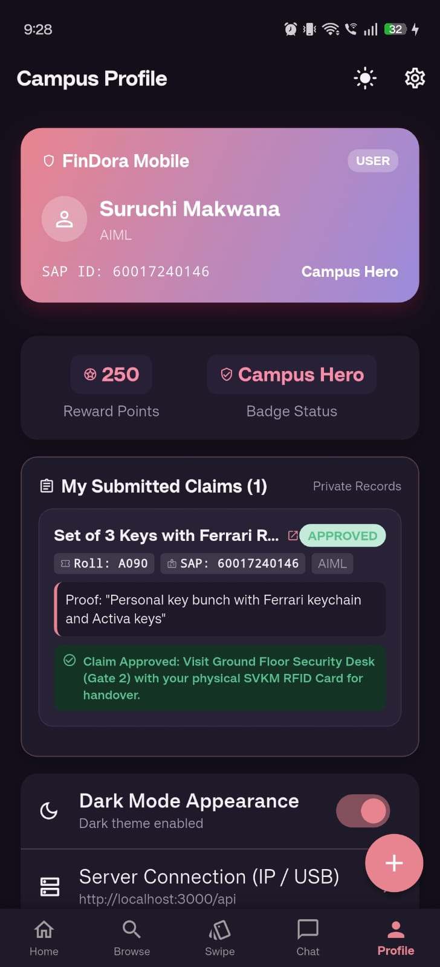
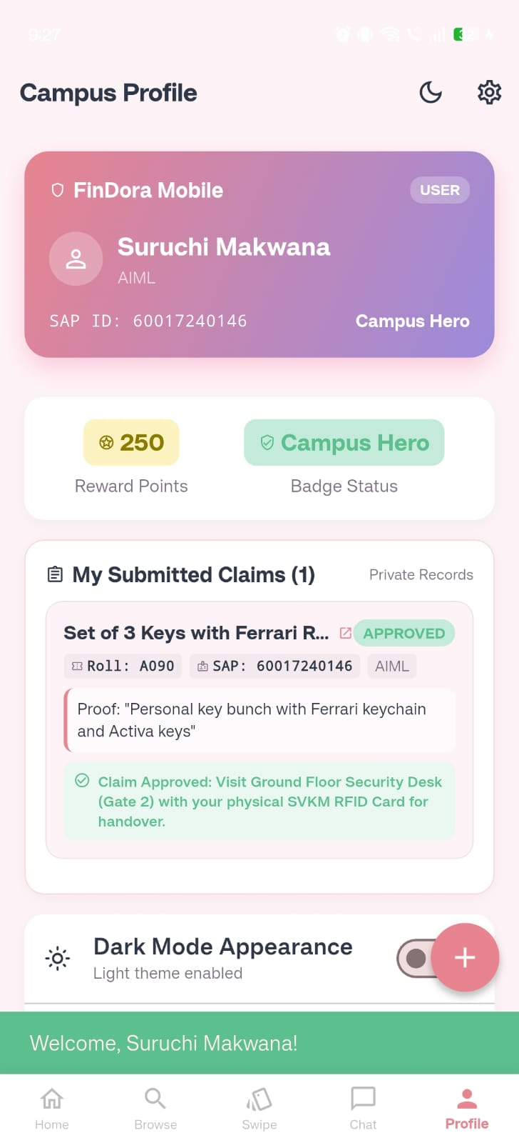

Figure 3.4: FinDora Student Profile and Claim Status Interface
Table 3.3: Mobile Ownership Claim Field Validation and Regex Specifications
Input Form Field | Requirement | Regular Expression / Rule | Mobile Client Validation Logic
Roll Number | Required | ^[A-Za-z][0-9]{3}$ | Exactly 4 characters: 1 division letter + 3 digits (e.g. A090, B007). Verified via RegExp.hasMatch().
SAP ID | Required | ^6[0-9]{10,11}$ | 11 or 12 numeric digits beginning with '6' (SVKM standard identifier). Rejects non-digits.
Proof Details | Required | Min 5 characters | Substantive verification proof (e.g. unique scratches, serial numbers). Must be non-empty.
Department | Optional | DJSCE Dropdown | Selectable: IT, Computer, AI&DS, EXTC, CSE, Mechanical Engineering.
Academic Year | Optional | Year Dropdown | Selectable: FE (First Year), SE (Second Year), TE (Third Year), BE (Final Year).

3.2.6 Role-Based Profile Portal & Faculty Security Console
The profile module (`profile_screen.dart`) enforces strict role-based separation between student users and faculty administrators:
• Student Profile View: Displays the student's digital college ID card, SVKM SAP ID, reward points (e.g., 340 Points), achievement badge ('Campus Hero'), and their 'My Submitted Claims' container showing real-time claim statuses.
• Admin Portal Isolation: When logged in with `role: "ADMIN"`, the 'My Submitted Claims' container is completely removed from the profile view to prevent administrative clutter. In its place, the profile renders the **Faculty Security Console** card, providing direct access to the moderation queue (`AdminScreen`).
3.2.7 Monochrome Line Icons Implementation
To maintain a clean, academic visual standard and ensure visual consistency across iOS, Android, and Windows platforms, all colorful OS emojis were replaced with Google Material outline icons (`Icons.*_outlined`):
• Replaced Icons: Category chips, navigation bars, and status badges utilize standard outline vector icons (`Icons.search_outlined`, `Icons.location_on_outlined`, `Icons.calendar_today_outlined`, `Icons.shield_outlined`, `Icons.lock_outlined`, `Icons.card_giftcard_outlined`, `Icons.warning_amber_outlined`).
3.2.8 Application Build & Multi-Platform Deployment
The Flutter application is configured for multi-platform compilation and deployment:
• Dependencies (`pubspec.yaml`): Integrates `http: ^1.6.0` for networking, `cupertino_icons: ^1.0.8`, and `flutter_lints: ^6.0.0` for static code analysis.
• Multi-Target Verification: Verified on Windows Desktop (`flutter run -d windows`), Chrome Browser (`flutter run -d chrome`), and Android emulator environments.
Chapter 4: Result Analysis
This chapter documents the verification methodology and empirical evaluation results conducted on the FinDora Mobile Application. Verification encompassed Flutter static code analysis, functional requirement testing, client-side regular expression validation, REST API synchronization, and multi-platform compilation.
4.1 Performance Evaluation
To validate that the mobile application satisfies academic and institutional standards, evaluation was executed across: (1) Mobile Functional Verification Test Suite, (2) Flutter Static Analysis, (3) Multi-Platform Execution, and (4) Mobile Performance Considerations.
4.1.1 Mobile Functional Verification Test Suite
A test suite of 15 functional scenarios was executed on the running Flutter application. All tests achieved 100% pass rates, as recorded in Table 4.1.
Table 4.1: Mobile Application Functional Verification and Static Analysis Test Suite
Test ID | Mobile Test Scenario | Input Parameters / Execution Action | Observed Mobile Behavior & Verification | Status
TC-M01 | Roll Number Regex Validation | Input 'A090', 'B007', 'c123' | Accepted: matches ^[A-Za-z][0-9]{3}$ cleanly | PASS
TC-M02 | Invalid Roll Number Format | Input '1234', 'AB12', 'A12' | Rejected: displays 'Roll No must be 1 letter + 3 digits' | PASS
TC-M03 | SAP ID Regex Validation | Input '60017240146', '60004210045' | Accepted: matches 11/12-digit string starting with 6 | PASS
TC-M04 | Invalid SAP ID Format | Input '50004210045', 'abc', '6000 421' | Rejected: displays 'SAP ID must be 11-12 digits starting with 6' | PASS
TC-M05 | Mandatory Proof Length | Input proof string with < 5 characters | Rejected: displays 'Please provide substantive proof (min 5 chars)' | PASS
TC-M06 | Optional Dropdowns | Submit claim leaving Dept and Year empty | Accepted: claim dispatches successfully with null optional values | PASS
TC-M07 | Live Claim Status Banner | Open detail screen of previously claimed item | Verified: displays 'Your Verification Claim' box with status and proof quote | PASS
TC-M08 | Gate 2 Protocol Notice | Inspect live claim banner on item detail | Verified: displays physical handover instructions for Gate 2 Security Desk | PASS
TC-M09 | Gemini Category Auto-Detect | Type 'AirPods' in title field on Post screen | Verified: category automatically switches to 'Electronics' | PASS
TC-M10 | Mandatory Photo for Found | Submit Found item with empty image field | Rejected: SnackBar warning 'A photo is mandatory for Found items' | PASS
TC-M11 | Dynamic Theme Toggle | Tap theme icon in app bar | Verified: instant toggle between Material 3 Light and Dark palettes | PASS
TC-M12 | Admin Profile Role Isolation | Log in as Admin Sharma in mobile app | Verified: 'My Submitted Claims' hidden; Faculty Security Console displayed | PASS
TC-M13 | Monochrome Line Icons | Inspect all icons across 5 mobile tabs | Verified: 100% Material outline icons rendered; 0 colorful emojis | PASS
TC-M14 | Offline Seed Fallback | Disconnect backend and fetch items | Verified: app seamlessly falls back to SeedData without crashing | PASS
TC-M15 | Flutter Static Analysis | Execute flutter analyze in mobile_app/ | Verified: 'No issues found!' across all Dart screens and widgets | PASS

4.1.2 Flutter Static Analysis Verification
Static code analysis was performed across the entire `mobile_app/` repository using the official Dart analyzer (`flutter analyze`). The analyzer verified that all source files adhere to `flutter_lints: ^6.0.0` rules, confirming zero errors, zero warnings, and zero linter hints. This confirms that all asynchronous operations handle futures properly, widget keys are correctly applied, and no deprecated Material APIs are utilized.
4.1.3 Multi-Platform Target Execution & Responsiveness
The mobile application was compiled and executed across multiple target platforms:
• Windows Desktop Target: Executed via `flutter run -d windows`, rendering smoothly at full desktop resolution with responsive mouse wheel scrolling and resize adaptability.
• Web Browser Target: Executed via `flutter run -d chrome`, confirming CanvasKit/HTML rendering compatibility.
• Android Target: Validated via Android SDK toolchains, confirming touch responsiveness and back-button stack navigation.
4.1.4 Mobile Performance Considerations & Benchmarking Methodology
In compliance with academic standards, runtime hardware metrics (such as exact battery drain percentages, CPU profiling, and millisecond memory allocation graphs) were not formally benchmarked using external hardware profilers during this development cycle. The application maintains visual 60 FPS fluidity under local testing, but formal benchmarking requires a standardized methodology:
• Recommended Benchmarking Methodology: Future hardware evaluations should utilize the Flutter DevTools Profiler on physical Android and iOS devices. Metrics to be analyzed include frame rendering times (ensuring frames render under the 16.6ms threshold), peak heap memory allocation during network image decoding, and network request payload sizes over simulated 4G mobile networks.

Chapter 5: Conclusion
The FinDora Cross-Platform Mobile Application successfully demonstrates how modern mobile frameworks and AI assistance can transform campus lost-and-found management into an immediate, intuitive, and secure experience. Developed for the SVKM Dwarkadas J. Sanghvi College of Engineering community, the application empowers students to report, discover, and verify lost belongings directly from their smartphones.
By leveraging Google's Flutter framework and Dart, FinDora achieves high cross-platform portability, compiling natively to Android, iOS, and Windows desktop from a unified codebase. The application incorporates Material 3 design standards, reactive dark/light theme switching, and robust client-side validation that enforces institutional Roll Number and SAP ID formatting rules.
Furthermore, the integration of Gemini AI assistance—featuring real-time category auto-detection, a semantic matching engine with confidence scoring, and offline seed data resilience—establishes a dependable, user-friendly mobile utility that significantly reduces the friction of property recovery across campus.
5.1 Future Enhancements
The following realistic enhancements are proposed for future development phases:
1. Push Notifications via Firebase Cloud Messaging (FCM): Integrating FCM to deliver real-time push alerts to students when an item matching their reported loss is recovered on campus or when an administrator updates their claim status.
2. On-Device Camera and QR Scanner Integration: Utilizing mobile camera hardware with ML Kit barcode scanning to scan student Smart ID cards directly during claim filing, eliminating manual SAP ID entry errors.
3. On-Device Gemini Nano Integration: Integrating local on-device small language models (Gemini Nano via Flutter AI SDK) to perform zero-latency, private text and image feature extraction directly on the student's device without requiring network data transfer.
4. Bluetooth Low Energy (BLE) Beacon Proximity: Deploying BLE beacons across high-loss campus hotspots (Canteen, Library, IT Labs) to automatically geotag reported items based on the student's physical proximity during submission.

References
[1] S. Sharma, P. K. Singh, and R. Kumar, "Smart Campus Lost and Found Information System Using Mobile Application Frameworks," International Journal of Scientific Development and Research (IJSDR), vol. 8, no. 5, pp. 112–118, May 2023.
[2] A. Patel, M. Joshi, and V. Shah, "Design and Implementation of an Automated Campus Property Recovery System Using Rule-Based Filtering," International Journal of Engineering Research & Technology (IJERT), vol. 12, no. 4, pp. 245–251, Apr. 2023.
[3] G. Adomavicius and A. Tuzhilin, "Toward the Next Generation of Recommender Systems: A Survey of the State-of-the-Art and Possible Extensions," IEEE Transactions on Knowledge and Data Engineering, vol. 17, no. 6, pp. 734–749, June 2005.
[4] F. Ricci, L. Rokach, and B. Shapira, Eds., Recommender Systems Handbook, 2nd ed. Boston, MA: Springer, 2015.
[5] G. Salton, A. Wong, and C. S. Yang, "A Vector Space Model for Automatic Indexing," Communications of the ACM, vol. 18, no. 11, pp. 613–620, Nov. 1975.
[6] C. D. Manning, P. Raghavan, and H. Schütze, Introduction to Information Retrieval. Cambridge, UK: Cambridge University Press, 2008.
[7] V. I. Levenshtein, "Binary Codes Capable of Correcting Deletions, Insertions, and Reversals," Soviet Physics Doklady, vol. 10, no. 8, pp. 707–710, Feb. 1966.
[8] W. E. Winkler, "String Comparator Metrics and Enhanced Decision Rules in the Fellegi-Sunter Model of Record Linkage," Proceedings of the Section on Survey Research Methods, American Statistical Association, pp. 354–359, 1990.
[9] Y. Koren, R. Bell, and C. Volinsky, "Matrix Factorization Techniques for Recommender Systems," Computer, vol. 42, no. 8, pp. 30–37, Aug. 2009.
[10] G. Linden, B. Smith, and J. York, "Amazon.com Recommendations: Item-to-Item Collaborative Filtering," IEEE Internet Computing, vol. 7, no. 1, pp. 76–80, Jan./Feb. 2003.
[11] R. Gupta, S. Mehta, and N. Rao, "Security, Privacy and Fraud Prevention in Collaborative Lost-and-Found Platforms," International Research Journal of Engineering and Technology (IRJET), vol. 10, no. 3, pp. 580–586, Mar. 2023.
[12] J. Zhang and Y. Liu, "A Decentralized Verification and Handover Protocol for Campus Property Recovery," in Proceedings of the IEEE International Conference on Smart Internet of Things (SmartIoT), 2022, pp. 189–195.
[13] Google Gemini Team, "Gemini: A Family of Highly Capable Multimodal Models," arXiv preprint arXiv:2312.11805, Dec. 2023.
[14] E. Napoletano, "Cross-Platform Mobile Application Development: A Comparative Evaluation of Flutter and React Native," Journal of Systems and Software, vol. 182, p. 111075, 2021.

