Clinical, Laboratory, and Pharmacological Predictors of Adverse Drug Reactions: Insights from Machine Learning Models.
Name: Trevor Mukuve
Student number:2414222
Supervisor: Noroozi Amin

Table of Contents
- Abstract
- Introduction
  - Literature Review
  - Aims and Objectives
- Methodology
  - Data source and Study Design
  - Data Preparation and Preprocessing
  - Data loading & initial inspection
  - Feature selection
  - Train-test split
  - Model structure
  - Model Evaluation Strategy
  - Model Explainability
- Implementation
  - Implementation overview
  - Model training
  - Prediction on Unseen Data
- Results
  - Classification Performance
  - Confusion Matrix Analysis
  - Comparative Model Performance
  - Receiver Operating Characteristic (ROC) Analysis
  - Explainability of Results
- Discussion
  - Clinical Implications
- Conclusions Recommendations
  - Conclusions
  - Recommendations for future research
- References
- Appendix
Keywords: Adverse Drug Reaction (ADR), Classification, Logistic Regression, ROC-AUC, Machine Learning, SVC, Classification Report, Confusion Matrix

- Abstract
Adverse drug reactions (ADRs) are a major cause of preventable patient harm and prolonged hospitalisation. In clinical decision-support systems, the ability to accurately identify patients at risk of an ADR is essential to reduce unnecessary alerts, minimise alarm fatigue, and allocate clinical resources appropriately. This study aims to evaluate interpretable machine learning models for ADR prediction using routinely collected clinical, laboratory, and pharmacological data from a group of hospitalised patients.
Using a retrospective dataset from a Brazilian tertiary hospital cohort, Logistic Regression (LR) and Support Vector Classification (SVC) models were developed with cost-sensitive learning to address class imbalance. Precision, accuracy, recall, F1-score, and confusion matrix analysis, were assessed for model performance with emphasis on recall for the ADR class (class 1) to assess how reliable it is at ruling out ADR risks.
The SVC model achieved a class 1 recall of 0.66, correctly identifying 47 ADR cases, with an overall accuracy of 0.64. Logistic Regression achieved a class 1 recall of 0.60, correctly identifying 41 non-ADR cases, with an overall accuracy of 0.62. While both models demonstrated moderate predictive performance, the SVC model showed slightly improved reliability in identifying low-risk patients, highlighting important differences in error profiles that accuracy alone can miss.
Permutation-based feature importance and SHAP analysis indicated that medication burden, renal dysfunction markers, comorbidity burden, and key laboratory abnormalities were the strongest contributors to ADR risk; this is consistent with established clinical evidence. Overall, the findings demonstrate that interpretable machine learning models can support ADR risk stratification that is clinically meaningful, specifically by identifying patients who are likely to experience adverse drug reactions.
- Introduction
Adverse drug reactions (ADRs) are involuntary, harmful impacts associated with the consumption of medicines. They are a major cause of mortality, morbidity, and hospital costs; in addition, they pose significant risks and account for about 8.4% of hospital admissions (Coleman and Pontefract, 2016; Montané and Santesmases, 2020). Studies also show that 45% of ADR-related hospital admissions are preventable, indicating a large proportion of avoidable medication-related harm (Osanlou et al., 2022). They further indicate that adverse drug reactions cause roughly 6–7% of unplanned hospital stays, with many leading to extended hospitalisation, though patient harm was preventable (Pirmohamed et al., 2004).
Many studies have shown that patients in hospitals experiencing ADRs experience increased morbidity and health deterioration, which often leads to additional diagnostic tests and therapeutic interventions. In the event of severe ADRs, there is increased mortality risk, particularly among the elderly and patients with multiple comorbidities (Suh et al., 2000; Laroche et al., 2025). Older adults are disproportionately affected by ADRs due to polypharmacy, age-related physiological changes, and comorbidities, making them a high-priority population for predictive risk-stratification approaches (Zazzara et al., 2021)
Older patients are more susceptible to ADRs due to age-related changes in their pharmacokinetics and pharmacodynamics. This can stem from their reduced renal function, which decreases drug clearance and leads to the risk of accumulation and toxicity of the drug within their body, at the same time, impaired physiological homeostasis can exaggerate drug responses and limit compensatory mechanisms, worsening side effects like that of postural hypotension (Bellanca et al., 2023; Laville et al., 2024; Osanlou et al., 2022b). In addition, polypharmacy increases the risk of ADRs when the number of medications used together increases, causing an increase in drug-drug interactions (DDIs), which further heighten the potential for harmful effects when multiple drugs are combined (Westerink et al., 2023). This can also be seen in medication changes during hospitalisation, which add to the risk of ADRs and complicate prescribing and monitoring (Karuppannan et al., 2022).
When it comes to healthcare-related costs, ADR-related costs are high, stemming from extended bed occupancy, additional investigations, and escalated care levels. As previously mentioned, ADRs lead to increased patient harm but also longer hospital stays and higher expenses, often driven by preventable use of antibiotics or cardiovascular drugs (Suh et al., 2000). ADR-related hospitalisations strain public health systems worldwide because they cause inefficient resource use. Preventing ADRs offers a major opportunity for cost savings, highlighting the magnitude of early detection and interference (Karuppannan et al., 2022).
Many drugs have side effects and DDIs that can range from mild to severe, and these can be influenced by multiple factors, making it complex to assess with the naked eye (Quik et al., 2025). Therefore, machine learning can be beneficial for addressing this issue more effectively. Early detection of risks allows for proactive medication review, allowing doses to be adjusted and enhanced monitoring to be implemented prior to severe and dangerous side effects occurring (Laroche et al., 2025). Data science and machine learning algorithms have demonstrated high predictive performance for ADR risk, enabling precise collection and management of clinical data conclusions to aid in predicting side effects earlier and save patients from potential harm and eventual death (He et al., 2025).
  - Literature Review
In more recent years, Machine learning (ML) has been applied in healthcare to improve risk prediction, decision support, and patient safety, including the detection of ADRs at increasing amounts. Early reviews, such as a study done by Miotto et al. (2017), highlighted the potential of ML models to integrate various clinical data and uncover complex patterns that traditional statistical approaches struggle to capture. Though they emphasised key limitations, including data quality issues, model interpretability, and the difficulty of translating predictive performance into clinical utility.
These challenges are also relevant in pharmacovigilance, where model-informed decisions may directly impact patient safety. Traditional pharmacovigilance systems, such as spontaneous reporting databases, are limited by common errors, including under-reporting, reporting bias, and delayed signal detection, which leads to reduced effectiveness for real-time clinical risk prediction (Inácio et al., 2017). Quantitative signal-detection methods that are applied to spontaneous reporting systems have improved post-marketing surveillance but remain mostly retrospective and are not designed to support patient-level risk prediction at the point of care (Bate and Evans, 2009). More recent reviews reinforce these early observations, observing that although machine learning enables the integration of diverse clinical data streams, its real-world impact remains limited by fragmented data sources, inconsistent outcome definitions, and limited clinical validation (Kim et al., 2022).
Recent systematic reviews of ML applications in pharmacovigilance indicate that ML-based models perform better than traditional statistical approaches for ADR prediction, this is seen particularly when applied to structured electronic health record (EHR) data (Pilipiec et al., 2022). A systematic review and meta-analysis by Hu et al. (2024) found that ML-based approaches often achieve higher discrimination than traditional logistic regression. Despite these improvements, the authors noted substantial heterogeneity across studies in terms of datasets. Studies using routinely collected EHR data have shown that incorporating laboratory and medication-related variables can improve ADR prediction performance, although generalisability remains dependent on dataset characteristics and validation strategy (Hu et al., 2024).
This unpredictability limits comparison between models, which raises concerns about reproducibility and generalisability. As previously discussed, reliance on global performance metrics limits clinical interpretability, often leading to a lack of consideration in regard to class imbalance and the asymmetric clinical consequences of misclassification, specifically false negatives in ADR detection. Similar concerns are reiterated across multiple systematic reviews, which report that external validation is performed in only a minority of studies and that sensitivity-oriented metrics are rarely prioritised, even though they are clearly relevant to patient safety and harm prevention (Dsouza et al., 2025; Kim et al., 2022). Together, these limitations highlight the need for evaluation strategies that prioritise clinically meaningful metrics, such as recall and sensitivity, rather than relying solely on aggregate performance measures. This consideration directly affects the evaluation framework adopted in the present study.
Several studies have sought to address the rarity of ADRs by using ensemble models or complex architectures. Zhao et al. (2022) showed that combining feature selection with ensemble classifiers improved the detection of rare ADRs in pharmacovigilance databases. While such approaches can increase predictive performance, they often come at the cost of interpretability. Hospital-based studies applying machine learning classifiers to ADR prediction have reported improved sensitivity compared with conventional methods, but often there is a cost of reduced interpretability and limitations in the clinical adoption (Nwokedi et al., 2025).
In clinical settings, a lack of transparency may hinder the trust, acceptance, and regulatory approval. This trade-off between performance and explainability remains a central challenge in applying ML to drug safety, when model outputs are intended to inform clinical decision-making rather than retrospective signal detection. This challenge is further amplified in studies exploring deep learning or hybrid architectures, they often report improved discrimination but provide limited insight into feature–outcome relationships, making clinical interpretation and regulatory use difficult (Khemani et al., 2025). As a result, performance gains may not translate into actionable decision support within hospital settings. The compromise between predictive performance and explainability underscores the importance of systematically comparing interpretable baseline models with more complex classifiers rather than assuming that increased model complexity necessarily leads to clinical improvements (Zhang et al., 2021).
Clinical risk-score–based approaches offer an alternative perspective. Lima et al. (2020) developed a validated ADR risk prediction tool using demographic, clinical, and pharmacological variables from hospitalised patients. The depth of this approach lies in its transparency and capability to be interpreted clinically, which facilitates potential adoption in routine care. However, the scoring system relies on predefined linear relationships and fixed weights, which hinder its ability to model any nonlinear interactions among predictors such as polypharmacy, comorbidity burden, and laboratory abnormalities. As patient complexity increases, among elderly and multimorbid populations, these restrictions may reduce predictive accuracy and adaptability across different clinical contexts. Comparative analyses suggest that while clinical risk scores offer transparency and ease of use, they are often outperformed by machine learning models in heterogeneous hospital populations. This highlights a balance between interpretability and adaptability rather than a simple superiority of one approach over another (Zhang et al., 2021).
More recent research has increasingly focused on explainable artificial intelligence (XAI) to bridge the gap between predictive performance and use in clinical settings. Techniques such as SHapley Additive exPlanations (SHAP) and Local Interpretable Model-agnostic Explanations (LIME) have been proposed to elevate transparency by quantifying feature contributions to individual predictions (Lundberg and Lee, 2017). Studies applying these methods to ADR prediction have shown that explainability tools can identify clinically acceptable risk factors, such as medication burden or renal impairment, thereby increasing clinician trust.
Nevertheless, many studies treat explainability as an add-on rather than integrating it systematically into model evaluation and interpretation. Furthermore, explanations derived from SHAP remain relevant and do not imply causality, a limitation that is sometimes undermined in the literature. Recent work in explainable pharmacovigilance further cautions that feature attribution methods may vary substantially across models and datasets, emphasising the importance of using explainability not as a post-hoc visual aid, but as an integral component of model evaluation and clinical reasoning (Ward et al., 2021). This perspective motivated the use of SHAP-based analysis alongside performance benchmarking seen in the study by Lundberg and Lee, 2017.
Despite the growing interest in ML-based ADR prediction, several gaps remain. First, many studies rely on single performance metrics, such as accuracy or ROC–AUC, without aligning evaluation strategies with clinical priorities. In pharmacovigilance, missing an ADR can have more severe consequences than generating false alerts, suggesting that we should prioritise recall and sensitivity. Secondly, comparisons between interpretable baseline models and more complex classifiers are often limited, making it difficult to assess whether performance gains can justify the reduced transparency. Third, reproducibility remains a concern, as methodological details such as preprocessing steps, handling of missing data, and class imbalance strategies are inconsistently reported. In addition, few studies clearly benchmark interpretable linear models against margin-based or nonlinear classifiers using the same dataset and evaluation framework, which limits insight into whether increased model complexity offers clinically meaningful benefits over simpler, more transparent approaches (Dsouza et al., 2025).
In summary, the existing literature shows that machine learning can enhance ADR prediction but also highlights persistent challenges with interpretability, reproducibility, and clinical relevance. There is a clear need for studies that systematically compare interpretable and margin-based ML models using structured hospital data, use of evaluation metrics that align with patient safety, and integrate explainability techniques to contextualise predictions within established pharmacological knowledge. Addressing these challenges requires not only improved predictive performance but also transparent model behaviour, reproducible workflows, and evaluation strategies that account for the asymmetric risks inherent in medication safety.
This study addresses these gaps by benchmarking Logistic Regression and Support Vector Classification models on real-world inpatient data, prioritising clinically meaningful evaluation metrics, and applying SHAP-based interpretation to support transparent and trustworthy ADR risk prediction.
  - Aims and Objectives
The primary aim of this study is to determine whether machine learning models can accurately predict the risk of adverse drug reactions (ADRs) in hospitalised patients using routinely collected demographic, clinical, laboratory, and pharmacological data. To achieve this, the objectives addressed in this study are as follows:
- To preprocess and curate structured hospital datasets to ensure analytical robustness and clinical relevance.
- Develop and benchmark interpretable machine learning models, specifically Logistic Regression and Support Vector Machines, to assess if they are suitable for ADR risk prediction.
- To evaluate model performance using standard classification metrics, including accuracy, precision, recall, F1-score, and the area under the receiver operating characteristic curve (ROC-AUC). This is done with particular attention to clinically meaningful trade-offs between sensitivity and specificity.
- To apply explainability methods, including SHAP values, to identify the most influential clinical, laboratory, and pharmacological predictors of ADR occurrence.
- Then compare the predictive performance and interpretability of the machine learning models with the established clinical ADR risk score proposed by Lima et al. (2020).
- Finally, assess the feasibility of integrating machine-learning-based ADR risk predictions into clinical decision-support systems, with attention to both technical feasibility and practical relevance in real-world hospital settings.

- Methodology
  - Data source and Study Design
This study utilised a secondary analysis of a hospital-based dataset conducted at Onfore Lopes University Hospital in Natal, Brazil (Lima et al., 2020). The dataset comprises of patients admitted to a 247-bed hospital between 2016 and December 2017. Ethical approval for the original data collection was granted by the Research Ethics Committee of the Federal University of Rio Grande do Norte (CAAE 34282914.0.0000.5992), and all patient records were anonymised prior to analysis. As this study involved secondary analysis of fully anonymised data, as stated above, ethical approval was not required.
The inclusion criteria comprised adult patients aged 18 years or older, while exclusions included hospital stays longer than 24 hours, admission due to an adverse drug reaction, fewer than 1 prescribed medication, intensive care unit admission, pregnancy, transplantation, or chemotherapy. Repeated admissions for the same individual were identified using a unique lifelong patient identifier and excluded to ensure independence of observations.
  - Data Preparation and Preprocessing
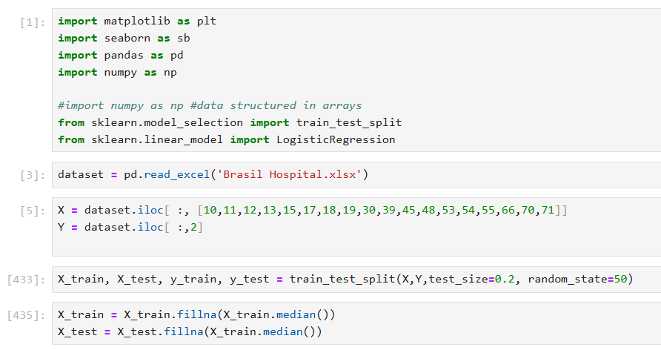
The data was downloaded and imported into Python, and the structure, completeness, and variable consistency were inspected. As shown in Figure 1, libraries such as pandas and NumPy for visualisations were used where applicable, and explicitly used ‘pd.read_excel’ to extract the Excel sheet into Python. The code used is seen in Figure 1.
Figure 1:Preprocessing and the data workflow used in this study. The code shows feature selection from the hospital dataset, train-test splitting (80/20), and median workflow applied to handling missing values, with statistics used derived from the training set and consistently applied to both training and test data to prevent data leakage.
Features irrelevant to the research question (e.g. patient number, ICD-10 chapter, days since admission) were removed to reduce interference, as shown in prior ADR modelling studies, and improve predictive signal (Wolff et al., 2023a; Wu et al., 2025). Missing values were handled using median attribution, with imputation statistics calculated from the training dataset and applied to both the training and test sets to prevent data leakage. Median imputation was selected for its resistance to outliers and appropriateness for skewed clinical laboratory data, such as creatinine, sodium, and urea levels. Following imputation, all predictors contained complete values and were compatible with machine-learning algorithms, as shown Appendix 1.
  - Data loading & initial inspection
As shown in Figure 1, the dataset was loaded into Python using pandas.read_excel, creating a DataFrame for systematic analysis of diverse clinical and laboratory variables. After importing the file, the dataset was reviewed by displaying the first rows, examining the number of records and variables, and summarising key statistics to understand its structure and detect issues such as missing data or inconsistent codes. This initial review exposed common real-world health data challenges: incomplete values, redundant columns, and inconsistent coding, consistent with problems frequently noted in ADR detection studies. (Ghosh et al., 2024; Mongkhonmath et al., 2025; Sommer et al., 2024).
  - Feature selection
The outcome variable was defined as the occurrence of an ADR during hospitalisation (0 = no ADR, 1 = ADR), coded as the “Case” variable in the provided data. Predictor variables were selected based on clinical relevance or prior evidence from the ADR prediction literature. This included demographic factors (age, sex); clinical characteristics (comorbidities); laboratory values (renal disease, urea [mg/dl]); and pharmacological variables (number of medications, number of ATCc drugs).
This feature selection strategy aligns with prior hospital-based ADR prediction studies, which demonstrate that combining clinical laboratory and pharmacological predictors improves risk stratification and model performance (Wu et al., 2025).
  - Train-test split
The dataset was randomly split into a training set (80% labelled trainX) and an independent test set (20% labelled TestY) using the code shown in Figure 2. Stratified sampling was used to maintain the proportions of ADR and non-ADR cases across both subsets, which is essential given the class imbalance in ADR data. The training set was used for model fitting and hyperparameter tuning, while the test set was reserved for final evaluation performance.
To tackle class imbalance during model training, class weighting was applied to penalise misclassifying ADR cases more heavily, thereby improving sensitivity to rare adverse events.
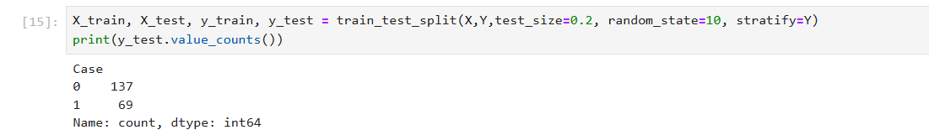
Figure 2: This figure shows the train-test split and the stratification explained above.

  - Model Structure
Two supervised machine learning models were used: logistic regression (LR), shown in Figure 3. Logistic regression was selected as a transparent and well-established baseline model widely used in clinical prediction tasks (Dsouza et al., 2025b, ￼. Its interpretability and robustness make it suitable for structuring clinical laboratory data and allow direct inspection of predictor-outcome relationships.
Support Vector Classification was selected to enable comparison with a margin-based classifier capable of modelling more complex boundaries. A linear Kernel was used to preserve interpretability and computational efficiency while maintaining strong performance in high-dimensional clinical datasets. For both models, class weighting was applied to mitigate outcome imbalance, and probability estimates were enabled to support threshold-independent evaluation via receiver operating characteristic (ROC) analysis.
The model was tuned with:
- class_weight = 'balanced'
- Kernel = “linear”
- Probability = “True”

  - Model Evaluation Strategy
Model predictions (on LR and SVC) were generated on an independent test dataset using trained classifier. These predicted class variables were compared against the true output variables to evaluate model performance. Classification evaluateion metrics, including precision, recall, F-1score, and class support were computed using the classification_report function from the scikit-learn library. Furthermore, confusion matrices were produced using the confusion_matrix function to display the distribution of TP, TN, FP and FN across classes. All evaluation metrics were calculated exclusively on the independent test set to ensure an unbiased assessment of model performance. The evaluation focussed on performance for the ADR class(Class 1) to reflect the clinical importance of identifying patients at risk of ADRs.
Model performance was evaluated using a range of entry-dependent and entry-independent metrics to highlight the clinical priorities of ADR detection. Entry-independent metrics included precision, recall, F1-score, accuracy, and confusion matrices, with a specific focus on recall for ADR cases (Case 1) due to the critical cost of missed adverse events. Entry-independent performance was analysed using ROC-AUC, providing a reciprocal measure of overall discrimination via decision thresholds.

  - Model Explainability
To improve transparency and clinical interpretability, post hoc feature attribution was performed using SHAP. SHAP provides a game-theoretic framework for quantifying the contribution of individual predictors to model predictions at both global and local levels. Global feature importance was assessed using SHAP summary plots, which rank predictors by their average contribution to ADR risk and indicate the direction and magnitude of their effects.
Explainability analysis was used to contextualise model outputs in relation to established pharmacological and clinical risk factors. It is acknowledged that SHAP-derived explanations are associative rather than causal; however, they provide insight into model behaviour and support clinically informed interpretation of the predictors.

- Implementation
  - Implementation Overview
Model development and evaluation followed a structured, reproducible machine learning approach informed by best practices in pharmacovigilance research (Wolff et al., 2023; Farnoush et al., 2024). The implementation included dataset preparation, model training, prediction on unseen data, performance evaluation using clinically relevant metrics, and post hoc explainability analysis. All analyses were conducted using Python-based data science libraries, including Jupyter Notebook, pandas, NumPy, and scikit-learn, to ensure reproducibility consistent with ADR prediction studies (Jiao et al., 2024).
  - Model Training
Both LR and SVC models were trained on the pre-processed training dataset, with class-balanced outcome imbalance. Model hyperparameters were configured to optimise stability, interpretability, and sensitivity to rare ADR cases. Training was performed exclusively on the training subset to prevent information leakage and ensure unbiased evaluation.
  - Prediction on Unseen Data
Following training, each model generated a prediction on the independent test dataset. These predictions formed the basis for subsequent performance evaluation, including classification metrics, confusion matrix analysis, and receiver operating characteristic (ROC) evaluation.

- Results
  - Classification Performance
The classification performance of LR and SVC for ADR prediction on the independent test dataset is presented in Tables 1 and 2. Both models showed moderate predictive performance. SVC achieved higher recall and F1-score for ADR cases than LR, indicating improved sensitivity for ADR detection under class imbalance.
Table 1: Table showing LR classification report.
Class | Precision | Recall | F1-score | Support
0 – no ADR | 0.80 | 0.72 | 0.76 | 137
1 – ADR | 0.54 | 0.64 | 0.58 | 69
Accuracy |  | 0.69 |  | 206

Class | Precision | Recall | F1-score | Support
0 – no ADR | 0.81 | 0.74 | 0.78 | 137
1 – ADR | 0.56 | 0.65 | 0.60 | 69
Accuracy |  | 0.71
Table 2: SVC classification report

  - Confusion Matrix Analysis
The confusion matrices for LR and SVC are shown in Figure 3 and Figure 4: Confusion matrix for the Support Vector Classifier, highlighting improved ADR case detection compared with Logistic Regression. : Confusion Matrix for the Logistic Regression model illustrating true and false classifications for ADR detection on the test dataset.. As illustrated, both models prioritised identifying ADR cases through class-balanced learning. The SVC identified a slightly higher proportion of ADR cases, accompanied by a modest increase in false-positive predictions. This pattern reflects a sensitivity-oriented classification strategy aligned with patient safety priorities in ADR detection (Van Dung et al., 2025a).
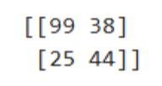
Figure 3: Confusion Matrix for the Logistic Regression model illustrating true and false classifications for ADR detection on the test dataset.
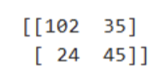
Figure 4: Confusion matrix for the Support Vector Classifier, highlighting improved ADR case detection compared with Logistic Regression.
  - Comparative Model Performance
A comparative summary of model performance across clinically relevant metrics is provided in Table 4. As shown, the SVC outperformed LR in recall and F1-score for ADR cases and achieved marginally higher overall accuracy. These results indicate that the SVC offers improved sensitivity for ADR without loss of specificity
Table 4: Comparative performance of LR and SVC across clinically relevant evaluation metrics for ADR prediction.

Metric (1= ADR) | Logistic Regression | SVC(Best)
ADR Precision | 0.54 | 0.56
ADR Recall | 0.64 | 0.65
ADR F1-score | 0.58 | 0.60
Accuracy | 0.69 | 0.71

  - Receiver Operating Characteristic (ROC) Analysis
The ROC curves for the models are shown in Figures 10 and 11. LR and SVC achieved similar ROC-AUC scores (0.713 and 0.711), indicating comparable discrimination across the decision thresholds. Despite similar global discriminative ability, threshold-dependent metrics showed differences in clinical performance, with the SVC achieving higher recall and F1-score for ADR cases.
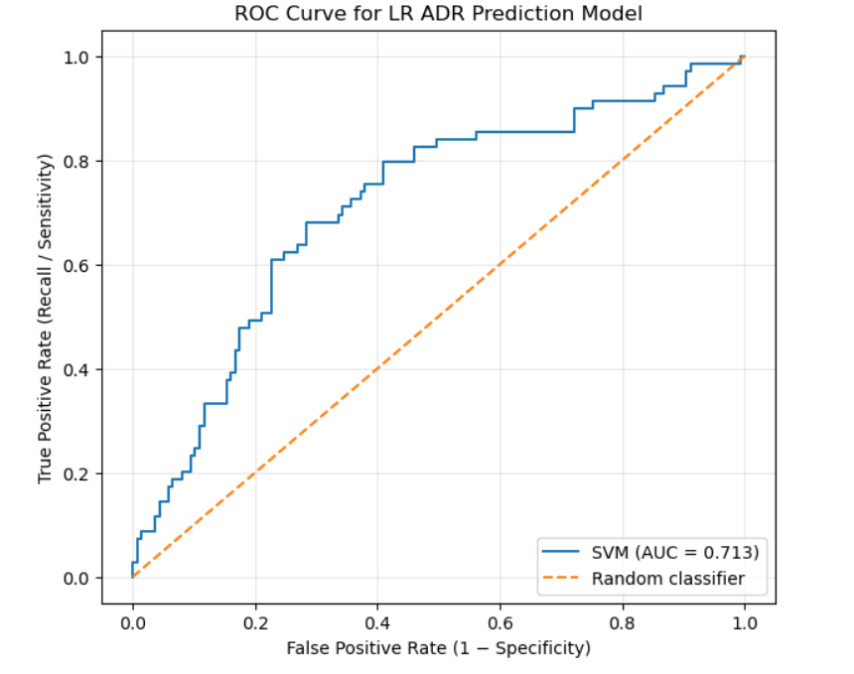
Figure 5:Receiver operating characteristic (ROC) curve for the Logistic Regression ADR prediction model evaluated on the independent test set (ROC–AUC = 713), demonstrating comparable global discrimination to the SVC model.
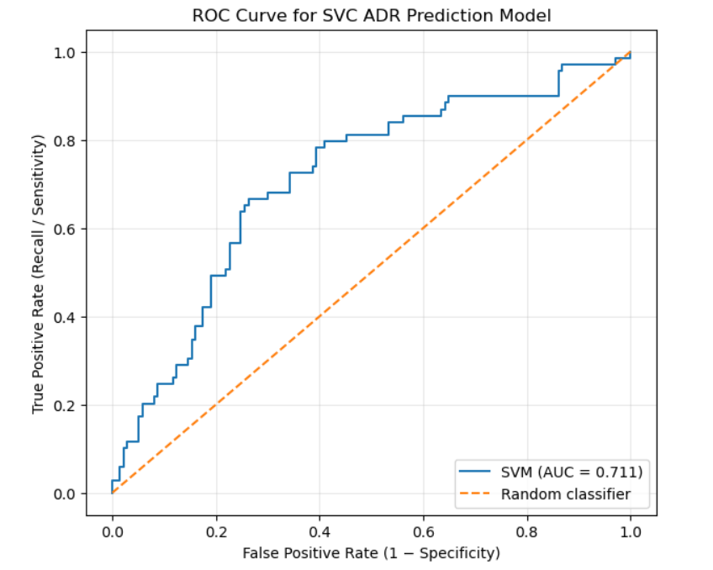
Figure 6: Receiver operating characteristic (ROC) curve for the Support Vector Classifier ADR prediction model evaluated on the independent test set (ROC–AUC = 0.711), illustrating discriminative performance across decision thresholds.
  - Explainability of Results
The universal feature importance derived from Shapley Additive Explanations (SHAP) is illustrated in Figures 12 and 13. The SHAP summary plots identified pharmacological variables that reflected medication burden, laboratory markers of renal function, and patient age as influential contributors to ADR risk across both models.
Figure 12 presents the overall feature importance ranking, while Figure 13 provides additional insight into the distribution and direction of feature effects on model predictions. Feature importance patterns were consistent across the models, supporting the robustness of the explainability analysis. Although SHAP-based explanations are associative rather than causal, they provide transparent insight into model behaviour and inform subsequent clinical interpretation of predictive performance.
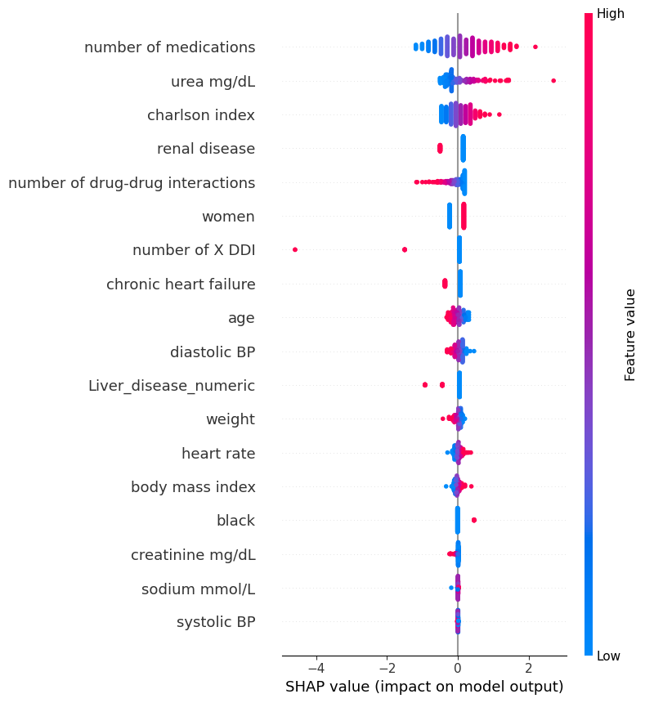

Figure 7:Receiver Operating Characteristic (ROC) curve for the Logistic Regression model in predicting adverse drug reactions, illustrating model discrimination across varying decision thresholds.
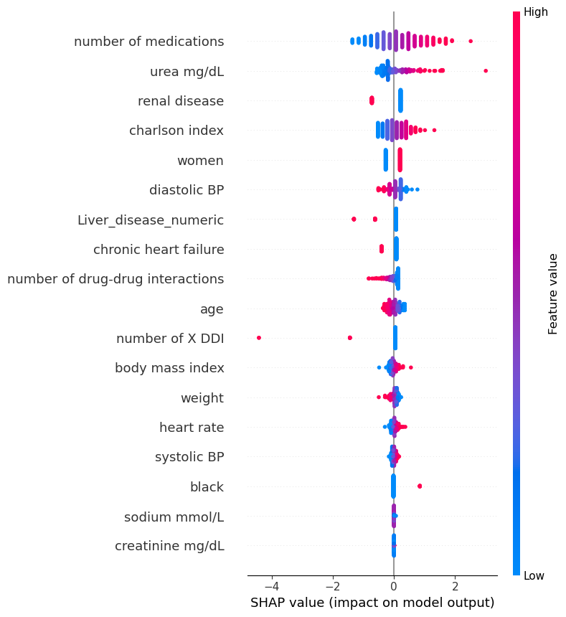

Figure 8: Receiver Operating Characteristics (ROC) curve for the Support Vector Classifier model in predicting adverse drug reactions, illustrating model discrimination across varying decision thresholds.
- Discussion
This study investigated the ability of machine learning models to predict adverse drug reactions (ADRs) through the use of clinical, laboratory, and pharmacological variables. Logistic Regression (LR) and Support Vector Classification (SVC) models were assessed for predictive performance but also through a clinical safety lens, with emphasis on recall, interpretability, and alignment with established pharmacovigilance principles. Therefore, in this, we will discuss the above aim of evaluating interpretable machine learning approaches for ADR risk prediction in hospitalised patients, with a focus on how the above data can be used for clinical safety and practical applicability.
A central consideration in evaluating both models was prioritising ADR recall. In clinical and pharmacovigilance contexts, failing to identify an ADR can result in serious patient harm, extended hospitalisation, or avoidable morbidity. Both models demonstrated moderate ADR recall, with Logistic Regression achieving 0.64 and SVC 0.65. While these values indicate that a proportion of ADR cases remain undetected, the models were still able to successfully identify many ADR events. However, despite these positive aspects, the moderate recall rates reveal an essential limitation: both models failed to detect a notable number of actual ADR cases. This may stem from factors such as class imbalance, the inherent complexity of ADR prediction, or restricted feature representation in the dataset. Consequently, relying solely on these models in a clinical setting could result in missed opportunities for timely intervention and an increased risk to patients. The prioritisation of ADR recall over overall accuracy in this study aligns with prior ADR prediction work showing that model performance through a patient-safety lens, rather than purely statistical optimisation (Chiu et al., 2024; Wolff et al., 2023b). Like these studies, the present findings reinforce that missing ADR cases pose greater clinical risk than false positives, supporting the methodological decision to emphasise recall when interpreting model performance. Nonetheless, it also highlights the need for further model refinement and cautious clinical integration.
Despite overall accuracy values of 69% for LR and 71% for SVC, the two models exhibited clinically distinct error profiles. This finding highlights the limitations of accuracy as a sole evaluation metric in medical prediction tasks with class imbalance and asymmetric consequences of misclassification. In this dataset, non-ADR cases were more prevalent than ADR cases, suggesting that accuracy alone can overstate model effectiveness by favouring the majority class. The observed differences in recall, precision, and class-specific performance demonstrate that accuracy can mask the clinically meaningful trade-offs. This reinforces recommendations from the medical machine learning literature that model evaluation should incorporate multiple metrics and be interpreted in the context of the clinical setting rather than relying on summative measures (Van Dung et al., 2025b; Wolff et al., 2023b). This interpretation is consistent with best-practice recommendations in medical machine learning, which emphasise context-aware, multi-metric evaluation in safety-critical applications to ensure that all aspects are covered.
Logistic Regression demonstrated slightly lower ADR recall than SVC, with SVC correctly identifying one additional ADR case. Although this difference may appear numerically small, it carries clinical significance in safety-critical environments. In hospital settings, a single additional detected ADR is proactive in preventing patient harm or potentially triggering timely clinical intervention. This illustrates the importance of interpreting performance differences qualitatively rather than purely statistically. From a pharmacovigilance perspective, minimal improvements in sensitivity can be meaningful, particularly when models are used as decision-support tools rather than as independent systems.
Both models exhibited relatively low precision for the ADR class (1) with LR 0.54 and SVC 0.56. This indicates a substantial number of false positives, suggesting that some patients were flagged as high risk even though they did not experience an ADR. Rather than representing a modelling weakness, this behaviour reflects an acceptable and often desirable trade-off in pharmacovigilance. False positives typically prompt further clinical review, enhanced monitoring, or medication reassessment, which may still benefit patient safety. In contrast, false negatives represent missed opportunities for intervention. By accepting reduced precision in favour of higher recall, the models align with established safety-first principles in healthcare analytics. This justification demonstrates critical engagement with model behaviour rather than descriptive reporting of metrics.
Regarding the values used as determining factors, renal dysfunction indicators, including elevated urea levels and diagnosed renal disease, were strongly associated with an increased ADR risk. This aligns with pharmacokinetic principles, as impaired renal function reduces drug clearance, leading to accumulation and increased toxicity for renally excreted medications (Chiang et al., 2021). Identifying renal markers as important predictors demonstrates that the models were sensitive to physiological mechanisms known to have an impact on drug safety. This relationship between model outputs and established clinical theory strengthens confidence in the predictive approach described above and can justify integrating laboratory variables into ADR risk assessment (Chiu et al., 2024; Datta et al., 2021).
Nevertheless, several limitations of this study should be acknowledged. First, the models were developed and evaluated using data from a single tertiary hospital. Here, this may limit the ability to apply this data to other clinical settings or patient populations. In addition, the dataset contained missing values, resulting in the exclusion of some records during preprocessing. Although appropriate data-cleaning and imputation strategies were applied, this may have reduced the effective sample size and introduced bias. Third, ADR identification relied on routinely recorded clinical outcomes, which could be subject to underreporting or documentation bias by staff recording data within the hospital setting. Finally, while SHAP enhances interpretability, the results remain associative rather than causal and should not be interpreted as definitive mechanisms behind the cause of adverse drug reactions. In contrast, recent ADR prediction studies incorporating multicentre cohorts and external validation have demonstrated improved generalisability, underscoring the importance of validating models across diverse clinical settings (Lu et al., 2023; Van Dung et al., 2025b). These limitations highlight the need for cautious interpretation and external validation before introduction to a clinical environment (Kim et al., 2020; Wolff et al., 2023b).
Although overall predictive performance was comparable between Logistic Regression and SVC, important differences emerged in interpretation and the potential of clinical application. Logistic Regression offers transparent, coefficient-based explanations that are easily communicated to clinicians and stakeholders. When combined with explainability techniques such as SHAP, LR facilitates a clear understanding of how individual features contribute to risk predictions. In contrast, SVC models are inherently less interpretable, which may reduce their acceptance in clinical settings where accountability and explanations are essential to patient care. As seen above, SVC demonstrated competitive performance; however, its relative opacity reduces its suitability for utilisation as a clinical decision-support tool. This preference for transparent models is consistent with prior pharmacovigilance research, which has highlighted interpretation as a prerequisite for clinician trust, regulatory acceptance, and the efficient use of machine learning systems in healthcare settings (Ietswaart et al., 2020; Tan et al., 2022).
From a practical perspective, the findings suggest that Logistic Regression offers a better balance of the goals mentioned previously. As stated, in real-world healthcare settings, models must not only perform adequately but also be trusted and understood by clinicians. The transparency of Logistic Regression supports integration into clinical systems, facilitates auditing, and aligns with regulatory expectations for reasonable artificial intelligence use in healthcare. These considerations justify selecting Logistic Regression as the preferred model despite similar performance metrics. Importantly, the proposed models are intended to support decision-making by assisting clinicians in identifying high-risk patients, rather than replacing clinical judgement completely.
Overall, this study demonstrates that meaningful evaluation of ADR prediction models requires consideration of clinical context, interpretability, and safety implications alongside traditional performance metrics. By integrating SHAP-based explanations with model evaluation, the study provides insight into how well the models perform and why we make certain predictions. This dual focus strengthens the relevance of the findings and supports the potential application of interpretable machine learning models in pharmacovigilance and clinical decision support. Future work should focus on external validation across multiple hospital systems and prospective evaluation to assess the real-world impact of such models on clinical decision-making and patient safety.
  - Clinical Implications
The findings of this study extend beyond the capabilities of machine learning and have several implications for clinical practice and pharmacovigilance. Firstly, the results suggest that interpretable machine learning models can support early detection and ADR risk stratification by simply using routinely collected hospital data. This can allow clinicians to identify patients who may benefit from increased monitoring or a more proactive approach to their medication evaluation. In this context, the models are best positioned as tools that can be used to assist decisions rather than completely replacing clinical judgement.
The methods used above, using transparent models supported by explanatory techniques, enhance trust, accountability and potential acceptability as stated. Clinicians may be more likely to engage with these decision-support systems when model outputs are understandable in medical terms and grounded in established pharmacological mechanisms known to have the greatest impact, such as renal impairment markers or medication burden. These characteristics are key to the safe integration of machine learning into clinical settings and support the feasibility of deploying such interpretable machine learning models within hospital-based pharmacovigilance systems (Ietswaart et al., 2020; Tan et al., 2022).
Altogether, these findings demonstrate that interpretable machine learning models, when evaluated through a clinical safety lens, can deliver legitimate and trustworthy insights. Such approaches have the potential to support safer prescribing and enhance pharmacovigilance practice.

- Conclusions and recommendations
  - Conclusion.
Throughout this study, we examined the potential of machine learning models to predict adverse drug reactions (ADRs) using routinely collected clinical, laboratory, and pharmacological data from a hospital setting. By evaluating Logistic Regression and Support Vector Classification models for predictive performance and clinical safety, the research aimed to determine whether interpretable machine learning approaches could support pharmacovigilance and patient safety initiatives.
Findings discussed above demonstrate that both models identified patients at increased risk of ADRs with moderate recall, reflecting a clinically relevant level of sensitivity. Logistic Regression achieved slightly higher recall for the ADR class, while the Support Vector Classifier showed a comparable but slightly higher overall performance. Although overall accuracy remained modest, this outcome aligns with the complexity of ADR prediction, where heterogeneous patient profiles, polypharmacy, and interactions among comorbidities contribute to substantial uncertainty. Importantly, prioritising recall over accuracy aligns with pharmacovigilance principles, in which the consequences of missing an ADR typically outweigh the burden of false positives.
A key contribution of this study lies in its emphasis on interpretability beyond data science professionals. The use of transparent models, supported by feature importance and SHAP-based interpretations, enabled clinically meaningful insights into the drivers of ADR risk. Factors such as medication burden, comorbidity indices, renal function markers, and selected laboratory variables emerged as influential predictors, reinforcing established clinical knowledge and demonstrating machine learning's capacity to integrate multifactorial risk profiles. This is critical for real-world adoption, as clinicians are more likely to trust and engage with decision-support systems whose outputs are understandable and justifiable. At the same time, the results above suggest that relatively simple, well-validated machine learning models can perform competitively without sacrificing transparency. Rather than pursuing maximum predictive performance through complex or opaque architectures, this study demonstrates the value of balancing accuracy with explainability in safety-critical healthcare applications. In this context, the models developed should be viewed as tools for risk stratification rather than diagnostic instruments, supporting earlier research on identifying high-risk patients and facilitating targeted monitoring or intervention.
Several limitations should be acknowledged when interpreting these findings, as discussed; nonetheless, these limitations reflect common challenges seen in various papers when applying clinical machine learning. This reiterates the need for cautious interpretation without diminishing the practical relevance of the results.
Overall, this study demonstrates that interpretable machine learning models can meaningfully contribute to ADR risk prediction using routinely collected hospital data. Although the models are not suitable for clinical decision-making alone, they provide a promising foundation for expanding existing pharmacovigilance processes, research and supporting safer prescribing.
  - Recommendations for Future Research.
Future research should extend, validate and improve the findings of this study across broader clinical contexts. External validation using multi-centre datasets is essential to assess the generalisability and robustness of the proposed models. This outside validation would help determine whether the identified predictors and performance characteristics hold across different patient populations and healthcare systems.
Prospective studies are also required to assess real-world clinical impact. While retrospective performance metrics provide valuable insights and a model framework for how to encounter ML in clinical settings, they struggle to capture how clinicians interact with decision-support tools or whether such systems lead to measurable improvements in patient outcomes. Retrospective studies would not be considered relevant, and methods would need to be slowly integrated into real-time clinical practice presently if machine learning gains widespread acceptance in real-time clinical settings and workflows. Showing real-time data on ADR levels and reductions in incidence, severity, or hospital stay length would provide stronger evidence of clinical usefulness.
Methodologically, future work could explore incorporating longitudinal and temporal data, such as trends in laboratory values or changes in medication over time. These approaches may improve predictive performance while preserving interpretability, particularly when combined with explainable modelling techniques. Additionally, further investigation into strategies to address class imbalance, such as cost-sensitive learning or advanced resampling methods, may enhance ADR detection and the overall model validity.
Finally, future studies should address broader ethical and implementation considerations, including model fairness, transparency, and governance. As machine learning systems become increasingly integrated into clinical care, the importance of their supporting equitable and accountable decision-making will be critical. Addressing these challenges will be essential to translating predictive models from research settings into safe and effective clinical tools.

- References
Bate, A., Evans, S.J.W., 2009. Quantitative signal detection using spontaneous ADR reporting. Pharmacoepidemiol Drug Saf 18, 427–436. https://doi.org/10.1002/pds.1742
Chiang, C.-W., Zhang, P., Donneyong, M., Chen, Y., Su, Y., Li, L., 2021. Random control selection for conducting high-throughput adverse drug events screening using large-scale longitudinal health data. CPT: Pharmacometrics & Systems Pharmacology 10, 1032–1042. https://doi.org/10.1002/psp4.12673
Chiu, L.-W., Ku, Y.-E., Chan, F.-Y., Lie, W.-N., Chao, H.-J., Wang, S.-Y., Shen, W.-C., Chen, H.-Y., 2024. Machine learning algorithms to predict colistin-induced nephrotoxicity from electronic health records in patients with multidrug-resistant Gram-negative infection. International Journal of Antimicrobial Agents 64, 107175. https://doi.org/10.1016/j.ijantimicag.2024.107175
Coleman, J.J., Pontefract, S.K., 2016. Adverse drug reactions. Clin Med (Lond) 16, 481–485. https://doi.org/10.7861/clinmedicine.16-5-481
Datta, A., Flynn, N.R., Barnette, D.A., Woeltje, K.F., Miller, G.P., Swamidass, S.J., 2021. Machine learning liver-injuring drug interactions with non-steroidal anti-inflammatory drugs (NSAIDs) from a retrospective electronic health record (EHR) cohort. PLoS Comput Biol 17, e1009053. https://doi.org/10.1371/journal.pcbi.1009053
Dsouza, V.S., Leyens, L., Kurian, J.R., Brand, A., Brand, H., 2025a. Artificial intelligence (AI) in pharmacovigilance: A systematic review on predicting adverse drug reactions (ADR) in hospitalized patients. Research in Social and Administrative Pharmacy 21, 453–462. https://doi.org/10.1016/j.sapharm.2025.02.008
Dsouza, V.S., Leyens, L., Kurian, J.R., Brand, A., Brand, H., 2025b. Artificial intelligence (AI) in pharmacovigilance: A systematic review on predicting adverse drug reactions (ADR) in hospitalized patients. Research in Social and Administrative Pharmacy 21, 453–462. https://doi.org/10.1016/j.sapharm.2025.02.008
Full article: Changing paradigms in detecting rare adverse drug reactions: from disproportionality analysis, old and new, to machine learning [WWW Document], n.d. URL https://www.tandfonline.com/doi/full/10.1080/14740338.2022.2131770#abstract (accessed 12.11.25).
Ghosh, K., Bellinger, C., Corizzo, R., Branco, P., Krawczyk, B., Japkowicz, N., 2024. The class imbalance problem in deep learning. Mach Learn 113, 4845–4901. https://doi.org/10.1007/s10994-022-06268-8
He, M., Shi, Y., Han, F., Cai, Y., 2025. Prediction of adverse drug reactions based on pharmacogenomics combination features: a preliminary study. Front. Pharmacol. 16, 1448106. https://doi.org/10.3389/fphar.2025.1448106
Hu, Q., Chen, Y., Zou, D., He, Z., Xu, T., 2024. Predicting adverse drug event using machine learning based on electronic health records: a systematic review and meta-analysis. Front. Pharmacol. 15. https://doi.org/10.3389/fphar.2024.1497397
Ietswaart, R., Arat, S., Chen, A.X., Farahmand, S., Kim, B., DuMouchel, W., Armstrong, D., Fekete, A., Sutherland, J.J., Urban, L., 2020. Machine learning guided association of adverse drug reactions with in vitro target-based pharmacology. EBioMedicine 57, 102837. https://doi.org/10.1016/j.ebiom.2020.102837
Inácio, P., Cavaco, A., Airaksinen, M., 2017. The value of patient reporting to the pharmacovigilance system: a systematic review. Br J Clin Pharmacol 83, 227–246. https://doi.org/10.1111/bcp.13098
Karuppannan, M., Mohamad Rizal, N.A.N., Wong, K.-T., Mohd. Ali, S., Ting, K.-N., Boardman, H., 2022. Pharmacists’ experiences on adverse drug reaction: 10 years later. Front. Pharmacol. 13, 932942. https://doi.org/10.3389/fphar.2022.932942
Khemani, Dr.B., Malave, Dr.S., Shinde, S., Shukla, M., Shikalgar, R., Talwar, H., 2025. AI-driven pharmacovigilance: Enhancing adverse drug reaction detection with deep learning and NLP. MethodsX 15, 103460. https://doi.org/10.1016/j.mex.2025.103460
Kim, H.R., Sung, M., Park, J.A., Jeong, K., Kim, H.H., Lee, S., Park, Y.R., 2022. Analyzing adverse drug reaction using statistical and machine learning methods. Medicine (Baltimore) 101, e29387. https://doi.org/10.1097/MD.0000000000029387
Kim, M.G., Kim, J., Kim, S.C., Jeong, J., 2020. Twitter Analysis of the Nonmedical Use and Side Effects of Methylphenidate: Machine Learning Study. J Med Internet Res 22, e16466. https://doi.org/10.2196/16466
Laroche, M., Tarbouriech, N., Jai, T., Valnet‐Rabier, M., Nerich, V., 2025. Economic burden of hospital admissions for adverse drug reactions in France: The IATROSTAT‐ECO study. Brit J Clinical Pharma 91, 439–450. https://doi.org/10.1111/bcp.16266
Lima, S.I.V.C., Martins, R.R., Saldanha, V., Silbiger, V.N., Santos, I.C.C. dos, Araújo, I.B. de, Oliveira, A.G., 2020. Development and validation of a clinical instrument to predict risk of an adverse drug reactions in hospitalized patients. PLOS ONE 15, e0243714. https://doi.org/10.1371/journal.pone.0243714
Lu, Y.-T., Chao, H.-J., Chiang, Y.-C., Chen, H.-Y., 2023. Explainable Machine Learning Techniques To Predict Amiodarone-Induced Thyroid Dysfunction Risk: Multicenter, Retrospective Study With External Validation. J Med Internet Res 25, e43734. https://doi.org/10.2196/43734
Mongkhonmath, N., Olson, P.S., Puttarak, P., Chaiyakunapruk, N., Sawangjit, R., 2025. Systematic review and meta-analysis on effectiveness of strategies for enhancing adverse drug reaction reporting. Journal of the American Pharmacists Association 65, 102293. https://doi.org/10.1016/j.japh.2024.102293
Montané, E., Santesmases, J., 2020. Adverse drug reactions. Medicina Clínica (English Edition) 154, 178–184. https://doi.org/10.1016/j.medcle.2019.08.005
Nwokedi, V.U., Odedele, M.K., Yusuff, T.A., Anderson, I.A., Akanbi, O.O., Agu, C.P., Omoike, A.O., 2025. Developing and Validating Predictive Models for Adverse Drug Reactions using Electronic Health Records (EHRs): A Narrative Review. Epidemiology and Health Data Insights 1, ehdi019. https://doi.org/10.63946/ehdi/17369
Osanlou, R., Walker, L., Hughes, D.A., Burnside, G., Pirmohamed, M., 2022. Adverse drug reactions, multimorbidity and polypharmacy: a prospective analysis of 1 month of medical admissions. BMJ Open 12, e055551. https://doi.org/10.1136/bmjopen-2021-055551
Pilipiec, P., Liwicki, M., Bota, A., Pilipiec, P., Liwicki, M., Bota, A., 2022. Using Machine Learning for Pharmacovigilance: A Systematic Review. Pharmaceutics 14. https://doi.org/10.3390/pharmaceutics14020266
Pirmohamed, M., James, S., Meakin, S., Green, C., Scott, A.K., Walley, T.J., Farrar, K., Park, B.K., Breckenridge, A.M., 2004. Adverse drug reactions as cause of admission to hospital: prospective analysis of 18 820 patients. BMJ 329, 15–19. https://doi.org/10.1136/bmj.329.7456.15
Quik, J.M., Gosselt, H.R., Van Lint, J.A., Kosse, L.J., Ten Klooster, P.M., Vonkeman, H.E., Van Den Bemt, B.J.F., Jessurun, N.T., 2025. The burden of adverse drug reactions reported by patients in the Dutch ADR monitor: a proof of concept. Expert Opinion on Drug Safety 24, 1023–1033. https://doi.org/10.1080/14740338.2024.2383707
Sommer, J., Viviani, R., Wozniak, J., Stingl, J.C., Just, K.S., 2024. Dealing with adverse drug reactions in the context of polypharmacy using regression models. Sci Rep 14, 27355. https://doi.org/10.1038/s41598-024-78474-4
Suh, D.C., Woodall, B.S., Shin, S.K., Hermes-De Santis, E.R., 2000. Clinical and economic impact of adverse drug reactions in hospitalized patients. Ann Pharmacother 34, 1373–1379. https://doi.org/10.1345/aph.10094
Tan, H.X., Teo, C.H.D., Ang, P.S., Loke, W.P.C., Tham, M.Y., Tan, S.H., Soh, B.L.S., Foo, P.Q.B., Ling, Z.J., Yip, W.L.J., Tang, Y., Yang, J., Tung, K.H.A., Dorajoo, S.R., 2022. Combining Machine Learning with a Rule-Based Algorithm to Detect and Identify Related Entities of Documented Adverse Drug Reactions on Hospital Discharge Summaries. Drug Saf 45, 853–862. https://doi.org/10.1007/s40264-022-01196-x
Van Dung, H., Tan, V.M., Dieu, N.T., Van Linh, P., Van Khai, N., Ngan, T.T., Phuong, N.T.T., 2025a. Development and external validation of a machine learning model for predicting drug-induced immune thrombocytopenia in a real-world hospital cohort. BMC Med Inform Decis Mak 25, 265. https://doi.org/10.1186/s12911-025-03107-3
Van Dung, H., Tan, V.M., Dieu, N.T., Van Linh, P., Van Khai, N., Ngan, T.T., Phuong, N.T.T., 2025b. Development and external validation of a machine learning model for predicting drug-induced immune thrombocytopenia in a real-world hospital cohort. BMC Med Inform Decis Mak 25, 265. https://doi.org/10.1186/s12911-025-03107-3
Ward, I.R., Wang, L., Lu, J., Bennamoun, M., Dwivedi, G., Sanfilippo, F.M., 2021. Explainable artificial intelligence for pharmacovigilance: What features are important when predicting adverse outcomes? Computer Methods and Programs in Biomedicine 212, 106415. https://doi.org/10.1016/j.cmpb.2021.106415
Westerink, H.J., Kosse, L.J., Jessurun, N.T., Tubergen, A.V., Vonkeman, H.E., Nurmohamed, M.T., Van Den Bemt, B.J.F., De Vries, M., 2023. Patients’ and health-care professionals’ perspectives on adverse drug reaction burden attributed to the use of biological DMARDs: a qualitative study. Expert Opinion on Drug Safety 22, 417–424. https://doi.org/10.1080/14740338.2023.2134344
Wolff, P., Ríos, S.A., Gonzáles, C., 2023a. Machine Learning Methods for Predicting Adverse Drug Reactions in Hospitalized Patients. Procedia Computer Science, 27th International Conference on Knowledge Based and Intelligent Information and Engineering Sytems (KES 2023) 225, 22–31. https://doi.org/10.1016/j.procs.2023.09.087
Wolff, P., Ríos, S.A., Gonzáles, C., 2023b. Machine Learning Methods for Predicting Adverse Drug Reactions in Hospitalized Patients. Procedia Computer Science 225, 22–31. https://doi.org/10.1016/j.procs.2023.09.087
Wu, Y., Zhao, W., Zhang, L., Wang, Y., Wen, Y., Liu, L., 2025. Machine learning models for predicting chemotherapy-induced adverse drug reactions in colorectal cancer patients. Digestive and Liver Disease 57, 1845–1852. https://doi.org/10.1016/j.dld.2025.06.007
Zazzara, M.B., Palmer, K., Vetrano, D.L., Carfì, A., Onder, G., 2021. Adverse drug reactions in older adults: a narrative review of the literature. Eur Geriatr Med 12, 463–473. https://doi.org/10.1007/s41999-021-00481-9
Zhang, F., Sun, B., Diao, X., Zhao, W., Shu, T., 2021. Prediction of adverse drug reactions based on knowledge graph embedding. BMC Med Inform Decis Mak 21, 38. https://doi.org/10.1186/s12911-021-01402-3

Appendix
Appendix 1
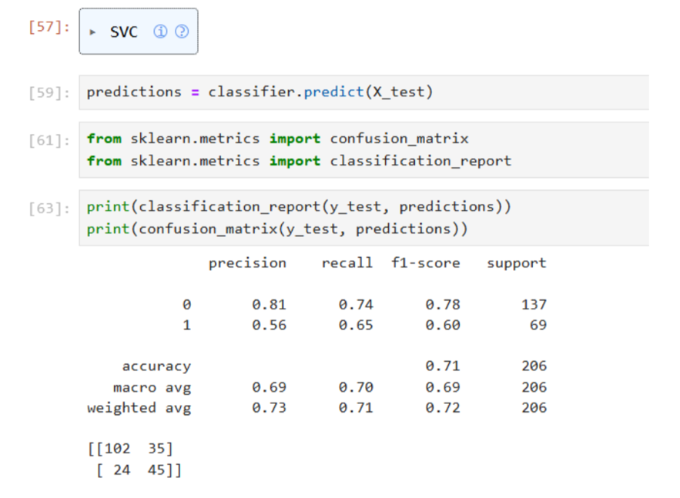
Link to python code used to evaluate both machine learning models - Full python code.html
Appendix 2:Python code used to evaluate classification performance on the independent test set, producing predicted class labels and computing precision, recall, F-1score, class support, and confusion matrices using two functions from scikit-learn library.

Appendix 2

