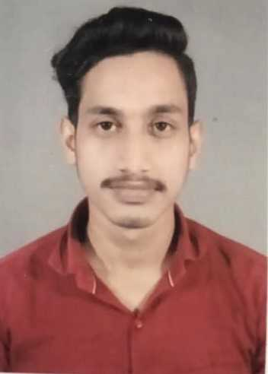

HIMANSHU AGRAHARI

Business Process Service



Male

 +91 6387893005

Objective

**Passionate towards my goals ,to achieve a good position by doing satisfying work in the BPS field and strongly focused to complete the tasks in the fast- faced environment. To secure a responsible career opportunity to utilize my skills to the success of the company.**

Education

* **Microtek college Of Management And Technology**

**-BACHELOR OF COMPUTER APPLICATION**

**-Percentage 75%**

* **Vanita Public School**
* **12th**
* **Percentage: 66%**
* **Raj English School**
* **10th**
* **cgpa 9.0**

Experience

* **Two year of experience of teaching upto class 8 standard students.**
* **Internship in Tech-Mahindra.**

Projects

* **Bank Management System**
* **Students Data Entry ( By using dot net language).**

 Varanasi, Uttar Pradesh ggg

 28.08.2000

[himanshuag11@gmail.com](mailto:himanshuag11@gmail.com)

__________________________________________________

**SKILLS**

Microsoft Office Proficient

Photoshop Intermediate

Web Development Novice

Photography Advanced

_________________________________

**ACHEIEVEMENTS**

Leadership

Awards

_________________________________

**INTEREST**

Playing Sports

Reading Novel

_________________________________

**HOBBY**

Photography

Editing