MSc Data Science (2026 - 2028)
Semester 01
Weekly Lab Evaluation
(Theory + Practical and Practical Papers)
Date: 30-5-2026
R PRACTICAL QUESTIONS – LAB 1
MDS Semester 1 – Statistical Methods with Inference

Practical 1: Importing and Analyzing a CSV Dataset in R

A retail company has provided a CSV file containing sales information with the
following variables:
• Product_ID
• Product Name
• Category
• Units_Sold
• Revenue
• Profit
Perform the following tasks in R:
1. Importing the Dataset (Import the CSV dataset into R using appropriate functions)
2. Descriptive Statistics (Generate summary statistics for all numerical variables and
find: Mean, Median, Minimum value, Maximum value & Quartiles)
3. Graphical Representation (Create a histogram for: Revenue & Profit)
4. Measures of Dispersion (Calculate: Variance, Standard deviation, Range)
Interpretation (Write a brief report explaining: Business performance)
Note: Students may create a dummy dataset on their own with appropriate values for the given variables.
Code: Attached 25048506_L1_CSVData.R file
Sample Output:
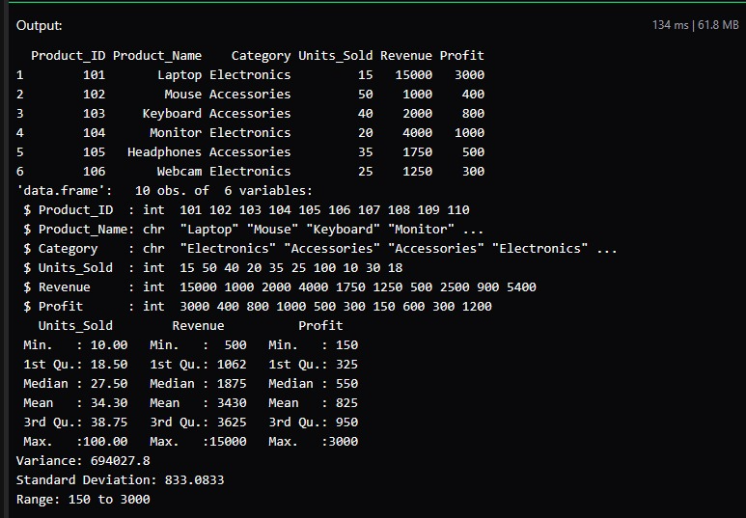
Practical 2: Analysis Using the Built-in mtcars Dataset
Using the built-in mtcars dataset in R, perform the following analysis.
1. Dataset Understanding (Load the mtcars dataset & display first 10 rows,
Summary statistics)
2. Central Tendency (Find: Mean mileage (mpg), Median mileage, Mean
horsepower (hp), Mean weight (wt), Compare mean and median mileage)
3. Measures of Dispersion (Calculate: Standard deviation of horsepower, Variance
of mileage, Range of weight).
4. Graphical Representation (Create Histogram for mileage)
Code: Attached 25048506_L1_MTCARS.R file
