Bài 1:

3.1

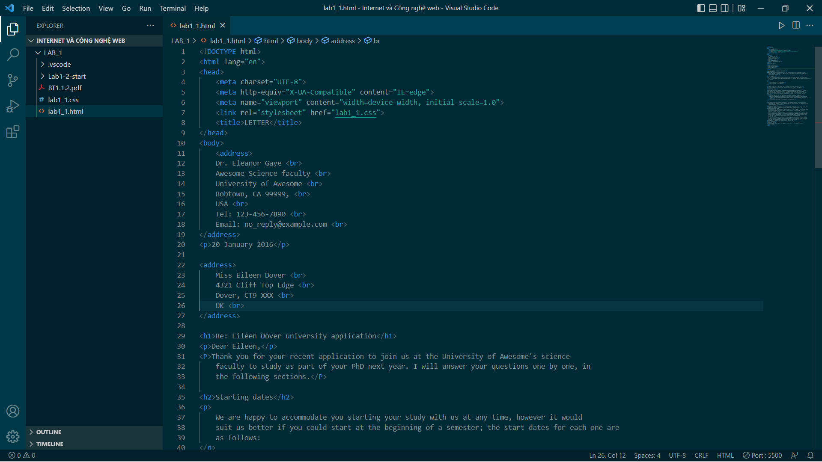

3.2

3.3

Bài 2:



