PostgreSQL exercise

1)Case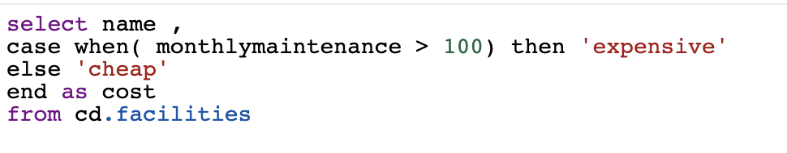

2)Distinct, order by, limit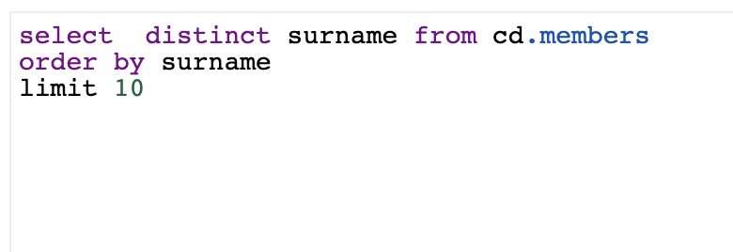

3) union

4) max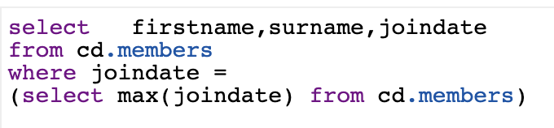

In order to select the latest joindate, function « **MAX** » can be used, but in order to select the max, we have to use again the ‘select’

5)Like ‘string’

6) In

7)Renaming column