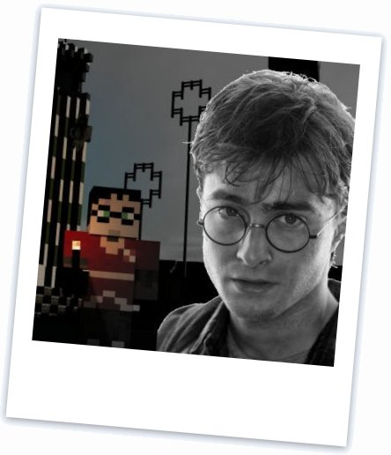
Stuff we like!
Last week some of you uploaded your ‘Ogres Online’ files to a webserver and linked them to the pages of the other Ninjas in your group.
This week we’ll take it one step further and create a mini-website to show off stuff we like and how far we’ve travelled in just six weeks.
We want everyone to put up their own page — and for all the pages to be linked from an index page.

Your challenge!
Make a web page about something you like. Ideas? Minecraft, Harry Potter, The Simpsons, your football team, CoderDojo … whatever you think is great. Keep it simple — or get as fancy as you like with tables, images, css. But, remember, you only have an hour or so to get it done.
Then each page will get uploaded to the upload site (same as last week).
Once you’ve done this, work together to create a top-level menu which links to all your files (we’ll call it index.html).
Each uploaded page will be linked to index.html and so at the end of the session you’ll be able to go to html.coderdojobray.com/uploads/ and see your page.

Method
1 Spend the first part of the Dojo (up to the break) creating your page.
Make the page title your name (for example ‘Donal’s Page’). Add your initial to the page name or use a nickname if someone else has the same name (for example John D’s Page‘).
When you save the page, use your name in the filename, for example donal.html or johnd.html
If you link to a stylesheet do a similar thing, e.g. donal.css or johnd.css
2 Use FileZilla to upload the files (same as last week).
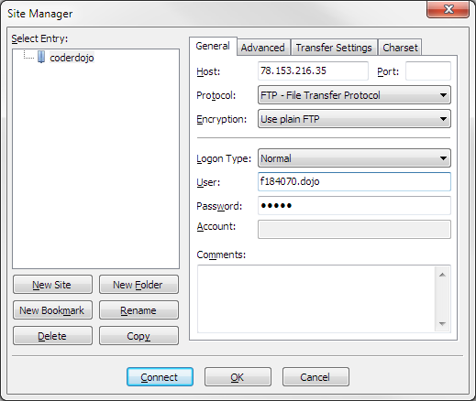
Settings:
Host: 78.153.216.35
Login Type: Normal
User: f184070.dojo
Password: shrek

3 Connect to the server and upload the files.
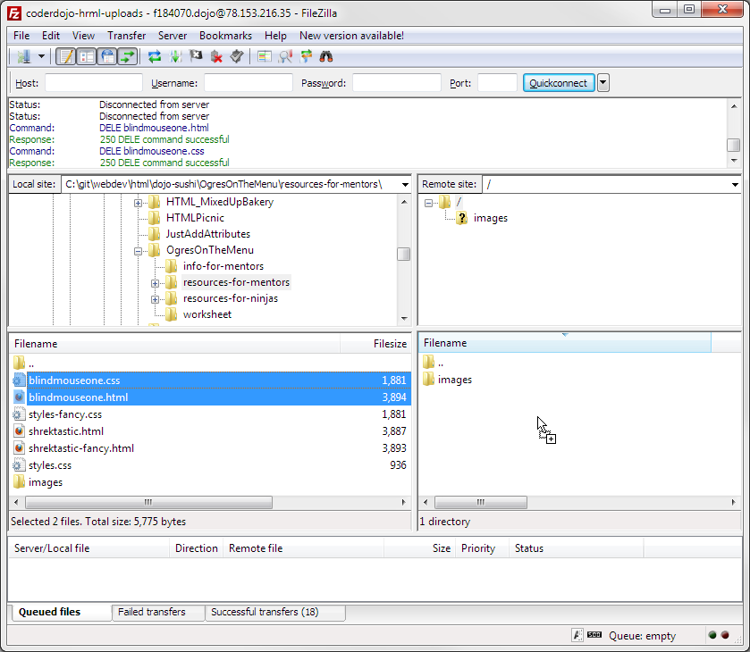
4 Now open your browser and see if you can see your files in
html.coderdojobray.com/uploads/

Feeling brave?
Add a link from your file back to the menu (index.html).

