Putting on the style
When we serve up our HTML Picnic we want it to look appetizing.
We’ve three courses — can we make each of them look special and make it easy to separate the Dojo Dips from the Shrek Sushi?
Yes we can!
“Spread out the stylesheet!”

What’s a stylesheet?
Remember the elements in your HTML file? (Our picnic containers!)
h1, h2, h3, p, em, ol, li, table (and so on and so on).
If you don’t add a stylesheet — the browser decides how they should look (which is really, really boring).
If you add a stylesheet — YOU decide how they should look (which is much more interesting).

How does it work?
A stylesheet is a file which ends with the file extension .css
(Q: What’s a file extension? What does css stand for?)
It contains a bunch of rules which tell the browser how to display the elements on the pages which are linked to the stylesheet.
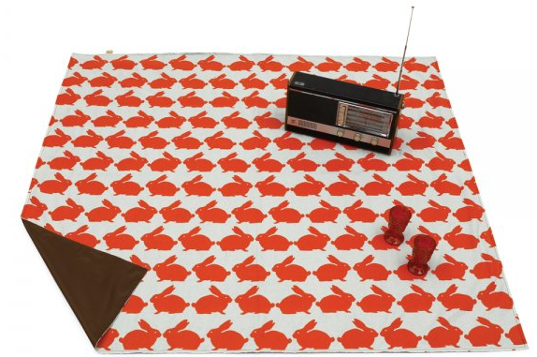
If you look at the
picnic-in-style.html page you’ll see this in action.
Questions: can you see how the page is linked to the stylesheet?
Where is the link made?
Where is the stylesheet?
Tip: remember what you know about filepaths!

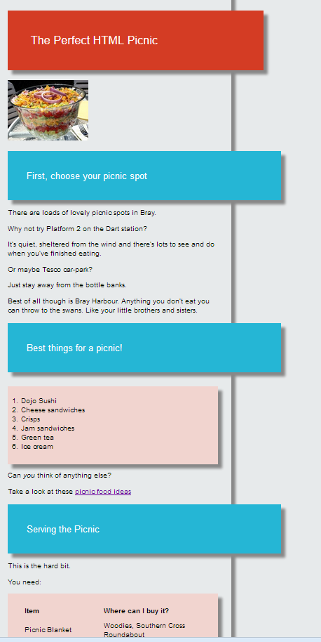
Your challenge!
Fix the picnic-in-style.html file that’s on the data key.
1. Open:
picnic-in-style.html in your web browser
and in a text editor
picnic-in-style.css in a text editor
2. See if you can edit the HTML file so that it looks like it does on the right (Tip: no need to edit the css file! Clue: attributes are important!)
Change the colours of
A. the background
B. the orange header
C. the blue headers

Feeling brave?
Put an orange border round the table which lists the items you need (and take off the drop-shadow),
Change the font to something more interesting.

