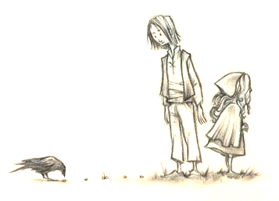
Following the crumbs

This challenge is to make sure you can find your files.
• Do you know what a file is?
• Do you know what a folder is?
• Do you know how to make a folder on your PC or Mac?
• Once you made it, can you find it?
• (Oh … and what’s a file extension?)

Your challenge!
1. Create a folder on your machine your for Dojo files
2. Write down where it is — for example —
C:\Users\Shrek\Documents\Dojo_files
3. Copy the FollowingTheCrumbs folder into your Dojo files folder.
4. Write down the full file path to file-extensions.html file which you can find copied folder. For example —
C:\Users\Shrek\Documents\Dojo_files\FollowingTheCrumbs\file-extensions.html
5. Can you see the whole of the file name in the folder?
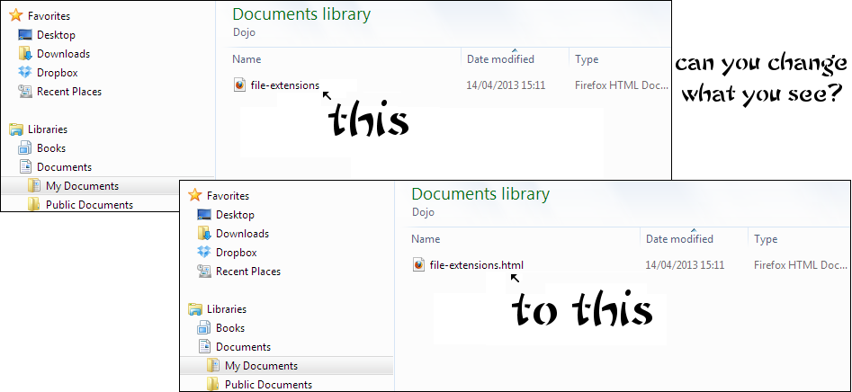

Feeling brave?
Give the file path to the Ninja sitting next to you.
Can they find it on your machine?
Take the file-extensions.html file and edit it so that it has a list of file extensions and what they stand for

For example:
.jpg — ‘JPEG’ file — digital image such as a photograph
.pdf — portable document format (Adobe Acrobat file)
.txt — a plain text file (no fancy formatting)

Can you make it look like this?

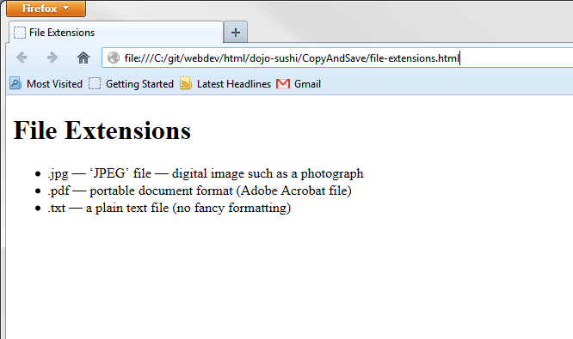

Or even like this?
