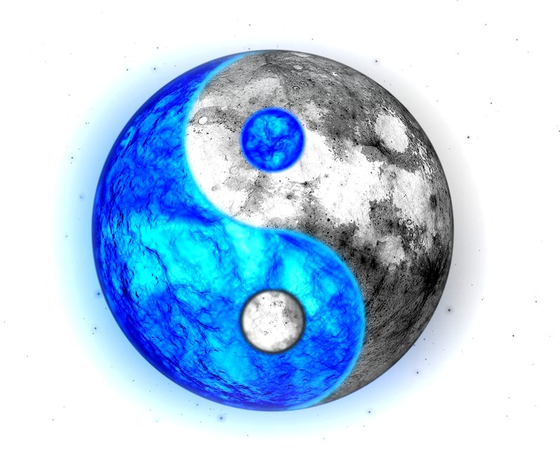
Planet Dojo

Can you add the stylesheets
to the webpages?

Your challenge!
1. Copy the PlanetDojo folder into your
Dojo files folder.
2. Open the mars.html file in your editor
and in your browser.
Can you see the picture of Mars as the page background?
3. Now open the other files.
You’ll see that the pictures are missing.
4. Can you fix this by:
— adding the references to the stylesheet in the HTML files (use mars.html as the example)
— add the selector for Venus in the sty;lesheet

Feeling brave?
1. Change the paths to the images in the stylesheet so they point to the files in the images folder rather than web resources.
2. Create a Home page that has links to all the planets. Use the planetdojo.jog image as the background.

