Broken table
Can you fix the broken table?

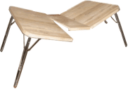
Your challenge!
There are two pictures of a HTML table on the other side of this sheet.
1. Copy the BrokenTable folder into your Dojo files folder.
2. Open the favourite-foods.html file in your editor and in your browser.
When you look at the file in your browser it looks like the first picture.
Can you see the picture of the Skittles is in the wrong column?
3. Can you fix the HTML so that the table looks like the second picture?

Feeling brave?
1. Add a new row for you and everyone else sitting at your block of desks. Ask the other Ninjas their favourite foods.
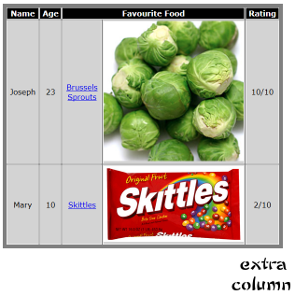
Remember: You will need to google to find images for the foods.
2. Add an extra column with your rating for each food (marks out of 10).
3. Create a brand new table for your favourite animals or sports teams or toys.
